

A critical study of why Greggs is so successful

Sasha Cranfield
1703081
BMBM5001
Research Project
2020

DECLARATION
This work has not previously been accepted in substance for any degree and is not being concurrently submitted in candidature for any degree.

Signed Sasha Cranfield
Date 26.05.20

STATEMENT 1
This dissertation is being submitted in partial fulfillment of the requirements for the degree of BA.
Signed Sasha Cranfield
Date 26.05.20

STATEMENT 2
This dissertation is the result of my own independent work/investigation, except where otherwise stated.
Other sources are acknowledged by footnotes giving explicit references. A bibliography is appended.
Signed Sasha Cranfield
Date 26.05.20

STATEMENT 3
I hereby give consent for my dissertation, if accepted, to be available for photocopying and interlibrary loan, and for the title and summary to be made available to outside organisations.

Signed Sasha Cranfield
Date 26.05.20

STATEMENT 4
I hereby give consent for my dissertation, if accepted, to be available on the university’s IT system to those who have consented to use the system.

Signed Sasha Cranfield
Date 26.05.20

COVID-19 MESSAGE
After the UK implemented a 24-hour curfew in March 2020, UWTSD took steps to support the research student and research during the curfew and University building closures.
Formal supervision meetings continued as much as possible and arranged via suitable meeting software and documents shared electronically.
Some research was at greater risk of delays, for example, projects requiring physical presence to undertake interviews, fieldwork, or data collection. Supervisors and research students urgently reviewed their research plans. UWTSD understands that some students’ projects and dissertations were planned to require in-person research and data collection that is not possible in this period of remote learning. Digital research activities that advance the studies, were prioritized. If it was no longer possible to continue with the existing plan then consideration of changes to the project plan should be considered to offset, wherever possible, undue future delays to the project/dissertation submission. All fieldwork conducted by students occurred remotely using electronic means wherever possible.
Students, with the help of their supervisors, are urged to document the extent of the disruption to their research.

Abstract
This research study was undertaken as part of a business management undergraduate degree. Greggs is a leading “food on the go” bakery chain that has been operating for more than 70 years. Greggs is seen as a successful business therefore this research aimed to understand some of the reasons why Greggs is perceived as being successful. The research methodology undertaken for this research was a quantitative one, using both secondary and primary data. The primary data was gathered via an online questionnaire to gain an understanding of why Greggs is so successful. For the secondary data collection, the Greggs corporative website was used, together with Statista.
A comprehensive literature review was done to gain a better understanding of the core reasons for the success of a business, looking at competition and the main critical success factors. The literature review aided the researcher in creating a research method, which would successfully help reach the aims and objectives of the research study. The aims of this research study were: 1) To investigate the development and the progression of Greggs; 2) TO identify the main success factors for Greggs’ success; 3) To identify competitors and future improvements to remain current. This research study suggests that Greggs has increased its sales over the past 10 years, with the number of stores increasing over the same time; the main success factors identified were customer service, product differentiation, efficient operations, finance, and competitive advantage. Several recommendations were made which could be considered for future improvements, for example, the expansion of their services to include the delivery of their products to local businesses.

Contents page
1. CHAPTER ONE-INTRODUCTION 9
1.1. Background 9
1.2. Rational 9
1.3. Aims and objectives 9
2. CHAPTER TWO- LITERATURE REVIEW 10
2.1. Introduction 10
2.2. Competition 10
2.2.1. Competitive advantage 10
2.2.2. Competitive Analysis 13
2.2.3. Competitive priorities 13
2.3. Success factors 13
2.3.1. Operations 14
2.3.2. Work procedures 14
2.3.3. People 14
2.3.4. Leadership 15
2.3.5. Marketing 15
2.3.6. Product differentiation 15
2.3.7. Finance 16
2.3.8. Customers and customer services 16
3. CHAPTER 3 – METHODOLOGY 17
3.1. Research Onion 17
3.1.1. Research philosophy 18
3.1.2. Research approaches 19
3.1.3. Method 19
3.1.4. Strategy 19
3.1.5. Time 20
3.1.6. Techniques and procedures 20
3.2. Sampling 21
3.3. Analysing 21
3.4. Validity and Reliability 21
3.5. Limitations 22
3.6. Ethics 22
4. CHAPTER 4- RESULTS 23
4.1. Demographics 23
4.2. Critical Success factors: 25
4.2.1. Product differentiation 25
4.2.2. Finance 27
4.2.3. Customer Service 27
4.3. Competitive Advantage 29
5. CHAPTER 5- DISCUSSION 31
6. Chapter 6- Conclusion 33
References 34

list of figures
Figure 1: Competitive advantage (Porter,1998) 12
Figure 2: Generic strategies (Porter,1998) 13
Figure 3: Saunders et al (2009) 18
Figure 4:Gender (Author, 2020) 24
Figure 5: Age (Author, 2020) 24
Figure 6 :Greggs Turnover (Greggs, 2020) 25
Figure 7: Greggs Stores (Greggs, 2020) 25
Figure 8: Operations (Author, 2020) 26
Figure 9: Important factors (Author, 2020) 26
Figure 10: Range of products (Author, 2020) 27
Figure 11: Quality of products 27
Figure 12: Range of products better than competitors (Author, 2020) 27
Figure 13: Priced correctly (Author, 2020) 28
Figure 14: Customer Service rating (Author, 2020) 28
Figure 15: Customer experience (Author, 2020) 29
Figure 16: Staff efficiency (Author, 2020) 29
Figure 17: How friendly are Greggs staff (Author, 2020) 29
Figure 18: Location (Author, 2020) 31

list of Tables
Table 1 : Overview of Research approach…..……………………………………………………………………………………….18

CHAPTER ONE-INTRODUCTION

Background
The “food on the go” sector has seen an increase over the past five years, and it will continue to grow in the future. Food to go specialists such as Greggs would see the biggest rise in value (Atherton, 2017). Greggs is one of the largest bakery chains in the UK. It was reported by the (BBC, 2017) that Greggs sales have risen by 7% since 2015 which means that they are growing and becoming more successful. This Research project will investigate the reason why Greggs is the largest chain and better understand the factors that have come into play for them to be successful.

Rationale
This research project will investigate the success behind Greggs. This topic is being researched, as there has not been much research done on the success of Greggs.

Aims and objectives
This research project aim is to critically evaluate the factors that have affected Gregg’s current success and growth.
The research objectives for this project are:
- To investigate the development and progression of Greggs
- To identify the main success factors to evaluate why Greggs is still growing and doing successful
- To Identify competitors and future improvement to stay current
The researcher will conduct research using a quantitative approach using questionnaires to collect data. Questionnaires will be distributed to members of the public using Google forms, SPSS, and Excel will be used to analyse the data. According to Saunders et al (2009), this data collection method is convenient as it allows for large amounts of data to be collected in an easily managed way.

CHAPTER TWO- LITERATURE REVIEW

Introduction
Greggs is a bakery “food-on-the-go” retailer in the UK. It sells savory products such as pastries, sandwiches, and sweet items such as donuts. It has over 1,700 stores up and down the UK. It was founded 75 years ago by John Gregg. Many developments have happened over the last five years with changes to how the shops look, introducing drive-throughs, and starting to do deliveries with Deliveroo (Greggs, 2013). Over the years Greggs, as shown an increase in sales revenue and, has become quite successful. This research tries to understand the factors that have contributed to Gregg’s success but also first looks at the literature to understand the different factors that contribute to success.

Competition
The competition gives purpose or reason for the existence of a business; it is the rivalry between businesses, it increases sales and allows for more customers. The more customers the business has the more profit would be made so having a great sense of competition and staying ahead of business competitors is important (Gitonga, 2018).

Competitive advantage
Competitive advantage is the advantage that is gained by offering great value or providing a great service. Innovation drives competitive advantage (Clegg, Kornberger, and Pitsis, 2016). Porter (1998) recognised that businesses are likely to watch their rivals but encouraged them to examine factors that could impact the business environment. He acknowledged that five forces make up foundations to gain competitive advantage. The forces are Competitive Rivalry, Supplier Power, Buyer Power, Threat of Substitution, the threat of New Entry. It is an essential and helpful tool to help chose the correct strategy to use for a competitive environment (Porter, 1998). Each of the forces influences the level of competitiveness. It helps managers determine whether they want to stay in the industry, they are in. The threat of new entrants refers to the risk that new competitors pose to existing businesses. The threat depends on the entry barriers which are economies of scale, access to distribution, legislative and brand loyalty (Combe, 2014).
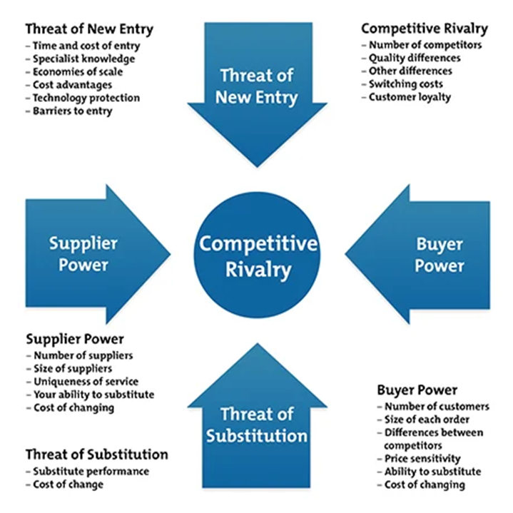
Competitive rivalry happens when a company has lots of competitors, customers can easily switch suppliers. Supplier power is determined by how easy it is for suppliers to increase their prices. The more suppliers there are the easier it would be to choose a cheaper alternative. The success business has depended on the power of the buyer. Buyer power refers to the consumer using on a business to get better quality products or services at a lower price. The threat of substitute products refers to customers finding different other ways of doing the same thing. A substitute that is cheap and easy can weaken a business’s position and profit (Mindtools, 2019).
Figure 1: Competitive advantage (Porter,1998)

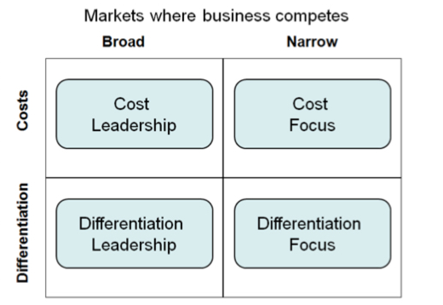
Achieving a competitive advantage can be done in many ways but there are two types of competitive advantage, which are cost advantage and differentiation advantage. A company that can dominate in cost or differentiation can provide products or services at a lower cost and can compete with its competitors

Figure 2: Generic strategies (Porter,1998)
According to Porter (1998), cost advantage can be achieved through performance by producing quality products or services at a lower cost. Companies that can do this is using a cost leadership strategy. Differentiation advantage can be achieved by offering unique products or services and charging superior prices. Businesses that depend more on branding, quality, and advertisement rather than efficiency. Some customers are prepared to pay more for a unique product and the best quality (Cambridge, no date).
A business that can perform better than its competitors over time can achieve a sustainable competitive advantage (Jurevicius, 2013). Businesses need to be able to find a strategy that is best to achieve a competitive advantage. They need to have at least one to be successful.

Competitive Analysis
Competitive analysis is crucial for understanding the environment in which the business operates (Deshpandé and Gatignon, 1994). It is a method used to evaluate competitors and get an understanding and comparison of their strengths and weaknesses (Boyd, 2019). Analysis should include and identification of present and potential competitors and where they are most vulnerable.
David Aaker (2001), suggests that the performance of a business is related to the control of resources and skills. Therefore, analysis reveals the causes behind such a successful track record on the other hand analysis of their failure should also be done as it will provide an idea of skills and resources that are needed to be successful within a given industry.

Competitive priorities
Competitive priorities are the abilities that the operations function can develop to give a business a competitive advantage in the market (Ried and Sanders, 2013). Managers must work closely with marketing to understand the competitive situation. Competitive priories that are important can be identified using four categories which are cost, quality, time, and flexibility. Competitive priorities are important as it allows businesses to set up goals.

Success factors
Business success is about the achievement of the goals and objectives of a company (Foley and Green, 1989). There are five main critical success factors for a business. A critical success factor can be defined as a business capability or condition that is essential to achieve a goal. The five critical success factors are Leadership, People, Operations, Marketing, and Finances (Foley and Green, 1989).

Operations
Internal factors can influence business success positively and negatively. Internal factors are things such as business culture, employees, finance, procedures, and technology (BBC, 2020). Slack, Brandon-Jones, and Johnson (2016) define operations as the decisions and responsibilities of managing the production and delivery of services and products. Businesses need to implement systems that are reliable, consistent, and repeatable.

Work procedures
Procedures and policies in business are an essential part of a business. They are important as it will address any issues and allow businesses to follow correct steps consistently (Sanelli, 2018).
Policies and procedures that are used effectively allow businesses to run much more smoothly and efficiently. They communicate the values and vision of the organization, ensuring employees understand exactly what is expected of them in certain situations. if used effectively, they can streamline your business. Policies and procedures allow also for business growth for the future (Unknown, 2020).
Having policies and procedures in place has many benefits for a business. It will set expectations it will allow employers to commit to values and missions of the business. It will ensure compliance with the law and will assist a business in meeting its requirements at law (Neideck, 2016).

People
Employees need to perform effectively as customers will feel that the business does not care about their needs and will go seek help somewhere else. Business success is also due to employee performance and it is a critical factor in their success. Businesses need a positive work environment so that employees can do their jobs effectively. Rewarding high performers and having incentives for employees will create a positive workplace. Another factor in achieving goals. Employees need to meet deadlines as it will avoid any unnecessary delays which could be detrimental to the business. (Leonard, 2019)

Leadership
Leadership in a business is important as it handles both internal and external stakeholders. (Patel, 2017).Strong leaders help organisations maximize productivity to achieve goals. There are many different effective-and ineffective-leadership styles ad is important for businesses to make sure they have an effective leadership style to be successful. Leaders have to motivate employees to work hard so that they can meet the business’s needs (Unknown, 2016).

Marketing
The heart of any business lies in marketing. Some aspects of a business rely on successful marketing. Marketing is the process in which a service or product is promoted to customers, without its customers and potential customers would not know about it, and businesses will not succeed. Marketing is important as sales drop, and some businesses will have to close because of it. Customers may not be aware of any offers being put out so businesses may not have the opportunity to progress and grow. Marketing is also a way of getting new customers. Business reputation also relies on marketing as it builds the brand name. Marketing allows for healthy competition as it gets the word out of prices of services or products which not only reaches existing customers but their competitors customers (Eddine, 2015).

Product differentiation
Product differentiation allows customers to choose certain brands to use which helps defend high prices products or services. It gives companies reason as to why they change product prices and allows for competition in prices. Product differentiation builds brand loyalty and equity (Pahwa, 2020).

Finance
Finance is the last factor that is important to the success of a business. Businesses should have Advanced financial controls to monitor their profits. A business needs to keep its pricing on par with what their competitors are charging. Businesses need to make sure they their assets are up to date and in good condition (Unknown, 2001).

Customers and customer services
Customers are the foundation for any business success. If a business does not have any source of income, then the business will fail. Businesses need to meet customers' needs to get ahead of the competition.
Turban et al (2002) describe customer services as several activities that are designed to improve customer satisfaction. Customer service is important as it increases customer loyalty, generates word of mouth, increases how often a customer uses business, and increases the amount of money they will spend. There are many reasons why customer service is important but each business must deliver the perfect service for the customers (McQuerrey, 2019). An essential part of customer service is keeping customers as it costs more to appeal to new customers. Businesses can provide excellent service by providing training as employees represent the business so it important for them to have the correct attitudes, having customer service policies in place, and surveying customers (Adams, 2016).
Customer loyalty allows for repeat business, which means customers, will buy products or use services repeatedly. Customer loyalty improves business image as loyal customers are likely to share positive experiences this will lead to new customers. The business provides customer loyalty schemes such as rewards for being a loyal customer.
.

CHAPTER 3 – METHODOLOGY
In this chapter, research will be defined and the reasons why it is important will be given. Using the Saunders et al (2009) research onion a structure for the research will be explained. The researcher will highlight some of the limitations of the research that will be undertaken, and remedies will be explained. Additionally, ethical implications that may arise will be addressed. The most beneficial method to investigate why Greggs is so successful will be evaluated.

Research Onion
Research is defined as a systematic and methodical process of investigation to grow to understand (Collins and Hussey, 2014). According to Clifford Woody research includes redefining problems and formulates a hypothesis or provides a solution (Korthari C.R, 2004).
The researcher will use the research onion, which is shown in Figure 3 to make sure that all the stages of research are followed and explained thoroughly.
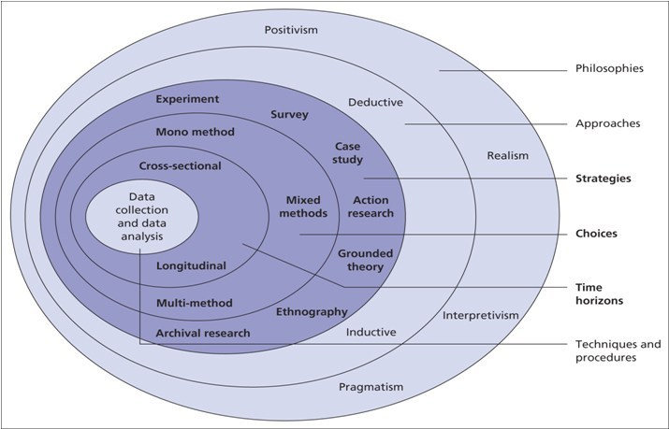
Figure 3: Saunders et al (2009)
The research onion illustrates a description of each stage of the research process. It works the same way as peeling an onion, from outer layers to the inner layers. Each layer has different options for the researcher to choose techniques and tools which are best suited. By working through the layers of the onion the researcher will have a comprehensive piece of research (Sahay, 2016).
LAYER | Method Taken
Philosophy | Interpretivism
Approach | Inductive
Method | Mono-method
Strategy | Case study
Time | Cross-sectional
Technique and Procedure | Questionnaire

Table 1: Overview of Research approach

Research philosophy
Research philosophy is the first layer of the onion that a researcher will have to peel back. There are many types of philosophy within this layer and the researcher needs to choose the right one. Research is defined as a belief about how data about a trend should be collected, analysed and used (Dudovskiy, 2019). According to Avogousti (2013), researchers need to first look at the range of philosophies to establish a high quality piece of research. Easterby-Smith, Thorpe, and Loewe (1994) suggest that there are three main reasons for understanding research philosophy. Firstly, it can help with clarifying research designs, secondly, it will help the researcher know which research designs the best suit them, and finally, it helps identify certain drawbacks within areas, and researchers can change it to fit their research design. The researcher has chosen to use an interpretive approach.

Research approaches
The second layer of the onion is research approaches. There are two types of approaches, inductive and deductive. According to Bryman and Bell (2015), inductive is an approach to the relationship between theory and research in which the past is generated out of the latter and deductive is the opposite, an approach to the relationship between theory and research in which the latter is conducted regarding a hypothesis and ideas inferred from the former. The difference between the both is that inductive is forced on testing existing theory whereas deductive is focused on generating new theory form data. The deductive approach begins with a hypothesis whereas inductive uses a research question (Gabriel, 2013).
This study will use an inductive approach. The researcher is using this approach as it best suits the study. The researcher aims to ask questions the research for this study will be a questionnaire and will provide quantitative data.

Method
The research method is the next layer. The researcher will be using a mono method. A mono-method study uses one type of method, quantitative or qualitative. Using a mixed method is often too long and complicated so there for the researcher has chosen to gather primary quantitative data a questionnaire.

Strategy
Samar Rahi (2017) defines a research strategy as a process of collecting and interpreting data with clear objectives. Some research strategies are case studies, surveys, experiments, ground theory, and ethnography. This researcher will be using a case study, an in-depth investigation of a particular case, in this instance the case is Greggs, that answers a specific research question (Gillham, 2000). Case studies are widely used research designs and are popular in research (Eisenhardt and Graebner, 2007). An advantage of used case studies is that they can be done remotely, research do not need to be present. A disadvantage of using a case study is that the data takes longer to analyse (Gale, 2018).

Time
The researcher has chosen to do a cross-sectional study design. A cross-sectional study is a type of observational study, which measures the outcome and experiences in the population. Surveys are a method of cross-sectional studies. The strengths of cross-sectional studies are that they are conducted faster (Setia, 2016). Another strength is that it paths away for further research. By using cross-sectional, it will allow the researcher to gather a large amount of data in a short time and can provide help with information about a variety of variables in determining the success of Greggs. A Cross-sectional study differs from longitudinal studies as they look at multiple measures over an extended period (Cherry, 2019). The researcher has chosen a cross-sectional research method, as it is the best method, which will help with achieving the aims and objectives of this study.

Techniques and procedures
The researcher has decided to use a questionnaire. Questionnaires are a research instrument that has a set of questions that is used to gather information from participants(Dudovskiy, 2018). It is a form of quantitative research. According to peters (2019), it collects a large amount of data that can be explored. The strengths of questionnaires are that they are relatively easy to analyse, they have quick response times and are simple to put together (Mcleod, 2018).
For this research, questionnaires will be shared online in Swansea. It will include both short and long questions about Greggs. The questionnaires will be made using Google forms, this will allow the survey to be easily accessed and shared. The questionnaire will consist of 20-25 questions based on some of the themes depicted from the literature review that was discussed at the start. The questions will be written clearly to prevent any misunderstandings. Please see appendix one for the questionnaire.
The questionnaire will be based on how the participants feel about being customer, customer service, the products, the prices, and convenience. It will get an understanding of the experiences at Greggs and weather there is any correlation of factors that have led to their success.

Sampling
Sampling is the selection of the population to observe so that one may estimate something about the population as a whole (Thompson, 2012). If done correctly sampling will let the results be valid and reliable if not the results may have little scientific and practical value (Daniel, 2012). A perfect sample would be like a scaled-down version of the population but this does not exist so a sample would have to be representative, this means it will seek to accurately reflect the characteristics of the population (Lohr, 2010).

Analysing
Once the data is collected, it will be analysed using SPSS and Excel. This will allow the researcher to get a deeper understanding of the data. A descriptive analysis will also be used to analyse the data.

Validity and Reliability
For results to be meaningful, it must have high validity and reliability. They show how well a method measure something. Validity is the extent to which results can measure to what they were supposed to measure (Middleton, 2020). Validity can be checked by comparing results with established theories. If results are accurate then they should be reproducible.
Reliability refers to the research instrument and whether it will produce the same results if the study was done at a different time (Denscombe, 2014). A reliable measurement may not always be valid, results may be reducible bot not accurate. Validity is the accuracy of a measure whereas reliability is the consistency of a measure. Questionnaires are low on validity and high on reliability.
The researcher will conduct a pilot study to see if the questions are suitable and understandable the researcher will carefully develop the questionnaire to minimize any validity issues.

Limitations
There will be some limitations to any research. It is important to understand that there may be limitations so that researchers can plan remedies to be able to solve the problem. The first limitation of this study is that because the questionnaire is online the sample size may not be met. There also may be sample bias as participants are self-selected which means it may not be representative of the population. The second limitation is that there is a deadline for the study, so the amount of time needed to collect data could be affected.

Ethics
Ethics considerations are an exceptionally important part of the research. It is important to deal with any ethical issues that may arise at any part of a research paper (Fisher, 2010). The researcher will take ethical consideration seriously and will consider it throughout the research.
The participants in the questionnaire will have to be over 18 to take part. Participants will be able to opt-in and out and anytime they wish. They will stay anonymous to protect them. Responders will have to complete a consent form before carrying on with the survey. See Appendix B for the consent forms. All the data will be kept on one password-protected device. The research will go through the University’s ethical approval procedure. See Appendix C

CHAPTER 4- RESULTS
This chapter introduces the results received from the data collected. Participants were customers of Greggs.

Demographics
There was an equal number of males and females answering this questionnaire. Most of the participants were in the age group 18-25 (34%), with the next popular age group being 55-64 years of age (18%).

Figure 4:Gender (Author, 2020)
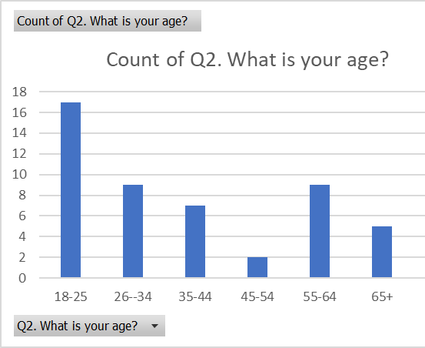
Figure 5: Age (Author, 2020)
Most of the participants visited Greggs either once a day (18%), once a week (18%), once every two weeks (12%), once a month (38%), and a large majority of the participants were long standing Greggs customers of between 1– 5 years, with 4% having been a customer for longer than 10 years.
The results below are presented alongside the aims of the research that has been set out:
Aim 1: To investigate the development and progression of Greggs
The researcher used secondary data to investigate the development and progression of Greggs, which was the first aim of the study. The secondary data used was gathered and turned into graphs to clearly show the increase of turnover and the number of stores Greggs has over a period of 13 years.

Figure 6 :Greggs Turnover (Greggs, 2020)
Greggs turnover for the last 13 years clearly shows that there has been a positive increase in their turnover from 2005 -2018.

Figure 7: Greggs Stores (Greggs, 2020)
This graph clearly shows the progression of Greggs in terms of how many shops they have opened over 13 years.
Aim 2: Identify the main success factors to evaluate why Greggs is growing and being successful
The literature suggests the following success factors, which the questionnaire tried to gather data.

Critical Success factors:
- Operations
The graph below suggests that a large majority of the participants believed that the processes Greggs used were extremely efficient (with 5 = very efficient, 4 = Efficient)
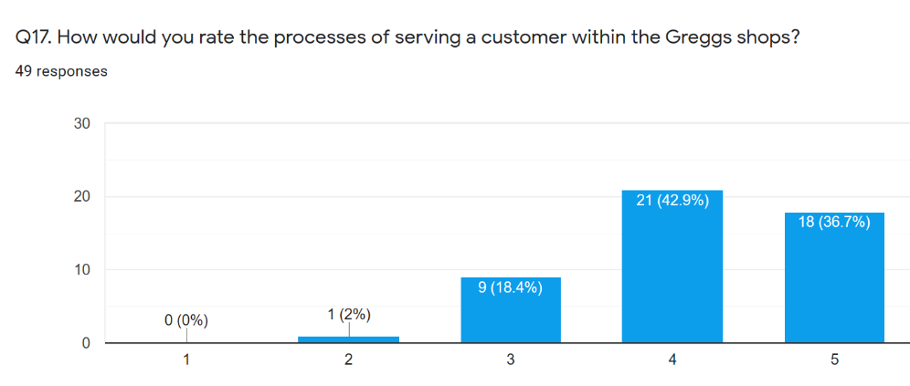
Figure 8: Operations (Author, 2020)

Product differentiation
Eighty percent of the participants ranked the Product as a very important factor when they shop at Greggs, while sixty-four percent indicated the next important factor was Price, then Convenience (62%), and the last factor being Customer service (50%)
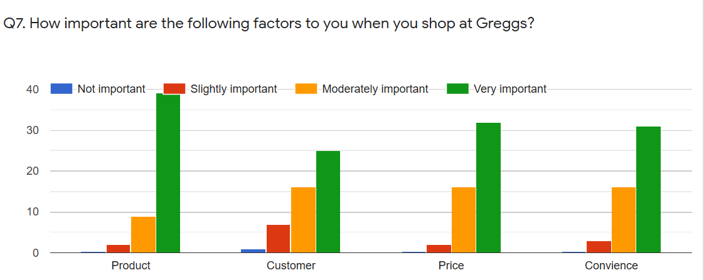

Figure 9: Important factors (Author, 2020)
Eighty-eight percent of the participants indicated that they were happy with the range of products Greggs provided and all the participants believed that the quality of the product matched the advertisements.
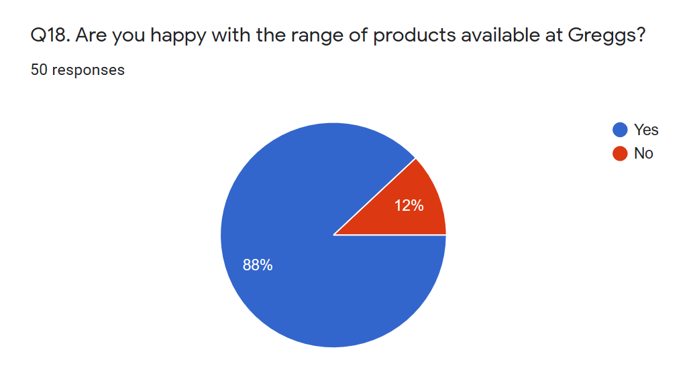
Figure 10: Range of products (Author, 2020)

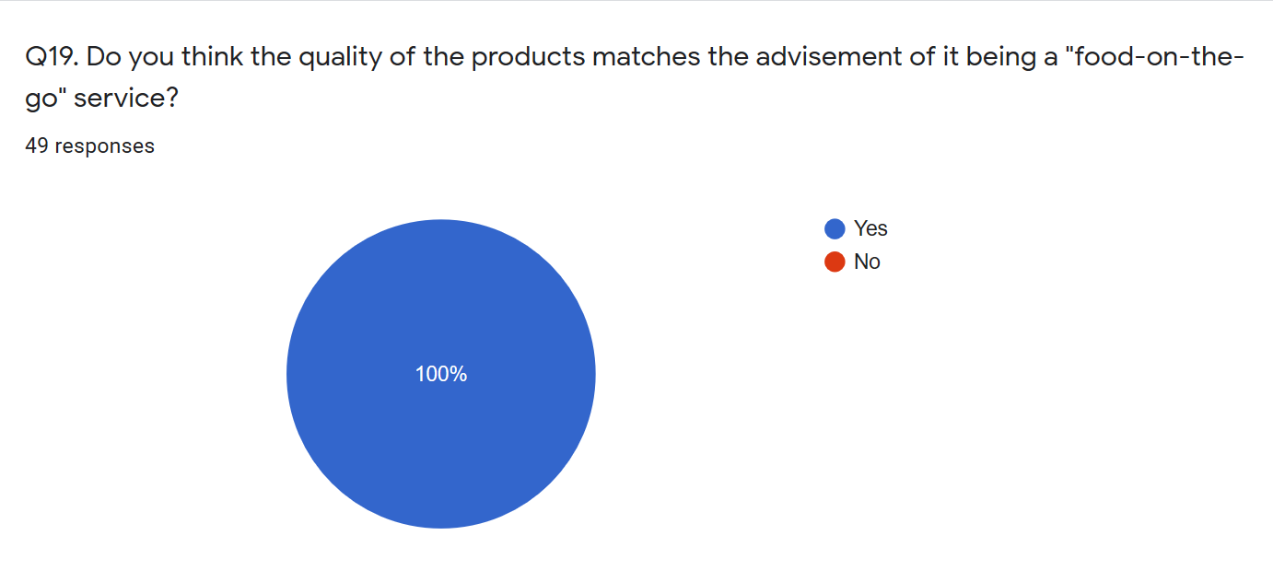
Figure 11: Quality of products
Seventy percent of participants believed the range of Greggs products were better than the competitors in the market.
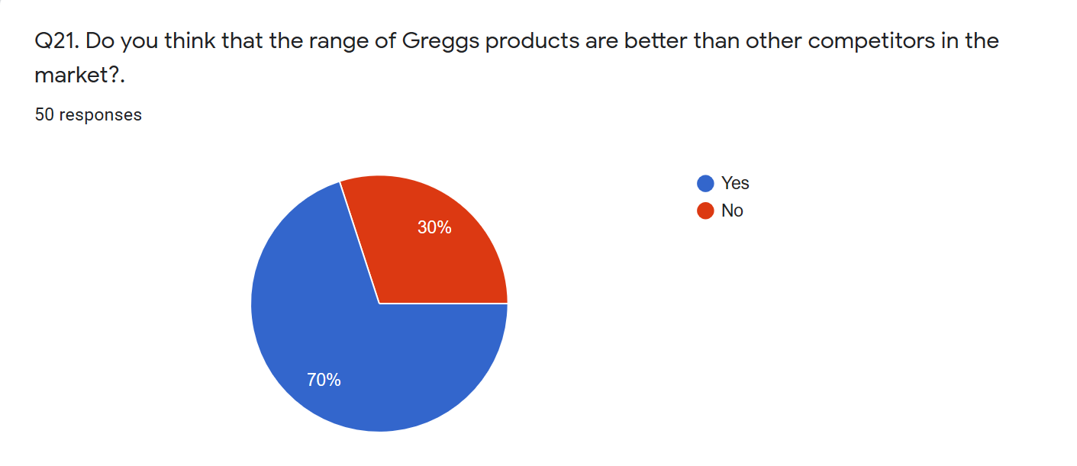
Figure 12: Range of products better than competitors (Author, 2020)

Finance
Eighty-two percent of the participants indicated that they thought that Greggs’ products were priced at the value they received.
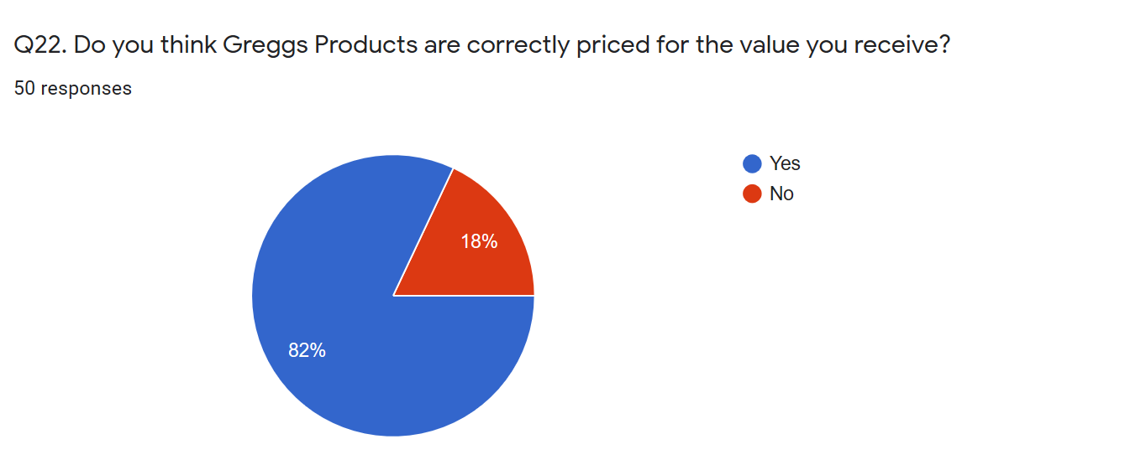
Figure 13: Priced correctly (Author, 2020)
An interesting figure was that sixty-eight percent of the participants indicated that Greggs's prices were affordable, with fourteen percent indicating it was cheap.
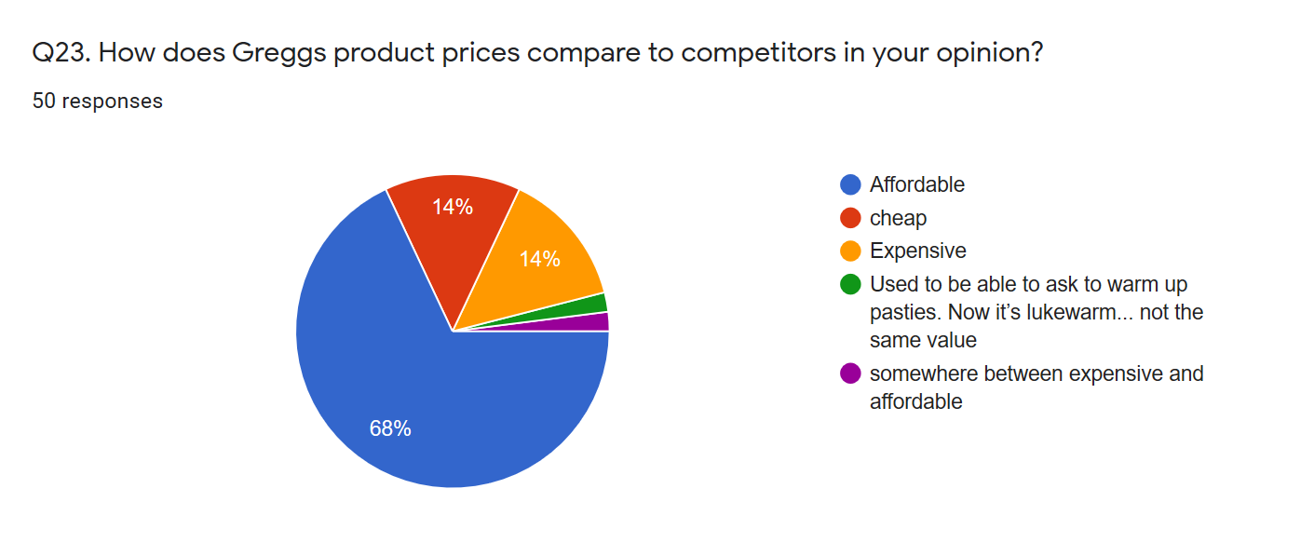

Customer Service
When asked, “How would you rate the customer service at Greggs “using a Likert scale of 1 = very bad to 5 = excellent, most of the participants were very positive about the experience with only 9% being neutral.
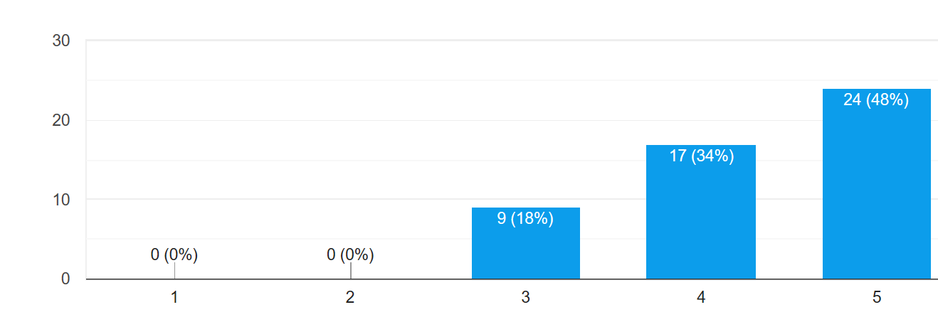
Figure 14: Customer Service rating (Author, 2020)
When asked if ever they experienced any bad quality of service from Greggs, 95% of the participants indicated “no”. One of the reasons given for this was “cold pasties”.

Figure 15: Customer experience (Author, 2020)
Many of the participants (82%) also indicated that Gregg’s staff were very efficient, with 2% indicating a negative response, and 13% being neutral.
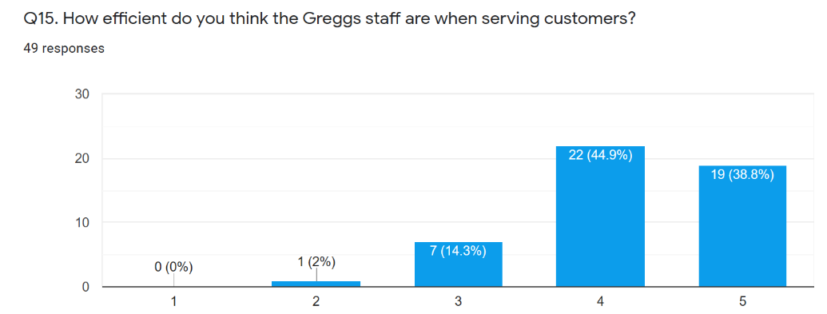

Figure 16: Staff efficiency (Author, 2020)

Seventy-eight percent of the participants found Greggs staff to be friendly.
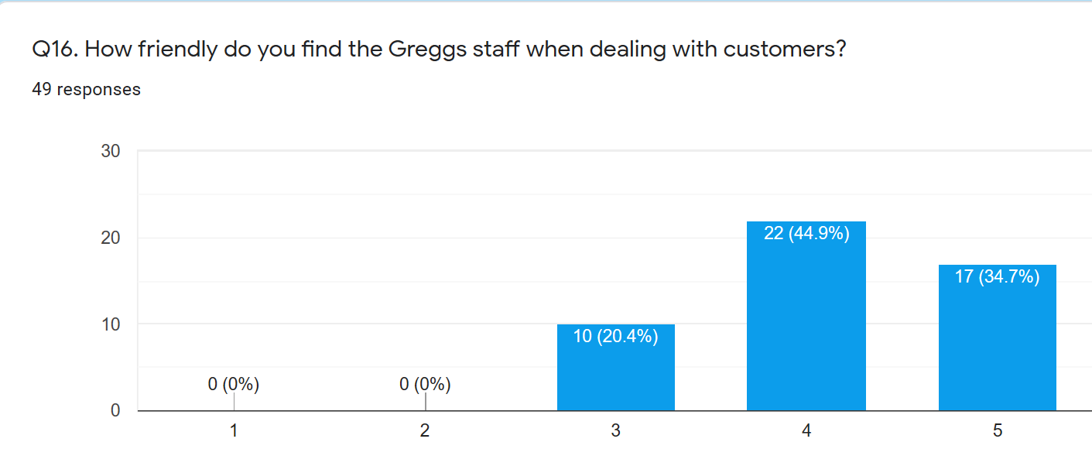
Figure 17: How friendly are Greggs staff (Author, 2020)

Competitive Advantage
For this section, both secondary and primary data were sought.
Secondary data: A competitive analysis was done using secondary data to better understand the competitive advantage that Greggs could have. Greggs has a few competitors but the main two are Costa and Pret a Manger (James, 2018). Pret a manger is an international sandwich chain that has over 400 shops and was founded in 1980 (Pret, 2016). Their strengths are that they have a strong online presence, which means that they have a strong relationship with their customers. They have high product quality, which increases their brand loyalty and improves their performance within the competitive market. Their weaknesses are that they have high job stress which means the work morale makes it difficult for the workers to be productive another weakness is that they are known for their bad customer service which affects their business growth due to word of mouth (James, 2018). Costa is the UK’s favourite coffee shop and the largest and fastest-growing coffee shop chain in the UK (Costa, 2016). A strength of costa is that they have a wide range of products compared to others. Their biggest weakness is that the prices are considered ability higher than any other food on the go shop (Bhasin, 2018)
Primary Data: Greggs has a cost advantage as they sell high-quality products for a reasonably affordable price, with deals and rewards being offered to their customers, this leads to brand loyalty.
Question 27 of the questionnaire asked the participants to indicate what they thought Greggs Unique Selling Point was. The following categories were listed:
- Fresh
- Tasty
- Affordable
- Quick and easy
- Variety
- Meal Deals
- Quality at affordable prices
- Vegan options
- Convenience
- Customer Service

A further question asked of the participants was whether location had an influence on whether they bought from a competitor or not, and the majority (60%) of participants indicated that it did, with 92% of the participants indicating that a Greggs was in an area local to them.

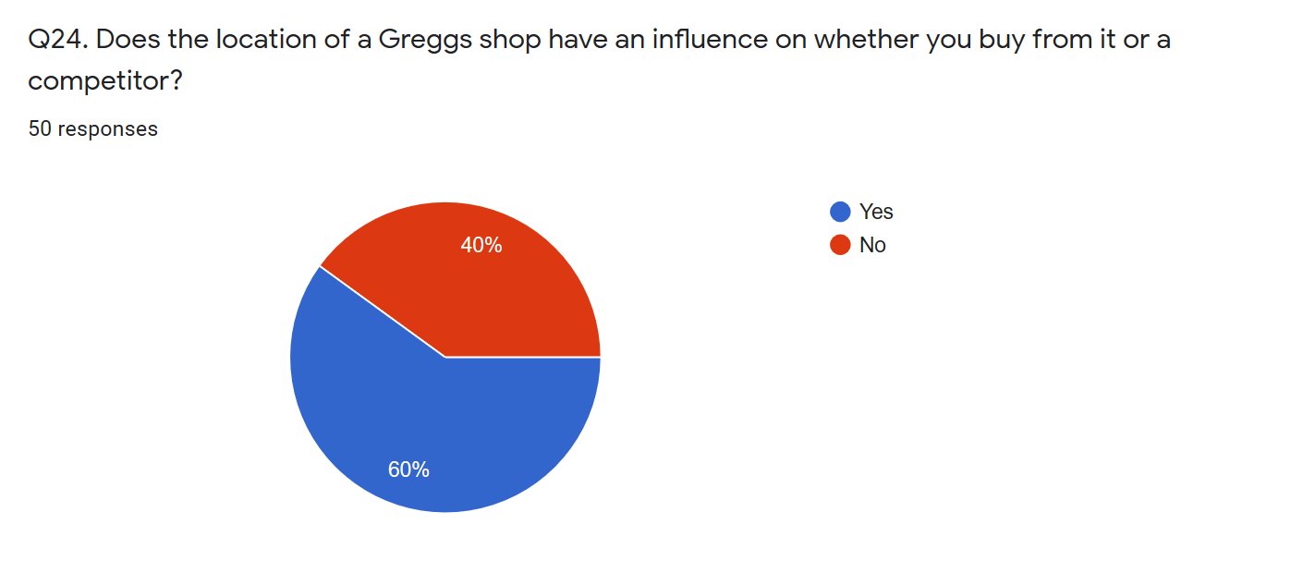
Figure 18: Location (Author, 2020)

Aim 3: To identify competitors and future improvements to stay current.
To answer this aim of the research a question was asked: “Are there any improvements you can suggest making Greggs more successful”. Some of the themes coming out of this question are:
- Deliver to local businesses
- Create a drive-thru
- More vegan / vegetarian options
- A better way of keeping pasties warm
- Queuing for services – self-service options
- More stock availability at the end of the day
- Returning some products to stock
- Enabling the breakfast products to be purchased throughout the day

CHAPTER 5- DISCUSSION
This chapter will show the analysis of the data collected by the researcher, to address the aims and objectives.
Aim 1: To investigate the development and progression of Greggs
From the secondary data collected over the past 10 years, Greggs has developed and progressed as a business, shown by the sales figures and the increase in the number of stores that Greggs has opened each year.
Aim 2: Identify the main success factors to evaluate why Greggs is growing and being successful
From the primary data, Greggs values their customer and their customer service is considered exceptional to most customers. The customer service is considered friendly, and efficient when being served. Brand loyalty is important to Greggs. They have several ways in which they try and keep their customers from going to competitors. Greggs has several ways to keep their customers, they have a rewards system where customers can receive freebies, discounts, and treats on their birthday (Greggs, 2016)
Greggs always have great customer experience as they have a “customer is always right” policy (Greggs, 2016). Greggs has a “mystery shopper” to check how well their staff is performing and how each shop is managed, which is an anonymous process.
Products are the most important factor when shopping at Greggs, and customers are happy with the range and quality of products provided by Greggs. Most customers indicated that they prefer the range of products at Greggs compared to the competitors, with Greggs having a variety of products from a vegetarian range to a vegan range. Greggs launch their brand products, for example, their crisps and some drinks are from their brand and have their products in superstores such as Iceland.
The customers valued the price of the products at Greggs which are cheap and affordable.
Greggs Unique Selling Point is that they have fresh products, they affordable, they have meal deals, quality is great, it is convenient with all the stores available in local areas, and they have a variety of affordable and quality options, including vegan and vegetarian options.
Aim 3: To identify competitors and future improvements to stay current.
The competitors of Greggs are Costa, Starbucks, Pret-a-Manger, Café Nero, and Jenkins. Each one of these competitors has its own strengths and weaknesses, as discussed above in the Competitive Advantage section of Chapter 3. Greggs takes its competitors weaknesses and makes it their strength, for example, Pret-a-Manger are known for their bad quality customer service, while Greggs makes Customer service a priority. Costa’s prices are considered less affordable, while Greggs has priced its products at an affordable range (Greggs, 2016).
In terms of the future improvements, several suggestions that have been made, some of which are viable and practical, and some of the improvements that Greggs could consider are the following:
- Deliver to local businesses
- Create a drive-thru service
- Improving the queuing system or creating self-service options
- More availability throughout the whole day
The limitations of this study were that there were only 50 participants involved. The sample may be too small which means there could be some error in the results however the sample has a mix of everyone so therefor is e a representative sample and can be generalised for the wider population.
If this study were to be done again it would be done under better circumstances. Hard copies of the questionnaires could have been given to each Greggs store for their customers to fill out. Interviews would have taken place with shop managers to get a better understanding of Greggs’ processes and operations.

Chapter 6- Conclusion
This study was about the success of Greggs. It aimed to investigate the development and the progression of Greggs, to identify the main success factors for Greggs’ success and to identify competitors and future improvements to remain current. The researcher feels like these aims were met by the gathering of both secondary data which were a set of statistics that the researcher analysed and put into graphs and primary data using a questionnaire given to Greggs customers online. These data aided the researcher to get a better understanding of Greggs and their success factors which were customer service, product differentiation, efficient operations, finance, and competitive advantage. The researcher gave a thorough discussion of the findings of this study and put forward some recommendations of what to do if this study was done again.

References
Aakar, D. (2001) Developing Business Strategies.
Adams, R. (2016) 10 Reasons Why Good Customer Service Is Your Most Important Metric.
Atherton, M. (2017) ‘Food-to-go sector to be worth £23.5bn by 2022’, Food Manafactura. Available at: https://www.foodmanufacture.co.uk/Article/2017/08/09/Food-to-go-market-in-multi-billion-pound-growth.
Avogousti, K. (2013) ‘RESEARCH PHILOSOPHY, METHODOLOGY, QUANTITATIVE AND QUALITATIVE METHODS’, Journal of Sciences, 11.
BBC (2017) Greggs sales up. Available at: https://www.bbc.co.uk/news/business-39112771 (Accessed: 21 February 2020).
BBC (2020) nternal factors.
Bhasin, H. (2018) ‘Costa SWOT Analysis’, Marketing101. Available at: https://www.marketing91.com/swot-analysis-costa-coffee/.
Boyd, J. (2019) ‘How to Do an Effective Competitive Analysis’, Brandwatch.
Bryman, A. and Bell, E. (2015) Business research methods. 4th edn. Oxford University Press.
Cambridge, university (no date) Porter’s Generic Competitive Strategies (ways of competing). Available at: https://www.ifm.eng.cam.ac.uk/research/dstools/porters-generic-competitive-strategies/ (Accessed: 25 May 2020).
Cherry, K. (2019) How Does the Cross-Sectional Research Method Work? very well mind. Available at: https://www.verywellmind.com/what-is-a-cross-sectional-study-2794978 (Accessed: 20 May 2020).
Clegg, S., Kornberger, M. and Pitsis, T. (2016) Managing and Organizations. 4th edn. SAGE.
Collins, J. and Hussey, R. (2014) Business Research. 4th edn.
Combe, C. (2014) Introduction to management. Oxford University Press.
Costa (2016) About Us. Available at: https://www.costa.co.uk/about-us/.
Daniel, J. (2012) Sampling essentials. SAGE publishers.
Denscombe, M. (2014) The good research guide: for small-scale social research projects. 5th edn. Open University Press.
Deshpandé, R. and Gatignon, H. (1994) ‘Competitive Analysis’, Marketing Letters, 5(3).
Dudovskiy, J. (2018) Writing a dissertation.
Dudovskiy, J. (2019) Research Philosophy.
Easterby-Smith, M., Thorpe, R. and Loewe, A. (1994) ‘Management Research, and Introduction’, Scholarly Journals.
Eddine, B. (2015) The Importance of Marketing for the Success of a Business, Linked In.
Eisenhardt, K. . and Graebner, M. . (2007) ‘Theory Building from cases : opportunities and challenges’, Academy of Management Reviw, 14, p. 532.
Fisher, C. (2010) Researching and writing a dissertation. 3rd edn.
Foley, P. and Green, H. (1989) Small Business success. SAGE publishers.
Gabriel, D. (2013) Inductive and deductive approaches, Research guides. Available at: https://deborahgabriel.com/2013/03/17/inductive-and-deductive-approaches-to-research/ (Accessed: 2 May 2020).
Gale, B. (2018) Case studies, Small Business. Available at: https://brandongaille.com/12-case-study-method-advantages-and-disadvantages/ (Accessed: 20 May 2020).
Gillham, B. (2000) Case study research methods. Bloomsbury.
Gitonga, I. J. (2018) ‘WHY Is Competition Important In Business’, Medium.
Greggs | About (2013). Available at: https://www.greggs.co.uk/about (Accessed: 21 February 2020).
James, M. (2018) Pret A Manger SWOT Analysis. Available at: https://www.case48.com/swot-case/9677-Pret-A-Manger (Accessed: 28 June 2020).
Jurevicius, O. (2013) ‘Competitive Advantage’, Management insight.
Korthari C.R (2004) Research methodology. 2nd edn.
Leonards, K. (2019) ‘Employee Performance in Business Organizations’, Small Business.
Lohr, S. (2010) Sampling: Design and analysis.
Mcleod, S. (2018) Questionnaires, Simplypsychology. Available at: https://www.simplypsychology.org/questionnaires.html (Accessed: 28 May 2020).
McQuerrey, L. (2019) Why is customer service important, Small Business.
Middleton, F. (2020) Validity and Reliability difference. Available at: https://www.scribbr.com/methodology/reliability-vs-validity/ (Accessed: 18 June 2020).
Neideck, S. (2016) ‘Reasons Why It’s Important To Have Policies and Procedures’, Human resources.
Pahwa, A. (2020) Product Differentiation, Marketing essentials.
Patal, C. (2017) ‘Importance of leadership’, About leaders.
Porter, M. (1998) Competitive advantage. The free Press.
Pret (206AD) About Us. Available at: https://www.pret.co.uk/en-gb/about-pret.
Ried, dan, and Sanders, N. (2013) operations management.
Sahay, A. (2016) ‘Peeling Saunders Research Onion’, Research Gate.
Sanelli, A. (2018) ‘The Importance of Policy & Procedure’, Convercent.
Setia, M.-S. (2016) ‘Methodology: cross sectional studies’, Indian J Dermatol, 61(3), pp. 261–264.
Slack, N., Brandon-Jones, A. and Johnson, R. (2016) Operations management. 7th edn. Oxford University Press.
The Difference Between Policy, Process, and Procedure (and Why You Need Them) (2020) Genisis Digital.
Thompson, S. K. (2012) Sampling. 2nd edn.
Unknown (2001) ‘Financial Factors’, Entrepreneur.
Unknown (2016) leadership styles in business.

Appendix A - questionnaire
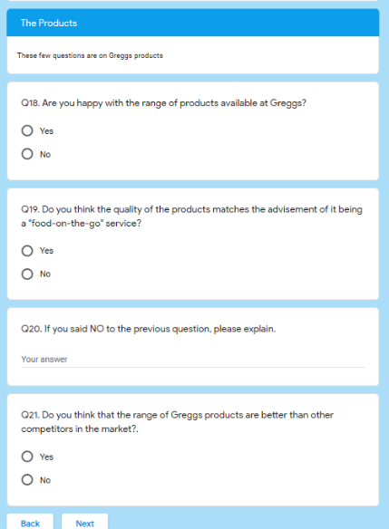
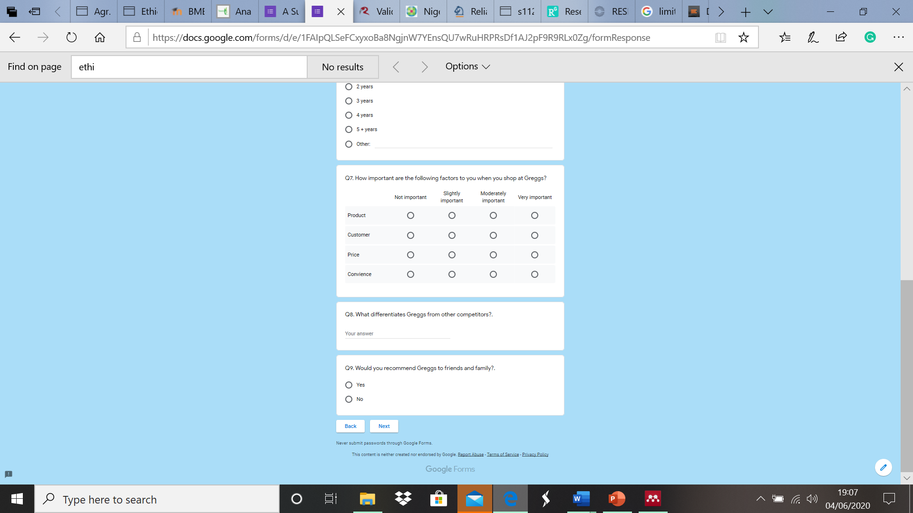
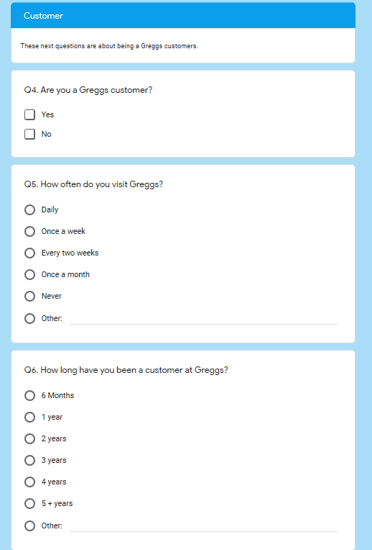
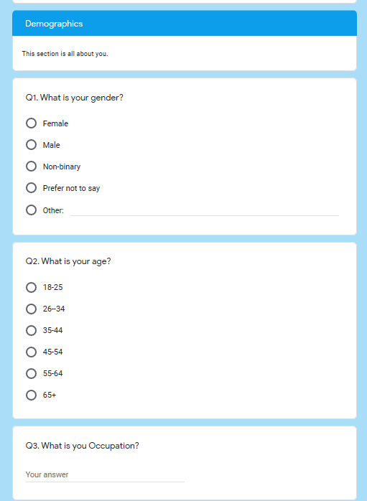
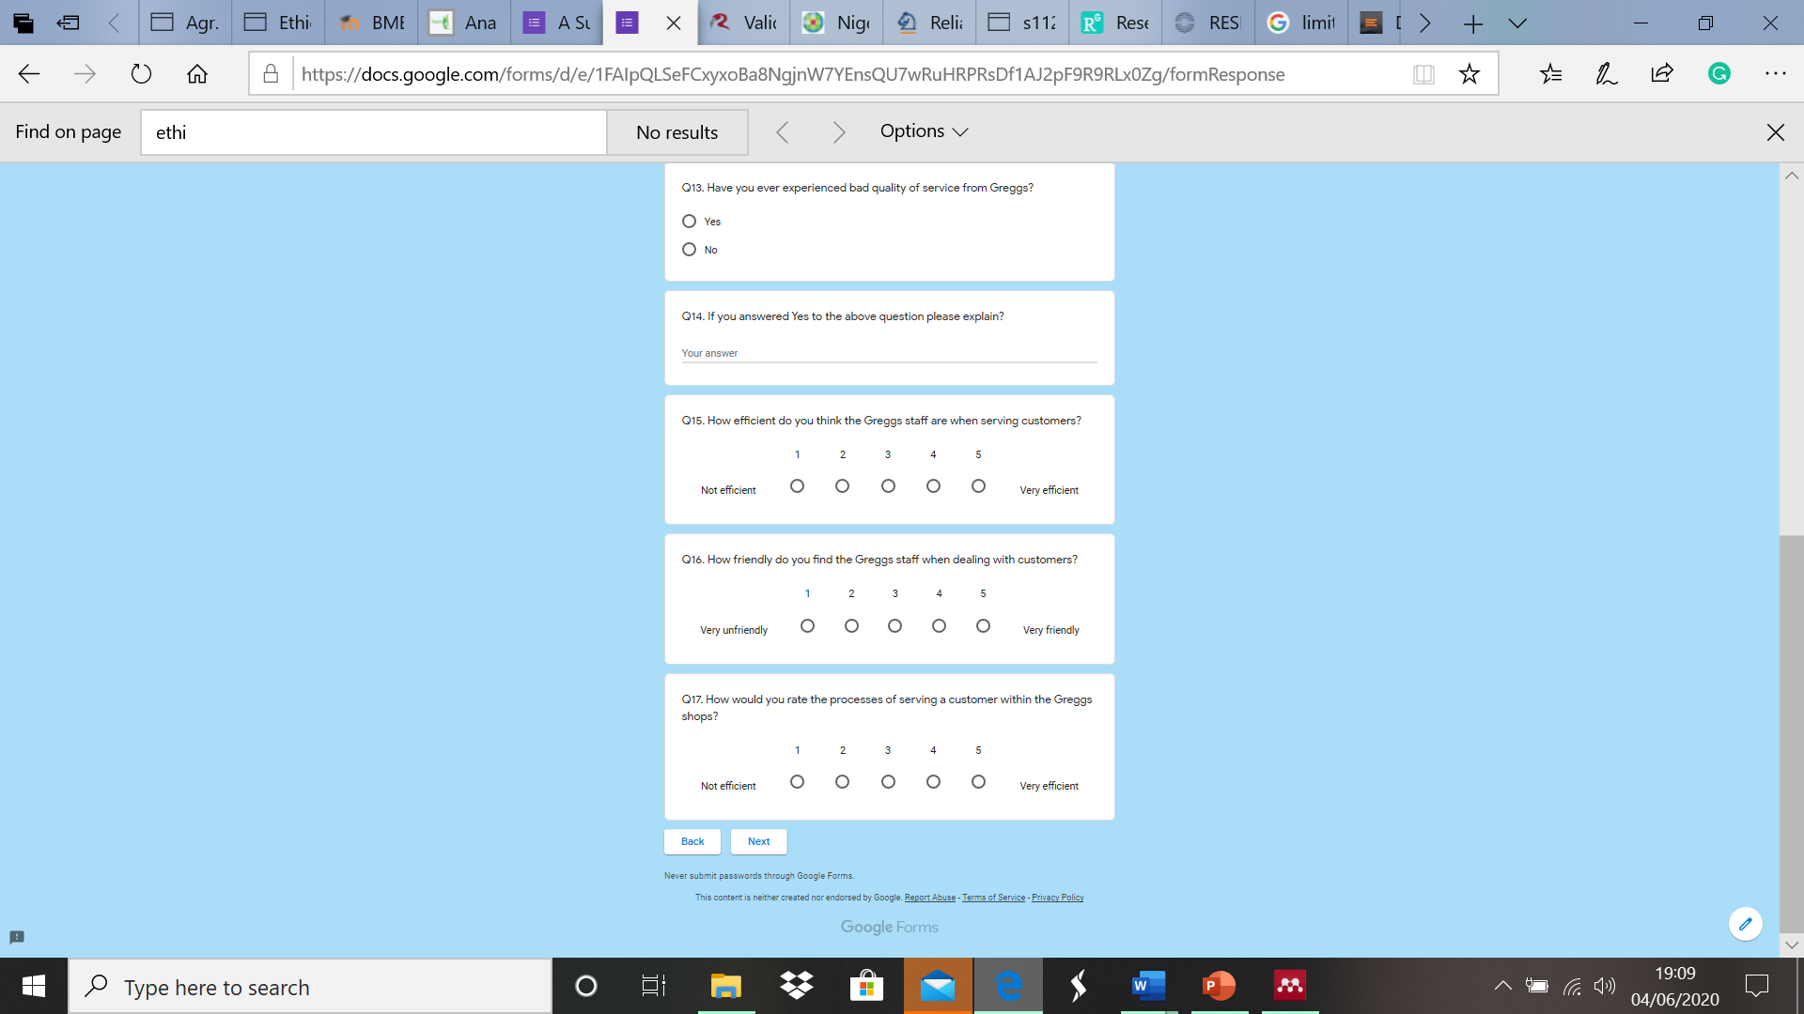
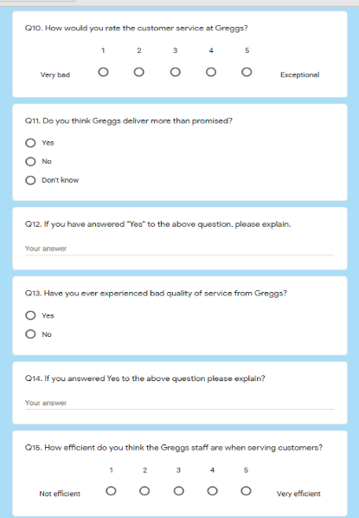

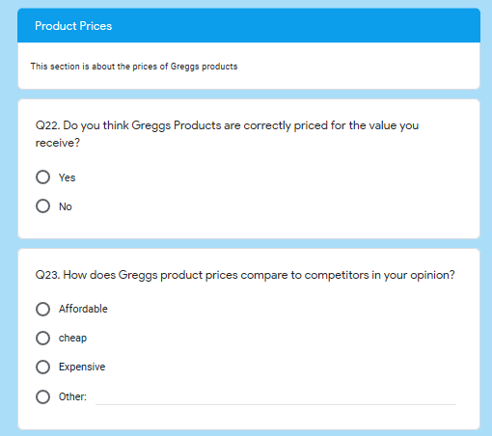
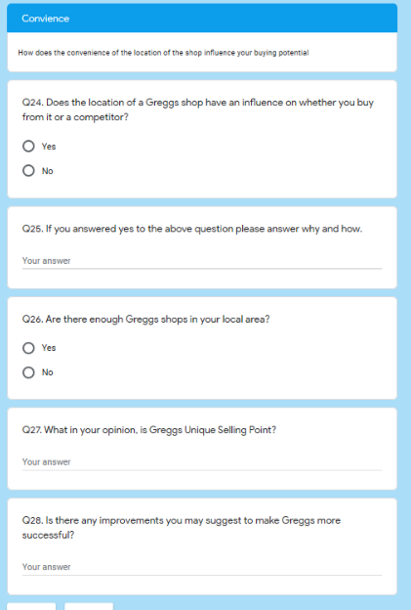

Appendix B – consent form
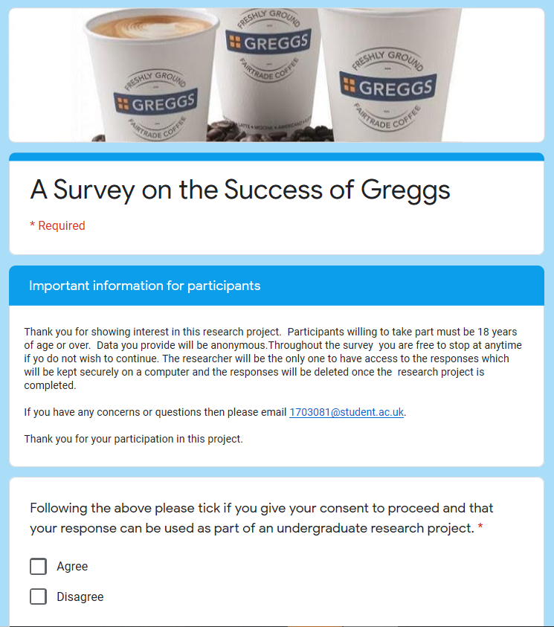

Appendix C – Ethics approval form
APPLICATION FOR ETHICAL APPROVAL
For research to result in benefit and minimize the risk of harm, it must be conducted ethically. A researcher may not be covered by the University’s insurance if ethical approval has not been obtained before commencement.
The University follows the OECD Frascati manual definition of research activity: “creative work undertaken on a systematic basis to increase the stock of knowledge, including knowledge of man, culture and society, and the use of this stock of knowledge to devise new applications”. As such this covers activities undertaken by members of staff, postgraduate research students, and both taught postgraduate and undergraduate students working on dissertations/projects.
The individual undertaking the research activity is known as the “principal researcher”.
Ethical approval is not required for routine audits, performance reviews, quality assurance studies, testing within normal educational requirements, and literary or artistic criticism.
Please read the notes for guidance before completing ALL sections of the form.
This form must be completed and approved before undertaking any research activity. Please see the Checklist for details of the process for different categories of application.

Application Process
All staff research projects and all research students must submit the Ethical Approval Form to the University Ethics Committee via the Academic Office (pgresearch@uwtsd.ac.uk). Staff research directly with personal study for taught undergraduate or master’s programs should be submitted via the Faculty procedures explained below.
Taught masters and taught undergraduate research Ethical Approval Forms are considered within Faculties. Faculties will provide details of the specific processes for this. Where the Ethical issues within any single ethical application are of concern the Faculty will refer these to the University Ethics Committee. Any student activity that involves the collection of primary data needs to undergo Ethical approval; this includes assignment work as well as dissertations.
Notes for guidance in completion of this form
Section A: About You
Please complete all relevant sections
Section B: Approval for research activity
Research proposals must be approved in principle before applying for Ethical Approval. The proposal approval only becomes final when ethical approval is received.

The process for proposal approval varies according to the individual and program of study:
- Research students, by application on form PG1 to the Research Degrees Committee
- Taught students by review of research proposal within Faculties (Faculties provide specific details of these processes)
- Staff, by agreement by the Head of School/Assistant Dean

Section C: External Ethical Guidance materials
Many discipline areas are required to operate with the discipline-specific codes of research ethics (for example health, psychology, education, etc.), any such codes must be listed and you must tick to confirm that you have consulted with these.
Section D: External Collaborative Research Activity
Provide details of the external collaborative partners, where appropriate you might want to submit a copy of the external collaboration agreement with the Ethical Approval Form. If the partner requires the research to be subject to its own internal Ethical approval process, then please provide details of that process and a copy of any final (or interim) approvals received from the organization.
Section E: Details of Research Activity
Remember that the individuals reviewing this Ethical Approval Form may not have seen your research proposal and may not be experts in the specific area of your research. The information provided should, therefore, be jargon free and clearly stated.
Indicative Title: please use the same title as used on the research proposal.
Purpose: The Ethical approval process will want to ensure that the methods you propose are adequate and appropriate to address the research aims and objectives. Excessive additional data collection be unethical.
Proposed Methods: The Ethical approval process seeks to ensure that you understand the methods that are intended, and that the implementation of those methods will be appropriate and without unnecessary impact on respondents. Please be specific.
Location: this needs to mention geographical location and local situation (for example, within Local Authority Offices in Cardiff, using a private room but close to other individuals). If you are collecting data within an organisational setting, then you need to explain the permissions that you have obtained to do this.
Research Activity outside of the UK: please complete this section in detail and note any guidance you have received. Also describe your own familiarity (or not) with the location that you will be utilising.
Section F: Scope of Research Activity
Please tick ALL the research activities that might be undertaken. If any additional types of activity are intended, then please add an extra box and describe these.
If you have answered no to all questions in F, then sections G and J do not need to be completed. Section H should be considered and may be completed. Signatures are still required in section K.
Section G: Intended Participants
Please tick all categories that might apply.
Numbers & Source: if you are using a series of different methods or research activities please list numbers for each stage/phase. Be clear about how you will find respondents. Will you use intermediaries, and if so how? How will you ensure compliance with your sampling strategy?
Information for participants: all participants should be appropriately informed about the research, what is expected of them and what will happen to the information that they provide. The Ethical review process does not ask to see this documentation, but requires this to be reviewed and approved by the Director of Studies in the case of research students, the supervisor/module tutor in relation to students on taught programmes and the Head of School/Assistant Dean in relation to staff research.
Section H: Anticipate Risks
All research carries some level of risk. The answers you provide to questions in this section will be reviewed to ensure that you have an appropriate understanding of the type of risks involved and how you can mitigate against these risks. If you have completed a full risk assessment, as required for example for laboratory work, field work, clinical tests, diving operations, or by a collaborative partner, you may append that to this form. In that case, please tick the box indicating this has been provided. You will not then be required to complete Section H.
Risk to participants Think very carefully about how your actions/questions/discussions might affect the people you are involving as participants. You might identify the risk as small, but it would still be a risk. Many types of question have the potential to make respondents less content with their life / job; you need to recognise and try to ameliorate any such effects
If these are business owners, time with you may reduce profit.
In some locations physical risk is very real to both participants and you, please consider this.
Risk to you, the researcher Think about where you will meet people, if there are any dangers involved in the location. If you are meeting people as individuals think about using a public place. In general, do not visit people in their own homes or remote locations. If you are talking to individuals about certain issues think about how their responses might affect you emotionally. What about the risk of collecting insufficient data?
Risk to the University When undertaking your research, you are acting as a member of the University (student or staff). Professionalism is important, so it is important to be well organised and well prepared. Punctuality, clarity etc. are all part of this. What will you do to ensure this? You must ensure you do not harm the good name of the University in any way and do nothing to undermine the reputation of the research it conducts and sponsors. Upholding high standards of conduct and integrity are vital in this regard. You must also conduct the research in such a way to minimise the potential for claims of negligence made against the University, its researchers and any collaborating individual or organisation. In this respect you should always comply with ethical, legal and professional frameworks, obligations and standards as required by statutory and regulatory authorities, as well as the university’s Research Integrity and Ethics Code of Practice. Research misconduct in this respect can take many forms, including:
- fabrication: making up results or other outputs (e.g., artefacts) and presenting them as if they were real
- falsification: manipulating research processes or changing or omitting data without good cause
- plagiarism: using other people’s material without giving proper credit
- failure to meet ethical, legal and professional obligations: for example, failure to declare competing interests; misrepresentation of involvement or authorship; misrepresentation of interests; breach of confidentiality; lack of informed consent; misuse of personal data; and abuse of research subjects or material
- improper dealing with allegations of misconduct: failing to address possible infringements such as attempts to cover up misconduct and reprisals against whistle-blowers
Adverse Outcomes. Think carefully about the possibilities, and cover here
Section I: Feedback, Consent and Confidentiality
Feedback to participants: outline your approach. Will interview transcripts be shared with respondents to check accuracy? Will summaries of questionnaire analysis be made available to respondents in some way? Will an overview report be provided? How and when?
Informed consent: Draft letter / e-mail / or heading (or footer) section of questionnaire must be approved by DoS/supervisor (if research student), supervisor/module tutor if taught student, or Head of School / Assistant Dean if a member of staff. Confidentiality/Anonymity. Explain clearly how you will ensure confidentiality and anonymity.
Section J: Data Protection and Storage
Before completing this section, it is necessary to read the University’s Research Data Management information. The questions that follow are designed to ensure compliance with the Data Protection Act as well as established research protocols.
Many research activities will involve electronic transfer of data and use of data management systems in the summarisation and analysis of data. You will need to explain these in relation to compliance with the Data Protection Act.
Think carefully about who access to your data will have, this will include supervisors and examiners. Also, that a thesis will be made available via the University library and the British Library system. If you are seeking an access bar for a period after completion, then mention it here. If you will provide a copy of your findings, or intend to give a presentation, to a facilitating/ supporting/accessing organisation then explain that in this section. But also think about the general principle of data sharing, as explained in the Research Data Management information. In terms of storage of data please ensure security and mitigate against loss of data.
Section K: Declaration
Ensure the appropriate countersignatures have been provided
Look carefully at the checklist and ensure that you comply with and tick all that are relevant to your research.

