4/8/2026

University of Wales Trinity Saint David

Module Name: Introduction to Web and Database Concepts
Module Code: ACCA4023

Student Name: Tejinder Singh Aulakh
Student ID:2533151
Group: 2
Submission Date:04/08/2026
Lecturer’s Name: DR. ANUM PARACHA

I W D

Table of Contents
1. Introduction 2
2. Requirements 2
3. Implementation 5
4. Evaluation 14
5. Conclusion 19
6. References (IEEE Format) 20
7. Appendices 21

Introduction

This module will give me the opportunity to have strong foundations needed to create and manage the two pillars of modern computing: databases and websites. This assignment is helping to learn how to build and render web pages using core technologies such as HMTL and CSS. This will help us in learning Web content, including text, graphics, media content, hypertext and hypermedia, web forms etc. Along with all this the work we produce is not functional but professional.

By end of this module, we will be able to Systematically understand and apply the technologies and standards needed for building and rendering web pages. We will follow Fundamental standards and principles of web design and applications i.e. interface and layout design principles, mobile web and device-independent web practices, web accessibility, etc. Web evaluation techniques and tools e.g. standards validation, browser evaluation tools, accessibility evaluation, and performance assessment. This will help us in gaining the essential skills for our future in computing and IT.

Requirements

I created a website with WIX in first term at university for my property company MKHA Properties. When our teacher asked us which static website we will make, I came up with the idea to develop my property company website for MKHA Properties. I will be the designer and developer for my website pages crafting the layout, building every component from scratch, and making sure it will be fast, accessible, and easy to navigate.

How TO - Make a Static Website
A static website has fixed content
It does not require programming languages to build one.
It is the easiest form of website to create.
Static websites are built of HTML, CSS, and Bootstrap, JavaScript.

Why create a static website?
Static websites are quick and easy to create.
It is cheap to host.
Static websites are secure.
It is fun and you can create awesome sites with HTML, CSS, and Bootstrap, JavaScript.

What do I need to know to build a static website
HTML, CSS, Bootstrap JavaScript are the basic languages to build any website.
- Create the structure with HTML. The first thing you have to learn, is HTML, which is the standard markup language for creating web pages.
- Style with CSS. The next step is to learn CSS, to set the layout of your web page with beautiful colours, fonts, and much more.
- Make it interactive with Bootstrap, JavaScript. After studying HTML and CSS, you should learn Bootstrap, JavaScript to create dynamic and interactive web pages for your users.
The best way to learn is to get practical. Start building today! [1]

Your website content is the second most important thing on your website design, so you need to give it some attention. Five pages that every business website needs. To build a five-page static website for a property domain (MKHA properties), you need a custom domain, standard frontend code (HTML, CSS, JS ,FL ) or a static site generator, reliable hosting, and structured content covering the home(about) , gallery (property listings), services, contact us, branches.
5-Page Structure
1) Home Page (About): Background information of the property business, agent profiles, or company mission.
2) Gallery (property listings): Detailed list, grid, or descriptions of real estate offerings and portfolios.
3) Services: Overview of neighbourhoods, areas, and sort of properties.
4) Contact Us: Inquiry form.
5) Branches: Office photo and address, number, e-mail, and social media.
Technical Requirements
1) Domain Name: Active registration for your specific web address (MKHA Properties).
2) Files and Markup: Clean HTML5 for structure, CSS3for styling, and lightweight JavaScript for mobile menus or image sliders, Bootstrap for free, open-source front-end framework.
3) Responsive Design: Mobile-friendly layouts that adapt clearly to phones, tablets, and desktops.
4) Hosting Platform: Static web hosting via services like GitHub Pages, Netlify, or standard cPanel web space.
Contents and Assets
1) Images: Optimized, compressed high-resolution photos of properties and locations to maintain fast load times.
2) Branding: Logo files, consistent colour palettes, and readable typography.
3) Legal Pages: Basic privacy policy statement or terms of use if collecting user form inputs. [2]

3. Implementation

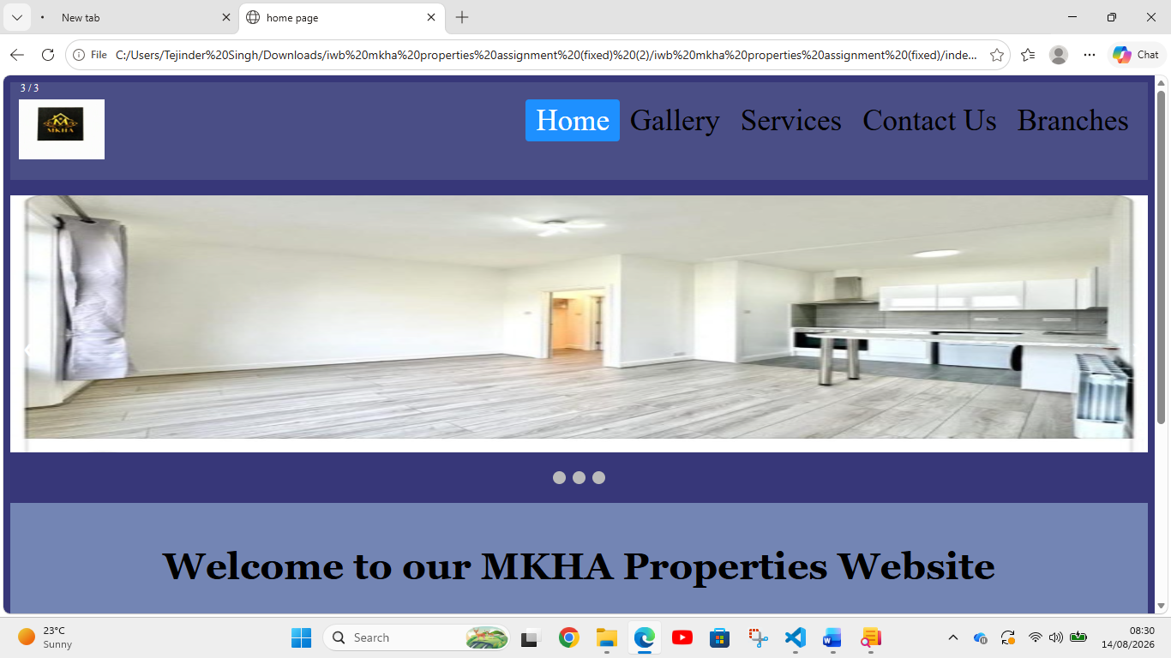

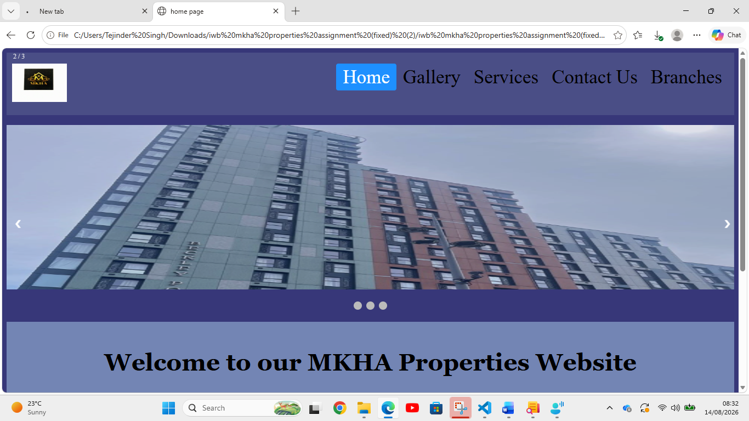

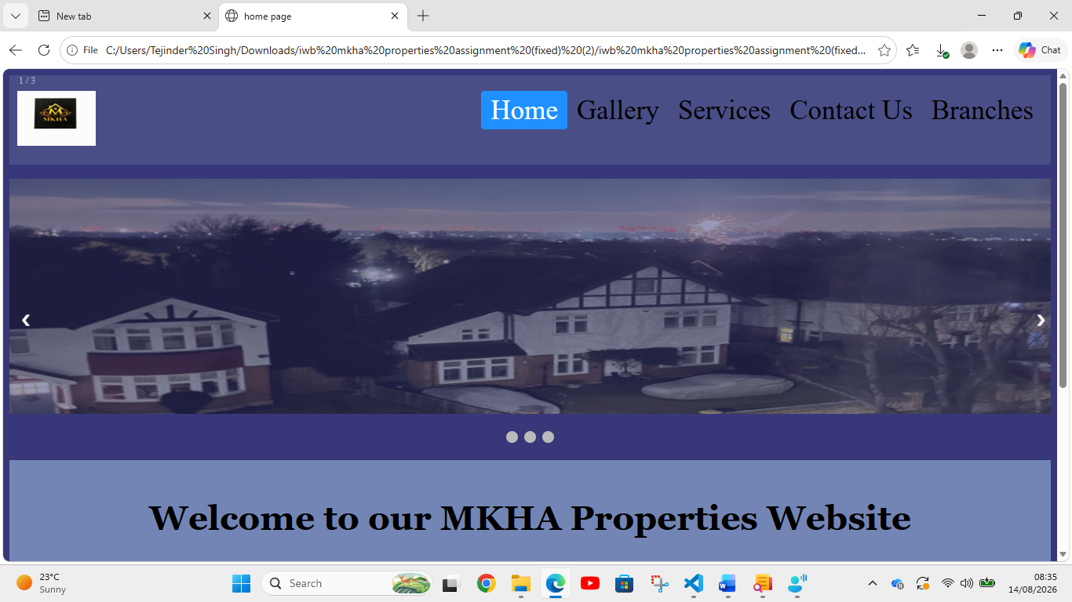

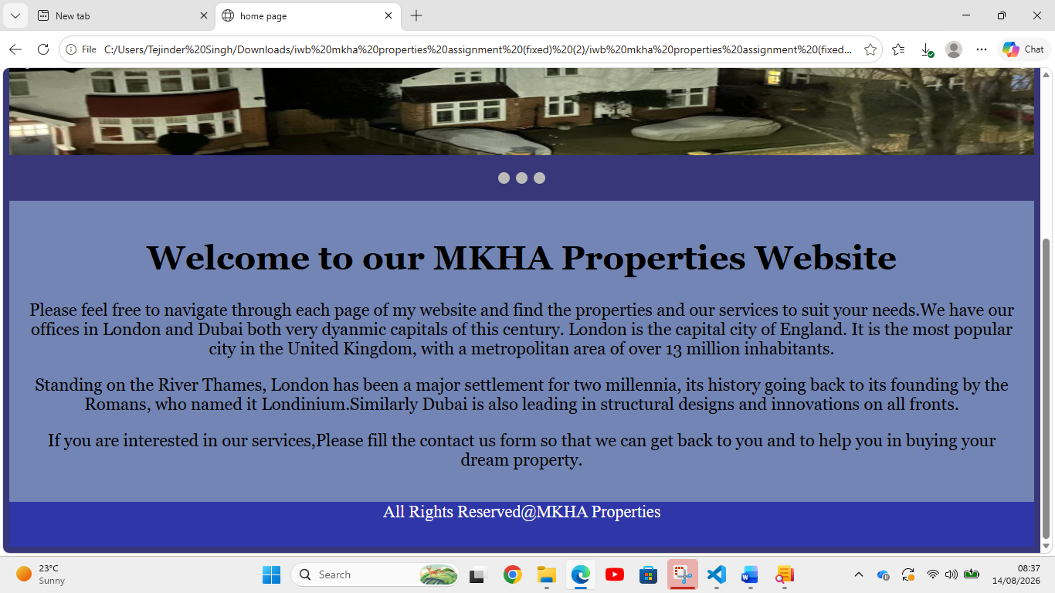

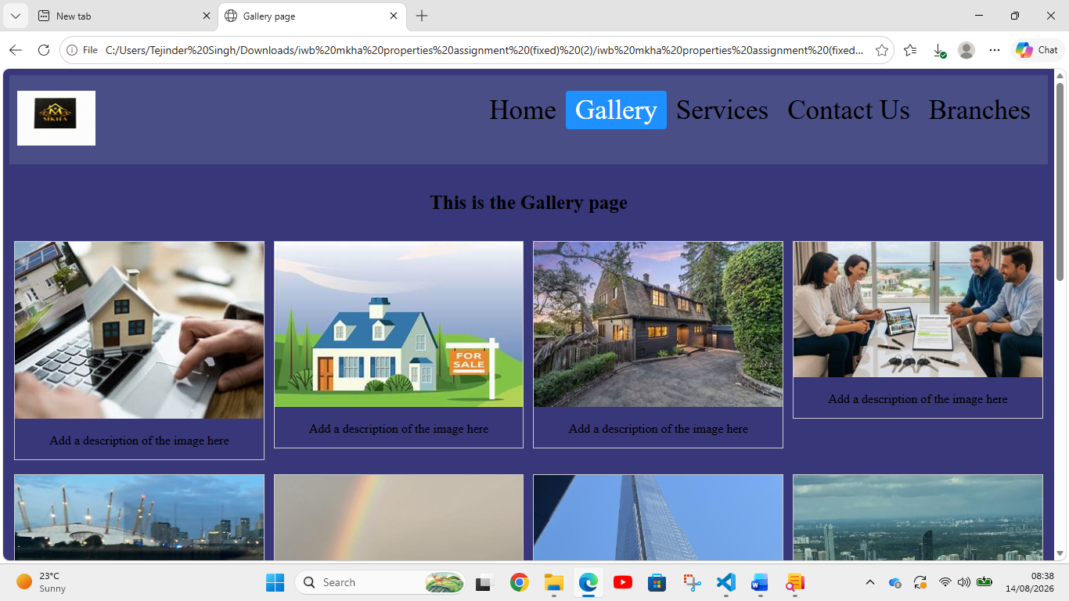

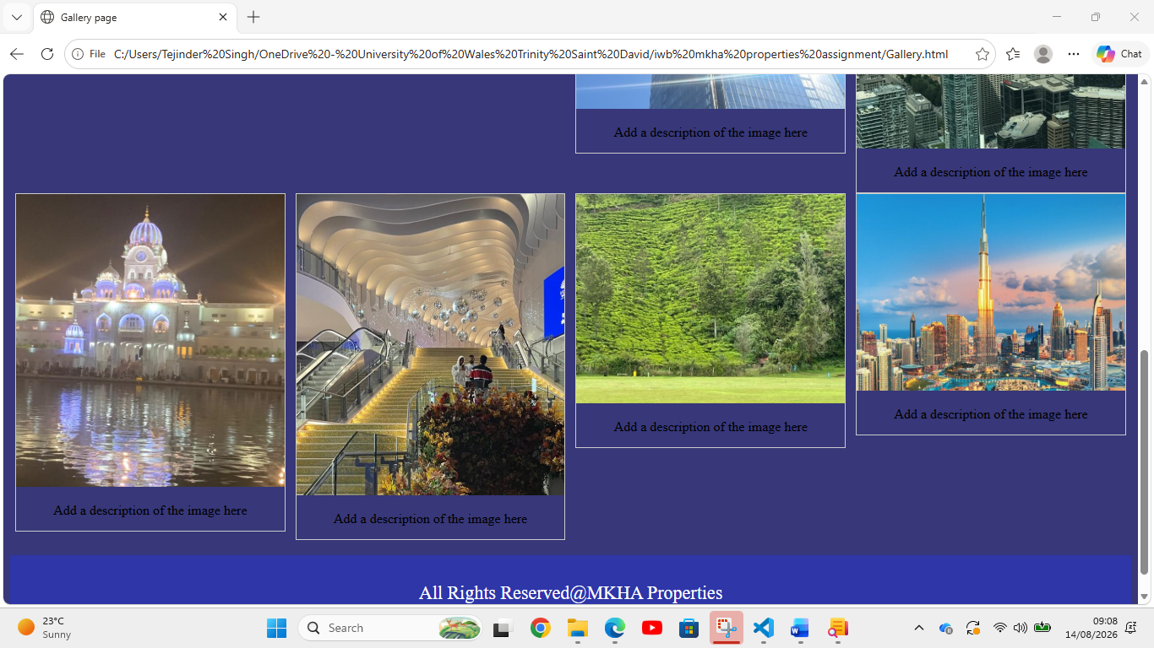

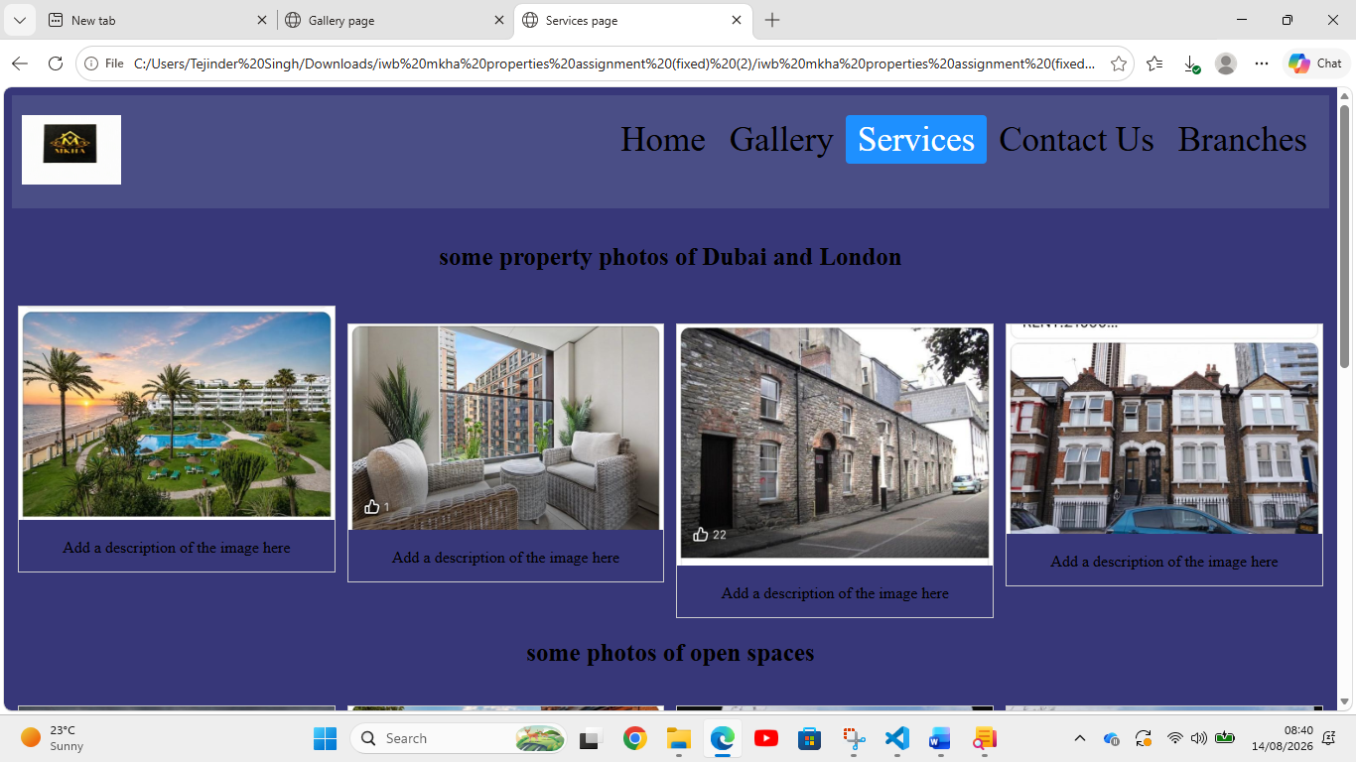

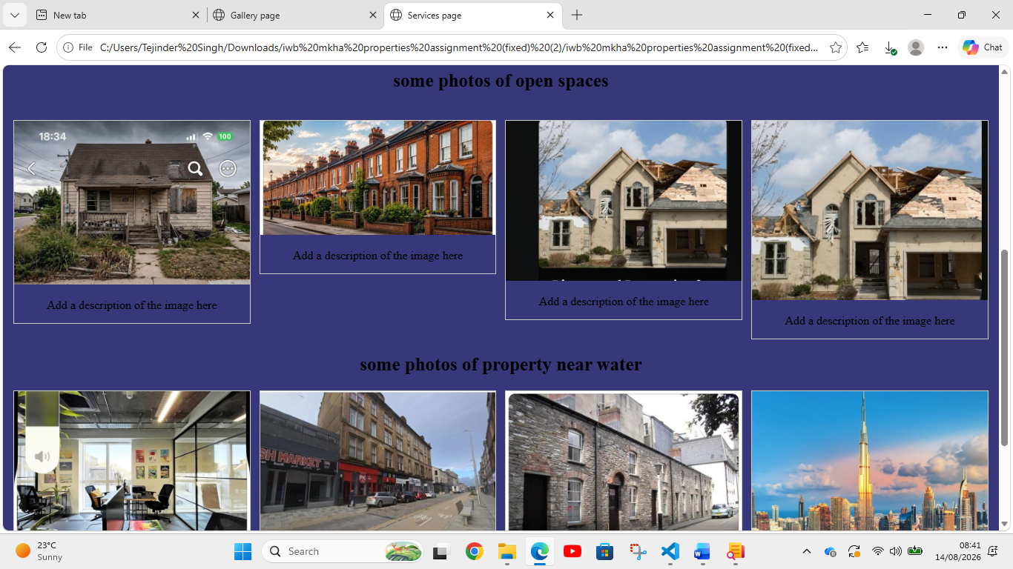

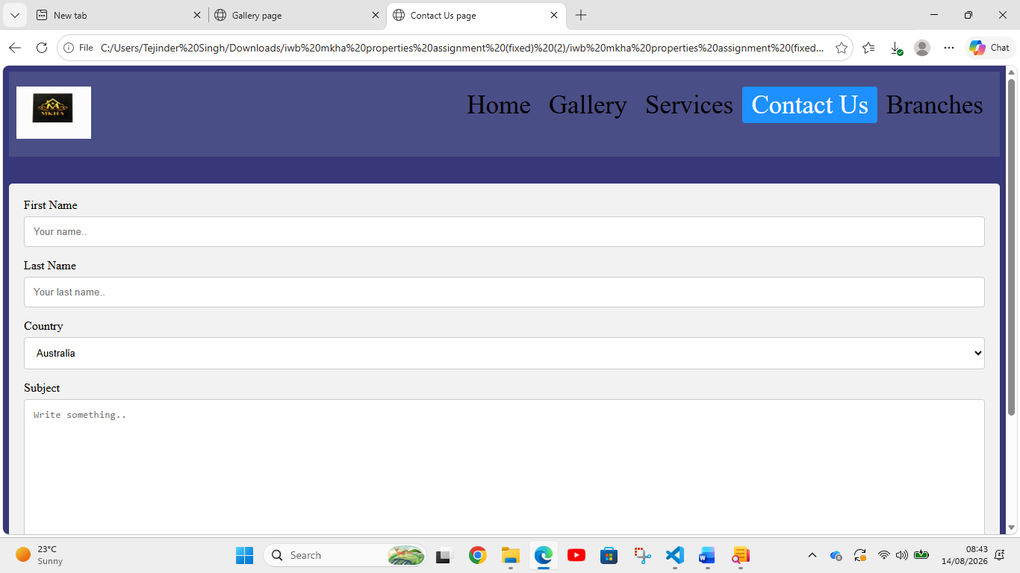

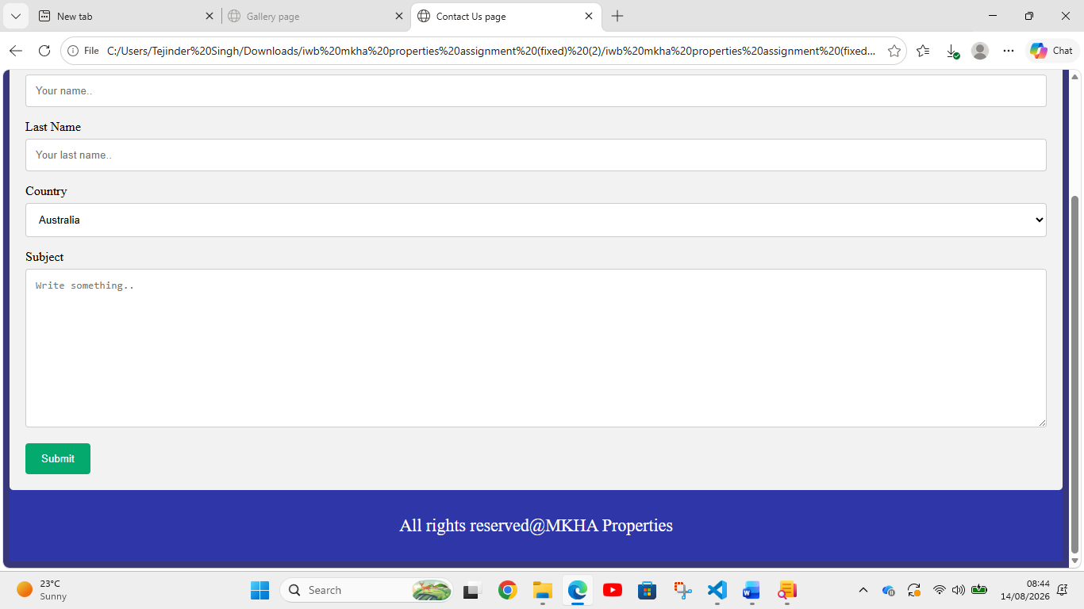

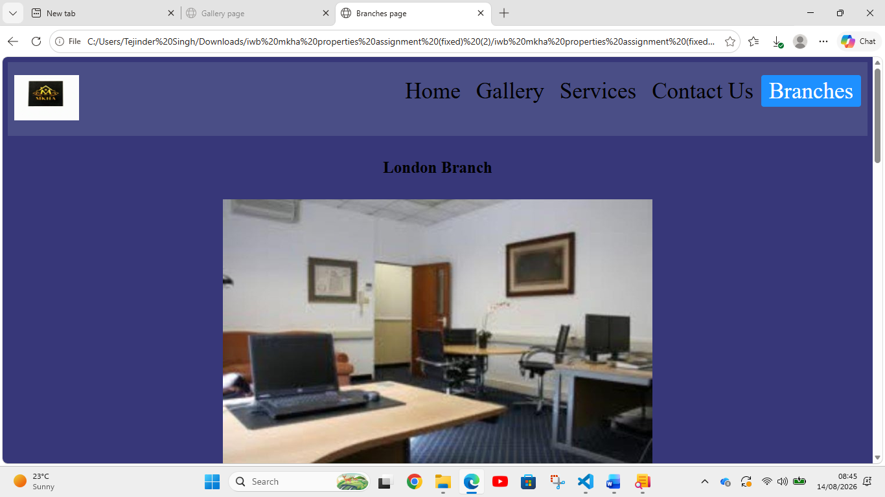

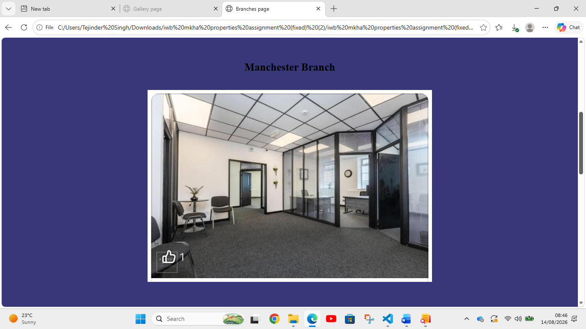

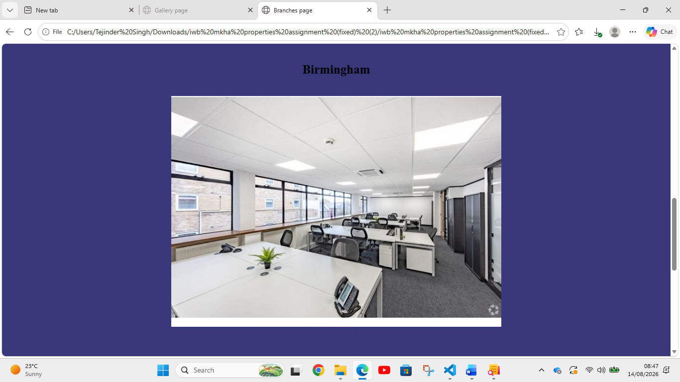

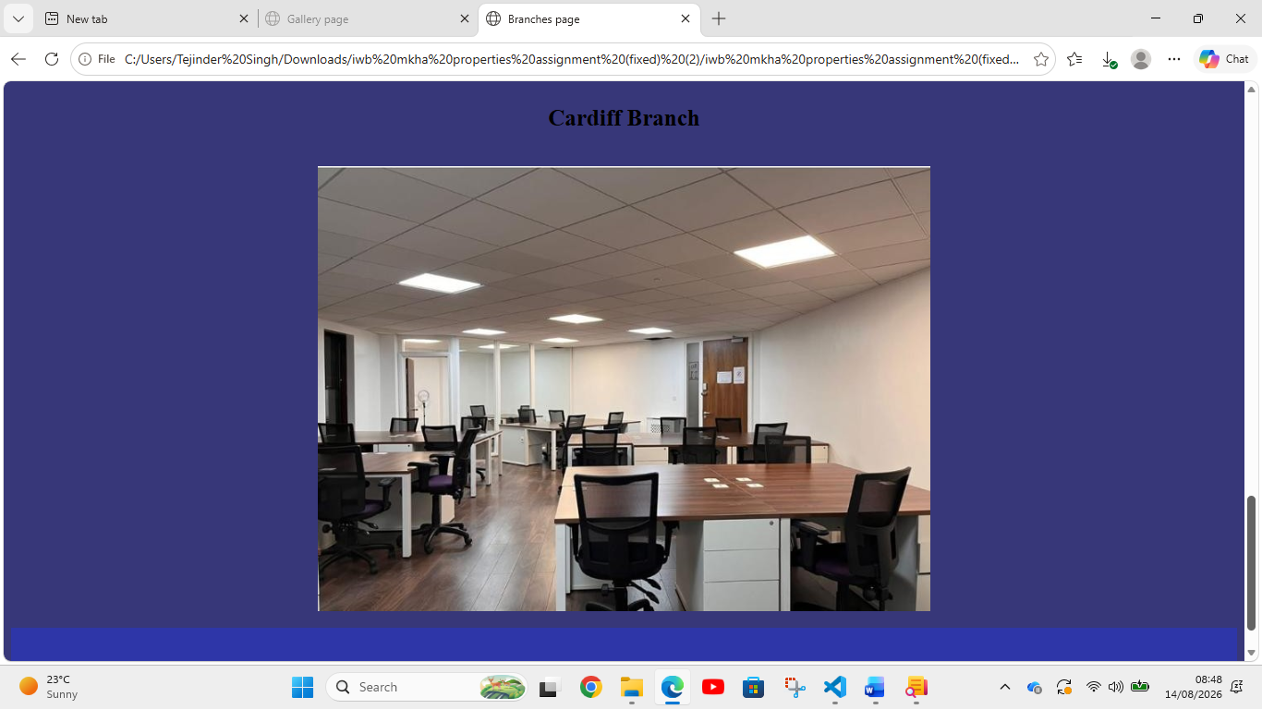

• Provide validation results (HTML & CSS).

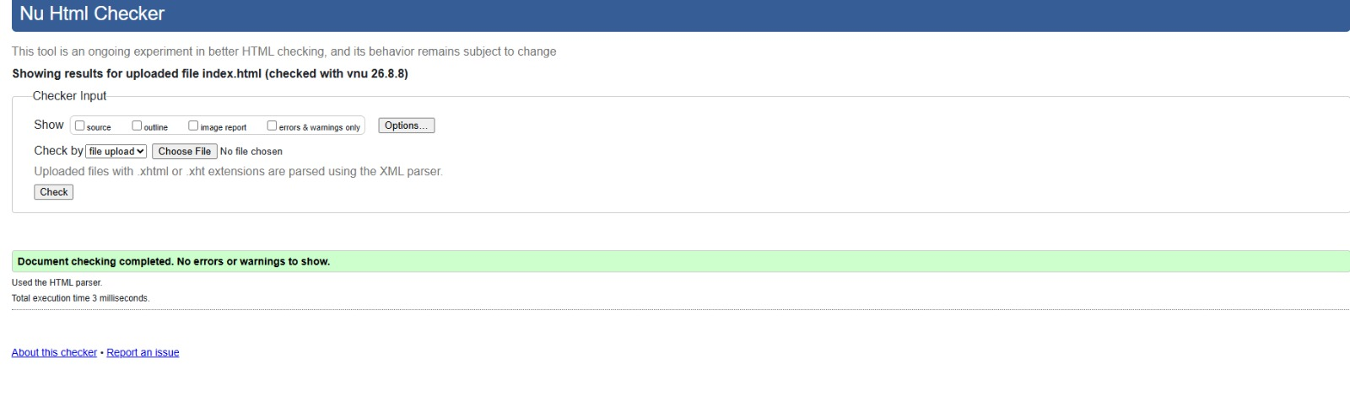

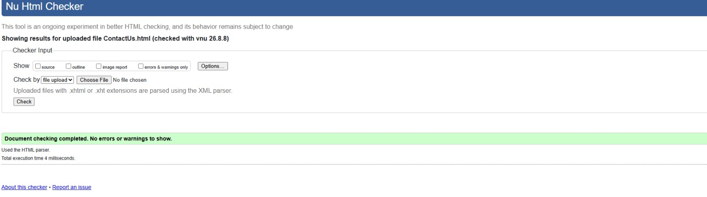

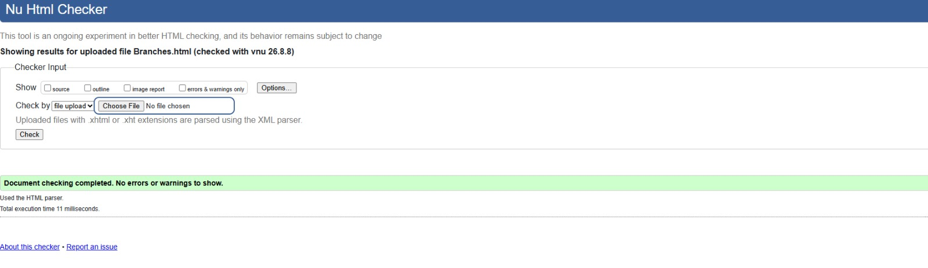

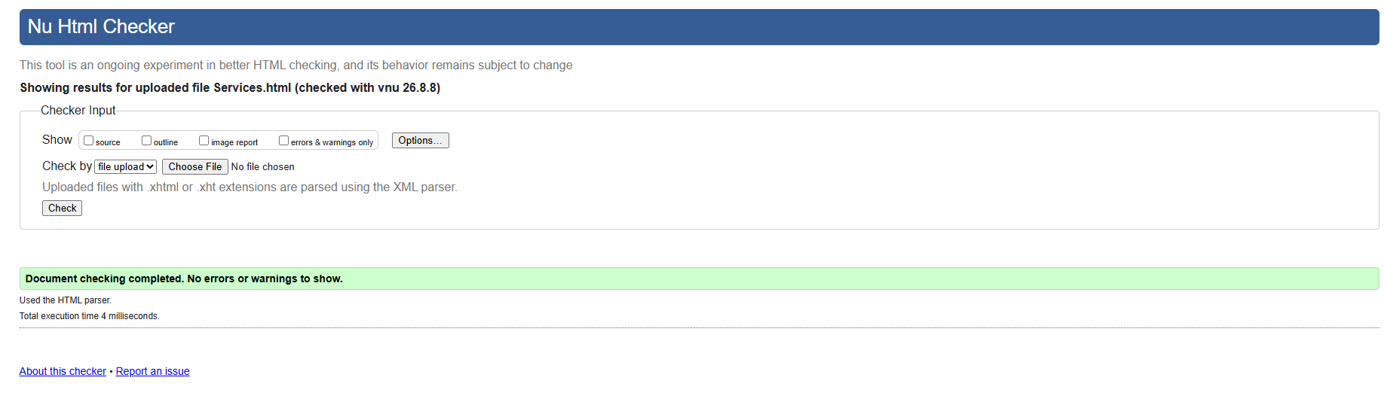
• Explain errors and fixes.
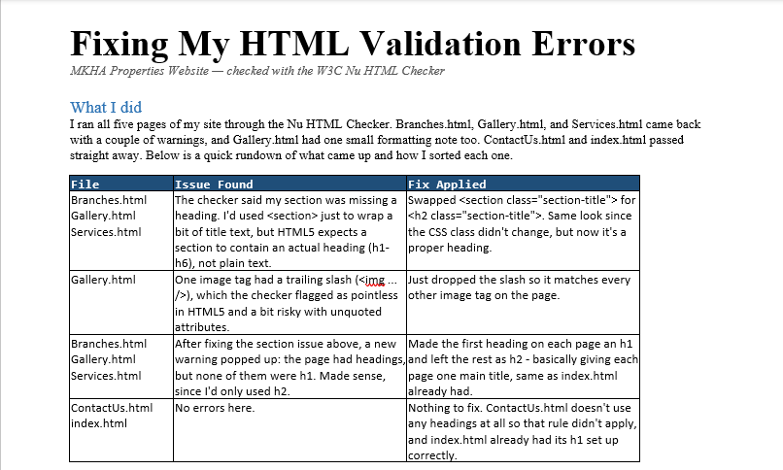
Result
After making these changes, all five pages pass the Nu HTML Checker with no errors or warnings left.

Evaluation
Evaluating web design requires research into how users interact with a site, ensuring the site is accessible to everyone, making it easy to use(usability), and optimizing it so search engines can find it (SEO). These four areas overlap to create a better digital experience well for everyone. [3]
- Evaluation Research:
1)It tests how well a website works through real user data and expert reviews.

2)It combines numbers (like click rates) with human feedback.

3)It uses tasks and interviews to find hidden site problems. [4]
b) Usability:
1)Its measurers how fast, quick and easy a user can reach the goal on a site.
2)It focuses on clear layouts, fast loading times, and simple menus.
3) It prevents users from getting frustrated by keeping navigation straightforward. [5]
c)Accessibility:
1)It ensures that people with various disabilities can use the site.
2) it follows rules like the WEB Content Accessibility Guidelines (WCAG).

3)It uses text labels for good images and clear color contrast for readability. [6]
d)SEO (Search Engine Optimization):
1)This helps the search engines read and rank the site pages.
2)It relies on clean code, good mobile layouts, and fast speeds.
3)It benefits from good accessibility and usability because search bots behave like restricted users. [7]

- Website Evaluation:
- Usability & Utility
- SEO Techniques Used
- Accessibility (WCAG 2.1)
To evaluate a website, check how easy it is to use (usability), how well search engines find it (SEO), and if everyone can read it, including people with disabilities (accessibility). [1, 2, 3, 4, 5]

📋 1. Usability & Utility
Usability focus on how easily a visitor can navigate the site and find a home or plot. Utility measures if the tools provided help them do it. [1, 2]
- Information Architecture: Property listings must be grouped clearly by type (e.g., residential, commercial, plots). A confusing layout causes users to leave quickly. [1, 2, 3]
- Search Filters: High utility depends on advanced filter options. Users need to filter by location, price range, and number of bedrooms immediately on the homepage. [1, 2]
- Speed & Performance: Pages must load in under two seconds. Slow load times for high-resolution property photos damage the user experience. [1]
- Mobile Responsiveness: A large percentage of property hunting happens on phones. The property search grids must scale cleanly onto smaller mobile screens. [1]

b) Website Evaluation: - Usability & Utility- SEO Techniques Used- Accessibility (WCAG 2.1)
To evaluate a website, check how easy it is to use (usability), how well search engines find it (SEO), and if everyone can read it, including people with disabilities (accessibility). [1, 2, 3, 4, 5]

🔍 2. SEO Techniques Used
Search Engine Optimization (SEO) ensures that when someone searches for real estate, this specific website appears on the first page of results. [1]
- Local Keyword Targeting: The site should target high-volume geo-specific phrases (e.g., "plots for sale in Al Manama" or "villas for rent") within its page text. [1]
- Optimised Meta Data: Each individual property listing page needs a unique Meta Title and Meta Description that includes the price and neighborhood to win clicks in search results. [1]
- Image Compression: Real estate sites use heavy imagery. Using modern file types like WebP ensures fast loading, which Google uses as a major ranking signal. [1]
- Clean URL Structure: Simple, descriptive links (e.g., ://domain.com) help search engines crawl and understand the site structure easily. [1]
To evaluate a website, check how easy it is to use (usability), how well search engines find it (SEO), and if everyone can read it, including people with disabilities (accessibility). [1, 2, 3, 4, 5]

♿ 3. Accessibility (WCAG 2.1)
Web accessibility ensures that everyone, including individuals with visual, motor, or cognitive disabilities, can successfully use the website. [1, 2]
- Keyboard Navigation: Users must be able to navigate through the entire website, including dropdown forms and map widgets, using only the Tab key.
- Image Alt Text: All property photos must include descriptive alternative text (e.g., alt="Three-bedroom villa front view") so screen readers can describe the image to visually impaired users
- Color Contrast: Text overlays on top of bright property images must maintain a contrast ratio of at least 4.5:1 to remain readable.
- Form Labels: Search input fields and contact forms must feature clear, permanent text labels instead of disappearing placeholder text so assistive tools can read them properly. [1, 2, 3, 4]

- Website Comparison:
- Usability
- Accessibility
- SEO
- Mobile Friendliness
- Conclusion

Evaluating a property platform like MKH Properties or local equivalents involves weighing key performance criteria. Below is a comparative website analysis covering core digital standards. [1, 2, 3]
Usability
- Property Search Filters: Clean layout with quick filters for location, price, and bedrooms.
- Call to Action (CTA): Clear booking or enquiry buttons on listing pages.
- Information Hierarchy: Intuitive menu structure, though some pages suffer from text clutter. [1, 2, 3]
Accessibility
- Contrast & Typography: Adequate color contrast, though font sizes on mobile views can occasionally be too small.
- Alt Tags: Descriptive alt text missing on a few secondary property gallery images.
- Keyboard Navigation: Basic support present, but screen reader optimization needs improvement. [1, 2]
SEO
- Mobile-First Indexing: Fully aligned with modern search engine crawling criteria.
- Metadata: Optimized meta titles and location-based keywords for regional intent.
- Page Load Speed: Affected heavily by high-resolution property imagery requiring better compression/lazy loading. [1, 2, 3, 4, 5]
Mobile Friendliness
- Responsive Grid: Automatically scales columns and property card grids smoothly across devices.
- Touch Targets: Buttons and phone triggers are appropriately sized for mobile screens.
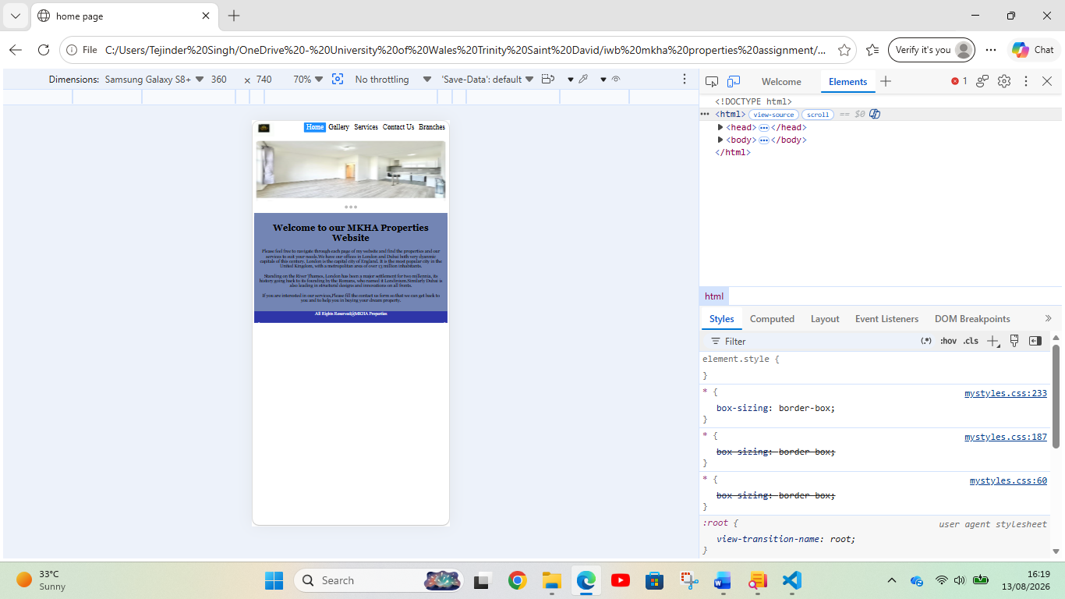

- Performance: Minor latency spikes on mobile data due to heavy media files. [1, 2, 3, 4, 5]

Conclusion
The digital footprint is solid, offering functional responsive designs and clear local search optimization. Priority improvements should focus on image compression for speed, and enhanced accessibility compliance for screen readers.

Conclusion

This assignment successfully applied functional development concepts to build a functional, five-page static website for MKHA Properties. The planning steps and execution steps I have explained thoroughly in the presentation. Through the practical application of semantic HTML5, the core structural blueprint for each page was established, ensuring accessibility and search engine readability. Structured cascading style sheets (CSS) were then implemented to manage the visual layout, typography, and responsive design elements. This separation of content and presentation ensured a consistent user experience across different screen sizes.

We were helped by our teacher’s guidance and using tools like W3Schools, Bootstrap etc. Building this project highlighted the importance of clean coding practices, logical file directories, and user-first navigation paths. While the current static architecture effectively showcases the business services and listings, future iterations could integrate JavaScript to add dynamic property filtering or interactive contact forms. Ultimately, this assignment provided critical hands-on experience, bringing theoretical web principles with real-world website development.

References (IEEE Format)

[1] | https://www.w3schools.com/howto/howto_website_static.asp, "w3schools," https://www.w3schools.com/howto/howto_website_static.asp, 11 january 2026. [Online]. Available: https://www.w3schools.com/howto/howto_website_static.asp. [Accessed 12 auagust 2026].
[2] | K. Smoothy, "https://webhivedigital.com/5-pages-every-website-needs/," https://webhivedigital.com/5-pages-every-website-needs/, 5 october 2022. [Online]. Available: https://webhivedigital.com/5-pages-every-website-needs/. [Accessed 12 august 2026].
[3] | mdpi, "https://www.mdpi.com/3042-5042/2/1/1," mdpi, 2 january 2025. [Online]. Available: https://www.mdpi.com/3042-5042/2/1/1. [Accessed 13 august 2026].
[4] | s. nature, "https://www.nature.com/nature-index/topics/l4/web-accessibility-evaluation-and-user-experience," spring nature, 2026. [Online]. Available: https://www.nature.com/nature-index/topics/l4/web-accessibility-evaluation-and-user-experience. [Accessed 13 august 2026].
[5] | n. b. z. soomaiya hamid, "https://www.researchgate.net/publication/346424847_Assessing_Ecommerce_Websites_Usability_and_Accessibility_Study," researchgate, 2020. [Online]. Available: https://www.researchgate.net/publication/346424847_Assessing_Ecommerce_Websites_Usability_and_Accessibility_Study. [Accessed 13 august 2026].
[6] | n. b. k. z. soomaiya hamid, "https://www.researchgate.net/publication/346424847_Assessing_Ecommerce_Websites_Usability_and_Accessibility_Study," researchgate, 2020. [Online]. Available: https://www.researchgate.net/publication/346424847_Assessing_Ecommerce_Websites_Usability_and_Accessibility_Study. [Accessed 13 august 2026].
[7] | a. sidiropoulos, "https://www.mdpi.com/3042-5042/2/1/1," mdpi, 2 january 2025. [Online]. Available: https://www.mdpi.com/3042-5042/2/1/1. [Accessed 13 august 2026].

7. Appendices
Include full HTML and CSS code listings.
First putting screenshots of HTML and CSS code listings when first I was building the website.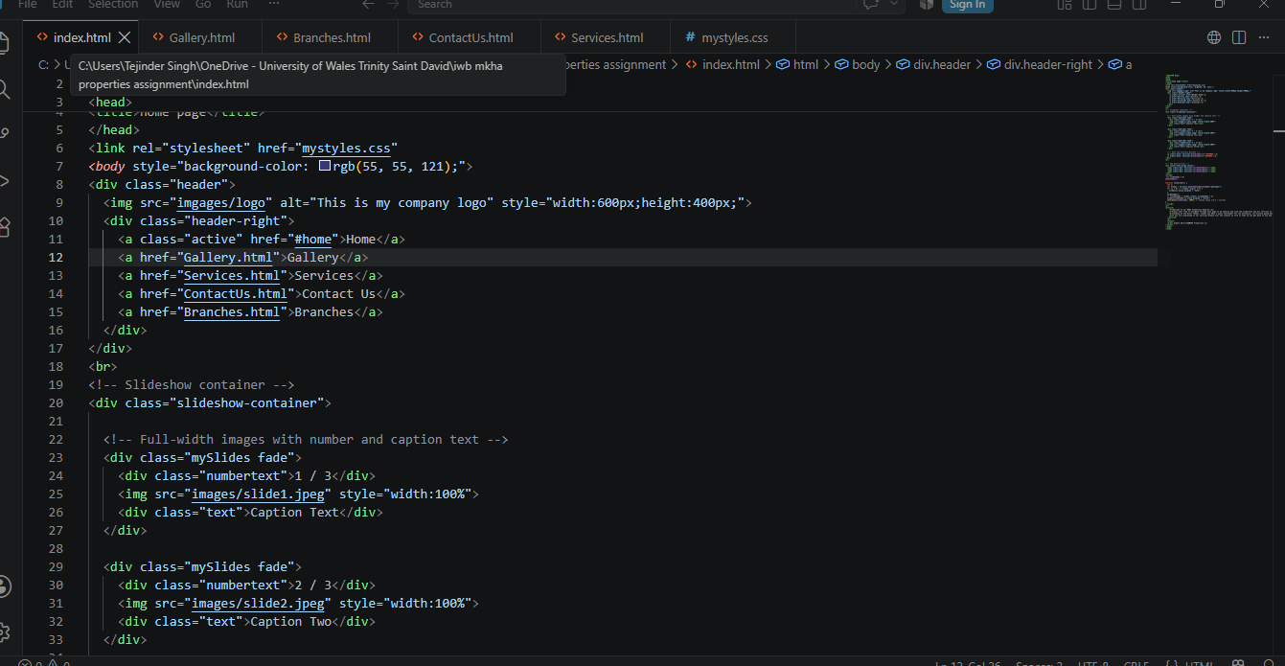
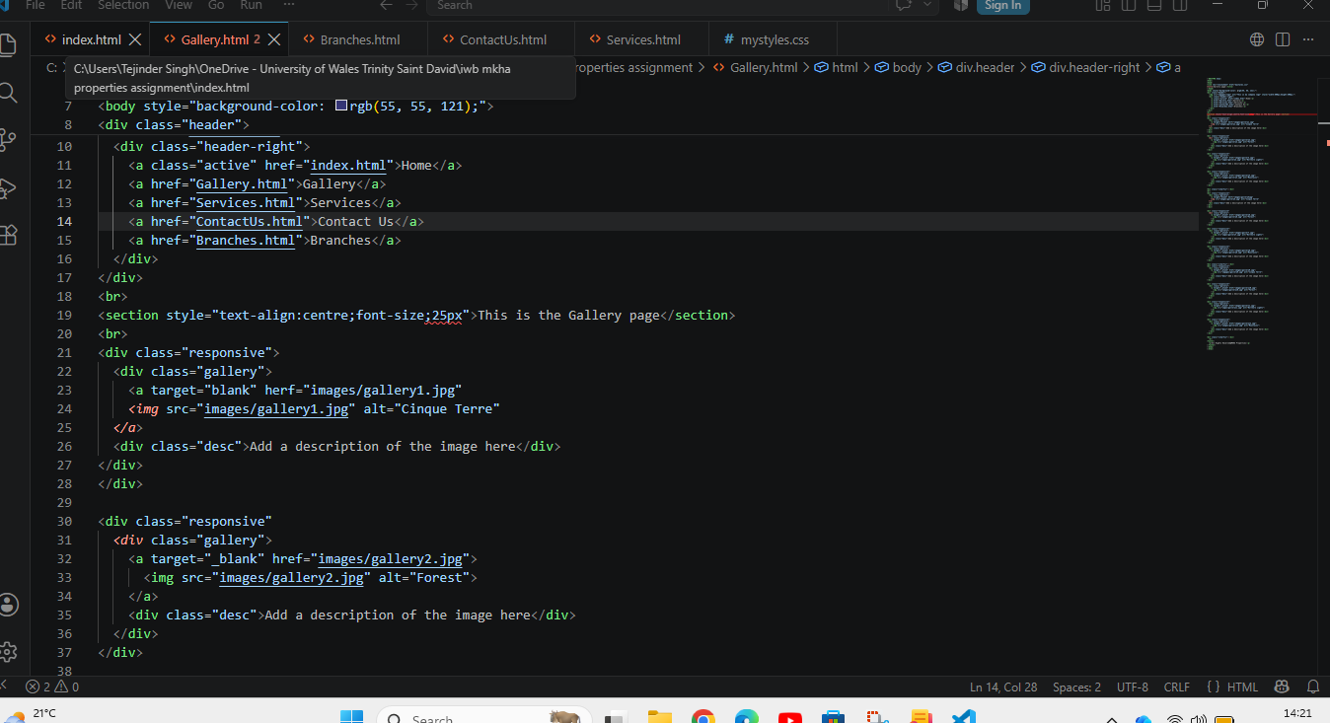

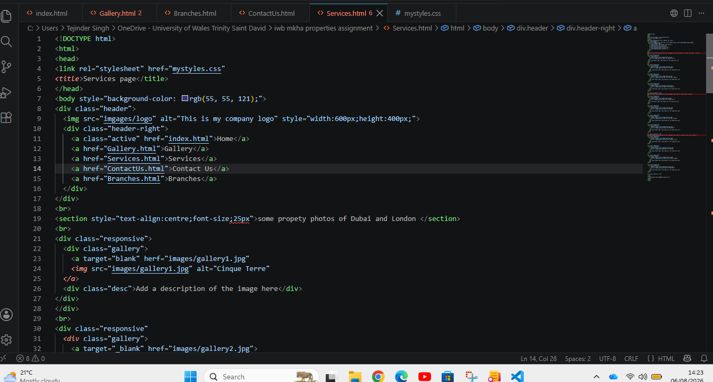

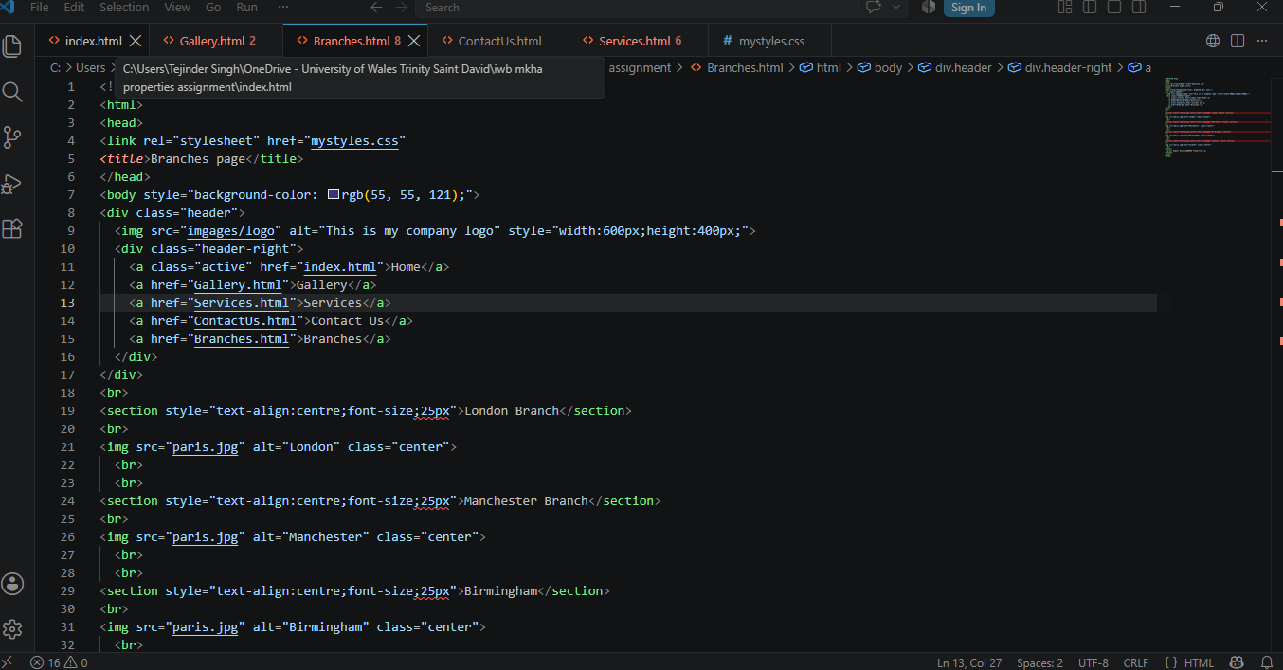

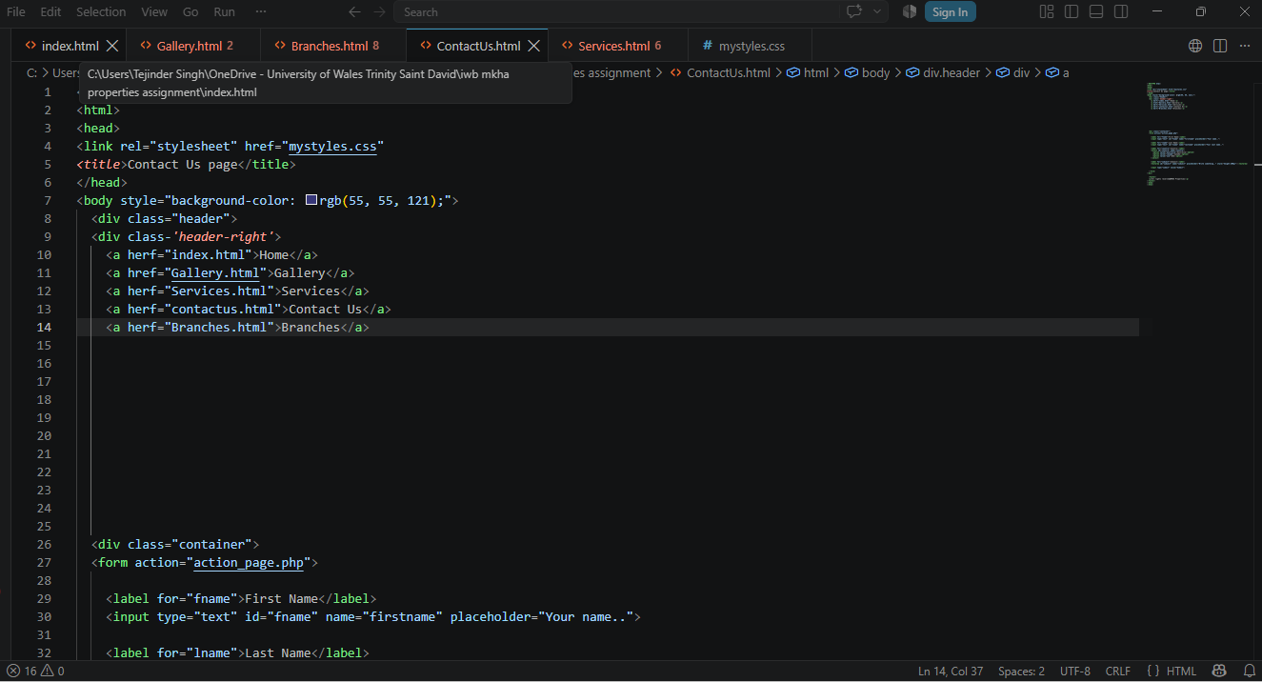

Screenshots of final HTML and CSS code listings for the MKHA Properties.


