

BSc (Hons) Health and Social Care

Student name: Dan-Matei Voiculescu
Student ID: 2411572
Group 2

Module name: Introduction to Physiology
Module code: BMPH5023_LON

Lecturer name: Dr. Soban Hadiq
Assessment 1: Case Study Report - Asthma

04.05 2026

Table of Contents

- Introduction…………………………………………………………….3
- Understanding Asthma and Respiratory Health…………………3
- Structure of the Respiratory System………………………………4

Gas exchange in lungs……………………………………………….6
- Impact of Irritants on the Respiratory System……………………7

Recording and tracking respiratory functions……………………8
- Evidence-Based Lifestyle Recommendations…………………….9
- Conclusions…………………………………………………………….10
- References………………………………………………………………11

1.Introduction

As a nurse at Oakridge Surgery, I started to organize a twice-weekly asthma clinic for teenagers (13 to 19 years old age) with one of the general practitioners. Since many young people who had asthma as children now experience more severe episodes when they enter adolescence, this service has become more important. Clinical conversations in our practice have brought attention to the fact that lifestyle modifications common to this age group, like smoking, vaping, and going to crowded social gatherings, lead to worse asthma control (NICE, 2024). During visits and consultations with teenagers who have asthma, it has become clear for all of us that many adolescents have limited understanding of their condition, its triggers, and the importance of consistent self-management. This lack of knowledge reduces their engagement with personalised asthma action plans and increases the likelihood of preventable flare-ups (Asthma + Lung UK, 2023).
We decided to gather medical and scientific data to help the patients understand how the respiratory system absorbs oxygen and releases carbon dioxide, as well as how smoking, vaping, and exposure with respiratory conditions can affect the respiratory system. We further addressed the need of having patients record and track their respiratory data continuously, particularly peak flow values.

2.Understanding Asthma and Respiratory Health
According to the World Health Organization (2023), asthma is a long-term inflammatory condition in which the airways narrow and swell, making it the most common chronic disease among children while also affecting adults worldwide. WHO (2023) reports that in 2019 the condition was responsible for around 455,000 deaths and affected an estimated 262 million people globally, highlighting its significant impact as a major noncommunicable disease. Asthma is one of the most prevalent chronic respiratory diseases in the UK, with over five million individuals undergoing treatment for it (Asthma + Lung UK, 2023). Asthma affects people of all ages, but it is more common in children and adolescents. This condition can result in symptoms like difficulty breathing, coughing, tightness in the chest, and dyspnoea.
The muscles surrounding the airways tighten and create more mucus when the airways become inflamed and sensitive to specific triggers, resulting in asthma (NICE, 2021).
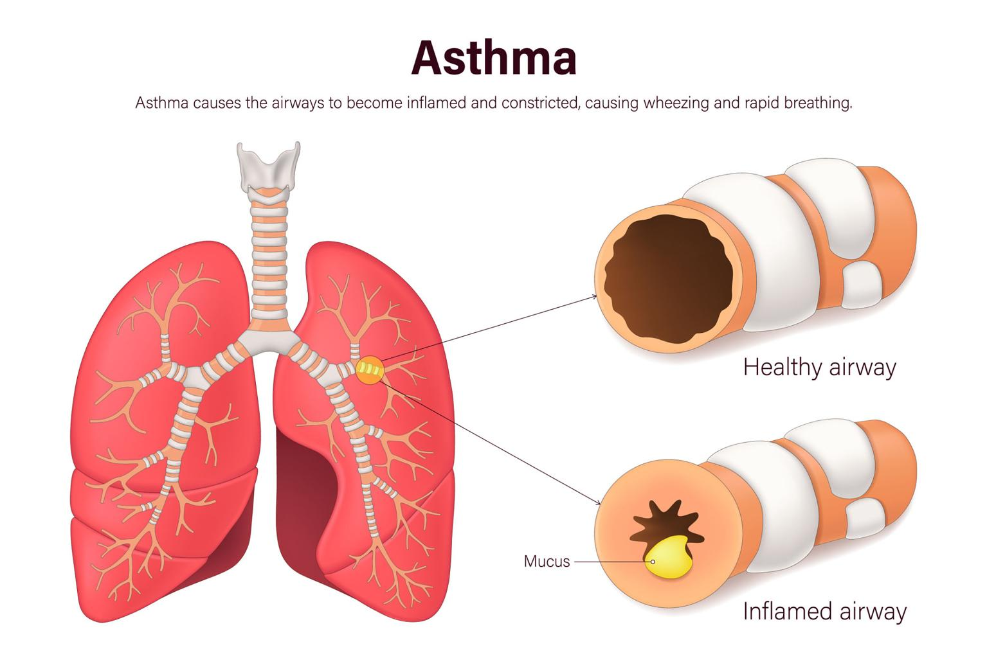 Figure 1 (NHS, 2023)
Asthma symptoms can vary in severity and worsen during an asthma attack or exacerbation (NHS, 2023). Asthma episodes can be moderate or severe, and if left untreated, they could become fatal. Asthmatic episodes can be made worse by several risk factors. These include exposure to allergens, including dust mites or pollen, smoking, vaping, respiratory diseases and air pollution (World Health Organization, 2023).
Adolescence is a time when lifestyle habits often change, and some young people may try smoking or vaping. These activities can exacerbate airway irritation and introduce toxic compounds into the lungs (Public Health England, 2021). Crowded environments like bars, clubs, and social gatherings might increase the risk of respiratory illnesses and triggering an asthma attack.

3.Structure of the Respiratory System

The respiratory system is responsible for breathing and gas exchange. Its primary function is to supply oxygen to the body’s tissues and remove carbon dioxide, a waste product produced during metabolism (Tortora and Derrickson, 2021).
The main structures of the respiratory system include:
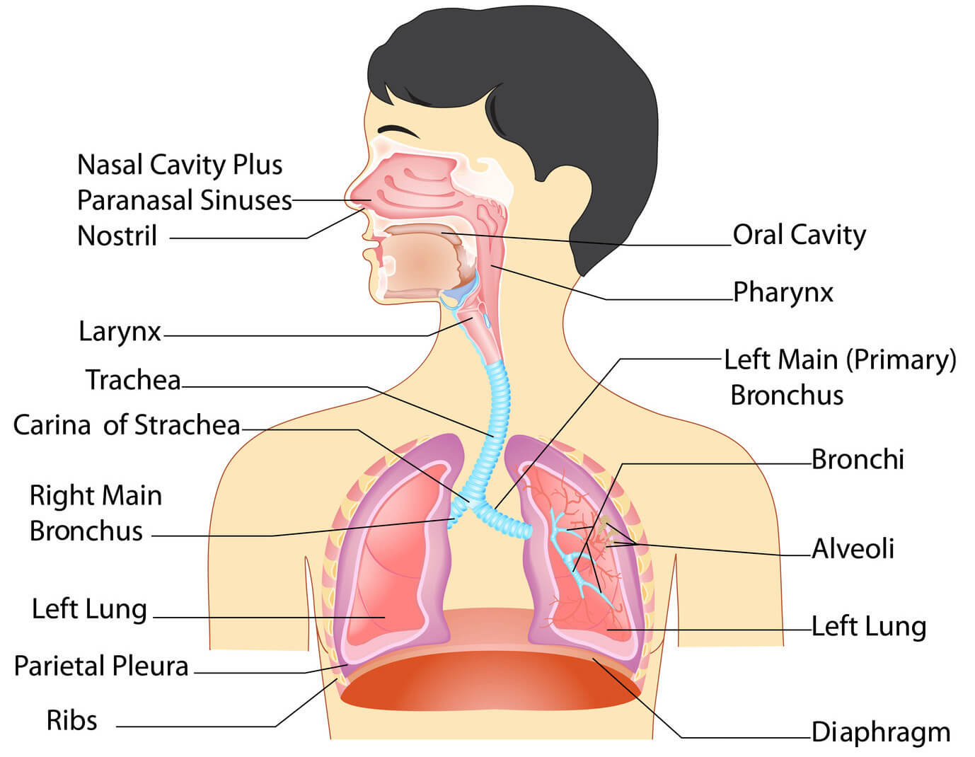
Figure 1 (Unknown author, n.d.)
Air enters the body through the nose or mouth and passes through the nasal cavity, where it is filtered, warmed and moistened. The air then travels through the pharynx and larynx before entering the trachea. The trachea divides into two bronchi that carry air into the lungs. Inside the lungs, the bronchi divide into smaller bronchioles that end in microscopic air sacs called alveoli (Marieb and Hoehn, 2019). Mechanical respiration, also known as ventilation, refers to the physical movement of air into and out of the lungs. It occurs in two main phases: inhalation and exhalation. During inhalation, the diaphragm contracts and moves downward while the intercostal muscles between the rib’s contracts. This action expands the thoracic cavity and decreases pressure inside the lungs, allowing air to flow into the lungs (Tortora and Derrickson, 2021). During exhalation, the diaphragm relaxes and moves upward while the intercostal muscles relax. This reduces the size of the thoracic cavity and increases pressure in the lungs, forcing air out of the respiratory system (Marieb and Hoehn, 2019). This continuous cycle of breathing ensures that oxygen reaches the lungs and carbon dioxide is removed from the body.

4.Gas exchange in lungs

Prange (1995) explains that gas exchange occurs in the alveoli of the lungs. The alveoli are tiny air sacs that have thin walls and are surrounded by a network of capillaries. This structure allows gases to move efficiently between the air in the lungs and the blood in the capillaries. The process of gas exchange occurs through diffusion, where gases move from areas of higher concentration to areas of lower concentration (Tortora and Derrickson, 2021).
When a person inhales, oxygen enters the alveoli and diffuses across the alveolar membrane into the surrounding capillaries. Oxygen then binds to haemoglobin in red blood cells and is transported throughout the body to support cellular respiration (Marieb and Hoehn, 2019).
At the same time, carbon dioxide produced by body cells travels through the bloodstream to the lungs. Carbon dioxide diffuses from the capillaries into the alveoli and is then removed from the body during exhalation (Arshad and Babu, 2024).
Efficient gas exchange is essential because oxygen is required for energy production within cells. Any disruption to the structure or function of the lungs can impair gas exchange and reduce oxygen delivery to the body (West, 2012).
The diagram above illustrates the difference between a normal airway and an asthmatic airway, showing how inflammation, muscle tightening, and mucus buildup reduce the space available for airflow:
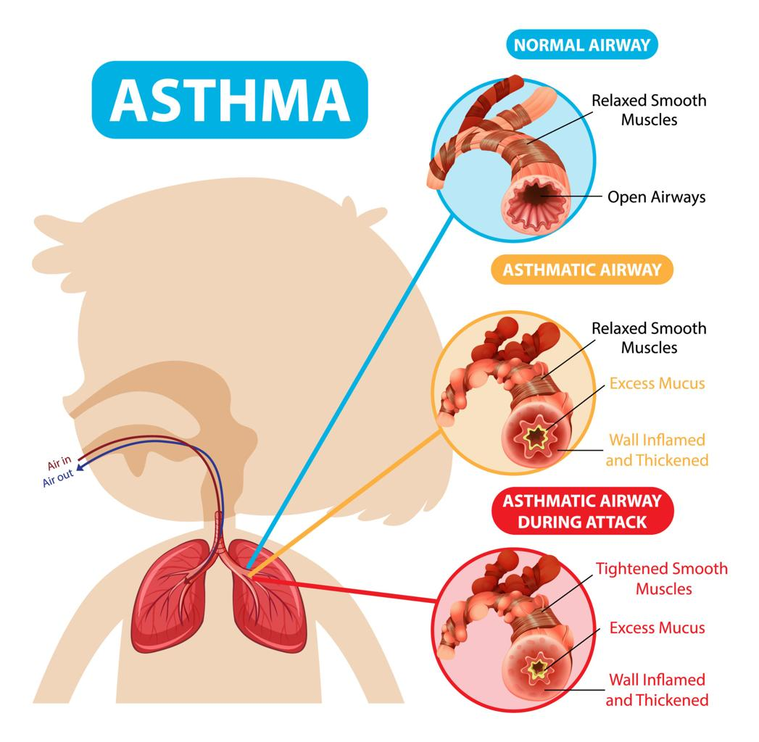 Figure 2 (Unknown author, Yahoo)

5.Impact of Irritants on the Respiratory System

Patients with asthma should be aware that environmental irritants such pollution, cigarette smoke, vaping aerosols, and respiratory infections might affect their respiratory systems. These irritants have the potential to produce airway swelling and inflammation, which can seriously impair breathing (WHO, 2023). By learning about the respiratory system and asthma triggers, the teenagers can better understand and control their asthma also lower their risk of severe flareups. As shown in the following figure, asthma can be triggered by multiple environmental and physiological factors:

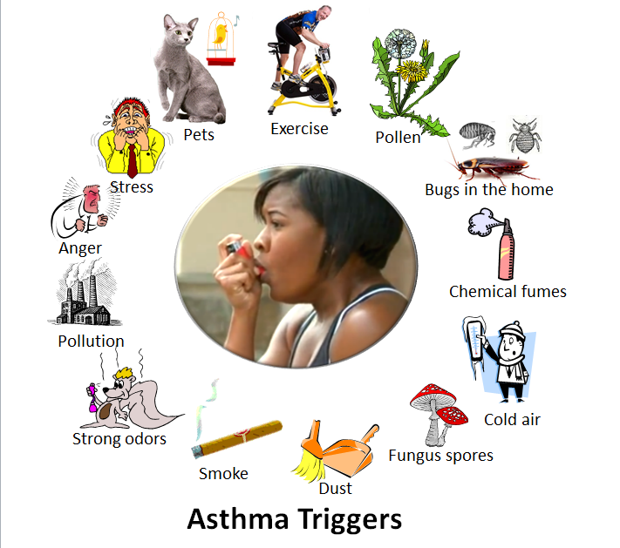
Figure 3 (Unknown author, Yahoo)
The airways are already inflamed and hyperresponsive in people who have asthma. Irritants cause several physiological reactions when they reach the respiratory system.

Mucus production rises, the smooth muscles around the airways constrict, and the lining of the airway’s swells (NICE, 2021).
These changes lead to narrowing of the airways, which restricts airflow and makes breathing more difficult. As a result, individuals may experience wheezing, coughing and shortness of breath (NHS, 2023).
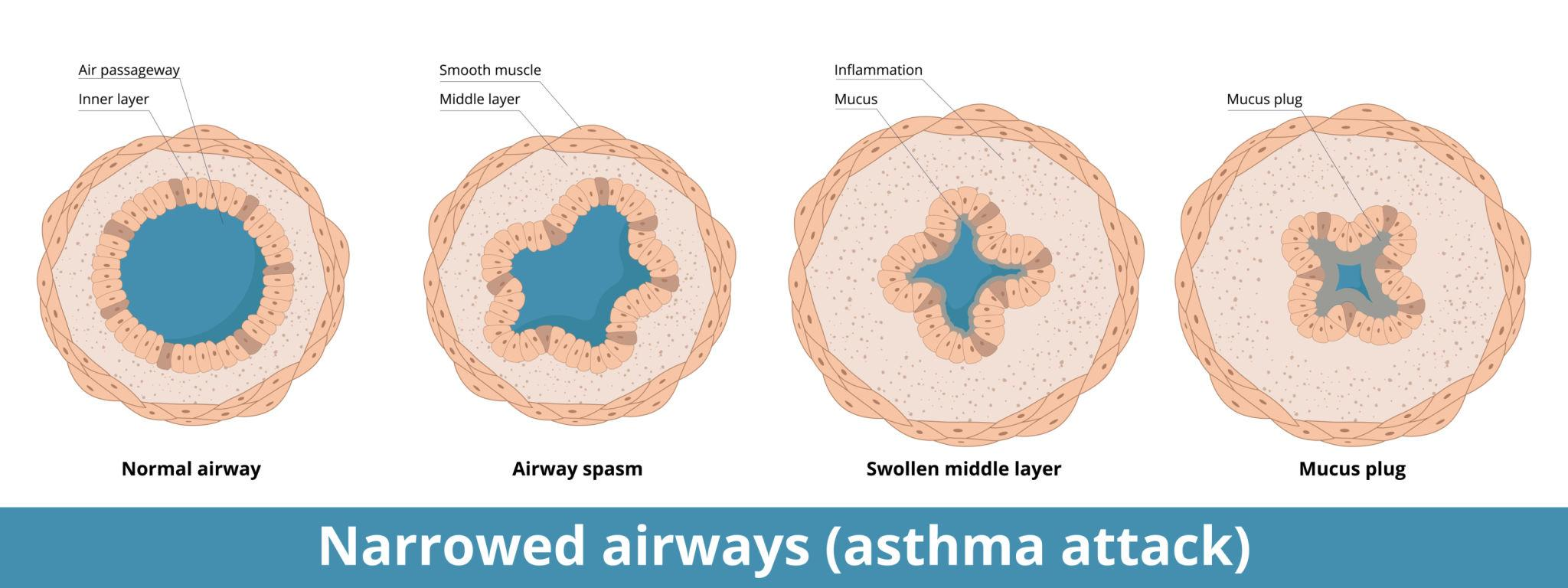

Figure 4 (Unknown author, Yahoo)
Smoking is particularly harmful because tobacco smoke contains thousands of chemicals that can damage lung tissue and impair normal respiratory function (WHO, 2023). Smoking also reduces the effectiveness of asthma medications, making it more difficult to control symptoms (British Lung Foundation, 2022). Vaping has also been linked to respiratory irritation and inflammation. Although often perceived as safer than smoking, e-cigarettes still contain chemicals and particles that can damage lung tissue and worsen asthma symptoms (Public Health England, 2021).
Respiratory infections can also exacerbate asthma by increasing airway inflammation and mucus production. Viruses such as rhinovirus, which causes the common cold, are known triggers for asthma exacerbations (Papadopoulos et al., 2012, p. 927).

6.Recording and tracking respiratory functions

Monitoring lung function is an important part of asthma management. One commonly used method is measuring peak expiratory flow (PEF) using a peak flow meter.
Peak flow measures how quickly a person can blow air out of their lungs after taking a deep breath. This measurement provides an indication of how well the airways are functioning (Asthma + Lung UK, 2023).
Regular monitoring of peak flow readings allows individuals to:
- Detect early signs of worsening asthma.
- Assess the effectiveness of medications.
- Identify triggers that may affect breathing.
- Monitor changes in lung function over time.
Patients are encouraged to record their peak flow readings daily and compare them with their personal best measurement. A significant drop in peak flow readings may indicate airway narrowing and the need for medical intervention (NICE, 2021).
Recording respiratory data also helps healthcare professionals evaluate treatment plans and adjust medications if necessary. Digital health apps and asthma diaries can support adolescents in tracking their respiratory health and improving self-management (Global Initiative for Asthma, 2023).
Asthma must be monitored and recorded because neglecting to do so can result in serious clinical concerns. Long-term asthma management is likely to worsen without regular monitoring, leading to ongoing airway inflammation and a progressive loss of lung function. Inaccurate documentation also raises the possibility of making risky treatment choices, like improperly increasing or decreasing medication. Overuse of relief inhalers may go undetected, hiding deteriorating symptoms and postponing essential treatment. Adolescents may also find it difficult to identify trends or triggers in the absence of organized monitoring, which would lower their level of self-management. In the end, uncontrolled or undiscovered symptom escalation is a contributing factor to an increase in emergency or unscheduled presentations (Arshad and Babu, 2024).

7.Evidence-Based Lifestyle Recommendations

Lifestyle modifications can play a significant role in improving asthma control and reducing the risk of exacerbations (Arshad and Babu, 2024)
Avoiding smoking or vaping is one of the most important recommendations. Tobacco smoke damages lung tissue and increases airway inflammation, while vaping can also irritate the respiratory system (WHO, 2023).
Reducing exposure to respiratory infections is also important. Practicing good hygiene, receiving recommended vaccinations, and avoiding close contact with individuals who are ill can help prevent infections that may trigger asthma symptoms (NHS, 2023).
Adherence to prescribed medication is another key factor in effective asthma management. Preventer inhalers containing corticosteroids help reduce airway inflammation and prevent asthma attacks when used regularly (NICE, 2021).
Maintaining a healthy lifestyle through regular physical activity, balanced nutrition and adequate sleep can also support overall respiratory health (Global Initiative for Asthma, 2023).
Healthcare professionals and families should provide education and support to help adolescents understand their condition and develop effective self-management skills.

8.Conclusion

Asthma is a chronic respiratory condition that affects the airways and can have a significant impact on breathing and overall health. Adolescents who perceive the respiratory system's architecture and physiology are better able to understand how oxygen enters the bloodstream and carbon dioxide exits the body. Smoking, vaping, and respiratory infections are examples of environmental irritants that can worsen asthma symptoms by inflaming and swelling the airways.
Therefore, teenagers can identify early changes in lung function and take necessary action by using peak flow monitor respiratory function.
Adherence to treatment plans, education, commitment and lifestyle changes are necessary
for effective asthma management.
Additionally, by being better informed about their illness, adolescents can actively participate in controlling their asthma and protecting their respiratory health.

9.References

Arshad, S.H. and Babu, K.S. (2024) Asthma. 2nd ed. Oxford: Oxford University Press. Available at: https://doi.org/10.1093/oso/9780199211265.001.0001.
Asthma + Lung UK (2023) Asthma statistics and peak flow monitoring. Available at: https://www.asthmaandlung.org.uk (Accessed: 17 March 2026)
British Lung Foundation (2022) Asthma and triggers. London: BLF.
Global Initiative for Asthma (GINA) (2023) Global strategy for asthma management and prevention. Available at: https://ginasthma.org (Accessed: 28 March 2026)
Marieb, E. and Hoehn, K. (2019) Human Anatomy and Physiology. 11th ed. Harlow: Pearson.
National Institute for Health and Care Excellence (NICE) (2021) Asthma: diagnosis, monitoring and chronic asthma management. London: NICE.
NHS (2023) Asthma. Available at: https://www.nhs.uk (Accessed: 20 March 2026)
NHS (2023) Asthma: healthy vs inflamed airway [Online image]. Available at: https://www.nhs.uk/... (Accessed: 20 March 2026).
Papadopoulos, N. et al. (2012) ‘Viruses and bacteria in acute asthma exacerbations’, Journal of Allergy and Clinical Immunology, 129(4), pp. 927-933.
Public Health England (2021) Vaping in England: Evidence update. London: PHE.
Prange, H. (1995) Respiratory physiology: understanding gas exchange. Illustrated edn. London: Published by Springer, 1995ISBN 10: 0412052113 / ISBN 13: 9780412052118
Tortora, G. and Derrickson, B. (2021) Principles of Anatomy and Physiology. 16th ed. Hoboken: Wiley.
Unknown author (n.d.) Anatomical diagram of the human respiratory system [Online image]. Source unknown. (Accessed: 21 March 2026).
Unknown author (n.d.) Diagram showing airway narrowing during an asthma attack [Online image]. https://uk.images.search.yahoo.com/search/images;. Accessed: (21 March 2026)
West, J. (2012) Respiratory Physiology: The Essentials. 9th ed. Philadelphia: Lippincott Williams & Wilkins.
World Health Organization (2023) Asthma. Available at: https://www.who.int/news-room/fact-sheets/detail/asthma (Accessed: 1 April 2026).
https://uk.images.search.yahoo.com/search/images; (Accessed: 30 March 2026)

