
Course: BSc (Hons) Health and Social Care
Module: Independent Project (BMHP6020_LON)

Component 1: Element 1 - Project Proposal

Student ID: 2211925
Student Name: Danielli de J L de Souza
Date of submission: 07/11/2026

Acknowledgement of the use of AI tools.
I confirm that I have not used any AI tools in the research and creation of this assignment. I confirm that I have not presented any AI generated materials as my own work. I confirm I have copies of my drafts, notes, and other resources I used, which I may be asked to provide in evidence
Project Proposal.
_ The Impact of Stress on the Mental Health of Care Workers in the UK_
Table of Contents
- Introduction
  - Aim
  - Objectives
  - Background / Rationale
- Methods
  - Methods
  - Keywords
  - Inclusion Criteria
  - Exclusion Criteria
- Resources and Timeline
  - Resources
  - Timescale
- Self-Reflection
2.0 Self-Reflection as a Researcher
- References
2.1 References

1. Introduction
1.1 Aim
The objective of the research project is to analyze the role of occupational stress on the mental health and well-being of care workers in the United Kingdom. The research aims to investigate the impact of work-related stress on individuals in the care industry.
1.2 Objectives
The project will examine key causes of stress among care workers, assess the effects of stress on their mental and job performance, discuss coping strategies used by care workers, and provide recommendations to enhance well-being and support systems in the care setting.
1.3 Background / Rationale
Care workers constitute an important component of the UK's health and social care system, providing essential support to elderly citizens, individuals with disabilities, and those living with chronic illnesses (Kinman & Teoh, 2018). Nevertheless, their jobs are usually stressful due to the long-term and hard-working nature of their work (Skills for Care, 2023). The Health and Safety Executive (2022) considered that a considerable percentage of the work-related ill health in the care sector includes stress, depression, and anxiety. Some of the contributing factors include long working hours, emotional burnout, poor staffing, and low recognition (Ravalier et al., 2021). The project is thus significant because it seeks to raise awareness of psychological issues and propose evidence-based interventions to ensure resilience and retention.
2. Methods
1.4 Methods
The study will take the literature-based approach and utilise secondary data sources, in the form of academic works, policy reports, and professional reports, published between 2015 and 2025. Relevant sources will be identified using databases like CINAHL, PubMed, and Google Scholar. A thematic framework will be used to critically analyse the data, identifying recurring patterns of stress causes, mental health consequences, and coping mechanisms. Interpretation will be informed by the Job Demand-Control Support model (Karasek & Theorell, 1990), which provides a theoretical perspective on how job pressure and a lack of autonomy contribute to psychological strain.
1.5 Keywords
Stress, mental health, care workers, burnout, wellbeing, occupational stress, UK social care.
1.6 Inclusion Criteria
Articles published between 2015 and 2025 in English that study UK-based care workers, occupational stress, and mental health outcomes, will be considered to ensure current and relevant information.
1.7 Exclusion Criteria
Sources focusing solely on other health professionals, non-UK populations, or pre-2015 studies will be eliminated to keep the contextual and methodological relevance.
3. Resources and Timeline
1.8 Resources
The project will rely on the databases of university libraries, online journals, publication Skills for Care, and government reports. The writing and referencing will be facilitated through Microsoft Word and RefWorks, whereas the recording and the categorization of literature themes will be done through Excel.
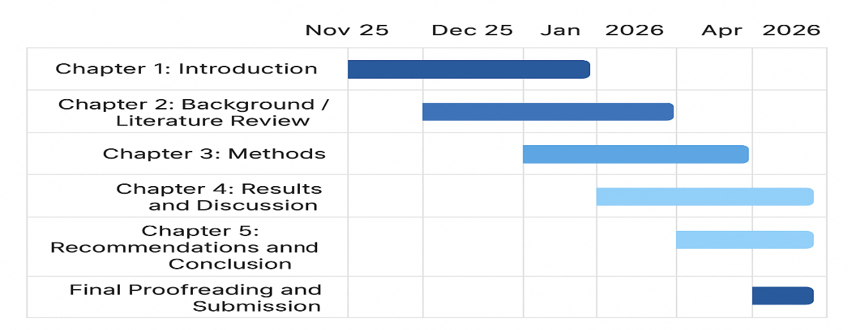
4. Self-Reflection
2.0 Self-Reflection as Researcher
Aspect | Reflection
Strengths | Good organization, strong analytical skills, and understanding of care work.
Ethical Commitment | Committed to honesty, integrity, and accurate referencing throughout the research.
Challenges | Managing time effectively and avoiding personal bias.
Opportunities for Growth | Developing research, critical thinking, and writing skills for future practice.

References
Health and Safety Executive (2022) Work-related stress, anxiety or depression statistics in Great Britain 2022. Available at: https://www.hse.gov.uk (Accessed: 1 November 2025).
Karasek, R. and Theorell, T. (1990) Healthy Work: Stress, Productivity and the Reconstruction of Working Life. New York: Basic Books.
Kinman, G. and Teoh, K. (2018) What could make a difference to the mental health of UK social workers? London: British Association of Social Workers. https://www.som.org.uk/sites/som.org.uk/files/What_could_make_a_difference_to_the_mental_health_of_UK_doctors_LTF_SOM.pdf
Ravalier, J., Wainwright, E., Clabburn, O., Loon, M., & Smyth, N. (2021). Working conditions and wellbeing in UK social workers. Journal of Social Work, 21(5), 1105-1123. https://journals.sagepub.com/doi/abs/10.1177/1468017320949361
Skills for Care (2023) The State of the Adult Social Care Sector and Workforce in England. Leeds: Skills for Care.

