

Task 1 Academic Report
What is the most effective way to motivate staff?
Student name: Nicoleta Elena Ispas
Student ID: 2113247
Module code: BMSW 4001
Assignment section: Task 1 - Academic report - ‘What is the most effective way to motivate staff?’
Lecturer’s name: Md Nazmul Hasan



Table of content
Page
Introduction.............................................................................................................................3
Why do an employee needs to be motivated..........................................................................3
Types of employee motivation................................................................................................4
Ways in which bad managers kill motivation..........................................................................5
Employee recognition and rewards.........................................................................................6
Recognition from the public....................................................................................................7
The definition of reward management....................................................................................7
What is the purpose of the reward management....................................................................8
Money motivates people.........................................................................................................9
Management challenges.......................................................................................................10
Scientifically Proven Ways to Motivate Employees..............................................................11
Three common employee challenges and how to overcome them.......................................12
Conclusion............................................................................................................................13
References.............................................................................................................................13

Introduction:
The purpose of Task 1 is to find out what are the most effective ways in which staff can be motivated.
One way which can help staff be motivated is the money. Sometimes people get motivated when they get paid well because they really feel like the work and effort they put in their job is actually seen and rewarded, but it is not always the case. Sometimes, they just need little rewards such as discounts and other things which will make them feel happy. Some people get more motivated when it comes to holidays and the conditions they work in. When people work in good conditions the level of motivation increases because they feel happier and more respected and they will actually enjoy going to work.
Why do an employee needs to be motivated?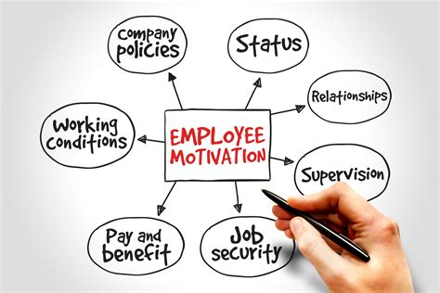
Motivated people are organized, enthusiastic, and productive, and they are dedicated to their work. Motivated employees go the extra mile and do their best. Motivation leads to lower turnover and greater employee productivity when you find the right methods.
Finding ways to increase employee motivation is crucial not only for their well-being but also for the health and longevity of your company. Think of it as preventive maintenance-it is harder to rekindle motivation after a break than it is to sustain it.
Types of employee motivation: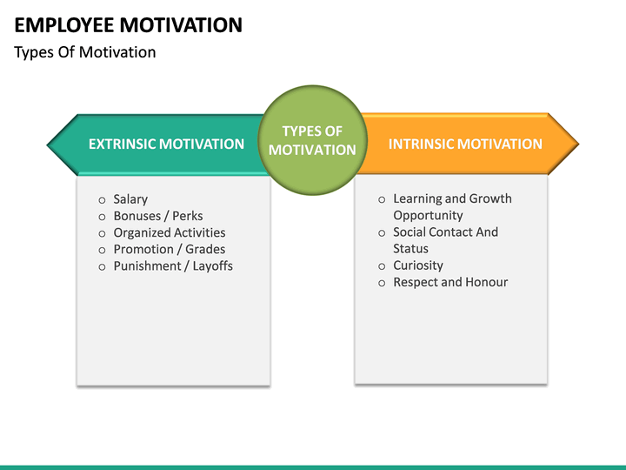
Psychologist Abraham Maslow outlined a universal hierarchy of needs that all human beings have in common to motivate them. This allows us to motivate others by meeting their needs. Human experience can be explained by his hierarchy as much at work as anywhere else.
The two most common ways to motivate employees at work include intrinsic motivation and extrinsic motivation.
Extrinsic motivation: Rewards and recognition are examples of external factors that stimulate intrinsic motivation. Humans have two primary needs that are met by extrinsic motivation: physiological needs and safety needs.
Intrinsic motivation: A person is intrinsically motivated when they are motivated by their internal belief systems, or by their desire to stay in line with their internal beliefs. Love, belonging, and esteem are the three highest levels of Maslow's hierarchy of needs that intrinsic motivation fulfills.
Ways in which bad managers kill motivation:
It will be your daily task to convince people to believe in your cause and your future, no matter how many people you lead - only persuasive communication can turn strategy into action. The key to increasing productivity is to convince your employees to work smarter, faster, and more efficiently. To get more money, you need to convince financiers. In order for your products and services to be more successful, you need to convince customers to buy more. In order to succeed in your endeavors, you'll need to convince your boss or colleagues to provide more resources. Colleagues need to be convinced to cooperate with you.
Speaking with people in a way that shows them you understand their concerns and issues; communicating clearly and connecting them with the cause; motivating people to talk; and understanding what it takes to change people's behavior are only certain ways to communicate with power.
By communicating well, and encouraging their teams to communicate well, leaders can accelerate team innovation, allowing them to share information, successes, and failures, and work cooperatively rather than competing. Employees value communication skills among their most valuable attributes.
Employee recognition and rewards:
Giving a thank you note - An effective recognition method can be handwritten thanks from department leaders. According to two institutions, this tactic is used with regularity. According to information available on exceptional employee efforts, the frequency varied between daily and biweekly. It is usually colleagues who provide information. It is important that department leaders ensure the data provided is sufficient for them to write a personally thanking note identifying the employee's unique behavior before this type of recognition is given. When possible, recognize behaviors that align with the vision and mission of the department or organization. Department leaders can effectively recognize others by writing handwritten thank you notes. Participants in the survey noted that most employees who receive a thank you note personally or by email provide her with positive feedback about the gesture. In order to use this tool effectively, it is important to incorporate a personalized message, write in a specific style (handwritten or typed), and deliver through an appropriate method (personal message, e-mail, home/office, etc.).
Recognition from the public:
Most recognition tools have a public nature so they are similar to the above strategies. You can share feedback in-person with your colleagues, give a verbal commendation in front of your team, publish articles in a department newsletter, and post on your department or school's bulletin board. The communication of outstanding employee behaviors and attitudes can be accomplished by all methods. In addition to publicizing the work of the pharmacy department’s staff at all levels, such as technicians and pharmacists, this tool can be used to highlight the efforts of other healthcare professionals who support pharmacy staff in providing patient care.
The definition of reward management: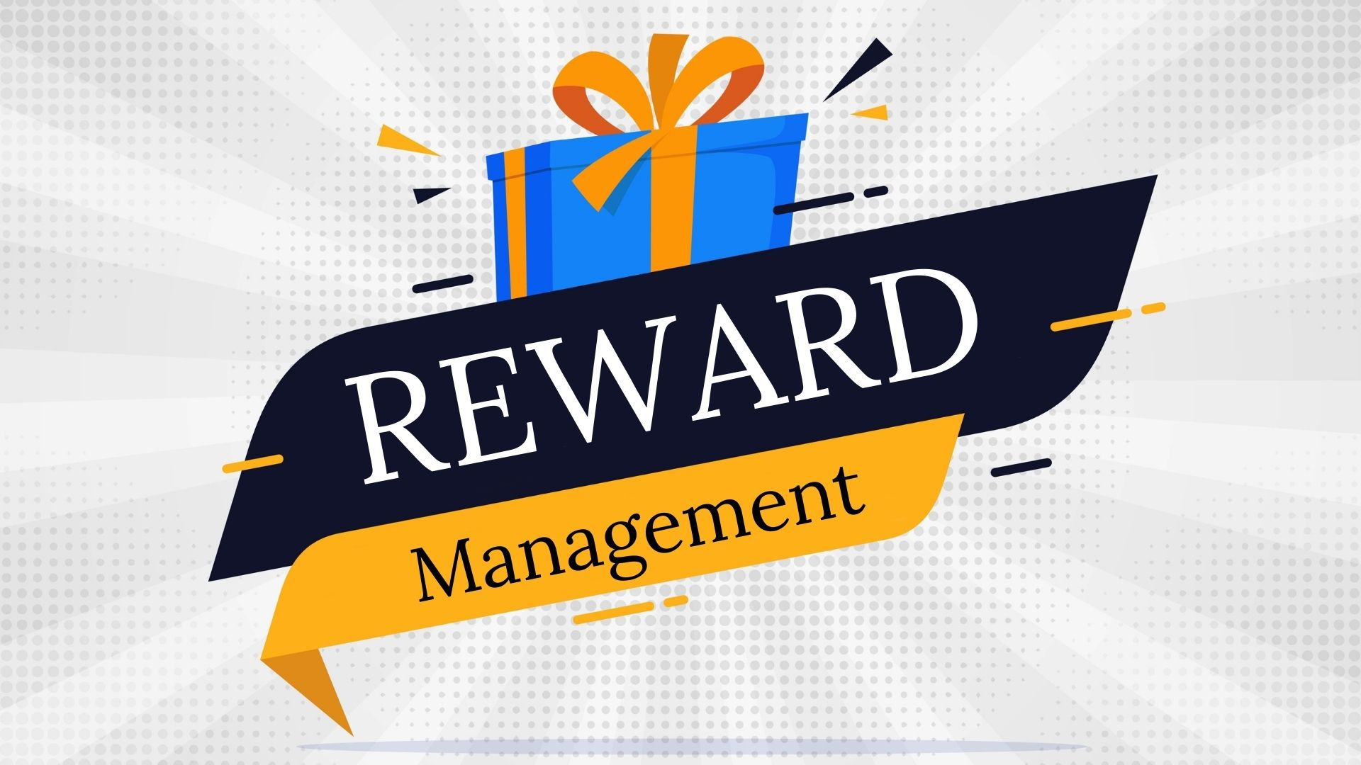
It is concerned with policies, practices, and strategies that ensure the contributions individuals make toward the accomplishment of organizational, departmental, and team goals are recognized and rewarded. These questions are answered by defining the following: (1) How are people valued? (2) How are they to be rewarded based on that value? In practice, reward management means designing, implementing, and maintaining rewards systems. They include interrelated practices, procedures, processes and processes relating to the recognition of jobs and people, the grading and pay structure (pay structure management), the actual recognition and compensation of achievements and performance, employee benefits, and other reward management procedures. To achieve corporate goals and to improve performance, reward systems are designed to satisfy the organization's requirements for attracting, retaining and motivating high-quality employees. They are also there to support the organization's employees. As for other external requirements, such as meeting employment laws and taxes, they must, of course, meet them too. Pay and benefits are just a portion of reward management. As well as financial rewards, the system considers non-financial rewards, including recognition, autonomy, learning opportunities, and increased job responsibilities.
What is the purpose of the reward management?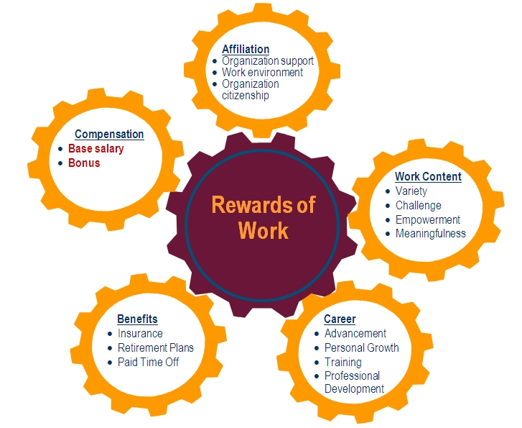
- Developing an organizational culture that fosters high performance can help businesses achieve their goals;
- The organization needs to attract and retain talented employees;
- Engage employees by motivating them;
- Compensation based on value created;
- Both the employer and the employees will be able to gain value from the rewards investment;
Money motivates people:
The myth that rewards programs cost money is a common one among managers. Money can purchase items such as plaques, gift certificates, movie tickets, or even larger items such as travel. Money-based rewards aren't distinctive, individual, or motivational. To truly show you care for your team, a personal, nonmonetary gift is ideal. Giving a personal, nonmonetary gift to your team is ultimately a more meaningful way of showing them you care.
Management challenges:
- Difficult employees - A common challenge managers face is how to address any issues before they transform into major problems. Knowing how to properly address any issues before they transform into major problems is one of the most important things to know. If you want to address a specific concern, ask your team members for feedback about any difficulties they encounter in completing work or communicating with their colleagues.
Take the time to listen to your team and observe how they feel. Implement any suggestions you think can help. If you have no idea what to do next, enlist the support of an employee relations professional. In addition to conflict resolution, they provide employee relations training.
- Pressure to perform - When you feel stressed about your leadership position frequently, take some time to remember why you were recruited for the position. New managers especially may feel they are under pressure to achieve greatness right out of the gate. You will likely face unexpected situations. Your decision to resolve conflicts and react to challenges reveals your leadership ability. Leaders learn from their experiences and mistakes. While planning can be helpful, you will likely face unexpected situations.
- Poor teamwork - To re-establish teamwork, managers should revisit the purpose of a project when employees spend a lot of time on individual tasks. Employees tend to be more motivated when managers acknowledge and clarify their work's purpose.
Team-building exercises are also a great way to teach everyone how to work together effectively. Divide the team into partners so they can work with each other on a specific project. Use exercises that reflect the challenges your team faces; for example, if they need to establish a better relationship, we suggest relationship building exercises.
Scientifically Proven Ways to Motivate Employees: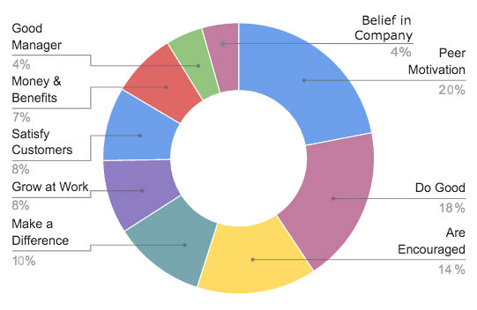
- Create a pleasent environment for your customers - A dingy, boring space doesn't appeal to anyone for long periods of time. It makes work much more enjoyable when you have an aesthetically pleasing, well-lit, functional, and fun workspace. You should start by making sure your equipment is up-to-date and working properly. We're talking about changing out the Cold War–era back office computer, your glacially slow point-of-sale system, or anything else that a frustrated customer would be tempted to throw out the window. You must also make sure everything looks clean and nice.
Adding some greenery does not have to be expensive. At a flea market, you might find interesting furniture pieces or pieces by local artists.Your employees (and your customers, by extension) will greatly enjoy all these little touches.
- Offering food - Can good snacks help retain employees? Probably. It's impossible to work well when you're hungry. There are times when all you need to do is feed people to make them happy. It may seem simple, but it's true. Employees must also be reasonably satisfied with their jobs for it to be successful. Still, food is an extremely important factor. Seamless surveyed employees and found that 57 percent felt worth more and appreciated if they were given food-related perks. You get the impression that your employer is concerned about you as a person when they attend to your physical needs. According to another study, 33 percent said food perks would increase their likelihood of endorsing their employer in a "best places to work for" survey, which means that good snacks will not only help you keep employees, but can also encourage great new hires.
- Ask people what they want - Doing the unexpected might be the best thing you can do for your employees, and perhaps your company as a whole. Instead of trying to guess what's most important to them, sit down and find out what they value.
Three common employee challenges and how to overcome them:
- Employees being too busy - Make sure your training materials are broken up into bite-sized chunks, so that employees can consume them faster.
- Employees detaching themselves from learning - Do not confine your programs to theories. Instead, infuse your programs with practical, real-life, relatable scenarios that will pique students' cognitive abilities.
- Being trained it is not always a good option for employees - Learning industry professionals refer to the following golden rule when discussing employee development: 70-20-10; Training takes place on-the-job 70 percent of the time. 20 percent of this occurs via feedback or relationships, and the remaining 10 percent takes place in formal training settings.
Conclusion:
This is the ending part of my assignment in which I am going to discuss about the overall of the topic I was given. The topic I was given is called ‘ What is the most effective way to motivate staff?’
I enumerated some of the reasons why employees need motivation and I gave examples of the things managers could do to make sure that they are able to motivate their employees. I also gave examples of ways which have been proven by the specialists on how managers can motivate their workers.

References:
- Armstrong, M. and Brown, D. (2019) Armstrong’s handbook of reward management practice improving performance through reward. 6th ed. London: Kogan Page.
- Blog.trginternationa (Sep 7, 2018) blog.trginternational.com Available at https://blog.trginternational.com/3-common-employee-development-challenges-and-how-to-overcome-them (Accessed: 27.03.2022)
- CMI (Fourt of may 2021) managers.org.uk Available at https://www.managers.org.uk/knowledge-and-insights/article/eight-ways-bad-managers-kill-conversations-and-motivation/(Accessed: 17.03.2022
- Cohen (2006) Compliment Staff.pdf
- Indeed (June 9, 2021) Indeed.com Available at https://www.indeed.com/career-advice/career-development/management-challenges (Accessed: 19.03.2022)
- Phillips et al (2017) Novel Approaches to Staff Rewards.pdf
- Simplilearn (2021) simplilearn.com Available at https://www.simplilearn.com/employee-motivation-and-productivity-article(Accessed: 17.03.2022)
- Squareup (november,24.2020) squareup.com Available at https://squareup.com/us/en/townsquare/how-to-motivate-your-employees (Accessed: 19.03.2022)

