The object I will be implementing into my imaginary museum exhibit will be the newly discovered Aztec “Death Whistles”. I will be talking about how it will be displayed, and show an example of a description that would be suitable around it.

While I expect there to be a lot of available information surrounding the whistle, the first description the audience would be greeted with is: “The Aztecs were skilled craftsmen, and produced a variety of musical instruments. They were able to generate noises that were connected with many different life events by using materials like as clay, sugar cane, turkey feathers, ores, frog skins, and many more. The Aztec death whistle was the most startling of these sounds. At first, historians considered the clay sculptures to be little more than playthings; hence museums categorised and stored the whistles. Surprisingly, no one blew into the clay sculpture until a significant amount of time had passed. Because of the eerie, wailing sound that is emanated from the whistle, our knowledge of Aztec instruments and ceremonies has changed considerably. According to some historians, the Aztecs used to blow the death whistle to aid the departed on their trip to the underworld. The chilling scream-like sounds are supposed to have been utilised by tribes as psychological warfare to intimidate foes before combat. I chose this object as it is relatively new, small and detailed, and produces an emotional response when heard, making it very appropriate for an exhibit piece.”
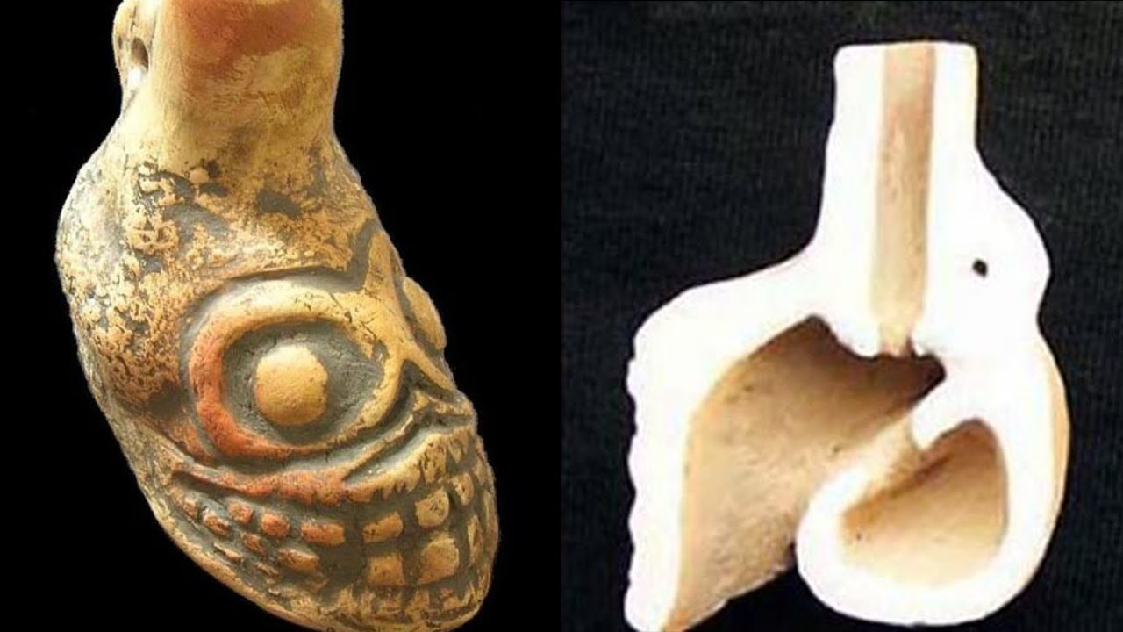
In the process of selecting the case setting for the Aztec Death Whistles, the first thing that has to be done is to make sure that the intended audience would notice it without difficulty. To achieve this goal, I need to consider the lighting, space, and the display format. The site selection should allow the audience to view the object freely, read its description, and to learn about it without the worry of breaking it (Micunovic, 2022). Therefore, when placing the artifact, the exhibition should use a small spire-like table and glass casing format, where the whistle sits on the table, encased in a small glass dome for protection and security. The table will rise about three feet from the ground so everyone can see it without difficulty. The transparent glass dome will allow the audience to view the object from all angles without damaging it. The resting position of the whistle should be on its base which will allow the audience to see its detailed structure which includes its eyes, mouth, and the skull-like carving, without bending or straining their muscles (Johnsen, 2022). Allowing the audience to see the full details of the artwork will help them appreciate the Aztec’s cultural and artistic characteristics.

The quality of the lighting will also be a vital aspect when displaying the whistle in my exhibition. Sufficient lighting will allow the audience to read the artifact’s description in order understand its historical, cultural, and aesthetic features. In this exhibit, the lighting will emanate from below in a way that illuminates the artwork and the accompanying description beside it, without affecting the eyesight of the viewers (Ranfagni, 2022). I would have a light directly under the whistle in the glass dome, which should make it almost ‘glow’ due to its hollow structure. This lighting will also help to capture the attention of the audience walking through the museum. Contextually, the goal of displaying the artwork is to allow the audience to gain a deeper understanding of the Aztecs abilities to impact their enemies psychologically. Some of the socio-cultural attributes of the Aztecs are evident in modern times. The exhibition is designed to be appropriate for an audience of all different sexes and nationalities, and most age groups. Age sensitivity is something that should be considered by parents before exposing their children to this display, and cultural awareness is a clear attribute this exhibit considers. The implication of the wide target audience is that the display format will avoid sensitive language that could have a negative impact on the perspectives of the audience. The exhibition also avoids culture sensitive terms and language that could develop feelings of stereotyping and prejudice among the audience.

While the table will be closer to the center of the room, the nearest wall will have a large picture with a general description of what the object is. Artwork of the Aztecs using it would also be appropriate. Of course, the exhibit would be most suitable among other Aztec artifacts, and should be one piece of many to teach audiences about their culture. The display will not just have conventional methods of arranging and displaying information, I would also use technology where the audience can interactively access information about the sculpture using a touch screen (Jezowska, 2022). Using the interactive screen, the audience can read more information about the uses of the Death Whistles by the Aztecs, how they are made, cultural importance, and other things. Through the touch screen, the audience can play the noise made by the whistle loud enough for everyone near it to hear. I would not allow audiences to blow air into the whistle as over time it could become damaged.

Overall, I think I created a suitable attraction for a museum for an object that is very interesting and would draw eyes and ears towards it. The description is suitable to give the audience a good general insight into what the whistles are. The information provided regarding the art should impart significant socio-cultural knowledge in the audience (Kamba, 2022). After vising the exhibition, the audience should have a better understanding of the cultural traditions of the Aztecs.

References
Jezowska, K., 2022. Socialist, Humanist and Well-Designed: The Polish Welfare State at the International Labour Exhibition in Turin, 1961. Contemporary European History, pp.1-19.
Johnsen, U.H., Otto, T. and Warner, C.D., 2022. ‘Museum of Impermanence’: the making of an exhibition. Impermanence, p.305.
Kamba, N., 2022. Significance of Conservation of Cultural Heritages in Museums. In Conservation Practices in Museums (pp. 1-20). Springer, Tokyo.
Micunovic, M., Faivre, S. and Gašparović, M., 2022. Accuracy of remote sensing techniques in beach geomorphological surveys: a case study of Hvar island, Croatia (No. EGU22-533). Copernicus Meetings.
Ranfagni, T., 2022. Curating the exhibition ‘Beyond Development: Local Visions of Global Poverty’. Some observations on documentary practice in relation to Poverty and its representation. Journal ISSN, 1467, p.0437.

