

Student Name: Armin Farukbhai Bhohariya

Student ID: 2327511

Module Name: Marketing Management

Module Code: LCMB7024

Lecturer’s Name: Dr Laila Maazouz

Work Count: 2565

Term 1

Table of Contents

Introduction 4
Brand Extension 5
STP for the New Brand Extension 7
Segmentation 7
Targeting 9
Positioning 9
Customer Personal Profile 11
Customer Persona 1: Demographic Profile 11
Customer Persona 2: Psychographic Profile 12
Marketing Mix Strategy 13
Conclusion 16
Reference 17

Introduction
American multinational corporation in the sportswear and athletic industry known globally as Nike Inc. Blue Ribbon Sports was founded in 1964; Nike was officially declared in 1971; the company has been growing since then, and it is steadfastly becoming the biggest, most influential brand in the world (Bartleby.com, 2024). The Company is engaged in the design, development, manufacture and worldwide marketing and sale of footwear, apparel, equipment, and accessories for men, women and children. Among its signature products, the Air Jordan, Air Max, and Dri-FIT technology have revolutionised the sportswear market by blending innovation, comfort and performance.
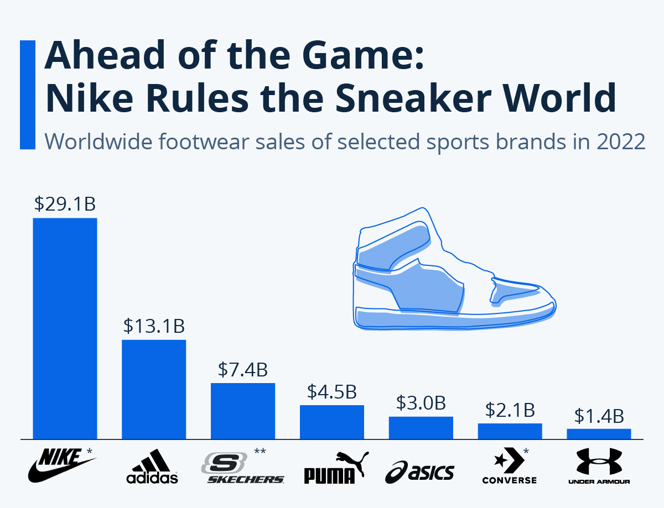
Figure 1: Ahead of the Game: Nike Rules the Sneaker World
(Source: Statista, 2024)
According to Statista (2024), the 2025 US$56.07 million market size of the sneakers market in Jordan will grow at a 6.59% annual rate. Besides its products, Nike is further recognised through its characterised brand identity; the iconic ‘swoosh’ logo and the world-renowned phrase ‘Just Do It’ denote motivation, empowerment and achievement (Renkex Digital Marketing Agency, 2025).

Through targeting professional athletes and everyday consumers on the advocacy of fitness and an active lifestyle, Nike has built a strong global presence. The brand is fully engaged in digital transformation through programs such as the Nike Training Club and the Nike Run Club by providing personalised content and training plans for customers.

This report seeks to develop a strategic brand extension for the Nike brand that circumscribes the ethos inherent in the brand while tapping into up-and-coming consumer needs. The report will seek to deliver wellness services under the Nike brand, conduct segmentation, targeting and positioning/classification (STP), develop a detailed customer persona, and create a marketing mix strategy. This portfolio will demonstrate that Nike is committed to continuing to innovate and maintain its competitive advantage by employing the appropriate brand extension strategy and customer-focused marketing strategy.

Brand Extension
Nike Wellness: Expanding into Holistic Health and Lifestyle
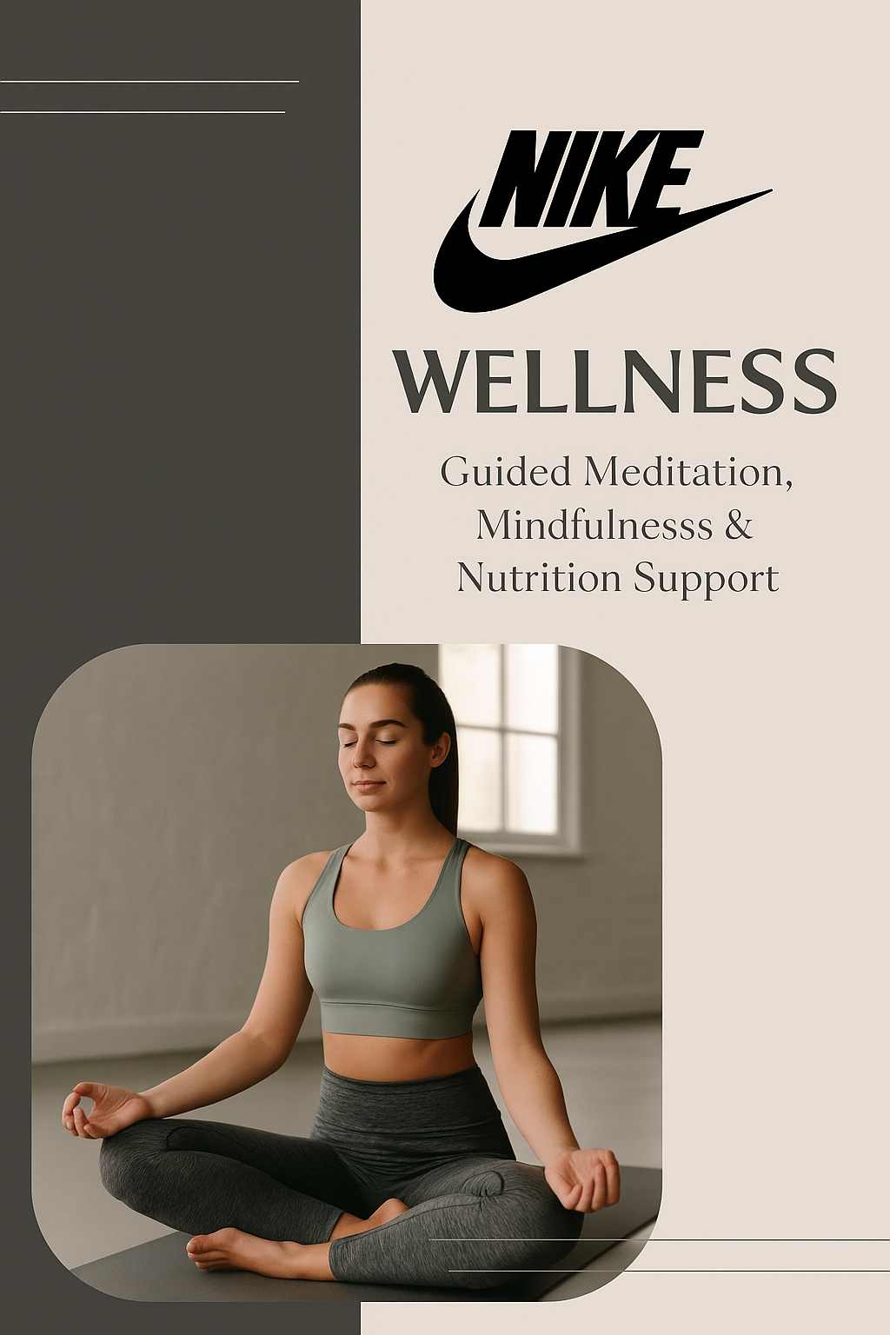
Figure 2: Nike Wellness service Logo
(Source: Self-made)
A brand extension proposed by Nike Wellness expands Nike’s reach beyond athletic apparel and footwear into the users and lifestyle space. Wellness-focused products would be included in this new line, including nutritional supplements, mindfulness and meditation apps, sleep aids, and recovery tools like massage devices and aromatherapy kits (Nike, 2023).
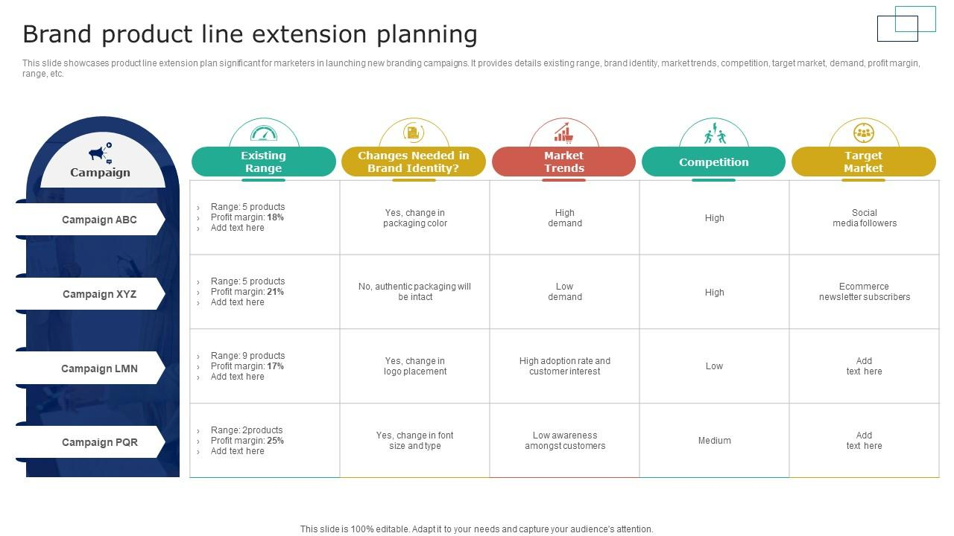
Figure 3: Nike Brand Extension Brand Product Line
(Source: Nike, 2023)
The idea is to assist the consumers with performance, recovery, as well as their mental well-being and overall lifestyle balance. All this extension is under the close bite of Nike’s core brand values of innovation, performance and inspiring people to achieve their personal best.
Aligning with Market Position and Adding Strategic Value
Nike Wellness takes an approach built on paying attention to physical performance and athletic inspiration (Nike, 2023). It adds to that by addressing the interest for all-around well-being from a consumer. It works for the athletes as well as for the ordinary man to maintain a healthy and balanced lifestyle away from the field, which in turn enriches their in-field performance. However, Kopp (2021) identified that the brand extension serves as a brand extension, with Nike having a worldwide reputation as a market leader in sportswear and fitness. Nike has a strong reputation for quality and innovation, which will give it good credibility in gaining consumers' trust in the wellness sector. The extension fits right into a booming wellness industry that has seen a surge of interest in mental health, recovery, and preventative care that has only intensified in an increasingly post-pandemic world. Nike Wellness contributes to Nike’s image by reinforcing the brand as a forward-thinking and health-conscious company (Yanthan, 2024). In recovery and mental well-being products, Nike has usually neglected those critical elements, but it fills a noticeable gap. It also satisfies the requirements of a modern consumer who is looking for a more holistic and integrated health solution. Nike Wellness brings together physical activity, mindfulness and recovery in a unified lifestyle that is seamless and elevated (Nike, 2023). As a result, Nike Wellness does not just extend the product portfolio but also deepens the brand’s emotional bonding with consumers and makes Nike not merely a sportswear provider but a full-fledged partner for personal well-being.

STP for the New Brand Extension
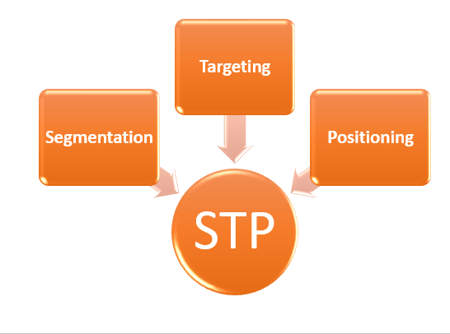
Figure 4: STP
(Source: Self-Made)

Segmentation
To effectively launch the Nike Wellness brand extension, segmentation is key. The market is divided based on demographic, geographic, psychographic, and behavioural factors:
- Demographic Segmentation: The intended audiences for Nike Wellness are adults aged 18 to 45, and both men and women of mid to high income. The population is young and very engaged in fitness, wellness, and self-improvement trends. This segment is filled with many in it, who are students, young professionals, or athletes, and who already invest in health and fitness-related products and services (Zhavoronkova, 2021).
- Geographic Segmentation: At the initial stage, however, the focus will be on the urban areas in North America, Europe and parts of Asia where apps for wellness and digital fitness platforms are most popular.
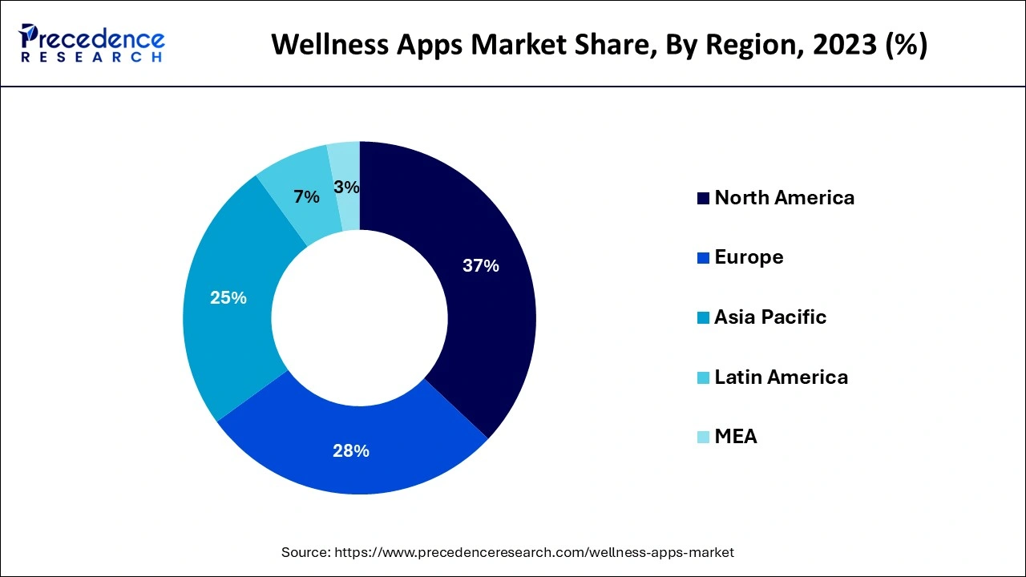
Figure 5: Wellness Apps Market Size to Hit USD 45.65 Billion By 2034
(Source: Precedence Research, 2024)
They are both highly penetrated with smartphones and are developing cultures around digital health and self-care.
- Psychographic Segmentation: As the key audience for the platform will be health-conscious, active lifestyles types, who believe mental clarity, emotional resilience to be important, and performance optimised, the platform will cater to both beginner and intermediate levels of fitness (Mańkowski and Sitek, 2022). They are the kind of customers who like balance, self-improvement and self-care trends.
- Behavioural Segmentation: Fitness apps are their go-to, and they also use fitness apps to track their health metrics and actively search for content that aids in all aspects of physical and mental wellness. They support brands that incorporate their values and give them a personalised experience. The aspirational and forward-thinking brand suited many already Nike customers (Gherra, 2024).
Since these segmentation bases match with Nike’s current brand identity and existing customer base and offer new potential to the rapidly growing digital wellness market, these bases are appropriate to these segmentation bases.

Targeting
Nike Wellness will adopt a differentiated targeting strategy, focusing on two key segments:
- Active Millennials and Gen Z (18–34 years): They are digitally savvy, they are fitness culture inclined and are more open to mental wellness tools. Their lives are lived through their brands and also lead them to be loyal to such brands when they manifest a lifestyle or a purpose (Milillo, 2024).
- Young Professionals and Amateur Athletes (25–45 years): Working individuals who appreciate productivity, performance and mental clarity are included in this segment (Russell, Punch, and McIntosh, 2022). About stress and time constraints, many are likely to adopt wellness tools that are integrated with their existing fitness routines.
Since they already have a strong relationship with Nike’s core offerings, this is a segment of people who will trust the brand more to assist with their total wellness journey.

Positioning
Nike Wellness will be positioned as an elite, performance-driven wellness platform that helps individuals unlock their full potential—mentally, physically, and emotionally.
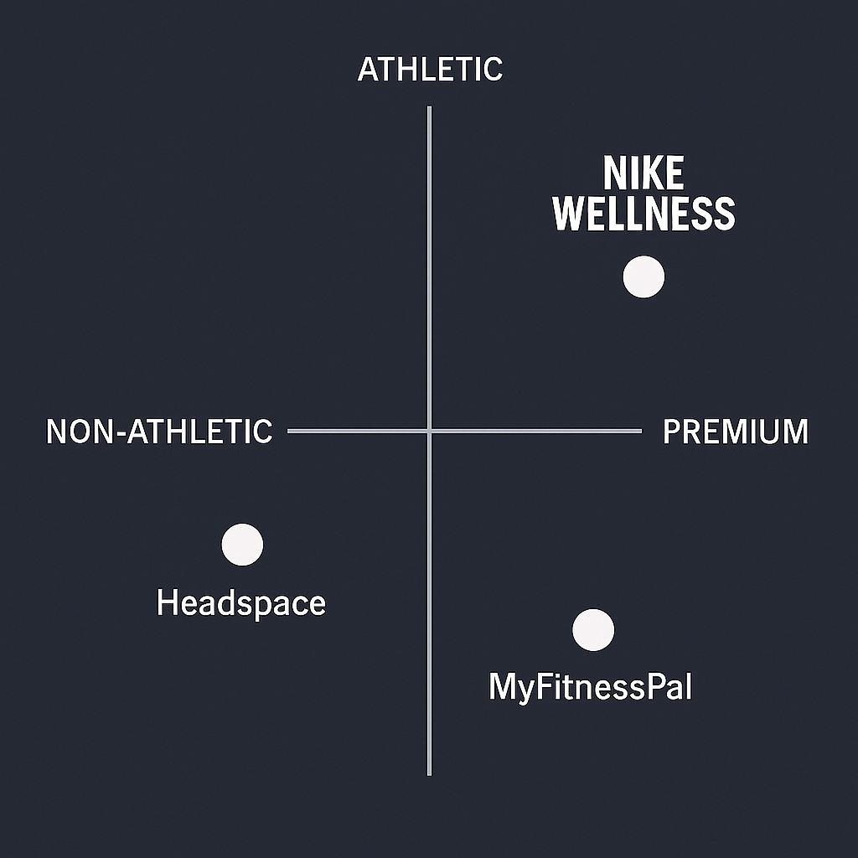
Figure 6: Nike Brand positioning
(Source: Self-Made)
Positioning Statement:
“For fitness-driven individuals seeking holistic wellbeing, Nike Wellness is a premium digital platform that integrates mindfulness, nutrition, and recovery with athletic performance—delivering personalised tools to elevate both mind and body. Unlike generic wellness apps, Nike Wellness combines the trusted power of Nike’s performance culture with science-backed wellness practices.”
On the other hand, Headspace and MyFitnessPal, Nike Wellness can differentiate in that they bring the credibility that comes with being athletic, the well-established brand loyalty and the performance and wellness focus to one integrated experience (Sax, 2021). The extension can be differentiated and offer enhanced value to Nike’s customer base by leveraging the existing Nike fitness ecosystem and inspirational brand identity.

Customer Personal Profile

Customer Persona 1: Demographic Profile
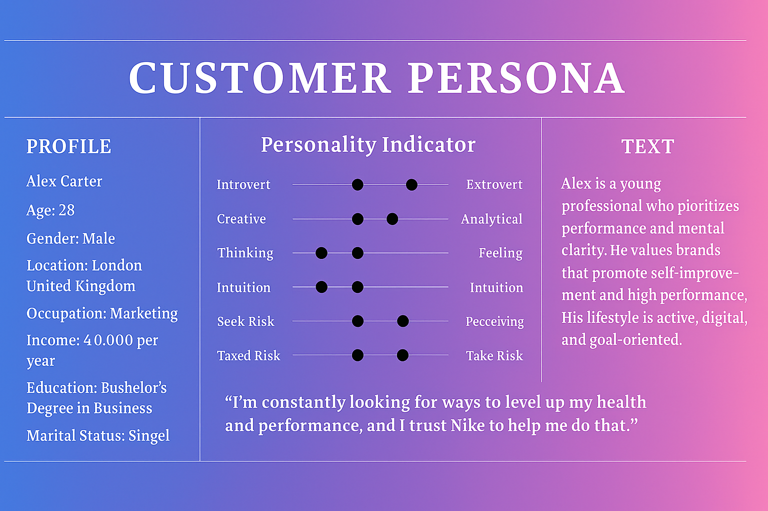
Figure 7: Customer persona of Alex, boxed on Demographic
(Source: Self-made)
Demographic Overview:
Alex is quite a typical Nike Wellness user in the young urban professional segment. He’s 28, but at a time in a man’s life where they’re at their healthiest, their performance is at its highest, and they’re usually getting promotions. Alex is earning a moderate income and has discretionary spending power for premium subscriptions as well as wellness tools. He has a full-time job with a Bachelor’s degree in a competitive corporate setting and knows what it means to be mentally clear, physically enduring, and influential. Having a metropolitan city at his feet in terms of gyms, running trails and digital services, he is an active person. Having tech-savvy features, he normally connects with fitness wearables, apps, and streaming content, thus perfect to be used by Nike’s integrated wellness platform. Since Alex is already a customer of Nike products such as shoes and apparel, he too is likely to be loyal to Nike Wellness, continuing his relationship with the brand as a whole solution provider and investing in his overall wellbeing as a service.

Customer Persona 2: Psychographic Profile
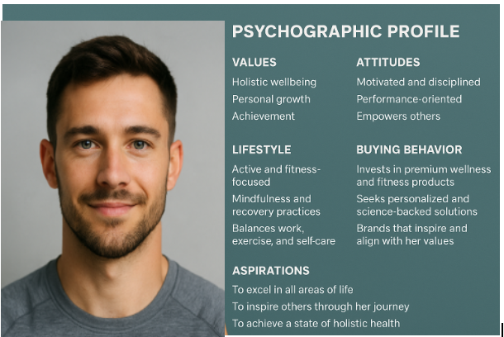
Figure 8: Customer persona of Alex, boxed on Psychographics
(Source: Self-made)
Psychographic Overview:
Alex is driven by a desire to optimise his lifestyle—balancing work, fitness, and mental wellbeing. Brands that propel performance and authenticity are what he values. He has an approach that is constantly inclined towards self-improvement and is always looking for new ways to stay healthy and focused. Alex is a driven person and tracks progress through wearables and wellness metrics. Especially those recommended by performance experts, he likes experimenting with new routines such as mindfulness or guided sleep exercises. Alex reacts emotionally to brands which empower him, allowing him to reflect his lifestyle in a way he admires. He’s receptive to Nike Wellness’s curated services because he likes premium services that provide value and are personalised. He consumes fitness influencers, subscribes to meditation playlists and pays for app-based services. Tying performance and wellness together into one seamless experience easily aligns with Alex’s ambition to remain on top in terms of both physical game and mental resilience, as Nike can provide.

Marketing Mix Strategy
As the world’s leading global brand of athletic footwear, apparel and equipment, Nike is essentially a product business. However, it still utilises tangible and intangible aspects in its marketing strategy that will increase consumer experience and brand loyalty. The 7Ps—Product, Price, Place, People, Process, Promotion and Physical Evidence—provide a full wrap of what Nike’s marketing strategy consists of and how they are capable of changing according to the environment.
Product: High-quality athletic footwear, performance apparel, and sports equipment are Nike’s core offerings. The company is famous for innovation, product design and performance enhancement. Being an innovative company, Nike constantly updates its product lines utilising the latest technologies such as Flyknit, Nike Air and Dri-FIT materials by the ever-changing requirements of athletes as well as everyday consumers (Nike, 2023). The products will come with an extra focus not only on functionality but also on style and how the user wants to express themselves.
Price: As a brand with a premium image and product quality, Nike uses value-based pricing. This examines the fact that it will priced at the top end of the market, but it is justified by its performance-enhancing features, cutting-edge design, and a strong emotional connection with consumers.
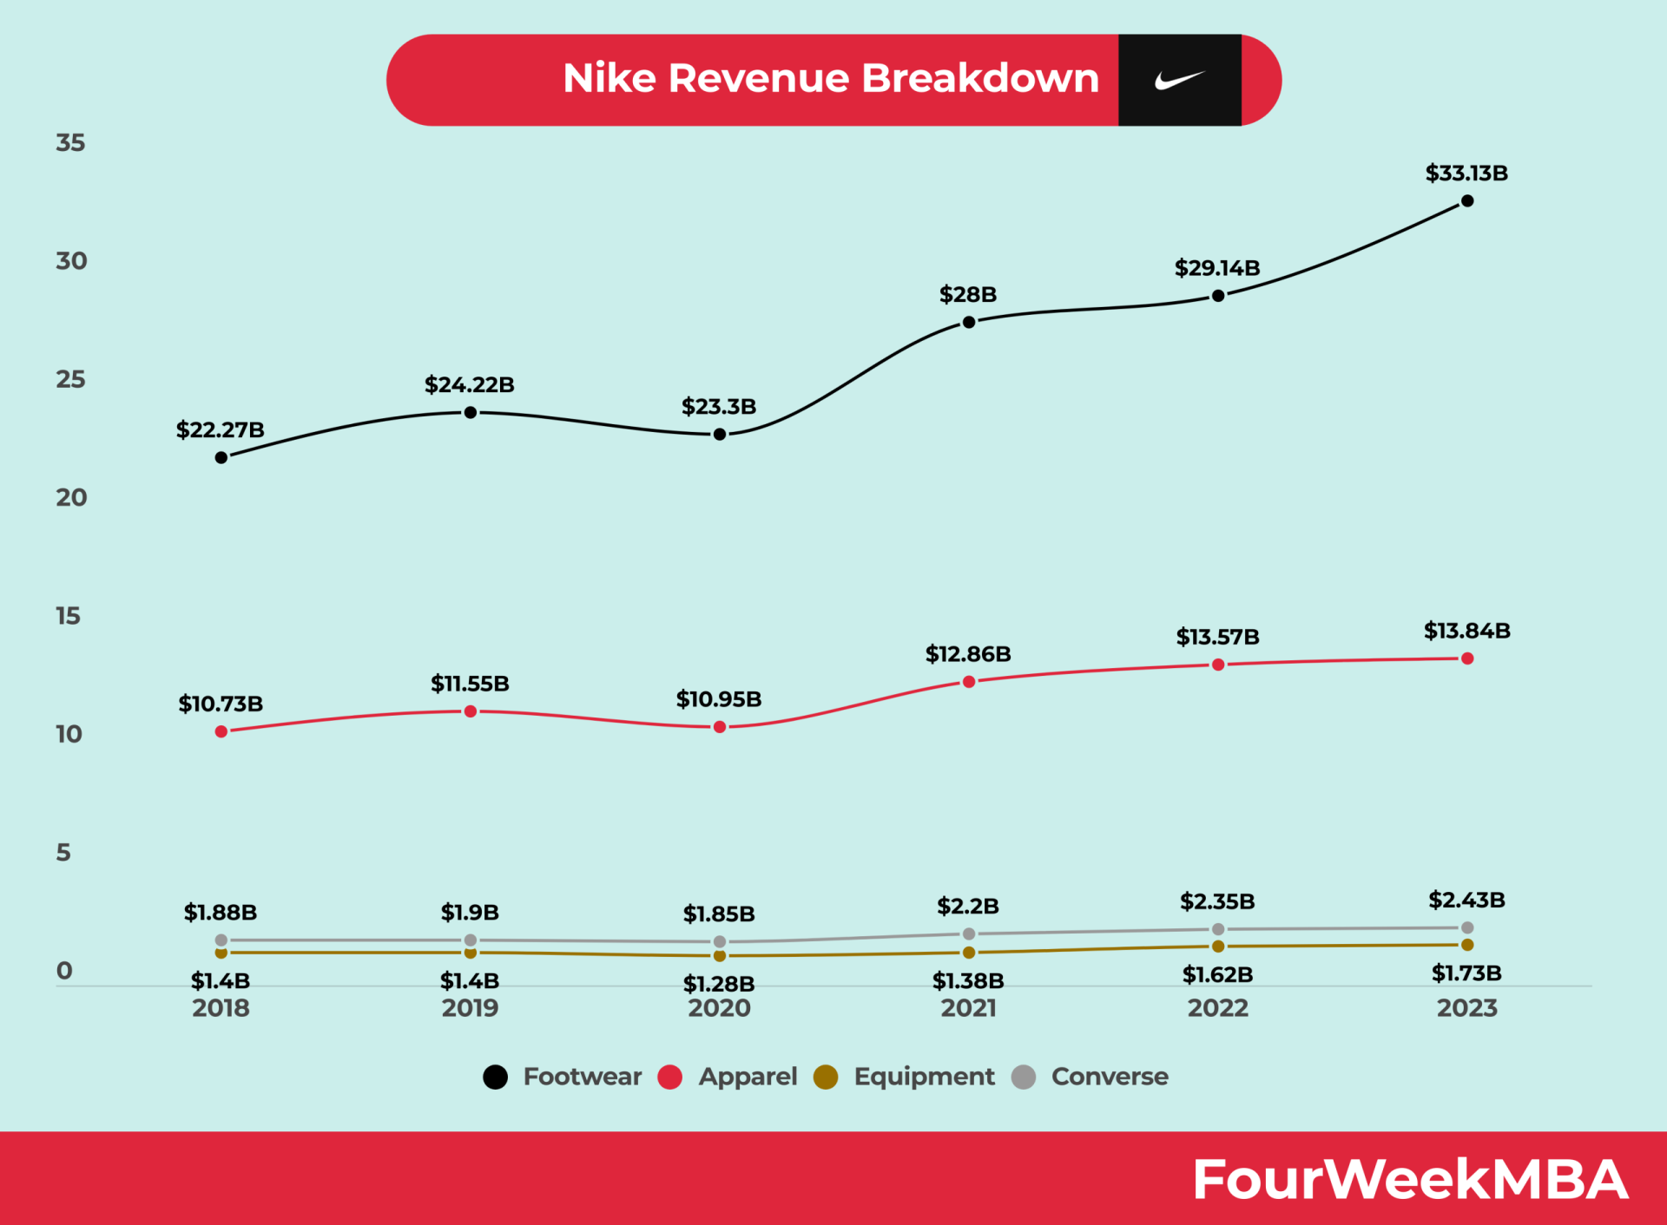
Figure 9: Nike’s pricing strategy
(Source: Cuofano, 2023)
On the product line, Lau (2025) identified that Nike also uses tiered pricing, offering premium collections like NikeLab or signature athlete shoes alongside more affordable alternatives to target different segments of customers. Loyalty programs, will exclusive member deals, and seasonal discounts provide further support to the brand’s ability to price flexibly without disrupting its premium positioning.
Place: Nike’s global distribution strategy is extensive as well as strategic. There are direct-to-consumer (DTC) channels, including Nike-owned retail stores, Nike.com, mobile apps, as well as third-party retailers, including sporting goods stores and e-commerce platforms (Nike, 2025). Nike will encourage more focus on the DTC channels for improving customer experience, gathering data and keeping hold of branding and pricing as its own. The brand will also change its place strategy to match local markets and make its products available to and keep them relevant in each area.
Promotion: The basis of Nike’s promotional strategy is strong emotional storytelling, inspirational messaging, and world-class endorsements. It has a very strong brand identity and uses its iconic 'Just Do It' slogan in its campaigns (Nike, 2024).
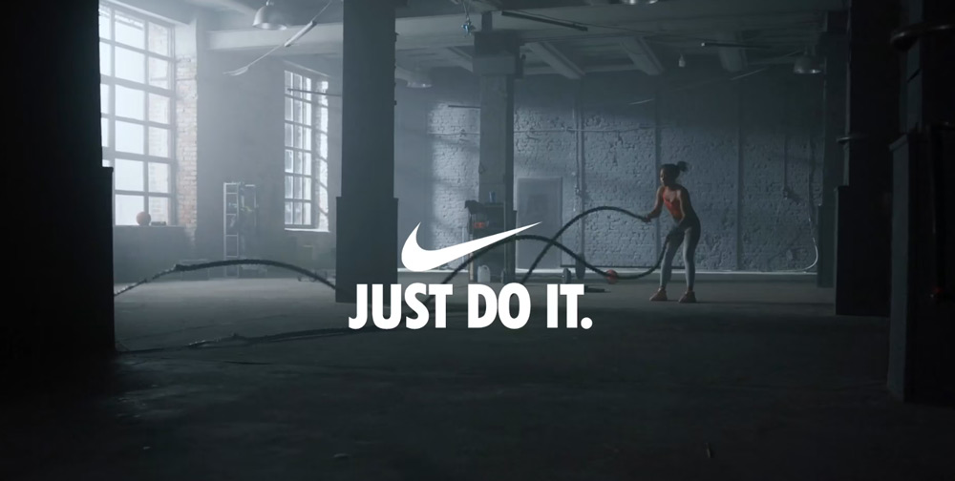
Figure 10: Nike’s Campaign
(Source: Nike, 2024)
Nike collaborates with top athletes like LeBron James, Serena Williams and Cristiano Ronaldo to reach out to the audience and promote authenticity. Younger consumers will be engaged through digital marketing, especially through social media platforms. Also, Nike will spend a lot on content marketing, influencer marketing collaborations, and other experiential marketing events that build brand loyalty and foster the community.
People: For Nike, people are the face of the brand, so it cares deeply about them, the employees, athletes, designers, and consumers. Staff are initially trained to embody the Culture of Hosting Nike’s culture of innovating, inclusion and motivation (Vijayan, 2024). The help in creating credibility and attracting aspirational buyers will be the brand's association with top athletes. Nike internalises a culture of diversity and leadership development, creating a positive work environment out of it. Externally, it works to serve strong customer relationships with custom offers such as Nike Membership’s personalised content, early access to products, and exclusive fitness resources.
Process: As part of Nike’s processes, efficiency, innovation, and customer satisfaction are the goals. It will use advanced technologies and practices when it comes to product development as well as delivery. It will be agile and responsive to the market trends and demand shifts, and it can quickly adapt to the market trends and to fast changes in demand. In retail, Nike blends mobile apps, online platforms and in-store features such as click-and-collect, digital fitting tools to create seamless shopping experiences (Gupta et al. 2024).
Physical Evidence: Nike is a product-based brand; it has been providing its customers with some physical evidence, such as its tangible goods, packaging, store design and branding elements. All products will be known by the legendary Nike Swoosh, a symbol of quality, performance and style. Slightly different from the rest of the big three brands, Nike’s stores will take an innovative approach to design, hanging modern architecture (Bethune, 2022). Moreover, the digital bridges through the Nike app and website support the overall experience of the brand will be a user-friendly, intuitive design and navigation.
Overall, the 7Ps marketing mix is applied by Nike based on a well-integrated and consumer-focused strategy.

Conclusion
Originally founded as Blue Ribbon Sports and formally rebranded in 1971, Nike Inc. is now a global powerhouse in the sportswear and athletic business. While its emphasis is on the design, development and marketing of footwear, apparel and equipment, Nike has not merely collaborated to transform Nike’s share in the sportswear market through the release of iconic products, like Air Jordan, Air Max, and Dri-Fit, but its strong brand identity — the swoosh logo and the motivational slogan ‘Just Do It’. With the market continually moving towards holistic wellness, Nike’s strategic brand extension into Nike Wellness stands to meet a growing consumer need and the company’s roots of innovation and performance. Nike uses a well-defined STP strategy and an integrated marketing mix to ensure that it continues to be a trusted partner in the development of personal and athletic capabilities.

Reference
Bartleby.com. (2024). History Of Nike Inc. Company. Available at: https://www.bartleby.com/essay/History-Of-Nike-Inc-Company-FK8ZRCDQ3FTD5 (Accessed: 18 April 2025)
Bethune, K.G., (2022). ‘Reimagining design: Unlocking strategic innovation’. MIT Press. Available at: https://books.google.com/books?hl=en&lr=&id=mLZNEAAAQBAJ&oi=fnd&pg=PR9&dq=Slightly+different+from+the+rest+of+the+big+three+brands,+Nike%E2%80%99s+stores+take+an+innovative+approach+to+design,+hanging+modern+architectures+&ots=cxyUnOjQGw&sig=D4xiw0wIVksm0WcJoBnzt-xMT1c (Accessed: 18 April 2025)
Cuofano, G. (2023). Nike Pricing Strategy. [online] FourWeekMBA. Available at: https://fourweekmba.com/nike-pricing-strategy/. (Accessed: 18 April 2025)
Gherra, E. (2024). Market analysis and customer segmentation for a well-being app (Doctoral dissertation, Politecnico di Torino). https://webthesis.biblio.polito.it/34175/ (Accessed: 18 April 2025)
Gupta, U., Somani, P., Behare, N., Mahajan, R., Singh, M. and Iyer, C.V., (2024). ‘Revolutionizing Retail: IoT Applications for Enhanced Customer Experience’. In Internet of Things Applications and Technology (pp. 60-80). Auerbach Publications. Available at: https://www.taylorfrancis.com/chapters/edit/10.1201/9781003458401-5/revolutionizing-retail-ushmita-gupta-pritesh-somani-nitesh-behare-rashmi-mahajan-meenakshi-singh-vishwanathan-iyer (Accessed: 18 April 2025)
Kopp, C. (2021). Understanding Brand Extension. [online] Investopedia. Available at: https://www.investopedia.com/terms/b/brand-extension.asp.
Lau, S. (2025). Nike’s Pricing Strategy: The Secret Behind Their Premium Brand Positioning - NewswireJet. [online] NewswireJet. Available at: https://newswirejet.com/nike-pricing-strategy/. (Accessed: 18 April 2025)
Mańkowski, D. and Sitek, M. (2022). ‘To be fi t, or how the media promote a healthy lifestyle. Analysis of selected magazines.’ Studies in Sport Humanities, 31, pp.29-35. https://sporthumanities.pl/seo/article/01.3001.0016.2820/en?language=pl (Accessed: 18 April 2025)
Milillo, J. (2024). Wellness Awakening: Gen Z as the Catalyst for a Well-Being Revolution. Available at: https://digitalcommons.liberty.edu/masters/1202/ (Accessed: 18 April 2025)
Nike (2023a). Nike Well Collective. Wellness & holistic fitness. [online] Nike.com. Available at: https://www.nike.com/in/nikewellcollective (Accessed: 18 April 2025)
Nike (2023b). Nike Brand Extension Brand Product Line Extension Planning. [online] Slideteam.net. Available at: https://www.slideteam.net/nike-brand-extension-brand-product-line-extension-planning.html (Accessed: 18 April 2025)
Nike (2023c). Sustainable Materials. [online] Nike.com. Available at: https://www.nike.com/in/sustainability/materials. (Accessed: 18 April 2025)
Nike (2024). Nike Marketing Strategy: The ‘Just Do It’ Campaign. [online] Krows Digital. Available at: https://krows-digital.com/nikes-just-do-it-campaign-a-masterclass-in-marketing-excellence/. (Accessed: 18 April 2025)
Nike (2025). Commerce Archives. [online] fabric Inc. Available at: https://fabric.inc/commerce. (Accessed: 18 April 2025)
Precedence Research. (2024). Wellness Apps Market Size to Hit USD 45.65 Billion By 2034. Available at: https://www.precedenceresearch.com/wellness-apps-market (Accessed: 18 April 2025)
Renkex Digital Marketing Agency. (2025). Comprehensive SWOT Analysis of Nike. Available at: Available at: https://rankexdigital.com/swot-analysis-of-nike/#:~:text=Known%20for%20its%20iconic%20%E2%80%9CJust%20Do%20It%E2%80%9D,current%20position%20and%20strategizing%20for%20future%20growth. (Accessed: 18 April 2025)
Russell, Z., Punch, S. and McIntosh, I. (2022). ‘Blurring the boundaries between leisure and work: Professionals as devotees in the mind-sport bridge.’ International Journal of the Sociology of Leisure, pp.1-20. Available at: https://link.springer.com/article/10.1007/s41978-021-00099-y (Accessed: 18 April 2025)
Sax, M. (2021). ‘Optimization of what? For-profit health apps as manipulative digital environments’. Ethics and Information Technology, 23(3), pp.345-361. Available at: https://link.springer.com/article/10.1007/s10676-020-09576-6 (Accessed: 18 April 2025)
Statista (2024). Sneakers – Jordan. Available at: https://www.statista.com/outlook/cmo/footwear/sneakers/jordan (Accessed: 18 April 2025)
Vijayan, P., (2024). ‘TRAINING EFFECTS ON EMPLOYEE PERFOMANCE-A STUDY AMONG RETAIL SALES EXECUTIVES AT DECATHLON TRIVANDRUM BRANCH’. Available at: http://115.242.226.198:8080/jspui/handle/123456789/1120 (Accessed: 18 April 2025)
Yanthan, N. (2024). Nike Marketing Strategy - 7 Best Findings from Case Studies. [online] Sprintzeal.com. Available at: https://www.sprintzeal.com/nike-marketing-strategy. (Accessed: 18 April 2025)
Zhavoronkova, A. (2021). ‘Sport marketing and its social implications. realize nike social media marketing strategy using in-depth analysis on four social media platforms.’ Available at: https://is.vsfs.cz/th/ef1qx/Zhavoronkova_Anna_35543_Sport_marketing_and_its_social_media_implications.pdf (Accessed: 18 April 2025)

