LCBB6004

Strategic Management & Sustainability

UWTSD

Assessment 1
MARKS &SPENCER – STRATEGIC REVIEW OF THE COMPANY’S CORPORATE AND BUSINESS STRATEGIES
Student: Ralitsa Yordanova
Student ID:2023562
Lecture: Dr. Hossein Shokri
Submission date: 20/12/2023

Table of Contents
INTRODUCTION 3
Company background: 3
Identifying Key Business and Corporate Strategies 4
Applying the Ansoff Matrix to Illustrate Strategy Directions: 5
Analysing Resources and Capabilities (Alignment with Strategy) 6
Use Value Chain and Value System Analysis: 6
Apply VRIO Analysis to Determine Sustainable Competitive Advantages: 7
Utilize the Suitability, Acceptance, and Feasibility (SAF) Framework 9
Examine Sustainability Efforts through Annual Reports, Policies, and Actions: 10
Analyse Alignment of Sustainability Goals with Corporate Strategy: 11
Conclusion 12
Reference list 13

Table of Figures
Figure 1 Ansoff Matrix 5
Table 1 M&S VRIO FRAMEWORK 7
Figure 2 Plan A 12

INTRODUCTION

The economy and markets are constantly evolving, as are the companies that make them up. Over time, many business models have, year after year, survived economic ups and downs and major entrepreneurial modes. And there comes the impact of the strategic review, as a tool that allows a company to position itself with the rest of the industry, to better understand its positioning in the market, and to ensure that its brand strategy is coherent (M&S, 2023a).
Management with a focus on sustainability integrates traditional business practises with a concern for the company's impact on society and the environment (Barney and Hesterly, 2019). The well-known British retailer Marks & Spencer is the focus of this report. In its capacity as an advantageous planner, the paper investigates the company's business and corporate objectives in detail, going above simple identification to evaluate the corporation's position in the market and critically examine strategic decisions and their implementation (Whittington et al., 2020, pp.12–23)

Company background:
“Marks and Spencer” is amongst the leading global retailers of clothing, beauty products, home products, and food products. It is a British company founded in 1884, that was created by two entrepreneurs Michael Marks and Thomas Spencer, and it is listed as a Plc in London Stock Exchange (LSE), and in FTSE 100 Index “Marks and Spencer” is amongst the leading global retailers of clothing, beauty products, home products, and food products. It is a British company founded in 1884, that was created by two entrepreneurs Michael Marks and Thomas Spencer, and it is listed as a Plc in London Stock Exchange (LSE), and in FTSE 100 Index (M&S, 2023a). It has more than 1400 locations for its stores globally and more than 72,000 employees. The mission of the company is “… bringing quality, great value food, clothing, and homeware to millions of customers around the world… ‘’ (M&S, 2023a). “Marks and Spencer” is among the leading companies in the field of mass retail. It has business customers worldwide and this great expansion led to the sub-division of the corporation into regional units and country units for the European market, the Asian market, the African market, the North American, the South American, and the Australian market, so obviously it has a presence on all continents. Its headquarters are in London. The company has several brands, as follows: Per Una, Autograph, Good Move, Rosie, Blue Harbour, M&S Collection, Boutique, Jaeger, and M&S Energy (M&S, 2023a).

Identifying Key Business and Corporate Strategies

Marks & Spencer is well-known in the retail sector because of its innovative corporate strategy and successful business practises. The company's marketing approach, which is often the initial point of contact with customers, is focused on supplying high-quality products in the areas of home decor, clothing, and food (M&S, 2023a). At the same time, the corporate strategy that guides the company's overall direction places a premium on ethical sourcing, long-term viability, and concern for local and global communities and ecosystems (Allen and Helms, 2006).
The company is currently relying on a well-tailored differentiation strategy:
- A wide set of products that the company offers to its customers and businesses tailoring them to their specific needs. The products are great in terms of quality-to-price ratio.
- A good ratio in terms of location to store size ratio, so that the company can keep a great balance between its costs for keeping its stores and the opportunities for customers to find them, usually in central places of big cities.
- Unique and high-quality level of customer service at stores and online and great post-sales support, including money refund in thirty-five days.
Cost leadership is another strategy that M&S employs. By improving their supply chain and cutting down on wasteful practises, the company hopes to sell high-quality products at competitive prices. In a market where consumers are looking for both value and values, M&S's position as a competitor is bolstered by this dual approach that blends differentiation with cost leadership (Allen and Helms, 2006). The great price-to-quality ratio and the easy shopping process offered are the strongest competitive advantages of the company. However, especially in times of crisis, the price can be an issue in the deals of the company and rivals like H&M, IKEA or Walmart can often beat it with their generous discounts. So, a more balanced approach is to be recommended where the cost leadership strategy’s elements may mix with the current differentiation strategy (Lynch, 2018).

Applying the Ansoff Matrix to Illustrate Strategy Directions:
A good framework for comprehending the company's growth strategies is the Ansoff Matrix (Figure 1). Instead of trying to break into new markets, M&S is expanding its presence in existing ones by capitalising on the goodwill it has earned as a result of its commitment to high standards of quality and integrity in business practises (Lynch, 2018).
In response to shifting consumer tastes, the company prioritises developing environmentally friendly, technologically advanced products. The Ansoff Matrix also highlights how M&S diversified its offerings and entered new sectors to lessen risks associated with market saturation.

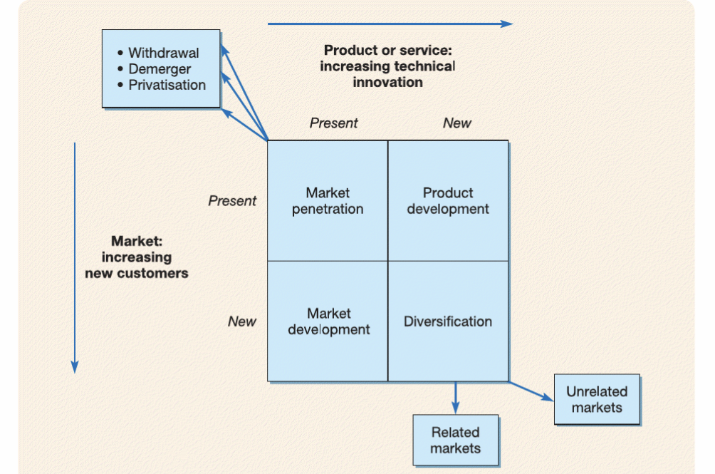
Figure 1 Ansoff Matrix
Source: (Lynch, 2018)

Analysing Resources and Capabilities (Alignment with Strategy)
Identification of Resources and Capabilities:
According to Lynch (2018) we can determine that organization's resources are its assets that provide value to the organisation. The managerial talents, practices, and leadership that distribute, share, and create value from an organization's resources are its capabilities.
Marks & Spencer has been able to achieve strategic success thanks in large part to its careful management of resources and development of distinctive competencies. The company's strengths lay in its well-established supply chain, ecosystem of suppliers that places a premium on ethical sourcing, renowned brand name, and dedicated team that places a premium on sustainability and quality. Some examples are paying close attention to what customers want, coming up with innovative solutions to problems, and streamlining processes (M&S, 2023a). The purpose of the company is to provide good everyday products such as clothes, food, and furniture to customers at affordable prices. The culture of “Marks and Spencer” is based on its culture value chain, defined as “… respecting and valuing each other's differences and helping each other to be the best version of ourselves...” (M&S, 2023a)
Marks & Spencer has prioritised resource effectiveness in its overall strategy. The corporation spends a lot of money on research and development, which fosters innovation in product and green initiative design. Putting money into the production chain guarantees efficient and timely product delivery, which increases happy customers (M&S, 2023a). The company's investment in its employees' growth through training and education is further evidence of its commitment to ethics and professionalism.

Use Value Chain and Value System Analysis:

A value chain is the set of operations which transform a product or service from raw materials to a finished goods that can be sold to a final consumer (Barney and Hesterly, 2019).
Marks & Spencer uses Value Chain and Value System analyses to explain how they create value for their customers and other stakeholders. The company's commitment to quality and sustainability is intertwined with its marketing, sales, and inbound logistics operations (Saeed and Kersten, 2019). Inbound logistics lays a greater emphasis on morally sound purchasing than does operations. Outbound logistics ensures timely delivery of exceptional goods while marketing and sales drive home the unique value proposition of ethical, high-quality products. Procurement and human resource management are two examples of support services that aid in bettering and strengthening the alignment of assets with strategic objectives.
M&S | V | R | I | O
Competitive disadvantage | No |  |  | No
Competitive  Parity | Yes | Yes | Yes | Yes
Sustainable competitive advantage | Yes | Yes | Yes | Yes

Apply VRIO Analysis to Determine Sustainable Competitive Advantages:

Table 1 M&S VRIO FRAMEWORK

The VRIO framework (Table 1) can be used to assess the potential of a company's assets and competencies to provide sustainable competitive advantages (Lynch, 2018).
- Value (V): A growing number of eco-conscious buyers recognise the great value in ethical product sourcing and a commitment to sustainability.
- Rarity (R): Due to its lengthy history and stable of ethical suppliers, the company enjoys a competitive advantage in the market.
- Imitability (I): An organization's resource must be costly to imitate, as competitors can exploit market profits to duplicate the rare resource over time.
- Organization (O): The company's organisational culture, which places a significant emphasis on quality and sustainability, is a distinguishing trait that contributes to the uniqueness and unmistakability of the company's assets and competencies.

Evaluating Strategy in Action
“Marks and Spencer” can be assessed as a very strong business player in the global food, clothing, beauty products, and furniture retail. It indeed has a great product range that can serve all target groups of mass customers, no matter their gender and age. At the same time, the company is revealed as a responsible business player who cares for the environment (Barney and Hesterly, 2019), and this is something that differentiates it strongly from its competitors: it makes a stunning commitment to through its road map to achieve net zero that spreads over all its business activities (M&S, 2023b).
Evaluating Sustainability Efforts
In terms of sustainability and environmental approach, “Marks and Spencer” reveals that they are a company that cares for the environment, and the main evidence for it is their Plan A initiative. The company made its road map on how to achieve net zero for its industrial waste and negative impact and in this road map ten priority areas are identified (M&S, 2023b):
- Zero deforestation – using 100 percent of its soy sourced from verified providers, whose farming does not rely on deforestation.
- Sustainable recycling – using 100 percent recycled polyester by 2025.
- Low-impact farming – supporting farmers to use less pesticides and to build a low-carbon farming.
- Increasing the range of plant-based protein – doubling the sales of vegetarian and vegan products by 2025.
- Suppliers and business partners to net zero journey – supporting its business partners and suppliers in the decarbonization of their businesses as well.
- Circular economy – mostly through recycling clothes schemes.
- Reducing food waste – 100 percent of edible food surplus to be redistributed up to 2026.
- Reducing and recycling package – 100 percent of its packaging to be recyclable up to 2026.
- Zero emissions property – efficiently using space, mostly in stores.
- Zero emissions transport – through cleaner fuels and low-carbon emissions of its fleet.
Evaluation of Success in Implementing Strategies:
Financial Success: Marks & Spencer found success in the marketplace by prioritising long-term viability, frugal operations, and product differentiation. Stable revenue growth, as seen by the company's financial records, implies that the company's strategies are resonating with its target market and meeting their evolving needs (M&S, 2023a). This is especially visible in the food industry, which has attracted a growing number of eco- and health-conscious customers with its emphasis on sustainability and quality craftsmanship.
Brand Perception:
Strategic choices have a positive impact on how people view the brand. Marks & Spencer has built a reputation among consumers as a company that prioritises social and environmental responsibility (M&S, 2023b). When businesses' actions are consistent with their stated morals, their customers become more loyal to them for reasons beyond the quality of their products.

Utilize the Suitability, Acceptance, and Feasibility (SAF) Framework

Suitability:
Suitability examines whether a plan addresses the fundamental concerns related to an organization's potential and limits (Whittington et al., 2020).
The chosen strategies were in line with both client needs and the company's standing in the industry. The company's longstanding commitment to quality complements the emphasis on differentiation and sustainability (Saeed and Kersten, 2019).
Acceptability:
Acceptability examines if a plan satisfies stakeholders' expectations (Whittington et al., 2020).
Companies that prioritise the well-being of their employees, as well as the environment and society at large, attract the support of socially conscious investors.
Feasibility:
Feasibility requires a clear consideration of whether a plan is feasible in practice. In each situation, evaluation tools and approaches are supplied, explained, and demonstrated (Whittington et al., 2020).
The fact that the company's methods were successful demonstrates that others like them are feasible. The company's supply chain, partnerships with ethical suppliers, and organisational structure are all indicators of the efficiency of the techniques taken. By consistently investing in green and cutting-edge projects, we show our commitment to these strategies' long-term viability.
Successful Execution:
Marks & Spencer's 2007 launch of Plan A, a comprehensive sustainable development strategy, is a notable achievement. As part of this effort, the company set lofty goals in the areas of social responsibility and environmental protection. Marks & Spencer has accomplished its aim of sending zero waste from its warehouses and stores to landfills, in addition to making significant progress in reducing carbon dioxide emissions (M&S, 2023b). This success in achieving sustainability goals demonstrates the efficacy of the methods used to achieve them.
Challenges Faced:
It hasn't always been smooth sailing for Marks & Spencer. The exciting challenge presented by the rapid digital transformation of the retail sector is the need for ongoing adaptation and capital investment in e-commerce capabilities. In addition, despite significant advancements, it has been difficult to achieve some sustainability goals, especially those pertaining to the supply chain, due to the challenges of obtaining ecologically friendly supplies and assuring moral behaviour across the board in the supply chain itself (Lynch, 2018).

Examine Sustainability Efforts through Annual Reports, Policies, and Actions:
According to the research (M&s, 2023a) we can determine that:
A thorough source of information regarding Marks and Spencer's sustainability activities is their annual reports. Both the triumphs and failures encountered on the way to achieving sustainability objectives are documented here. Regular sharing of waste management measures, responsible supplier data, and carbon footprint reduction targets shows a commitment to transparency and accountability.
Policies:
Environmentally friendly measures are further evidence of the company's dedication to ethical business practises (Barney and Hesterly, 2019). Ethical purchasing, waste prevention, and energy efficiency are all tenets of Marks and Spencer's operational framework. These regulations are crucial. These standards serve as a roadmap for decision-makers at all levels of the organisation to ensure environmental considerations are integral to daily operations.
Moves:
Marks & Spencer's actions are indicative of the company's dedication to environmental responsibility. From campaigns to reduce single-use plastics to the introduction of environmentally friendly product lines, the firm is heavily involved in initiatives that benefit society (M&S, 2023b). Associations with NGOs, participation in industry-wide environmental efforts, and community outreach programmes are all concrete examples of the company's desire to make a positive impact beyond its core business.

Analyse Alignment of Sustainability Goals with Corporate Strategy:

Marks & Spencer has demonstrated its commitment to sustainability by integrating environmental goals into the fabric of the company's core business.
Marks & Spencer's strategy of differentiating itself through its emphasis on sustainably and ethically sourced items is spot on (Viltard, 2017). A growing number of eco-conscious shoppers appreciate the company's assortment of high-quality ethical products.
Marks & Spencer's sustainability goals are consistent with their strategic priority of long-term profitability (Barney and Hesterly, 2019). By reducing its environmental effect, the corporation ensures its supplier base will last through times of resource constraint and global warming.
Enhancing Brand Image (Figure 2): The brand image of Marks and Spencer is improved when ecological aims are in accordance with its commercial plan. The company's environmental sustainability efforts fascinate its clients and stakeholders, solidifying its reputation as a socially and environmentally conscientious label (M&S, 2023b).

Conclusion
In conclusion, Marks and Spencer's strategic analysis demonstrates the company's dedication to a consistent strategy that integrates sustainability into its core business objectives. Strategic decisions that produce outstanding outcomes are those that are well-aligned with market and operational needs (Viltard, 2017). Strategic choices centred on differentiation, cost control, and environmental sustainability have helped the company achieve a niche in the retail industry. In light of shifting customer preferences, these selections highlight high-quality products, ethical sourcing, and innovative ecologically friendly processes (M&S, 2023b). Indicators of the company's success in implementing these strategies include its financial health, positive reputation, and substantial development in sustainability programmes, most notably the Plan A programme. Marks & Spencer's strategic consistency is a driving force behind the company's commercial success, allowing it to maintain rapid expansion and adapt quickly to shifts in the retail landscape. In briefly, the company's strategic curve demonstrates how profit, ethics, and sustainability can coexist. It also serves as a guide for staying competitive in the dynamic retail industry of today.

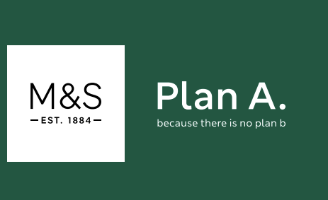
Figure 2 Plan A
Source: (M&S, 2023b)

Reference list
Allen, R.S. and Helms, M.M. (2006). Linking strategic practices and organizational performance to Porter’s generic strategies. Business Process Management Journal, 12(4), pp.433–454. doi:https://doi.org/10.1108/14637150610678069.
Barney, J.B. and Hesterly, W.S. (2019). Strategic management and competitive advantage : concepts and cases. 6 global edition ed. Harlow, England: Pearson.
Lynch, R. (2018). Strategic management. 8th ed. Harlow, United Kingdom ; New York: Pearson Education Limited.
M&S (2023a). 2023 Annual Report. [online] Marks & Spencer. Available at: https://corporate.marksandspencer.com/investors/our-performance-updates/2023-annual-report.
M&S (2023b). Plan A: Our Planet. [online] Plan A: Our Planet. Available at: https://corporate.marksandspencer.com/sustainability/plan-a-our-planet [Accessed 26 Nov. 2023].
Saeed, M. and Kersten, W. (2019). Drivers of Sustainable Supply Chain Management: Identification and Classification. Sustainability, [online] 11(4), p.1137. doi:https://doi.org/10.3390/su11041137.
Viltard, L.A. (2017). Strategic mistakes (AVOIDABLE) The topicality of Michel Porter’s generic strategies. Independent Journal of Management & Production, [online] 8(2), pp.474–497. doi:https://doi.org/10.14807/ijmp.v8i2.580.
Whittington, R., Regner, P., Angwin, D., Johnson, G. and Scholes, K. (2020). Exploring Strategy. 12th ed. Hoboken: Pearson.

