BMHP5023 INTRODUCTION TO PHYSIOLOGY
Student Name: Popy Akter
Student ID: 2408414

Component 1: Written Assignment (Case Study Report)
Table of Contents
Introduction 3
Definition of the condition 3
Key risk factors 3
Purpose of the report 3
Section 1: Anatomy and Physiology 3
Explanation of blood sugar regulation 3
Description of cell metabolism 4
Section 2: Pathophysiology and Impact 6
Consequences of blood sugar regulation failure 6
Lifestyle factors affecting glucose control 6
Section 3: Monitoring and Data Use 7
Importance of tracking health data 7
Routine data helps in managing the condition 7
Section 4: Evidence-based Lifestyle Recommendations 7
Suggestions for realistic lifestyle changes 7
Explanation of changes improving psychological outcomes 9
Conclusion 9
Summary of key findings 9
Reinforcing the significance of understanding and managing the condition 9
Reflection on the role of health professionals in patient education 10
References 11

Introduction

Definition of the condition
Diabetes is a condition that can be defined as a chronic metabolic illness with an increased blood sugar level (Randväli et al. 2024). It happens due to insufficient production of insulin by the pancreas or ineffective usage of insulin by the body. Insulin is a hormone and is important to allow glucose to penetrate cells to produce energy. Hence, without proper insulin usage or enough production, glucose tends to build up in the blood. It leads to serious health complications over time, such as damage to the blood vessels, heart, nerves, kidneys, and eyes (Ismail et al. 2021). In cases of high blood sugar, glucose stays in the bloodstream and cannot reach cells, leading to hyperglycemia.

Key risk factors
Weight and lifestyle: Overweight and obesity are the major risk factors of type 2 diabetes, as this is condition stores fat in the abdomen (Beulens et al. 2022). A stationary lifestyle, such as spending the majority of time sitting or engaging in insufficient physical activity, increases the risk.
Genetics and demographics: The chances of developing type 2, diabetes can increase if one has siblings or parents with this disease. The risk also increases with age, particularly for people aged 45 and above.
Medical history: Conditions, like prediabetes, gestational diabetes, and non-alcoholic fatty liver disease (NAFLD), and high blood pressure, can escalate the chances of developing type 2 diabetes (Randväli et al. 2024).

Purpose of the report
The report aims to explain the condition of blood sugar, its anatomy, psychological aspects, its impacts, consequences, and the importance of monitoring its level for human health.

Section 1: Anatomy and Physiology

Explanation of blood sugar regulation
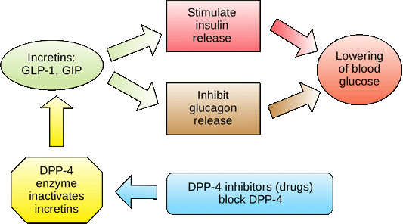
Figure 1: Regulation of blood glucose
(Source: Influenced by Gromova et al. 2021)
The glucose regulation cycle involves some stages that have been mentioned below. Glucose level is regulated through an effective feedback system that involves insulin, the pancreas, and glucose uptake.
After a meal: Carbohydrates decay into glucose, and they enter the bloodstream and increase the levels of blood sugar.
Insulin release: The rise of blood glucose is detected by the pancreas, and insulin is released (Gromova et al. 2021).
Glucose uptake: Insulin advances into cells and facilitates glucose uptake, which results in a drop in blood sugar levels.
Glucagon release: In cases where the blood sugar becomes too low, glucagon is released by the pancreas.
Glycogenolysis: The Liver is signalled through glucagon to break down the glycogen back into glucose (Campbell and Newgard, 2021). It is also instructed to release glycogen into the blood, which raises blood sugar.
Maintaining balance: This is a continuous process between glucagon and insulin, ensuring a healthy level of blood glucose. A steady energy supply can be ensured to be provided to cells in this way.

Description of cell metabolism
Glucose and oxygen are used by cellular metabolism as inputs that produce adenosine triphosphate (ATP). It can also be considered as a usable energy means, as well as water and carbon dioxide (Conte et al. 2021). Glycolysis, which breaks down glucose in the cytoplasm or the Krebs cycle, further oxidises the production of glycolysis in the mitochondria. Moreover, it creates an electron transport chain that occurs in the mitochondria and releases a significant amount of ATP. These are the three main stages of aerobic cellular respiration. Oxygen enables the release of stored energy of glucose in a controlled way to power cells’ activities (Karl et al. 2021).
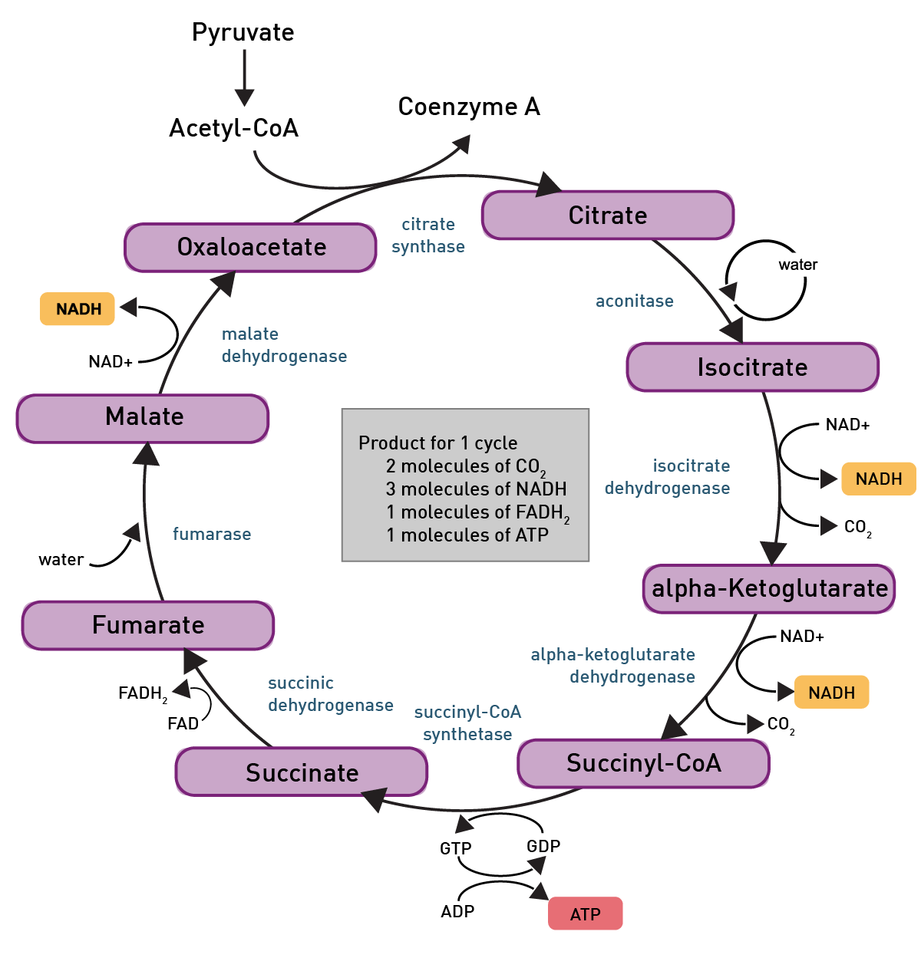
Figure 2: Cell metabolism with microplate readers
(Source: Influenced by Conte et al. 2021)
The three main processes of cell metabolism involve glycolysis, the Krebs cycle (TCA Cycle), and the electron transport chain. The overall goal of the metabolic pathway is to successfully convert the chemical energy present in glycogen into ATP (Conte et al. 2021). The principal energy currency of a cell is this process to ensure it can perform multiple functions. For instance, oxygen is necessary in the electron chain as the final acceptor of electrons to combine with protons and electrons forming water.

Section 2: Pathophysiology and Impact

Consequences of blood sugar regulation failure
Failure of blood sugar regulation can cause life-threatening complications, including kidney failure, heart disease, nerve damage, or vision loss. According to Numsang et al. (2023), there is a chance of developing Diabetic Ketoacidosis (DKA) in cases of blood sugar emergencies. It is mainly the result of untreated hyperglycemia that results in DKA, especially for patients with type 1 diabetes. For patients of type 2 diabetes, Hyperosmolar Hyperglycemic State (HHS) can occur, which a critical medical case is requiring immediate attention and proper care (Pabel et al. 2021). Besides, there is a probability of developing foot problems due to nerve damage, resulting in ulcers, serious infections, and severe cases.
On another note, in the cases of unregulated low blood sugar or hypoglycemia, severe symptoms are also seen. For instance, such a condition can cause shaking, sweating, or weakness among the patients (Beulens et al. 2022). It often increases hunger and causes dizziness, trouble concentrating, and confusion as prominent symptoms. In addition, seizures, severe neurological problems, and loss of consciousness are common symptoms in extreme low blood sugar level cases. In both high and low blood sugar conditions, long-term health problems can arise (Numsang et al. 2023). Such a health situation can damage nerves and blood vessels throughout the body, which highlights the necessity of managing sugar levels for type 2 diabetic patients.

Lifestyle factors affecting glucose control
Glucose control is profoundly impacted by lifestyle choices, such as a healthy diet, regular physical activities, weight management, and the like. Other key elements, such as alcohol consumption, adequate hydration, sleeping quality, and stress management, are other important areas of glucose control (Eckel et al. 2021).
Dietary choices: Having a balanced diet that is rich in protein, fibre, and healthy fats is essential to consume them from plant-based food. It is also important to consider consuming protein and even vegetables before carbohydrate (Chiavaroli et al. 2021). This step can assist in reducing spikes in blood sugar, and type 2 diabetes patients must avoid sugary drinks as well.
Physical activities: Regular exercise or physical activities of any type support muscles to utilise glucose for producing energy (Eckel et al. 2021). Insulin sensitivity in the body is increased by such activities, and also lowers the level of blood sugar. Besides, light activities, such as housework or walking, can help in minimising levels of blood sugar.
Weight management: Type 2 diabetic patients must manage their weight, which significantly minimises the risk of developing further issues. It helps in controlling sugar levels, and losing weight can reduce the probability of developing overall hyperglycemia.

Section 3: Monitoring and Data Use

Importance of tracking health data
Personal health data must be tracked, such as blood sugar, to manage or prevent particular medical conditions. Torres-Ronda et al. (2022) have shared that healthy health data can promote the overall well-being of a person. For instance, for chronic diabetes or type 2 diabetes, consistently monitoring indicates valuable insights to make informed choices regarding diet, lifestyle, and medication. Tracking such data can be seen as a proactive approach to empower an individual to have better control over their health (Hawkes et al. 2022). Type 2 diabetes patients can also focus on self-management with such health insights through smarter daily decisions. It provides them with a sense of control over their condition so that immediate actions can be taken at the time of an emergency (Pabel et al. 2021). Thus, a guided treatment decision can also be taken based on how the body responds to the treatment plans.

Routine data helps in managing the condition
Routine data for type 2 diabetics can include readings of activity levels to recognise patterns and triggers. As per the view of Husdal et al. (2021), routine data is predominant to treat diabetes to adjust the treatment plans and enable virtual feedback. It can also help in creating a loop of self-management feedback and actions to enhance the health outcomes. Moreover, monitoring blood sugar can be done using a continuous glucose monitor (CGM). Fingerstick tests can also be acknowledged to allow an individual to make informed choices for their lifestyle (Butt, 2022).

Section 4: Evidence-based Lifestyle Recommendations

Suggestions for realistic lifestyle changes
As per NICE guidelines, realistic dietary changes must be made for type 2 diabetic patients. For example, maintaining portion size is mandatory where the “plate method” can be applied. It provides a simple visual guide to fill the plate with non-starchy vegetables, a quarter of high-fibre carbs, and a quarter of protein (Albarqouni et al. 2022). Low glycemic carbs must be prioritised instead of eliminating carbohydrates from the diet. Patients must think of realistic exercise strategies by combining resistance training and aerobics. Patients can aim for 150 minutes of moderately intense workout per week or a 10-minute walk per day.
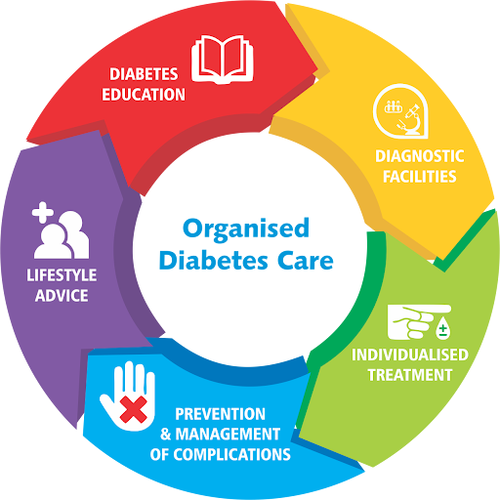
Figure 3: Organised care for diabetic patients
(Source: Influenced by Sampson et al. 2021)
A clinical study of Sampson et al. (2021) on lifestyle changes for diabetic patients has shown how important weight management is. The article suggests that a type 2 diabetic individual can start by targeting a 5-10% in a year. A modest amount of weight loss can be helpful to reduce blood sugar levels and high cholesterol. Similarly, the NICE guideline has also focused on educational and psychological support for such patients. Structured education is available, such as “Diabetes Education for Self-Management for Ongoing and Newly Diagnosed” (DESMOND) (Chiavaroli et al. 2021). Qualified professionals can also be considered for diet plans to encourage a personalised plan.

Explanation of changes improving psychological outcomes
Type 2 diabetes is a crucial stressor that can negatively influence the psychological well-being of a person. Distress can be related to diabetes, and it can cause depressive symptoms among the patients as well (Kong et al. 2022). Such situations require proper lifestyle and psychological interventions that are clinically proven. The implementation of these interventions can improve the situation by addressing the stress factors. For instance, Cognitive-behavioural Therapy (CBT) can be used for patients to restructure their negative thoughts (Jude et al. 2022). The mechanism of CBT changes dysfunctional thoughts to build effective coping strategies.
On another note, mindfulness-based interventions can also be helpful in reducing stress. These interventions are known for reducing stress levels, depression, and anxiety (Kong et al. 2022). Therefore, a positive psychological outcome can be ensured for type 2 diabetic patients. These can improve the psychological state of patients by enhancing their mental and metabolic outcomes. Hawkes et al. (2022) have also shown the effectiveness of motivation-focused counselling. These can be seen as a didactic approach, where counsellors assist patients to explore their reasons and resolve ambivalence. Patients can also join peer-support programs, where other patients share their own lived experiences and motivate others.

Conclusion

Summary of key findings
The critical analysis of the study has shown that type 2 diabetes is a critical and serious health condition. It can damage the patients’ physical and psychological well-being, which must be adhered to. The main risk elements are found to be weight management, changes in lifestyle, genetics, and clinical history. Blood sugar regulation has been shown through the analytical viewpoints of the study, followed by a description of cell metabolism. Lifestyle factors and how they affect the clinical condition have shown that regular monitoring of the states can help in self-management as well.

Reinforcing the significance of understanding and managing the condition
Managing this chronic condition is found to be significant in coming up with effective interventions. In this context, the analysis has demonstrated that using CGM or fingerstick tests can be used to check blood sugar levels. It helps in generating decisions regarding changes in daily routine or interventions required. The study has also been recommended, guided by clinical research and international protocols, such as NICE. Changing dietary habits, regular physical activities, and moderate exercise can assist in managing extreme cases.

Reflection on the role of health professionals in patient education
Patient education can be initiated by medical professionals, as they can discuss the severity of the conditions. Their opinions of management ideas are also respected by patients, which can be taken into account. Professionals can educate patients to empower them, share decision-making, and improve health outcomes.

References
Albarqouni, L., Ringsten, M., Montori, V., Jørgensen, K.J., Bulbeck, H. and Johansson, M., 2022. Evaluation of evidence supporting NICE recommendations to change people's lifestyle in clinical practice: cross sectional survey. BMJ medicine, 1(1), p.e000130.
Beulens, J.W., Pinho, M.G., Abreu, T.C., den Braver, N.R., Lam, T.M., Huss, A., Vlaanderen, J., Sonnenschein, T., Siddiqui, N.Z., Yuan, Z. and Kerckhoffs, J., 2022. Environmental risk factors of type 2 diabetes—an exposome approach. Diabetologia, 65(2), pp.263-274.
Butt, S.M., 2022. Management and treatment of type 2 diabetes. International Journal of Computations, Information and Manufacturing (IJCIM), 2(1).
Campbell, J.E. and Newgard, C.B., 2021. Mechanisms controlling pancreatic islet cell function in insulin secretion. Nature reviews Molecular cell biology, 22(2), pp.142-158.
Chiavaroli, L., Lee, D., Ahmed, A., Cheung, A., Khan, T.A., Blanco, S., Mirrahimi, A., Jenkins, D.J., Livesey, G., Wolever, T.M. and Rahelić, D., 2021. Effect of low glycaemic index or load dietary patterns on glycaemic control and cardiometabolic risk factors in diabetes: systematic review and meta-analysis of randomised controlled trials. Bmj, 374.
Conte, F., van Buuringen, N., Voermans, N.C. and Lefeber, D.J., 2021. Galactose in human metabolism, glycosylation and congenital metabolic diseases: Time for a closer look. Biochimica et Biophysica Acta (BBA)-General Subjects, 1865(8), p.129898.
Eckel, R.H., Bornfeldt, K.E. and Goldberg, I.J., 2021. Cardiovascular disease in diabetes, beyond glucose. Cell metabolism, 33(8), pp.1519-1545.
Gromova, L.V., Fetissov, S.O. and Gruzdkov, A.A., 2021. Mechanisms of glucose absorption in the small intestine in health and metabolic diseases and their role in appetite regulation. Nutrients, 13(7), p.2474.
Hawkes, S., Pantazis, A., Purdie, A., Gautam, A., Kiwuwa-Muyingo, S., Buse, K., Tanaka, S., Borkotoky, K., Sharma, S. and Verma, R., 2022. Sex-disaggregated data matters: tracking the impact of COVID-19 on the health of women and men. Economia Politica, 39(1), pp.55-73.
Husdal, R., Thors Adolfsson, E., Leksell, J. and Nordgren, L., 2021. Diabetes care provided by national standards can improve patients' self‐management skills: A qualitative study of how people with type 2 diabetes perceive primary diabetes care. Health Expectations, 24(3), pp.1000-1008.
Ismail, L., Materwala, H. and Al Kaabi, J., 2021. Association of risk factors with type 2 diabetes: A systematic review. Computational and structural biotechnology journal, 19, pp.1759-1785.
Jude, E.B., Malecki, M.T., Gomez Huelgas, R., Prazny, M., Snoek, F., Tankova, T., Giugliano, D. and Khunti, K., 2022. Expert panel guidance and narrative review of treatment simplification of complex insulin regimens to improve outcomes in type 2 diabetes. Diabetes Therapy, 13(4), pp.619-634.
Karl, F., Hudecek, M., Berberich-Siebelt, F., Mackensen, A. and Mougiakakos, D., 2021. T-Cell metabolism in graft versus host disease. Frontiers in Immunology, 12, p.760008.
Kong, L., Ren, J., Fang, S., He, T., Zhou, X. and Fang, M., 2022. Effects of traditional Chinese mind-body exercise-Baduanjin for type 2 diabetes on psychological well-being: a systematic review and meta-analysis. Frontiers in Public Health, 10, p.923411.
Numsang, P., Oumtanee, A., Kurat, S., Sananok, R., Kraichan, S. and Sarapoke, P., 2023. “Failure to control blood sugar” experiences of persons with type 2 diabetes mellitus. International journal of nursing sciences, 10(4), pp.527-532.
Pabel, S., Hamdani, N., Luedde, M. and Sossalla, S., 2021. SGLT2 inhibitors and their mode of action in heart failure—has the mystery been unravelled?. Current heart failure reports, 18(5), pp.315-328.
Randväli, M., Toomsoo, T. and Šteinmiller, J., 2024. The main risk factors in type 2 diabetes for cognitive dysfunction, depression, and psychosocial problems: a systematic review. Diabetology, 5(1), pp.40-59.
Regeer, H., van Empelen, P., Bilo, H.J., de Koning, E.J. and Huisman, S.D., 2022. Change is possible: How increased patient activation is associated with favorable changes in well-being, self-management and health outcomes among people with type 2 diabetes mellitus: A prospective longitudinal study. Patient Education and Counseling, 105(4), pp.821-827.
Sampson, M., Clark, A., Bachmann, M., Garner, N., Irvine, L., Howe, A., Greaves, C., Auckland, S., Smith, J., Turner, J. and Rea, D., 2021. Lifestyle intervention with or without lay volunteers to prevent type 2 diabetes in people with impaired fasting glucose and/or nondiabetic hyperglycemia: a randomized clinical trial. JAMA internal medicine, 181(2), pp.168-178.
Torres-Ronda, L., Beanland, E., Whitehead, S., Sweeting, A. and Clubb, J., 2022. Tracking systems in team sports: a narrative review of applications of the data and sport specific analysis. Sports Medicine-Open, 8(1), p.15.

