REPORT ON GOOGLE ORGANISATIONAL CULTURAL

Student: Violeta Lavinia Nedelea
Student Number: 2129062
Module: Workplace Culture and its Impact on
Organisational Efficiency
Module Code: BMSW5105
Lecturer Name: Aderemi Ojebode
Executive summary

This report provides a comprehensive analysis of the workplace culture at Google, focusing on its organizational ethos, values, sustainability practices, ethical elements, and potential ethical dilemmas. It also provides suggestions on how to improve Google's work environment, deal with problem areas, and get past important obstacles. The report's conclusions seek to advance knowledge of Google's corporate culture and offer practical advice for upcoming improvement initiatives.

Table of content

Introduction…………………………………………………………………………………………...4
Organisational culture, ethos, and values of Google………………………………………….…5
PESTLE Analysis of Google's organisational culture, ethos, and values……………………...6
Promoting sustainability at Google………….…………………………………………………......7
Key initiatives and practices related to digital sustainability at Google.………………………...7.
Key ethical elements on Google organisational culture………………………………………....9
Ethical dilemma……………………………………………………………………………………...10
Organisational improvements for Google’s culture………………………………………………11
Key barriers and recommendations……………………………………………………………….13
Conclusion…………………………………………………………………………………………...14
References…………………….………………………………………………………………….…15

Introduction

Google, a multinational force in the technology sector, was founded in 1998 by Sergey Brin and Larry Page. "To organise the world's information and make it universally accessible and useful" is the company's mission statement, which has motivated its unwavering pursuit of innovation and excellence. Over time, Google has expanded into fields like cloud computing, artificial intelligence, and mobile technologies, broadening its offerings beyond its primary search engine.
This report aims to provide a comprehensive examination of the organizational culture within Google. I aim to obtain a deeper understanding of the work environment that characterises this tech giant by exploring important elements like ethos, values, sustainability practises, and ethical components. A moral conundrum that might influence the company's culture will also be covered in the report.
To analyse the cultural dynamics at work at Google, this report will draw on established literature, pertinent theories, and organisational models. By combining these learnings, I hope to provide suggestions for developing a workplace culture that is even more ethically motivated, inclusive, and sustainable. These suggestions are intended to improve productivity and organisational efficiency while also improving employee happiness and well-being.
My goal in conducting this report is to clarify the unique cultural characteristics that have contributed to Google's success and to offer practical recommendations for its continued development. The report aims to tackle possible barriers and provide strategies for enhancement to guarantee the effective execution of these suggestions. By doing this, I hope to further I understand of how organisational culture can be a tactical advantage in securing long-term success in the quickly changing technological environment.


Fig. no.1 Google Logo

Organisational culture, ethos, and values of Google

Google's organisational culture is well known for having unique characteristics that make it stand out in the technology sector. The business is very focused on creating an atmosphere that inspires innovation, creativity, and teamwork among its workers. Its ethos and values, which are represented in many facets of its operations, are the foundation of this culture.

Organisational culture at Google

The organisational culture of Google is distinguished by a few essential components. First, it supports a flat organisational structure that fosters direct communication and leadership accessibility. This encourages a sense of ownership and accountability by enabling staff members at all levels to share their thoughts and viewpoints. Furthermore, the organisation prioritises a flexible work environment that enables staff members to work on projects they are enthusiastic about, which fosters intrinsic motivation. The company keep everybody happy; they treat everybody the same, they create this system to work nice and relaxed, no stress at work. They create conductive environment with recreation facilities. The employees are freedom to develop new business ideas. They create equality and diverse environment. They offer women opportunity for development. They create an interactive system that promote motivation.
The culture at Google also values creativity and taking chances. This dedication to innovation is demonstrated by the "20% time" policy, which permits staff members to set aside a portion of their workweek for personal projects. The creation of numerous popular goods and services, such as Gmail and Google News, has been facilitated by this policy (Elsbach, 2018).

Ethos and values at Google

The company's core values centre on the idea that technology has the power to transform the world for the better. Its mission statement, which highlights the objective of organising information to make it widely accessible and useful, makes this clear. This philosophy is further supported by the company's dedication to user-centric design and a seamless user experience.
Google promotes an innovative and transparent work atmosphere, motivating staff members to think creatively and take calculated chances. The company's well-known motto, "Don't be evil," sums up this culture and emphasises Google's dedication to moral behaviour and social responsibility (Smimou, 2020).
Moreover, Google places a high priority on elements like accountability, transparency, and a commitment to fostering an inclusive and diverse workplace. These principles are actively incorporated into the company's policies and procedures rather than being merely aspirational.

PESTLE Analysis of Google's organisational culture, ethos, and values

A PESTLE analysis evaluates the external factors that influence an organization. In the context of Google's organizational culture, ethos, and values, I will examine how various elements of the external environment impact these aspects.
Political factors: Google operates in a variety of regulatory environments and a global political landscape. Its dedication to unrestricted access to information is consistent with democratic ideals and the right to free speech. Google's philosophy of universal accessibility, however, may be called into question by political unrest and governmental restrictions, particularly in areas with severe internet censorship.
Economic factors: Google's capacity to fund research, development and sustainability projects is impacted by the state of the economy. A thriving economy makes it possible to invest more money in initiatives that share Google's values, like community outreach and renewable energy projects. However, during economic downturns, budgetary allocations might need to be reevaluated.
Sociocultural factors: it is evident in Google's organisational culture that innovation, diversity, and inclusivity are valued. Sociocultural trends impact Google's approach to product development and user experience, including changing consumer attitudes and preferences towards technology. Furthermore, the company's sustainability efforts are impacted by societal expectations regarding corporate social responsibility.
Technological factors: Google is a leader in technology innovation, and adopting new technologies is fundamental to the company's culture. Utilising technology to increase information accessibility and usefulness is central to the company's philosophy. Rapid advancements in technology also call for an organisational culture that is adaptable and flexible, encouraging employees to try new things and gain knowledge.
Legal factors: Google's organisational culture may be impacted by legal issues, especially when it comes to privacy, intellectual property, and antitrust laws. Google's values are centred on upholding legal compliance and ethical behaviour to preserve the trust of its stakeholders, partners, and users.
Environmental factors: a fundamental component of Google's culture and values is sustainability. With programmes like waste reduction and investments in renewable energy, the company is committed to lessening its environmental impact. Google's dedication to sustainability is further emphasised by environmental laws and public awareness of climate change (Marmol, 2015).
In summary, various external factors impact Google's organisational culture, ethos, and values. The business is in line with wider societal and economic trends with its dedication to innovation, inclusivity, and sustainability. Respecting the law and following regulations is essential to maintaining Google's reputation and core principles. Google can sustain a culture of innovation, transparency, and moral responsibility by skilfully managing the external environment.

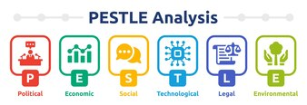
Fig. no.2 Pestle Analysis

Promoting sustainability at Google

Google's multiple efforts to reduce its environmental effect are evidence of its dedication to sustainability. The company has made significant investments in renewable energy projects across the globe and has set ambitious goals to run entirely on renewable energy. In addition, Google actively encourages recycling and composting as part of its goal of having zero waste sent to landfills.
For Google, promoting sustainability is not just a moral obligation but also a calculated business move. Studies indicate that companies that demonstrate a strong commitment to sustainability often reap rewards like improved employee morale and retention, cost savings from energy efficiency, and an enhanced reputation. Google has set high standards to lessen its environmental effect and is actively committed to digital sustainability (Danubianu, 2016).

Key initiatives and practices related to digital sustainability at Google.

Renewable energy: When it comes to sourcing renewable energy for its operations, Google is a global leader. To power its offices and data centres, the company has made large investments in renewable energy projects, such as wind and solar farms. Google has been using only renewable energy to power its operations for several years.
Energy efficiency: Google constantly aims to increase the infrastructure's and data centres' energy efficiency. This entails utilising cutting-edge cooling methods, streamlining server setups, and putting in place hardware with low energy consumption.
Water conservation: Water is a vital resource for cooling systems in data centres. Google uses cutting-edge water management techniques to minimise its impact on the environment and reduce water consumption.
Carbon offsetting: When reaching 100% renewable energy use proves difficult, Google funds high-calibre carbon offset projects. When renewable energy sources are not sufficient to eliminate emissions, these projects assist in making up for them.
Research and innovation: Google continues to work on research and development projects to enhance the field of sustainable computing. This involves investigating novel methods for designing hardware and software that consumes less energy.
Google demonstrates a strong commitment to digital sustainability by putting these initiatives into action. The company's initiatives not only lessen its own environmental effect but also serve as a model for the larger technology sector, inspiring other businesses to implement sustainable practises.
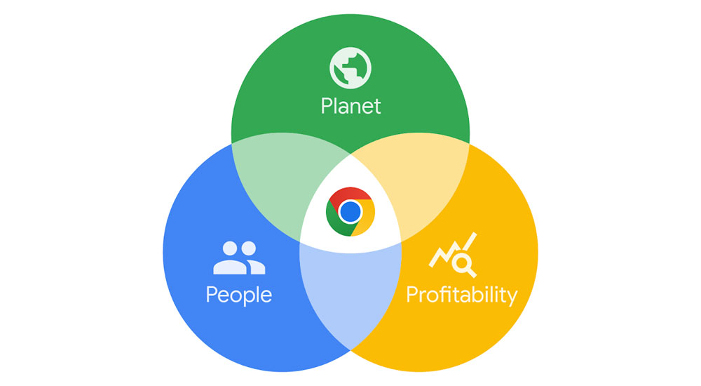
Fig. no.3 Digital sustainability

Framework to justify sustainability practices.

The Triple Bottom Line (TBL) framework offers a useful perspective for assessing Google's environmental initiatives. The economic, social, and environmental aspects of an organization's performance are considered by the TBL. Google's investments in renewable energy and waste reduction initiatives show how closely its sustainability initiatives align with the environmental dimension. In addition to improving the health of the environment, Google may gain a competitive edge in terms of resource efficiency and reputation by aggressively tackling environmental issues.
Google's dedication to innovation, inclusivity, and sustainability is intricately entwined with its organisational culture, ethos, and values. Google is positioned as a leader in both corporate responsibility and the tech sector due to its emphasis on promoting an open and creative culture, as well as its commitment to moral and sustainable business practises.

Key ethical elements on Google organisational culture

Google, like many other large organizations, places a strong emphasis on ethical elements in its organizational culture.
The McKinsey 7s model was developed in 1980s by McKinsey consultants Tom Peters, Robert Waterman, and Julien Philips with help from Richard Pascale and Anthony G. Athos. Through an examination of seven essential internal components that must be in harmony within an organisation, it offers a comprehensive method for evaluating and enhancing organisational effectiveness. These components are divided into "soft" and "hard" aspects (Alshaher, 2013).
Strategy: this is how the organisation intends to accomplish its objectives. The mission statement for Google reads, "Organise the world's information and make it universally accessible and useful." This mission statement highlights the significance of information accessibility while also indicating an ethical obligation to do so.
Structure: this describes the departments, divisions, and reporting lines that make up the organisation. Because of its flat organisational structure, Google encourages open communication and teamwork in the workplace. This can support the development of an ethical culture by promoting open communication and a sense of accountability among staff members.
Systems: these are the policies and procedures that direct how the company is run. Google has implemented several ethical reporting channels and a code of conduct, among other systems. The purpose of these systems is to guarantee that workers understand and follow moral guidelines.
Shared values: these are the fundamental principles and ideals that direct workers' conduct. Google's core principles are avoiding conflicts of interest, prioritising the user, and having a strong commitment to user trust. The organization's ethical behaviour is modelled by these values.
Skills: this is a reference to the employees' skills and abilities. Hiring and keeping top talent is very important to Google. They help to uphold an ethical culture by employing people who share the company's moral principles.
Staff: this has to do with how many and what kind of workers the company has. Google prioritises diversity and inclusion, which can help create a culture that is more moral by giving a variety of viewpoints and voices a platform.
Style: this is a reference to the behaviours and leadership style used inside the company. Leadership at Google has long been linked to creativity, openness, and a dedication to moral behaviour. This provides a model for staff members to emulate.

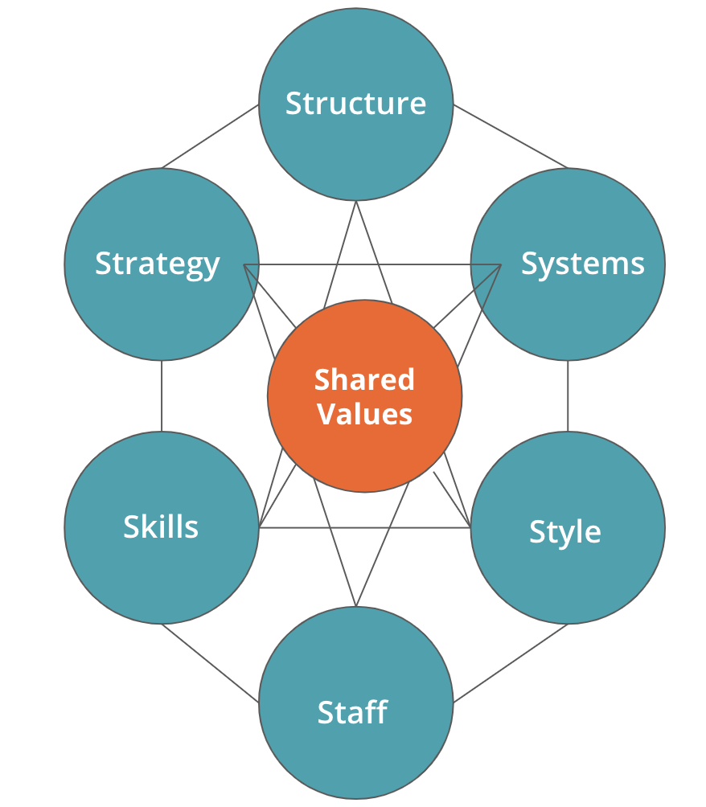
Fig. no.4 The McKinsey 7s model

A variety of tactics can be used to encourage these moral values among Google employees.
Training and education: it is possible to guarantee that staff members comprehend and assimilate the company's ethical values by offering frequent training on the Code of Conduct and ethical expectations.
Role modelling: leaders within the organisation should set an example of moral conduct at all levels. The importance of ethics in the workplace is reinforced when workers witness their leaders acting morally.
Recognition and rewards: an organization's emphasis on ethics can be strengthened by praising and rewarding staff members who act morally.
Clear communication: ensuring that employees are aware of the company's ethical expectations and have access to guidance when faced with ethical dilemmas is made easier by keeping open and transparent communication channels.

One ethical dilemma that can influence the culture at Google is the balance between user privacy and data collection for personalized services. To enhance its offerings, Google depends on gathering and evaluating user data; however, this may give rise to privacy and data security issues. For the company, finding the ideal balance between innovation and protecting user privacy is a constant challenge. This conundrum has the power to mould the culture of the organisation by impacting choices about data management, openness, and user confidence. To guarantee that user interests are prioritised while still promoting innovation and business growth, rigorous thought and ethical frameworks are needed.

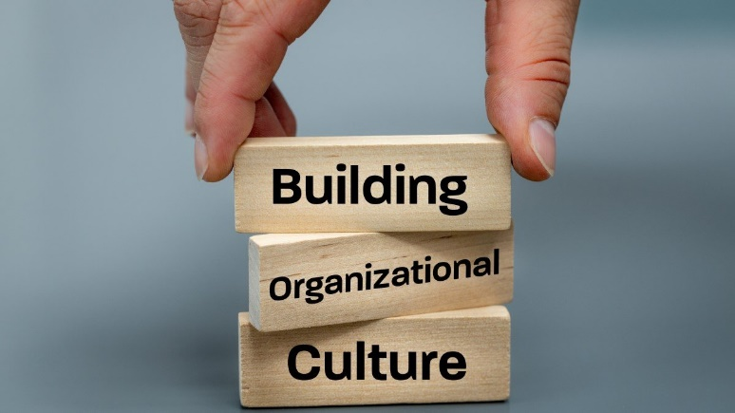
Fig. no.5 Building Organizational Culture

Organisational improvements for Google’s culture

Google is known for its innovative and dynamic organizational culture, but like any company, there's always room for improvement. Potential areas for organizational improvement for Google's culture are:
Emphasis on work-life balance: encourage time off, support flexible work schedules, and establish clear guidelines for communication after hours. A better work-life balance lowers burnout, raises spirits, and boosts output. During regular working hours, it results in more concentrated and productive work.
Diversity and inclusion: put plans in place to broaden the organization's diversity at all levels and promote inclusivity by offering mentorship and training opportunities. Diverse teams are better at solving problems because they have access to a greater variety of viewpoints and ideas. This can improve the general effectiveness of the organisation.
Transparency and open communication: encourage leaders to communicate openly and honestly by making sure they are aware of the company's objectives, difficulties, and choices. Establish regular avenues for feedback. Better communication cuts down on miscommunication, synchronises workers with company objectives, and saves time spent speculating or being uncertain. Consequently, decision-making and operations run more smoothly.
Empowerment and autonomy: encourage staff members to take initiative on projects and make decisions in their areas of specialisation. Provide intrapreneurship opportunities. Employees that feel empowered are typically more driven, inventive, and self-starting. They can move projects forward and make decisions more quickly, which eventually increases efficiency.
Continuous learning and development: invest in continuing education and training initiatives for staff members to advance their expertise. A knowledgeable and competent workforce can complete tasks more quickly and efficiently, producing higher-quality results.
Recognition and rewards: put in place a comprehensive programme for employee recognition and rewards that recognises and honours their accomplishments. Employees who receive recognition and rewards are typically more motivated, engaged, and productive. Because they are more inclined to go above and beyond in their work, employees may become more efficient as a result.
Clear goal setting and performance management: give staff members attainable goals to work towards and give them regular performance reviews. Employees can better understand expectations, coordinate their efforts, and make necessary adjustments with the support of clear goals and performance feedback. Increased efficiency and productivity follow from this.
By emphasising diversity and inclusion, communication, empowerment, development, recognition, and performance management, these suggestions aim to improve Google's workplace culture. An organisation that puts these changes into practise may become more inventive, engaged, and productive (Brown, 1998).

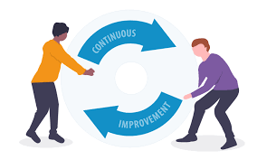
Fig. no.6 Continuous improvement

Key barriers and recommendations

Employee confusion and misalignment can result from unclear communication about organisational goals and strategies. Improve channels of communication to guarantee that strategic goals are conveyed clearly at all levels. Regular town hall meetings updated internal communications systems, and open reporting on the status of strategic goals could all be part of this. This will facilitate the alignment of efforts towards shared goals and foster a common understanding of the company's direction.
Inefficiencies and possible conflicts can arise from overlapping tasks or gaps in responsibilities caused by unclear roles and responsibilities. Examine job descriptions and responsibilities in detail to make sure they match company objectives. Ensure that employees have regular opportunities for training and development so they can carry out their roles in an efficient manner. Workflows will become more streamlined and effective as a result (Yukl, 2020).
Decreased motivation and engagement may result from a lack of acknowledgment and opportunity for employee input. Establish a comprehensive programme for employee recognition and rewards that recognises and honours their accomplishments. Give staff members the chance to participate in decision-making procedures, particularly when those decisions have an immediate bearing on their jobs. Employee motivation and morale will increase as a result, increasing output and efficiency (Zheng, 2010).
Obsolescence and inefficiency can result from a failure to adjust to ever-changing external factors, such as changes in market trends or advances in technology. Examine the outside world on a regular basis to spot new trends and innovations. To be competitive and relevant, organisations must adapt their technologies, procedures, and strategies. By doing this, you can make sure the company is ready to adapt to changing conditions (Alvesson, 2012).
Employee morale can suffer because of unclear direction, incoherence, and ineffective leadership. Make sure that the organization's leaders, at all levels, model and advance the intended cultural shifts. To give leaders the tools they need to manage teams successfully, offer them leadership development and training. This will establish the tone for the entire company, which will improve employee conduct and organisational effectiveness.
These recommendations offer a methodical way to deal with important obstacles and encourage constructive organisational change.

Conclusion

This report has provided a comprehensive overview of Google's organizational culture, ethos, and values. It's clear that Google prioritises encouraging a culture of creativity, teamwork, and user-centeredness. The cornerstone of the company's organisational ethos is its commitment to diversity and inclusion, as well as other core values like user trust.
In addition, Google's continuous efforts to establish a work environment that fosters professional growth, a healthy work-life balance, and employee well-being demonstrate the organisational culture's durability. The company demonstrates its commitment to long-term cultural sustainability through its investments in learning and development programmes and its initiatives to support the physical and mental health of its employees.
Google's organisational culture places a high value on ethical issues. The business maintains the highest moral standards, placing a strong emphasis on openness, user privacy, and ethical AI development. Since trust and integrity are fundamental to Google's relationships with users and stakeholders, these ethical components are woven throughout the company's operations.
The report also outlined several possible organisational improvement areas, such as performance management, empowerment, empowerment, communication, diversity and inclusion, and work-life balance. These suggestions offer a methodical strategy for removing significant obstacles and encouraging constructive organisational change.
In conclusion, Google's organisational culture is a dynamic and changing factor that supports the company's success as a leader in the world of technology. Google is positioned to carry on its tradition of influencing the digital landscape while preserving an environment at work that empowers and inspires its staff by fostering an innovative culture, fulfilling ethical standards, and putting targeted improvements into place.

References

Alshaher, A.A.-F. (2013) ‘THE MCKINSEY 7S MODEL FRAMEWORK FOR E-LEARNING SYSTEM READINESS ASSESSMENT’, International journal of advances in engineering and technology, 6(5), pp. 1948–1948.

Alvesson, M (2012) Understanding organisational change. (Online) London: Thousand Oaks, Calif: Sage Publications

Bortolotti, T., Boscari, S. and Danese, P. (2015) ‘Successful lean implementation: Organizational culture and soft lean practices’; International journal of production economics, 160, pp. 182–201.

Brown, A.D. (1998) Organisational culture. 2nd ed. Harlow: Pearson.

Chión, S.J., Charles, V. and Morales, J. (2020) ‘The impact of organisational culture, organisational structure and technological infrastructure on process improvement through knowledge sharing’, Business process management journal, 26(6), pp. 1443–1472.

Danubianu Mirela and Teodorescu Cristian (2016) ‘Managerial Tools for Sustainable Development’, Present environment & sustainable development, 10(1), pp. 151–160.

Elsbach, K.D. and Stigliani, I. (2018) ‘Design Thinking and Organizational Culture: A Review and Framework for Future Research’, Journal of Management, 44(6), pp. 2274–2306.

Handy, C. B. (1985). Understanding Organizations: 4th ed. Harmondsworth: Penguin.

Holtbrügge, D., Baron, A. and Friedmann, C. (2015) ‘Personal attributes, organizational conditions, and ethical attitudes: A social cognitive approach’, Business ethics (Oxford, England), 24(3), pp. 264–281.

Liu, G., Tsui, E. and Kianto, A. (2021) ‘Knowledge-friendly organisational culture and performance: A meta-analysis’, Journal of business research, 134, pp. 738–753.

Marmol, T. del and Feys, B. (2015) PESTLE analysis. Translated by C. Probert. Namur: Lemaitre Publishing.

Robbins, S. P., & Judge, T. (2013). Organizational behaviour (15th ed.). Boston: Pearson.

Smimou, K. (2020) ‘Corporate culture, ethical stimulus, and managerial momentum: Theory and evidence’, Business ethics (Oxford, England), 29(2), pp. 360–387.

Szeto, M.C.H. (2017) ‘2 Challenges for a community of practice: recognising complexity with the mckinsey 7s framework’, BMJ leader, 1(Suppl 1), pp. A1–A2.

Tear, M.J. et al. (2020) ‘Safety culture and power: Interactions between perceptions of safety culture, organisational hierarchy, and national culture’, Safety science, 121, pp. 550–561.

Yukl, G.A. and Gardner, W.M. (2020) Leadership in organizations. Ninth edition, Global edition. Harlow: Pearson.

Zheng, W., Yang, B. and McLean, G.N. (2010) ‘Linking organizational culture, structure, strategy, and organizational effectiveness: Mediating role of knowledge management’, Journal of business research, 63(7), pp. 763–771.

