As part of gaining Qualified Teacher Status and in pursuit of a career in teaching, included in order to meet Qualified Teacher Status Standards (The Qualified Teacher Training Standards, 2009) is the requirement of investigation into Curriculum Enhancement and Development. This occurred as part of my first Professional Teaching Experience at School X. Within the Secondary Schools context, there is an age range from 11-16 and additionally sixth form. School X’s most recent Estyn report accredits both the performance of the school as well as its prospects for improvement as Excellent. (Estyn, 2015) As a result of the prosperity within the school, and linking with the departmental development plan at School X (Appendix A) the previous short course qualification of Religious Education has now made way for the introduction of full course GCSE Religious Education (WJEC, 2017). As a result of this factor, a preferred investigation for research in regards to this element Initial Teacher Education, the individual route of pursuit related to sharing success criteria. This included what would be needed to attain the entirety of marks related to GCSE practise questions as well as how to accomplish this through a variety of methods and approaches (WJEC, 2017).
The opinions regarding the sharing of success criteria varies throughout school establishments across Wales and the further world vary, in a similar way that the majority of aspects do within Secondary school environments (Barringer, Orfalea, Pholman and Robinson, 2010: P.5). When focusing on the ideas shared and surrounding the impact of sharing success criteria, both positive and negative views towards approaches have been demonstrated. When focusing on the purpose and what is sought to be achieved through success criteria, it could be said that it is not just to complete a task, but rather to understand what the task itself is expecting (Hattie, 2012: P.7). In this way, success criteria allows individuals to attain their maximum potential and sometimes more in terms of natural ability (Baker, Evers and Brock, 2017: P.127) through direction and demonstration of exactly what is expected in order reach maximal marks (Heritage, 2012: P.53). In order to actually define success criteria, it must be understood that there are two types that could be presented depending on what is sought from the process itself. The first type of criterion regards how learning commences and occurs, and is so called process criteria (Absolum and Gray, 2011: P.83). The other focuses on the outcome of the task and how students will know they have achieved the desired results and is therefore named product criteria (Absolum and Gray, 2011: P.84). When approaching this piece, both were concerned in order to attempt to ensure visual learning and recognisable progress that could be evaluated as part of this piece (Phillips and Phillips, 2008: P.2). This is not to imply that this is always possible though, and there are a number of variables that cannot be controlled in these circumstances which will be investigated further as part of this piece. In regards to the selected sample, reasoning and justification for this is similar for the reason of chosen testing that proceeded, and majorly comes down to convenience (Brewer and Hunter, 2006, P.94). The purpose of convenience testing refers to qualitative rather than quantitative data (Newman, Benz and Ridenour, 1998, P.16-17) which means that the group being referred to throughout this piece was selective because they were a reliable source to investigate in terms of timetabling. This would not be the best option for other cases of research, for example, if a sparser amount of recollection was needed, a quantitative approach may be preferred in order to inspect diversity and how differences occur within fixed situations and scenarios (Dwyer and Bernauer, 2014).
Objectives also matter as part of research and the use of such as a tool (Singh). The purpose of sharing success criteria in this instance was firstly as a means of researching progress and how it is aided in the classroom. Furthermore, the second purpose was to explore how practise and preparation for summative assessment allows progress, although this is ultimately through formative assessment as a continuum (Popham, 2008: P.4). The way in which this occurred was through a variety of procedures, every lesson spent with a year nine class that was selected again due to recurring lessons in which monitoring could commence. As part of these lessons it was required that two practise GCSE questions should be completed, with assistance if necessary, in order to familiarise themselves with the WJEC’s marking scheme (WJEC, 2017). This is required within all GCSE classes, both short course as year ten and eleven are continuing and long, in preparation for their GCSE exams. The context of the required practise questions range from two to fifteen marks, as demonstrated within the GCSE question papers (WJEC, 2017). Although it was required to provide a range of these questions, based upon and similar to the ones already presented by the WJEC examining board, the question requirements were not as specific as the structure that was required to be familiarised with by students. This is because of the limited resources available due to the new specifications recent introduction in 2017. This again links back to the convenience presented within the GCSE classes that could be further helped through sharing the relevant criteria for success which will be required by them in the future, as part of their exam periods (WJEC, 2017).
There are various different adaptations of the way in which to address succession within summative assessment in terms of GCSE questioning as a whole. An example of this is point, evidence, explain, link or otherwise referred to as PEEL (Tyrer and Taylor, 2013:137) another method, and the one used within the context of School X’s GCSE practise structures, is an anagram of KISSJO (Appendix B). This meant that the standard of which was being adopted and shared is as follows, starting with Knowledge and understanding, Influence on beliefs where appropriate, Sources of wisdom and authority, Specialist religious language, Judgement and evaluation and Other views (Appendix B). This then extends to what is precisely needed to answer the designated questions, beginning with a mark scheme referring to a question that would gain a student with two marks and asks for a definition of a key term and an example of knowledge (WJEC, 2019). A four mark question requires students to describe. This is suggested as five points that are supported with religious language and sources of wisdom where appropriate (Appendix B). The next sample questions address explanation of a specific religious topic. An explain question is worth eight marks and should contain four points, supported by evidence as well as an explanation of the mentioned religious belief, teaching or practise and therefore, the suggested method refers back to previous suggested methods of building arguments and tackling exam style questions using PEE (Jenkinson, 2011:P42). The questions worth the most credits as part of the Religious Studies specification requires duality and discussion about more than one viewpoint and include reference to non-religious ideas about the nominated topic (Appendix B). In order to attain the entire fifteen marks a suggested six to eight PEEL’s are suggested to be used here including the plenitude of KISSJO (Appendix B). The provided structure for School X is taken by all members of the staff assisting GCSE students and therefore was again a matter of applying this conveniently when tackling GCSE questions (Gravetter and Forzano, 2011 P.151). This was therefore built up too formatively in order to pre and post-test students in a more summative sense that would then be recorded for evaluation of progress and if sharing the mentioned success criteria aids students in their fluency of their writing and attainment.
According to relevant literature, in order to create a balanced sense of purpose, formative assessment should ultimately meet summative assessment as part of the learning process (Burke, 2010). In order for any assessment to correctly commence it must be beneficial to both teaching and learning, in order for students to understand how to improve it must be demonstrated clearly in terms of what is desired as part of feedback (Fautley and Savage, 2010:P.13)Furthermore, assessment for learning is considered easy to incorporate into the practise of everyday lessons (Harrison et al., 2003:P.2) and allow students visible aims within their learning experience and be given advice when difficulties initially arise (Berry, 2008). Another aid of practising summative assessment within a formative context is the environment that can be created (Sambell, McDowell and Montgomery, 2013 P.8). Furthermore, attempting to complete GCSE style questions outside of exam contexts is the way in which help is constantly on hand (Oers, 2012:P.95). Students began working in pairs or small groups, away from the usual summative practise which ensues students working independently and in silence (Benson, 2014 P:41) and allows students to co-operate and share ideas which ultimately benefits their own input and knowledge when in a variety of circumstances, not just those which are created for research purposes (Frey, Fisher and Everlove, 2009:P.97). When the practise questions concerned in this essay were addressed for the research project, the atmosphere was not as relaxed as when students began getting to grips with criteria and structure. After the Christmas period, full course religious education was introduced to all year 9 students. The introduction of requirements for succeeding as part of GCSE Religious Studies full course did not please some students as much as others, and this extends to the practise questions that were designated for lessons. It was often clear and sometimes vocalised that students did not wish to practise their skills and within the context of School X it was often questioned by students the purpose of pursuing the same techniques ‘over and over again’. A recognisable response that was established by all staff practising in within School X was that of a ‘practise makes perfect’ mentality. It was advised that More Able and Talented students were able to pick up relevant techniques needed to succeed and meant that the students that were used as part of the designated research task were chosen in order to focus on a class that might need extra support and as much practise as possible, and upon this revelation a year nine class was selected. Another reason for this selection was down to the ways in which students with a lower ability compare themselves to more able and talented pupils (Marsh, Carmen and McInerney, 2008, P.122) and that with extra support it was hopeful that recognisable progress would be made for students and observes alike to see.
The research task as a whole was set up in order to highlight the importance of research within the classroom and understand the purpose of a selected topic, as future teachers, from inside of the classroom. In many ways, the data that was collected and gathered as part of the mentioned task, will be similar to what will commence in the classroom. An example of this is the recording of future test results and assignments mark, which would also be analysed to discover what students have presented as well as how teaching aids this, in terms of feedback on a progressive, but also personal level (QTS Standards, 2009; 3.2.1). There are also cases against feedback and mock assessment and assessment alike, which have already briefly been highlighted. One argument against feedback is the ideology that feedback is only present in order to justify what mark a student is given (Maclellan, 2001). Furthermore, another thought is that feedback can sometimes be too hard to understand or complex for the students to adjust too without consolidation (Burke, 2010: P.22). Additionally, there is ideology that sometimes feedback might be inappropriate and damaging because of the encouragement that can sometimes be given to students irrespective of the quality of work (Pelligrino, 2001). Therefore as part of the feedback supplied to students as part of the research task, it was essential to be valid, fair and helpful in order for students to progress. When conceptualising the idea of non-assessed learning, it could be considered a challenge in itself for students to begin completing exam style questions without worry. This can range from a fear of failure (Martin, 2010: P.4) to stress about the setting of the exam (Stringer, 2012:P.31), and is something that has been pinpointed as a negative as part of their learning experiences. Therefore, as part of class learning leading up to summative assessment there must be support for students and allow reduction of stress in various ways. This again supports the scenarios in which exam style criteria was practised within the classroom in School X.
The predicted outcomes for the selected class with support were hopeful for succession before the practise of the pre and post testing periods, based on the ideology that the material that was presented to students would be engaging and informative enough to withhold students attention and allow them to make full use of their formative sessions (Ediger, Marlow and Digumarti Bhaskara Rao, 2005: P.180). It was also made clear and important again to students of the structures and techniques that needed to be used that would help with the designated tasks before introduction was offered into the research that would be partaken as part of university study, if member of the class allowed (BERA, 2018). The basis of anonymity were made clear throughout the research project for myself personally, for example, through my own investigations (Denscome, 2014) as well as and in the lead up to the research project, students were also made clear of this key factor of the process to ensure informed consent from all (Babbie, 2008 P.69). Another important note that was communicated to students in this instance was that when completing the pre and post testing that it would be in exam style conditions to ensure valid and reliable results (Taylor, 2013). In the lead up to the pre and post testing periods, students were told that the purpose of the tests were not to judge them, and that they would not count for anything the way it would in exam circumstances of which these techniques are applied. It was advisable that students try their best within the provided circumstances and the results based on this methodology will be further explained as part of the continuation of this piece. Part of this includes students recognising their abilities in order to develop and witness progress of their own (Bartlett, 2015 P.29) and furthermore, it has been said in order for this to become possible that success criteria should offer natural differentiation (Bartlett, 2016 P.32). Therefore, it is not expected that everyone will attain maximum marks, or that all students will suddenly progress because of the sharing of success criteria, as it is said that students who do not work are worried about not being in control of their own results (Horowits and Wakefield, 2012) although it was hopefully enticing enough through sharing success criteria to generate measureable results that would aid students in some ways with their exam expectations (Sanzo, Myran and Caggiano, 2016 P.66). In terms of recognising improvement and what progress looks like, this majorly comes down to an individual (Ferrer-Wreder, 2004). In many ways, sharing of how to succeed, is similar to other aspects within the classroom, and very much depends on a student’s mind-set (Oakley, 2017 P.4). Those who reflect on their feedback and seek to find ways to improve are always predicted to achieve their goals and is why these are common classroom practises (Westberg and Jason, 2001 P.VII). Success criteria is embedded throughout the curriculum not only for students, but for staff akin. A clear indication of this occurrence is as part of the School’s development plan (Appendix A) and this descends further into individual department improvement plans as previously mentioned. (Appendix C)The way in which this coupling has aided is similar to the ways in which success criteria operates. There are often updates regarding progression and pinpointing of items that have or are yet to be completed. Social studies fifth project highlighted as part of the departmental development programme is the introduction of effective schemes of learning within key stage 4 in order for students to attain accreditation for R.E (Appendix C).
Other documentation that is relevant when approaching research topics is that of the schools policy. As it is stated within the publication itself, the purpose of the mentioned is to ensure procedures are documented and consulted frequently (Appendix D). As well as this, relevant to school X’s mission statement, their first improvement priority is to ensure outstanding pupil outcomes and it could be said that practise of GCSE style exam questions could fit into this category. Adding to this point, data protection is also highlighted within school X’s policy and this is something that again must be considered when completing research within the classroom. This implies once more of the importance and need to communicate the purpose and expectations of research clearly to students that would become the sample class, through such methods as clear and concise targets (Black and William, 2005). A point of referral for instruction in terms of communicating research was the British Educational Research Association (BERA, 2019). This is used in order to promote the use of research within the classroom through a critical, current approach to look at the efficiency of policies and practises (BERA, 2019). Through application of the advice given by BERA documents, it became clear that asking students to participate in research should be something that is fluid and flexible in order to establish a ranger of statistics that are appropriate for analysation (BERA 2018). But as well as this students must be considered and once more it is vital that students perform in both pre and post-test fashions to the best of their abilities. This in turn will allow for valid and reliable results that are not biased in any way as previously mentioned, and as well as this, the application of the advice demonstrated as part of the British Research Association meant that students had the opportunity and were clearly advised that if in any way they felt uncomfortable or unwilling to participate as part of the selected research methods, that they had the right empirically to withdraw if they felt necessary (BERA, 2019). Therefore it was important to ensure clear communication about ethics and the rights students have in these scenarios (BERA, 2018). The importance of the inclusion and following of precise guidelines resorts back to the risks associated with research that cannot always be eliminated, but sometimes minimised in many ways (Glasius, Lange, Bartman, 2017: P.16) as it is always immanent that there might be some sort of difficulty when working with such a variable as human beings (Olofsson and Zinn, 2018 P. 267).
Methodology is also an important factor to mention when considering approaches and procedures as part of conducting research. When selecting particular research methods, it was first to be considered what result was sought from the research and testing periods (Kumar, 2011 P.2). As part of the required research, in order for succession to occur, objectives must be concerned as they are known to be connected with most aspects of learning, in order to inform the learner of the purpose of their learning (Kotharti, 2004 P.2). As mentioned in this piece, the aim of the selected methods and approaches mainly depended upon convenience in terms of sampling due to the short nature of the provided placement. Research in many ways can be a summary of current situations and scenarios (Khan, 2008 P.4) with no exception being within the classroom and for educational purposes. Relevant to this is decision-making, and as part of research methodology is the decisions which emerge from the generated research (Achari, 2014 P.17). The sharing of success criteria if it is embedded correctly within the classroom, can be made an integral part of good classroom practise (Clarke, Timperley and Hattie, 2003) it is therefore important that through sharing of the criterion that students benefit in line with effective use that should enhance student achievement and raise teacher quality (Moss and Brookhart, 2010). This once more correlates with the ideology presented previously of ethical and valid research that allows students to view progression of their own by knowing what is needed for succession (Hattie and Yates, 2014). Furthermore, another positive of convenience sampling with familiar participants is that students may be more willing to participate in the scheduled research activities (Smith and Smith, 2006). In contrast to this, within the construction of research practises and methodology comes limitations, some of which that may only become clear upon reflection and in hindsight. This is compatible when looking at another situation that occurred as part of research methodology, when upon communicating pre and post testing situations and scenarios, an episode of underlying bias unintentionally arose when a student asked if they should try harder in the post testing period in order to ensure progression in marks as part of research. This was denied although upon consultation and advice with a personal mentor, it was decided that this was something that might still occur, especially as it was vocalised to the class and that the selected sample group may need to be changed. Apparent to this upon presentation of their results it was clear that students had not be honest with their capability, and the initially selected top band class would be better if replaced by middle band students due to a more solidified relationship in terms of trust as more time had been spent here.
Another aspect that could be considered limiting is that of the use of convenience sampling itself, this is due to the fact that convenience sampling does not allow for scientific analysis, this is applicable because of the factor whereby the vast population is not clearly represented within the designated sample (Lavrakas, 2008:P.149). Availability sampling again such as when based on convenience can be seen as an easy option and in many ways it is, and where a more randomised selection would be present, there would be less sense control where as these risks are minimised within a controlled situation such as when basing sampling on convenience (Daniel, 2012:P.83). As well as this, convenience sampling can often be considered haphazard or accidental as those that participate are ready and willing whilst making the consensus of results restricted because of this lack of variety (Onwuegbuzie, Jaio and Bostick, 2004:P.109). This is also supported further by the idea that results would only be measured from a selected sample class, rather than a whole year group or multiples classes. This is not to discount the overall reliability regarding outcomes that derive from convenience testing another benefit of the mentioned, is the fact that its occurrence was costless as well as simple to conduct (Ellison, Farrant and Barwick 2009:P.198) which fitted the situation in the most appropriate fashion and is further support for the selection of this methodology when sampling data for this research. The purpose of the selective topic is also something that might be questioned when interpreting this essay and its context, and the reasoning behind sharing success criteria. The main reasoning aside from the progression towards attaining success as part of their examinations especially (Bakers, Evers and Brock, 2017:P.127) which also helped in terms of convenience, there was also further influence from the idea that modelling is of specific importance, and very beneficial (Gherson, 2015:P.114) as something that could be supplied for students correctly to help with questions. Therefore, the fact that model answers were needed to be written and included as a way for students to visualise the way in which success would look was something that on a personal level had to be studied and applied the same ways in which students would. This was done in order to present reliable, valid exemplar material that meets all requirements of the success criteria to aid students when participating in written GCSE style questions.
In order to present evaluative reasoning based on pre and post testing outcomes, the sequential periods must be approached and carefully studied. As part of the designated research, students were asked to complete an exam style question relevant to the predicted topic students would be studying at this points according to the scheme of work. At this point in time, Christianity and the aspects needed to attain accreditation for this part A by the WJEC examining board (WJEC, 2017) was the focus of lessons for year nine students. The provided lessons would start with introduction to the different denominations of Christianity and assess examples of how ideology and practise differs within these instances. Therefore, through consolidation with other staff members, the agreeable task for research would be scheduled as an eight mark question titled: ‘Explain Christian Denominations’. It is important to note here that this question is not one that is previously presented as part of sample material for this examination (WJEC, 2017) this is due to the factor that the introduction of the now presented exam specification only being released for a single exam period thus far in two thousand and seventeen.
Within the pre-testing phase, previously communicated were the expectations of the research task and that students should attempt the designated question after viewing relevant material presented to them as part of the lesson which would be relevant to the presented question. As previously mentioned, the entire project was due to commence with a higher ability class, although here further insight into the limitations presented with this class could be compared with the middle band class that actually completed the entire task. The research sample were then designated ten minutes, a little longer than the ‘mark a minute’ criteria often use within the context of school X in which to attempt their designated question. It has been mentioned prior also that exam style conditions of silent, individual work would commence as part of the testing periods, however, this was extremely difficult to control. Due to the lack of structure and clear expectations, students intensely struggled with the reality of the task. Outstanding examples of this could be demonstrated from three students within the classroom situation that follows;
A student raises their hand and the researcher approaches.
Student A: “Am I doing this right? What else can I use?”
Researcher: “I can’t help you right now, you know that, just try your best”.
Student A: “Well then, I don’t know what else to do, I think that’s enough”.
The presented student finished their work at four lines (Appendix F), three minutes into the designated ten before staring out of the window for the remainder.
Input from another student showed the top end of the succession outcomes that were presented with the most from the class with a respective four marks (Appendix G) Student B based their piece of writing on the context they had acquired from the lesson presented, and to the best of their ability applied the point, evidence and explain structure that was presented within the social studies department at school X. According to the demonstrated material that emerged from this student without the help of sharing of success criteria, although attaining the highest marks in the class, this student still only had attained half of the impending marks that could have been further aided by the reminder of the criterion applied correctly.
The third student that stood out in terms of struggle without help or direct instructions presented their worries very vocally.
Student C: “No but Miss. I really don’t know what to do”.
Researcher: “Don’t worry, just try your best”.
Student C: “Well I’m not doing it then because I haven’t got a clue”.
The highlighted student drew attention from the whole class when expressing their possible anxiety about the presented situation and without the research becoming biased through aiding this student where others were not helped, the student refused to complete the task as they felt incapable and too unsure without scaffolding of any kind at this early introductory phase of the GCSE Religious Education accreditation specification.
After the respective pre-testing period and end of the provided lesson, the student’s answers were marked. Upon reflection, it becomes clear that the students were not clear about what was needed in order for them to access the better levels of recognition, and as mentioned prior, the maximum marks at this stage emitted from students was that of half the possible marks available. The remainder of outcomes follows. In a class of twenty nine students; two gained four marks, seven ensured three marks, fourteen students were around the two mark border, and four reached a single mark while two failed to complete the designated task. That therefore stands at an overwhelming ninety nine percent of students unable to ensure even half the provided marks on offer as part of this eight mark describe question. When feedback was designated as part of the lesson that followed, it was made clear to students that the question required an approach of point, evidence, explain as previously covered, or ‘KISS’. Many students commented on the fact that if they had known that was the approach needed, then they might have achieved better marks. This suggests support for the sharing of success criteria, especially in early stages of practise within the classroom.
As part of the post-testing term, amongst feedback and self-assessment when asked what could be done better, one response from a student was ‘I wish I would have known how to get the marks better’ in response it was verified that a model answer would be supplied for students to look at and study, as well as the success criteria gone over before the next testing period. Additionally as part of preparing for the post-testing date, a model answer, broken down and labelled through the point, evidence and explain method was constructed personally and checked through with a mentor before it would be distributed to students as exemplar material. The aim of doing this again relates to whether the sharing of such helps students in terms of their achievements in anyway. Moreover, as part of the space regarding lessons between the periods of testing, each lesson as was required by departmental policy to ensure two opportunities to practise exam style questions were presented each lesson, and as part of these lessons, specific focus was drawn towards the criterion highlighted and already mentioned as part of this piece (Savage, 2011). For example, the way in which this was done was through application of the relevant criteria in other circumstances. When writing things own within class it was asked for a PEE approach, this was furthered as part of written responses and consolidation of ideas, in order to ensure the focus on the criteria was prominent amongst all students. This approach is also taken within other departments, for example, both History and English also use the PEE structure, supporting the previous point of focusing in a cross curricular fashion on how to structure their writing.
The post-testing occurred approximately a week after the first testing period and differed from the first occurrence in a variety of ways. Although the sample, timing and conditions were the same, the entirety of the purpose relevant to the research task must depend on a measureable factor, and as a result must come back to the underlying purpose that was sought as part of the research and methodology: if sharing how to succeed aids students in any way. In order to establish how this sharing helps, before the period of testing, the methods that had been applied throughout learning were revisited and it was asked of students what they thought needed to succeed relating to the question that was once more posed ‘Explain Christian Denominations’. A clarity established throughout the class as a whole unified a solid success criteria and frame of the fore mentioned point, evidence explain including aspects of religious knowledge and understanding, influence on belief, sources of wisdom and authority and specialist religious language, or KISS. Students then were asked to commit to silence before participating in the second recorded research activity. The outcomes of the relevant research were that of which was expected in terms of improvement. The results of the post-test generated results were that of completely opposite to the pre-testing period. Whereas ninety nine percent of students previously attained under half the available marks, ninety percent of students marks that had been recorded had now been boosted to over half of that which were on offer. The statistics for this are demonstrated as follows: generated as part of the post-testing period, a singular student acquired one mark and another student acquired two marks similarly. Three out of the twenty nine present students were now at the three mark threshold whilst four were at four marks. An overwhelming fifteen students at this point were now situated above half of the marks on offer now gaining five marks. A following four students were at a point solidifying six marks out of a possible eight on offer, with a single individual only missed a singular mark as part of their hard work and study (Appendix H). In hindsight it could be argued that the presented improvement of results could be biased as the same question was used as part of the researching process. However, throughout the time spent with the research sample, it was clear to see how confidence and capability improved as part of the focus on, and sharing of success criteria. For example, the first instance of testing various students raised their hands and posed questions regarding what was sought of students, this was eradicated in the further instance when all students attempted the question that was given to them, some putting in more effort than other but ultimately all completing the task in question for the purpose of research.
On the other hand of the progressive outcomes, an aspect that might be questionable is the reliability of the outcomes which the research activity provided. It could be suggested that the idea of sharing success criteria before the commencing of the task is not realistic, as in exam conditions, students would not get this sort of help beforehand (Kotchian and Simmons, 2012). Moreover, bias could become a viewpoint due to the fact that the same question was used in both pre and post testing phases. Additionally, another factor that could be questioned is the idea that students might base their provided answer on the model one already provided to them as an example of how to gain full marks (King, Keohane and Verba, 1994). Despite all these influencing or questionable factors, it is clear despite which particular methods students individually focused on to improve, they did indeed do so, and to an exceptional standard upon reflection and analysation of the results. Furthermore, students who at a previous time would have refused to complete an extensive piece such as in the exam style scenarios provided, were now at a point where they were attempting to complete the question without asking for any provisional guidance. Thus, through these various pieces of evidence which emerged as part of the researching periods, it is suggested that students do indeed progress and feel more at ease when competing a task, especially when the piece that is relevant to the task is extensive through the sharing of success criteria. Upon further feedback with students relevant to their provided answers, it was mentioned by several individuals that the idea that the necessary structure provided, was a lot easier to comprehend and attempt when broken down and shown exampled. Which suggests support for the aforementioned idea that modelling helps consolidation and solidifies ideas when attempting exam style questions, and other extensive pieces of work.
On the whole, the research project itself took considerable planning and preparation and there are many aspects to be aware of in order to ensure safeguarding is enforced throughout the duration of the task (Baginsky, 2008). It is clear that as part of participation in research activity, guidelines and expectations must be communicated correctly in order for situations not to become unfair or biased in anyway. As well as this, in upon reflection and through personal experience, it is also important that sample participants are willing and read to participate in the set tasks (Ainscow, Beresford and Harris, 2016). Through participation in conducting research, other factors that surfaced unexpectedly arose, such as in terms of accidental bias and unfair advantage, although was avoided again after recognising where mistakes has happened, and collectively was a learning experience not only for students who would benefit in their learning, but personally in terms of recognising visible learning and how learning actually is aided within the context of the classroom. Another aspect brought to light in awe of the research task was that of worry that surrounds examination and marking. The majority of students that were present in both the sample class that did not participate in the research activity as well as those that did has students amongst them that enquired whether they would be graded on the project and if their marks would go towards anything. It was as made clear throughout as state prior the purpose of the research task was to measure the use of success criteria, and that marking would only be relevant for myself so students should try their best as in this way they would count. This did ease students in ways although the provided situation was a struggle for many based on a variety of factors as mentioned throughout the majority of this piece. This research activity also demonstrated the versatile and capable nature of young people in their ability to master new skills in such short periods and demonstrate them to an excellent standard. Despite overarching affecting factors such as the imposing stress and uncontrollable variables, it is clear that through having the opportunities to harness their skills, the skills themselves are developed and improved, helping students in their progression and in working towards gaining accreditation at GCSE level in Religious Education. Once more, it was a challenging aspect of the project when researching when students were not able or did not want to attempt to complete the provided task as part of research. It was in relation to this that led to commitment personally to ensure that even though challenging tasks were commencing, that students were not struggling but being helped throughout the duration of both learning and research tasks.
This is not to always say that students every lesson would completely commit to the questions that would be displayed on a recurring basis, but through the provision of variable opportunities to apply these skills needed in order to succeed, students would be more confident in their abilities when tackling challenging question, situations and scenarios alike. A sense of clarity in this way has allowed students to give the reader, in this instance myself, but where similarly it could be applied in exam style scenarios, the exact and direct pinpointing of what is sought from the provided question. Furthermore, it is clear throughout the course of the schools context that there are hopes for outstanding grades and progression cross-circularly, with no exception when looking at the Religious Education front. Supportive again of this is the reactions shared when feedback occurred within the sample class. The majority of students seem to want to do well and improve their learning, especially if it means acquiring special recognition by the leader of the class. It could be said that this is based on natural ideology that we as humans are seen to want to succeed (Coon and Mitterer, 2014). Those that had done well were very proud of themselves and had further motivation to try to attempt these sorts of questions, for example, the student who attained the highest marks throughout the class asked if there would be more opportunities to apply the skills they had learned through the sharing of success criteria. Oppositely, those who might not have done as well as they could have despite the mentioned fact that it was communicated that the marks would only be used for research purposes, seemed more disheartened and negative about the way in which the testing went in general, as well as less willing to work towards improving their marks and complete questions of a similar nature due to what personally it is believed to be, fear of disappointment. It is therefore even more important that success criteria is not only shared within classroom contexts, but constantly applied and given opportunity to be focused upon as part of students learning throughout daily school schedules.
If the research task were to be re-done, there would be several aspects that upon review could have been handled differently or made easier in various ways. An example of this is the use of the same question for both testing periods. In order to eradicate any form of bias if the task were re-approached it may be a better idea to possibly use similar questions in the testing phases rather than the same question. This could be done by ensuring that the structure and criteria are communicated clearly and their importance targeted as the need to know and then applying this appropriately dependant on the relevant trigger words such as ‘explain’ or ‘describe’. It is clear that having precise and direct instruction can ensure and direct retrieval of acquired knowledge (Lefrançois, 2000). Regarding how this project has benefitted myself, firstly in regards to future teaching, it has allowed the development of patience as well as perseverance in terms of working with adolescence. Secondly, the sharing of success criteria seems to have shown strong influence on students learning, and is it now of belief that if properly and consistently applied, that it will indeed benefit students learning and attainment. Furthermore, this research project has allowed the importance of safeguarding and ethical implications to arise and be worked through alongside that which is desired as part of attaining research, protecting young people at all time. Moreover, the research itself allowed personal insight into the requirements needed in order to produce valid and reliable results that could be measured accurately, and by doing so aid learning not just in this instance, but in all areas of improving learning and achievement.
When working within a situation that is constantly vibrant as secondary education, it becomes obvious that learning for students is not always the same, or straight forward for all. But despite this factor, learning must be present, available and accessible to all in order for individuals to succeed to the best of their own individual abilities. This is not to say that the outcome of results as part of this piece are incorrect in anyway, however, they may be called limited. On the whole students were ready and able to participate where appropriate in research activities although it might have been beneficial to have more than two monitored periods or self and peer assess answers in order for students to think for themselves about ideas regarding improvement in their own pieces of work whilst helping others at the same time. Formative and summative assessment are clearly both crucial practises in order to provide assessment of learning and has been ongoing, this therefore suggests the use of formative and summative assessment being used into the foreseeable future accompanied by success criteria and model examples alike. Therefore it is a personal motivation that throughout a career in teaching that formative assessment will aid summative assessment (Burke 2010). Additionally, the success criteria presented in these instances must be clear and enable students to reach and fulfil their maximum potential as individuals, so high expectations should always be present. Finally, in order to gain the entire impact of success criteria, it should be a continuous focus rather than something that is just skimmed over, and rather should be integrated where possible, as the practise and application of techniques in different situations will ensure that skills are being constantly enhance. Not all students will improve and progress, and not all individuals’ strengths lay within the academic fields, but if students are showing improvement whilst challenging themselves as part of the learning processes, then they will indeed improve in whichever desired sense that they believe needs be. It is a frequently used quotation that ‘practise makes perfect’ and in many ways this could be considered applicable when learning. In the way that in a single instance a methodology would be used, then left and came back to shortly before an examination period, the long forgotten technique would be harder to apply or even remember. Whereas if the criteria and techniques were constantly used and applied in a variety of ways, the information and skills that are needed relevant to the provided context will be a lot easier to reflect upon, analyse and then apply. It is therefore very beneficial, proved throughout this piece, that sharing success criteria with students allows a focus and direct goal in terms of generating an answer. In this way, different techniques like and unlike in the provided situation, can be tested, used and then improved upon, based on the desired outcome of the classroom scenario. The purpose of school is to create the next generation of learners and this could not be done without constant rethinking of how to better the curriculum and help students become life-long learners who seek to succeed throughout their lives.

Appendix A
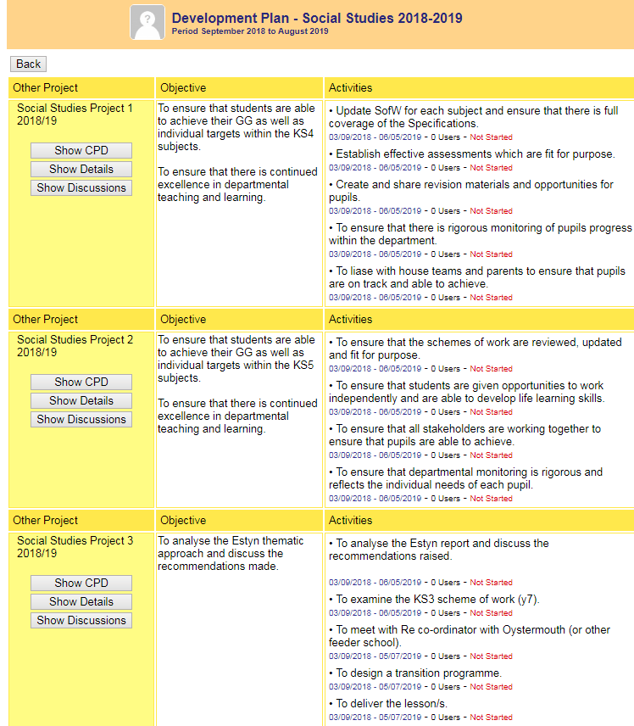

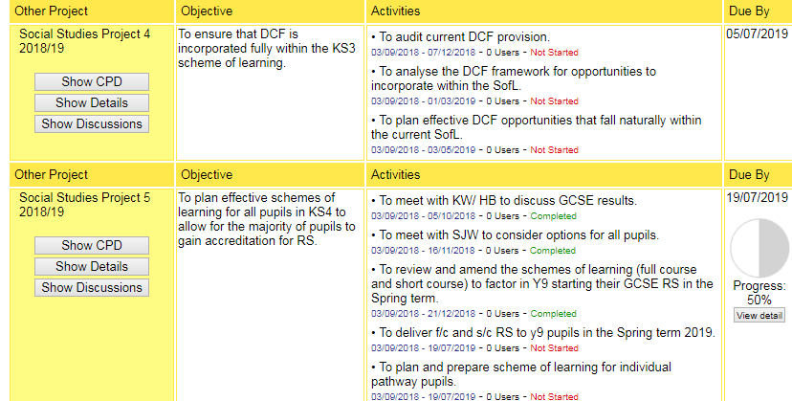

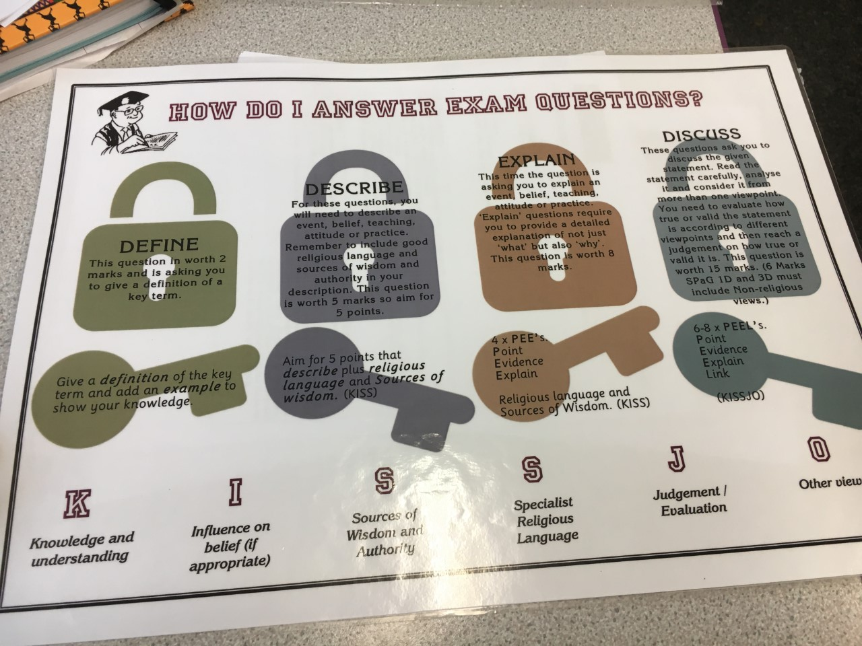
Appendix B

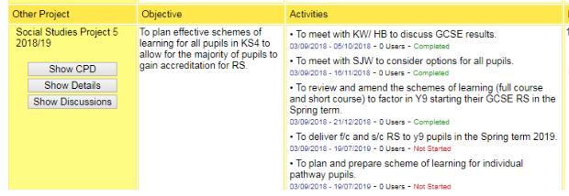
Appendix C

Appendix D
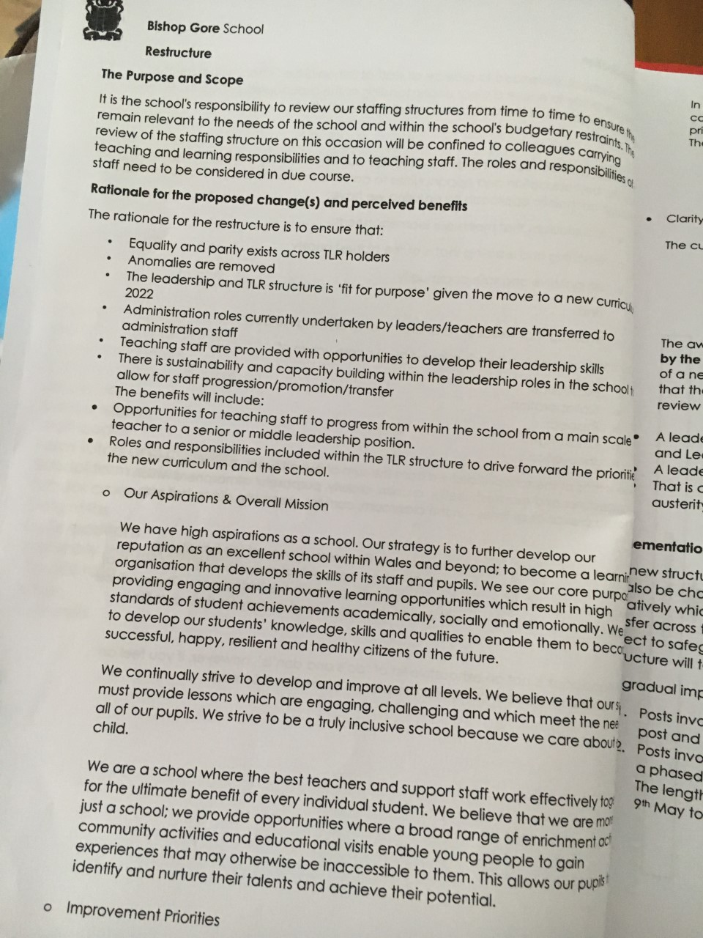
Appendix E



Appendix F

Appendix G
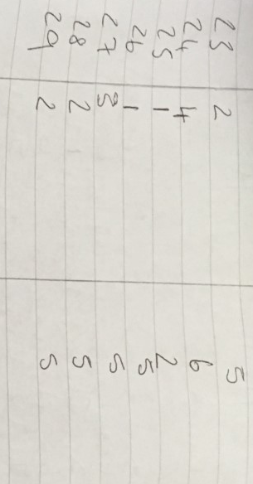
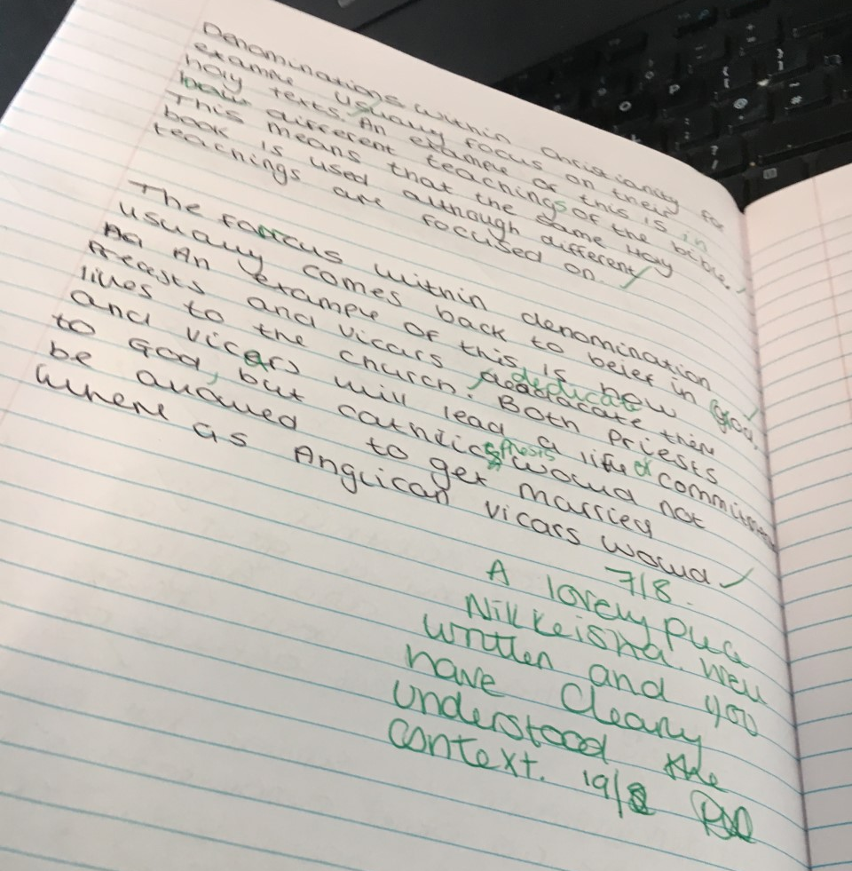
Appendix H


Reference list.

- Absolum, M. and Gray, J. (2011). Clarity in the Classroom. New Zealand: Portage & Main Press, p.83-84.
- Achari, P. (2014). Research Methodology. Traverse: Horizon Books, p.17.
- Ainscow, M., Beresford, J. and Harris, A. (2016). Creating the Conditions for School Improvement. London and New York: Routledge.
- Babbie, E. (2008). The basics of social research. Belmont, Calif.: Thomson/Wadsworth, p.69.
- Baginsky, M. (2008). Safeguarding children and schools. London: Jessica Kingsley Publishers.
- Baker, T., Evers, G. and Brock, R. (n.d.). Targeted teaching. City Oaks, California: SAGE, p.127.
- Bartlett, J. (2015). Outstanding Assessment for Learning in the Classroom. Abingdon: Taylor and Francis, p.29.
- Bartlett, J. (2016). Outstanding Differentiation for learning in the Classroom. Abingdon: Cenveo Publishing, p.32.
- Bera.ac.uk. (2018). Ethical Guidelines for Educational Research, fourth edition (2018) | BERA. [online] Available at: https://www.bera.ac.uk/researchers-resources/publications/ethical-guidelines-for-educational-research-2018 [Accessed 5 May 2019].
- Bera.ac.uk. (2019). Promoting educational research | BERA. [online] Available at: https://www.bera.ac.uk/promoting-educational-research [Accessed 5 May 2019].
- Benson, G. (2014). Exam Tips: How to study for Exam without Stress, Fear or Failure.. Transtudent World, p.41.
- Berry, R. (2013). Assessment for learning. Johanneshov: MTM.
- Black, P. and William, D. (2005). Inside the black box: Raising Standards through Classroom Assessment. Chiswick: Kings College.
- Brewer, J. and Hunter, A. (2002). Foundations of Multimethod Research: Synthesizing styles. California: SAGE, p.94.
- Burke, D. and Pieterick, J. (2010). Giving students effective written feedback. Maidenhead, England: McGraw-Hill/Open University Press, p.22.
- Coon, D. and Mitterer, J. (2014). Psychology. Belmont, Calif: Wadsworth/Cengage Learning.
- Daniel, J. (2012). Sampling essentials. Los Angeles: Sage Publications, p.83.
- Denscombe, M. (2014). The Good research guide. Maidenhead, England: McGraw-Hill/Open University Press.
- Dwyer, L. and Bernauer, J. (2014). Quantitative Research for the Qualitative Researcher. California: SAGE.
- Ediger, Marlow and Digumarti Bhaskara Rao (2005). Quality School Education. New Delhi: Discovery Publishing House, p.180.
- Ellison, S., Barwick, V. and Farrant, T. (2009). Practical statistics for the analytical scientist. Cambridge: Royal Society of Chemistry, p.198.
- Estyn. (2015). School X’s inspection report.
- Ethical Guidelines for Educational Research. (2018). 4th ed. Great Britain: BERA.
- Fautley, M. and Savage, J. (2013). Lesson planning for effective learning. New York: Mc Graw Hill, p.13.
- Ferrer-Wreder, L. (2004). Successful prevention and youth development programs. New York: Kluwer Academic/Plenum Publishers.
- Frey, N., Everlove, S. and Fisher, D. (2009). Productive group work. Alexandria, Va.: ASCD, p.97.
- Gherson, M. (2015). How to be Outstanding in the Classroom. Abingdon: Routledge, p.114.
- Glasius, M., Lange, M. and Bartman, J. (2017). Research, Ethics and Risk in the Authoritarian Field. Amsterdam: European Research Council, p.16.
- Gravetter, F. and Forzano, L. (2011). Research Methods of the Behavioural Sciences. 4th ed. Beltmont: Wadsworth Cengage Learning, p.151.
- Gweddill.gov.wales. (2009). The Qualified Teacher Status Standards Wales 2009. [online] Available at: https://gweddill.gov.wales/legislation/subordinate/nonsi/educationwales/2009/3220099/?lang=en [Accessed 4 May 2019].
- Hattie, J. (2003). Unlocking Formative Assessment. Practical strategies for enhancing students' learning in the primary and intermediate classroom. Auckland: Hodder Moa Beckett.
- Hattie, J. (2012). Visible learning for teachers. London: Routledge, p.7.
- Hattie, J. and Yates, G. (2014). Visible learning and the science of how we learn. London, England: Routledge.
- Harrison., Lee., Marshall and William. (2003). Assessment For Learning. Oxfordshire: Open University Press, p.2.
- Horowitz, A. and Wakefield, J. (2012). All we have to fear: Psychiatry's Transformation of Natural anxieties. New York: Oxford University Press.
- Jenkinson, L. (2011). Writing essays. Lulu Com, p.42.
- Khan (2008). Research Methodology. New Delhi: APH Publishing, p.4.
- King, G., Keohane, R. and Verba, S. (1994). Designing Social Inquiry. Princeton: Princeton University Press.
- Kotchian, V. and Simmons, C. (2012). SSAT an ISEE for Dummies. New Jersey: Wiley.
- Kothari, C. (2004). Research methodology. New Delhi: New Age International (P) Ltd., p.2.
- Kumar, R. (2011). Research methodology. California: SAGE, p.2.
- Lavrakas, P. (2008). Encyclopedia of survey research methods. Thousand Oaks, California: SAGE Publications, p.149.
- Lefrançois, G. (2000). Psychology for teaching. Belmont, CA: Wadsworth/Thomson Learning.
- Maclellan, E. (2001). Assessment for Learning: the differing perceptions of tutors and students. Assessment and Evaluation in Higher Education. p.42.
- Margaret, H. (2010). Formative Assessment: Making it happen in the classroom. California: SAGE, p.53.
- Marsh, H., Carmen, R. and McInerney, D. (2008). SelfProcesses, Learning and Enabling Human Potential.. Montana: Information Age Publishing, p.122.
- Moss, C. and Brookhart, S. (2009). Advancing Formative Assessment in Every Classroom: A Guide for Instructional Leaders. Alexandria: ASCD.
- Oakley, B. (2017). Mindshift: Break through Obstacles to Learning and Discover your hidden potential. New York: TarcherPerigree, p.4.
- Olofsson, A. and Zinn, J. (2018). Researching Risk and Uncertainty. New York: Springer International Publishing, p.267.
- Onwuegbuzie, A., Jaio, Q. and Bostick, S. (2004). Library Anxiety: Theory, Research and Applications. Maryland USA: Scarecrow Press, p.109.
- Pellegrino, J., Chudowski, N. and Glaser, R. (2001). Knowing what students know. Washington, DC: National Academy Press.
- Phillips, J. and Phillips, P. (2008). Beyond learning objectives. Birmingham, Ala.: ROI Institute, p.2.
- Pohlman, C., Orfalea, P., Robinson, M. and Barringer, M. (2013). Schools for all kinds of minds. San Francisco, Calif.: Jossey-Bass, p.5.
- Newman, I., Benz, C. and Ridenour, C. (1998). Qualitative-Quantitative Research Methodology: Exploring the interactive continuum. Illinois: Library of Congress, pp.16-17.
- Sambell, K., McDowell, L. and Montgomery, C. (2013). Assessment for learning in higher education. Abingdon, Oxon: Routledge, p.8.
- Sanzo, K., Myran, S. and Caggiano, J. (2016). Formative Assessment Leadership: Identify, Plan, Apply, Refine. New York: Routledge Publishing, p.66.
- Savage, J. (2011). Cross-curricular teaching and learning in the secondary school. London and New York: Routlege.
- Singh, Y. (2006). Fundamental Of Research Methodology and Statistics. New Age International, p.7.
- Smith, S. and Smith, M. (2006). Teachers Engaged in Research:. Information Age Publishing, p.Georgia.
- Stringer, W. (2012). Strategies to Fright Exam and achieve Exam Success.. London: Venus Publishing, p.31.
- Tyrer, G. and Taylor, P. (2013). The literacy leader's toolkit. London: Bloomsbury, p.137.
- Westberg, J. and Jason, H. (2011). Fostering reflection and providing feedback. New York: Springer Publishing, p.VII.
- Wjec.co.uk. (2019). Resources. [online] Available at: https://www.wjec.co.uk/qualifications/qualification-resources.html?subject=ReligiousStudies&level=gcsefrom2017&pastpaper=true [Accessed 5 May 2019].
- Wjec.co.uk. (2017). Sample Assessment Material. [online] Available at: https://www.wjec.co.uk/qualifications/religious-studies/r-religious-studies-gcse-2017/wjec-gcse-religious%20studies-sams-from-2017-e.pdf [Accessed 5 May 2019].
- Wjec.co.uk. (2017). [online] WJEC GCSE in Religious Studies Available at: https://www.wjec.co.uk/qualifications/religious-studies/r-religious-studies-gcse-2017/wjec-gcse-religious-studies-spec-from-2017-e.pdf [Accessed 4 May 2019].

