UWTSD


WISA
Engine performance characteristics

Motorsport Technology
ACHA4012

Daniel Wylie Morris
(2317275)
30/03/2025

Contents
• Introduction 3
• Testing Equipment and Methods 3
• Collected Data 5
• Calculated Data 7
• Conclusion 11
• Evaluation 12

Introduction

The aim of the Dynamometer Test is to obtain an assortment of data, including the load and engine RPM (revolutions per minute) at predetermined RPM intervals. At each matching RPM level, the engine's fuel flow rate and lambda value will also be noted. A number of key engine performance parameters, such as power, torque, specific fuel consumption (SFC), brake mean effective pressure (BMEP) and overall thermal efficiency, will be calculated using this data. A complete understanding of the engine's performance characteristics and operational efficiency can be obtained by examining these results.

Testing Equipment and Methods

The dynamometer that is used to measure the performance metrics of the engine is a Schenck W230 Model. The dynamometer is connected to a Honda 1.6 VTEC engine. The engine is connected to a fuel supply system that includes a lift pump, fuel flow meter as well as a fuel regulator which is used to accommodate both fuel injected and non-fuel injected engines. The model of dynamometer used is a eddy current dynamometer. An eddy current system which allows the load to be applied for extensive sensor integration which allows for the monitoring of an array of engine parameters. To regulate the heat that is emitted during any testing there is also a cooling system. The engine and dynamometer are controlled from a control room so that the testing can be done from a safe location in case of any incidents that could occur.

A dynamometer system can be used for engine testing in three different ways: P-curve tests, automated test modes, and manual modes. In manual mode, real-time engine performance data is provided by controlling the throttle and dynamometer to modify RPM and load. With automated test mode, the system can execute preset sequences like load tests or drive cycles without requiring human input. The P-curve tests include sweep tests, which progressively raise RPM for faster results without putting undue strain on the engine, and step tests, which aim for precise RPMs for reliable data. The information gathered is utilised to assess and improve engine performance, including variables like RPM, torque, fuel flow, and lambda.

Collected Data
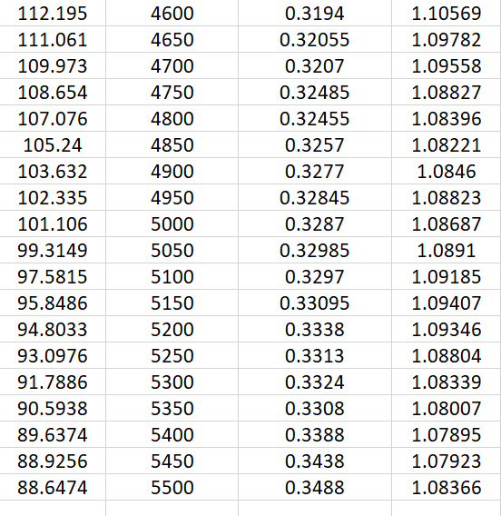
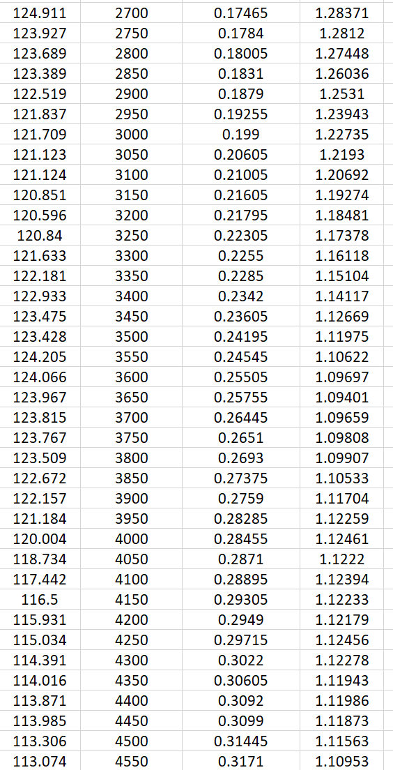
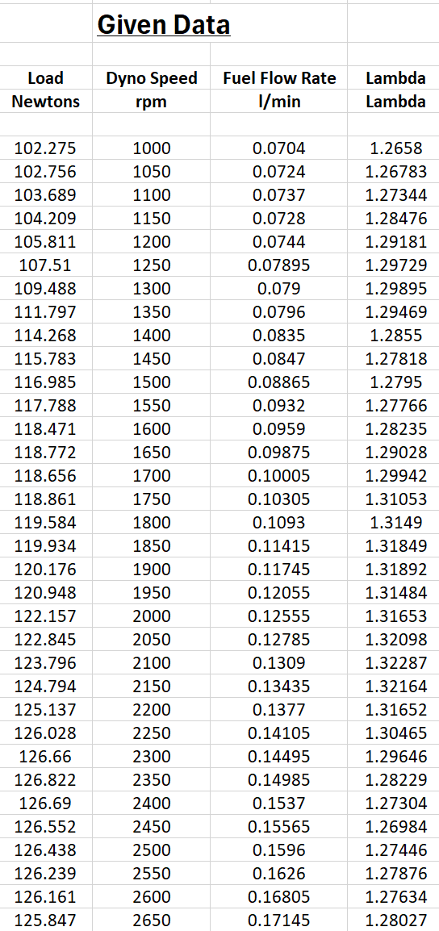

Using the data that was collected I was able to determine the Torque, Power, BMEP, SFC, Overall Thermal Efficiency, Energy Input and Brake Power values

First, I was able to determine the Torque value by multiplying the engines force by the radius of the dynamometer that I was able to acquire from the dynamometer’s specification.
Now that I had obtained the torque value I was able to use that to determine the power value in horsepower. The equation used to determine this was Torque multiplied by engine speed all divided by 5252. I also converted the power into watts by multiplying the power in horsepower by 745.7.
Then I needed to determine the Brake Mean effective pressure (BMEP). Using the equation of 2PI multiply by torque multiplied by engine speed all divided by 1.590431281 I was able to determine the BMEP in pascals. I also converted the pascals into bar by multiplying it by 0.00001.
Next up I needed to get the SFC or specific fuel consumption. I was able to determine this by

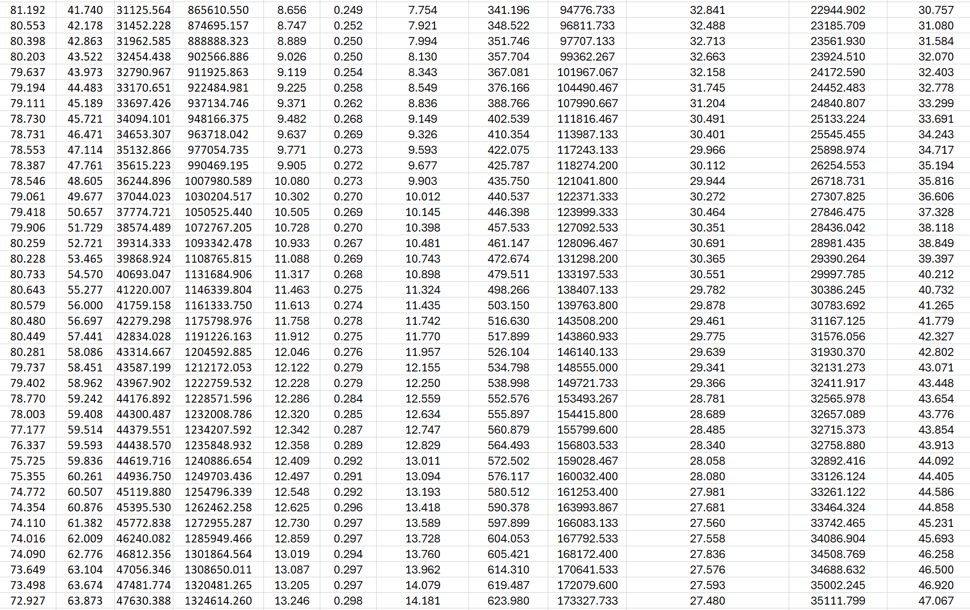
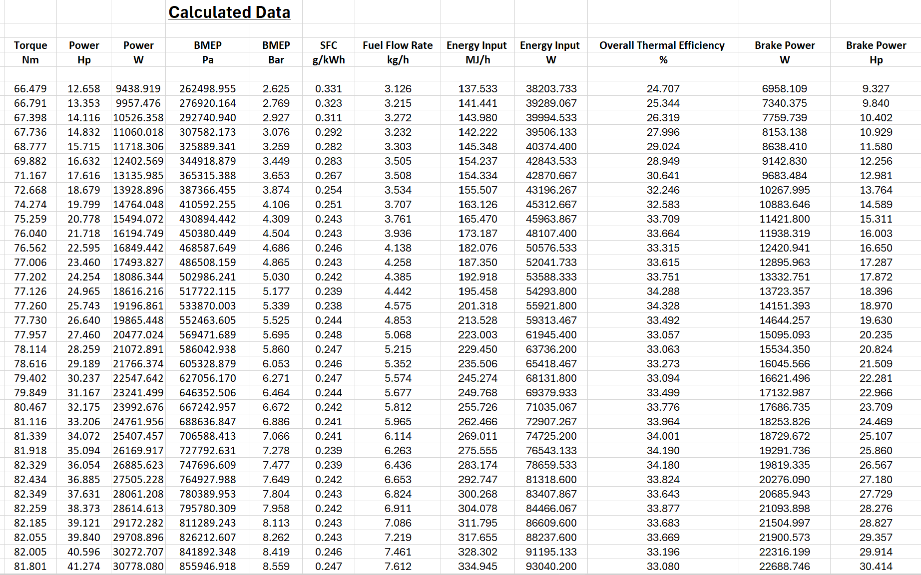
Calculated Data

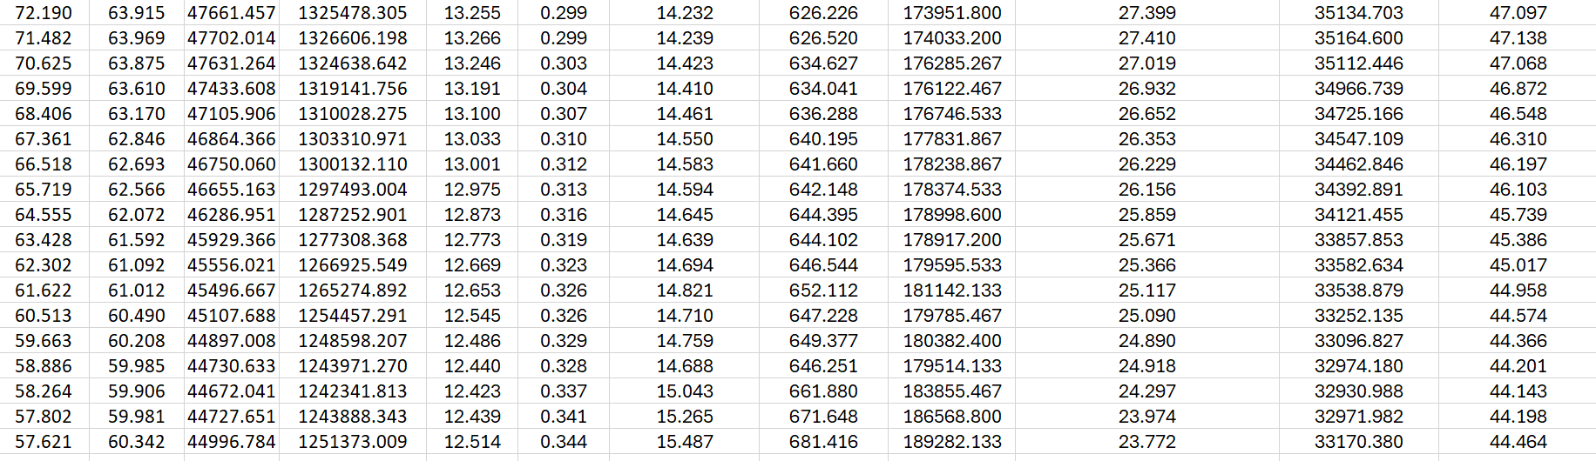

Using the data I calculated I was able to create 3 graphs one comparing SFC to Engine speed, one comparing Torque vs Engine speed and one comparing brake power vs engine speed as well as suggest reasons why there are varies between each of the graphs.

Suggest reasons why the SFC varies as it does with Engine Speed ?

An array of factors related to an engines performance and its fuel economy can result in Specific Fuel Consumption (SFC) to vary with engine speed. Incomplete combustion at lower engine speeds might result in increased SFC because of inefficient fuel use. The engine works more efficiently at higher speeds which in turn lowers the SFC value because the fuel is burned in a more efficient way per unit of power generated. However, SFC begins to rise once more at high speeds due to an increase in pumping, parasitic, thermal, and frictional losses. SFC fluctuates at different engine speeds due to changes in the air-fuel mixture, timing of ignition, and mechanical efficiency.
Suggest reasons why torque varies as it does with engine speed ?

Due to things like airflow, mechanical resistance, and combustion efficiency, the torque will vary with engine speed. Less air enters the cylinders at low speeds resulting in a weaker combustion which in turn results in the power production becoming lower, leading to decreased torque. Airflow and fuel mixing rise with increasing engine speed, allowing more powerful combustion and a rise in torque. At an average speed where power generating circumstances are ideal, the engine can achieve its maximum torque. However, higher friction, heat losses, and restrictions in the delivery of fuel and air cause torque to decrease at very high speeds, lowering overall efficiency.

Suggest reasons why brake power varies as it does with engine speed ?

Given the fluctuations in the fuel-air mixture, mechanical losses, and combustion efficiency, brake power varies with engine speed. Since there is less fuel and air entering the cylinders at low speed. The cylinders therefore produce less energy, which restricts the amount of brake power. Due to improved fuel burning and better energy conversion, combustion becomes more efficient, and power generation increases as engine speed increases. While the engine is functioning at its most powerful, brake power will normally peak new that speed. However, at the highest speeds, the engine's ability to generate useful power is decreased due to the increased friction, heat losses, and a drop in volumetric efficiency, every one of which can result in a decrease in brake power.

Conclusion

The dynamometer data analysis illustrates that efficiency and mechanical problems lead to torque and power to vary drastically with engine speed. Due to better fuel-air mixing, better combustion efficiency, and ideal cylinder filling, torque will improve as engine speed rises from the lower RPMs. Until the greatest torque is achieved at a specific engine speed the engine will operates at its highest mechanical efficiency. Following this, the engine will struggle to effectively use the intake and will burn the required amount of fuel and air which will result in a reduction in volumetric efficiency and higher frictional and thermal losses, which cause torque to diminish.
The pattern for power which derives from the result of torque and engine speed is a slightly different. Initially the power will gradually rise as the torque and speed increases. As the speed of rotation is still increasing the power may also continue to increase even after the torque has peaked and starts to go down making up for the little decrease in torque. Nevertheless there is severe frictional losses, heat accumulation, and restrictions in the delivery of fuel and combustion stability can lead the power to eventually plateau or begin to drop at high engine speeds. The h igher speeds will also result in increased strain on parts like crankshafts, bearings, and pistons, which will further lower the overall efficiency and power production.
Engine performance is greatly influenced by the fuel flow rate. This is due to the fact that m ore fuel is used to maintain combustion and power generation as the engine speed rises. However, because there are inefficiencies like incomplete combustion, increased exhaust losses, and higher specific fuel consumption (SFC) at extreme RPMs affect overall efficiency, the relationship between fuel flow rate and power output is not always linear. This explains why with a perfect range where the engine is running the most efficiently, fuel economy will often decline at both very low and very high speeds.
All things taken into account the data illustrates the way that internal combustion engines will generally behave, with an optimal speed range for maximum performance and efficiency before that peak performance will start to occur due to temperature and mechanical constraints. Enhancing an engines performance, whether in industrial machines, automotive applications, or performance tuning will require an understanding of an array of variances in torque, power, and fuel consumption. Maintaining peak performance while reducing the fuel consumption and mechanical wear depends heavily on engine management which includes the best possible gear selection, air-fuel ratio regulation, and cooling system efficiency.

Evaluation

As the experiment was unable to be carried out due to a broken dynamometer, we were supplied with data to use for this report. If able to redo this report a working dynamometer would be a great addition to help with personal understanding and also the understanding of how the experimental really works. I would improve my own understanding by doing my background reading on the topic to truly understand how the entire process works.

