University of Wales Trinity Saint David

Wales Institute of Science & Art



Fatigue Analysis of a Connecting Rod using ANSYS Mechanical
Structural Component Analysis (ACHA7030)

Ben Ellis-Jones
2204298
Date (12/2025)
Contents
1. Methodology & Workflow 2
Material research and selection 2
Model validation 2
Simply supported beam 3
Thermal load case 4
Geometry 5
Solver Setup and Analysis Workflow 6
2. Boundary Conditions & Load Cases 7
Ridged Dynamics 7
Steady-State Thermal 10
Static Structural 11
Combined Loading 12
Big end 12
Small end 15
Critical evaluation 17
3. Fatigue Life & Safety Factor Comparisons 18
4. Discussions & Critical Evaluation 19

Methodology & Workflow

Model validation
Validations models are an extremely useful tool that allow engineers to check the correlation between FEA predictions and real-world behaviour by comparing analytical and FEA results for a simplified model.

Simply supported beam
The Bending cantilever with axil force uses a stainless-steel cuboid that is fixed at one end and has a force with components of 1600N in the x (horizontal) and -7650N in the z (vertical) direction acting on the other end as shown in figure 1.
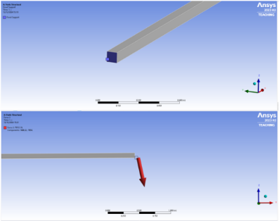
Figure 1- Boundary conditions for Simply supported beam

The counter leaver dimensions and material properties that were used can be seen in table 1.
Table 1- material properties and beam diameter used
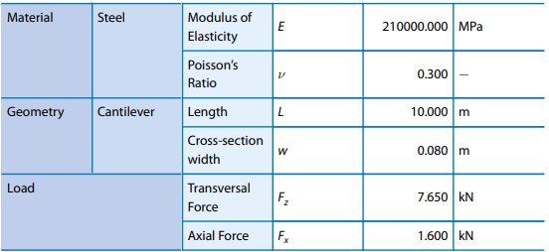

The analytical result was calculated at 3557.478mm of deflection by using the equation shown in figure 2.
Equation 1- deformation equation for cantilever beam problem

Figure 2- boundary conditions for bimetallic beamEquation 1- deformation equation for cantilever beam problem

The model produces a peak deformation of 3555.506mm. This data means that the model is accurate to 0.055% of the analytical result. This is an acceptable degree of accuracy for the methodology and software to be used going forward with this project.

Thermal load case
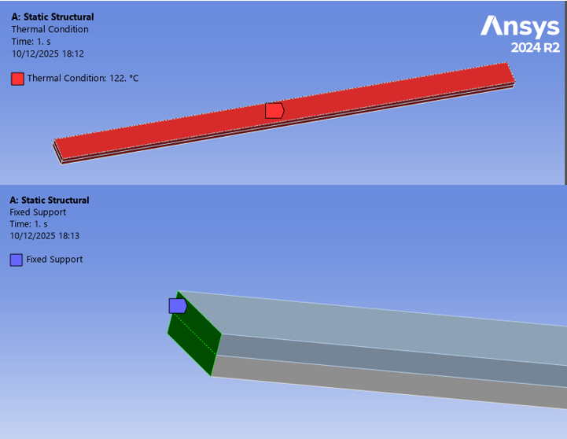
The bimetallic strip validation model consists of a half copper half invar strip, two metals with different properties (Youngs modulus, Poisson’s ratio, Coefficient of thermal expansion). This means that when a thermal load is applied, the invar will deform more than the copper causing the beam to bend. The boundary conditions are shown in figure 2.
Figure 2- boundary conditions for bimetallic beam

Equation 2-deformation equation for bimetallic beam problemFigure 2- boundary conditions for bimetallic beam
The Bimetallic strip dimensions and material properties that were used can be seen in Table 2
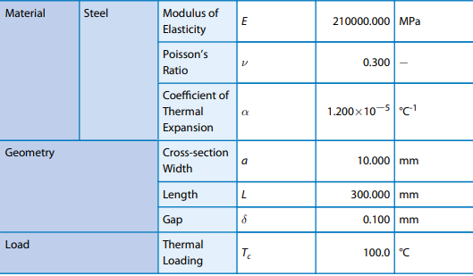
Table 2- material properties and beam dimensions for biometric validation

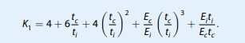
The analytical solution was calculated using the equation in equation 2 and produced a
Equation 2-deformation equation for bimetallic beam problem

Figure 3- CAD assemblyEquation 2-deformation equation for bimetallic beam problem
value of 7.049mm of maximum deflection.
The FEA model produced a maximum total deformation of 7.123mm which is 1.05% greater than the analytical calculation. This is an acceptable degree of accuracy for the methodology and software to be used going forward with this project.

Geometry
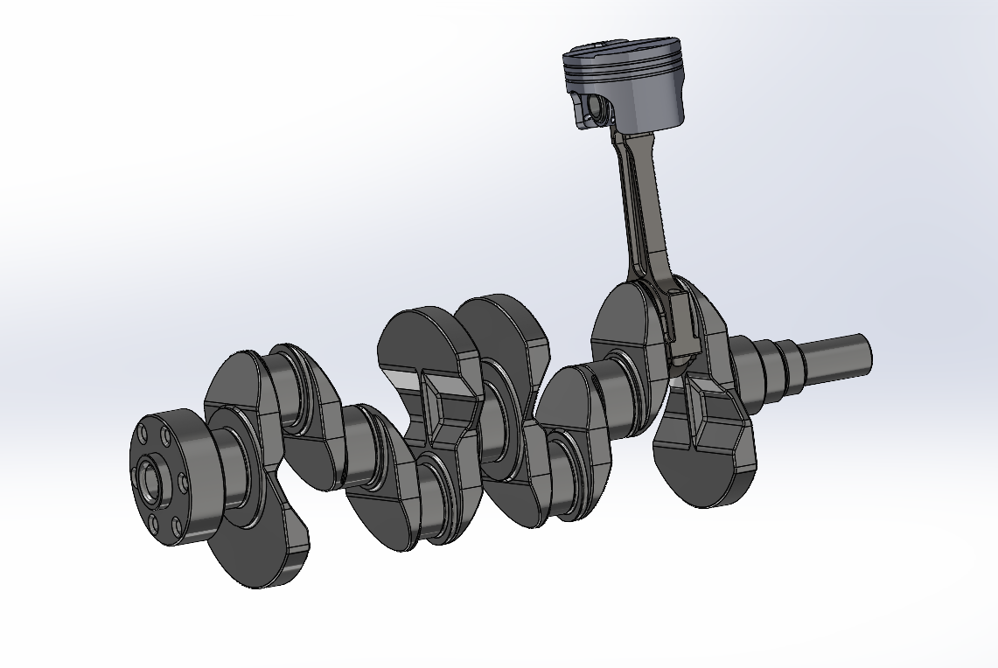
The geometry for this work is a 4-component assembly as seen in figure 5, which was provided to all students by Andrew Noble. The 4 components of the assembly are A Crankshaft, Connecting Rod, Gudgeoned Pin and Piston. Components have been simplified with filleted edges to improve the quality of meshing.
Figure 3- CAD assembly

Equation 3- equation for calculating connecting rod angle from crank angleFigure 3- CAD assembly

Boundary Conditions & Load Cases

Material research and selection
The connecting rods used in the Ford Sigma engine are manufactured from powder -metal steel (Ford Authority , n.d.), produced through a prosses called powder metal forging. There are no forger or sintered powder metals in the Granter Edu pack database, so an alternative metal was selected to represent the connecting rod as accurately as possible. AISI 4140 normalised low alloy steel was selected as it is a wrought steel alloy and Connecting Rods are listed in the typical uses section of AISI 4140 normalised low alloy steel’s page on Granter Edu pack.
This study uses Aluminium, 6061, T6 for the piston material, this material was selected for the piston because it is commonly used in automotive piston manufacturing (Aluminum.com, 2025).

Ridged Dynamics

The correct materials were assigned to each component in the assembly using structural steel for the gudgeoned pin and crank shaft, Aluminium 6061 T6 for the Piston and AISI 4140 normalised low alloy steel for the connecting rod.

Joints
Revolute body to body joints were created to accurately represent the mechanical relationships between the piston and gudgeon pin, gudgeon pin and connecting rod, connecting rod and crank shaft. Ground to body joints were used to constrain components the need external reference points. A revolute joint was used between ground and the crankshaft to prevent translation in all axes and allow for rotation only in the z axis. A general joint was used between the ground and the piston preventing rotation about all axis and allowing for translation only in the z axis. These constraints allow the assembly to behave realistically.

Steady-State Thermal
In order to perform Steady state thermal testing, the connecting rods stiffness behaviour was set to flexible, and all other bodies were supressed. Thermal loadings were applied to represent operating temperatures of an internal combustion engine at the small and big end of a connecting rod. Temperature loads were applied at the bores of the big and small end of the connecting rod based on published tribo-dynamic studies. Jiabao Yin, Rui Zhang, Bugao Lyu and Xianghui Mang found that a “experimental bearing achieves 133°C” (Yin, et al., 2024) at the big end bearing under operational conditions. In a study by the same authors “Temperature evolution prediction of engine big-end bearing by tribo-dynamics modelling and wireless measurement verification” (Yin, et al., 2024) , the small end bearing is considered, this study finds that “the test bearing upper part reaches 165 °C”. These findings were used as the boundary conditions for this study.

Static Structural
To prevent translation of the whole connecting rod when inertia and gas forces are applied, constraints were applied. A cylindrical support that is free for radial deformation only was used because it allows for local deformation whilst constraining to connecting rod. This support was applied to the opposite end from the inertia forces.
The maximum tensile and compressive deformation and stress on a connecting rod are needed for fatigue analysis and what the static structural section is calculates. The maximum tensile and compressive forces do not occur at 0 degrees of Crank angle. This means that the global co-ordinate system will not be aligned with the direction that these forces are acting in and a custom co-ordinate system must be used when applying forces to the connecting rod.
The crank angle that correlated to the peak cylinder pressure in the provided excel (at the relevant RPM) was assumed to be the crank angle where the highest compressive forces were seen as the ridged dynamics model calculates forces with respect to time and not crank angle. Once the maximum compressive force from the rigid dynamics output was assigned a crank angle, the crank angle difference between the maximum tensile and compressive forces can be calculated. This was calculated using the ratio of time differences between two compressive peaks and a compressive and tensile peak and the RPM.

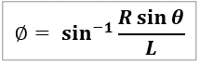
Gass pressure from corresponding calculated crank angles was used to calculate gas force. This was done by converting bar into pascals and then pressure into force by multiplying by the area of the cylinder which was calculated using the bore from the technical sheet provided.
Equation 3- equation for calculating connecting rod angle from crank angle

The equation if figure ~ was used to convert crank angles (theta) at the tensile and compressive peaks into connecting rod angles (Phi) where R is crank radius and L is connecting rod length.
The Tensile rod angle was calculated by using the sum of crank angle difference to the compressive peak and the crank angle difference between the compressive peak and the global co-ordinate system.
The calculated gas force and inertia forces were applied to the bore of the connecting rod at the big and small ends using bearing loads acting in alignment with the custom co-ordinate systems.

Combined Loading
To combine the loads cases, built in ANSYS solution combination and fatigue tools were used. The fatigue tool was set to use goodman as its mean stress theory and was set to consider the X component of the normal stress.

Big end
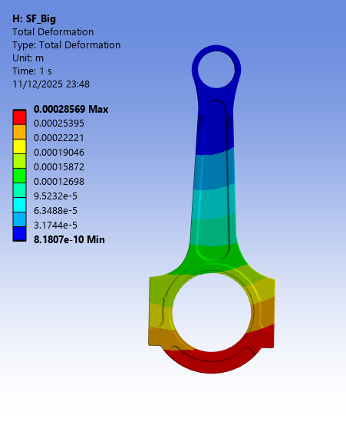
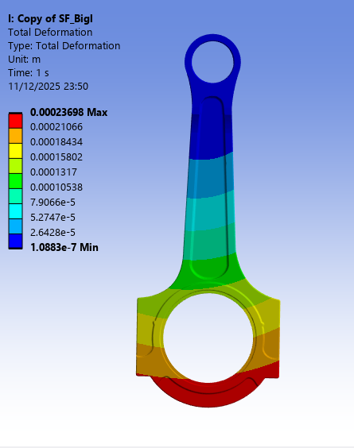
Figure 4- Total deformation- compression acting on the big end of the connecting rod
Figure 5- total deformation - tension acting on the big end of the connecting rod

Figures 4 and 5 show the total deformation under peak compressive and tensile loads respectfully at the big end of the connecting rod. Both cases show similar deformation patterns with the peak deformation can be seen at the underside of the connecting rod. Larger deformation is seen when the connecting rod is under compression. This may be because the gas force is acting against the inertia force whereas they are both acting in the same direction under tensile loading.
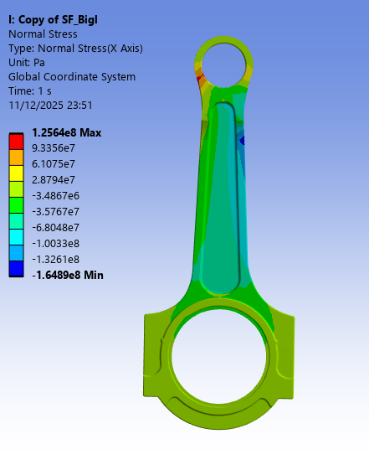
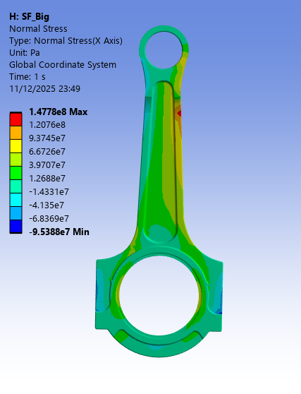
Figure 6- normal stress - compression acting on the big end of the connecting rod
Figure 7- normal stress - tension acting on the big end of the connecting rod
Figures 6 and 7 show the Normal stress under peak compressive and tensile loads respectfully at the big end of the connecting rod. Under compressive loads, significant stress is seen at the small end bearing whereas under tensile loads the peak stress is seen in the main body of the crank shaft, this is because the peak tensile force occurs at 168 degrees crank angle from TDC.

Small end
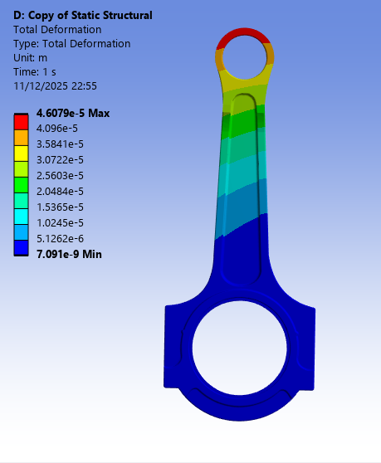
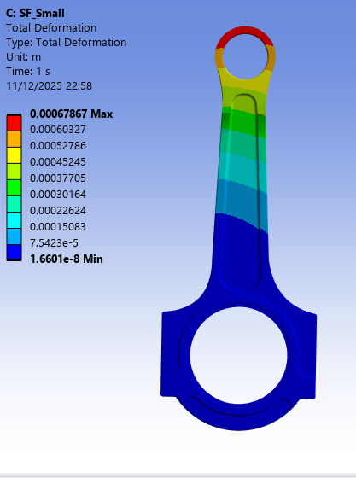
Figure 8- total deformation - tensile acting on the small end of the connecting rod
Figure 9- total deformation - compression acting on the small end of the connecting rod

Figures 9 and 8 show the total deformation under peak compressive and tensile loads respectfully at the small end of the connecting rod. Both cases show similar deformation patterns with the peak deformation can be seen at the top of the connecting rod. Larger deformation is seen when the connecting rod is under compression.

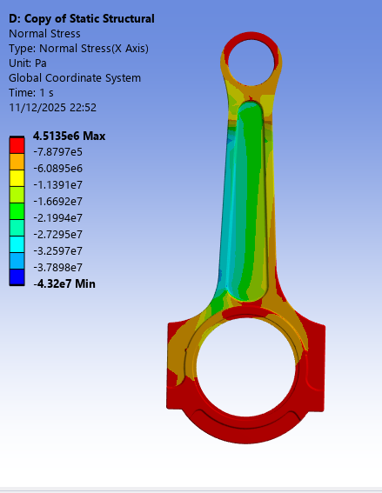
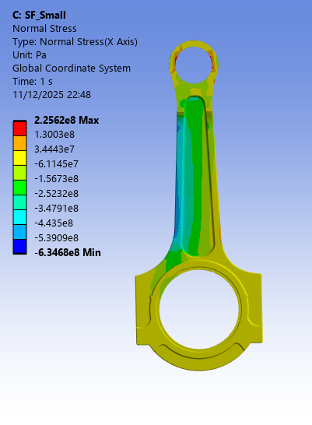
Figure 10-- normal stress - tension acting on the small end of the connecting rod
Figure 11- normal stress - compression acting on the small end of the connecting rod
Figures 11 and 10 show the Normal stress under peak compressive and tensile loads respectfully at the big end of the connecting rod. There is higher stress seen under compression. Under tensile loads, high stress can be seen around the big end bearing and small end bearing as it is being ‘stretched’.

Critical evaluation
Several modelling assumptions and simplifications will have impacted the results.
The geometry simplification to all components will have affected the weight of each component with will affect the rigid dynamics inertia force calculations. The geometry changes could have an effect on stress paths affecting the normal stress and safety factor calculations.
At the static structural phase, forces were applied on the same part of the geometry as a constraint affecting the forces impact on the component. Gass forces applied at the contract when calculating for big end forces and Inertia force applied at the constraint when calculating for small end forces.
Only one motion load can be imported to the steady state section. Both compressive and tensile forces are needed for safety factor calculations. These forces were applied as bearing loads manually instead of imported directly from the rigid dynamics.

Fatigue Life & Safety Factor Comparisons
This section displays and compares the results from the analytical and FEA for inertia forces and safety factors.

Inertia forces
Figure 12 shows the FEA predictions calculated in rigid dynamics and the analytical results. Both outputs are plotted over one engine cycle.
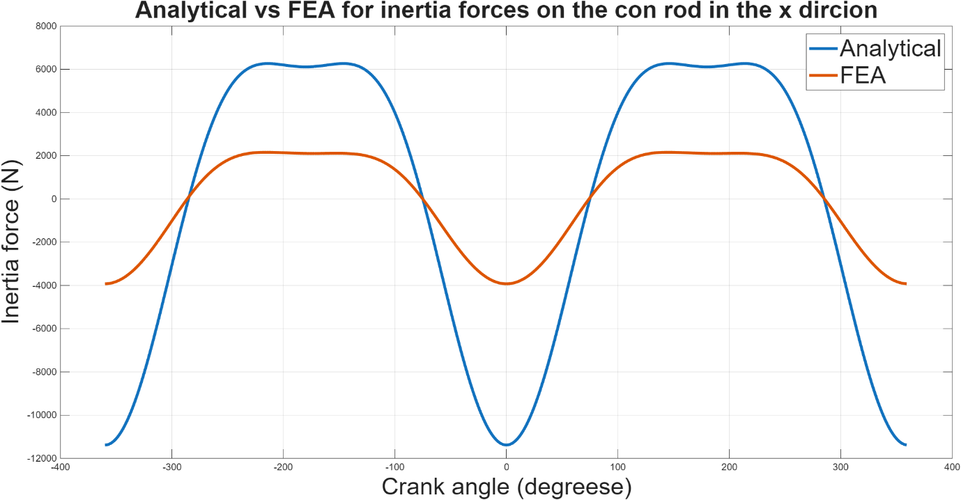
Figure 12- FEA vs Analytical for inertia forces in the x direction
Table 3- table of comparison for analytical and FEA results for inertia force
 | Analytical | FEA
Compressive inertia force peak (N) | -11380 | -3925.1
Tensile inertia force peak (N) | 6260.25 | 2162.4

Table3 shows poor correlation between the two methods of calculation with the analytical method producing significantly higher compressive and tensile forces.
Possible reasons for differences
Small discrepancies can be expected due to assumptions in ANSYS’s rigid dynamics solver or the boundary conditions used. However, significant discrepancy as seen in figure 12 suggest an error in the modelling methodology or calculations

Safety factor
To evaluate the fatigue performance of the connecting rod, safety factors were calculated. A safety factor above 1 is considered to have an infinite life span as it can withstand 1e^8 cycles of the tested load case.
Table 4- comparative table for safety factors when looking at the big and small end of the connecting rod with and without thermal loadings
 |  | Without thermal loads |  | With thermal loads
 | Analytical | FEA small end | FEA big end | FEA small end | FEA big end
Safety Factor | 3.5423 | 1.2127 | 2.4306 | 2.0586 | 3.4081

Table 4 compares the fatigue safety factors form analytical and FEA. All calculations produce a safety factor above 1 indicating that the connecting rod for the sigma engine will not experience failure in its lifetime. The safety factor is as high as 3.5423 in the analytical and 3.4081 when considering forces acting on the big end of the connecting rod and including thermal loads.
When applying a thermal load, the safety factor should decrease as metals become more malleable when heat is applied but that is not what is observed in table 4
Forces were separated to what was seen at the small end and big end of the connecting rod and was not combined to give a wholistic stress, deformation or safety factor output.

Discussions & Critical Evaluation
The validation studies demonstrated that the ANSYS Mechanical setup can reproduce analytical solutions for both mechanical and thermo-mechanical problems to within 1%.
The stress and deformation distributions under peak tensile and compressive loads were calculated using a combination of rigid dynamics, steady state thermal and static structural solvers in ANSYS. The maximum stress was observed around bearing bores at both ends which is what would be expected.
However, there was poor correlation between the analytical and FEA results for inertia forces and safety factors (safety factors are calculated using the inertia forces so the discrepancy is carried forward).
This study uses ANSYS to calculate the inertia forces and perform a fatigue study. Future work should be focused around both methods of calculating inertia force to get better corelation before the forces are carried forward into the static structural and fatigue analysis sections.
Thermal loads were included to better represent the real-world, but they are not typically used in industry for fatigue study’s because they do not have a significant positive impact on the model whilst adding complexity.
There are no connecting rod bolts are the most common part to fail. Whilst the connecting rod would not fail under these conditions it is possible that the bolts would have a safety factor of below 1 under the same conditions.

Appendix
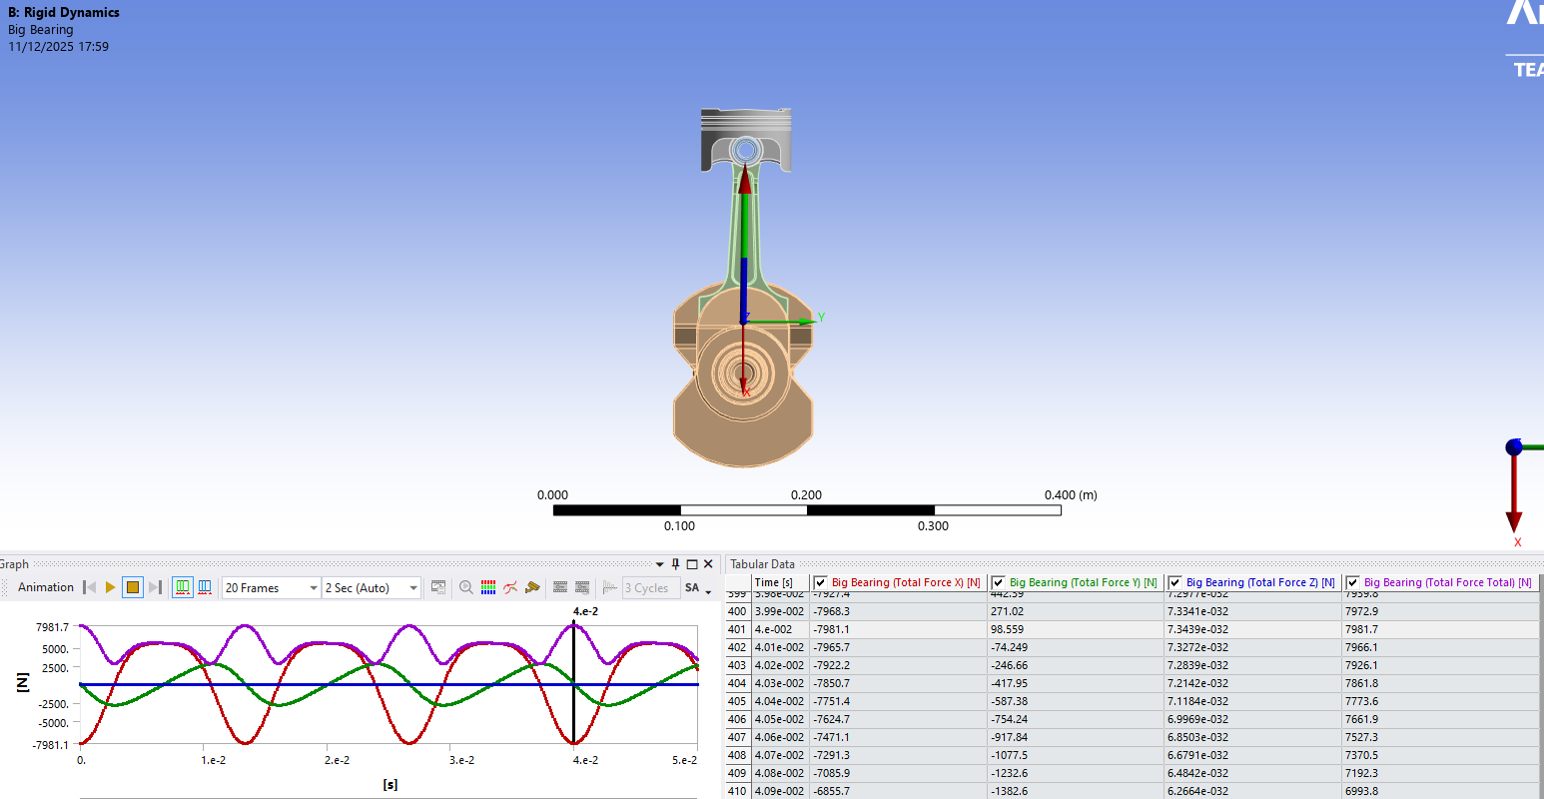
Figure 13- rigid dynamic result for compression peak at the big end probe

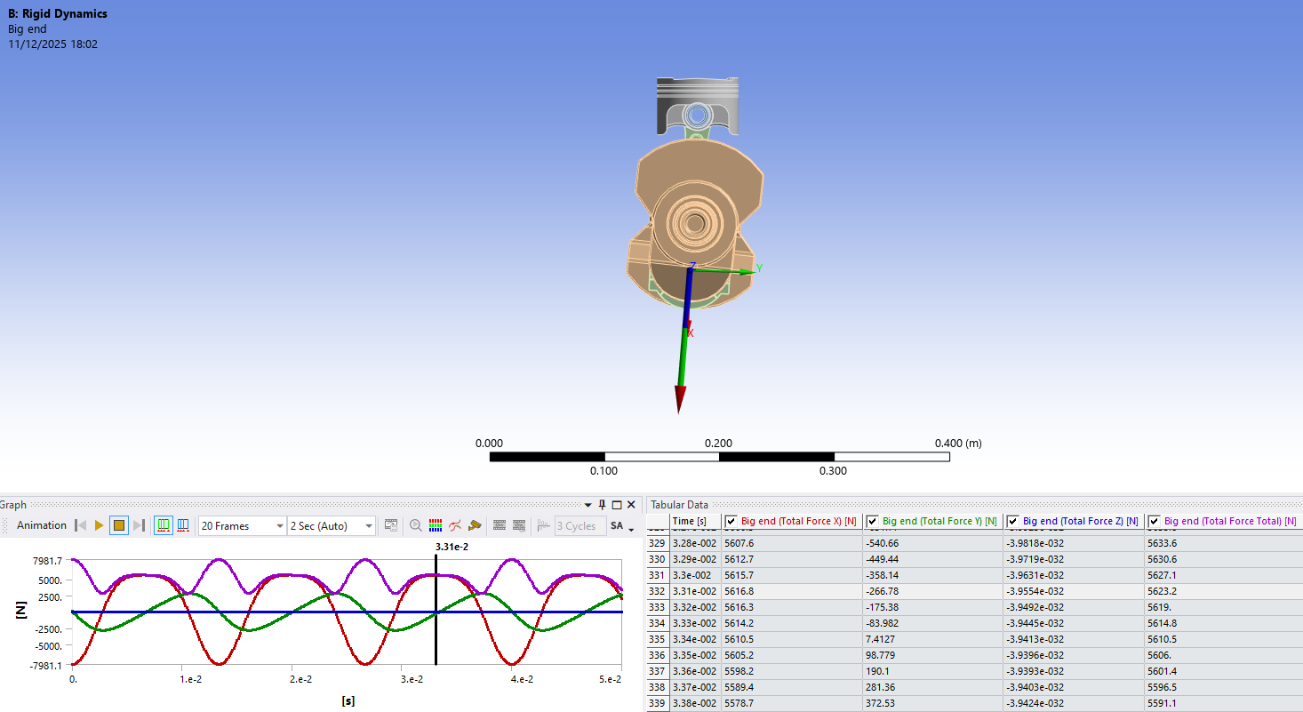
Figure 14 - rigid dynamic result for tensile peak at the big end probe

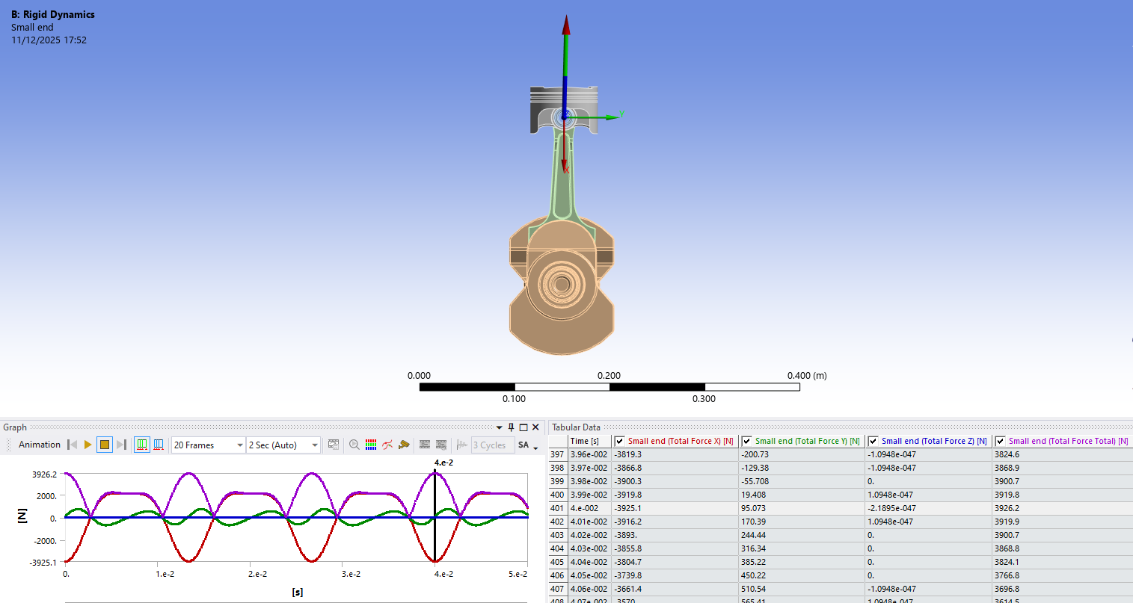
Figure 15rigid dynamic result for compression peak at the small end probe

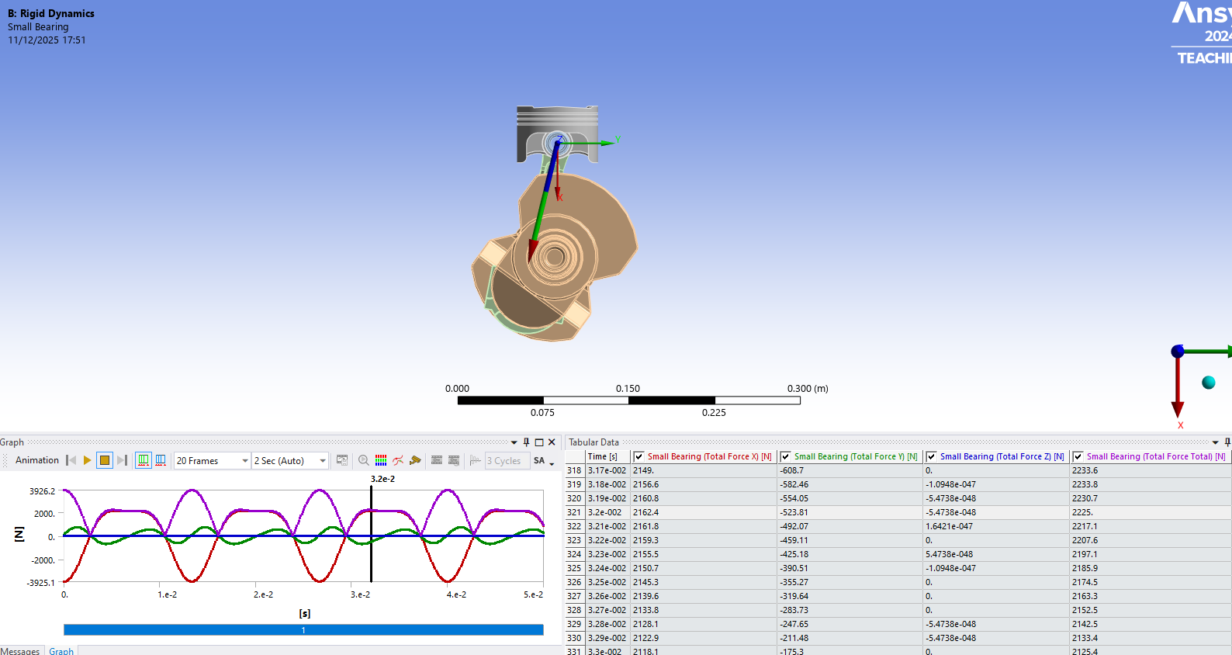
Figure 16-rigid dynamic result for tensile peak at the small end probe

References
Aluminum.com, 2025. A Deep Dive into 6061-T6 Aluminum: Properties, Heat Treatment & Uses. [Online]
Available at: https://www.hxm-aluminum.com/news-blog/blog/a-deep-dive-into-6061-t6-aluminum-properties-heat-treatment-uses.html
[Accessed 12 12 2025].
Ford Authority , n.d. Ford 1.6L Sigma Engine. [Online]
Available at: https://fordauthority.com/fmc/ford-motor-company-engines/ford-sigma-engine-family/ford-1-6l-sigma-engine/
[Accessed 12 12 2025].
Yin, J., Zhang, R., Lyu, B. & Meng, X., 2024. Temperature evolution prediction of engine big-end bearing by tribo-dynamics modeling and wireless measurement verification. Tribology International, Volume 194.
Yin, J., Zhang, R., Lyu, B. & Meng, X., 2024. Tribo-dynamics analysis of engine small-end bearing under real temperature boundary conditions by a wireless in-situ measuring technology. Tribology International, Volume 194.

Table of figures

Figure 1- Boundary conditions for Simply supported beam 2
Figure 2- boundary conditions for bimetallic beam 4
Figure 3- CAD assembly 6
Figure 4- Total deformation- compression acting on the big end of the connecting rod 10
Figure 5- total deformation - tension acting on the big end of the connecting rod 10
Figure 6- normal stress - compression acting on the big end of the connecting rod 11
Figure 7- normal stress - tension acting on the big end of the connecting rod 11
Figure 8- total deformation - tensile acting on the small end of the connecting rod 12
Figure 9- total deformation - compression acting on the small end of the connecting rod 12
Figure 10-- normal stress - tension acting on the small end of the connecting rod 13
Figure 11- normal stress - compression acting on the small end of the connecting rod 13
Figure 12- FEA vs Analytical for inertia forces in the x direction 15
Figure 13- rigid dynamic result for compression peak at the big end probe 17
Figure 14 - rigid dynamic result for tensile peak at the big end probe 18
Figure 15rigid dynamic result for compression peak at the small end probe 18
Figure 16-rigid dynamic result for tensile peak at the small end probe 19
Table 1- material properties and beam diameter used 3
Table 2- material properties and beam dimensions for biometric validation 4
Table 3- table of comparison for analytical and FEA results for inertia force 15
Table 4- comparative table for safety factors when looking at the big and small end of the connecting rod with and without thermal loadings 16
Equation 1- deformation equation for cantilever beam problem 3
Figure 2- boundary conditions for bimetallic beamEquation 1- deformation equation for cantilever beam problem 3
Equation 2-deformation equation for bimetallic beam problemFigure 2- boundary conditions for bimetallic beam 4
Equation 2-deformation equation for bimetallic beam problem 5
Figure 3- CAD assemblyEquation 2-deformation equation for bimetallic beam problem 5
Equation 3- equation for calculating connecting rod angle from crank angleFigure 3- CAD assembly 6
Equation 3- equation for calculating connecting rod angle from crank angle 9

