Health and Wellbeing Sustainable Development

Assessment 1- Report

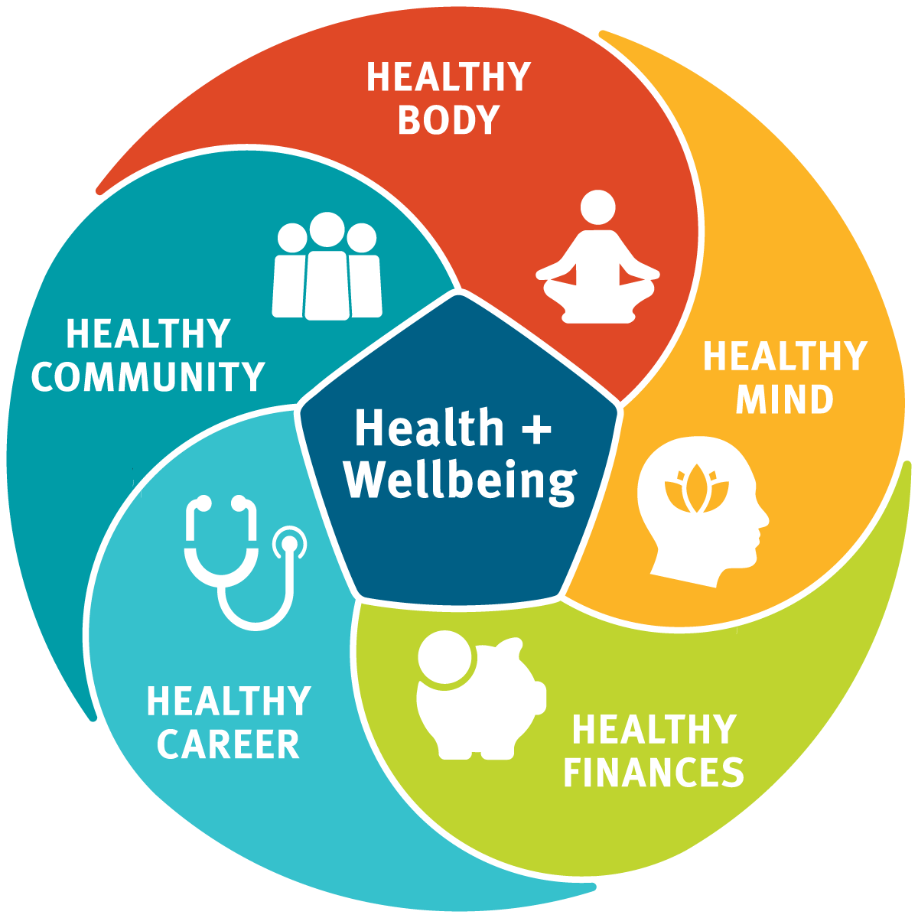

Module code: BMHP6021
Student name: Catiana Braganca
Lecturer: Cristopher Mafuva

Table of Contents

Health and Wellbeing Sustainable Development 1
Assessment 1- Report 1
Introduction: 3
Briefly discuss the 17 Sustainable Development Goals 3
Detailed discussion of the 3 SDGs of your choice: 5
Two to three UK policies or initiatives adopted by UK government in meeting these 3 SDGs 5
Introduction of identified city/borough 5
Local policies and statistics (borough) identified to meet the 3 SDGs 5
Reviewing the status of borough to meeting the 3 SDGs 5
Recommendations (minimum four) 5
Conclusions 5
References 5

Introduction:
In this assignment report, we will make a project report based on London as a health and wellbeing consultant.
It is required to choose three sustainable Development goals where one of them is mandatory, which is Goal 3- Good health and well-being, the other two sustainable goals chosen by me are Goal 5- Gender Equality and Goal 4- Quality Education.
In the Development of this report, we will be analysing policies in the UK that the government achieved in addressing these goals, The borough I choose to discuss is Barking & Dagenham Council.
In Conclusion, we will be providing recommendations using evidence to improve the actual problem of the borough on the sustainable development goals created by the United Nations

Briefly discuss the 17 Sustainable Development Goals
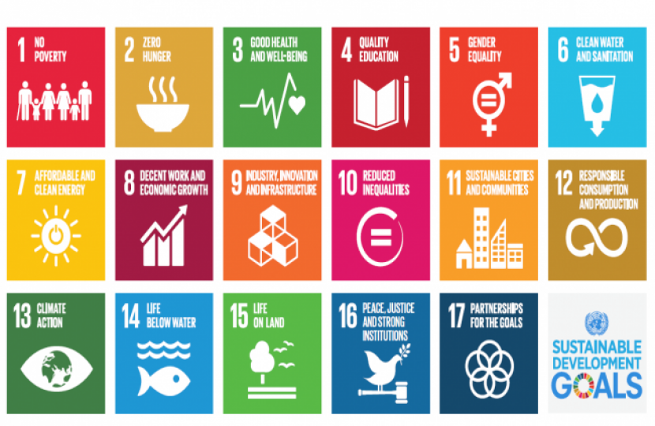
According to the (United Nations, 2015), they created Sustainable Development Goals. A group of 17 universal goals, to progress the world and the value of people´s lives over the world in the year 2030. Below is what they came up with.
17 Sustainable Development goals include:
First Goal- No Poverty, the first goal aims to finish poverty in all aspects around the world. The organization (UNICEF, n.d) explains that child poverty is the absence of community and personal needs income to recognize rights including good food, water, health, learning, and housing. A child without their basic needs can´t have opportunities and the capacity to reach their highest potential. A poor child is more affected than a poor adult because it affects their permanent life and has consequences in the future.
Second Goal - Zero Hunger, the second goal aims to eliminate the lack of food, accomplish food safety, make better nourishments, and provide continual agriculture. (United Nations,2015). The Organization (UN Environment Programme,2024) states that the growth of world residents and variations in eating models place weight on the climate making the requirement to create nutrition for an extra two billion individuals in 2030, although conserving and improving the normal supply ground, where the happiness of current and future creations base.
Third Goal- Good Health and well-being, The organisation UNICEF evidence that health and well-being are essential at each step of individual life, starting from the initial. The third goal focuses on the avoidance of unnecessary suffering from preventable disease and early death, it aims at principal objectives that improve the health of a nation’s global residents. (UNICEF, n.d)
Fourth Goal- Quality Education, makes sure that everyone has a good education as well as opportunities for long-term study. (UNICEF, n.d) the fourth goal helps with the decrease of inequality and differences, together in a condition of entrance and value.
Fifth Goal- Gender Equality, accomplish equal opportunities for men and women and permit every adult female and girl. (UNICEF, n.d) the fifth goal is based on gender equality which is an individual right, while young ladies and young man on common tackle similar difficulties in early infancy, sex differences become more evident as infants develop.
Sixth Goal- clean water and sanitation, the sixth goal is to make sure that there is water available, as the continuous control of water and cleanliness for everyone.
(UNICEF, n.d) Water and hygiene are serious to the health of humans and the earth. The sixth goal does not simply focus on the problems linked to the consumption of water, sanitation, and hygiene but furthermore the value and continual of water reserves globally.
Seven Goal- Affordable and Clean Energy, makes sure that has low-cost, decent, continual, and current energy for everyone. (UNICEF, n.d) Sustainable energy is an important facilitator and considerably increases the value, availability, and consistency of benefits that children rely on for their existence, improvement, and welfare.

Eight Goal- Decent work and economic growth, this goal is about children's labour it focuses on ending the terrible forms of labour in a child for example employment and using a child to be a soldier, and to eliminate any kind of child work in 2015. (UNICEF, n.d). Children in most countries of the world are defined as child labour when they have a very short age to work and take actions that might affect their bodies with injuries, psychological, community, or learning progress.
Nine goals- Industry, Innovation, and Infrastructure
It has been shown by the (UN Environment Programme, 2024) that building new simpler structures, upgrading, or reconstructing current infrastructure schemes, and abusing the perspective of intelligent machinery can highly commit to the decrease of atmosphere effects and tragedy risks along with the creation of strength and the rise of competence in applying usual incomes.
Tenth goal- Reduced Inequalities. According to (UNICEF, n.d) public and financial differences and weaknesses in young life can reduce the opportunities for the comprehension of an individual´s rights and the capacity to recognize an individual´s maximum expectations. Discrimination focuses on age, sexual category, cultural or ethnic group, disability position, sexual orientation, or other causes that work to damage some people in loads of diverse and regularly hidden ways, all over their lives.
Eleventh goal- Sustainable Cities and Community (UN Environmental program,2024) This goal aims to construct a city's strength, which is important to prevent human, communal, and financial damage, whereas enhancing the continual development procedures is required to safeguard the atmosphere and alleviate tragedy hazard and weather alteration.
Twelve Goal- Responsible Consumption and Production, sustainable development goal 12 analyse ways they may help our territory by creating alterations to our consumption and production models. There are two ways that all of us may help which is by diminishing waste and making reflection regarding where they purchase their aliments and costumes. (United Nations,2015)
Thirteenth goal- Climate Action (UNICEF, n.d) evidence that climate alteration and earth damage are issues of fairness that ruin the freedom of all children, particularly the most unfavorable. Climate change influences a child´s capacity to live, develop, and flourish.
Fourteenth goal- Life Below Water. this goal is important in helping life on the planet, they support general and local basic cycling and monitoring the weather. Ocean promotes natural finances such as nutrition, equipment, objects, and energy. (UN Environment Programme 2024)
The fifteenth goal- Life on Land, is also another important goal that protects and rebuilds earthly creatures, battles erosion, freezes and changes land degeneration, and terminates a variety of life absences. (Department of Global Communication 2023)
Sixteenth goal- Promote justice and peaceful and inclusive societies. The purpose of this goal is to bring the approach to fairness for everyone and create active, responsible, and inclusive associations at all stages. (UNICEF, n.d)
Seventeen Goal- Partnership for the Goals, The seventeen development sustainable goals may individual remain achieved with a firm responsibility to universal collaboration and support to make sure nobody is placed backside in our progress to growth. (United Nations, n.d)

Detailed discussion of the 3 SDGs of your choice:
Goal 4- Quality Education
Sustainable development goal 4, understands the desire to promote good education for everyone. Including mainly sensitive people such as deprived children, children who live in countryside areas, individuals with ill health, or immigrant children. (UNICEF, n.d)
The organisation (UNESCO,2023) consider that right of education is human for everyone during the life and that value should relate to access. The agency of United Nations is the single organisation that has permission to discuss every form of education, also they assigned to guide the agenda of global education 2030 by using SDG 4.
Goal 3- Good Health and Wellbeing
This goal makes sure that people have healthy lifestyles and provide comfort for everyone of any age (United Nations, 2015)
Zones with the greatest problem of disease and forgotten people groups and regions are urgent areas. Health and well-being are also named for serious funds for investigation and enhancement, health funding, and health hazard decrease and organisation. (UNICEF, n.d)
A clean world is necessary for individual health and welfare. Alternatively, atmosphere and water contamination as well as poor control of dangerous elements and unwanted leads to weak health. Natural tragedies and ecological tremors might have considerable influence on well-being, involving losses, damages, illnesses, incapacities, mental problems and extra secondary effects with harm to health services and disturbance to the distribution of health facilities ended prolonged phases of time. (UNEP,2024)

Goal 5- Gender Equality
Gender Equality is defined as all men and women, young girls and boys are free to choose any profession, decide to eat healthily, and have skills they desire deprived of discrimination. (Human Rights Careers)
Young girls, because of estimated female tasks, can elevate an unbalanced obligation of domestic job, opportunity to stay married, hazards of young pregnancy, also sexual and female or male violence. (UNICEF, n.d)

Two to three UK policies or initiatives adopted by UK government in meeting these 3 SDGs.

Goal 3- Good Health and Wellbeing
According to (Health Foundation, 2022) people are straining to receive the proper care they want because of the issues of high prices for living people will feel under force, and the government will apply policies.
Deliver shortage of employees. the NHS needs a continuing workers plan, supported by continuous government financing the policy should consider the quantity of employees and which kind might be wanted in future and in what way they will stay qualified, employed, and reserved after they stay in the NHS. This indicates reflecting on the way care might adjust to connect the public’s health necessities, in addition to how to lower employees' jobs and increase structural principles.
Minimize the number of people waiting in hospitals to be treated, to improve this problem policies need to be considered including enhancing NHS infrastructure, increasing information and numerical organisation, helping with actual control, and familiarising rules and reimbursement schemes to provision new inventions in care.
Allow individuals to live healthy lives.
Allowing the population to live beneficial lives must be of principal importance. The government has dedicated itself to increasing the country but therefore has not coordinated this motivation with the policy variations or financing required to challenge community and financial drivers of health disparities. Cross-government action is required such as, increasing living conditions and reinforcing public safety. Their work delivers a mixture of interferences that might create a portion of a cross-government method to enhance health and falling health inequalities. This must include enough money for resident government, who play an essential position in enhancing health however have understood their community well-being finances have reduced by about four per person from 2015 – with money dropping more in additional underprivileged areas. The new government must take onward the situation late health differences white paper to state how this will be finished, organising the involvement of every sector over its Health Promotion Team. (Health Foundation,2022)

Goal 4- Quality Education:
According to (the Department for Education,2021) they create a plan to explain the delivery of important findings, control and calculate their success as well as make sure that people have permanent growth.
- Increase the education principles for children and young people in all positions of the country who are ready with the intelligence, talents, and certificates they want.
- Give Assistance to the highest poor and unprotected children and young people over good-value area assistance so that nobody is placed backside. The assistance categories include DCMS, Department of Health and Social Care (DHSC), DWP, Home Office (HO), MHCLG, and Ministry of Justice (MoJ).

Goal 5- Gender Equality
Human Rights Act 1998 is based on the essential human rights and liberty that all human beings in England are authorised. It integrates the rights revealed in the European Convention of Human Rights inside the Home British Act.
The Act is divided into different articles of human rights, the articles are obtained from the European Convention on Human Rights. This Act declares that people have the right to live and be free from suffering and cruel or damaging medicine. It also says that people are free from slavering, and mandatory employment. (Equality and Human Rights Commission, 2018)

Equality Act 2010- gender is one of the safeguarded descriptions in the Act and there are detailed specifications excluding sexual persecution and workplace judgement involving salary. (UK Parliament, 2024) The Equality Act legitimately defends individuals from discrimination in the job and broader civilisation. (GOV.UK,2013)

Introduction of the identified borough

Health profile of Barking and Dagenham Borough
Barking and Dagenham's profile demonstrates a photograph of public health, it is considered to represent a dialogue starter, this helps health services and local authority comprehend their public necessity, therefore they may work as a team to progress society’s health and decrease health inequalities. (Public Health England,2020)
The city district was integrated in 1993 as the Municipal Borough of Barking. It was demolished in 1968 and separated, with the larger part involved with the past area of the National Borough of Dagenham to create the London Borough of Barking, the borough Barking & Dagenham was relabelled in 1980 (FamilySearch,2024)
According to (Public Health England,2020) There are more disadvantages to Barking and Dagenham borough, out of 20 per cent, it is one of the poorest districts in comparison to England, and life expectancy is reduced either in men or women. Around 22.5 per cent of children live in minimal-wage families. More teenage women are getting pregnant in the borough, but England is normal. The scales of legal homelessness, aggressive crime (hospital prices for violence), below 75 death scale with heart diseases, below 75 death scale with cancer and work (becoming old between the ages of 16 to 64) are critically compared to England's normal.
Regarding the advantages of the borough there are some including the rate for alcohol-related injury hospital entries is 503*, better compared to the normal in England. The rate of murdered and gravely harmed on highways is superior to the England standard.
Local policies and statistics (borough) identified to meet the 3 SDGs

Reviewing the status of city/borough to meeting the 3 SDGs

Recommendations (minimum four)

Conclusions

References:

United Nations, (2015) https://education.nationalgeographic.org/resource/sustainable-development-goals/
UNICEF,(n.d) https://data.unicef.org/sdgs/goal-1-no-poverty/
UN Environment Programme (2024) https://www.unep.org/explore-topics/sustainable-development-goals/why-do-sustainable-development-goals-matter/goal-2
(Department for Education,2021) https://www.gov.uk/government/publications/department-for-education-outcome-delivery-plan/dfe-outcome-delivery-plan-2021-to-2022
(Department of Global Communication,2023) https://www.un.org/sustainabledevelopment/wp-content/uploads/2019/01/Goal-15-Fast-Facts.pdf
https://www.unesco.org/en/articles/ensuring-quality-education
https://www.humanrightscareers.com/issues/what-does-gender-equality-mean/

Equality and Human Rights Commission (2018) The Human Right Act . Available at: https://www.equalityhumanrights.com/human-rights/human-rights-act (Accessed:
GOV.UK (2013) Equality Act 2010: guidance. Available at: https://www.gov.uk/guidance/equality-act-2010-guidance (Accessed:
Public Health England(2020) Local Authority Health Profile 2019. Available at: https://fingertips.phe.org.uk/static-reports/health-profiles/2019/E09000002.html?area-name=Barking%20and%20Dagenham (Accessed:
Health Foundatio ( 2022) Four health policy priorities for the new government Available at: https://www.health.org.uk/sites/default/files/2022-09/four_health_policy_priorities_for_the_new_government_0.pdf Accessed:

