Using turtle

Turtle is a Python library that is used to do some basic graphical work (using a cursor).

The turtle is a cursor, and we can instruct it to move.

For example, here I have moved the turtle forward, turned it right and then moved forward again:

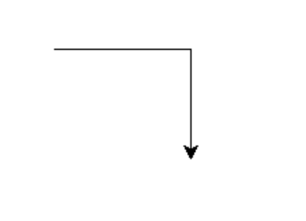

Despite its simplicity, Turtle is a useful tool for learning how to program because you can see a graphical result on the screen. It is helpful to build logic skills, as well as programming skills. We will use turtle to practice the use of loops etc.

Start a new python file in the PyCharm IDE, but DO NOT call it turtle.py! (this is because it will cause confusion with the turtle library.) Call it another name, eg move.py

First, we need to import the turtle library. This contains all the commands required to make the turtle move. I've also added turtle.done() at the end which will keep the turtle window open.

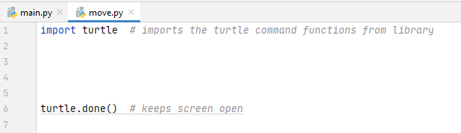

Next, we need to create a turtle with turtle.Turtle(). We will chose a variable for our turtle (I've chosen myturt)

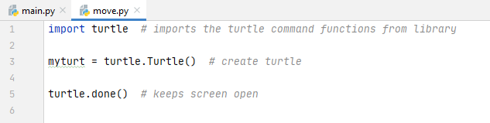

Run the program, and you should see a window pop up. This is a "Python Turtle Graphics" window and you will see the turtle on it:

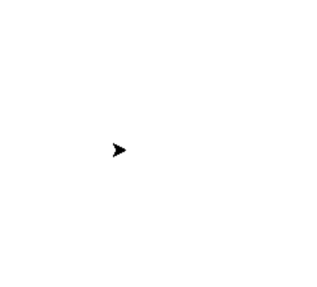

forward()

Now, we can use our variable myturt to control our turtle. I've used the forward() function

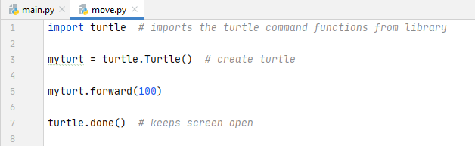

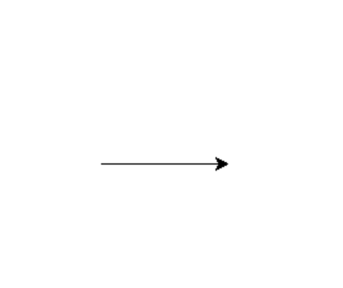

.left() and .right()

To turn the turtle, use .left() and .right() with a number in degrees.

For example, here I have turned the turtle by 90° left

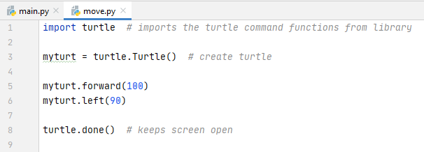

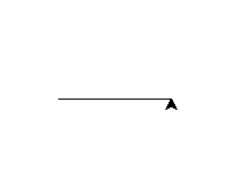

If I continue and move the turtle forward again, I will create a corner:

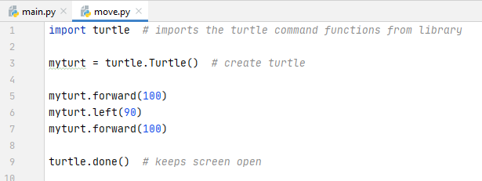

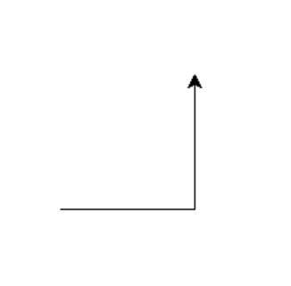
.penup() and .pendown()

penup() and pendown() do exactly as they sound – raise and lower the pen. Below, I've gone forward, raised the pen, gone forward (invisibly), lowered the pen and gone forward again:

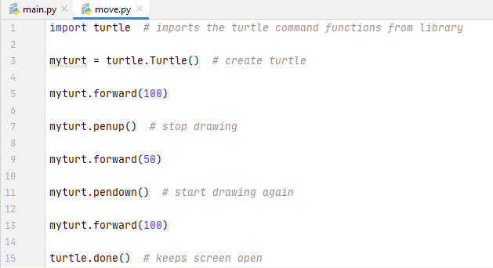

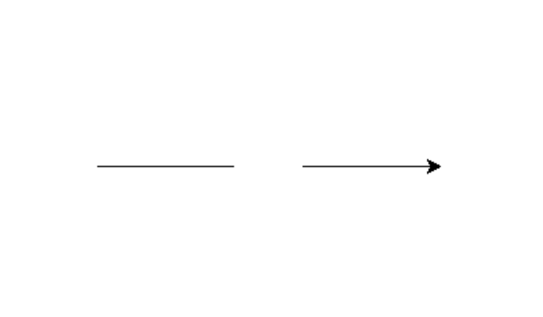

goto() – using coordinates

You can move your turtle position to a coordinate with .goto(). The coordinates start at the middle of the window:

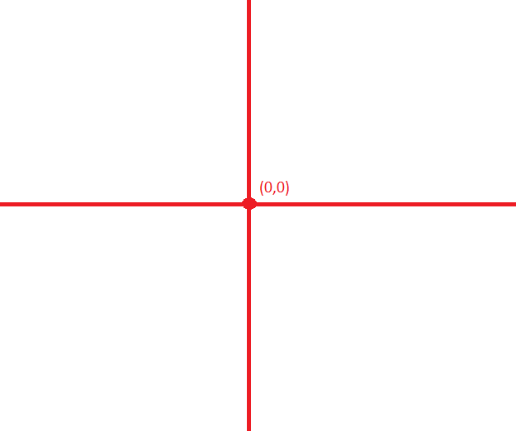

For example:

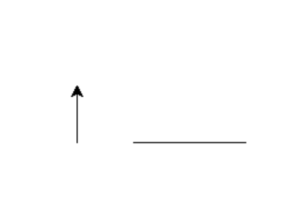

import turtle # imports the turtle command functions from library
myturt = turtle.Turtle()
myturt.forward(100)
myturt.penup()
myturt.goto(-50,0) # move to coordinate
myturt.pendown()
myturt.left(90)
myturt.forward(50)
turtle.done() # keeps screen open

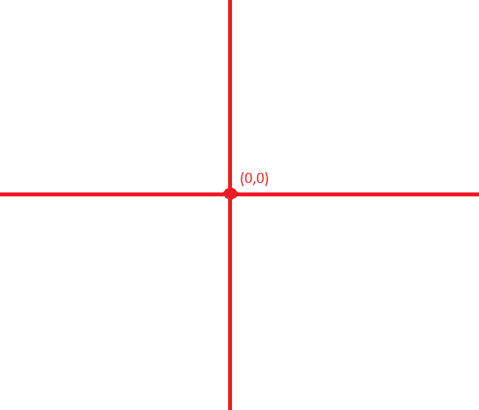

(-50,0)
.circle()

To draw a circle in python, we just need to provide the radius required:

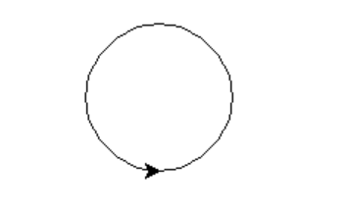

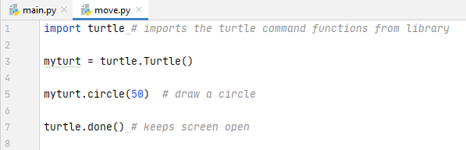

There is also a second parameter we can use if we don't want a full circle (eg we might want a semi circle)



