Embedded C
ACDA4013
Generating a program for a specified embedded requirement in C.
Student ID: 2214461(Owen Wild)
Word Count:1500

Contents
Table of Figures 3
Abstract 4
Introduction 4
Code 5
Initiation 5
Scenario One 7
Scenario Two 7
Scenario Three 8
Scenario Four 8
Conclusion 8

Table of Figures
Figure 1 - circuit layout 5
Figure 2 - initiation variable 6
Figure 3 - four-way switch setup 6
Figure 4 - Variable resistor setup 7
Figure 5 - Scenario one 7
Figure 6 - Scenario Two 8
Figure 7 - Scenario Three 8
Figure 8 - Scenario four 9

Abstract
This report outlines how a PIC18F45K50 can be coded in Embedded C to be able to carry out tasks like controlling a motor, flashing LED and displaying resistor values on a display. Four tasks were carried out and are detailed in this report.

Introduction
The brief for this report is to showcase how a microcontroller can be used and programmed in embedded C to perform tasks. The microcontroller that is used is a PIC18FF45K50 to perform four different tasks. The circuit build is shown in Figure 1 - circuit layout, the circuit consists of resistors, a button, an LCD display, a variable resistor, PIC18F45K50, a motor, LEDs, a 4-way switch and a virtual terminal. The four tasks that the circuit had to do was when the switch was in the first position the LCD display showed the value of the variable resistor. The second position of the switch had the function of when the variable resistor was at a certain value threshold the motor would spin clockwise, anticlockwise or stopped and also was shown on the LCD display and the virtual terminal with the variable resistor value as well. The third position of the 4-way switch was to make a Knight-Ridder mode where the LEDs were used the words Kitt mode were displayed on the LCD and the virtual terminal. Finally, the fourth position of the switch was when the button was pressed the motor would spin clockwise as long as the button was pressed. This was also displayed on the LCD display and the virtual terminal.

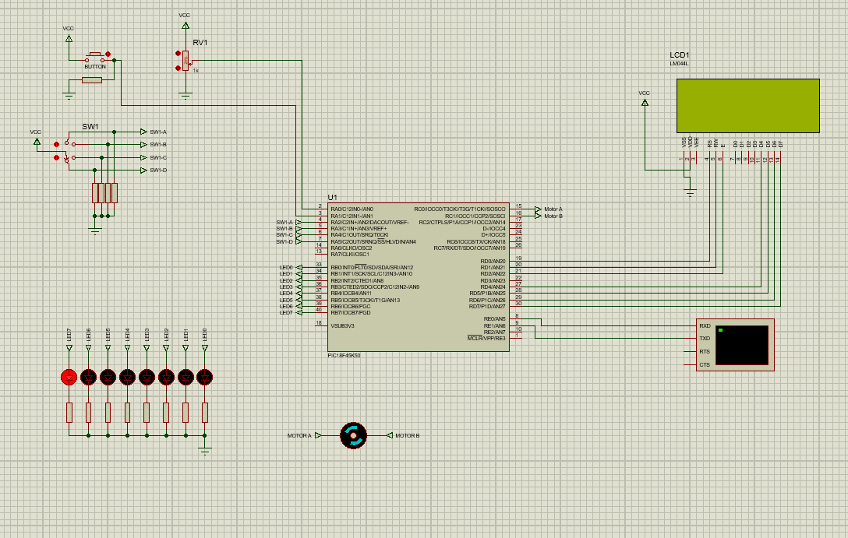
Figure 1 - circuit layout

Code
This part of the report will look into how the microcontroller was codded to perform the four different tasks within the circuit given.

Initiation
Initiation of the code is important because it sets up the groundwork to be able to write and execute the program.
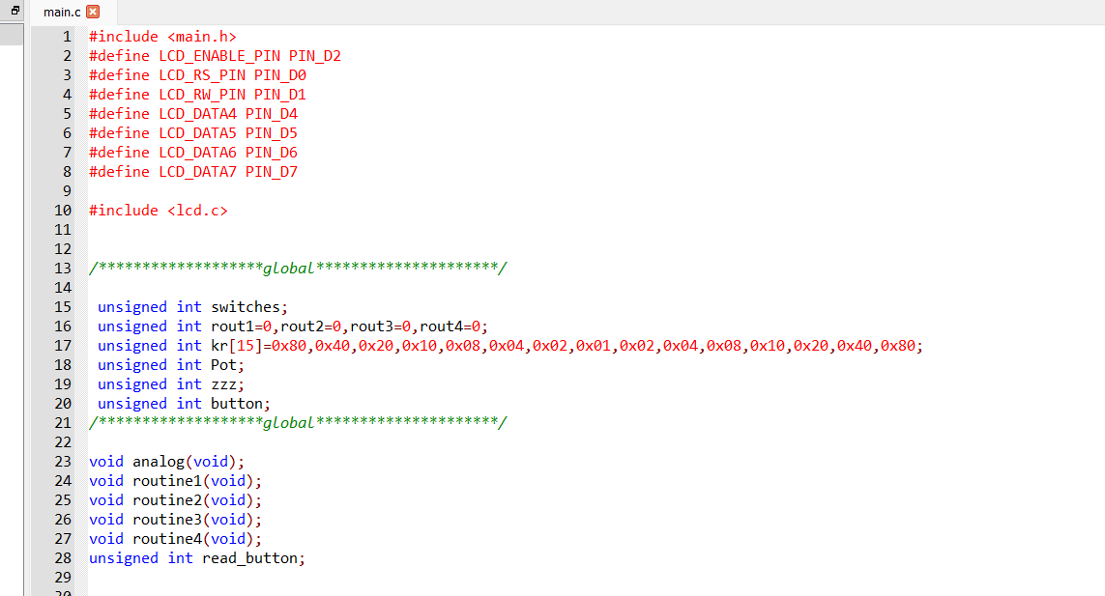
Figure 2 - initiation variable
Figure 2 - initiation variable showcases the global variables that are used within the entire code. Most of the variables that are used are placeholders first before they are coded so they can store a value in them. The others have values already assigned to them to be used in a certain function to be able to carry out the tasks. The two variables that have a value assigned to them are one for the four-way switch and the other is the LED position for the Knight-Ridder mode.

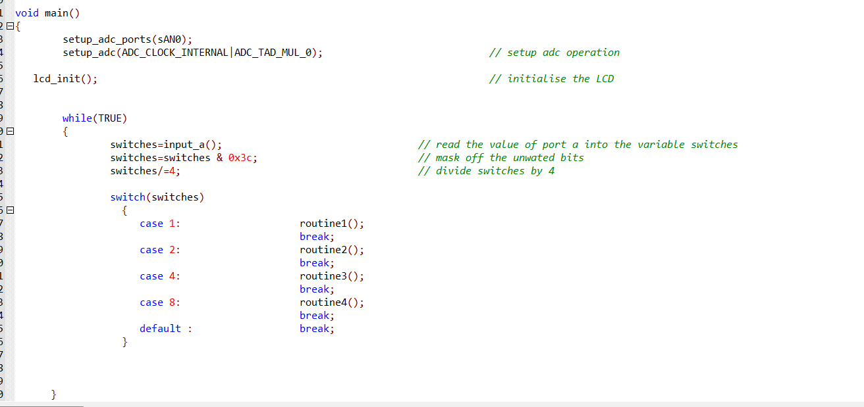
Figure 3 - four-way switch setup

This part of the code that is shown in Figure 3 - four-way switch setup helps us do all of the tasks that are required. The first part of this code is to set the ADC input pins so that when the variable resistor (Pot) is changing and the button is pressed the input from them can be used by the Pic. This is done in the void main as this is used throughout the code as well as the initialisation of the LCD display. The while (TRUE) loop is to set up the four-way switch so each position can have a different function attached to it and to set it up so that it can be used to control those functions.

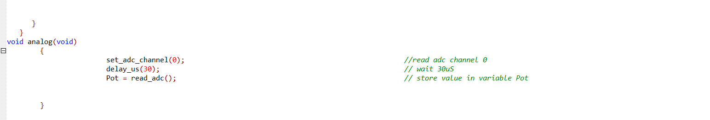
Figure 4 - Variable resistor setup

The last thing to do on the installation of the code before that four tasks can be written and working is to set up a variable that holds the variable resistor value this is shown in Figure 4 - Variable resistor setup. The way it works is by taking what is input on the AN0 pin of the pic that is connected to the variable resistor. The value is taken and then delayed by 30µs and then stored in the variable Pot.

Scenario One

Scenario one is to read the pot value and display it on the LCD Display this is shown in Figure 5 - Scenario one. This code is set up in a void routine and carries out the functions of reading the variable resistor values and displaying them on line 1 of the LCD display screen and the virtual terminal as well.

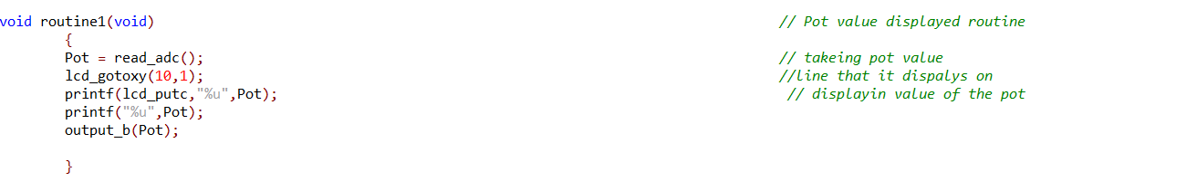
Figure 5 - Scenario one

Scenario Two

Scenario two utilises the use of if else and else if statement this is done in a for loop. The reason behind using a for loop is three different conditions need to do different outputs this is where the loop comes in. The if loop has the conditions that when the variable resistor value is less than 75 the motor will spin clockwise and output the direction and the value of the variable resistor on line 2 of the LCD display and the virtual terminal. The else if loop of the for loop has the condition if the value of the variable resistor value is between 76 and 174 the motor will stop and will display the motor stopped on both displays. Finally, the final part of the for loop is in the else conditions loop where if the value of the variable resistor is not in any of the other conditions it will carry out this loop. Which will turn the motor anticlockwise and show this and the value of the variable resistor value on both displays. All this is shown in Figure 6 - Scenario Two. How the motor turns is by stating which pin is high and low to turn the motor from the Pic.
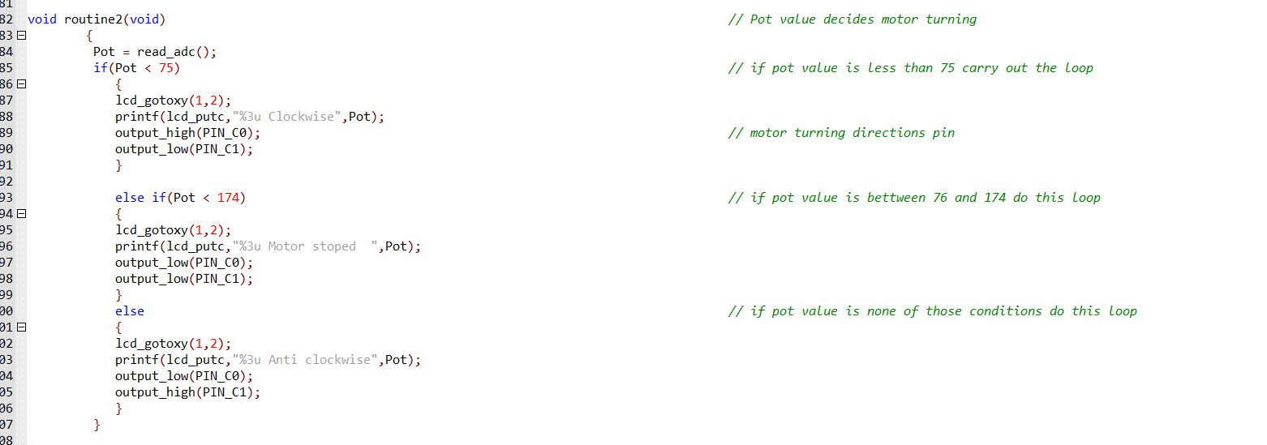
Figure 6 - Scenario Two

Scenario Three
Scenario three uses the LEDs to make a flashing sequence going from left to right and then back again. The Kr variable setup in the initialisation is used as this shows where the LEDs are. The zzz variable says what LEDs need to light up in the sequences. There is a delay of 150mS this is so we can see it more clearly. Figure 7 - Scenario Three shows the code that is related to the scenario.

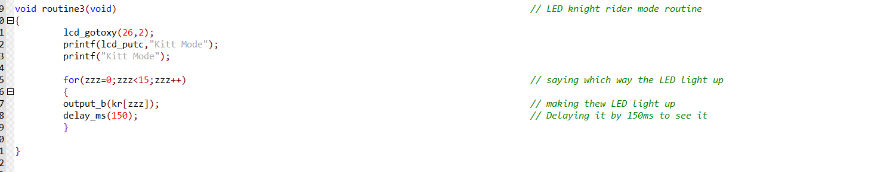
Figure 7 - Scenario Three

Scenario Four
Scenario four is the final one that is done for this task and consists of the button being pressed to turn the motor. How this is done is to initialise the Pin A1 where the button is connected. So, when the button is pressed the motor will turn and when it's released the motor will stop turning. The words button pressed are displayed on both displays. The code for this scenario is shown in Figure 8 - Scenario four.
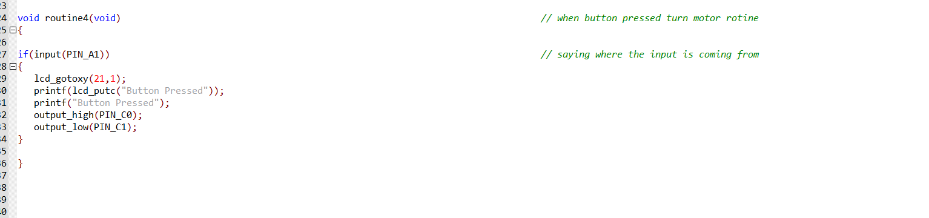
Figure 8 - Scenario four

Conclusion
The finding of doing this report is that the code works and it executed the four tasks that are required. Also, this report highlights how a programming language like embedded C can control a microcontroller to preform certain tasks and objectives. One improvement to this code that can be done is when the four-way switch is changing to a new scenario that it doesn’t add both the past and new scenarios together by executing both at the same time. The final take away from this report is to show how easy it is to program the microcontroller with a little embedded C knowledge to preform some basic task that the Pic can do.

