L4 – Quality & Business Improvement
Quality Tools and Root Cause Analysis

As a process improvement engineer I have been brought into a company that manufactures free-standing pillar drill bases.
I will be analysing the sand casting process (operation 1) and how it can be improved and also the vertical milling (operation 2)
Below are CAD drawings of the bases.

I will be using a series of quality tools to prioritise a corrective action plan to reduce the quantity of defects throughout both stages of the process. These tools will involve process improvement, finding the problems using root cause analysis, using poke yoke to minimise the chances of error due to increased ease of work.

I have made a table to display all the types of defects on the products that each worker causes in the time-span of a week. They have been split into 5 sections and I have also totalled them at the end to show most and least efficient workers.

operation 1
 | surface finish | defective finishing | x blow hole | improper shape | other | total
worker A | 26 | 0 | 17 | 5 | 0 | 48
worker B | 48 | 0 | 17 | 8 | 0 | 73
operation 2
 | surface finish | defective finishing | x blow hole | improper shape | other | total
worker C | 24 | 2 | 3 | 2 | 2 | 33
worker D | 26 | 4 | 6 | 5 | 2 | 43

Defected products cause major cost to the company as not only materials that have gone into the product cost money but also the time and workspace taken up by these will also lead to the companies outgoings without any income from the materials spent. This is known as MUDA.
From this table you can clearly see that worker B causes the most defected free-standing pillar drill bases. This problem could have occurred from a variety of reasons; one being the lack of training that the employee could have received, poor training will lead to a lack of expertise in their role which will lead to a higher number of defects on the products. Another reason could be lack of experience in the role, operation 1 could be far more difficult than operation 2 and possible worker A could have been in the role for a more extended period of time than worker B.
The data from this table isn’t very reliable as data shown is only tested over the period of a week. There could have been problems with worker B outside of the work place which may have affected his performance in work. The data would have been better if the testing was carried out over a year and then averaged for a week.
You can also see from this table that surface finish is by far the greatest defect that is caused by the manufacturing process. It is 63% of the problem so I believe this should be targeted first and root cause analysis should be carried out to find the reasoning behind this. I have worked out this by adding up all of the defects from each worker, adding up the defects by surface finish from each worker and then dividing the defects by surface finish the total defects and then multiplying it by one hundred to find the percentage of defects by surface finish.
(124÷197)x100=63%
Below I have used the fishbone diagram to try to find the root cause for the surface finish defects on the products.


The fishbone diagram is the best tool to analyse the possible causes for the defects within surface finish. Fishbone analysis is an ideal process improvement tool as it is used to find the root cause of the problems and takes into a account many factors that affect the manufacturing of the product.
After using this method of root cause analysis I believe to have found the some of the main problems with the operations which are the cleanliness of the work place, the machinery that is used as it is outdated and also the lack of training and experience with some of the operators.
Through researching the benefits of a cleaner work place I have found that there is a direct correlation between productivity/accuracy of tasks and how clean and tidy the operators workplace is. This is proven by the statement below.
‘The workplace environment influences employees’ productivity, performance and well-being. No matter the industry, maintaining a clean workplace may help keep staff members safe, healthy and efficient.’
CopperPoint Insurance Companies. Unknow. The importance of a clean workplace. http://www.pinpointnews.net/wordpress/the-importance-of-a-clean-workplace/ 19/04/2019 11:40.
Like the statement by CopperPoint shows that not only does it increase productivity but also can reduce the chances/severity of sickness which could have caused the increase in number of defects by worker B being affected by conditions he works in day to day.
Another root cause I have found was the outdated machinery. Through researching sandcasting and milling by questioning operators who perform these operations day in day out they have stated that ‘equipment used in sandcasting can easily gain defects and can become liable to poor operations when ware and tear occurs’. This gives strongly suggests that the machinery and equipment used to perform the operation can cause major defects like surface finish when ageing.
Possible lack of experience and training is a problem that you can pick out by analysing the fishbone as it is on of the root causes of the defects on surface finish. Incompetent employees can lead to a huge volume of problems within the work place as it can lead to lack of confidence which will cause problems with productivity. Also incompetency will lead to higher volumes of defected products which will lead to loss on profit.
To analyse further into this I have found that the majority of the defects falling into the surface finish section are created by worker 2.
From the chart above you can also see that the defects made by worker B are far greater than the other workers. I have shown this by making a Pareto chart below. A pareto chart is a brilliant way of targeting problems within an organisation as Pareto believed that 80% of all results were created by 20% of work put in. This is again shown in the graph following.

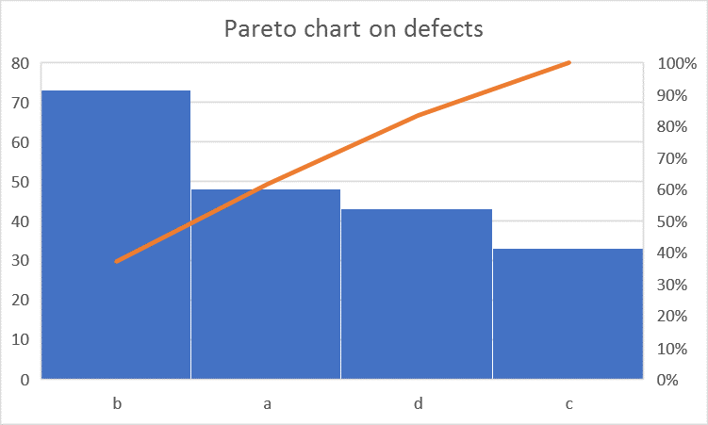
Number of defects
% of defects
worker

This Pareto chart clearly shows that worker B has created the most problems. As a process improvement engineer I would target this first and use root cause analysis to attempt to find the problems with worker B.
It also shows that both workers A and B cause the higher number of defects on the product which tells me that the first process of the manufacturing is either the more difficult process or the workers A and B have the less experience/skill within the role.
As shown below by a reputable manufacturing company sand casting is a very difficult process and has many disadvantages that are shown in the list of defects caused by the workers.
- Lower accuracy: Sand casting is not suitable for applications requiring extremely tight tolerances. Again, in these scenarios, conventional machining is typically the more suitable option.
- Rough surface finish: Because of the nature of the sand material, the finished part will have a rough surface finish (typically around 125 RMS). Unless this is suitable for the product, further machining and finishing are almost always required.
LeClaire, December 2018. What Are The Pros And Cons Of Manufacturing With Sand Casting? https://www.leclairemfg.com/about-us/blog/what-are-the-pros-and-cons-of-manufacturing-with-sand-casting/ 19/04/2019 8:45.
This then backs up my analysis that sandcasting is the easier of the two processes hence the less frequent problems. Also I believe the source of information would be very accurate as it is told by a company that uses this process day to day and would have no reason to display false information.

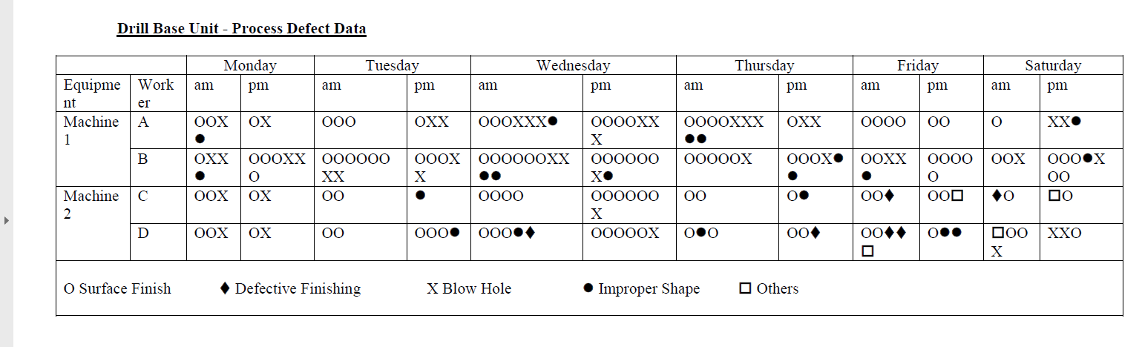
Below is the table that shows when the defects occurred during the week of testing. And the number of each. You can clearly see from the table that the highest number of defects happened on a Wednesday. This could be for a number of reasons.
Some of the reasons I believe they could have occurred due to are:
- Working longer hours on Wednesday so more products are made which will therefor the operators of the machines will make more defected products.
- Increased fatigue throughout the week.
- Difference in environment e.g. supervisor not being present on Wednesdays causing lack of concentration leading to more defected products.
- Machinery/equipment being changed over on a Wednesday causing more defects to the products.
- Machinery/equipment being changed over on a Thursday, meaning the equipment has come to the end of its use by date and is being changed over the next day.

Out of the five possibilities I have decided that number 3 is the most likely as change of normal environment for a worker can cause great effect to their productivity and accuracy of a task.
The change in environment could be many factors not only the loss of a supervisor. It could be an increase in maintenance on machinery for that day or different group of staff which could have an effect on the worker.

The first act I would do after analysing the business using the tools I have used would be to further improve the training and competency on not only worker B but all works working on both stages of manufacturing. This will not only decrease the chances of defective products but also improve the productivity of them as they will have further expertise in their role and their job will become second nature so defected product to fully functional product ratio will decrease. This will be very beneficial to the company as there will be more products made, less MUDA which will therefor lead to larger profits in the long run.
Another act that I believe would benefit the business would be to train all four workers on each section so they can vary their jobs evenly. This would allow them not to find their job so tedious and which may lead them to fall into alpha mode causing more defects as they are not concentrating on the task in hand as they believe they can do it whilst concentrating on other surroundings. Also this would allow cover for all sections if one worker may have to take time off work. Another benefit would be that the shift patterns could be changed to allow more days off work with rotating work stations and shift times.
With rotating the shift pattern this may take out the effect of whichever possible problems that are occurring during the Wednesday to Thursday morning. I would use a shift pattern involving less days in work with more hours worked each day. This will allow the workers to put more effort in in these days as they will have more time to themselves out of the work place with more days off. This therefor should decrease fatigue increasing attention span and decreasing defected products.

The next part of the action plan I have created involves using poke yoke reduce the difficulty of the first process which is sand casting, through researching through different websites I have found that sand casting is not an easy procedure to perform and have also found from using the fish bone diagram to find the root cause of the surface finish problems that the machines and equipment used for these process. My advice for the business would be to use a capital injection to purchase a higher quality newer machine that is used for the sand casting higher quality moulds to produce a higher quality product with a lower defected percentage.
High quality training must be given when the machine is commissioned within the work place to allow workers to have a good range of knowledge about the machine and also completely competent in using the machine and equipment aiding it. The poke yoke factor of this will involve the new machinery being a lot easier to use than the previous and making it a fool proof process for a competent worker.
The last action I would take in my action plan would be to change the daily plan to have a very short meeting at the start of the day to allow employees to discuss any defects with the equipment they are using, to give feedback to management on and to have any queries answered by management also. This will improve productivity by leaving workers get anything they may want to discuss off their mind and also allow better communication within the organisation. I would also recommend a utilising a short period of the day also to ensure all work stations are kept clean. This will allow better moral in the workplace as the workers would rather work in a clean and tidy environment rather than being angered by how untidy and dirty the place is.

To conclude on this analysis of an organisation that was experiencing problems with defective products, many problems within that workplace have been found and I have created an action plan to attempt to decrease the severity of these problems if not eliminate them all together.

.

