Module Title: BMSK5005
Assignment Title: Workplace Culture and its impact on Organizational Efficiency
Module Lecturer’s Name: Dr Isaiah Oino
STUDENT NAME: Faisal Ahmed Rana
STUDENT ID:1604528

Table of Contents
Introduction 1
1. Impact of external forces on the organisation (PESTLE and SWOT Analysis) 2
SWOT analysis and impact on workplace culture 3
PEST analysis and impact of the factors on culture 4
2. Formal and informal relationships between departments and people 7
3. The description of organizational culture, ethos and values 9
4. Establishing a culture of sustainability within the workplace 11
5. Corporate social and environmental responsibility 12
6. Personal ethical standards, values and beliefs 14
7. Communication channels for sharing information and building relationships 15
8. Barriers to effective functioning in the organisation and ways to overcome them 16
Conclusion 18
References 19

Introduction
The workplace culture is the combination of some specific principals, attitudes as well as norms which are inherently constructed in the business organization differentiating the organization from others. AstraZeneca has been selected as the organization on which the report is going to be constructed. The functional aspects of all the organizations are required to be designed in a specific way of channelling the formal as well as the informal relationship between the departments and people. Most of the organizations are basically recognized with the organizational culture as they try to show own cultural dogma in case of operating and expanding the business organizations (Garber, 2011). AstraZeneca has the establishment of a culture of sustainability as one of the prime goals because it helps AstraZeneca to reach the competitive edge in a particular market situation. As the part of the Sociocultural Responsibility (CSR), AstraZeneca has to conduct the social awareness program of drug addiction in every year. In response to the corporate responsibilities of AstraZeneca, the employees have to pay back some responsibilities as well towards AstraZeneca and the society. The communication channel is basically known as the way through which the information flows in each of the corners of the organization. The barriers to effective functioning are meant is the impediments occurred while making communication which can reduce the profitability as well as productivity at the same time.

1. Impact of external forces on the organisation (PESTLE and SWOT Analysis)
To have a clear understanding regarding the external forces affecting AstraZeneca, it is required to conduct a critical evaluation of the PESTLE and SWOT analysis how the factors effect on the workplace culture.

SWOT analysis and impact on workplace culture
The potential, capacities, lacking as well as challenges of any organization are analyzed with the help of the SWOT analysis. It has basically four components and these are the strengths, opportunities, threats and weaknesses.
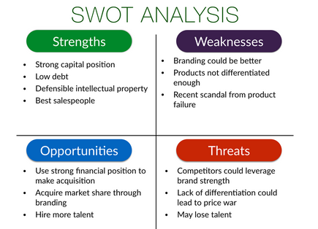
Figure 1: SWOT analysis
Source: (Seth, 2011).
In case of strengths, the strengths are the capabilities of a particular organization by which they can move on to the further development. The strengths are bringing positive impact on AstraZeneca as it motivates the employees on a large number. The quality of the R&D division is the major strengths for AstraZeneca as it results in a 5% increase in sales volume just investing £40 million in every year (Melling, 2015). The R&D division of AstraZeneca is basically pharmaceuticals and biotechnology-based. The other strengths of AstraZeneca are the global recognition as AstraZeneca has been operating its business operation in more than 122 countries all over the world creating the employment of more than 50000 employees. The product diversification is another strength for AstraZeneca which has basically 147 ranges of pharmaceutical products making itself in a position of the 5th biggest company all over the world. In case of weaknesses, the main weakness of AstraZeneca is the recent scandal where AstraZeneca has been charged fine for noncompliance with the regulations of the government and which resulted from 100 lawsuits. The workplace culture of AstraZeneca has been badly affected as the experienced employees have started shifting to other organizations by losing the trust on AstraZeneca. AstraZeneca has to face a loss of £150 million due to the intervention of Brexit. In case of opportunities, AstraZeneca has the chance to launch machine of cryosurgery for the better treatment of skin diseases. AstraZeneca has the opportunity to expand the business in the Asian subcontinent as the people of that region are suffering from many diseases and they have a lack of healthcare facilities. AstraZeneca has to work more the cancer disease for huge recognition and employee engagement impacting on the culture (Stern, 2014). In case of threats, AstraZeneca has to face intense competition in the present pharmaceutical industry because all the firms are quite advanced to grab the new technologies. The government regulations can cause the price abnormalities to the products of AstraZeneca. These treats can put the impact on the workplace culture by making the employees frustrated about losing their jobs. The SWOT analysis of AstraZeneca is going to be summarized below.
SWOT analysis of AstraZeneca
Strengths  - The quality of the R&D division  - global recognition  - Product diversification | Weaknesses  - Noncompliance with the regulations  - Loss for Brexit
Opportunities  - Machine of cryosurgery  - Work more the cancer disease | Threats  - Intense competition  - Regulations of government

PEST analysis and impact of the factors on culture
There are some factors that put the impact on the organization and organizational culture which can be conducted by the PEST analysis which has four components such as the political, economic, social and technological factors (Peter, 2013). AstraZeneca needs to conduct the PEST analysis for analyzing the factors impacting on the workplace culture.
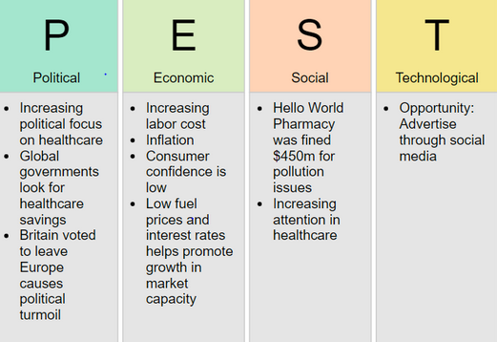
Figure 2: PEST analysis
Source: (Harrison, 2015).
In terms of the political factors of a particular pharmaceuticals company, the government regulations, legislation as well as policies are basically considered. AstraZeneca has to face the less political barrier in the UK as the UK is quite stable as measured by the stability index 2017 (Booth and Melling, 2017). AstraZeneca has been bound to abide by some particular acts such as Medicine Act, 1968, Data Protection Act, 1998, Health and Safety act, 1974 etc. to get the positive legal response from the government. Thus, the workplace culture is affected because the employees get happy and confident when they observe that AstraZeneca is very obedient to the political issues. In case of economic factors, the UK economy is now in recovering mood due to the economic downturn happened in 2016 making the business operation of AstraZeneca more complicated. AstraZeneca is the sufferer to lose £50 million each year due to the intervention of Brexit as AstraZeneca has to carry out the moving business operation in different countries of EU (Daniel, 2017). AstraZeneca has got rid of the long-term damage as the UK has come out of the EU. The unemployment rate is only 4.3% which is moderate for AstraZeneca to carry on the business operation in such a positive business environment.
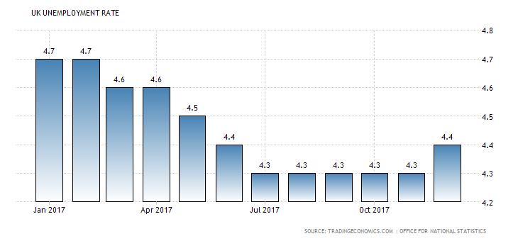
Figure 3: Unemployment rate in the UK
Source: (Garber, 2011).
The economic factors have helped AstraZeneca to develop a positive workplace culture because the economic condition is quite stable right now and recovery of the financial distress is active. In terms of the socio-cultural factors, AstraZeneca has to consider the attitudes, lifestyles, beliefs and other aspects related to the demographical environment. The socio-cultural factors work differently for AstraZeneca as the sales of medication for the HIV patients is only 5% in the Asian countries in comparison to that in the UK because the conservative social and religious beliefs in the Asian part (Waddington, et al, 2016). As the part of the Sociocultural Responsibility (CSR), AstraZeneca has to conduct the social awareness program of drug addiction in every year. The cultural diversity has been increasing the teamwork among the workers in terms of the decision making. AstraZeneca has been able to develop the cooperative workplace culture due to the intervention of the socio-cultural factor. As the part of the technological factors, the market share of the AstraZeneca is totally dependent on the technological factor. The quality of the R&D division is the major strengths for AstraZeneca as it results from a 5% increase in sales volume just investing £40 million in every year. The R&D division of AstraZeneca is basically pharmaceuticals and biotechnology-based (Victor, 2014). AstraZeneca has made the technological environment in more than 50 sites on the amount of £15 million. The PEST analysis of AstraZeneca is going to be summarized below:
PEST analysis of AstraZeneca
Political factor | - Politically stable  - Complicated regulations
Economic factor | - Loss due to the intervention of Brexit  - Lower unemployment rate
Social factor | - Corporate Social responsibility (CSR)  - Regional diversity  - The ethical standards
Technological factor | - Adequate background of technology.  - R&D department.

2. Formal and informal relationships between departments and people
The functional aspects of all the organizations are required to be designed in a specific way of channelling the formal as well as an informal relationship between the departments and people (Peter, 2013). The diagram in which the hierarchical chart of an organization to build the relationship between different departments and people to maintain the flow of the information throughout the organization is called the organizational chart by which an employee can identify his or her position and responsibility in the organization.
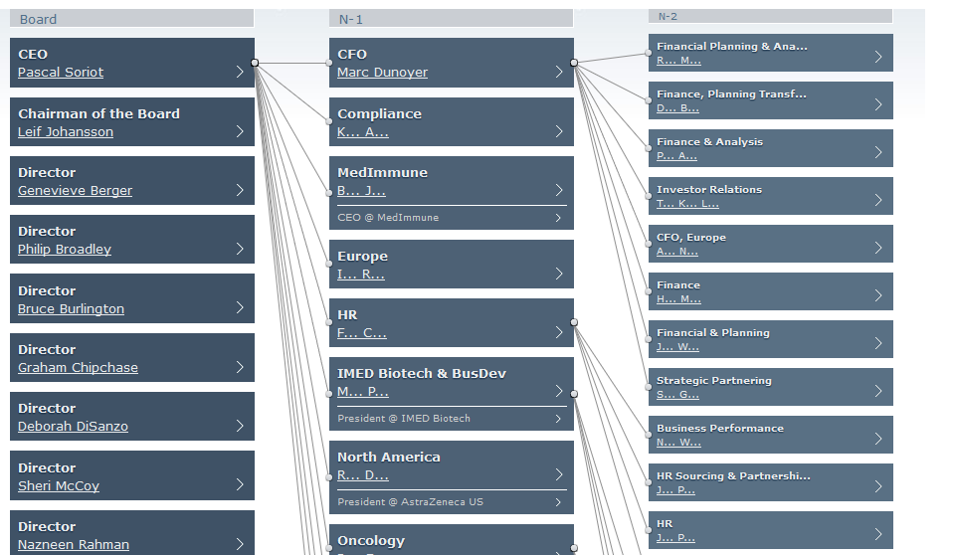
Figure 4: Formal relationships between departments and people
Source: (Astrazeneca.com, 2018).
In the case of informal relationships between departments and people, the relationship can take two forms, one is known as the formal relationship and another one is the informal relationship. The formal relationship is the particular form of relationship to carry out the official activities in a specified way following the organizational diagram of the communication. In the case of the informal relationship, there is no binding of rules in making communication or delivering messages from one staff to another staff. AstraZeneca basically follows that tall organizational structure and the organizational chart basically depicts the formal relationship (Jane, 2017). In the given figure it is clear that how the formal relationship can be constructed between different individual and departments. The success of AstraZeneca is very dependent on the organizational chart of the formal relationship.
AstraZeneca can never ever able to achieve any particular target if there is any communication gap available in the organizational chart. AstraZeneca employed the specialist to depict the chart and verified the organizational chart to find out whether there was any communication gap available. The organizational chart of AstraZeneca represents that the board is positioned in the leading position of the TOP management. The departments and the managers are bound to report to the board. The board of AstraZeneca consists of the CEO who leads the organization staying at the top of the board, Chairman and the board of directors who are very experienced. AstraZeneca basically follows the top to bottom approach to depict the formal relationship as AstraZeneca is recognized as the hierarchical organization (Leemans, 2016). The organizational chart has been designed in such a way which basically designs the formal relationship between the people as well. The middle managers are bound to report to the head of each of the departments such as the head of HR, the head of Production etc. all the people must have to ultimately report to the CEO who is in the decision-making power as the member of the board. The decision coming from the CEO has to flow down to each of the people through proper communication tools and skills. It is not possible to maintain the flow of information without the proper forms of the communication channel (Booth and Melling, 2017). The mediums that are used for making the communication of formal relationships are known as the meeting, emails, leaflets, notice board, memos etc. AstraZeneca directs all the employees to follow the given mediums, the hierarchy of communication because it will be a very tough job for AstraZeneca to manage the employees without these mediums of formal relation.
In case of the informal relationships between departments and people, there is a lack of regulations in terms of making communication with different departments and people. The informal relationship is basically formed based on the social relation where the organizational rules are not applied.

Figure 5: Informal relationships between departments and people
Source: (Daniel, 2017).
The informal relationship increases the motivation among the employees. AstraZeneca basically follows two media for forming the informal relationships, one is known as the team formation and other is known as the grapevine. Different teams such research team, production team etc. help to add value and expertise in the organization along with overlooking the ranking. As the part of grapevine, AstraZeneca arranges a monthly buffet party with all the employees to develop the informal relationship between people to reduce the intimacy gap between the higher-level employees and lower level employees (Cooper, 2013). The informal relationship develops the commitments among the employees and creates them goal oriented. The treat of the informal communication is that the rumour can be raised and that is why a monitoring board should be available to oversee the informal relationship.

3. The description of organizational culture, ethos and values
Most of the organizations are basically recognized with the organizational culture as they try to show own cultural dogma in case of operating and expanding the business organizations. The attitudes, beliefs, thinking etc. include to the organizational culture of AstraZeneca. AstraZeneca has been able to establish its own organizational culture which has created differentiation from other organizations (Stern, 2014). The organizational culture of AstraZeneca has been designed in such a way to give the value towards the employees. The organizational ethics and values are basically dependent on how the organizational culture has been designed. The components of the organizational culture, ethos and values of AstraZeneca are going to be described below

Figure 6: Organizational culture, ethos and values
Source: (Peter, 2013).
The capability of fulfilling the responsibility is basically defined as the autonomy. The degree of the intervention is measured by the autonomy. That is why the autonomy is considered as one of the vital components of the organizational culture of AstraZeneca. The employees or subordinates will be indifferent or incapable to perform their responsibility in case the autonomy is not applied in that particular organization. That is why the working capability will be disrupted in case of missing of the autonomy disrupting the values and ethics as well (Leemans, 2016). AstraZeneca has been able to retain proper autonomy in AstraZeneca as it follows the formal organizational structure. The flow of workings is described regarding how the activities will be performed in the positioning structure ensuring the ethics and values as well.
The person should be set in the particular position of the organizational structure where he deserves. The employees with higher responsibly can never be placed in the lower segment of the organizational structure because it will, damage the ethics, values and culture of AstraZeneca as well. AstraZeneca tries to form the research team in such an informal way so that the employees or the team members may feel the equality and can enjoy the scope of equality as well. AstraZeneca has been very liberal in case of the reward and appraisal system because it sets the short-term goal for the staffs and they are recognized with the financial and nonfinancial rewards upon achieving the short-term goals to maintain good workplace culture. AstraZeneca believes that the appropriate reward systems can make the employees motivated and encourage them to work more (Elsdon, 2013). In case of the lack of a reward system, the ethics and values of the employees of AstraZeneca can be destroyed forcing them to take illegal ways. AstraZeneca has the strong punishment system to maintain the organizational standards, ethics and values. AstraZeneca is very serious about the conflict management because it includes the instant procedures and process to dissolve the organizational disputes on an urgent basis. AstraZeneca believes that the fair judgment can work as the weapon to create a strong organizational culture deriving the ethics and values as well. AstraZeneca has already deployed 5 comfit management specialists to eradicate the agency conflict and other form forms of conflicts from AstraZeneca.

4. Establishing a culture of sustainability within the workplace
AstraZeneca has the establishment of a culture of sustainability as one of the prime goals because it helps AstraZeneca to reach the competitive edge in a particular market situation. AstraZeneca goes through a particular process for bringing the culture of sustainability which is going to be mentioned below:

Figure 7: the process of the culture of sustainability within the workplace
Source: (Booth and Melling, 2017).
It is required to understand the culture that AstraZeneca belongs before bringing sustainability because all the strategies of the sustainability of culture will be in vain in case of not assessing the current culture properly. There is no formal process of understanding the current culture. To know about the current culture, AstraZeneca needs to make an interview with the founders because they know each and every pros and con of the present organizational culture. AstraZeneca can assess the policies and procedures of the organization since the beginning to find out the specific cultural aspects of AstraZeneca. AstraZeneca also arranges the informal meeting along with face to face interview for the purpose of understanding the culture. AstraZeneca also puts importance on the Office grapevine to understand the current culture (Jane, 2017). AstraZeneca needs to focus on the creation of the possible opportunities in the workplace for the employees as the plan of sustainability of culture. AstraZeneca arranges two-month training programs along with compensation and reward system. AstraZeneca also keeps a close eye on the conflict management, employment position as well as capabilities. The sustainable culture should be free from any biases, discrimination etc. In the case of the employee engagement, the behaviour of the employees is changed subconsciously by various motivational and reward incentives.
The performance of the employees is recognized in AstraZeneca along with ensuring the health and social care setting in AstraZeneca. In AstraZeneca, the employees get the chance of exploiting the opportunities in the way of establishing a sustainable culture. That is how the employees of AstraZeneca get motivated to achieve the goal of AstraZeneca resulted from the sustainable environment-friendly culture. In the case of feedback and refinements, AstraZeneca is always ready to change the organizational culture based on the feedback and needs to develop further sustainable culture (Victor, 2014). That is why the feedback and refinement stage is known as the evaluation stage where the corrective actions are taken. AstraZeneca has set an open box in front of the entrance of all the branches inviting the stakeholders to give their feedbacks. AstraZeneca has a 12-month organizational cycle and the refinements are implemented in the organizational culture based on the feedback and suggestions to develop a sustainable culture.

5. Corporate social and environmental responsibility
The corporate entity is not only operated for profit-making because CSR has added another responsibility to the business organization which is related to the society, environment as well as nation. The reason behind the CSR is that most of the organizations in the modern business world are completely violating the ethical and environmental standards which are putting the negative impact on the society and environment (Ford, 2014). That way all the business entities are bound to play the CSR for the benefit of the society, people and the environment. As the part of the Sociocultural Responsibility (CSR), AstraZeneca has to conduct the social awareness program of drug addiction in every year. The cultural diversity has been increasing the teamwork among the workers in terms of the decision making. AstraZeneca has been able to develop the cooperative workplace culture due to the intervention of the socio-cultural factor.

Figure 8: Activities of CSR
Source: (Brown, 2013).
In the case of CSR towards behaviour, in most of the time, the pharmaceuticals companies are seen to break the ethical behaviour and illegal promotions which force them to face the legal ground. In this regard, AstraZeneca needs to set some ethical standards of behaviour as the part of social responsibility proving the business as the lawful one. AstraZeneca has been initiating different social programs to meet these social responsibilities. AstraZeneca has prepared the code of conduct where all the ethical standards are mentioned and all the employees of AstraZeneca are bound to abide by all the code of conduct what so ever (Waddington, et al, 2016). AstraZeneca has directed the employees to follow the international drugs proportioning standards along with Consumers protection Act 2015. The ethical behaviour of AstraZeneca should be reviewed by the Global Safety Board.
In CSR towards people, the employees are an integral part of AstraZeneca and that is why AstraZeneca has some responsibilities towards the employees. AstraZeneca has started the reward and compensation programs and allotted £50 million for their competition and reward each as the part of the responsibility towards the employees. AstraZeneca has recently launched Employee safeguard Program for ensuring the safety of the employees in compliance with the Health and Safety act, 1974. In CSR towards Planet, AstraZeneca has recently been very serious to the planet because the pharmaceuticals companies are polluting the environment to large extent by emitting the CO2 with the large amount (Ober, 2012). The wastage and chemicals are mixed with the water polluting the water. AstraZeneca has taken a long-term plan to be the carbon-free company by 2030. AstraZeneca has set the short-term goal to reduce the carbon to 12% in the next 4 years. AstraZeneca has also established the waste management scheme which has planned to reduce the wastage by 90% in next 10 years.

6. Personal ethical standards, values and beliefs
In response to the corporate responsibilities of AstraZeneca, the employees have to pay back some responsibilities as well towards AstraZeneca and the society. The responsibilities of the employees are demonstrated with the help of the values, ethical standards as well as beliefs (Harrison, 2015). I am to consider myself as an employee of AstraZeneca, I am supposed to abide by the following standards, values and beliefs towards AstraZeneca and the society.
- First of all, an employee should respect to and comply with the policies, procedures as well as regulations bonded by AstraZeneca. There is a general rule of each of the organization that all the employees have to maintain the ethical standards while doing operations. The employee of AstraZeneca works as an agent and that is why he should not break the drug promotional laws while doing duty.
- He should refrain himself from making illegal marketing tactics breaking the distribution laws. AstraZeneca has been initiating different social programs to meet these social responsibilities (Leemans, 2016). AstraZeneca has prepared the code of conduct where all the ethical standards are mentioned and all the employees of AstraZeneca are bound to abide by all the code of conduct what so ever. The employee should not be engaged in the bribery because it is opposed to the ethical standard.
- The employee belonging to the research team should look for the invention of the environment and health friendly health formula avoiding all kinds of harmful research to the environment. The employee has to show some humane behaviour rather forcing to gain own benefit. That is why the personal belief of the employees is very important.
- He should abide by all the instructions from AstraZeneca to reduce the CO2 in large extent. The employee has to reduce the carbon emission where he finds it possible. This ethical concept of the employee can ensure the safety of the environment.
- The employee has the right to give feedback or suggestions how the waste of AstraZeneca can properly be managed. The employee should demonstrate his own concern towards the environment.
In conclusion, as the ethics are known as the sense of perceiving right or wrong, the ethics should not be applied only in case of while doing the organizational activities. The employees should apply the ethics in case of the personal values as well as believes as well for individual contribution to the society (Astrazeneca.com, 2018). As an employee, I must have to possess my ethical responsibility to facilitate the CSR of AstraZeneca.

7. Communication channels for sharing information and building relationships
The communication channel is basically known as the way through which the information flows in each of the corners of the organization. The communications channels are basically used for planning and executing the plans. Then communication channels are basically categorized into three segments (Elsdon, 2013). These segments are known as the downward communication, upward communication and lateral communication.

Figure 9: Communication channels for sharing information and building relationships
Source: (Keet, 2012).
In case of the downward communication, the information is delivered to the subordinates of AstraZeneca. The downward communication happens when the CEO of AstraZeneca asks the head of the research department for the next medicine plan. The relation of direction is created in terms of the downward communication. As the employees need to report to the upper managers, the relationship should be sound between the staffs and the managers. The top management basically sent the messages to the subordinates in case of the downward communication. The subordinates deliver the messages to the higher authority through the help of the upward communication. The higher authority of AstraZeneca is so proactive that they welcome the feedback of the subordinates. AstraZeneca has set the feedback boxes in every branch of the AstraZeneca so that the staffs never hesitate to inform the higher authority regarding any issue in the workplace. The face to face feedback is another form of upward communication (Booth and Melling, 2017). The employees in the same category use the lateral communication because there is no subordinates or superiors in this communication channel. The other name of the lateral communication is known as the horizontal communication. In this communication system, the research executive makes the contract with the marketing executive (Melling, 2015). AstraZeneca has employed a communication specialist to make the communication free from any type of rumour to keep the workplace free from any type of disturbance.

8. Barriers to effective functioning in the organisation and ways to overcome them
The barriers to effective functioning are meant is the impediments occurred while making communication which can reduce the profitability as well as productivity at the same time. Most of the organizations are exposed to the barriers.

Figure 10: Barriers to communication
Source: (Ober, 2012).
The prime barrier to AstraZeneca is known as the opaque goal of the employees. This barrier decreases the productivity of AstraZeneca as the employees fail to set the target unanimously (Astrazeneca.com, 2018). All the efforts fall in vain because of not getting any clear goal. In AstraZeneca, the research team has a lack of engagement which has created a tough situation to accomplish the goal.
The improper communication channel is known as the other barrier which creates the impediment in terms of cooperation of the workers. The directive leadership style is another barrier because it lacks the proper autonomy to have the job done by the employees. The task-oriented goal is known as another barrier to proper functioning because it puts extreme pressure on the employees (Leemans, 2016). The deficiency in the conflict management is known as another vital impediment to the proper functioning. The storming among the employees can cause huge loss to AstraZeneca as it decreases the mutual respect and cooperation among the staffs.
Ways to overcome the barriers
AstraZeneca needs to take immediate steps to overcome the barriers to keep the productivity and profitability unaffected. The following suggestions are going to be given to AstraZeneca to get rid of the barriers.
- AstraZeneca should align the goals to get rid of the barriers by forming the 10-member team. The specific goal should be set for each of the team (Seth, 2011). The research manager must have to arrange a team meeting just within 5 days of the formation to inform all the employees regarding the goals and duration.
- The digital communication channel should be established in the IT department of AstraZeneca just within the next 10 days to retain the privacy of the information.
- AstraZeneca must have to apply the transformational leadership style just in next 5 days to make the participation of the employees and the team leader should be provided 3-month training for the appropriate leadership. The leaders should be selected within the next 12 days on the basis of experience and expertise by the board of directors.
- At least 3 conflict management specialists have to be appointed on an urgent basis just in next 2 days to observe the relationship of the employees and to manage all the conflicts.

Conclusion
That is why it has been found in the given report that AstraZeneca has to main the workplace culture which the help of the ethical beliefs, values playing the significant roles. For the adjustment of the workplace culture, it requires to make the analysis on the external environment because the external environment can never be changed. I have also been found in the given report that the understanding, employee engagement and opportunities are required to be built for a sustainable culture. CSR programs are required to be arranged to ensure the responsibilities to the society and environment (Waddington, et al, 2016). The communication channel is basically known as the way through which the information flows in each of the corners of the organization. The barriers to effective functioning are meant is the impediments occurred while making communication which can reduce the profitability as well as productivity at the same time.

References
Astrazeneca.com. (2018). AstraZeneca - Research-Based BioPharmaceutical Company. [online] Available at: https://www.astrazeneca.com/ [Accessed 4 Aug. 2018].
Booth, A. and Melling, J. (2017). Managing the Modern Workplace. Florence: Taylor and Francis.
Brown, A. (2013). Organisational culture. London: Financial Times Pitman Publ.
Cooper, C. (2013). Business ethics. Chichester, West Sussex: Wiley.
Daniel, L. (2017). Institutions, culture and sustainable development. Bradford, England: Emerald
Elsdon, R. (2013). Affiliation in the workplace. Westport, Conn.: Praeger.
Environmental Sustainability, 5(3-4), pp.272-277.
Ford, D. (2014). Managing business relationships. [Chichester]: John Wiley & Sons Inc.
Garber, P. (2011). Conducting Workplace Investigations. Amherst: HRD Press.
Group Pub.
Harrison, S. (2015). External environment. Deddington, Oxfordshire: Philip Allan.
Jane, B. (2017). Design for a sustainable culture. New York: Sage Pub.
Keet, R. (2012). Conflict management. Northlands, Gauteng, South Africa: Macmillan South.
Leemans, R. (2016). Redefining environmental sustainability. Current Opinion in
Melling, J. (2015). Managing the Modern Workplace. Florence: Taylor and Francis.
Ober, S. (2012). Contemporary business communication. Boston, Mass.: Houghton Mifflin.
Peter, D. (2013). Workplace Culture. Randburg: KR Publishing.
Seth, C. (2011). Swot analysis. Namur: Bright Sage Pub.
Stern, J. (2014). Barriers to Corporate culture. New York: Amacom.
Victor, K. (2014). Technological Infrastructures. Around the Globe. Hershey, Pa.: IGI Global.
Waddington, P., Badger, D. and Bull, R. (2016). The violent workplace. Cullompton, UK: Willan.

