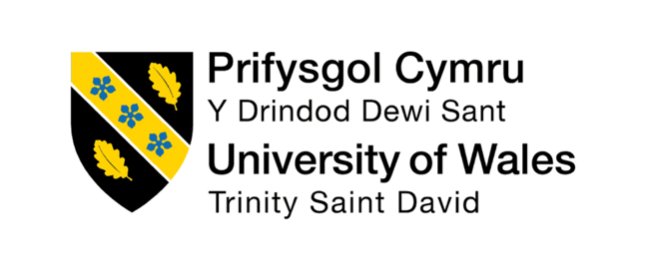

PROGRAMME: BA (HONS) LEADERSHIP AND MANAGEMENT SKILLS FOR THE WORKPLACE
Organisational Culture C1
MODULE CODE: LCLM5005

Student name: Halima Hussein
Student ID: 2409649
Table of Contents
1. Introduction 4
2. Organisational Culture, Structure and Decision-Making at Severn Trent Water 5
2.1 Influence of Culture on Organisational Structure 5
2.2 Impact of Culture on Decision Making 6
3. Identifying Organisational Culture Through Relevant Theories and Models 8
3.1 Schein's Model 8
3.2 Handy's Cultural Types 9
3.3 Hofstede's Cultural Dimensions 10
Determining the Prevailing Culture 10
4. Organisational Culture and Adaptation to External Environmental Influences 12
4.1 PESTLE Analysis 12
4.2 Responding to Industry Competition 13
4.3 Managing Globalisation and Workforce Diversity 14
5. Organisational Culture as an Enabler or Barrier to Organisational Effectiveness 15
5.1 Culture as an Enabler 15
5.2 Culture as a Barrier 15
6. Impact of Organisational Culture on Performance and Recommendations 16
6.1 Impact on Organisational Performance 16
6.2 Theory-Informed Recommendations 16
7. Conclusion 17
References 18

List of Figures
Figure 1: Severn Trent Water Logo 4
Figure 2: Schein's Model 8
Figure 3: Handy's Model 9
Figure 4: PESTEL Analysis 12

1. Introduction
Organisational culture is a core element of organisational performance since it shapes the behaviour of the employees, organisational decisions, leadership style, and organisational performance (Egwu and Nwosu, 2025). According to Mullins and Christy (2016), culture is what reflects the values, beliefs, assumptions and behaviours that characterise how things are done around here. In contemporary organisations, culture has an impact on the organisational structure, employee motivation, communication and responding to environmental challenges. With organisations also working in a more complex and globalised world, learning about organisational culture is critical to staying competitive and achieving strategic goals.
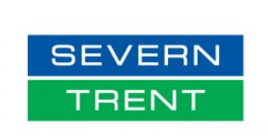
Figure 1: Severn Trent Water Logo
(Source: Open Water, 2026)
The report will be a critical analysis of the role of culture in the structure and decision-making processes by the organisation, and uses theoretical frameworks like the Three Levels of Culture by Schein, Cultural types as developed by Handy and Cultural dimensions as developed by Hofstede. Using these models, the report will produce the existing culture in Severn Trent Water and evaluate how effective this culture is in achieving the organisational goals and sustainability in the long term.

2. Organisational Culture, Structure and Decision-Making at Severn Trent Water

2.1 Influence of Culture on Organisational Structure
The structure adopted by Severn Trent Water is greatly influenced by organisational culture. The organisation is a leading utility provider that functions in a highly regulated setting, and therefore, the structure must provide support to compliance, reliability in its operations, and service excellence. The values promoted by the culture of Severn Trent include teamwork, responsibility, sustainability and customer centricity, and these are echoed in the organisational structure.
The company has a functional organisational structure which makes various departments work efficiently together. The functions, including operations, engineering, finance, customer services, environmental management, and technology, should be working in close collaboration to help in the realisation of the organisational objectives (Nzuva, 2022). This is a culture of cross-functional communication and teamwork. Instead of using hierarchical authority as the only means of exercising authority, Severn Trent promotes the idea of staff giving ideas and engaging in problem solving processes. This is a method that encourages and empowers employees, as well as ensuring that they feel like owners of organisational success.
In addition, the priority of sustainability and innovation within the organisation shapes the formation of expert teams that perform environmental efforts, digitalisation process tasks and operational enhancements. Such structures enhance teamwork, exchange of knowledge and ensure that priorities by the organisation are kept in mind with organisational values. The culture thus performs the role of guiding towards an organisation that can balance regulatory compliance and flexibility as well as innovation (Williams, 2022).
The organisation should, however, ensure that there are formal structures as well because the water industry is a regulatory one. There is a need to have transparent reporting lines, performance management programs, and governance systems to institute accountability and adherence to the required laws. As a result, it can be concluded that Severn Trent exhibits the balance between formal organisational control and collaborative working practises.

2.2 Impact of Culture on Decision Making
Severn Trent Water's organisational culture influences the decision-making process in the organisation in a very significant manner. Culture determines the decision-making criteria, decision-making stakeholders, and the general approach embraced by the management in solving organisational challenges (Xenikou and Furnham, 2022).
It is important to note that the organisation has a strong commitment to customer service that has been brought about by one of the most important cultural influences on the decision-making process. Most of the infrastructure investment decisions, service enhancement and technological innovation are also considered in terms of the effect they have on customer satisfaction (Purnamasari et.al. 2025). This customer focus approach also makes sure that the organisational behaviour is consistent with the expectations of the stakeholders. Another important cultural value affecting decision-making is sustainability. With environmental issues gaining importance, Severn Trent incorporates sustainability issues in its strategic planning and operational processes.
The organisational process of environmental protection, sustainable development, is directing the decision-making concerning water conservation, the application of renewable energy sources, carbon reduction projects, and other decisions (Gandrita et.al. 2023). This serves to show the role of cultural values in determining organisational priorities that extend beyond just financial factors.
The decision-making processes are also influenced by the collaborative culture within the organisation. The staff members of various departments are also invited to engage in discussions and share expertise in solving complicated issues. These strategies enhance the quality of decisions made because a variety of opinions will be included, and the chances of making narrow or prejudiced judgments are minimised (Valcozzena et.al. 2025). It is the collaboration of the cross-functional teams that is mostly necessary when dealing with issues related to climate change, infrastructure management, and compliance with regulations.
The decision is also affected by technology and innovation. The organisation actively adopts the practices of digital transformation and decision-making based on data. Strategic and operational decision-making processes are increasingly unified with analytics, performance measurements and technological solutions by managers (Riipa et.al. 2025). This is representative of a learning, innovative, and continuous improvement culture.
Although collaborative decision-making is beneficial in several ways, it may prove to be a problem in certain situations. Seeking the advice of a number of stakeholders could also slow down the decision-making process, particularly when urgency is paramount. But the culture of the organisation is more inclined towards participation, accountability and evidence-based decision-making. The relationship between organisational culture and structure and decision-making at Severn Trent Water is a depiction of strong and weak aspects. The organisational culture is also positive because it encourages teamwork, innovation and participation of employees (Ghani et al. al 2023). These qualities assist in effective communication, improved problem solving and improved relations with stakeholders.

3. Identifying Organisational Culture Through Relevant Theories and Models

3.1 Schein's Model
This model suggests that organisational culture is at three levels: artefacts, espoused values, and underlying assumptions. This model offers useful information on the cultural characteristics of Severn Trent Water.
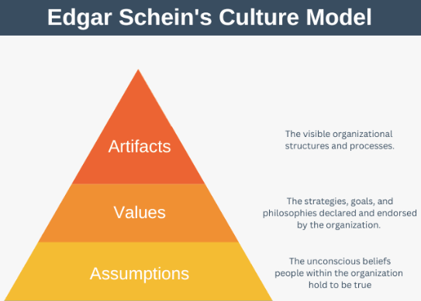
Figure 2: Schein's Model
(Source: Expert Program Management, 2026)
At the basic level, artefacts are tangible and observable embodiments of culture. At Severn Trent, sustainability reports, environmental campaigns, employee wellbeing programmes, diversity programmes, customer engagement initiatives, and digital transformation initiatives are all artefacts. These apparent aspects portray how the organisation strives to be sustainable, innovative and engage stakeholders (Attanasio et.al. 2022).
The latter level is made up of espoused values. Customer focus, integrity, accountability, innovation, collaboration, and environmental responsibility are some of the values propounded by Severn Trent publicly. Such values are conveyed through corporate strategies, the leadership messages and organisational policies. The strength of the alignment between verbal values and organisational behaviour offers some reason to believe that verbal values are ingrained in the organisation.
The third tier is basic underlying assumptions; this entails unconscious beliefs that drive behaviour. The assumptions at Severn Trent seem to be based on the notion that environmental sustainability is the key to long-term success, the idea that customers have to be at the heart of organisational decision-making, and the idea that a new challenge requires innovation to tackle. It seems that employees accept these assumptions being the general truth that informs organisational behaviour (Koçak et.al. 2023).
The implementation of the Schein model into practice has shown that Severn Trent has a relatively positive organisational culture since artefacts, values, and assumptions are congruent with each other. This kind of alignment enhances cultural uniformity, and it helps in organisational effectiveness.

3.2 Handy's Cultural Types
According to Handy, there were four major types of culture, namely: power culture, role culture, task culture and person culture. Critique of Severn Trent Water indicates that both role culture and task culture can be traced in the organisation.
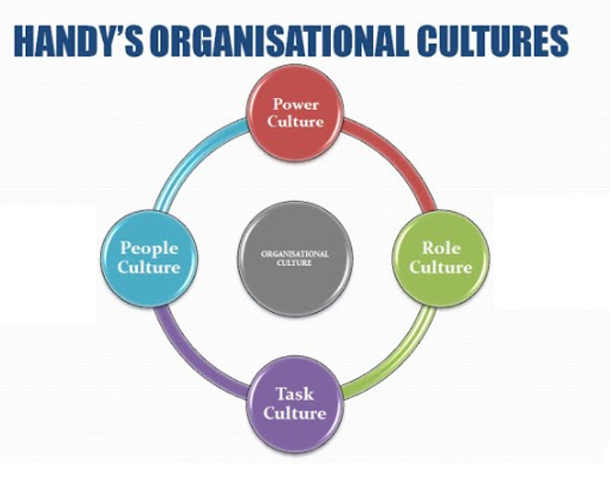
Figure 3: Handy's Model
(Source: Mister Simplify, 2026)
Role culture is defined by well-defined roles, formal processes and well-organised systems of authority. These features can be observed in Severn Trent because of the high regulation of the water industry. Accountability and standardisation are required due to compliance requirements, operational procedures and governance structures (Schönherr et.al. 2022). Workers know what they are obliged to do and work under set policies and guidelines.
Task culture, in turn, can also be highly traced throughout the organisation. Task culture puts an emphasis on the importance of teamwork, flexibility, expertise, and problem-solving. Severn Trent tends to form cross-functional teams as a method of organising infrastructure projects, ongoing sustainability and technological development (Yousef, 2024). Workers are motivated to work together and share some specialised knowledge to accomplish organisational goals.
Blending role and task cultures allows Severn Trent to strike a balance between stability and innovation. Where role culture brings about conformity and consistency in supporting operational stability, task culture favours flexibility and ongoing advancement. This mixture is very effective in a sector that is not only regulated but also a sector that is fast-changing in its environmental needs.

3.3 Hofstede's Cultural Dimensions
Another way of analysing the organisational culture is through the Cultural Dimensions framework offered by Hofstede. Designed to be used in comparison of the national cultures, the framework can be transferred to organisational situations. Severn Trent has manifested relatively low power distance since employees are urged to get involved in the decision-making and can discuss issues directly with management. This facilitates knowledge exchange and involvement of staff. The collectivism traits in the organisation manifest in its focus on teamwork and cooperation (Valcozzena et.al. 2025). There is often an interdepartmental interaction among employees to gather around shared objectives.
The organisation displays moderate or high uncertainty avoidance since the organisation is situated in a highly regulated industry where risk management and compliance are crucial. Formal procedures and operational controls are also a plus as it minimizes any uncertainties and ensures reliability in the services. In the meantime, the organisation encourages creativity and continuous change in an effort to address emerging challenges.

Determining the Prevailing Culture
A comparison of the Schein Model, the Handy Cultural Types and the Cultural Dimensions by Hofstede suggests that the current culture of work in Severn Trent Water is a task-based culture of collaboration and sustainability, which has high criteria of role culture. The organisation balances regulation discipline, the innovator, collaboration, and stakeholders (Williams, 2022). Such a cultural mix allows Severn Trent to remain operationally superior and helps it to respond to the changing environment, technology, and society. Consequently, organisational culture forms a useful strategic resource that leads to long-term organisational performance and sustainability.

4. Organisational Culture and Adaptation to External Environmental Influences

4.1 PESTLE Analysis
The organisational culture has a significant role in assisting Severn Trent Water to react to external environmental factors.
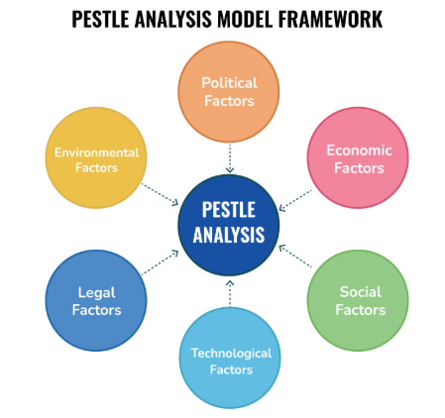
Figure 4: PESTEL Analysis
(Source: SpeakingNerd, 2026)
Political issues matter especially as there is a wide-ranging regulation in the water sector of the UK. The policies and performance requirements set by government and regulatory authorities in the industry must be observed by Severn Trent. Ethical behaviour, responsibility and transparency within the organisation are encouraged by the organisation's culture that enables the employees to appreciate the significance of regulatory compliance and accountability in the community.
The performance of organisations is also influenced by the economic conditions. The increasing operation cost, inflation and need to invest in infrastructure put financial strain on utility providers (Kole, 2025). The high efficiency and constant improvement culture in Severn Trent has enabled employees to find new methods of managing the costs by not compromising service standards. This promotes sustainable financial sustainability.
Expectations among the stakeholders are still influenced by social factors. What grows is the expectation of customers in having reliable services, environmental responsibility and open contact. The culture at Severn Trent is customer-oriented; thus, making stakeholder needs take centre stage in the decision-making process. The staff is motivated to provide and take good quality services and to have a good relationship with the customers (Rivaldo and Nabella, 2023).
In the utility sector, technological changes are enhancing businesses with digital systems, automation, artificial intelligence and data analytics. The organisation will encourage a culture of innovation, which encourages the use of technology and is also conducive to lifelong learning. Employees are motivated to welcome change and find ways to perform better.
Legal considerations would involve adherence to environmental laws, health and safety acts, as well as operational standards. The culture within Severn Trent supports professionalism and accountability by ensuring that workers adhere to the laid-down procedures and that they stick to high standards of behaviour.
The environmental issues are some of the greatest external forces with respect to the organisation. Sustainable business practices are needed to address climate change, water shortage, carbon reduction goals and environmental issues of biodiversity. Severn Trent supports the culture of sustainability fostering investment into the environmental protection programs, renewable energy and conservation programmes. The dedication boosts organisational sustainability and fosters long-term sustainability goals.

4.2 Responding to Industry Competition
Even though there is minimal direct rivalry in the UK water industry, organisations are also being considered based on the quality of service, customer satisfaction, efficiency and environmental performance. Organisational culture is thus crucial in assisting Severn Trent to remain in a competitive stance in the industry (Aluko et.al. 2026). The culture of the organisation encourages constant improvement and innovation. The employees are motivated to seek possible areas to enhance the operations and customer experiences. This emphasis on innovation contributes to the effectiveness with which the company reacts to the emerging expectations of the stakeholders and shifts in industry norms and standards.
Satisfaction of customers is an important part of organisational success. The customer centred culture at the Severn Trent implies that the staff know that they have to provide uniform services and solve the customer problems effectively. Strong relations with the stakeholders contribute to the organisational image and trust of the population.

4.3 Managing Globalisation and Workforce Diversity
This has been boosted by globalisation, which has led to the emphasis on workforce diversity and inclusive cultures within organisations. Though primarily, the work of Severn Trent is within the United Kingdom, it is also under the impact of the international tendencies regarding the technology, sustainability and employment practice. Organisational culture is important in assisting the company to deal with such influences successfully (Kharroubi, 2021).
Severn Trent advocates diversity, equality and inclusiveness within the organisation. There is a promotion of the sharing of ideas, experiences, and views by employees of various origins. Such an inclusive culture will create a culture of support in which the individuals will feel respected and appreciated. The diversity of the workforce boosts creativity and problem solving abilities because employees offer alternative solutions to the organisational problems. The organisational level emphasis on teamwork and a feeling of respect enables teams to work effectively within their functional lines (Gifford et.al. 2022).

5. Organisational Culture as an Enabler or Barrier to Organisational Effectiveness

5.1 Culture as an Enabler
The organisational culture is an important facilitator of performance at Severn Trent Water. The values of the organisation foster employee participation, collaboration, novelty, responsibility and customer satisfaction. With these values, employees who express themselves with such values are more likely to show commitment and make contributions towards the organisational goals. Knowledge sharing and communication are encouraged by a culture of collaboration. Staff members are supported to collaborate as a team to find answers to issues and create new solutions. Moreover, the organisation's endeavour to be sustainable also builds stakeholder relations and improves corporate reputation. These cultural features increase organisational performance and contribute to long-term success (Żemojtel-Piotrowska and Piotrowski, 2023).

5.2 Culture as a Barrier
Though it has its merits, organisational culture hampers effectiveness at times. The collaborative culture can have a sluggish effect on decisions, as consultation and consensus-building can also take more time. In cases where there is a need to act, a lot of talk might hinder action.
The compliance and risk management highly promoted by the organisation can also limit flexibility and discourage an experimental approach. Employees might be hesitant in coming up with new ideas when they perceive that there are serious risks with the change (Kole, 2025). The change may be met with resistance when it threatens existing practice or ways of doing things due to new technologies or ways of operating. These may sometimes constrain organisational responsiveness.

6. Impact of Organisational Culture on Performance and Recommendations

6.1 Impact on Organisational Performance
The organisational culture directly affects the performance of Severn Trent. The presence of a good culture leads to operational efficiency as a result of fostering accountability, teamwork and constant improvement. The employees are aware of what is expected within organisations and work towards the attainment of performance targets (Rivaldo and Nabella, 2023). This will help in maintaining trustworthy service delivery and better customer results.
Culture also has a positive impact on employee performance. The focus on wellbeing, development, and engagement in the organisation is an added drive and job satisfaction. This makes employees become more productive as well as determined towards organisational objectives (Asif and Shaheen, 2022). Moreover, the sustainability culture of Severn Trent boosts the environmental performance of the organisation and the trust of the stakeholders, leading to the success of the organisation in the long term.

6.2 Theory-Informed Recommendations
To enhance organisational culture further, Severn Trent should further promote innovation by involving employees more in decision making as well as problem solving processes. This suggestion correlates with a model given by Schein, which emphasises the need to strengthen assumptions that promote learning and flexibility.
The organisation will also need to enhance cross functional interaction to promote the task culture which was proposed by Handy. Increased sharing of knowledge would facilitate innovation and learning in an organisation. Moreover, the management should institute a more responsive decision making process, which will still allow compliance with regulations (Richey Jr et.al. 2023). Lastly, leadership development programmes would have to be increased to sustain low power-distance traits observed within the framework of Hofstede and empower the employees.

7. Conclusion
Organisational culture has been imperative in defining the flexibility, performance and effectiveness of Severn Trent Water. The analysis has established that the organisation has a culture that fosters its response to political, economic, social, technological, legal and environmental threats through a high level of accountability, innovation, sustainability and customer service. Even though it might sometimes pose certain obstacles because of some of the cultural characteristics, the overall contribution of culture is overwhelming. It facilitates employee involvement, teamwork, stakeholder confidence and ongoing enhancement, as well as aligning with organisational goals. Moreover, culture will add value in terms of operational efficiency, environmental performance and customer satisfaction. Through further promotion of innovation, development of leadership and nimble decision-making, the organisation of Severn Trent will be able to amplify organisational performance, as well as prolong its success in the sector of exceptionally controlled water regulations.

References
Aluko, H.A., Achi, F. and Titus, O.F. (2026) From human capital to competitive advantage: Indigenous knowledge, adaptation, and innovation in entrepreneurial success. Journal of the International Council for Small Business, pp.1-29. https://doi.org/10.1080/26437015.2026.2673344
Asif, M. and Shaheen, A. (2022) Creating a high-performance workplace by the determination of importance of job satisfaction, employee engagement, and leadership. Journal of Business Insight and Innovation, 1(2), pp.9-15. https://insightfuljournals.com/index.php/JBII/article/view/10
Attanasio, G., Preghenella, N., De Toni, A.F. and Battistella, C. (2022) Stakeholder engagement in business models for sustainability: The stakeholder value flow model for sustainable development. Business Strategy and the Environment, 31(3), pp.860-874. https://onlinelibrary.wiley.com/doi/abs/10.1002/bse.2922
Egwu, K.U. and Nwosu, I.A. (2025) Influence of Organisational Culture on Employee Behaviour and Productivity: A Narrative Review. International Journal of Sub-Saharan African Research, 3(1), pp.291-302. https://www.ijssar.com/paper/influence-of-organisational-culture-on-employee-behaviour-and-productivity-a-narrative-review
Expert Program Management, (2026) Edgar Schein’s Organizational Culture Model Assessed Through: < https://expertprogrammanagement.com/2022/09/edgar-schein-culture-model/ > Assessed On: 26.06.26
Gandrita, D.M., Gandrita, A., Rosado, D.P. and Carmo, M.D. (2023) Environmental sustainability for strategic planning effectiveness and organizational improvement. Sustainability, 15(8), p.6774. https://doi.org/10.3390/su15086774
Ghani, B., Hyder, S.I., Yoo, S. and Han, H. (2023) Does employee engagement promote innovation? The Facilitators of innovative workplace behavior via mediation and moderation. Heliyon, 9(11). https://www.cell.com/heliyon/fulltext/S2405-8440(23)09025-4
Gifford, R., van der Vaart, T., Molleman, E. and van der Linden, M.C. (2022) Working together in emergency care? How professional boundaries influence integration efforts and operational performance. International Journal of Operations & Production Management, 42(13), pp.54-78. https://doi.org/10.1108/IJOPM-10-2021-0644
Kharroubi, D., 2021. Global workforce diversity management: Challenges across the world. Ekonomicko-manazerske spektrum, 15(1), pp.28-37. https://www.ceeol.com/search/article-detail?id=1007179
Koçak, Ö., Levinthal, D.A. and Puranam, P. (2023) The dual challenge of search and coordination for organizational adaptation: How structures of influence matter. Organization Science, 34(2), pp.851-869. https://pubsonline.informs.org/doi/full/10.1287/orsc.2022.1601
Kole, J.K.T. (2025) Applying Hofstede’s cultural dimensions in education: Insights, critiques, and implications for diverse classrooms. Open Journal of Social Sciences, 13(5), pp.94-110.
Mullins, L. and Christy, G. (2016). Management and Organisational Behaviour (11th ed.). Pearson Education Limited.
Nzuva, S.M. (2022) The impact of organisational culture on employees' productivity: a comprehensive systematic review. European Journal of Business and Management. 10.7176/EJBM/14-4-05
Open Water, (2026) Severn Trent Water Ltd Assessed Through: < https://www.open-water.org.uk/for-customers/find-a-retailer/suppliers/severn-trent-water-ltd/ > Assessed On: 26.06.26
Purnamasari, R., Hasanudin, A.I., Zulfikar, R. and Yazid, H. (2025) Technological infrastructure and financial resource availability in enhancing public services and government performance: The role of digital innovation adoption in Indonesia. Social Sciences & Humanities Open, 11, p.101621.
Richey Jr, R.G., Chowdhury, S., Davis‐Sramek, B., Giannakis, M. and Dwivedi, Y.K. (2023) Artificial intelligence in logistics and supply chain management: A primer and roadmap for research. Journal of Business Logistics, 44(4), pp.532-549. https://onlinelibrary.wiley.com/doi/abs/10.1111/jbl.12364
Riipa, M.B., Begum, N., Hriday, M.S.H. and Haque, S.A. (2025) Role of data analytics in enhancing business decision-making and operational efficiency. International Journal of Communication Networks and Information Security, 17(2), pp.400-412. https://www.researchgate.net/profile/
Rivaldo, Y. and Nabella, S.D. (2023) Employee performance: Education, training, experience and work discipline. Calitatea, 24(193), pp.182-188.
Schönherr, N., Vogel-Pöschl, H., Findler, F. and Martinuzzi, A. (2022) Accountability by design? Exploring design characteristics of corporate social responsibility standards. Sustainability Accounting, Management and Policy Journal, 13(1), pp.1-29. https://doi.org/10.1108/SAMPJ-07-2020-0257
SpeakingNerd, (2026) Advanced Guide to Application of PESTLE Model Assessed Through: < https://speakingnerd.com/strategy/strategy-models/pestel-analysis > Assessed On: 26.06.26
Valcozzena, S., Riso, V. and Cantele, S. (2025) Managing firm sustainability planning process: insights on strategic integration complexity. Management Decision. https://doi.org/10.1108/MD-12-2023-2421
Williams, P. (2022) Organisational culture: definitions, distinctions and functions. In Handbook of research methods for organisational culture (pp. 5-22). Edward Elgar Publishing. https://doi.org/10.4337/9781788976268.00008
Xenikou, A. and Furnham, A. (2022) Leadership and organizational culture. Handbook of research methods for organisational culture, pp.23-38. https://books.google.co.in/books?hl=en&lr=&id=e0lgEAAAQBAJ
Yousef, K. (2024) Exploring the impact of cultural diversity in global projects: A comparative analysis of virtual and face-to-face teamwork. International Journal of Cross Cultural Management, 24(2), pp.411-430. https://doi.org/10.1177/14705958241253754
Żemojtel-Piotrowska, M. and Piotrowski, J. (2023) Hofstede’s cultural dimensions theory. In Encyclopedia of sexual psychology and behavior (pp. 1-4). Cham: Springer International Publishing. https://doi.org/10.1007/978-3-031-08956-5_1124-1

