Cover Page
Level 5 Assessment Specification

Programme: BSc Health and Social Care

Student Name: Lazara Laureana Guillen Pedroso

Student Number: 2329253

Module: Changemakers: Creativity and Value Creation

Module Code: BMHP5014

Lecturer: Alice Clayton

Assignment Title: Component 1. Online Portfolio of Set
Exercises
Submission Deadline: 17th November 2025 14:00

Task 1- Concept Map

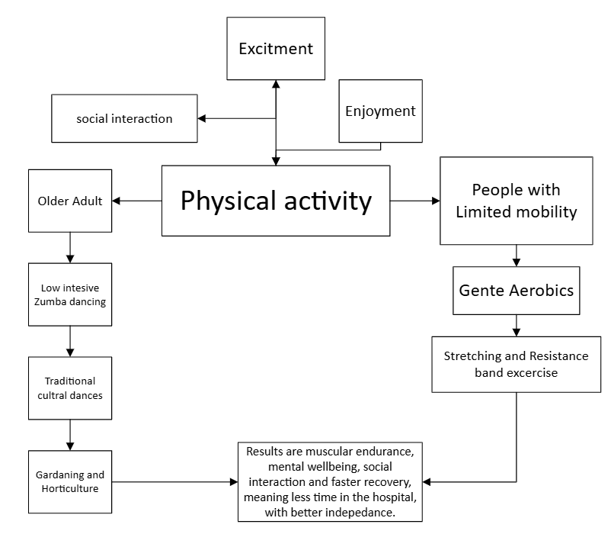

Creativity is the tendency to generate or recognize ideas, alternatives or possibility with a sense of intense curiosity that may be useful in solving problems, communicating with others and entertaining ourselves and others with positive attitude, strong motivation and determination. In health and social care sector creativity refers to use the creative and innovative approaches to improve people health. This may include gentle dance, chair aerobics exercises, stretching and movement for adult and people with limited mobility.

Creativity links a positive connection with wellbeing because emotional health creativity provides powerful outlet for expressing emotions, creativity activities reduce stress, anxiety, building understanding of different perspective feeling of sadness by empathy connection, foster social connection, reduce isolation and loneliness. Furthermore, creativity develops essential life skills, like resilience, adaptability, critical thinking making people better improves health and wellbeing, reducing the need for medication of residents, in addition can also improve the health and wellbeing of the workforce. (Patterson and Zibarras, 2017)

There are several tools you can use to encourage creativity in the workplace. Creativity problem solving (CPS) is the mental process of searching for original and previously solution problem. Furthermore, in such case you can use creative problem solving which allows you to explore potential solutions regardless of whether a problem has been defined, and it is less structured that other innovation process (Angeler et al., 2023). In addiction thinking creative promote the possibilities to view problems from different and fresh perspectives and experiment with new or different strategies from various angles, come up with innovative solutions and opportunities that enhances our ability to solve problems effectively.

Task 2 Self Reflection of Group Activity

Activity: Paper Clip
Reflection based on Gibbs reflective cycle, this reflective cycle is a framework for reflection commonly used in learning and professional development (Gibbs, 2013) It involves six stages, description, feeling, evaluation, analysis, conclusion and action plan.
Description:
I am currently studying the programme BSc Health and Social Care. I was in a group of five students doing an activity to generate as many uses a possible for a paperclip and my goal is to find whether is the best choice.
Feeling:
I felt a bit overwhelmed at first, however then I got really excited about the creative possibilities and the wide range of ideas multiples in divergent thinking looking for alternative solution. Nevertheless, I felt a sense of pressure to find the right solution, it is the convergent thinking which made me initially focus on a single design right idea.
Evaluation:
The good thing and worked well about the aspects of the experience are the team was able to generate a high volume of diverse ideas and several creative solutions (divergent thinking)
The bad thing or what did not work well is that I spent a lot of time in the creative part of the activity. Furthermore, few ideas were dismissed too quickly additionally I did not let enough time on focus to find the single best (convergent thinking)
Analysis: The relationship between divergent and convergent phases is essential and I realize balance and manage the time to find the right choices is crucial.

Conclusion:
I learned from this experience about the connection between divergent and convergent thinking. I would do things differently; I should get many divergent thinking ideas quickly and immediately start to focus on the best choice.
Action Plan:
In Future I will make sure manage my time better and my emotional feeling. Furthermore, improving interpersonal relationships and team dynamic to focus on my goal.

Task 3 Case Study of a UK Innovation
Case study 1 “NHS at Home” Remote Monitoring to Reduce Hospital Admissions.
Innovation is the action or process of translating an idea into a new or improved product, service, or method that creates values. Therefore, it is more than invention, is the process of applying that invention to a practical use. It comes in many forms, drives progress additionally is crucial for economic growth and social progress. Including unlimited technology and involve and involve creating or develop new business processes, finding new sources of supply furthermore improving the organization of an industry (Farmer et al.,2018)
Innovation is needed for fast and more accurate diagnoses, helping analysers scans like MRI and X-rays, Furthermore, to speed up the diagnosis of different health conditions, in addition improve the effectivity and personalization of the treatment. It is essential for prevention and early detection that help to manage the health conditions before becoming critical, improving patient care and outcomes, addressing systemic challenges by improving efficiency, innovation can reduce the pression of the healthcare staff in the complex health sector. (Williams And Daley, 2021)
NHS at Home initiative is an example of creativity thinking, by introducing remote monitoring technologies wearable devices, home based monitoring systems and digital platforms. Patients could manage their health from homes. Wearable devices to track vital signs like heart rate, blood pressure, glucose levels for diabetic patients and the data were automatically sent to a secure online platform also having accessed by both service user and healthcare provider.
Patients could manage their health from homes, this innovation aimed to empower services users, the patients were to interpret and understand their health data allowing them to make decision regarding to their care. Home based health monitoring like ECG machine is advanced health check at home and device for check glucose levels from your phone wherever. All this innovation was beneficial for early detection of health deterioration, reduce hospital visits, unplanned hospital admissions and readmission. Given the patients the comfort and flexibility, Furthermore, improved quality of live by management of chronic conditions such as heart, blood pressure, diabetes and COPD, reduce stress and optimized healthcare resources. However, there is some disadvantages.
The main disadvantages include digital exclusion, may not be suitable for all patients especially those who are older with physical and cognitive limitations. Furthermore, may not have the necessary technology at home or difficult to get internet access. In addition, reduce human contact, patients miss face to face consultation. Healthcare provider may have some technical challenges due to poor network coverage in rural area, clinical risk and lack of funding. In conclusion NHS at Home remote monitoring is essential for building a more proactive efficient and patients centred healthcare system that improves quality of life and reduces pressure and costs on the wider NHS system.

Task 4 Research task
Obesity in children and adolescents is a major issue in England, due to the long-term impacts on physical health, mental health and long-term health. Therefore, the association between sleep duration and obesity in children and adolescent is essential. This data involving 57,848 children and adolescent overall analysed revealed significant association of short sleep duration with changes in Body Mass Index (BMI), weigh gain and risk of obesity. In toddlers (1-2) years, preschool ages (3-5) years and school ages (6- !3) years in subgroup analyses, geographic region and sleep duration (Deng et al.,2021)
Our finding show that short sleep duration can increase the risk of obesity in children and adolescent especially within (3-13) years old. In addiction the relationship between obesity and sleep duration involves different factor such hormone regulation, reduced physical activity and increased calories intake. By contrast and long sleep duration is beneficial to preventing obesity.
Children in the more deprived areas or parts of England in 2023-24 where twice as likely to be obese, compared with those children in the least deprived areas. In 2009-10 the most deprived areas had slightly increase from 12.5% to 12.7% in obesity and in 2023-24 the analyse found the highest rate of obesity from 23.5% to 28.9% (Iacobucci, 2024) This poor area often a higher concentration of fast-food restaurants and fewer supermarkets with fresh products. Furthermore, peoples in these areas have limited access to healthier options. The costs of participation in sports or others physical activities can be too expensive for low-income families also lack the knowledges and resources about healthy lifestyles can contribute to this complex current issue in health and social care
In conclusion, controlling obesity in children and adolescent is essential because it prevents a wide range of serious potentially health problems during childhood and later in life, such as heart diseases, type 2 diabetes, high blood pressure, asthma or certain cancer. Additionally, can also lead to psychological issues such as low self-esteem and bullying.

Task 5 Podcast

Task 6 NHS Leadership Framework Analysis
The Leadership Framework is a strategic roadmap that defines the principles, practices and behaviors required for effective leadership withing organization. It provides a common language to describe what good leadership looks like. The NHS Leadership framework is a set of principles and behaviours essential and designed to guarantee and promote effective leadership including all staff levels within the health and social care sectors.
(NHS England, 2024) The NHS provides service, available to all irrespective of gender, race, disability, age, sexual orientation and religion or belief. Furthermore, the access is based on clinical need, not in individual ability to pay. The highest standards of professional of NHS works across organisational and in partnership with other organization in the best interest of patients. The NHS values provide common ground for continuous improvement with respect and dignity, commitment to quality of care, compassion, improving lives, everyone counts and working together for patients.
The NHS Leadership Framework is comprised of seven domains with five of these are considered core for all leaders, while the final two relate to senior positional roles. Demonstrating personal qualities, this includes managing oneself and engaging in continuing personal development and working with others is focuses on building and maintain relationships encouraging contribution from all and working effectively. Additionally, managing services, improving services, setting direction, creating the vision and delivering strategy. These seven domains describe the behaviours, knowledge, skills and attitudes expected of effective leaders. (Eliiz, Derrett and Greenfield, 2025)

Working with others is one of the domains that effective leadership requires to draw up the values, strengths and abilities to deliver high standards of service, building and maintaining relationships, encouraging contribution and working withing teams. In addiction working with other links to creativity and innovation by fosters trust and communication, a leader’s ability to build trust and good atmosphere where the team member feels empowered to take risks, share ideas, good listening, setting clear goals, learn from one another and ensuring members are involved in decisions making. Additionally, mutual trust contributes to better patient care. Examples of leadership resolving conflict with diplomacy and emotional intelligent. Example in care home resident’s handover or healthcare when the nurse teaching patients to manage their health. Furthermore, when a charge nurse organizing a meeting to do patient’s handover to next shift to ensure the team deliver effectively high quality of care and patients wishes and concerns are heard and addressed for better care.

Task 7 Self -Reflexion Journal Entry
In this model, I have learned that creativity is essential and cost-effective approach for creating significant value in health and social care, moving beyond basic needs to improve well-being, support person centre care and reduce pressure on the system. Furthermore, improved physical and mental health to individual by creative activities such as dance, music, gardening and arts, providing benefit and alleviating depression and anxiety, slowing cognitive decline in dementia and manage chronic pain. Therefore, enhanced well-being and quality of life, reducing loneliness and isolation.
The development of new simple, efficient and safe methods of care, such as new patient assessment forms, technological aids and new models of automatic machine make easier and improve job satisfaction. Therefore, self-reflexion is essential to improve the quality of care and performance by fostering continuous learning also by the critically analysing practitioners can identify strengths and weaknesses. Furthermore, supports emotional health and deepens professional commitment.
The key message is that creativity is crucial for living a rich, proven health benefit, meaningful and healthy life and should be fully integrated in to health and social care at all levels of policy and practice.

References

Angeler, D.G. et al. (2023) ‘Navigating the multiple dimensions of the creativity-mental disorder link: a Convergence Mental Health perspective’, Discover Mental Health, 3(1). Available at: https://doi.org/10.1007/s44192-023-00051-4.
Deng, X. et al. (2021) ‘Sleep duration and obesity in children and adolescents: evidence from an updated and dose–response meta-analysis’, Sleep medicine, 78, pp. 169–181. Available at: https://doi.org/10.1016/j.sleep.2020.12.027.
Cosimato, S., Di Paola, N. and Vona, R. (2024) ‘Digital social innovation: how healthcare ecosystems face Covid-19 challenges’, Technology analysis & strategic management, 36(8), pp. 1763–1778. Available at: https://doi.org/10.1080/09537325.2022.2111117.
Eljiz, K., Derrett, A. and Greenfield, D. (2025) ‘Key lessons for excellent healthcare leadership—a systems lens to drive safe, quality outcomes’, International journal for quality in health care, 37(2). Available at: https://doi.org/10.1093/intqhc/mzaf035.
Farmer, J. et al. (2018) ‘Applying social innovation theory to examine how community co-designed health services develop: using a case study approach and mixed methods’, BMC health services research, 18(1). Available at: https://doi.org/10.1186/s12913-018-2852-0.
‘Fostering Creativity and Innovation in Environmental Health’ (2024) Journal of environmental Ith, 87(5), pp.24-26
Gatto, A. and Sadik-Zada, E.R. (2023) Frontiers and Best Practices in Bio, Circular, and Green Growth and Eco-Innovation. Basel: MDPI - Multidisciplinary Digital Publishing Institute. Available at: https://doi.org/10.3390/books978-3-0365-7565-0.
Gibbs, G. (2013) Learning by doing: a guide to teaching and learning methods. Oxford Centre for Staff and Learning Development, p-49
Iacobucci, G. (2024) ‘Childhood obesity in England’s most deprived areas is double that in affluent areas’, BMJ (Online), 387, p. q2457. Available at: https://doi.org/10.1136/bmj.q2457.
The National Health Service (2024) The NHS Leadership Framework. Available at: https://www,leadershipacademy.nhs.uk.
Ojo, K.S. and Volkova, N.V. (2023) ‘Modelling Innovation competence profiles: the empowering roles of self-monitoring and resilience’, BMC Psychology, 11(1). Available at: https://doi.org/10.1186/s40359-023-01340-x.
Patterson, F. and Zibarras, L.D. (2017) ‘Selecting for creativity and innovation potential: implications for practice in healthcare education’, Advances in health sciences education : theory and practice, 22(2), pp. 417–428. Available at: https://doi.org/10.1007/s10459-016-9731-4
Rashid, A., Nawaz, S. and Zaman, U. (2021) ‘Examining the effect of inclusive climate on public health official’s creative performance: Mediating role of innovation climate’, Journal of public affairs, 21(3). Available at: https://doi.org/10.1002/pa.2273.
van Niekerk, L., Manderson, L. and Balabanova, D. (2021) ‘The application of social innovation in healthcare: a scoping review’, Infectious diseases of poverty, 10(1). Available at: https://doi.org/10.1186/s40249-021-00794-8.
Williams, M. and Daley, S. (2021) ‘Innovation in dementia education within undergraduate healthcare programmes: A scoping review’, Nurse education today, 98. Available at: https://doi.org/10.1016/j.nedt.2020.104742.

