LCLM4005 Employability and Career Development
Component 1: Mock Interview – Preparation Document
Student name: Nicolae-Daniel Toma
Student ID: 2514774
Programme: CertHE Business Skills for the Workplace
Lecturer: Bentil Oduro
Position applied for: Warehouse Team Leader – Chilled Warehouse, Cotteswold Dairy
1. JOB ADVERTISEMENT
Warehouse Team Leader – Chilled Warehouse
Employer: Cotteswold Dairy Ltd, Tewkesbury, Gloucestershire, GL20 8JE
Source: CV-Library (cv-library.co.uk) | Job reference: 0388 | Accessed: 17 October 2026
https://www.cv-library.co.uk/job/225684632/warehouse-team-leader
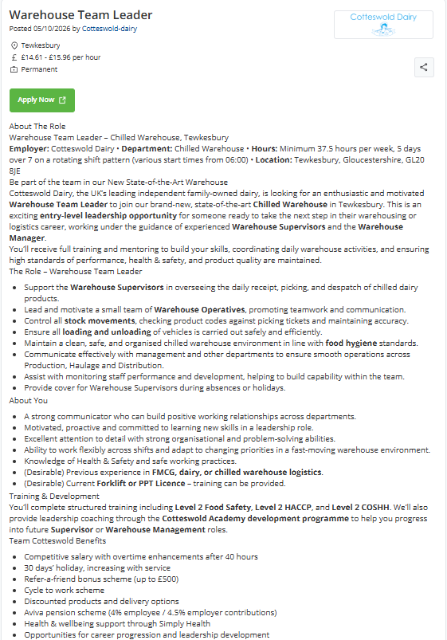

NICOLAE-DANIEL TOMA
07446 597 645 | tomanicolaedaniel@gmail.com | Worcester, WR4 9AP
PERSONAL STATEMENT
Reliable warehouse operative with over nine years experience in retail supply chain operations at DHL Supply Chain (Sainsbury’s), holding counterbalance and reach truck licences, plus four years running my own food business. Seeking a Warehouse Team Leader role in a chilled food environment where I can lead a team safely and keep standards high.
KEY SKILLS
- Leading by example on the warehouse floor | - Reach truck and counterbalance forklift
- Health, safety and operational compliance | - PPT, LLOP, long-legger and pump truck
- Food hygiene and product quality | - Stock control and replenishment
- Planning, organisation and problem-solving | - Loading, unloading and despatch
- Teamwork and clear communication | - Working to targets and deadlines
EMPLOYMENT HISTORY
Warehouse / Material Handling Operative June 2017 – Present
DHL Supply Chain – Sainsbury’s Operations
- Receive, store, pick and despatch retail stock in a high-volume operation
- Operate reach truck, counterbalance forklift, PPT, LLOP, long-legger and pump truck as tasks require
- Keep stock replenished and goods flowing so picking and despatch run on time
- Follow site health and safety procedures, staying alert to pedestrians, vehicles, racking and load stability
- Adapt quickly to changing workloads and priorities as a reliable member of the shift team
- Help settle new starters on the shift, showing them the site layout, pedestrian routes and safe equipment checks
- Report safety issues such as damaged pallets and unstable loads, supporting a safe and compliant operation
Owner / Food Business Operator April 2021 – June 2025
Polonicul – independent fresh hot food takeaway business
- Ran a rented food premises producing fresh homemade meals, with full responsibility for daily operations
- Planned ingredient orders and controlled stock to reduce waste while keeping fresh products available
- Managed purchasing, storage, food preparation, food hygiene standards and customer service
- Balanced competing daily demands without losing focus on product quality
EDUCATION
CertHE Business Skills for the Workplace January 2026 – Present
University of Wales Trinity Saint David, Birmingham
LICENCES AND CERTIFICATES
- Counterbalance Forklift Licence – RTITB / ITSSAR accredited
- Reach Truck Licence – RTITB / ITSSAR accredited
- Level 2 Award in Food Hygiene
LANGUAGES
Romanian – native | English – fluent
REFERENCES
Available on request.
Nicolae-Daniel Toma
07446 597 645 | tomanicolaedaniel@gmail.com
Hiring Manager
Cotteswold Dairy Ltd
Tewkesbury, Gloucestershire, GL20 8JE
17 October 2026
Dear Hiring Manager,
I wish to apply for the role of Warehouse Team Leader in your Chilled Warehouse (ref. 0388), currently being advertised on CV-Library. Please find enclosed my CV for your consideration.
I have over nine years experience in the retail supply chain industry, and I believe the knowledge of fast-moving consumer goods, warehouse equipment and safe working practices built up during this time makes me the right candidate for the role. I am also studying for a CertHE in Business Skills for the Workplace at the University of Wales Trinity Saint David.
In my current role as a Warehouse and Material Handling Operative at DHL Supply Chain, working on Sainsbury’s operations, I have been responsible for receiving, storing, picking and despatching stock, and for loading and unloading safely using counterbalance, reach truck, PPT and LLOP equipment. For example, when new starters join my shift, I am often asked to help them settle in. I show them the site layout, pedestrian routes and safe equipment checks, and stay close by during their first shifts, so they build confidence quickly, work safely and help the shift keep pace with its targets.
From 2021 to 2025 I also ran my own fresh hot food takeaway business, where I was responsible for purchasing, stock control, food hygiene and customer service, and I hold a Level 2 Food Hygiene certificate. All of this, coupled with my enthusiasm and dedication, attention to detail and practical problem-solving, has helped me understand how important quality and hygiene are when handling food.
I am confident that I can bring this level of commitment with me to your organisation and help Cotteswold Dairy build upon its reputation as the UK’s leading independent family-owned dairy, delivering over 100 million litres of milk and dairy products a year since 1938. With my previous experience and expertise, I believe my contribution will have an immediate impact in your brand-new, state-of-the-art chilled warehouse, and I would welcome the development offered through the Cotteswold Academy.
Thank you for your time and consideration. I look forward to meeting with you to discuss my application further.
Yours faithfully, Nicolae-Daniel Toma.

