Module Name: Contemporary Themes in the Hotel
and Hospitality Sector - LEVEL 6
Module Code: BMIH6001
Student Name: Abdul Mannan
Student ID: 2009122
Executive Summary
The UK hotel sector intends to use Internet of Things (IoT) technology to increase user experience, effectiveness, and cost savings. LED lighting and environmental management are two examples of Internet of Things (IoT) devices that can change their configurations based on use, increasing user engagement even further. However, there are concerns about safety, initiative range, and dependency on development. To maximise the benefits of IoT while lowering costs, businesses must differentiate themselves by setting safety expectations, strong administrative standards, and robust testing methodologies. To increase IoT usage while limiting potential hazards, businesses must exercise caution and prioritise their customers' demands. Personal training is crucial, but finances must also be addressed. Reliability is critical for the development of sustainable Internet of Things devices, air conditioning equipment, and waste reduction solutions. Innovative sustainability differs from safety measures, which must be exact, thorough, and comprehensive. Collaboration with government entities, developmental service providers, and the private sector will increase IoT linkages.
Table of Contents
1. Introduction 4
2. Overview of literature: 4
2.1 SWOT Analysis on the Technology Theme (IoT) 4
2.2 Current use of IoT in the UK hotel and hospitality sector 6
2.3 Impact of IoT on the Hotel and Hospitality Sector of the UK 8
3. Application to the hotel and hospitality sector 9
3.1 Evaluation of using IoT in HouseKeeping of the UK hotels 9
3.2 Impact of IoT in HouseKeeping 11
4. Recommendation to overcome the issues 12
5. Conclusion 13
References 14

1. Introduction
The hospitality sector of the UK has evolved over the years (Tektelic, 2022). It is able to adapt to the changes of consumer preferences and technology advancements. The hospitality sector of the UK is a very important part of the country’s economy. It also significantly contributes to the employment and tourism of the country. IOT is a very important technology as it connects everyday devices to the internet and enables them to share data. IoT plays a very important role in optimising processes and saving energy. IoT makes things very easy and more convenient. It connects everyday devices like the thermostats, lights and door locks with the Internet and creates a network that benefits both guests and the business. IoT helps to enhance the experience of the guests through smart room controls. This allows them to easily adjust the settings and personalise their stay (MEWS, 2022). This also adds a touch and understands the preferences of every individual guest. IoT also helps to create efficient management by providing time data on inventory. This helps to prevent shortages and reduces waste. IoT technology in the hospitality industry helps to easily perform its operation operations and improves guest satisfaction. This contributes to the overall efficiency and makes the entire experience. Very smooth and enjoyable for everyone involved here.

2. Overview of literature:

2.1 SWOT Analysis on the Technology Theme (IoT)
Strengths | Weaknesses
- Enhanced guest experience: The implementation of IoT has considered personalised and consistent visitor experiences through clever room controls and creative attendant services.  - Operational efficiency: The Internet of Things has improved energy efficiency, strengthened predictive maintenance, and simplified inventory management, among other aspects of functional effectiveness (Nadkarni et al., 2020).  - Innovation and differentiation: In a crowded market, lodgings that embrace IoT innovations set themselves apart by offering innovative services such as keyless entry, contactless booking, and smart amenities. | - Data security concerns: Given the company's difficulties in implementing stringent network security policies to prevent information theft and unauthorised access, the wide breadth and storage of sensitive visitor data is probably certainly a concern.  - High implementation costs: Implementing IoT developments may necessitate certain upfront costs, such as device setup and protocol reconciliation. The monetary weight may be an issue for persons who live in low-cost housing or have a low income (Sharma and Gupta, 2021).  - Dependency on technology: Resorts that rely on Internet of Things equipment are vulnerable to technical issues, system outages, and internet attacks, all of which disrupt regular operations and may hurt customer pleasure.
Opportunities | Threats
- Market growth and demand: The growing customer thirst for perceptive and connected items enables hotel chains to attract educated customers while also capitalising on the expanding business market through IoT-powered neighbourly ties.  - Data analytics for Personalization: Hospitality organisations may gain valuable insights into their visitors' preferences by utilising data collected from IoT devices. The information can be used to adapt advertising, provide customised products, and boost overall consumer retention (Bisoi et al., 2020).  - Integration with emerging technologies: Collaboration between IoT and growing technologies, such as virtual reality and computer logic, could provide new opportunities for creating interesting and unique experiences for viewers. | - Privacy regulations: The development of database insurance plans may impair data on visitor usage and volatility. Strong safety requirements should continue to appeal to hotels, even if they restrict the capacity to employ digital innovations.  - Competitive pressure: As IoT becomes more prevalent in the industry, motels that fail to make these changes may face more competition and may lose revenue to more savvy hotels (Mercan et al., 2021).  - Rapid technological advancements: The rapid advancement of technology may cause current IoT systems to become obsolete soon, necessitating ongoing examination for adjustments and improvements.
Table 1: SWOT analysis of using IoT in the UK Hotel and Hospitality sector
(Source: Author)

2.2 Current use of IoT in the UK hotel and hospitality sector
Hotels and restaurants in the United Kingdom like Hotel Premier Inn are gradually integrating the Internet of Things (IoT) to improve customer service and efficiency. Most hotels use an IoT platform to combine and simplify training. Smart camera installation is an important IoT application in the United Kingdom. Interior and mobile technologies allow visitors greater responsibility over temperature, temperature management, and entertainment settings (Conrady and Buck, 2007). The product also delivers an individual perspective, as well as increased energy levels due to the availability of diversity and consistency. The Internet of Things will have a significant impact on how firms operate inside.
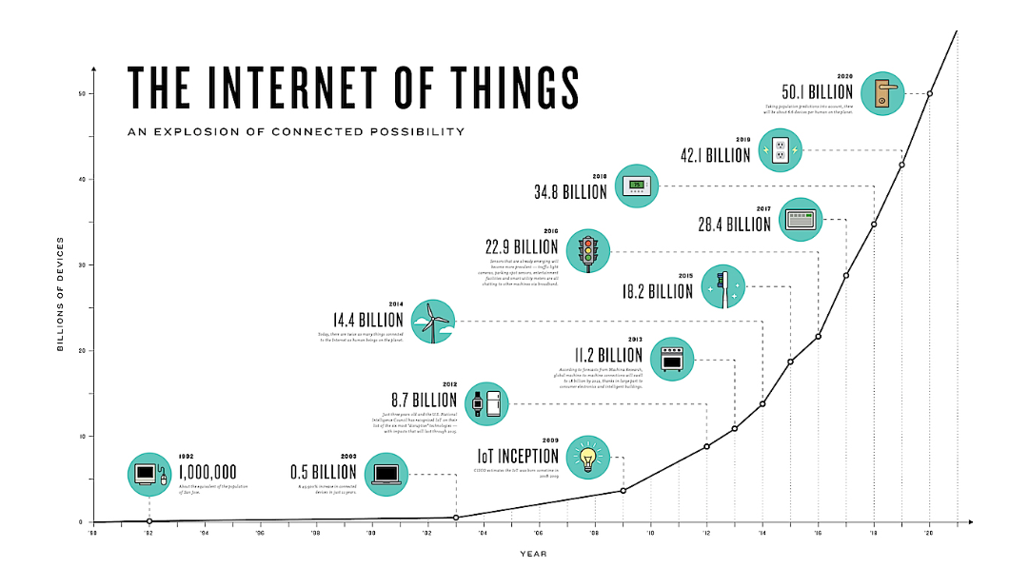
Figure 1: Market Size of Internet of Things
(Source: puzzlepartner, 2023)
They use advanced equipment and sensors to monitor and assess actions in order to clean the room quickly. This saves money and prevents genuine issues. Furthermore, as the internet of things (IoT) gains traction, hotels will be prepared to deal with equipment issues as they become more expensive. Another key area where IoT has made great development is safety. To improve customer security, the hotel has implemented a sophisticated surveillance tracking system that includes spotlights and detectors (Yuksel et al., 2020). These systems, which detect anomalous behaviours and gradually trigger notifications, may improve traditional safety processes. Management may benefit immensely from the Internet of Things. Organised cities may use the Internet of Things to notify visitors about future celebrations, event locations, and other surrounding attractions.
This has several advantages, including allowing hotels to better understand the needs of tourists and clients, as well as offer more support. Furthermore, given the current coronavirus issue, the British corporation uses IoT with ease. Overall, computer structures, remote management structures, and administrative permissions increase satisfaction while decreasing in-person interactions (Mercan et al., 2020). Despite these advancements, data security and system management remain a challenge. If associations wish to protect users' data and keep customers from sliding into these types of external firms, they must prosper in challenging conditions. The UK sports industry and regulatory organisations routinely employ the Internet of Things (IoT) to improve customer experiences for businesses and tourists. The Internet of Things (IoT) is transforming businesses and ushering in a new era of change by providing tailored finance, proactive help, and environmental monitoring tools (Mercan et al., 2021).

2.3 Impact of IoT on the Hotel and Hospitality Sector of the UK
There are advantages and disadvantages to implementing the Internet of Things (IoT) in the UK leisure industry (Leung, 2021). They approached the challenge with inventiveness and dedication. Intelligent dwellings with environmental oversight provide a more pleasant and equitable experience for customers. It provides a specific purpose while also enhancing consumer accountability due to its design, which allows for human leadership and attempts to reduce energy use and consumption in general. Furthermore, the Internet of Things has established residential operations that ensure the driving and cognitive assessment of inventory management. Preventive methods identify structures without missing any measures, avoiding lengthy and costly restorations (Verma et al., 2021).
The Internet of Things placement allows for more effective inventory management by ensuring products are appropriately confined and removing organisational issues (Kansakar and Shabani, 2019). The tourism industry in the United Kingdom is gradually embracing the Internet of Things to improve all aspects of the client experience. A reputable concierge business will keep companies up to date on the newest information and confirmed discounts while people visit. In the post-pandemic era, the outer structure is critical for encouraging the creation of a secure and efficient workplace by integrating flexible job market links with crucial industry-specific organisations. However, these benefits are not without costs (Narayan et al., 2022). Security and private protection are two of the most serious concerns.
The Internet of Things (IoT) devices record a large amount of secret and private data, which cannot be successfully stored. Failure to collect information about clients may jeopardise the hotel's integrity and standing. The Internet of Things will benefit the UK property industry in a variety of ways, including increased customer satisfaction and energy efficiency, but it is critical to understand its challenges (Ozdemir et al., 2023).

3. Application to the hotel and hospitality sector

3.1 Evaluation of using IoT in Housekeeping of the UK hotels
The UK hotel and restaurant sector faces different opportunities and challenges as it integrates Internet of Things (IoT) technology into the home.
Efficiency: IoT devices such as smart lighting systems, sensors and thermostats that automatically adjust settings based on usage can improve energy efficiency and save hotels money (Wynn and Lam, 2023).
Enhanced Guest Experience: Smart TVs, voice-activated assistants, custom camera settings, and other IoT features can be customised to a visitor's preferences, enhancing their overall enjoyment and experience. By using IoT, 53% of Indian hotels already achieved benefits in enhancing guest experience (Mathur, 2022).
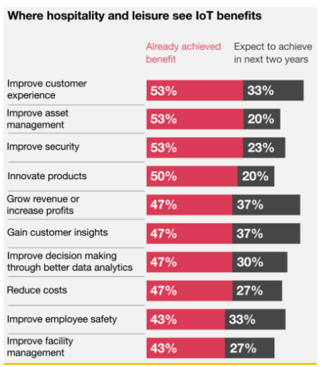
Figure 2: Different advantages of IoT in the Hotel & Hospitality sector
(Source: Mathur, 2022)
Streamlined Operations: Real-time monitoring of utilisation rates, inventory levels, and maintenance requirements via IoT sensors allows for proactive management and more efficient use of hotel resources and schedules.
Cost Reduction: Energy costs can be reduced through automatic lighting, water use and temperature control systems. Proactive maintenance with IoT sensors also reduces downtime and repair costs. By using IoT, 47% of Indian hotels already achieved benefits in reducing costs (Mathur, 2022).
Data Security Concerns: Connected IoT devices increase the risk of cybersecurity breaches, jeopardising sensitive customer data and hotel operations (Car and Šimunić, 2019).
Complexity and Integration Challenges: Integrating IoT devices from various manufacturers into existing hotel systems can be challenging and costly. This necessitates strong infrastructure and technical expertise.
Privacy Issues: IoT devices collect a wealth of data about traveller behaviour and preferences, raising privacy concerns about how hotels and other third-party service providers store, access, and use this information (Pappas et al., 2021).

3.2 Impact of IoT in Housekeeping
Positive Impacts
Smart lighting screens, room controls, and area sensors are just a few examples of IoT devices that can help private organisations achieve financial and practical benefits by improving resource efficiency and energy consumption. Voice-activated fast TVs and programmable cameras are two Internet of Things capabilities that aim to answer client problems. This raises the company's acceptability and secures the retention of both clientele and business. Monitoring and reviewing IoT device tools regularly allows organisations to manage drives, allocate tasks, distribute resources, and ensure their legality and importance (Ahmed et al., 202w). IoT innovation aids in environmental management by improving asset utilisation, reducing waste, and regulating energy consumption. All of this is consistent with the lodging industry's increasing emphasis on ecologically friendly operations (Yuksel et al., 2020).
Negative Impacts
The Exposed internet of Things is vulnerable to hacker organisations, increasing the likelihood that unknowing consumer information will be stolen or exploited. Designing an Internet of Things (IoT) network in-house can be challenging and time-consuming. To remain consistent and confident, one requires a large area, power, and reliable aid. Consumption actions provide tremendous joy for IoT devices (Buhalis and Moldavska, 2022). This raises concerns about the units' custody, restrictions, and use, regardless of the likelihood of inadvertent misuse or unlawful entrance. Massive responsibilities, regular maintenance, common checks, and region utilisation are all jeopardised by pushing connected device aims, neighbourhood failures, or other problems (Mercan et al., 2020).
Overall, allowing IoT advances may benefit transportation companies by increasing comfort, promoting consumer pleasure, and offering an economic advantage. However, there are other aspects to consider, such as discomfort, financial and security concerns, and an increased need for innovation (Hu et al., 2021). To fully reap the benefits of the "IoT" and avoid missed opportunities in the hotel industry, a thorough study of these enhancements is required, regardless of network safety rules, sound assessment, or culinary instructions. UK businesses want to differentiate themselves from competitors by leveraging IoT to give personalised attention and exceptional assistance. In the hospitality industry, it encourages creativity and innovation. The Internet of Things is rapidly evolving, which is why creative activities are critical and clients are always interested in the latest advances (Maglovska and Dimitrov, 2020).

4. Recommendation to overcome the issues
Given the myriad ways in which IoT devices may collect personal information about visitors, foundations should use discretion while attempting to restore data. Developing and maintaining client safety knowledge necessitates dedication to encryption skills, specific security assessments, and data validation requirements. Furthermore, it has become easier to carry out prescribed security checks and offer personnel with the tools needed to manage device safety. Furthermore, housing options must account for the significant upfront costs associated with completing the IoT project. It is critical to completely investigate everything that is currently going on with the Internet of Things while considering a variety of helpful and appropriate options. Establishing relationships with designers, utilising public energy, and adhering to a noise execution plan are all ways to reduce costs. Tenants of IoT gadgets and concepts should be able to recognise similarities and compatibility in order to avoid coordination issues and gain a better understanding of comparisons. It is hoped that selecting an accelerated course that meets generally acknowledged parameters will help them stay current and lessen the probability of experiencing financial difficulties. As IoT accelerates, continuous training of hotel staff becomes essential. Employees must move, move and maintain IoT devices. With this ongoing training, employees can adapt to changing situations, quickly resolve obstacles and understand the benefits of improvements made.
Hotels should use IoT to test acceptable customer experience. These organisations must support green IoT devices, advanced air conditioners and waste reduction technologies. Implementing the right practices can help companies meet the broader goals and expectations of environmentally conscious travellers while gaining a competitive advantage.
To solve security problems, accommodation companies must implement clear and comprehensive safeguards for the collection, storage, and use of visitors. Giving visitors clear access and responsibility for their data can speed up the process of building trust. These precautions must be implemented and continually evaluated to demonstrate a commitment to safety.
By staying on top of new developments and being willing to reconnect often, the companies can ensure the long-term relevance and success of the IoT business. With the rapid pace of technological innovation, hospitality companies must find IoT solutions that remain secure in the long term. This highlights the importance of choosing inclusive and renewable technologies and steps. By working together, hospitality companies can pioneer the adoption of IoT advances, challenges, and best practices in the hospitality industry. Additionally, the hotel companies should interact with government agencies, technology providers and the business sector to stay abreast of the latest developments, legislation, and high standards.

5. Conclusion
The UK travel industry is using IoT to improve customer service, operational efficiency and innovation. Internet of Things (IoT) applications have reduced homework, increased productivity, and improved customer service, but they also bring connectivity and data security challenges. Data security, high implementation costs and reliability are all issues that need to be addressed. This area has a significant impact on challenges such as customer service, energy consumption and space management, as well as increased operating costs and security concerns. Solutions to these problems include employee training, budgeting, proper classification, and safety requirements and cooperation with business partners. Proactive measures such as the Internet of Things must be properly implemented to promote creativity.

References
Ahmed, M., Abdou, M.Y.K. and Elnagar, A.M., (2022). The impact of implementing the Internet of Things (IoT) on customer satisfaction: evidence from Egypt. Journal of Association of Arab Universities for Tourism and Hospitality, 22(2), pp.365-380. https://journals.ekb.eg/article_226102_4b0cfbae205461dc67e44961d78f3277.pdf
Bisoi, S., Roy, M. and Samal, A., (2020). Impact of artificial intelligence in the hospitality industry. International Journal of Advanced Science and Technology, 29(5), pp.4265-4276.https://www.researchgate.net/profile/Mou-Roy-2/publication/343180745_Impact_of_Artificial_Intelligence_in_the_Hospitality_Industry/links/5f1a9c8b92851cd5fa421ba3/Impact-of-Artificial-Intelligence-in-the-Hospitality-Industry.pdf
Buhalis, D. and Moldavska, I., (2022). Voice assistants in hospitality: using artificial intelligence for customer service. Journal of Hospitality and Tourism Technology, 13(3), pp.386-403. https://eprints.bournemouth.ac.uk/36952/3/Voice%20Assistants%20in%20Hospitality%208NOV21%20CLEAN.pdf
Car, T., Stifanich, L.P. and Šimunić, M., (2019). Internet of things (iot) in tourism and hospitality: Opportunities and challenges. Tourism in South East Europe, 5, pp.163-175.https://www.academia.edu/download/66894304/293-internet-of-things-iot-in-tourism-and-hospitality-opportunities-and-challenges.pdf
Conrady, R. and Buck, M., (2007). Trends and Issues in Global Tourism... Berlin, Germany: Springer. https://perpus.univpancasila.ac.id/repository/EBUPT180159.pdf
Hu, M.Y., Pantano, E. and Stylos, N., (2021). How does Internet of Things (IOT) affect travel experience?. In Tourism marketing in Western Europe (pp. 9-25). Wallingford UK: CABI.http://bi-dam-prod.s3.amazonaws.com/611acdbdd5ef2b6ead5ae7f2/1b8db236583f12068010622dc984f670e1f74d2d/9781789248753_23_22ee664de13cffbeff60bec96ea10bbf.pdf
Kansakar, P., Munir, A. and Shabani, N., (2019). Technology in the hospitality industry: Prospects and challenges. IEEE Consumer Electronics Magazine, 8(3), pp.60-65.https://ieeexplore.ieee.org/abstract/document/8684803/
Leung, R., (2021). Hospitality technology progress towards intelligent buildings: a perspective article. Tourism Review, 76(1), pp.69-73. https://www.emerald.com/insight/content/doi/10.1108/TR-05-2019-0173/full/html
Maglovska, C.R. and Dimitrov, N.V., (2020, September). The Internet of Things in a hotel context. In Tourism International Scientific Conference Vrnjačka Banja-TISC (Vol. 5, No. 1, pp. 416-433). https://www.tisc.rs/proceedings/index.php/hitmc/article/download/350/345
Mathur, S., (2022). How is IoT changing the hospitality industry? Available at: https://www.zenatix.com/how-is-iot-changing-the-hospitality-industry/ [Accessed on 02-02-2024]
Mercan, S., Akkaya, K., Cain, L. and Thomas, J., (2020), November. Security, privacy and ethical concerns of IoT implementations in hospitality domain. In 2020 International Conferences on Internet of Things (iThings) and IEEE Green Computing and Communications (GreenCom) and IEEE Cyber, Physical and Social Computing (CPSCom) and IEEE Smart Data (SmartData) and IEEE Congress on Cybermatics (Cybermatics) (pp. 198-203). IEEE. https://ieeexplore.ieee.org/abstract/document/9291524/
Mercan, S., Akkaya, K., Cain, L. and Thomas, J., (2020, November). Security, privacy and ethical concerns of IoT implementations in hospitality domain. In 2020 International Conferences on Internet of Things (iThings) and IEEE Green Computing and Communications (GreenCom) and IEEE Cyber, Physical and Social Computing (CPSCom) and IEEE Smart Data (SmartData) and IEEE Congress on Cybermatics (Cybermatics) (pp. 198-203). IEEE.https://ieeexplore.ieee.org/abstract/document/9291524/
Mercan, S., Cain, L., Akkaya, K., Cebe, M., Uluagac, S., Alonso, M. and Cobanoglu, C., (2021). Improving the service industry with hyper-connectivity: IoT in hospitality. International Journal of Contemporary Hospitality Management, 33(1), pp.243-262.https://www.emerald.com/insight/content/doi/10.1108/IJCHM-06-2020-0621/full/html
Mercan, S., Cain, L., Akkaya, K., Cebe, M., Uluagac, S., Alonso, M. and Cobanoglu, C., (2021). Improving the service industry with hyper-connectivity: IoT in hospitality. International Journal of Contemporary Hospitality Management, 33(1), pp.243-262. https://www.emerald.com/insight/content/doi/10.1108/IJCHM-06-2020-0621/full/html
MEWS, (2022). How the internet of things (IoT) benefits the hospitality industry. Available at:https://www.mews.com/en/blog/iot-in-hospitality [Accessed on: 02.02.24]
Nadkarni, S., Kriechbaumer, F., Rothenberger, M. and Christodoulidou, N., (2020). The path to the Hotel of Things: Internet of Things and Big Data converging in hospitality. Journal of Hospitality and Tourism Technology, 11(1), pp.93-107.https://www.emerald.com/insight/content/doi/10.1108/JHTT-12-2018-0120/full/html
Narayan, R., Gehlot, A., Singh, R., Akram, S.V., Priyadarshi, N. and Twala, B., (2022). Hospitality Feedback System 4.0: Digitalization of Feedback System with Integration of Industry 4.0 Enabling Technologies. Sustainability, 14(19), p.12158. https://www.mdpi.com/2071-1050/14/19/12158
Ozdemir, O., Dogru, T., Kizildag, M. and Erkmen, E., (2023). A critical reflection on digitalization for the hospitality and tourism industry: value implications for stakeholders. International Journal of Contemporary Hospitality Management. https://www.emerald.com/insight/content/doi/10.1108/IJCHM-04-2022-0535/full/html
Pappas, N., Caputo, A., Pellegrini, M.M., Marzi, G. and Michopoulou, E., (2021). The complexity of decision-making processes and IoT adoption in accommodation SMEs. Journal of Business Research, 131, pp.573-583. https://www.sciencedirect.com/science/article/pii/S0148296321000102
Puzzlepartner, (2023). The Internet of Things: The Impact on the Travel and Hotel Industry. Available at: https://www.puzzlepartner.co/the-internet-of-things-the-impact-on-the-travel-and-hotel-industry/ [Accessed on 02-02-2024]
Sharma, U. and Gupta, D., (2021, July). Analyzing the applications of internet of things in hotel industry. In Journal of Physics: Conference Series (Vol. 1969, No. 1, p. 012041). IOP Publishing.https://iopscience.iop.org/article/10.1088/1742-6596/1969/1/012041/meta
Tektelic, (2022). Possible IoT Applications In Hospitality Sector. Available at:https://tektelic.com/expertise/possible-iot-applications-in-hospitality-sector/ [Accessed on: 02.02.24]
Verma, A., Shukla, V.K. and Sharma, R., (2021). Convergence of IOT in tourism industry: a pragmatic analysis. In Journal of Physics: Conference Series (Vol. 1714, No. 1, p. 012037). IOP Publishing. https://iopscience.iop.org/article/10.1088/1742-6596/1714/1/012037/meta
Wynn, M. and Lam, C., (2023). Digitalisation and IT strategy in the hospitality industry. Systems, 11(10), p.501. https://www.mdpi.com/2079-8954/11/10/501
Yuksel, A.S., Cankaya, I.A. and Cankaya, S.F., (2020). IoT for hospitality industry: paperless buffet management. In Securing the Internet of Things: Concepts, Methodologies, Tools, and Applications (pp. 1388-1408). IGI Global.https://www.igi-global.com/chapter/iot-for-hospitality-industry/234998
Yuksel, A.S., Cankaya, I.A. and Cankaya, S.F., (2020). IoT for hospitality industry: paperless buffet management. In Securing the Internet of Things: Concepts, Methodologies, Tools, and Applications (pp. 1388-1408). IGI Global. https://www.igi-global.com/chapter/iot-for-hospitality-industry/234998

