Professional Career Development

Course Title-BMSW4005

Student Name-Elizabeth Kokori/1910041

Lecturer Name-Joy Botu
Date-2020

Table of Content
- Introduction
- Body
- Personal reflection
- Improved skills
- Next height in employment
- Personal strength
- Areas of weakness
- Employment goals
- Conclusion
- References

Introduction
Reflection is referred to as an activity that is geared toward critical analysis of persons own experience and practical skills and responses in other to improve more in personal career development. In life it is very imperative for an individual to halt and reflect on a day to day basis to further know how things has happened, what went wrong and what need to be improved. It is not enough to have an experience and to learn without reflecting on it because if you fail to reflect on these experiences you may forget its learning potentiality. {Gibbs, 1988, p9}
In this report, I am going to reflect on my journey so far on how I have position myself to develop my academic and employability skills, my challenges and opportunities, my strength and weaknesses and possible achievement so far. This also include the part I choose to follow to develop my career and my readiness to achieving my full potential in the job that I want to train for. This reflection is also to share my experience using public literature books and journals to interpret my work.
The reflective report is a mental shift for me to evaluate my self or system if it is aligned with the new normal of technological advancement and personal career and skills development that is required for the changing world

Body
Before coming to study at the University of Wales trinity saint Davies, I had no higher school certificate and that has relegated me to work lower salary wages. I have always worked in the care sector for the years I have been in the United Kingdom working with the vulnerable and people with learning disabilities. Although my job as a health care professional has been rewarding but if has not giving me the satisfaction and financial security that I desire knowing for the fact that I have growing family responsibility begin to border me, all these factors motivated me to develop my career further to enable me have adequate social and financial status and to achieve these goals I need to improve on my academic and employability skills.
My desire to have a career development came with lot of challenges, I was scared of how to cope with studies as my educational background is the use of pen and paper, I was not sure if I will be able to use the computer because of no digital skill. On the other hand, I have family commitment, felt anxious returning to school after so many years. Working as a care support worker only gave me basic training to work practically. However, I wanted to develop to understand the theoretical aspect of my line of job to make my self relevant and to contribute to the success of the workplace.
From my previous background I did not know the term self-awareness and the importance of self-development as I journey along my career development part, I came to realise that having an understanding and being brilliant are parallel and they are relevant to our social environment. I realised that if I develop my skill, I can be able to reach out to a larger society and have a better life
I can ascertain that from the start of my career development since October 2019 up until now I have understood the part way to follow to achieve my academic goals, the different skills and knowledge that are required to develop and these skills and knowledge has improve the way I carry out duties in the workplace. Acknowledging the gap between my management and myself as an individual motivated me to relearn to develop and improve my skills, that is what inspired me to get a university degree.
Since my course, I have acquired and gained more knowledge that will be a great impact to my entire professional development. Have realized that soft skills development are important skills for achievement. According to {Schon, 1983} he describes reflection as before, during and after learning process.

Skills and knowledge achieved
- Communication Skills
- Team Working
- Adaptability skills
- Problem Solving
- Critical thinking

*Communication Skills -In the course of study, I have improved in my written and verbal communication, this has given me the confident to be able to interact with my colleague as well as my classmate this skill has also enable me to maintain good relationships with my manager enhance the way I communicate with doctors and nurse , I have also understand how to maintain body language maintaining eye contact can indicate how confidence you are . I have been able to write a comprehensive hand over report for other staff to read and understand, effective communication skills have given me the confidence to be able to stand in front the class for presentation. This skill has given the opportunity and confidence to be able to share my career goals and has enable be understand and maintain my body language. Before I did not have the knowledge of negative and positive body language, but my career development has enabled me to improve in my communication skill.
*Team Working – Working in a team has made me understand that for a team to succeed, it is impossible for an individual to bring change in an organisation. For a team to be effective, the team member needs to respect and listen to other people opinion as the purpose of a team is to work together to improve productivity and synergy. I now have the understanding to be inclusive in team working irrespective of who they are , Ethnicity Sex or race, there should not be discrimination, this improve team culture , I have also learn that it is important to offer to help any weaker line in the team to increase productivity and also to be transparent and take responsibility in the case of any mistake. I can attest that my team working skills has improve. However, there is need to keep learning for more improvement.
* Adaptability – This skill has enabled me to be adaptable to the challenges in my workplace regarding work pattern as the shift pattern changes, I must flexible and be available for work. This skill has enabled me to adapt to various changes and challenges in the workplace. I had to adapt to attending different training courses that are relevant to my job and learn how to use the computer. This skill is important for employment and employer are interested in the flexibility of any employee and how well they can adapt to challenges and change. I have been able to have the knowledge of some aspect of digital skills adapting to this skill has giving the confidence to use Microsoft word in the workplace and to study.
*Problem Solving Skills- I have improve and gain confidence in this area as it has enhanced the way I solve problem that arises in the workplace. As my job is mostly working alone, I have the knowledge of working with my own initiative making the right decision at the right time instead of calling my manager for solution at all time. My problem-solving skills has increased the confidence of my employer trusting me to make quick decisions to solving problems.
*Critical Thinking – These skills have improved my knowledge on how to reflect on the negative or positive ideas in the workplace if there has been success or not. My critical thinking has improved by reading books, having discussion with co-worker and classmates, and using literature and journal to bring new ideas that will improve the workplaces and develop as an individual.
In addition to the knowledge I have achieved, I have realized that employers value people who are honest and have self-respect, trust worthy, people who ere able to integrate with others, and ability to be able to present ideas that will increase the performance in the work place. This course has giving me the opportunity to be able to improve on these qualities and has made ma to be more relevant at work.

Next Height in Employment
I am ready to start looking forward for a more rewarding employment because of the confidence I have been able to demonstrate in my career development in the following career skills. My personality and the way I interact with friends and colleagues has improved, I can demonstrate positive work ethics by managing my time appropriately, following instructions and maintaining integrity respecting other people.
Working effectively in a team has made me realise that you can improve productivity if we work together regardless of cultural differences and values respecting other people views and opinion , the ability to cope with diversity is very important in the workplace and employer sees this skills as one of their criterial of employment. I have gained and improved in my team working skills.
Communication skills has improve as the way and manner I interact with classmate and colleague have improved , I am able to read and write clearly for people understanding and my confidence in public speaking has improved as I progress in my career development skills.
I have also gained digital skill; this has enabled me to have the ability to select and use technology effectively. I did not have the ability to justify the specification of a job. However, I have that experience now and that can allow me to attain susses in gaining employment.
Understanding policies and procedures, ability to demonstrate safety skill in the workplace, solving problem in a logical way, and good self-respect are the skills that has enhance my confidence in attaining my full potential. I have also developed my CV writing skills and preparing to start searching for job that is in line of my course of study Health and Social Care in Leadership and Management. When you have the following skills that I am going to be listed below shows your readiness for employment.
*Self-awareness
*Time management
*Ability to work with other
*Coping with diversity
*Problem solving
*Professional knowledge and skills
* Digital skills

Analysis of my personal Strength

I am using the Johari window to analyse my strength as I progress in this reflective report.

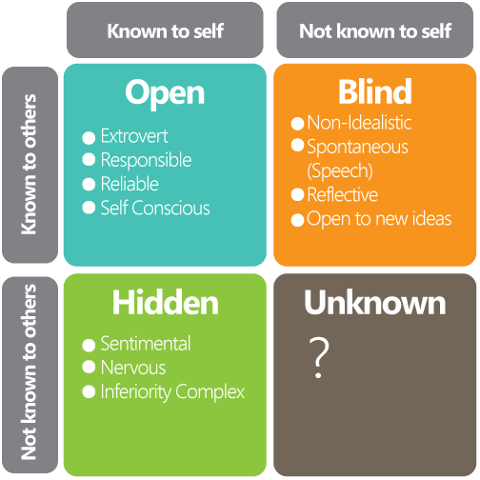
This Photo by Unknown Author is licensed under CC BY-NC
The Johari window was created by two American psychologist Joseph Luft and Harry Ingram in the 1950’s. The main purpose of this model is to allow people to understand who they are and to be able to build relationships on trust with other people in all dynamic system or fields. This model also for enhancing transparency amongst other people, their idea is to learn about yourself.
- The Johari Window has given me the tool to understand self-awareness of how to communicate and inspire people with my attitude and the ability to make people trust me to enable us build good relationships in the workplace or at school. The first window which is the open area clearly describes my stronger strength that I am aware of as well as others, My strength includes effective communication skill, I can communicate effectively with team member verbally and I can write clearly in the way other people can understand, and I am able to control my body language.
Team working, in this aspect of my strength I can work with other people amicably helping and supporting other team member who may be struggling to complete tasks as we know that effective teamwork can create synergy.
Time keeping is also my strength, by this I am able to organise my day to day tasks, this enable me to manage my family responsibility, work and school work , I am very passionate with what I do as a care provider I need to be passionate to be able to provide care to the vulnerable, and this strength I have carried on unto working with other people regardless of who they are, and I am also a committed individual to take pleasure in achieving success. I am going to make a list of my strength below.
My Strength
- Communication
- Team working
- Time keeping
- Passionate
- Commitment
- Adaptability

- The second window is the hidden area this is what I know about myself as an individual that others do not know, this may be some information that I am willing to share because I have not build trust and afraid of people being judgemental towards me.
- The blind areas describe what others know about me that I am unaware, sometime people have different view from how you see things, team member might not inform me of what they know about me because they do not want to hurt my feelings. The unknown area represents what I and others do not know about, and this might be inner strength or talent that needs developing. The Johari window has helped me to understand myself and build trust amongst team and has enable me to learn more about my strength by being more open minded so I can learn from other people’s feedback as this will allow me to improve on myself and a create conducive atmosphere amongst team. The Johari window clearly explains how important it is to enlarge my open space by being honest and open minded, because the more people know and understand you and trust you the more, they are willing to share information.

My Areas of Weakness
My area of weakness can be described as those inherent characteristics that I have to develop to enhance my strength better as an individual. Knowing that weakness can prevent me from achieving my full potential it is my responsibility to work on those weakness qualities to improve. I will list out my weakness as the following
- Organization
- Finance
- Career Development
- Digital skills
- Public speaking
- Asking for help
.
My organisation skills has not been the best .however I have set out a plan to allow be put my schedule in place to enable me carry out my daily activities starting from home to the workplace and this has earned me positive comment in the workplace and at school.
Finance Before coming to United Kingdom, I have always wanted to improve on my career but there was no proper finance. Now I can study by taking out student finance loan to achieve my academic pursuits.
Career Development. Before now I only have the basis work training that allows me to be employed in a limited work position. However, I have applied to in skills in the workplace to further developed and acquire the skills that will enable me to be employable in a wilder scale.
Digital skills. Before now, I have only used the computer to only access emails and the use of Microsoft word. However, I have enrolled in a training centre to enable me to have more knowledge of digital skills this will enhance my academic research skill and workplace criteria.
Public speaking. This has always been one of my weakness, I was always scared to speak whenever there are team meetings at work. But through being able to ask questions and discuss with classmate and participating in class presentation I have improve and gained more confidence in public speaking.
Asking for help. I like to complete tasks without asking for help and that will usually make my work slower in time. However, I have learned to ask for help in that helping hands create quick result and increase synergy. SWOT analysis also described the opportunities that are available to enable me to learn new skills in line with my development plan. For example, leaning the use of modern technology in the workplace and the treats I could possibly face which can be referred to financial treats and childcare. I have used the SWOT analysis to highlight the areas of my weakness below.

SWOT ANALYSIS

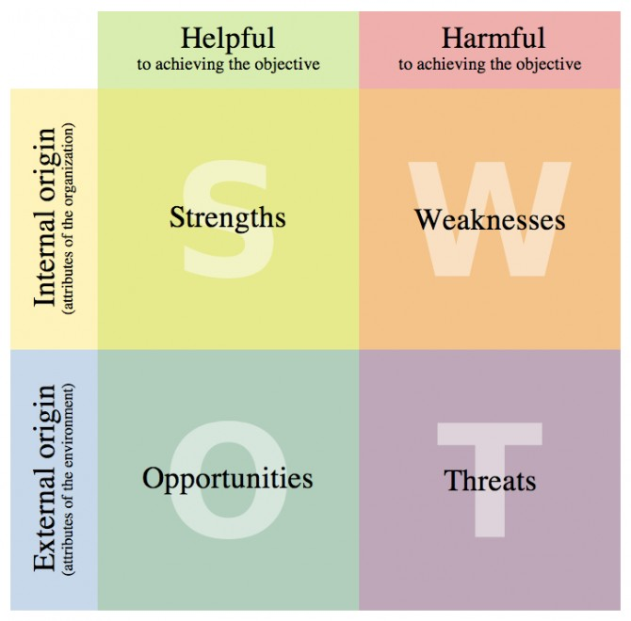
This Photo by Unknown Author is licensed under CC BY-SA

Establishing employment goals and develop a personal action plan/development plan.

I have been able to make progress since the start of my Higher Certificate for skills in the workplace. This has enabled me to be more self-aware and have built my confidence on how to set myself in getting the job that I need. One of my employment goals is to improve on my employability skills that will make an employer to want to hire me. Currently I work in the care sector as a care support worker. However, my aim is to gain more knowledge to increase my understanding of how to attain a higher position in health sector.
There is a clear sense of direction on how to achieve my employment gaols by improving the areas where I need to improve. My employment goals are to improve more on my communication skills, team working, time management digital skills. My goal to achieve success and attain a leadership role in my team, making myself available for training purposes for personal performance in the workplace.
Over the course of study, I have gained experience working with other people, each other supporting others to contribute to the success of an organization., I have managed to keep my skills up and be useful in the workplace. As I progress in my employment goals, it gives me self-satisfaction that I need. For my employment goals and the skills that employers require are
- Effective communication skills
- Reading and writing
- Positive facial expression
- Ability to listen and give information
- Confidence
- Team working
- Time management
- Numerical skills
My personal development plan is to be able to achieve a leadership and management professional career in the health sector and as such it is my responsibility to know what I need to do the resource that I need to help me fulfil my career goals both now and future times. Furthermore my career time frame in achieving a certificate degree in health and social care is the space of three years which I am nearly completing my first year completing my foundation certificate course in health and social care and there after proceed to completing level five and six in the next two years.
I now understand the requirements that is required through the university guidelines on how to proceed to my next level of career development. Within the next two years I should be graduating with a degree certificate if I follow my personal development plan with commitment and great focused and determination. In attaining my goals, it is my responsibility to enrol in the course, create time to attend classes complete assignment on time and understand the policies and procedures of becoming a professional in the care sector. Where I am now is to finish my certificate course and make progress to develop into having a career in health and social care as a manager as an advancement of role in future , my vision is to be able to lead and manage people to increase performance in the workplace. The care sector is where I have always had passion to follow in attaining my career goals and it is my duty to process improvement in this career part as this career goal is associated with who I am as an individual. My motivation in advancing and develop my career goals is to create financial security for my family and be proud of myself of having a fulfilled life and be able to give back to the society at large.
Personal development is referred to as the tools a learner requires to enable him or her plan for future career part and develop and provide the medium to reflect on your work and learning performance and achievement{ Quality Assurance Agency for Higher Education 2009b}.
To further explain my PDP, I will be using the SMART analysis which are
S- Specific
M- Measurable
A-Achievable
R- Realistic
T- Time management
These have put together to enable me
- Learn more skills there is always opportunity to learn new things
- Read more to gain more knowledge of my career goals
- Improve my work Life balance, to create time out of work and family to study
- Communicate effectively for clearer understanding
- Challenge myself out of my comfort zone
Working with these development plan will allow me to achieve my goals and become effective in the workplace and also will enable me have a career in leadership and management which can be achievable in the space of three years with commitment and dedication to study.

Personal Development Plan Diagram
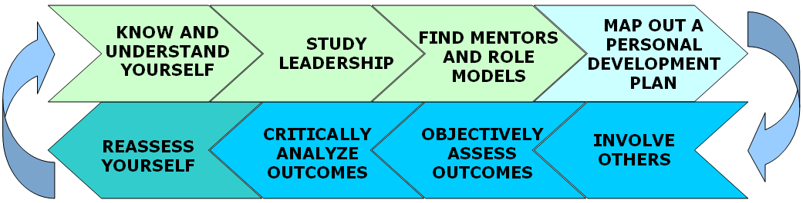
This Photo by Unknown Author is licensed under CC BY-SA-NC
This personal development plan diagram represent the skills I have learned to improve my workplace performance, and also represent how I have plan to relearn and add value to my present skills to stay relevant to meet with the challenges of the present times. My plan to develop new career goal will enable me to secure myself and become a person of value, it is my responsibility to evaluate my experiences for the demand of the present and future goals. As I developed to be a manager in health and social care, I need to improve to understand the Government regulations that governs both the employer and the employee, for example understanding the employment law is very relevant to my professional career and these law include .Health and safety at work Act 1977, Human right Act, 1998, and Data protection Act,

Summary
This reflective report has explained and analyse the important ok personal skill acquisition that will make you employable and make relevant in the workplace. The beginning of my study was scary, However I was able to settle in learn of the skills that I need to be successful in the workplace and the report has clearly highlighted the skills I need to improve on and also show which areas are my strength and weakness by using the Johari Window analysis. This report also summarises how ready I am in the next height of employment through my experience and personal soft skills developed and improved on.
This also include how I have set a career goals and plan on how to achieve it in the set time that is require for it to be completed which is realistic.

Conclusion
By observation, it is important for an individual to have a mental shift critical thinking of how to develop and improve on the skills that will enhance or improve workplace performance and also look for a creative way to help organization increase. This report also outlines that to be relevant it is essential to relearn by having a personal development plan and be committed to allow success and value to the individual in future,

References
Luft, J. and Ingham, H. {1955}
Adapted from www.busnessballs.com Copyright alan chapman {2003}
Luft, 2014. Johari’s Window. Silverwood Book
Gibbs, G {1988}. Learning by doing: a guide to teaching and learning methods

