1
Skills for the Workplace
Module Assignment Submission
Student Name: | ABDUR RAHIM ROAP
Student Number: | 1911044
Module No: | BMSK4002
Module Title: | Effective Team Working and Communication Part 1

Statement of Confirmation of Authenticity
By the act of making this submission, the student declares that this is the work of the student named above. The work has not, in whole or in part, been knowingly presented elsewhere for assessment, or where an assessment has been built on a previous assessment, this has been identified. Where materials have been used from other sources it has been properly acknowledged. If this statement is untrue, the student acknowledges that an assessment offence has been committed.
Attention is drawn to the plagiarism and unfair practice policies of both the University and of ILM.

Contents
Introduction 3
Name of Presenter 3
Abstract 3
Intendment 3
Methodology 4
Analysis 4
Introspection 5
Table 1 - Presentation Plan 7
Table 2 - Presentation Content 8
Appendix A 9
Appendix B 12
Appendix C 13
Appendix D 14
Appendix E 15
Appendix F 16
References 17
Bibliography 19

Introduction

I’m a mature student whose only regret in life is not fulfilling my desire for a degree-level education. Sometimes, what you want is not always what you get in life. Having worked in the Indian catering trade for the past 35 years with the last 20 years of those as a self-employed business proprietor, I decided to go into semi-retirement and work part-time. Whilst doing so and time on my hands, the opportunity presented itself to pursue an educational path at degree level. On the recommendation of a work colleague, I chose to do an HCert in Skills in the Workplace. This would allow me to gain entry to a degree course. The course itself would give practical and academic knowledge pertaining to and relevant to my chosen career path. Having not taken any form of education for nigh on 27 years, I did so with some apprehension, to say the least.
Now, in my fourth module, I can honestly say that this apprehension was not grounded in fact. I was pleasantly surprised at my capabilities and this course has only enhanced them. Turning weakness’ into strengths along the way. Hopefully, with a lot of diligence and hard work, I will stay the course literally and metaphorically speaking and realise my dream of graduate education and make my family proud. In many ways, looking forward it would seem I’m destined to follow Wheelan's Integrated Model of Group Development (1990/1994a) of infancy, adolescence, adulthood, and maturity minus the group part.

Name of Presenter
Mr. Abdur Rahim Roap

Abstract
This commentary describes the finer details of group and team formation and to showcase however brief, the myriad theories and models that punctuate this academic field and discuss developments in the study of teamwork, Furthermore, to offer an assessment of how this may benefit a leader or manager. Employing Gibbs' Reflective Cycle (1988) an introspective discussion of the learning experience will be undertaken.

Intendment

The primary purpose of this module from the outset was to learn the finer points of teamwork and communication. To that end, we as a Cohort were tasked to form a group or team and yield a PowerPoint presentation (see Appendix A) showcasing our knowledge of the subject matter and whether we can bond as a team and deliver a presentation worthy of praise.
Alas, in these difficult times with the onset of the Covid-19 crisis this is not attainable. Many compromises had to be made. Improvising has been key.

Methodology

My fellow students and I, together with our capable lecturer Beth Lowden, have had to adapt at breakneck speed. The University bought forward the introduction of the use of Microsoft Teams. A useful aid to social distancing. This required a steep learning curve on our part, having to adapt to the finer intricacies of Microsoft Teams. Learning material originally supplied had to be adapted to meld with the new reality of distance learning. Although not a new concept, think Open University’s online courses, it came as a shock to the system none the less.
As Winston Churchill said, “It is always wise to look ahead, but difficult to look further than you can see”. So, a compromise had to be reached has the way forward. It was decided that under the circumstances the team presentation format would be abandoned in favour of an individual exposition.

Analysis

Naturally, for us, the students presented a new scale of difficulty that we had not envisaged. Many, including myself, felt that this was an extra burden. The ‘to and froing’ in the cohort’s WhatsApp group was a testament to that (see Appendix C). The irony; the situation warranted greater teamwork as a cohort and not has individual teams who candidly would be competing against each other. Knowledge amongst us was flowing freely unlike before. Comradery and collaboration took root and you can see we were blossoming if you can excuse the pun.
We were making progress has a whole even though some in the group were having difficulty with some concepts regarding the differences between groups and teams. Perseverance prevailed. However, during our workshop on 6th May 2020, it transpired that the resources had been updated and modified that it induced the proverbial spanner in the works. To our lecturer’s, Beth Lowden, surprise, the criteria had changed and she had no knowledge of the update.
This meant that the cohort had to pivot and make the required alteration to work rendered. For me this was no easy task as my PowerPoint presentation was scheduled for Sunday 10th May, leaving me little room to manoeuvre. The deadline was anchored. The alternative was to risk a lower grade. This was not a desirable outcome. As such I worked till the early hours of the morning preparing my Presentation plan (Table 1), Handouts, (Appendix B) contents (Table 2) and feedback sheet (Appendix D) to forward to my lecturer before the Sunday deadline and not least the now modified draft copy presentation assignment cover sheet. Others had asked for their presentation to be delayed; I chose not to.

Introspection

Of all the modules completed, this has been no doubt the most difficult. New skills had to be learned; the use of Microsoft Teams; the use of PowerPoint software to produce the presentation and communicating through digital means to converse and learn. Not to mention the actual module itself.
The presentation itself was difficult. I had no prior experience but knowing my target audience were my fellow students made the situation more bearable. My demon of fast-talking had to be tamed otherwise the presentation would end quickly. Well below the allotted time. But I managed.
We were apprehensive and nervous especially my fellow student Ripa Begum who quite frankly was a bag of nerves. However, her presentation was a joy to watch and was impressive considering how agitated she was. Holly Gucci particularly impressed me with her presentational skills. I watched all presentations in earnest and picked out the finer nuances that each bought to the presentation. We were all unique in our ways.
The knowledge imparted by us to us, I like to think was useful and relevant to our future career path.
The Presentation feedback sheet was handed to each member of the audience for a candid assessment of the presentation including any feedback given.
The results (available in Appendix E) were collated and show the areas that were well-grounded and those that require improvement. The feedback suggests the area of improvement. My eye contact and body language were scored lower. Considering, that the presentation was delivered via Teams this was to be expected. My strengths; first impression and communication. The overall presentation score given (marked 1 to 10) shows I had an 86% scoring rate. This compares favourably with my course average. The feedback sheet displays the scores meted out by me for what I consider an honest assessment of my presentation. This candid appraisal scores me lower than that given by my fellow students. This reflects my disappointment at my ability to deliver on the day. I expected to do a better job not so much for the scores garnered, moreover, the delivery was not what I hoped. I know the month of Ramadan with a strict fasting regime in place may be considered mitigation, but still, my disappointment is not tempered by my failure to achieve.
The feedback, however, was constructive and keenly taken on board that will be worked on for the betterment of future presentations. I like to think I did well all things considered. As I intend to move forward and complete a degree education, improvements will need to be mustered and monitored in the next two to three years if I am to be successful in my endeavour. To this end, I’ve assessed my skills for working in groups and teams, see the completed checklist (Appendix F) to ascertain where my weakness’ and strengths lay for me to reach an equilibrium.
Ideally, in a perfect world, the presentation would have been done under the original criteria meaning that each team member would have been allotted a shorter timeframe for their segment of the presentation. Thus, making it easier to perform and the opportunity for mistakes diminished. That being said, the most effective and able teams are accomplished by definition. And “one of the essential ingredients of high performing individuals, teams, and organisations is creativity (Basadur, 2004). So, bringing together a group of people during these difficult times doesn’t necessarily mean that we’d form a great successful team and release our inherent inventiveness.
Against this backdrop, the opportunity to work as a team has been lost to us all and we’ll never know what the outcome would have been. To quote Steve Jobs; “that's always been in my mind my metaphor for a team working really hard on something they're passionate about. It's that through the team, through that group of incredibly talented people bumping up against each other, having arguments, having fights sometimes, making some noise, and working together they polish each other and they polish the ideas, and what comes out are these really beautiful stones”.
Touché!
Finally, I feel I need to make a special mention to Beth Lowden, our assiduous lecturer for her Herculean effort helping us, and for getting us through this burdensome time. The extra workshops delivered in her own time was appreciated by all. A special mention has to be also given to Julia Ault, a fellow lecturer for her formidable effort to emend the student resources to the changing environment and ultimately to the benefit of ourselves. Well done to both!

Table 1 - Presentation plan

Table 2 - Presentation Content
Team Work: the Building Blocks



- Presentation will last around 8 to minutes

- Handout will be provided after Presentation

- Question and answer session

- Feedback forms at the end of Presentation

Table 2 - Presentation Content
Team Work: the Building Blocks
Slide | Content | Time
1 | Presentation Title: Team Work: the Building Blocks | 22s
2 | Overview of presentation | 15s
3 | Introduction | 19s
4 | The Group | 36s
5 | The Team | 11s
6 | The difference between groups and teams | 3s
7 | Groups v Teams – Groups | 37s
8 | Groups v Teams – Teams | 34s
9 | Tuckman’s Team Development (1965, 1977a) | 23s
10 | Wheelan's Integrated Model of Group Development (1990/1994a) | 26s
11 | Gersick's Punctuated Equilibrium Model (1988, 1989, 1991) | 33s
12 | Honourable mentions | 22s
13-15 | Bruce Tuckman’s Team Development | 65/39/25s
16-17 | Final thoughts | 70s
18 | Any Questions?
19 | Contact details
20-24 | References
25 | Presentation end

Appendix A

Appendix B

Appendix C

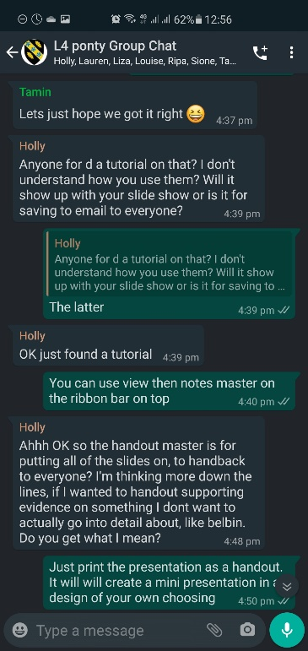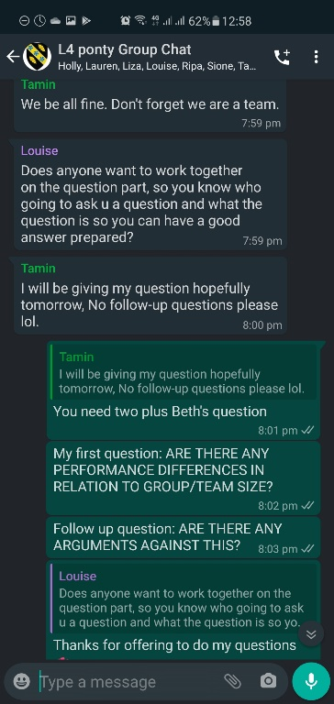

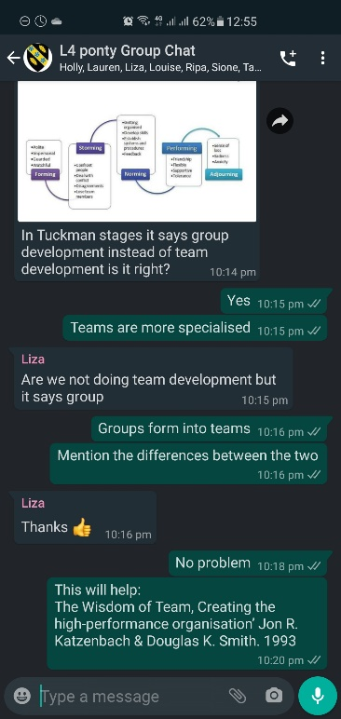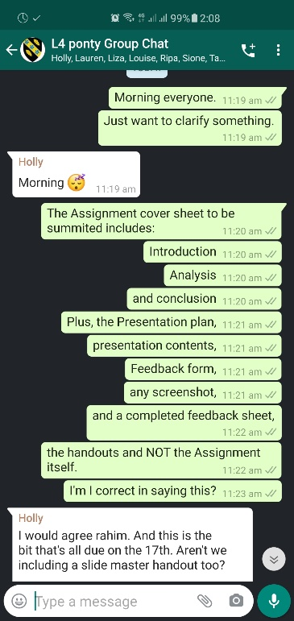

Presentation Feedback Sheet
Module: BMSK4002
Topic: Team Work: the Building Blocks

Appendix D
Presenting: ABDUR RAHIM ROAP | Date: 10.05.20

CRITERIA | 1 | 2 | 3 | 4 | 5
FIRST IMPRESSION
CONFIDENCE
BODY LANGUAGE
COMMUNICATION
EYE CONTACT
TONE OF VOICE

Rate each person 1-5 on each component of their presentation skills
(1-lowest to 5 highest)

Did the accompanying PowerPoint slides support and convey the message properly? Circle - YES NO

Did the accompanying handout support the presentation adequately?
Circle - YES NO

Did you feel you learnt on the subject covered? Circle - YES NO

Overall, how did you fell the presentation went? (between 1 lowest-10 highest) Circle- 1 2 3 4 5 6 7 8 9 10

Any feedback/comments for future presentations? (comment below)

What can I do better next time?

Appendix E

Appendix F

© Education and Training Foundation 2014

References

Andersen, E. (2013) 21 Quotes from Henry Ford on business, Leadership and Life [online] available at https://www.forbes.com/sites/erikaandersen/2013/05/31/21-quotes-from-henry-ford-on-business-leadership-and-life/#2baed601293c accessed 10 May 2020

Basadur, M (2004). ‘Leading others to think innovatively together: creative leadership’, Leadership Quarterly 15(1) 103-21 [online] available at https://www.academia.edu/18302235/Leading_others_to_think_innovatively_together_Creative_leadership accessed 10 May 2020
Belbin (1981). Why use Belbin Team roles? [online] available at https://www.belbin.com/about/belbin-team-roles/ accessed 10 May 2020

Ebray.net (2020) Homans’ Theory Of Group Formation [online] available at https://ebrary.net/2817/management/theories_group_formation accessed 10 May 2020

Ebray.net (2020) Wheelan's Integrated Model of Group Development (1990/1994a) [online] available at https://ebrary.net/3071/management/wheelans_integrated_model_group_development accessed 10 May 2020

Gersick, C. J. G. (1988) ‘Time and transition in work teams: Toward a new model of group development’ University of California, Los Angeles [online] available at http://web.mit.edu/curhan/www/docs/Articles/15341_Readings/Group_Dynamics/Gersick_1988_Time_and_transition.pdf accessed 10 May 2020

Gibbs, G. (1988). Learning by doing: A guide to teaching and learning methods. Further Education Unit. Oxford Polytechnic: Oxford.

Hackman J. R. (2002) Leading Teams: Setting the Stage for Great Performances. Boston: Harvard Business School Press [online] available at https://books.google.co.uk/books?hl=en&lr=&id=snfoCQAAQBAJ&oi=fnd&pg=PR5&dq=j.+richard+hackman+2002&ots=SAp7py_bUg&sig=M5j1YIxWB9UeIPFOWptz9yswmZw#v=onepage&q=j.%20richard%20hackman%202002&f=false accessed 10 May 2020

Indeed (2019) The 9 Belbin Team Roles (With Examples) [online] available at https://www.indeed.com/career-advice/career-development/belbin-team-roles accessed 10 May 2020
Jones, A. (2019). The Tuckman’s Model implementation effect and analysis and new development of Jones LSI model on a small group. Journal of Management. 6. 23-28. [online] available at https://www.researchgate.net/publication/335176254_THE_TUCKMAN'S_MODEL_IMPLEMENTATION_EFFECT_AND_ANALYSIS_THE_NEW_DEVELOPMENT_OF_JONES_LSI_MODEL_ON_A_SMALL_GROUP accessed 10 May 2020

Klug M, Bagrow JP. 2016 Understanding the group dynamics and success of teams. R. Soc. open sci. [online] available at http://dx.doi.org/10.1098/rsos.160007 accessed 10 May 2020
Mueller, J.S. (2012) Why individuals in larger teams perform worse Organizational Behaviour and Human Decision Processes [online] available at https://isiarticles.com/bundles/Article/pre/pdf/4543.pdf accessed 10 May 2020
Seijts, G. & Latham, G. (2000). The Effects of Goal Setting and Group Size on Performance in a Social Dilemma. Canadian Journal of Behavioural Science 32. 104-116. [online] available at https://www.researchgate.net/publication/232563251_The_Effects_of_Goal_Setting_and_Group_Size_on_Performance_in_a_Social_Dilemma accessed 10 May 2020
Wagner, J. A. (1995). Studies of individualism-collectivism: Effects on cooperation in groups. Academy of Management Journal, 38(1), 152–172 [online] available at https://www-jstor-org.ezproxy.uwtsd.ac.uk/stable/256731?seq=1#metadata_info_tab_contents accessed 10 May 2020
Quote Master (2020). Winston Churchill [online] available at https://www.quotemaster.org/q2854af20dd544dc7188722dfd468d1ef accessed 10 May 2020
Quote Master (2020). Steve Jobs [online] available at https://www.quotemaster.org/qf3a7a755238e671a6ea31f27c1af0a54 accessed 10 May 2020

Bibliography

Andersen, E. (2013) 21 Quotes from Henry Ford on business, Leadership and Life [online] available at https://www.forbes.com/sites/erikaandersen/2013/05/31/21-quotes-from-henry-ford-on-business-leadership-and-life/#2baed601293c accessed 10 May 2020

Bedwell, W. Funke, G. Knott, B. (2013) ‘Team workload: A multilevel perspective. Organizational Psychology Review. 4. 99-123 [online] available at ‘https://www.researchgate.net/publication/274470999_Team_workload_A_multilevel_perspective accessed 10 May 2020

Basadur, M (2004). ‘Leading others to think innovatively together: creative leadership’, Leadership Quarterly 15(1) 103-21 [online] available at https://www.academia.edu/18302235/Leading_others_to_think_innovatively_together_Creative_leadership accessed 10 May 2020
Belbin (1981). Why use Belbin Team roles? [online] available at https://www.belbin.com/about/belbin-team-roles/ accessed 10 May 2020
Carton, A.M. and Cummings, I.N. (2012) A Theory of Subgroups in Work Teams. Academy of Management Review, 37, 441-470. [online] available at https://www-jstor-org.ezproxy.uwtsd.ac.uk/stable/23218097?seq=1#metadata_info_tab_contents accessed 10 May 2020

Cohen, S. G., & Bailey, D. E. (1997). What makes teams work: Group effectiveness research from the shop floor to the executive suite. Journal of Management, 23, 239-290. [online] available at https://journals.sagepub.com/doi/10.1177/014920639702300303 accessed 0 May 2020
Drexler, A. & Sibbet, D. (1994) Team Models - Drexler-Sibbet Team Performance Model (2019) Youtube Video, added by Michael Küsters [online] available at https://www.youtube.com/watch?v=Ay4KWk6nLjo accessed 10 May 2020
Ebray.net (2020) Homans’ Theory Of Group Formation [online] available at https://ebrary.net/2817/management/theories_group_formation accessed 10 May 2020

Ebray.net (2020) Wheelan's Integrated Model of Group Development (1990/1994a) [online] available at https://ebrary.net/3071/management/wheelans_integrated_model_group_development accessed 10 May 2020

Free management e-books. Richard Hackman's 'Five Factor Model’ [online] available at http://www.free-management-ebooks.com/faqld/development-03.htm accessed 10 May 2020

Gersick, C. J. G. (1988) ‘Time and transition in work teams: Toward a new model of group development’ University of California, Los Angeles [online] available at http://web.mit.edu/curhan/www/docs/Articles/15341_Readings/Group_Dynamics/Gersick_1988_Time_and_transition.pdf accessed 10 May 2020

Gibbs, G. (1988). Learning by doing: A guide to teaching and learning methods. Further Education Unit. Oxford Polytechnic: Oxford.

Gratton, L. & Erickson, T.J. (2007) Gratton, Lynda & Erickson, Tamara. (2007). Eight ways to build collaborative teams. Harvard business review. 85. 100-9, 153. [online] available at https://www.academia.edu/9187315/Eight_Ways_to_Build_Collaborative_Teams accessed 10 May 2020

Hackman J. R. (2002) Leading Teams: Setting the Stage for Great Performances. Boston: Harvard Business School Press [online] available at https://books.google.co.uk/books?hl=en&lr=&id=snfoCQAAQBAJ&oi=fnd&pg=PR5&dq=j.+richard+hackman+2002&ots=SAp7py_bUg&sig=M5j1YIxWB9UeIPFOWptz9yswmZw#v=onepage&q=j.%20richard%20hackman%202002&f=false accessed 10 May 2020

Indeed (2019) The 9 Belbin Team Roles (With Examples) [online] available at https://www.indeed.com/career-advice/career-development/belbin-team-roles accessed 10 May 2020

Jones, A. (2019). The Tuckman’s Model implementation effect and analysis and new development of Jones LSI model on a small group. Journal of Management. 6. 23-28. [online] available at https://www.researchgate.net/publication/335176254_THE_TUCKMAN'S_MODEL_IMPLEMENTATION_EFFECT_AND_ANALYSIS_THE_NEW_DEVELOPMENT_OF_JONES_LSI_MODEL_ON_A_SMALL_GROUP accessed 10 May 2020

Klug M, Bagrow JP. 2016 Understanding the group dynamics and success of teams. R. Soc. open sci. [online] available at http://dx.doi.org/10.1098/rsos.160007 accessed 10 May 2020
Liquid Research. (2020) Group Development - Theories and Models - Gersick's Punctuated Equilibrium Model [online] available at http://www.liquisearch.com/group_development/theories_and_models/gersicks_punctuated_equilibrium_model accessed 10 May 2020

Locke, E. (2020) Edwin A. Locke Ph.D. [online] available at https://edwinlocke.com/ accessed 10 May 2020

Locke, E. (2020) Edwin Locke’s Goal Setting Theory [online] available at https://www.researchgate.net/publication/232501090_A_Theory_of_Goal_Setting_Task_Performance accessed 10 May 2020

Maccoby, M. 92020) ‘Michael Maccoby Gamesman Theory’ [online] available at http://www.maccoby.com/MMaccoby/ accessed on 10 May 2020
Maund, A. Schriek, M. and Tinkler, P. K. Certificate in Higher Education: Skills in the Workplace Student Yearbook. 36-37 London: Sage Publications Ltd.

Morgan, Salas and Glickman's Team Model[online] available at https://ebrary.net/3072/management/morgan_salas_glickmans_team_model accessed 10 May 2020

Mueller, J.S. (2012) Why individuals in larger teams perform worse Organizational Behaviour and Human Decision Processes [online] available at https://isiarticles.com/bundles/Article/pre/pdf/4543.pdf accessed 10 May 2020

Render, J. (2019) ‘Drexler/Sibbet Team Performance Model’ [online] available at https://agile-mercurial.com/2019/06/13/drexler-and-sibbets-team-performance-model/ accessed 10 May 2020

Seijts, G. & Latham, G. (2000). The Effects of Goal Setting and Group Size on Performance in a Social Dilemma. Canadian Journal of Behavioural Science 32. 104-116. [online] available at https://www.researchgate.net/publication/232563251_The_Effects_of_Goal_Setting_and_Group_Size_on_Performance_in_a_Social_Dilemma accessed 10 May 2020

Wagner, J. A. (1995). Studies of individualism-collectivism: Effects on cooperation in groups. Academy of Management Journal, 38(1), 152–172 [online] available at https://www-jstor-org.ezproxy.uwtsd.ac.uk/stable/256731?seq=1#metadata_info_tab_contents accessed 10 May 2020

Walsh, J.P. & Maloney, N. G. Collaboration Structure, Communication Media, and Problems in Scientific Work Teams, Journal of Computer-Mediated Communication, Volume 12, Issue 2, 1 January 2007, 712–732, [online] available at https://doi.org/10.1111/j.1083-6101.2007.00346.x accessed 10 May 2020

Qin, Z. & Johnson, D. & Johnson, R. (1995). Cooperative Versus Competitive Efforts and Problem Solving. Review of Educational Research [online] available at https://www.researchgate.net/publication/243785438_Cooperative_Versus_Competitive_Efforts_and_Problem_Solving accessed 10 May 2020

Quote Master (2020). Winston Churchill [online] available at https://www.quotemaster.org/q2854af20dd544dc7188722dfd468d1ef accessed 10 May 2020

Quote Master (2020). Steve Jobs [online] available at https://www.quotemaster.org/qf3a7a755238e671a6ea31f27c1af0a54 accessed 10 May 2020

