

Student: | Ratchada Caliendo-Chan (1916134)
Course: | BALM Level 5
Module: | DRW BMSW5102 – A2
Title: | Individual Employee’s Career Plan in Tesco PLC
Lecturer: | Koushik Modak



INDIVIDUAL EMPLOYEE’S CAREER PLAN

Table of Contents
Introduction 3
Recruitment and selection at Tesco 4
Motivational theory in practice at Tesco 6
Tesco Context 8
Individual Employee’s Career Plan at Tesco 9
Conclusion 11
References 12
Appendix 1 - Personal Development Plan 13
Appendix 2 – Self-Analysis 14
Appendix 3 - Individual Employee’s Career Plan 15
Appendix 4 - Scheduled Annual Review and Performance Assessment Plan 15

Introduction

Based on my experience as an HR trainee officer working in the Tesco HR Department in the past. Hence, in this case scenario, the work experience in the past with Tesco can be made into my reflection investigating and evaluating how Tesco has driven its company so successful and how can individual employee develop their employee’s career plan at Tesco. However, this report focuses on the individual employee’s career plan.

Recruitment and selection at Tesco

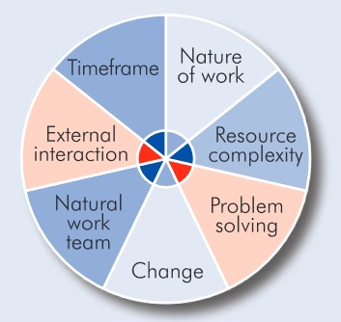
(Business Case Studies, 2021).

Tesco has its terms of recruitment and selection to help to acquire the correct persons to fulfil its post. Employment at Tesco is magnetising the precise attribute and average of aptitude to apply for vacancies. It selects them grounded on their recital in various variety procedures such as interview and collection conferences. Variety is choosing the utmost appropriate individual from the aptitude collection to fill in the job vacant grounded on multiple showing and rejection procedures, such as group discussion, individual interview and procedural interview, etc. These types of techniques empower Tesco to get the correct persons to fulfil their posts. Tesco requires individuals for altogether types of careers extending from safekeeping at the entrance to the executive in the storehouse entails them to hand-pick the ideal persons for the role who pair their job description and individual requirement. These also empower Tesco to do it in an additional organized and organized mode such that everybody acquires an equivalent fortuitous and variety is grounded exclusively on their enactment. The occupation depiction and being stipulations are accommodating in the variety procedure by aiding the candidate in pinpointing the occupation, which is the élite appropriate applicant’s personality. The application could apply for the job they feel they could do justice. These are further enhanced by making tools like the “job match tool” available so that the applicant could easily find suitable engagement. Job description helpful to the application to understand all the position’s responsibilities in applying for which job. The several responsibilities labyrinthine in doing the work make the application understand in encroachment if he/she fits for the occupation before a “hands-on experience’ on the job. The various methods of attracting and recruiting carried out by Tesco is internal talent plan list (advertising in the intranet for two weeks), advertising on the Tesco website, advertising in Google, journals and mass media. The existing system’s main strengths are that Tesco allows persons internal the organization to petition for an occupation, contribute the first inclination to the employees, and then transfer on to broadcast external.

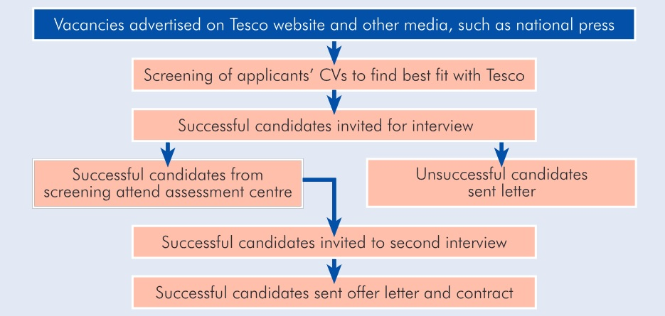
(Business Case Studies, 2021).

Tesco also has workforce planning which helps them identify the available vacancies and various ways to tackle them. I also feel the “Job match tool” is the strength of the existing system, allowing applicants to identify the vacancy that suits their qualifications and personality quickly. The disadvantage of the current scheme, I sense, is the shortage of sufficient coaching delivered by the executives and additional mentors to the existing workforces so that they are capable adequate to apply for the numerous posts within the organization and simultaneously have career growth. There are multiple benefits of using both interviews and assessment centres in the selection process. The line manager can identify if the applicant can mingle with the team and perform well in various situations the applicant might face as part of this job without checking out after recruiting him. In the interview process, the attitude towards work and their lateral thinking is assessing, and they, too, make sure that the candidate would fit the condition and job description (Business Case Studies, 2021).

Motivational theory in practice at Tesco

The types of non-financial reward Tesco uses for their employees is motivation which is attracting employees to do something they want to do. It is something that no one has to force them because they want to do it enthusiastically. Bountiful or emerging abilities, maintenance, acquaintance and backing to their workforces are the categories of non-financial recompense that Tesco uses to stimulate them; it aids them to perform extra vigorous, productive, and loyal in Tesco PLC. Motivated employees are dedicating to their work, and they will labour firmer. What is more, complete the job in the fewer stint. The employees are attentive on their employment because inspiration is an appetite for accomplishment for its sake and not merely the capability to reply to suchlike inducements Tesco propositions. And this is the type of inspiration that is indispensable for headship at Tesco. Tesco becomes one of the most prominent enterprises because of its motivated employees. At Tesco, four motivational theories are connected to Tesco.

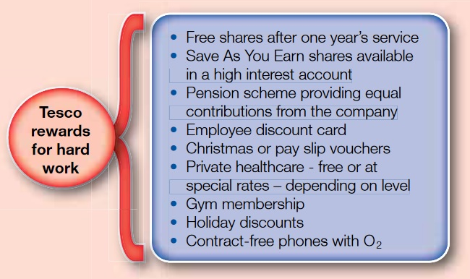

Taylor’s Motivational Theory - Via is appreciating their employees. Amplified broadcastings, what is more being queried for opinions will succour workforces exist extra enthused. This theory is connecting to Tesco.

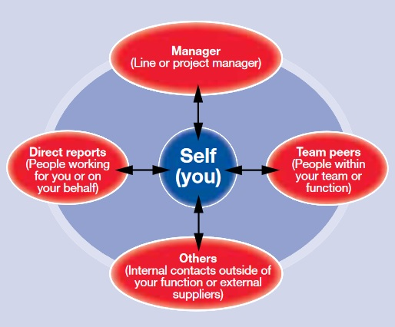

Mayo Effect – The situation assists workforces to understand their behaviour, strengths and drawbacks. This concept connects to Tesco via implementing 360 degrees feedback that can develop employees’ tools.

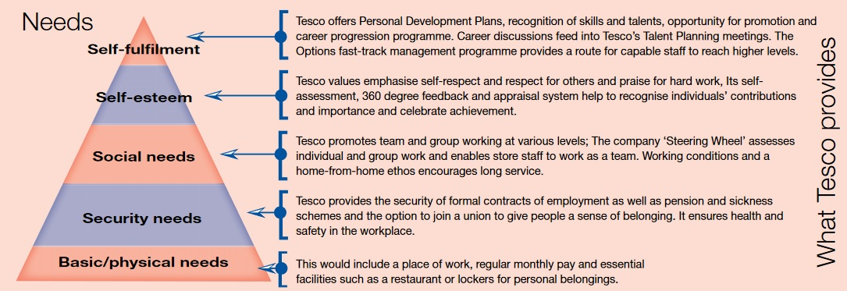

Maslow Theory – Via philanthropic the five rudimentary necessities of employees to be inspired at employment. This concept is connecting to Tesco.

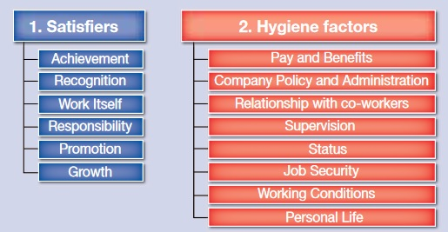

Herzberg Theory – Via motivating workforces, a corporate necessity to produce circumstances that create them sense fulfilled in the work environment. Moreover, via compensating consideration to cleanliness aspects what is more via empowering satisfiers. This theory is connecting to Tesco (Business Case Studies, 2021).

Tesco Context

Tesco Human Resources, located at the Hertfordshire office, is reputed to be the largest private-sector employer. Whichever as a junior or a managerial in stores and warehouses with other specialized roles such as finance and human resources, it can offer competitive wage and benefit packages for all jobs. Tesco employs over 300,000 people in the UK, and if including the worldwide employees, it falls at more than 400,000 employees. Tesco is also the UK’s largest food retailer and growing more in Asia and Central Europe. It propositions various amenities for non-food and food commodities, comprising insurance, entertainment, appliances and more than meets the eye (Tesco, PLC., 2020).

Individual Employee’s Career Plan at Tesco

Tesco Human Resources Development (HRD) pacts with coaching and evolving workforces to progress their recital echelons thru the corporation. The occupation necessities are constantly shifting, so the workforce in Tesco PLC. must exist constantly urbanized to deferment pertinent to the occupation requirements. There are some indispensable person supply improvement utilities in any corporate, not just at Tesco. Initially, coaching and improvement is the core of a constant exertion to develop worker abilities, comprehension and governmental functioning. The coaching is delivering workforces with comprehension and the abilities that they would necessity for their current job. Although improvement is acquiring beyond today's shop, the workforce’s necessity to exist ready to manage with the corporation by way of it alterations and raises. Secondly, functioning executive and evaluation functioning management are the goal-oriented processes cast-off to maximize the efficiency of employee’s line-ups and the general corporation

In contrast, functioning evaluation is an official scheme of rereading and appraising the individuals and the team's functioning. Thirdly Occupation Scheduling and Improvement is a continuing procedure whereby a specific cliques occupation ambitions and then recognises the resources toward attain them. Occupation improvement is a official loom expended via the corporation to ensure that workforces with the appropriate credentials and capabilities are obtainable for raise or reassignment whenever required. Fourthly corporation improvement is a strategic and orderly endeavour to create the corporation extra efficient by making an extra optimistic behavioural ecosystem. Tesco HRD forever involves coaching a worker once he or she is employed. To provide breaks to acquire fresh dexterities allocating means helpful for the corporation and the employee’s accountabilities and other improvement activities. The Tesco HRD may have thought that there is only one thing worse than coaching employees and losing them. That is not teaching them and leaving them employed within the corporation; hence, they are so many training schemes for their employees to benefit (Tesco Careers, 2021).

Now I will discuss Tesco's individual career planning process and how I would have done it. The individual career planning process includes the following steps. The first one self-assessment, the second one exploration and research, the third one decision making, the fourth one taking action and the last one evaluating. These are the steps included in the process of individual career planning. The first step is self-assessment, to self - assess involves thoughtful contemplation. Reflection and appraisal of the exciting personality characteristic’s values, abilities, etc. Through various methods such as using a whole host of 360 career-related tools and instruments, the self-assessment at the Tesco career planning process or individual career planning process. In the following steps, exploration and research in the career planning process component consist of exploration and study being information-gathering, and this is the time to explore. To collect and organize all the available resources to eventually begin analysing them. To see the top decision-making step of a career planning process, you put all the pieces of information about yourself and your carefully connected carrier information. Together as best as possible, then taking action from the decision loaded option selected the gold city rotating motion is one of those things that is easier said than done. This stage is about literally being proactive after you have made your career-related decision and identifying your goals.

Moreover, to keep in mind that many of the peoples who carry an achievement are the ones who persistently evaluate and calculate their status continuous status. Because they keep track of their career development thoughtfully, and this is the last in the self-evaluation process or the previous step in the career planning process that is the individuals' career planning process (see Appendix 1) (see Appendix 2) (see Appendix 3) (see Appendix 4).

Conclusion

The process of career planning in Tesco involves several stages. However, the 360 is a handy tool to conduct future career plan within Tesco PLC. The first stage is self-assessment career planning process begins with self-assessment. In this stage, an employee has to identify their strength and weaknesses. Similarly, the HRM of Tesco can assess the abilities of its human resources so that the career planning process begins with the self-assessment or self-audit (see Appendix 1). The second stage is setting goals. Goals are to be selected, keeping into accountabilities, qualifications, skills, and competencies. Goals must be attainable or can also develop career goals of its employees in terms of positions, responsibilities or carriers so, the second stage is setting goals. The third stage is exploring opportunities within Tesco.

In this stage, an employee has to search for different options from the Tesco career website that can help to accomplish the career goals. The next step is choosing an action plan. After identifying various opportunities, an employee has to select a career option that suits the knowledge, skills and capabilities. The individual can choose multiple departments such as the HR department or whatever career fields one is desires. Tesco has various type of opportunities for their employees to choose from its variety. However, where the individual wants to go, he must prepare a detailed plan to chase down his dream position. Finally, the last stage is reviewing career plans. The employee should check the own individual career plans periodically. If the employee feels that his career goals are stuck and not going to be accomplishing throughout the review process, he works in Tesco. Then he can quit with Tesco, and he will find another organization where he can achieve his career goals. Recap, the career planning process contains five stages self-assessment, setting career goals exploring different opportunities, choose an action plan and reviewing career plans periodically.

References

Armstrong, M. and Taylor, S., (2020) Armstrong’s handbook of human resource management practice. 15th edn. London, England; New York, New, New York; New Delhi India:; London, England; New York, New York; New Delhi India:; London, England; New York, New York; New Delhi India: Kogan Page.

Business Case Studies (2021) Motivational theory in practice at tesco. [online]. Available at: https://moodle.uwtsd.ac.uk/pluginfile.php/346272/mod_resource/content/2/HRM_CS_Tesco.pdf (Accessed: 25 March 2021)

Business Case Studies (2021) Recruitment and selection at Tesco. [online]. Available at: https://moodle.uwtsd.ac.uk/pluginfile.php/346270/mod_resource/content/1/BMSK5002 Case Study 2.pdf (Accessed: March 25, 2021)

Hudson Global (2018) What is 360-degree feedback? - Hudson Global [video]. Available at: https://www.youtube.com/watch?v=eT4tohLWeUw&ab_channel=HudsonGlobal (Accessed: 6 May 2021)

Mullins, L. J. and McLean, J. E. (2019) Organisational behaviour in the workplace. 12th edn. Harlow: Pearson.

Tesco Careers (2021) Diversity and Inclusion. [online]. Available at: https://www.tesco-careers.com/explore-our-world/everyone-is-welcome/(Accessed: March 25, 2021)
Tesco News (2017) Technology | 360 | Tesco – Tesco News [video]. Available at:

Tesco PLC (2020) Annual Report 2020. [online]. Available at: https://www.tescoplc.com/media/755761/tes006_ar2020_web_updated_200505.pdf (Access: 25 March 2021)

Tesco PLC (2021) Our history. Available at: https://www.tescoplc.com/about/our-history/(Access: March 25, 2021)

Thapa, A. (n.d.), Career Planning: Process, Steps and Stages | HRM. [online]. Available at: https://www.businessmanagementideas.com/human-resource-management-2/career-planning/career-planning-process-steps-and-stages-hrm/19694 (Accessed: 3 May 2021)

Appendix 1 - Personal Development Plan

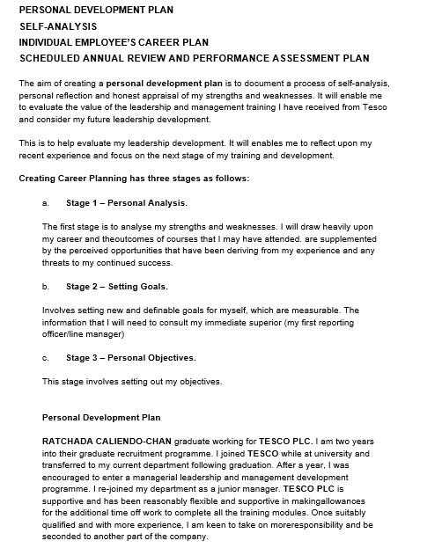

Appendix 2 – Self-Analysis

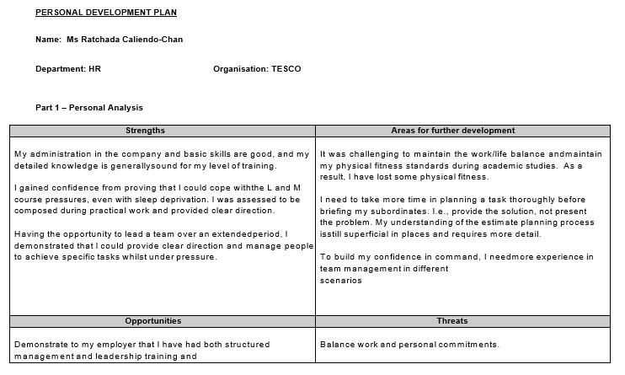

Appendix 3 - Individual Employee’s Career Plan

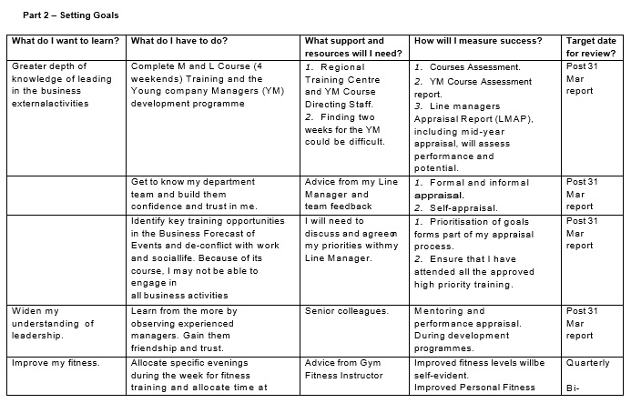

Appendix 4 - Scheduled Annual Review and Performance Assessment Plan



