Name: Nancy Akuffobea
Student Number: 2204043
Course: Ways of Thinking
Tutor Name: Gwenllian Beynon
Words Count:

How Pablo Picasso Utilized Cubism in His work
In this essay, I am going to focus on Pablo Picasso and how he used cubism in his artwork throughout his life. Throughout his career will be discussing about Blue period, Rose period, African period and Cubism, I will be showing some of his famous paintings such as: Les Demoiselles Davignon, Girl with a Mandolin and Ma Jolie. I am going to use theories such as Vincent Van Gogh for an indent study of semiotics in his work, to analyse the meaning behind the picture.

Cubism was one of the many abstract art movements in the twentieth century. Since 1800, many artists have gravitated toward "abstraction." Cubism was a scientific method distinguished by a limited colour palette, forms reduced to geometric shapes, subtle shading to flatten the surface and the presentation of subject matter from multiple contemporary perspectives (Edward F.Fry, p. 9, 1966,). The results were intentionally and unavoidably abstract (IdeelArt.com, 2022). Cubism is an abstract movement originated by Pablo Picasso (born 1881-1973) and Georges Braque (born 1882–1963); this movement is based on shapes being broken down into geometrical elements to represent abstract forms of artwork.

Pablo Picasso went through a lot of creative periods throughout his life and showed the distinct styles and mediums he used during his time as an artist. His art evolved from naturalism, during his childhood, to cubism further. Picasso experienced the First World War and Second World War, which was a considerable influence for him with most of his art. In the majority of his art, he expresses emotions and feelings via the use of colours (Masterworksfineart.com, 2022). It was a way to get out the frustration within him created because of the war. The wars provided Picasso with an opportunity to express exasperation, annoyance, anger, irritation, sadness, etc... Picasso was feeling all these emotions but could only express them through the median of art (Adil, 2018).
He went through a phase called the “Blue Period “(Adil, 2018) which started in 1901 and ended around 1904. During this period, Picasso mostly painted with sad tones such as blue and green which hence the name (Williams S. Lieberman, p. 17-18, 1930,). His paintings featured scenes of poverty, melancholy, and sadness, therefore Picasso decided to work with these sad tones which stand for misery and despair. In the time of this period, his paintings had coldness and misery. This is when Picasso was facing the death of his friend, which affected him, this is what lead him through the blue period (Williams S. Lieberman, p. 16-17, 1930,).

After a long journey with the blue period, Picasso’s depression gradually ended, and his psychological state improved (Williams S. Lieberman, p. 20-21, 1930,). He started making friends and his art style started changing into a more positive and gentle style, this period is called “Rose Period” (Adil, 2018). This started in 1904 and it lasted until 1906. He used negative tones in his work before, but he started using lively, laid back and warm tones such as pink, reds, yellows, oranges, light blues etc... to indicate the happiness he felt. Clowns, carnival performers, and Harlequins inspired him. During this time, Picasso started dating a lady named Fernande Olivier in 1904 which changed the way Picasso presided over art and made him into more of a positive person (Adil, 2018).

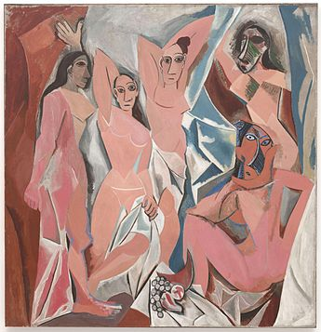
Fig. 1 Pablo Picasso, (1907), Paris, Les Demoiselles Davignon

Picasso began using more basic shapes in his work after the Rose Period (Adil, 2018) which lasted for only 2 years. From 1906 till 1909 Picasso started being inspired by Iberian stone Heads, this period of his life was called “The African Period” also known as “Negro Phase” (Adil, 2018). On the report of some people, he was also influenced by African sculptures, masks, and the art of ancient Egypt.

The painting above, called “Les Demoiselles d'Avignon” (Edward F. Fry, 14-15, 1966) depicts five women in a brothel. Each person in the painting is presented in an unsettlingly aggressive manner, and none are traditionally feminine. The ladies are depicted with jagged and disconnected body outlines, giving them a slightly threatening appearance. The person on the left has Egyptian or southern Asian face traits and clothing. The two figures are depicted in Picasso's native Spain's Iberian style, while the two on the right are depicted with African mask-like characteristics. The African masks symbolize unseen, supernatural forces which are beneficial to the community. The spread figure on the bottom right is a collage of multiple perspectives of herself, but the others are shown in a flattened geometric form with limited three-dimensionality. This piece is saddened by these misshapen bodies. You can notice brown paper in the image, there are many possible meanings to this. The brown paper can symbolize how Paris merchants would “wrap food” (Jstor, p. 4, 2021), this could indicate an appetizing or economic view of an encounter with a prostitute.

Picasso started painting objects and people how he thought of them not as how he saw them (Adil, 2018). In consequence, the paintings started to look more geometrical and simpler. In order to explore further, Picasso started to break the shapes down to discover a modern style of painting. His work became more conceptual and surreal in a way, it seemed like he wanted people to find clues and understanding in his artwork. ‌

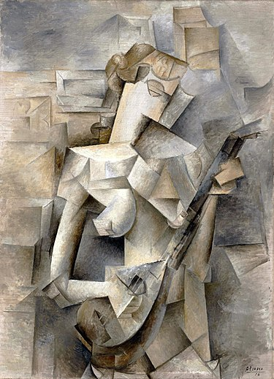
Fig. 2 Pablo Picasso, Paris, (1910), Girl with a Mandolin

When we talk about conceptual art, its art that has a meaning behind it more than the appearance of the finished illustration. In this painting, Girl with a Mandolin, you can see she that she is holding the instrument with delicacy as if it was meaningful to her. Picasso used neutral, achromatic, and indecisive colours such as greys and browns. The figure's contours and interior drawing have been split down into interpenetrative geometrical parts. The colour scheme is characterized by brown tones that fade to beige. Blue-grey highlights, which are frequently immediately contrasted with dark structural lines, give the painting a facet-like fluidity. Picasso used a random sequence of geometric forms to generate unidentifiable images in the backdrop behind the girl. The background was painted in the same style as the subject; it's unclear which shapes and forms are the topic, and which are the background. However, the person may be identified since she is painted in lighter tones than the backdrop. (Pablopicasso.2022)

If we look at Vincent Van Gogh work, we can see similarities that Picasso and Van Gogh share. Both artists used shapes and drawings expressively, they both simplified shapes and broke forms into flat colours instead of traditionally modelled forms.

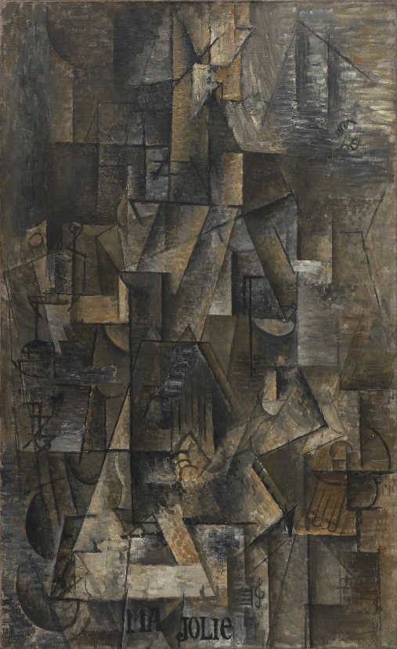
Fig.3 Pablo Picasso, (Winter 1911-1912), Ma Jolie, Paris

“Ma Jolie” (Artchive.com, 2022) is an example of abstract cubism; you cannot identify what is going on in the picture but there is still meaning behind it. Regardless of the illustration seeming to evaporate into an arbitrary web of flat, angular, unblurred planes. These components involve a lady clutching a musical instrument. Thus, it accomplishes in becoming both a representative work of high analytic cubism and a very classic theme at the same time. Ma Jolie is the name given by Picasso to his lover, Marcelle Humbert, whom the painting depicts (MoMa. 2022). Ma Jolie translates from French to “My pretty girl” in English. He used very dark and sad colours, such as browns and greys, in the painting. Perhaps he chose those colours because of his emotions at the time. Humbert passed away three years after Picasso painted this portrait inspired by her (Pablopicasso. 2022).

This painting reminds me of “Girl with a Mandolin,” as the tones are remarkably similar, and they both represent Picassos lovers.. However, where “Girl with a mandolin” and “Ma Jolie” both feature lovers, “Les Demoiselles Davignon” features prositutes. Despite this, all three paintings have a focus on women. This could to be attributed to his early exposure to females as a child by his dad who took him to brothels in southern spain (Widewalls, 2021)
In this essay I discussed about how cubism was a way of breaking shapes and expressing reality. I talked about how this technique was invented by the famous artist Pablo Picasso, known for his amazing artwork and extraordinary multiple talents and Vincent Van Gog which share similar art style with Pablo Picasso. I used semiotics in my work to analyse the paintings better and show the symbolism in Pablo Picassos work.

Reference list
Adil, N. (2018). PICASSO’S ART DURING WORLD WAR, INFLUENCE OF WAR ON HIS ARTISTIC EXPRESSION. Journal of Research and Reviews in Social Sciences Pakistan, [online] 1(1), pp.83–95. Available at: https://journal.kinnaird.edu.pk/wp-content/uploads/2018/12/paper-10.pdf.
Artchive.com. (2022). Picasso: ‘Ma Jolie’ (Woman with a Zither or Guitar). [online] Available at: http://www.artchive.com/artchive/P/picasso/ma_jolie.jpg.html [Accessed 26 Nov. 2022].
IdeelArt.com. (2022). IdeelArt | The online gallerist. [online] Available at: https://www.ideelart.com/magazine/cubist-collage [Accessed 27 Nov. 2022].
Harold P. Blum (2018),Picasso’s Prolonged Adolescence, Blue Period, and Blind Figures - ProQuest. . Proquest.com. [online] doi:101521prev20131002267. [Accessed 27 Nov. 2022]
Masterworksfineart.com. (2022). What was Picasso’s inspiration? [online] Available at: https://news.masterworksfineart.com/2019/11/28/what-was-picassos-inspiration#continue-reading [Accessed 26 Nov. 2022].
Pablopicasso.org. (2022a). Ma Jolie, 1911-1912 by Pablo Picasso. [online] Available at: https://www.pablopicasso.org/ma-jolie.jsp [Accessed 26 Nov. 2022].
Pablopicasso.org. (2022b). Pablo Picasso Biography. [online] Available at: https://www.pablopicasso.org/picasso-biography.jsp [Accessed 24 Nov. 2022].
Tate (2017). Cubism | Tate. [online] Tate. Available at: https://www.tate.org.uk/art/art-terms/cubism [Accessed 29 Nov. 2022].
Pablopicasso.org. (2022). Girl with Mandolin, 1910 by Pablo Picasso. [online] Available at: https://www.pablopicasso.org/girl-with-mandolin.jsp [Accessed 11 Dec. 2022].
‌
Jstor.org. (2021). Books at the Borders of Picasso’s Les Demoiselles d’Avignon on JSTOR. [online] Available at: https://www.jstor.org/stable/48647116?seq=4#metadata_info_tab_contents [Accessed 10 Dec. 2022].

Widewalls. (2021). Pablo Picasso and His Troubling Relationship With Women | Widewalls. [online] Available at: https://www.widewalls.ch/magazine/picasso-women [Accessed 10 Dec. 2022].
Edward F. Fry. (1966), New York And Toronto Oxford University Press,
William S. Lieberman. (1930), Chicago Illinois Raintree, Pablo Picasso Master of Modern Art.

The Museum of Modern Art. (2020). Pablo Picasso | MoMA. [online] Available at: https://www.moma.org/artists/4609 [Accessed 11 Dec. 2022].
‌

‌

