

Postgraduate/Distance Learning
Assignment coversheet & feedback form

THIS SHEET MUST BE THE FIRST PAGE OF THE ASSIGNMENT YOU ARE SUBMITTING (DO NOT SEND AS A SEPARATE FILE)

For completion by the student:
Student Name: JONATHAN WEEKES

Student University Email: 2234148@student.uwtsd.ac.uk

Module code: HPCA7028  Module title: SACRED SKIES | Student ID number:  2234148 |  |  | Educational support needs:  Yes
Assignment title: A CRITICAL EXAMINATION OF THE SKY IN RELATION TO MATERIAL CULTURE

Assignment due date:
This assignment is for the 1st module of the degree
I confirm that this is my original work and that I have adhered to the University policy on plagiarism.
Signed ……………J.WEEKES……………………………
Email submission:if you are submitting this form via email, please tick this box
(as a substitute for your signature) to confirm that you agree to the above declaration.
Assignment Mark
1st Marker’s Provisional mark
2nd Marker’s/Moderator’s provisional mark
External Examiner’s mark (if relevant)
Final Mark

NB. All marks are provisional until confirmed by the Final Examination Board.

ALL COMMENTS ARE ON THE PDF OF YOUR PAPER IN TURNITIN

For completion by Marker 1 :
Comments:

Marker’s signature: |  |  | Date:
For completion by Marker 2/Moderator:

Comments:

Marker’s Signature: |  | Date:
External Examiner’s comments (if relevant)

External Examiner’s Signature: |  | Date:

A Critical Examination of the Sky in Relation to Material Culture

Our understanding of history grows by looking at a study area from different perspectives. While the study of ancient monuments has principally been the domain of archaeology, our understanding of the people that built them has been enriched by exploring their relationship to the sky using multidisciplinary approaches. These methods, including phenomenological and anthropological methods, have given an appreciation for the sky beliefs that may have been connected to these monuments, and the cosmologies of their ancient builders.
This paper will examine an archaeological site in Leitrim, Ireland, and its relationship to the sky, using the holistic multidisciplinary approach of Skyscape Archaeology, to understand its orientation in context of the phenomenological experience at the site, and with reference to anthropological evidence, including local folk histories.

Megalithic monuments across Western Europe have been a subject of great interest for centuries, with much academic debate around their function and classification, interest in the ethnicity and origin of the tomb builders, and what they may reveal of the culture or cultures of those who created them.
Methodologies within archaeology have evolved over the centuries, helping to build a picture of the chronology of the different types of monuments that we see, and with the advent of technologies such as radiocarbon dating and genetic testing, have answered some of these questions around “when” and “by whom” these monuments were built, and now the questions that archaeologists face are more focused on “why were these monuments built”
Our understanding of ancient sites and glimpses into the cosmologies of ancient peoples can be gained not only by looking at what is on the ground, as in traditional archaeological methods, but also by understanding how the material culture of monuments are constructed in relationship to the sky.
The study of archaeostatronomy developed to explore this question of the relationship between ancient monuments and the sky and has seen developments in its own methodologies over the past century. While early archaeologists raised questions about alignments of ancient sites, such as Sir Norman Lockyer’s astronomical surveys, General Charles Valancey’s studies of Newgrange and acknowledgement that Stonehenge had a mid-summer sunrise alignment, a more methodological approach to exploring the relationship of these sites to the sky was not expanded upon until the work of Alexander Thom, who developed a more rigorous, scientific approach and is considered the founder of modern archeoastronomy.
Thom’s method helped to precisely calculate whether ancient monuments indeed had significant alignments to the sky, by taking three measurements: azimuth, horizon altitude and latitude. By correcting the azimuth to true north, it is possible then to calculate the declination and therefore identify if it is oriented towards any significant solar, lunar or stellar events, such as solstices and equinoxes.
Thom’s approach led to an effort to catalogue orientations of hundreds of sites, creating a database that drew broad patterns, recording their orientations based on their axis of symmetry but this approach drew criticism as findings were interpreted irrespective of local variations, and meant that significance of individual sites was missed.
As the discipline has developed, the methodology has been adapted in different directions in response to these different criticisms. Thom responded to criticisms of his method by developing more precise formulae that would take into account such phenomena as refraction, parallax and lunar perturbation.
Other researchers, however, took a more reflexive approach in their adaptation of archaeoastronomy’s methodology, considering that this focus on symmetry and precision may be embedded in our ontological position, and that ancient peoples may not have had the same preoccupation with precision as we do today. Growing from this awareness, approaches such as Fabio Silva’s “window of visibility” have sought to shed unfounded assumptions and develop a more phenomenological approach, considering also the experiential view from ancient sites rather than a preoccupation on precision.
Developments in anthropological methods and thought have also enriched this field, considering the relationship between representations of the sky and social concerns. Stephen McClusky describes Stanislaw Iwaniszewski explanation of the sky as ‘providing meaningful patterns for conducting life on earth’ and that ‘the principles by which the sky is ordered are the structures of social organizations rather than mathematical abstractions’
The emergent Skyscape Archaeology is a multidisciplinary approach that has evolved in recent decades, developing its methodologies to include phenomenological and anthropological evidence to build a more comprehensive understanding of ancient monuments. Drawing on these multiple disciplines, Skyscape Archaeology aims to help understand the cosmologies of the tomb builders, not only understanding the relationship between monuments and sky phenomena, but what that means to the peoples who built them.
This approach will be considered useful in the following study, incorporating measurements of orientation and also anthropological and phenomenological evidence of the study area, to form a holistic understanding of the archaeological site.
Study area
The site being examined in this paper is situated on a hilltop within Tullinwillin townland, near Drumkeeran, County Leitrim, Ireland. The land is currently owned by my partner’s family, who have grazed cattle on the land for many generations.
The site is registered on the National Monuments Survey (LE015-109002-), classified as a “house of indeterminate date”, and is scheduled to be included in the next review of the Record of Monuments and Places.
The National Monuments Survey includes a description of the site from 'The Archaeological Inventory of County Leitrim' compiled by Michael J. Moore, describing the site as ‘located at the NE end of a NE-SW drumlin ridge with a small valley immediately to the NE and higher ground beyond that. A rectangular house-site (int. dims 10m NW-SE; 4.3m NE-SW) defined by slight traces of stone walls is at the centre of cashel’. The surrounding cashel is further described as ‘a grass-covered oval area (int. dims 39m E-W; 29.7m N-S) defined by the grass-covered foundations of a stone wall (Wth 1-1.5m). The original entrance is not identified.’
The local community have a different folk history about the site. Local folklore and mythology are known to be able preserve important insights on archaeological interpretations of sites, and there is a growing movement within modern archaeology to include such indigenous knowledge to inform our understanding of such monuments.
Regarding the site at Tullinwillin, there is no local lore of there ever being a house on that hilltop in Tullinwillin, and the suggestion is mostly responded to with incredulity by people locally, owing to the site’s exposure to the heavy winds. There is, however, other local folklore that discusses the site, stating that a chieftain was once buried there. This local knowledge has been passed down over the generations, from grandparents to grandchildren, and when the ownership of the land has changed hands. The site is also locally referred to as a “fairy fort” or simply a “fort”.
Those in the family and neighbouring farms who would not generally consider themselves superstitious offer some warning or word of advice when talking about visiting the fort, and caution not to leave anything behind or take anything away from it, and that if you hear any voices that you must turn your jacket inside out. While some people locally would steer clear of the fort altogether, there are some members of my partner’s family would occasionally need to spend the night up there, keeping an eye on the cattle, and describe the space as ethereal and otherworldly, and commanding a sense of reverence.
The term Fairy Fort, is not an official classification of ancient monument in Ireland, but commonly refers to the remains of ring forts, early medieval defensive structures, historically used by families to protect livestock. They consisted of a deep ditch surrounding a walled-off area of high ground, and many also would have a series of passageways beneath them in order to hide stores of food and to escape if necessary.
Brian Tillisen explains that ‘Ring forts that have been eroded and overgrown bear a resemblance to barrow mounds, so people may have utilized the old forts as burial places, thinking that was what the site had been all along,’ and so there is evidence of people incorrectly associating the sites with burials.
However, Springs explains that in the north-west of Ireland, in areas such as Fermanagh, Mayo, Sligo, Donegal and Leitrim, the term “Fairy Forts”, is also used by local people to refer to wedge tombs.
This opens the question as to whether this site is also a wedge tomb, and the burial site of the local chieftain as per the folk history, and that confusion around the term “Fairy Fort” may have led to misclassification.
Wedge Tombs
Archaeologists have gained an understanding of wedge tombs through examining pottery and other artifacts, as well as through carbon dating methods. A wedge tomb, or wedge-shaped gallery grave to give it its full name, were built in bronze age Ireland, and used for burial between 2500BCE and 1800BCE. They vary considerably in size, but are characterised by their wedge shape, with two sub-parallel walls, one or more capstones, and commonly a “portico” at the front of the monument. Many of these tombs are suspected to be covered with an oval or d-shaped cairn, which allowed the opening a view of the horizon
While the archaeological evidence has given a story of the monuments’ chronology, it is not until the archaeoastronomy of these sites was explored that an understanding of their symbolic significance could be discussed.
Robb conducted fieldwork on 120 wedge tombs and examined the orientations and indicated alignments of each of them. The sites’ orientations were measured by determining their axis of symmetry, and results showed that these monuments are typically aligned with the setting sun, with mostly autumn, winter or spring alignments. This was consistent with earlier orientation data by Ruggles, and marked a change from the earlier passage tombs in Ireland, where there was otherwise a pattern of orientation towards sunrises.

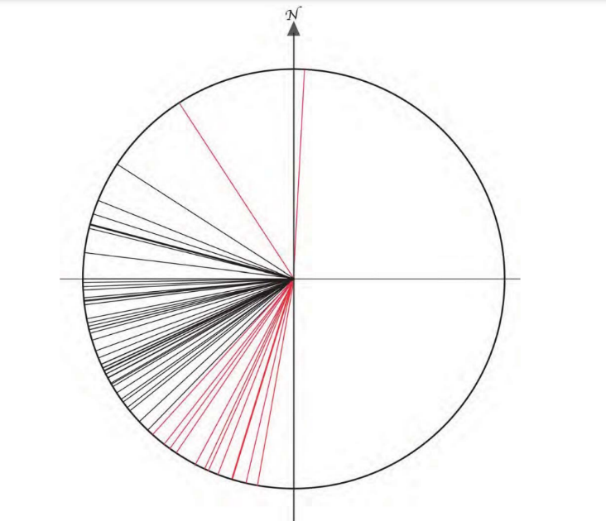
Figure 1: Orientation of Wedge Tombs in Ireland by azimuth. Black lines indicate solar significance; Red lines indicate no solar significance. Springs, Landscape Contexts of Wedge Tombs in the North West Ireland, pp184.

Springs researched various factors that could indicate criteria for the siting of wedge tombs, looking at numerous environment factors, but also looking at their orientations in regards solar declinations. They identified significant solar alignments in September, October, November, February and March, with some located on the hills with indicated alignment to the Winter Solstice (Figure 1).
Due to the consistency of these orientations, they are interpreted as intentional and reflecting a common pattern or tradition of tomb building, based on common underlying cultural beliefs. The cultural significance of these sunset orientations has been considered, with the end of the day being symbolically related to the end of life, and that the opening of the wedge tombs being oriented toward the sunset may be connected with a belief that it would allow the spirit or soul of the person interred to go into the sunset.
Houses of Indeterminate Age
While there has been much research on the orientations of identified megalithic sites, there has been very little research into the orientations of sites classified as “houses of indeterminate age”.
By looking at the National Monuments Survey, we can see approximate references to the orientation of sites that fall within the same category. In Leitrim, there are 45 sites with the designation: 18 are noted as having their longest wall oriented on a NW/SE axis, 11 with an E/W axis, 8 along a N/S axis, 4 along a NE/SW axis, and 4 without mention of their axis. In the description of their setting, most are described as being situated on a slope, while others are in valleys, close to rivers, streams or lakes, or close to a cliff or steps.
Reasons for orientations of such houses are speculated to be related to prevailing winds, so that the landscape protects or shields the house (or at least the doorway) from the weather, rather than any alignment with sky phenomena.
This study
This study will look to examine the site in terms of its orientation to see whether or not it is consistent with those of previously studied wedge tombs, namely having an orientation with an autumn, winter or spring sunset, and thus potentially supporting the local folk history that it is the burial place of the local chieftain.
Methodology
Before carrying out the fieldwork, the site was viewed using Google Earth to establish its location and altitude. A Digital Elevation Model, HeyWhatsThat, was used to model the horizon around the site and help identify targets on the horizon. This software uses Shuttle Radar Topography digital elevation data to create a 360° horizon panorama. The site was also found on the Sites and Monuments Record (SMR).
For the fieldwork, mobile fence posts were used for targeting rods, a 3m measuring tape for measurements and a Suunto Tandem combined compass and clinometer to establish the azimuths and the elevations. Photos were taken using a Samsung S23 Ultra, via the camera and the theodolite application Dioptra.
The site’s condition and morphology were observed and sketched (Figure 2), the main challenges being that many of the stones were covered in heather and other vegetation, and signs that many others were removed over the centuries to be used for nearby walls. The stones that were still visible and in place indicated a single, straight line, but the other stones that could be felt beneath the vegetation gave more of a square shape to the site, and suggested two possible rooms or chambers.
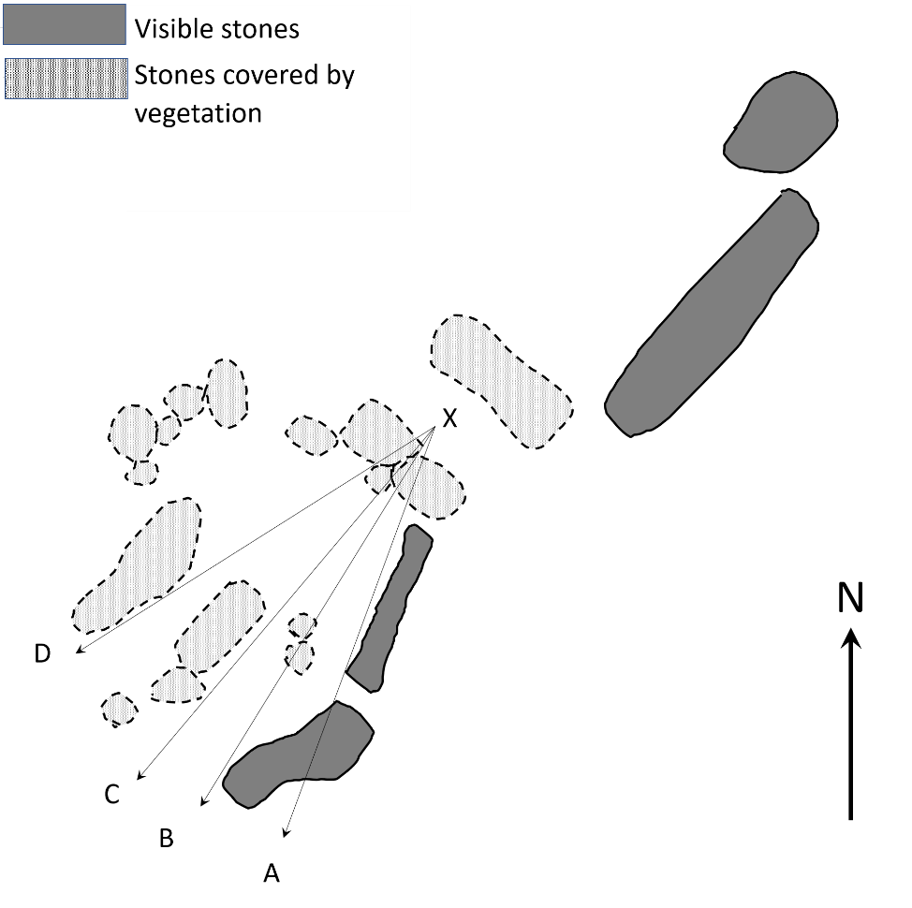
Figure 2: Sketched Layout of Tullinwillin Site, annotated with target lines.
Other smaller stones, visible and overgrown, were identified in a small cluster beside the site. The entire site sat in the centre of an encircling oval-shaped stone and embankment ridge. It is important to note that the footprint of the identified stones did not match the dimensions given in the National Monument Survey, and the stones included in the sketch (Figure 2) were those situated at the centre of the oval earthworks, in close proximity with the prominent, visible stones.
To measure the orientation, it was first necessary to establish the axis of the site. The visible stones indicated an axis, running approximately from south-west to north-east. Based on the identifiable stones, there was a suggested entrance and back wall to one chamber. Mobile fence posts were used to mark:
- Points B and D, either side of the entrance, according to Silva’s “window of visibility”.
- Point A, which was a target point lined up with view along the left wall of the site, where one of the prominent stones identified a clear side wall.
- Point C, which was the visual midpoint, measured between A and D, according to Hoskin’s “axis of symmetry” (to allow comparison with Robb’s and Spring’s findings).
Azimuths for all of these points were measured from point X, a point judged to be at the centre of the suggested back wall, and checked viewing them from 180-degree angle to check for any magnetic interference caused by the stones at the site.
As the azimuth measurements taken using the compass were relative to magnetic north, these were adjusted to true north using an online calculator by the National Oceanic and Atmospheric Administration. Where trees obscured the view of the horizon, altitude figures were taken from HeyWhatsThat.
Once the fieldwork was completed, the data was entered into the Sacred Skies Calculations Spreadsheet to calculate the declinations. These were cross referenced against the Reference Tables for Skyscape Archaeology, developed by Fabio Silva.
Elevation data was exported from HeyWhatsThat and input into Stellarium’s planetarium software, to provide a simulated view of what would be seen and experienced from the site, to provide insights over and above the calculations of its declination.

Results
The Tullinwillin site is situated at 52.227944N and 8.167377W with an elevation of 171m
The orientation of the Tullinwillin site was measured during the course of this study, and the results are listed in Table 1. For a declination to have solar significance in 2000BCE, it would need to fall between -23.9° and +23.9°.

Table 1: Wedge tomb information in study area
Point | Azimuth | Horizon Altitude | Solar Declination | Solar Significance
A | 199 | 1.42 | -32.17° | None
B | 209 | 1.06 | -29.75° | None
C | 227 | -0.01 | -23.50° | Dec 21 (sunset)
D | 255 | 0.26 | -8.49° | Feb 27/Oct 14 (sunset)
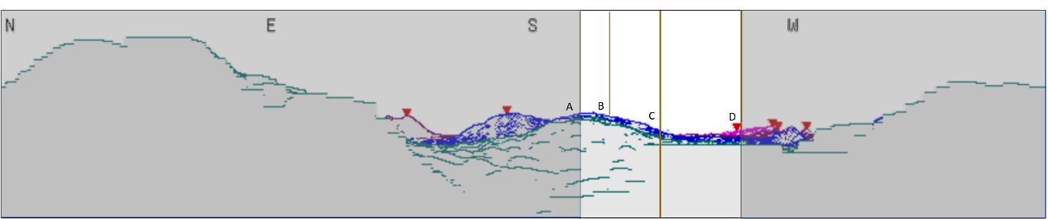
Figure 3: View from Tullinwillin site, reconstructed using a Digital Elevation Model, HeyWhatsThat. Target points A, B, C and D are marked on the horizon image, with the areas beyond the window of visibility greyed out.

The results show an orientation along the site’s central axis with the sunset on 21 December, Winter Solstice. Within the window of visibility (Figure 3), the lefthand view is too far to the south to have any solar significance in terms of the sunset declinations, but from the midpoint onward to the righthand side of the chamber, its orientation would give it view of the sunset from 14 October until 27 February.
Using Stellarium’s planetarium software, it was possible to view a simulated recreation of the horizon at sunsets throughout the year, and watch the experience of the sun setting behind the mountains in the distance. This simulation shows the setting sun arriving in the left-hand wall of the chamber and setting behind the hills at winter solstice. When the date is adjusted to other sunsets, again the tomb’s window of visibility gives a view of the sun setting from October until early March.

Discussion
This study looked to measure the orientation of the site at Tullinwillin to identify if any indicated solar alignments are consistent with wedge tombs, and consistent with the local folk history about the site, that it is the burial place of a local chieftain, rather than a house of indeterminate age.
As reported by Robb and Springs, wedge tombs show a general preference in orientation to sunsets in the autumn, winter and spring. Their method was based on identifying the axis of symmetry of the sites, and whether this axis had solar significance. While most wedge tombs were found to be aligned with late autumn and early spring, there were some located on hills with indicated alignment to the Winter Solstice. The orientation of this site was measured based on its axis of symmetry to allow comparison with these studies, and is found to be consistent with these findings, namely its central axis is oriented towards the Winter Solstice.
In line with emergent methods in Skyscape Archaeology, this study also looked at the window of visibility, to consider the phenomenological experience of the view from the tomb’s aperture. With this in mind, the window of visibility was measured and viewed using Stellarium and showed that, from late autumn to early spring, this tomb would have view of the setting sun and the couple of hours leading up to it, as opposed to simply the moment at which the sun passed below the horizon. This considers the phenomenological experience, rather than just the mathematical moment, of the setting sun.
Considering the symbolism of the sunset orientations in relation to death, this view of the approaching sunset and the moment that the sun reaches the horizon might represent the sky and the sun enacting beliefs around the soul’s journey after death, representing matters that concern the people and society that built them, as per Stanislaw Iwaniszewski.
As well as allowing for a consideration of the cosmologies and beliefs contemporaneous to the site’s construction and use, this study also identifies the relevance of folk history in the interpretation of archaeological sites. While often beliefs that Fairy Forts were places of burial are summarily dismissed as misunderstanding, local variations and meanings of the term “Fairy Forts” can lead to their own misunderstandings when classifying archaeological sites.
Springs identifies that there are wedge tombs in north west Ireland that are referred to as Fairy Forts, and it may be in this case that confusion around this term has led to a misinterpretation and misclassification. Just as there is a growing movement within modern archaeology to include indigenous knowledge to inform our understanding of archaeological sites, the local folk history about this site may be helpful in providing an accurate understanding of its history.
In conclusion, the multidisciplinary approach to looking at the Tullinwillin site has helped provide a broader picture of this monument. Not only does the measurement of its orientation show a consistency with other wedge tombs, but through using emergent approaches in Skyscape Archaeology, we are able to consider the site beyond a cold measurement of its axis, but also gain insight into the phenomenological experience of this site’s view of the horizon as the sun sets at Winter Solstice and throughout the winter months. This study also highlights the value of indigenous knowledge in the interpretation of archaeological sites and how they can be part of a holistic approach to study material culture and the sky, giving a fuller or clearer picture of the past, and the cosmologies of the people who built it.
References
Bruchac, M. Indigenous Knowledge and Traditional Knowledge. Department of Anthropology Papers, University of Pensylvania (2014)
Haynes, K. Reflexivity in Qualitative Analysis. Qualitative Organisational Research. London: Sage (2012), 72-89
Henty, L. Skyscape Archaeology: an Emerging Interdiscipline for Archaeoastronomers and Archaeologists. Journal of Physics: Conference Series, Vol 685 (2016)
Henty, L. The Archaeoastronomy of Tomnaverie Recumbent Stone Circle: A Comparison of Methodologies. Papers from the Institute of Archaeology, 24(1): 15 (2014), pp. 1-15
Historic Environment Viewer. ArcGIS Web Application. Online Resource https://maps.archaeology.ie/HistoricEnvironment. Accessed 22 April 2023
Hoskins, Michael. Tombs, Temples and their Orientations. (Ocarina Books: Bognor Regis, 2001), pp12
Kowowsky, M. HeyWhatsThat Testbed. Online Resource, https://www.heywhatsthat.com/, Accessed 3 March 2023
McCluskey, Stephen C. Disciplinary Perspectives on Archaeoastronomy (2014) in C.L.N. Ruggles (ed.), Handbook of Archaeoastronomy and Ethnoastronomy (New York: Springer, 2015), pp 30-37

Moore, Michael J. 'The Archaeological Inventory of County Leitrim (Dublin: Stationery Office, 2003)
National Geophysical Data Center (2019). NCEI Geomagnetic Calculators. Online Resource Noaa.gov. https://www.ngdc.noaa.gov/geomag/calculators/magcalc.shtml. Accessed 18 March 2023
Ó Cróinín, Dáibhí. A New History of Ireland. (Oxford: Oxford University Press, 2005)
O’Brien, William Francis. Sacred Ground: Megalithic Tombs in Coastal South-west Ireland. (National University of Ireland, Galway, 1999).
O’Reilly, J.P. On the orientation of some cromlechs in the neighbourhood of Dublin. Proceedings of the Royal Irish Academy, 20 (1898) pp589-605
Prendergast, F. Telephone Conversation with Jonathan Weekes, 15 March 2023.
Robb, Kathryn. Archaeoastronomy, Landscape and Belief, A study of Wedge Tombs Orientations in Ireland. MA Thesis, National University of Ireland (2001)
Ruggles, Clive. Astronomy in Prehistoric Britain and Ireland. (Yale University Press: New Haven, 1999a).
Silva, F. A Tomb with a View: New Methods for Bridging the Gap Between Land and Sky in Megalithic Archaeology. Advances in Archaeological Practice, Vol 2, Issue 1 (2014) pp24-37.
Silva, F. Reference Tables for Skyscape Archaeology. Online Resource. https://s3.eu-west-2.amazonaws.com/skyscape-archaeology/ReferenceTables.html (2019). Accessed 18 March 2023.
Silva, F. Skyscapes, Cosmology and Archaeology Module – Calculations Workbook. MA Cultural Astronomy and Astrology, University of Wales Trinity St David (2016).
Springs, Kurt. Landscape Contexts of Wedge Tombs in Northwest Ireland. Journal of World Anthropology: Occasional Papers: Volume II, Number II (2015), pp43-229.
Tillesen, Brian. Fairy Forts and the Banshee in Modern Coastal Sligo, Ireland: An Ethnography of Local Beliefs and Interpretations of these Traditions. MA Thesis, University of Central Florida (2010).

Kurt Springs. Landscape Contexts of Wedge Tombs in Northwest Ireland. Journal of World Anthropology: Occasional Papers: Volume II, Number II (2015), pp.50
Ibid. pp51
Liz Henty. The Archaeoastronomy of Tomnaverie Recumbent Stone Circle: A Comparison of Methodologies. Papers from the Institute of Archaeology, 24(1): 15 (2014), pp. 1-15,
Liz Henty. Skyscape Archaeology: An Emerging Interdiscipline for Archaeoastronomers and Archaeologists. Journal of Physics: Conference Series, Vol 685 (2016), pp3.
Kurt Springs. Landscape Contexts of Wedge Tombs in Northwest Ireland (2015) pp164.
Liz Henty. Skyscape Archaeology: An Emerging Interdiscipline for Archaeoastronomers and Archaeologists (2016), pp3.
Ibid. pp5
Michael Hoskins. Tombs, Temples and their Orientations. Ocarina Books: Bognor Regis (2001), pp12
Fabio Silva. A Tomb with a View: New Methods for Bridging the Gap Between Land and Sky in Megalithic Archaeology. Advances in Archaeological Practice, Vol 2, Issue 1 (2014) pp25
Liz Henty. Skyscape Archaeology: An Emerging Interdiscipline for Archaeoastronomers and Archaeologists. (2016), pp4.
Kathryn Haynes. Reflexivity in Qualitative Analysis. Qualitative Organisational Research. (London: Sage, 2012), pp82.
Fabio Silva. A Tomb with a View. (2014) pp24
Stephen C. McCluskey. Disciplinary Perspectives on Archaeoastronomy. In C.L.N. Ruggles (ed.), Handbook of Archaeoastronomy and Ethnoastronomy. (New York: Springer Science + Business Media, 2014), pp232.
Ibid. pp 233.
Liz Henty. Skyscape Archaeology: An Emerging Interdiscipline for Archaeoastronomers and Archaeologists. (2016), pp12.
Michael J. Moore. 'The Archaeological Inventory of County Leitrim (Dublin: Stationery Office, 2003)
Historic Environment Viewer. ArcGIS Web Application. Online Resource https://maps.archaeology.ie/HistoricEnvironment. Accessed 15 March 2023.
Margaret Bruchac. Indigenous Knowledge and Traditional Knowledge. Department of Anthropology Papers, University of Pennsylvania (2014), pp8
Ibid. pp14
Brian Tillesen. Fairy Forts And the Banshee in Modern Coastal Sligo, Ireland: An Ethnography Of Local Beliefs And Interpretations Of These Traditions. MA Thesis, University of Central Florida (2010), pp54.
Dáibhí Ó Cróinín. A New History of Ireland. (Oxford: Oxford University Press, 2005)
Kurt Springs. Landscape Contexts of Wedge Tombs in Northwest Ireland (2015), pp.86
Ibid, pp64
Ibid, pp60
W. O’Brien, Sacred Ground: Megalithic Tombs in Coastal South-west Ireland. Bronze Age Studies 4. (Department of Archaeology: National University of Ireland, Galway, 1999) pp199
Kathryn Robb, Archaeoastronomy, Landscape and Belief, A study of Wedge Tombs Orientations in Ireland. (MA Thesis, National University of Ireland, 2001)
Michael Hoskins. Tombs, temples and their Orientations. (Ocarina Books: Bognor Regis, 2001), pp12
Clive Ruggles. Astronomy in Prehistoric Britain and Ireland. (Yale University Press: New Haven, 1999a).
Kurt Springs. Landscape Contexts of Wedge Tombs in Northwest Ireland. (2015) pp43
Ibid, pp196
Ibid, pp204
Ibid, pp205
Historic Environment Viewer. ArcGIS Web Application. Online Resource https://maps.archaeology.ie/HistoricEnvironment. Accessed 22 April 2023
Frank Prendergast. Telephone Conversation with Jonathan Weekes, 15 March 2023.
Michael Kowowsky. HeyWhatsThat Testbed. Online Resource, https://www.heywhatsthat.com/, Accessed 3 March 2023.
Fabio Silva. A Tomb with a View (2014), pp24
Fabio Silva. A Tomb with a View (2014) pp26
Michael Hoskins. Tombs, Temples and their Orientations (2001), pp12
National Geophysical Data Center (2019). NCEI Geomagnetic Calculators. Online Resource Noaa.gov. https://www.ngdc.noaa.gov/geomag/calculators/magcalc.shtml. Accessed 18 March 2023
Fabio Silva. Skyscapes, Cosmology and Archaeology Module – Calculations Workbook. MA Cultural Astronomy and Astrology, University of Wales Trinity St David (2016).
Fabio Silva. Reference Tables for Skyscape Archaeology. Online Resource. https://s3.eu-west-2.amazonaws.com/skyscape-archaeology/ReferenceTables.html (2019). Accessed 18 March 2023.
Kurt Springs. Landscape Contexts of Wedge Tombs in Northwest Ireland (2015), pp171
Kathryn Robb, Archaeoastronomy, Landscape and Belief, A study of Wedge Tombs Orientations in Ireland. MA Thesis, National University of Ireland (2001)
Kurt Springs. Landscape Contexts of Wedge Tombs in Northwest Ireland. (2015)
Ibid, pp196
Ibid, pp205
Stephen C. McCluskey. Disciplinary Perspectives on Archaeoastronomy (2014) in C.L.N. Ruggles (ed.), Handbook of Archaeoastronomy and Ethnoastronomy (New York: Springer, 2015), pp 233.
Brian Tillesen. Fairy Forts And the Banshee In Modern Coastal Sligo, Ireland (2010), pp54.
Kurt Springs. Landscape Contexts of Wedge Tombs in Northwest Ireland (2015), pp.86
Margaret Bruchac. Indigenous Knowledge and Traditional Knowledge (2014), pp8

