


An investigation into the suitability of pendine firing shelters to provide protection from bullet attack
by
George Atkins

Supervisor: Dr Gareth Collett
Second Marker: Dr Ewa Kazimierska

Project submitted as part of the requirements for the award of BEng (Hons) OME

Declaration of Originality
I, George Atkins, declare that I am the sole author of this Project; that all references cited have been consulted; that I have conducted all work of which this is a record, and that the finished work lies within the prescribed word limits.
This work has not previously been accepted as part of any other degree submission.
Signed : 
Date : 15/03/2024

FORM OF CONSENT
I, George Atkins, hereby consent that my Project, submitted in candidature for the BEng (Hons) OME degree, if successful, may be made available for inter-library loan or photocopying (subject to the law of copyright), and that the title and abstract may be made available to outside organisations.
Signed :
Date : 15/03/2024
Copyright Acknowledgement
I acknowledge that the copyright of this project report, and any product developed as part of the project, belong to University of Wales Trinity Saint David, Swansea.

Abstract

Introduction
This research investigates the suitability of firing shelters deployed at MOD Pendine to protect personnel within the firing shelters from bullet impact. The aim of the research was to evaluate through theoretical and practical means the efficacy of the shelter when impacted by a bullet.

Methods
The first method used was to use the De Marre equation to identify if the shelter would theoretically prevent a 12.7mm ball round from perforating the armour.
The second method employed was to conduct a trial firing 12.7mm ball ammunition against a representative target.

Results
The De Marre equation suggests that a 12.7mm ball projectile would have to be travelling at 1277.87ms⁻¹ in order to perforate the firing shelters.
The physical trial identified the mean muzzle velocity of the 12.7mm rounds fired was 897.05ms⁻¹. And that of the 10 rounds fired at a representative target, none of them perforated.

Discussion
Results from the both methods indicate that the firing shelters are suitable protection from ball nature munitions up to 12.7mm.
The author concludes that the firing shelters at Pendine are adequate protection from ball nature munitions up to 12.7mm. However, further research is required to assess the effectiveness of the shelters against other threats.

Contents
Abstract 2
Introduction 2
Methods 2
Results 2
Discussion 2
Contents 3
Chapter 1 – Introduction 5
Introduction 5
Aims 8
Objectives 9
Structure of the report 9
Chapter 2 – Research and review of literature 10
Introduction 10
Literature concerning the theoretical method 10
Literature concerning the practical method 14
Conclusion 18
Chapter 3 – Research methodology 19
Introduction 19
Theoretical research overview 19
Practical research overview 19
Data collection for the theoretical method 20
Data collection for the practical method 20
Research deliverables 20
Conclusion 20
Chapter 4 – Design and implementation 22
Introduction 22
Theoretical problem formulation 22
Practical trial instrumentation 22
Practical trial layout 23
Practical trial safety considerations 24
Conclusion 25
Chapter 5 – Test and Evaluation 26
Introduction 26
Theoretical problem solution 26
Practical trial set-up 27
Practical trial conduct 28
Practical trial results 28
Chapter 6 – Conclusions and recommendations 30
Summary 30
Conclusion 30
Recommendations for further research 30
Chapter 7 – Reflections 31
Introduction 31
Experiences 31
Lessons Learned 31
References 32

Figure 1 – Open Backed Firing Shelter 4
Figure 2 – Enclosed Firing Shelter 5
Figure 3 – Equipment Shelter 6
Figure 4 – Pendine Blocks Protecting Shelter 7
Figure 5 – Target Failure Modes 11
Figure 6 – Ballistic Testing Tunnel Range Set-up 14
Figure 7 – Radar Set-up 15
Figure 8 – Flash Radiography Images 16
Figure 9 – Internal Destruction Zones 17
Figure 10 – Trial Layout 23
Figure 11 – De Marre Equation Calculator 25
Figure 12 – HMG 26
Figure 13 – RHA Target 26
Figure 14 – Front of Target Plate Post-Shot 1 28
Figure 15 – Front of Target Plate Post-Shot 1 28
Figure 16 – Rear of Target Plate Post-Shot 10 28

Equation 1 – Recht Equation 9
Equation 2 – THOR Equation 10
Equation 3 – De Marre Equation 12
Equation 4 – Zhao Equation 12

Table 1 – Projectile Weight and Diameter 25
Table 2 – Practical Trial Results 27

Chapter 1 – Introduction

Introduction
Pendine Range is a Ministry of Defence (MoD) facility operated by QinetiQ under what is known as the Long Term Partnering Agreement (LTPA). The Range provides defence Test and Evaluation (T&E) and training to ensure that the equipment used by the British Armed Forces is fit for purpose, safe to use and fulfils the requirements demanded of it. [1]
T&E of weapons and munitions is inherently dangerous and several measures are put in place in order to protect those who are conducting the tests from harm. Most of the weapons are fired remotely and under precaution.
One of the most common ways of protecting staff during firing activities is to position them inside firing shelters. These come in several different varieties but all are of thick steel walls and roof, some of them are open backed and some have doors. See below images for examples.
Figure 1 shows a firing shelter used for the remote operation of weapons systems, it has no floor and no rear. The walls and roof are constructed from 40mm thick Rolled Homogenous Armour (RHA). This type is typically used for lanyard fired weapon systems, as the lanyard can be passed over the shelter and operated from within.
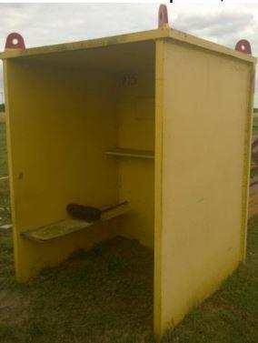
Figure 1 – Open Backed Firing Shelter
Figure 2 shows another type of shelter, this one is fully enclosed in RHA of varying thicknesses, the side facing the weapon system and the roof is 40mm thick, with the remaining sides of the box being 30mm thick. This type of shelter is primarily used for electrically fired weapon systems, the operator can be fully encased in the shelter, with the firing cable coming from the hole visible at the bottom left of the shelter (circled in red) in Figure 2.
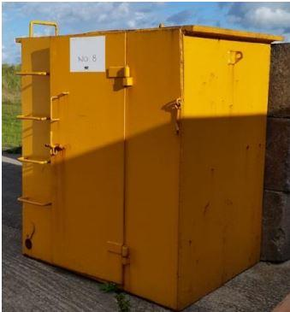
Figure 2 – Enclosed Firing Shelter
Figure 3 shows a third type of shelter, primarily used for protecting equipment, typically cameras, rather than people. This is because of its thinner construction of 15mm RHA and the opening at the front of the shelter to allow equipment to face out.
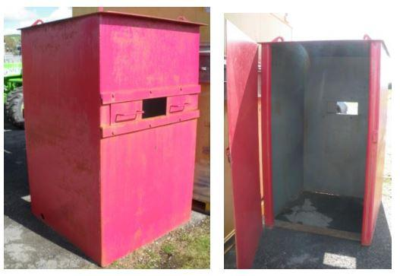
Figure 3 – Equipment Shelter

Written resources within the company regarding the firing shelters is sparse and the suitability of using the firing shelters alone as a means of protecting staff has been questioned.
Currently the shelters are not deemed sufficient protection to be deployed alone. In order to provide additional protection and allow work to go ahead, the shelters must have a protection wall of reinforced concrete blocks in front of the shelter. These blocks are called Pendine blocks and are 6’ long, 2’ high and 2’ wide made from reinforced concrete. Arranged in a wall three blocks high in front of the firing shelter, see figure 4 below.
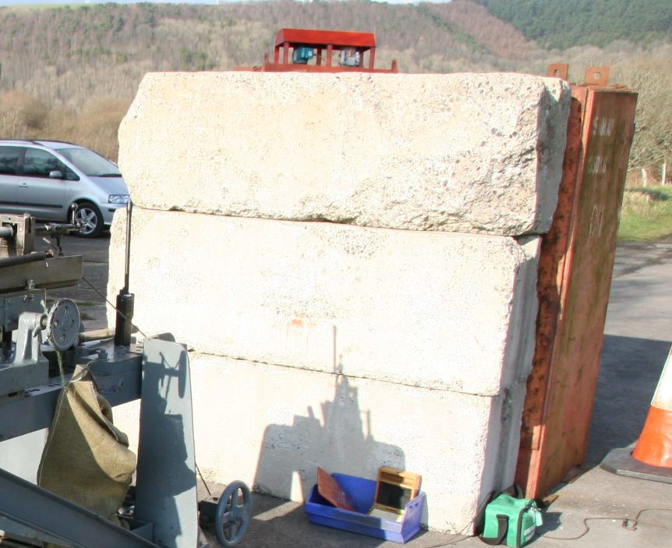
Figure 4 – Pendine Blocks Protecting Shelter
Whilst this undoubtedly increases the amount of protection afforded to the operator inside the shelter, the blocks do pose complications to trials.
When conducting firings using a lanyard, the blocks result in a greater distance between one end of the lanyard, around the trigger of the weapon, and the other end, in the hand of the weapon operator in the firing shelter. This length of lanyard results in two factors which can effect weapon operation. The first is that the greater length of lanyard means it is more difficult for the operator to pick up the tension in the lanyard and fire. The second is that the longer the length of the lanyard, the more opportunity there is for the lanyard to snag on something. If the lanyard snags, the weapon may not fire when intended to if the trigger cannot be pulled, or may fire for longer than intended, if the trigger cannot be released.
Certain firings are conducted from a trailer which can be lowered to the ground using hydraulics to provide a solid firing point. The trailer is unable to lift the weight of the gun mount, shelter and 3 Pendine blocks. Meaning the blocks must be taken away and re-added every time the trailer moves, which can be several times a day.
The additional movement of Pendine blocks creates more risk for the range staff due to the hazards of using a telehandler and slinger to move concrete blocks that weigh 1500Kg. Removal of the requirement for blocks in front of the shelter would eliminate the risk to Range staff.

Aims
The main aim of this project is to assess the firing shelters at MoD Pendine and provide evidence that they provide suitable protection from bullet impacts to the people deployed within them.
The assessment shall be done theoretically in the first instance using equations from penetration mechanics field of study.
The assessment shall also be carried out practically by conducting a trial firing small arms ammunition into a target plate representative of the firing shelters, thereby proving or disproving the theoretical work by experimentation.

Objectives
The objectives are to:
- Collect research into penetration mechanics equations and the practical ballistic testing of armour in order to inform the design of the theoretical and practical assessments of the firing shelters.
- Design a theoretical assessment of the firing shelters.
- Design a trial to practically asses the firing shelters.
- Create a safe system of work to conduct the trial.
- Capture data from the trial.
- Collate results from the trial and compare them to the theoretical results.
- Conclude findings from the research and suggest further research if applicable.

Structure of the report
Chapter one illustrates an overview of the report. It details the aims and objectives that once achieved will bring success to this research.
Chapter two details the research done into existing literature to inform both the theoretical and practical assessments of Pendine’s firing shelters.
Chapter three explores the research done and identifies which theoretical and practical assessments shall be used.
Chapter four explains the method of conducting both the theoretical and practical experiments to assess the firing shelters.
Chapter five covers what was conducted in both the theoretical and practical experiments and displays the raw results.
Chapter six summarises the report, concludes the findings of the trials and suggests further research which may be undertaken.
Chapter seven reflects upon the authors experiences of conducting this research.

Chapter 2 – Research and review of literature

Introduction
As mentioned in Chapter 1, there is not much information about the firing shelters which is readily available. Only one document published by QinetiQ which aimed to address this very issue has been found. There has, however, been research in to the testing of different types of armour for military applications. This research includes both theoretical work to mathematically prove armours suitability against certain threats and also practical experiments to prove the theoretical findings. This research can be used to inform both a theoretical and practical method of assessing Pendine’s firing shelters.

Literature concerning the theoretical method
Initial research was done to see if QinetiQ had any literature pertaining to the firing shelters and if any testing had been carried out on them. One document in the company was found, titled “Assessment of Manned Splinter Proofs” Authored by Andrew King, Howard Sandford and James McGreary in 2017. [2] It reached the same conclusion that written information was sparse and attempted to resolve that issue. However, the report resulted in a database of the all the shelters deployed across all of QinetiQ’s ranges and their varying condition, rather than qualifying the shelters as fit for use.
Reference 2 made use of the Recht Equation (Equation 1), reported to be reliable at predicting the penetration of rigid projectiles impacting semi-infinite, yielding and ductile targets with velocities up to 1000ms⁻¹. Equation 1 below shows the Recht Equation.
Equation 1 – Recht Equation
$$\int_{0}^{X}{\left(\frac{A_{X}}{A_{P}}\right)}dx=\frac{1.61M}{bA_{P}}\left[\left(V_{0}-V\right)-\frac{a}{b}\ln\left(\frac{a+{bV}_{0}}{a+bV}\right)\right]$$
Where:
$$a= 2τ\ln\left(2Z\right)\left(1+\frac{f}{\tan{α}}\right)$$
$$b = 0.25\sqrt{Kρ}\left(1+\frac{f}{\tan{α}}\right)\sin{α}$$
$A_{X}=$instantaneous projectile area (m²)
$A_{p}=$maximum projectile area (m²)
$V_{0}=$ impact velocity (ms⁻¹)
$V =$instantaneous velocity (ms⁻¹)
All of the material properties $\left(τ, K, ρ,{ σ}_{y} and Z\right)$ only relate to the target, not the projectile.
$$Z = {\left(\frac{E}{{ σ}_{y}}\right)\left(1+\frac{2E}{{ σ}_{y}}\right)}^{-\frac{1}{2}}$$
Where:
$τ=$ shear strength (Nm⁻²)
$K =$bulk modulus (Nm⁻²)
$ρ =$density (Kgm⁻³)
$E =$Young’s modulus (Nm⁻²)
${ σ}_{y} =$yield strength (Nm⁻²)
$M =$mass of projectile
$α =$half angle of a conical nosed projectile. ~23.5° for ogives
$f =$dynamic coefficient of friction between the projectile and the target.
Another equation used in reference 2 is the Thor perforation equation (Equation 2).
Equation 2 – THOR Equation
$${\left(\frac{V_{s}}{{10}^{c}×M_{f}^{β}×{\left(\frac{1}{\cos{θ}}\right)}^{γ}×V_{s}^{φ}}\right)}^{\frac{1}{α}}$$

Where:
$α, β, c, γ and φ$ are Thor constants for mild steel
$V_{s}=$ strike velocity (fps)
$M_{f} =$mass of fragment (grains)
$θ =$Angle of attack of fragment to plane of target
Charles E. Anderson Jr. and John P. Riegel III state that Project Thor was researchers attempt to correlate the mass and velocity of fragments with damage to aircraft components. [3] However, the work was conducted in the 1940’s and the form of the equation was selected purely for the reason that it could be managed by the computational power available at the time. And it is suggested that more recent attempts to provide empirical correlations with experimental data may yield a superior equation. That said, it may be worth using the Thor equation as an indicator of material thickness required to prevent penetration. Equation 2 below shows the Thor Equation used in reference 2.
These equations may be useful to give an indication of the suitability of the Pendine firing shelters. Though certain values would have to be modified, for example the Thor equations use constants for mild steel, but the firing shelters are constructed of RHA, which has different mechanical properties.
Tansel Deniz describes in their thesis, titled “Ballistic Penetration of Hardened Steel Plates” [4] about the basics of terminal ballistics, which will form a large portion of the testing carried out on the firing shelters in this research. The thesis also goes into some detail about the failure modes of armour which may be experienced during testing, some of which are shown below in figure 5.
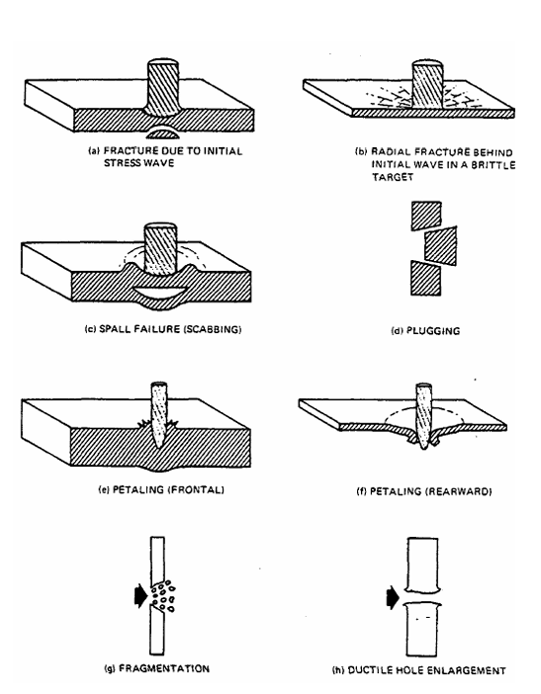
Figure 5 – Target Failure Modes
The thesis also makes mention of the THOR equations, and details some shortcomings, mainly the limitation to the fragment shape that can be used with confidence. For instance, predictions from the equations for extrapolations to projectiles with l/d ratios approximately equal to three, show good agreement with experimental results; however, for fragments with larger l/d than three, the accuracy of the predictions is not clear. [4]
Several other models were discussed in the thesis which may prove useful, including: Recht & Ipson's Model, regarding the impact of a plate whose thickness was on the order of the projectile diameter. Lambert's Model, which gives residual velocity of the projectile after interaction with the target plate. Stone's Model, for the depth of penetration of hard projectiles into structurally hard materials. Wijk's Model, concerning rigid projectile penetration and perforation into hard steel and metallic targets.
The book “Modern Impact and Penetration Mechanics” by James D. Walker [5] is a wealth of knowledge about the mechanics of penetration and how materials behave under impact. Of particular interest was the Chapter concerning the numerical simulation of tungsten impacting steel. It details how computations are made using several steps to achieve the result, an intensive process which requires a lot of data entry, variables and computing power and programs to give a result.
Another equation which can be considered for use is the De Marre equation, equation 3 below. The De Marre equation is in good agreement with numerical and experimental results from tests. De Marre assumed that a flat-nosed cylindrical projectile would not deform during the process of penetrating the target plate, and that the failure mode of the target plate was adiabatic shear. [6]
Equation 3 – De Marre Equation
$$V_{bl}=\frac{K.D^{0.75}T^{0.7}}{M^{0.5}\cos{θ}}$$
Where:
V_{bl} signifies the limiting velocity
K expresses the composite coefficient of armour piercing
D indicates the diameter of projectile (m)
T denotes the thickness of target plate (m)
M represents the mass of the projectile (kg)
$θ$ is the angle of attack. For example if the projectile is striking the target along the normal, this value would be zero.
The Zhao model expands upon the De Marre by considering the influence of target plate strength on the critical penetration velocity as well as the breakage and erosion of projectile during the process of penetration. [6]
Equation 4 – Zhao Equation
$$V_{bl}=K_{1}Y_{t}^{0.2}\sqrt[2]{\frac{C_{e}}{C_{m}\cos{θ}}}$$
Where:
$$K_{1}=1076.6\sqrt[2]{\frac{1}{[ε+(C_{e}×{10}^{3}/(C_{m}\cos{θ))]}}}$$
In which:

$$ε=\frac{K_{d}\cos^{1/3}θ}{C_{e}^{0.7}θ{(C_{m}×{10}^{-3})}^{1/3}}$$
$Y_{t}$ is yield strength of the target plate.
$$C_{e}=\frac{T}{D}$$
In which T denotes the thickness of target plate (m) and D indicates the diameter of projectile (m)
$$C_{m}=\frac{M}{D^{3}}$$
In which M represents the mass of the projectile (kg) and D indicates the diameter of projectile (m)
$θ$ is the angle of attack.

Literature concerning the practical method
Proving the suitability of the firing shelters using theoretical methods is a good start. The next step will be to devise a test that can prove the theory. There are several examples of tests that have been conducted by people in the area of armour testing.
AEP-55 is the NATO standard procedure for evaluating the protection level of light armoured vehicles. It details what data must be captured in order to properly evaluate the protection level of the item under test and what type of ballistic threat can be used. It does not however, detail exactly what measuring equipment must be used, leaving that to the discretion of the test house conducting the trial.
It provides further information, such as when firing multiple shots into a single target plate, that the plate is weakened by the impact and that the next shot fired must be a sufficient distance from the previous shot, so as to ensure that the full strength of the armour is being tested. [7] This document will prove very useful when designing the trial to test firing shelters as it an internationally recognised standard used to categorise the protection levels provided by armoured vehicles, this can be read across to the protection provided by firing shelters.
Several journal articles were consulted to identify the test set-up used by those in the scientific community for carrying out similar work. Not all of the journals were concerned with the testing of armour, but all involved some element of ballistic testing and the data capture tools that were essential for them to get the results that were required.
The first article was about the ballistic testing of steel plates manufactured using additive manufacturing. During the test the investigators utilised a set of three devices: an electromagnetic device for muzzle velocity measurement, an intelligent light screen for bullet velocity measurement, and a high speed camera for viewing the bullet interaction with the test specimen and calculating any residual velocity if penetration occurred. [8] Figure 6 shows the test set up used.
- Investigated specimen mount.
- High-speed camera.
- Light source.
- Protective box with bullet catcher.
- Intelligent light screen.
- Electromagnetic muzzle device.
- Barrel.
It appears that the testing was conducted inside a tunnel Range, limiting the affect that external factors (temperature, wind etc.) would have on the testing. It shows protection screens used for the high speed camera and the type of target stand used.
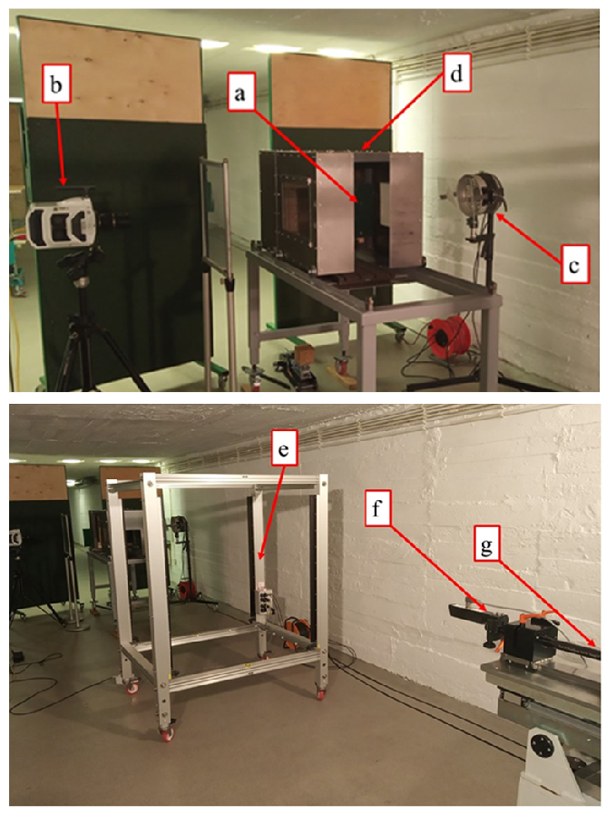
Figure 6 – Ballistic Testing Tunnel Range Set-up
The second was about testing the suitability of a new synthetic bone for use in ballistic testing. Again, high speed video was recorded, but they used a different method for recording impact velocity, the researchers on this project used an Oehler Model 36 Chronograph with three Model 57 screens [9], instead of the one light screen system used in article one.

The third article was concerned with ballistic testing of surface-treated alumina and silicon carbide. The testing was reported to have been carried out in accordance with AEP-55, there was no high speed cinematography on this trial though, just a doppler radar which gave muzzle and strike velocities. [10]
Figure 7 shows how the test was set up, using clamps to secure the test piece to a target frame, and the doppler radar position just to the right of the muzzle of the gun.
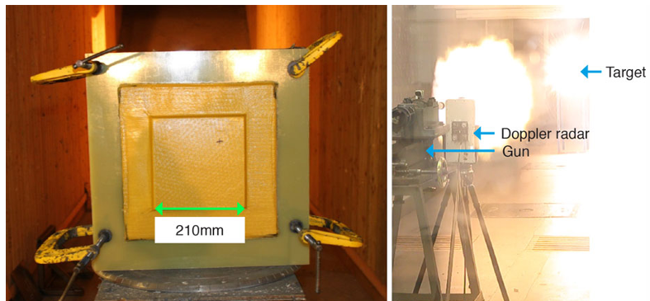
Figure 7 – Radar Set-up

The next article was about the ballistic testing of transparent armour ceramics. This article makes no mention of velocity equipment, but does make use of another piece of technology which could be useful, flash radiography. Figure 8 shows the images which can be captured using flash radiography. The top one shows the armour defeating the projectile and the bottom shows the armour being perforated. [11]
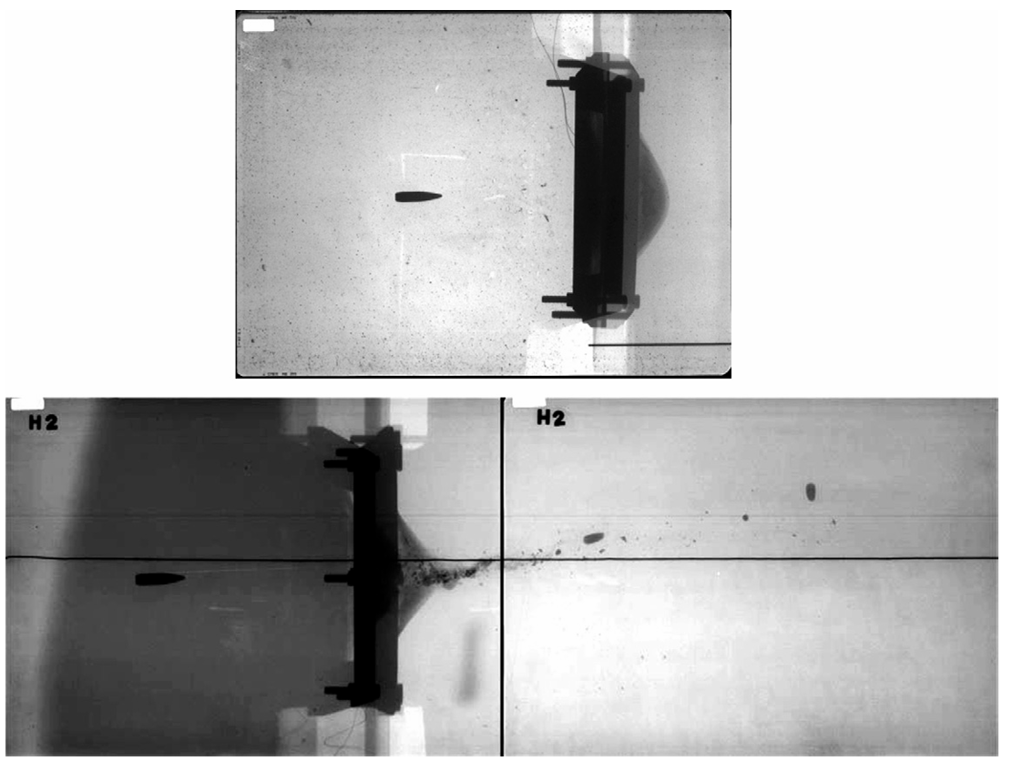
Figure 8 – Flash Radiography Images
The fourth article researched combined all of the above previously discussed instrumentation methods into one shoot. Muzzle velocity and strike velocity captured using sensors (not defined), bullet interaction with the target captured with high speed video cameras and x-ray pulsers. [12]
All of the papers reviewed so far have used conventional gunpowder weapons to fire the projectile. There is an alternative method however, using an airgun as detailed in “Study on Titanium Alloy TC4 Ballistic Penetration Resistance Part I: Ballistic Impact Tests”. [13] Though the velocities achieved (~200ms⁻¹) by the airgun may be too low for the requirements of the testing of firing shelters.
The research so far has detailed recording projectile velocity and interaction with targets, with the armour either being perforated or not as the pass / fail criteria. It would be useful to know how damaged the target is post testing in the event that the projectile did not perforate the target. An article titled “Non-destructive testing of light armours of CFRP after ballistic impacts by IR thermography methods” [14] details how thermograms can be taken of shot target specimens to identify damaged areas, see figure 9. The areas in white are internal destruction zones, that is damage beneath the surface of the target. Whilst this experiment was conducted on fibrous compositie armour, it could potentially be used for the firing shelters.
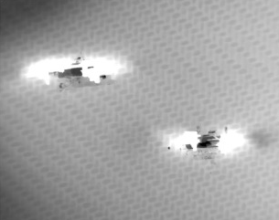
Figure 9 – Internal Destruction Zones

Conclusion
This literature review identified two methods for assessing the suitability of Pendine’s firing shelters to protect members of staff. The first is the theoretical method, utilising equations and material science to predict how the firing shelters would perform when faced with a ballistic threat. The second is the practical method, putting shelters, or a target representing the shelters to test against different ballistic threats in a controlled environment.
The review of literature concerning the theoretical method identified several equations which may be useful in determining the suitability of Pendine’s firing shelters. However, there are variables in these equations which are not known as some of the firing shelters are decades old and the passage of time may have altered the material properties of the shelter.
There is a wealth of literature pertaining to the practical method of ballistic testing. The research done will inform how the practical assessment shall take place and what the data capture requirements are.
The proposed method of assessing the suitability of Pendine’s firing shelters shall be twofold, the first method shall be to theoretically prove what ballistic threat that a firing shelter can withstand. Following this, a practical assessment shall be done to confirm the result of the theoretical assessment.

Chapter 3 – Research methodology

Introduction
This Chapter shall discuss the design of the research methodology and justify the research design in relation to the objectives of the research. The rationale behind choosing equations for the theoretical methodology will be considered.
Additionally, the requirements for the practical test shall be outlined. The methods for capturing the data required for the practical method however, shall be discussed in Chapter 4.

Theoretical research overview
The theoretical methods of ballistic assessment discussed in Chapter 2 were mostly derived post-experimentation. That is, a certain threat was fired against a known target at specific velocities and from the raw results, an equation complete with constants derived from the experimental results was created. That does not necessarily invalidate the usefulness of the theoretical equations, just that the ones discussed in Chapter 2 may not be suitable for providing assurance that Pendine’s current firing shelters are suitable for purpose. Several factors contribute to this:
- There are unknown grades of steel used in Pendine firing shelters construction. This factor means that the material properties of the shelter cannot be confirmed with 100% accuracy.
- Corrosive damage caused by long (20+ years) exposure to sea air may have altered the material properties of the shelter.
- Non-standard construction of firing shelters. As identified in Chapter 1, firing shelters at Pendine are not all constructed with the same dimensions, which is an issue when using one equation to try and prove each shelter individually.
Due to the limited information available on the current firing shelters (records have either been lost or destroyed) it was deemed prudent by the author to adjust the goals of the theoretical portion of this research from producing evidence to support the design of the current firing shelters, to identifying what material and thickness of that material is required to stop a threat representative of the worst case scenario that the firing shelter is likely to be subjected to.
This theoretical research should help to build a case to standardise the way in which shelters are constructed, and either confirm that the current shelters are suitable or unsuitable for protecting against the chosen threat.
There are a lot of variables required for the THOR, Recht and Zhao equations which are not known. To that end, the De Marre equation shall be used to determine the limiting velocity of a 12.7mm ball round impacting the 40mm thick RHA firing shelter at the normal angle.

Practical research overview
The practical methods of ballistic assessment identified in Chapter 2 are all similar. Firing a round into a target plate, whilst capturing data using various sensors. AEP-55 is the NATO standard, so testing should be conducted within the spirit of this document.
The method of data collection varied between each of the journals, but there was a common set of data that was captured. With muzzle and strike velocities of the projectile, and the projectiles interaction with the target being the two key elements. The practical assessment conducted as part of this research shall need to capture the velocities of the round as a minimum, in order to confirm that the correct value for velocity is being used in the theoretical assessment.
Conducting a practical experiment on targets representing the firing shelters remains the best way of determining the firing shelters suitability to protect the staff within from trials effects.
This practical research will confirm that the current shelters are either suitable or unsuitable for protecting Range personnel against the chosen threat.

Data collection for the theoretical method
The De Marre Equation requires the following variables to be known in order to solve for penetration limiting velocity:
The composite coefficient of armour piercing.
The diameter of projectile (m).
The thickness of target plate (m).
M represents the mass of the projectile (kg).
The obliquity of attack angle.

Data collection for the practical method
There are several data sets that will be captured during this trial.
- Muzzle velocity of the round fired.
- Strike velocity of the round.
- Meteorological data at the time that the round is fired.
- Temperature of the target plate.
- Projectile weight.
- Propellant weight.
- Bullet interaction with the target plate.
This set of data is collected to eliminate as many variables from what caused the results as possible. For example, if the one target is penetrated whilst another is not and none of the variables apart from the strike velocity are different between tests, then the failure of the target is attributable to the velocity and therefore the energy of the threat.

Research deliverables
The data gathered from both the theoretical and practical assessments can be used to inform the next decision of QinetiQ on whether the Pendine Firing Shelters are adequate protection alone or if the addition of a wall of Pendine Blocks is required. If the data produced is not adequate enough to inform such a decision, then the data can instead be used to help decide upon what more data is required in order to make a decision, or if indeed further or different experimentation is required.

Conclusion
This chapter has identified that the most suitable equation to use for the theoretical assessment is the De Marre equation, as all of the variables are known and it can be altered to suitably predict results for various target thicknesses and threats that the shelters shall face. The practical assessment has also been considered and it has been decided to replicate the tests researched in Chapter 2 using equipment available at Pendine Range. This type of work assessing target [plates against various threats has been conducted many times at the Range before, meaning the equipment and safety requirements are well understood.

Chapter 4 – Design and implementation

Introduction
This chapter of the report shall detail the design and implementation of both the theoretical and practical methods for assessing Pendine’s firing shelters.
For the theoretical portion of the research, this section shall describe which of the equations discussed in Chapter 2 shall be used as well as the variables that equation requires and where the values for the variables shall be identified.
For the practical element of the research, this segment shall describe how the data will be collected; the uncertainty of measurement of the selected methods of data capture are; what the Range layout will be; and safety considerations for conducting the research.

Theoretical problem formulation
It was chosen to first use the De Marre equation to identify the critical penetration velocity of a 12.7mm round. The round chosen for use is the 12.7mm National Reference Ammunition, which is used as a benchmark for all other 12.7mm ammunition to be assessed against.
The variables required to solve the equation, with the exception of the composite coefficient of armour piercing, can all by identified by physically measuring the attributes of the projectile and target. 10 rounds were disassembled so that the projectile diameter and weight could be recorded and a mean measurement of the diameter and weight could be used in the equation. There are several target thicknesses which can be used in the formula, shelters used for personnel protection tend to be 40mm thick, whilst shelters used for protecting equipment can be as little as 15mm thick.
The composite coefficient of armour piercing is related to the properties of the target plate; projectile material; projectile structure; and other factors. For ordinary armour-piercing projectiles, K ranges from 6200 to 73300 in value. When estimating, K usually takes the value 67650. [6]

Practical trial instrumentation
Muzzle velocity of the round fired will be captured by a doppler radar system. This system works by using the Doppler effect to measure the velocity of objects. The radar emits radio waves towards the target, when these waves encounter the rear of the projectile some of the waves are reflected back towards the radar head. The radar receives these echoes and detects the shift in frequency of the waves caused by the velocity of the round away from the radar. The system analyses the signal and converts the frequency change into a velocity. It is a highly accurate method of capturing not only the velocity of the round, but also its retardation and flightpath.
Strike velocity of the round will be captured in three ways. The same doppler radar system used to capture strike velocity will track the round to its last measurable point, in this case the target.
2 pairs of optical detectors will be used to give a velocity of the round as close to impact with the target as practicable. Optical detectors are essentially light gates, a pair of detectors are positioned a known distance apart from each other. When the round passes over the first detector, sensors within the detector identify the change in light intensity due to the shadow of the round passing over it. This produces a pulse of electricity which starts a timer recording. When the round passes over the second detector, the same process occurs, this time stopping the timer. The distance between the detectors is known as is the time taken to travel between them, using velocity = distance/time the velocity of the round can be calculated.
Optical detectors can be triggered falsely by clouds and rain drops if the sensitivity of the system is not set correctly to the conditions they are operating in. Errors in velocity measurement can also occur if the distance between the detectors is not measured accurately. For this reason, it is standard practice to deploy optical detectors in two pairs of two detectors, allowing the operator to check one against the other to assure accurate velocity measurement. Another drawback to the optical detectors is that due to the base length between the start and stop detectors, the measured velocity is actually at the midpoint between the detectors, making it impossible to measure true strike velocity using them. However, strike velocity can be extrapolated by applying the retardation figure calculated by the doppler radar to the observed velocity of the optical detectors, knowing the distance from the point of observed velocity to the target face is required for this and again, any errors in distance measurement will cause errors in the calculated strike velocity.
High Speed Digital Video (HSDV) footage can also be used to estimate strike velocity. The phantom cameras used at Pendine can record video footage at framerates of up to 40000 frames per second, which allows for detailed analysis of the projectile, including pitch and yaw measurement as well as velocity. The camera is calibrated for measurement by placing an object of known dimensions in the field of view. The pixels that this object occupies in the field of view of the camera is converted into the real world measurement. Once the round has been fired, the footage can be played back, the number of pixels which the round travels in a given number of frames can then be converted into a velocity using velocity = distance/time.
Meteorological data at the time that the round is fired will be captured using an on Range meteorological station which records: air temperature; wind speed and direction; barometric pressure; and relative humidity.
The temperature of the target plate shall be measured using a magnetic thermometer connected to a fluke multimeter. Target temperature is recorded as variations in temperature can have an effect on the material properties, though it will be minimal.
Projectile weight will be recorded on scales prior to firing. This is to ensure there are no anomalous projectiles which can impact the results of the test.
Propellant weight will be recorded on scales prior to firing. This is to ensure there are no anomalous projectiles which can impact the results of the test.
Bullet interaction with the target plate will be recorded using HSDV.

Practical trial layout
The trial will be set up in accordance with figure 10. The test barrel shall be located in the gun room and remotely operated from the control room. The gun room has built in CCTV fed back into the control room so that the gun be observed during firing. A doppler radar shall be deployed by the muzzle of the test barrel to capture muzzle velocity and track the projectile out to its impact with the target. Two pairs of optical detectors shall be positioned on the line of fire to capture the strike velocity as close to the target as possible. A HSDV camera will positioned perpendicular to the line of fire to observe the interaction of the projectile and target. This camera may have to be positioned in a shelter and the interaction viewed through a mirror in order to protect the camera from any fragmentation that may occur during the test. The target shall be positioned a distance of 25m from the muzzle of the barrel to allow the doppler radar to get a good trace of the target and to allow space for the optical detectors to be deployed. The velocity of the round will not drop too much over this distance and the engagement distance is far closer than anything the shelter would be subjected to during normal Range operation.
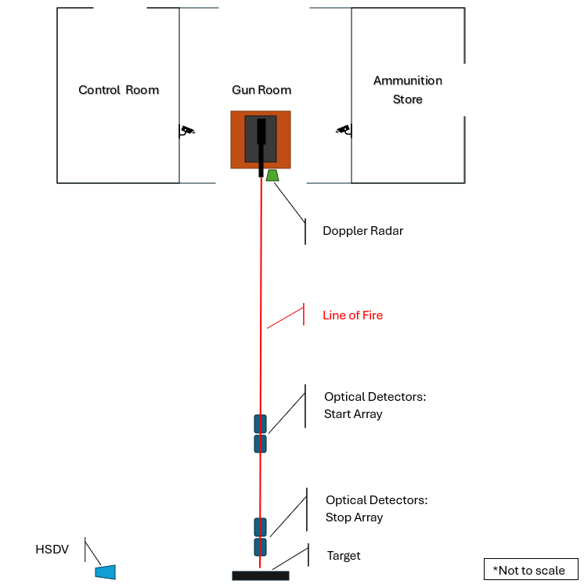
Figure 10 – Trial Layout

Practical trial safety considerations
As mentioned in Chapter 1, trials work is inherently dangerous, owing to the use of projectile weapons. As such, every effort must be made to bring the risk of conducting the activity to a level which is as low as reasonably practicable. This is done within QinetiQ by creating a safe system of work which comprises of:
- A Trials Conduct Document (TCD), detailing what is to be undertaken and how. This includes data capture requirements, OME required for the trial, resource requirements etc. This document also reference the myriad other documents needed to run a trial, such as the Range Standing Orders.
- A Hazardous Activity Risk Assessment (HARA). This document is used to identify what could cause injury on Range (hazard), how likely that injury is to occur and how serious the injury is (risk). The assessment is then used to identify actions to eliminate or reduce the hazard or risk. Risk Assessment is required by law under the Health and Safety at Work Regulations 1999. [15]
- A Safety Communications Brief, which is delivered by the Range Conducting Officer to all the participants in the trial prior to the activity commencing to ensure they are aware of what activity is being undertaken, to assign roles and responsibilities and to ensure everybody on Range is aware of the risks and controls associated with the activity.
The majority of hazards present on the Range are captured within a generic HARA [16] created for conducting small arms firings. The majority of controls are focused on ensuring that people are not within the firing arc of the weapon during firing and the safe operation of the gun system.

Conclusion
This chapter has identified that the variables for the De Marre equation shall be defined by measurement. It has also detailed how the practical assessment will be carried out, identifying the instrumentation requirements and layout for the activity. The safe conduct of the activity has also been discussed and the trial will be run as per similar activities that have been carried out at Pendine before.

Chapter 5 – Test and Evaluation

Introduction
This chapter shall detail the how the solution to the De Marre equation was reached, including how the variables will be defined

Theoretical problem solution
In order to solve the De Marre equation, the variables had to be defined. K was assigned a value of 67650, as this is used for estimation. The target thickness is known to be 40mm thick. The angle of attack will be 0, as this angle of attack has more chance of penetrating than angled impacts. The projectile diameter and weight were measured on a lot of standard 12.7mm ball rounds and the mean used
The mean projectile weight was measured using a set of laboratory scales and was found to be 45.5618g. The mean projectile diameter at the projectiles thickest point was measured using vernier callipers and was recorded as 12.945mm. Table 1 shows the raw data collected.
Table 1 – Projectile Weight and Diameter
Projectile Number | Projectile Diameter (mm) | Projectile Weight (g)
1 | 12.93 | 45.555
2 | 12.96 | 45.64
3 | 12.94 | 45.44
4 | 12.95 | 45.58
5 | 12.93 | 45.597
6 | 12.95 | 45.492
7 | 12.94 | 45.569
8 | 12.95 | 45.5
9 | 12.96 | 45.655
10 | 12.94 | 45.59
Mean | 12.945 | 45.5618

An excel sheet was created to solve the De Marre Equation for limiting velocity (figure 11) using the variables described.
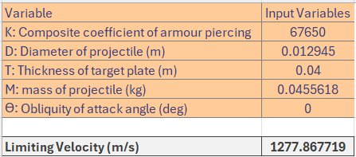
Figure 11 – De Marre Equation Calculator
Inputting the variables produced a limiting velocity of 1277.87ms⁻¹. Meaning it is estimated that projectiles of this nature would need to be travelling faster than 1277.87ms⁻¹ in order to penetrate the 40mm RHA plate.

Practical trial set-up
The trial undertaken differed slightly from the set-up proposed in Chapter 4 due to the unavailability of some pieces of equipment. The HSDV camera was not used as the equipment and competent operators were deployed on another trial which took precedence over this research. An additional change to the proposed set up was that a 12.7mm Heavy Machinegun (HMG) with Quick Change Barrel (QCB) was used for the test (figure 12), as the 12.7mm test barrel mounting was not fit for use at the time of the trial.
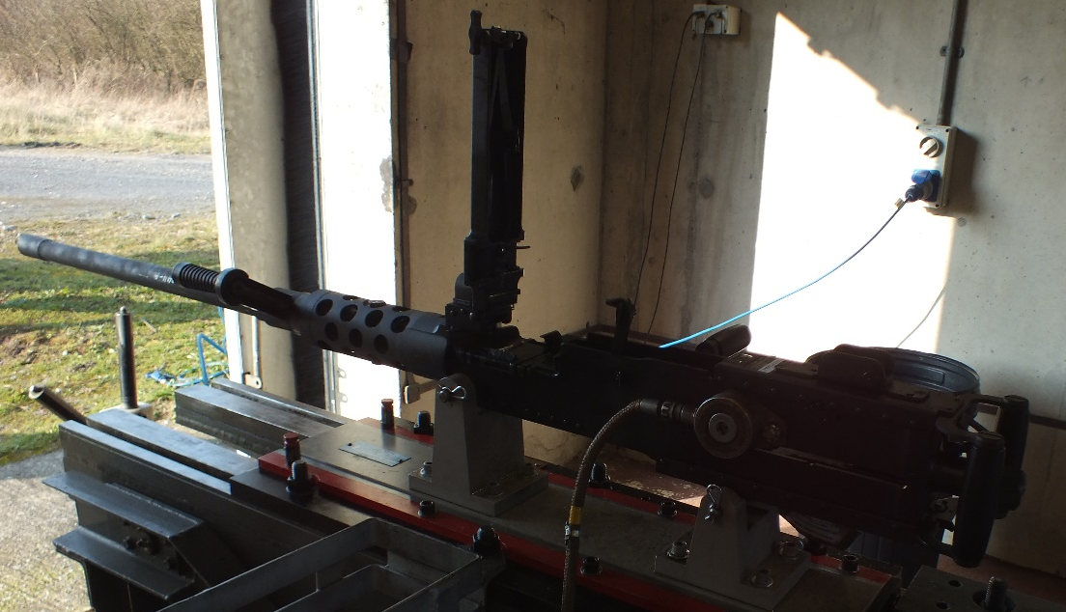
Figure 12 – HMG
A Weibel muzzle velocity radar was positioned beneath the muzzle of the weapon to capture muzzle and strike velocity of the fired round. It was decided not to deploy optical detectors as the weather was not clement to their use, and the facilities to suitably protect them from potential ricochet did not exist on the Range that the test was conducted on.
The target, a 40mm thick RHA plate was positioned 45m from the muzzle of the weapon system. The plate was supported upright by use of G-clamps (figure 13).
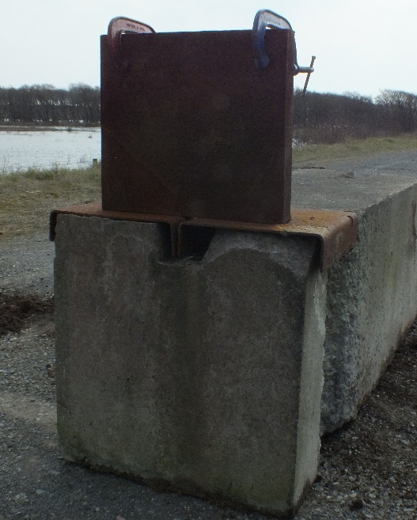
Figure 13 – RHA Target

Practical trial conduct
The trial was conducted at Pendine Range following standard safety procedures, meaning the gun was remotely operated, all personnel were under hard cover when firing took place, and the gun and ammunition were isolated when the target needed inspecting. The target was positioned 45m from the muzzle of the HMG and secured in position using clamps. The gun was then sighted on to the target using a borescope. Once the point of aim had been defined, the borescope was removed from the barrel and all personnel not required for loading the weapon were placed undercover.
The weapon was then loaded with a single 12.7mm round in accordance with the military publication for the HMG [17]. Once everyone was undercover and ready to fire, the weapon was operated remotely by the use of an Instrumented Firing Unit.
Once the round had been fired, the weapon was cleared before the target was inspected and data from the firing recorded. The process was then repeated from sighting the gun onto the plate. To attempt to avoid striking the same place on the target more than once, the point of aim of the gun was changed between each shot by adjusting the azimuth and elevation of the gun mount.
Ten shots were fired at the target plate in this fashion. All firings were conducted safely without incident.

Practical trial results
The raw results from the Weibel radar and if the plate failed and how after the shot is tabulated below in table 2.
Table 2 – Practical Trial Results
Round Number | Muzzle Velocity (ms⁻¹) | Strike Velocity (ms⁻¹) | Plate Failure? (Y/N) | Failure Mode
1 | 899.76 | 878.72 | N | N/A
2 | 902.02 | 882.28 | N | N/A
3 | 886.73 | 867.41 | N | N/A
4 | 902.17 | 880.17 | N | N/A
5 | 898.49 | 877.53 | N | N/A
6 | 904.63 | 883.15 | N | N/A
7 | 894.15 | 874.44 | N | N/A
8 | 897.98 | 878.51 | N | N/A
9 | 891.65 | 869.42 | N | N/A
10 | 892.89 | 873.13 | N | N/A
Mean | 897.05 | 876.27

Figure 14 shows the front face of the target plate after the first shot, Figure 15 shows the front face of the target plate after the final shot. None of the rounds perforated the target.
Figure 16 shows the rear of the target plate after the final shot, there was no deformation on the rear face of the target plate.

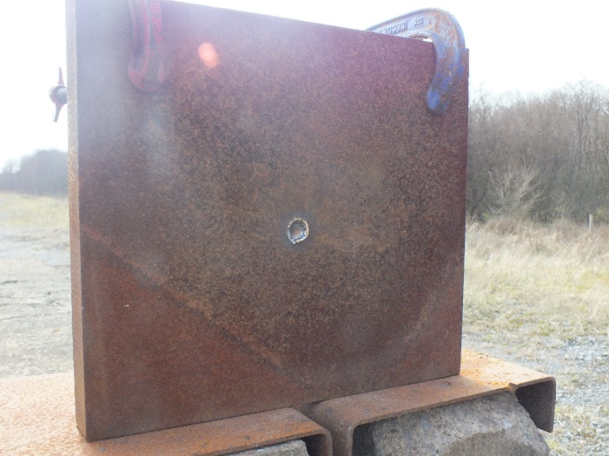
Figure 14 – Front of Target Plate Post-Shot 1

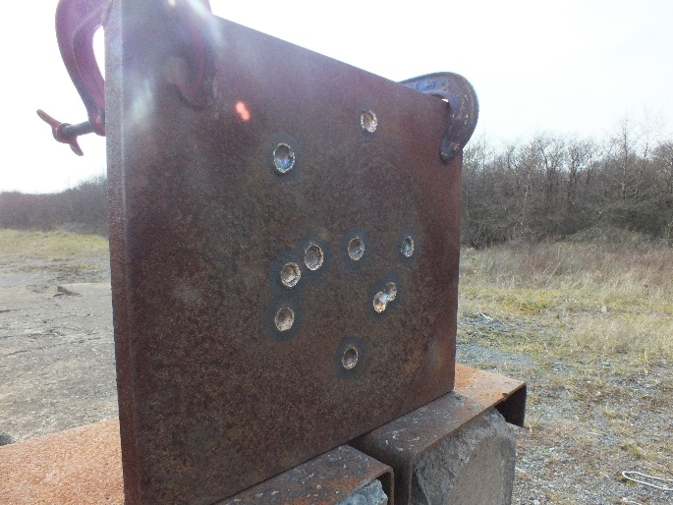
Figure 15 – Front of Target Plate Post-Shot 1
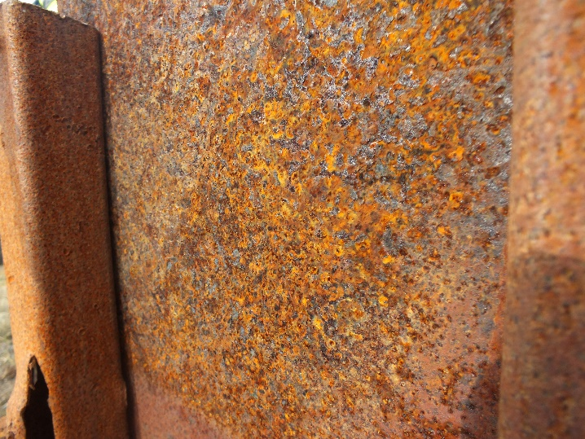
Figure 16 – Rear of Target Plate Post-Shot 10

Chapter 6 – Conclusions and recommendations

Summary
This report first identified that the efficacy of the firing shelters at Pendine was not fully understood to the point that extra protection blocks are needed to assure the site that personnel deployed within the shelters are protected from bullet impacts. The aim of this report was to identify a theoretical and practical method of assessing the firing shelters suitability to protect personnel from bullets.
To that end, research was conducted into methods of both academic and applied nature to conduct this assessment. From this research is was identified that the De Marre equation was a useable equation to make an assessment. The equipment, data capture and trial layout required to carry out a trial was also decided.
From this research both methods of evaluation were carried out. The findings of which shall be discussed and concluded in the next section.

Conclusion
Both the theoretical and practical methods of assessment have indicated that the 40mm thick RHA firing shelters in use at Pendine are sufficient to protect employees within from 12.7mm ball ammunition impacting the shelter along the normal.
The De Marre equation suggests that a 12.7mm ball projectile would have to be travelling at 1277.87ms⁻¹ in order to perforate the firing shelters at Pendine. This implies that is impossible for normal 12.7mm ball rounds to perforate the firing shelters, as the average muzzle velocity of the rounds recorded during the trial was 897.05ms⁻¹ and they decelerate from that point onwards.
The trial fired 10 rounds at a 40mm RHA plate, none of which pierced the target. The rear face of the target showed no signs of deformation, indicating that the plate was not close to failing by plugging, scabbing or any of the other modes of failure described in Figure 5.
The conclusion from this research is that Pendine blocks in front of firing shelters are superfluous for ball calibres up to 12.7mm.

Recommendations for further research
The research conducted thus far gives a good indication that the firing shelters are capable of protecting personnel within from ball calibres up to 12.7mm. However, in order to conform with AEP-55 (reference 7), 22 valid hits are needed to give 95% confidence in the efficacy of the armour, meaning further testing of the same type is required to meet this standard.
This initial research only considers ball ammunition. Other natures of ammunition, including those specifically designed to penetrate armour, are tested at Pendine. In order to fully confirm the suitability of the shelters to provide protection from bullet attack other natures could be tested. Further to this, fragment simulating projectiles may also be fired to asses the efficacy of the firing shelters against fragments caused by exploding munitions.
Improvements can be made to the practical experiment by using a more accurate weapon system to ensure more uniform spacing between shots and including optical detectors and HSDV in the data capture.

Chapter 7 – Reflections

Introduction
In this final chapter, the author reflects upon the journey undertaken throughout the course of this project. The author explores the research process, the challenges encountered, the lessons learned, and the implications of the findings.

Experiences
Initially, the research began with a comprehensive literature review to establish the theoretical and practical methods of assessing armour against ballistic impacts. The author learned a lot about the theoretical methods during this portion of research as it was an area of study that they were unfamiliar with. The practical method was less so, as the author conducts armour verification trials fairly regularly as part of their employment, it was good to see that the methods used in QinetiQ are widely accepted across the academic community as best practice.
Following the literature review, the actual assessments were carried out. The author was comfortable with the theoretical method chosen as it contained known variables. The ones not selected required variables that the author wasn’t sure of owing to their lack of knowledge in material science, more research could have been conducted in that field but the author felt it would have been against the purpose of this project. Similarly to the research, the conduct of the practical assessment was comfortable for the author as they are very experienced in that area.

Lessons Learned
The journey of conducting this project has been a profound learning experience, granting valuable insights and lessons. Firstly, the author has learnt the importance of flexibility in research endeavours, as unforeseen challenges are inevitable, such as unknown variables in equations or the lack of ideal equipment for the practical. Secondly, the author has gained an appreciation for the iterative nature of research, slightly altering the direction the research heads in the light of new information. Thirdly, the author learned the importance of engaging with subject matter experts in both the academic world with the regards of constructing the report and in the industry of which this research effects.

References

[1] | QinetiQ, “QinetiQ's work at MOD Pendine,” QinetiQ, [Online]. Available: https://www.qinetiq.com/en/pendine/about/qinetiqs-work-at-mod-pendine.
[2] | A. King, H. Sandford and J. McGreary, “Assessment of Manned Splinter Proofs,” QinetiQ, Fort Halstead, 2017.
[3] | C. E. Anderson and J. P. Riegel III, “A penetration model for metallic targets based on experimental data,” International Journal of Impact Engineering, vol. 80, pp. 24-35, 2015.
[4] | T. Deniz, “Ballistic Penetration of Hardened Steel Plates,” Middle East Technical University, Ankara, 2010.
[5] | J. D. Walker, Modern Impact and Penetration Mechanics, Cambridge University Press, 2021.
[6] | M. Alves, “Oblique penetration of tungsten alloy rod to finite-thickness,” Latin American Journal of Solids and Structures, vol. 16, no. 9, 2019.
[7] | NATO, “Procedures for Evaluating the Protection Level of Logistic and Light Armoured Vehicles Volume 1,” NATO, 2005.
[8] | I. Szachogłuchowicz, B. Fikus , K. Grzelak, J. Kluczy´nski, . J. Torzewski and J. Łuszczek, “Selective Laser Melted M300 Maraging Steel—Material Behaviour during Ballistic Testing,” MDPI, vol. 14, no. 2681, 2021.
[9] | A. E. Pullen, D. C. Kieser, G. Hooper and T. C. H. Plummer, “A study into the viability of Synbone® as a proxy for Sus scrofa (domesticus) ribs for use with 7.62 × 51 mm Full Metal Jacket ammunition in ballistic testing,” Forensic Science, Medicine and Pathology, vol. 17, pp. 665-669, 2021.
[10] | A. Harris, B. Vaughan, J. Yeomans, P. Smith and S. Burnage, “ Ballistic testing of surface-treated alumina and silicon carbide with improved adhesive bond strength,” Applied Ceramic Technology, 2016.
[11] | E. Straßburger, “Ballistic testing of transparent armour ceramics,” Journal of the European Ceramic Society, vol. 29, pp. 267-273, 2009.
[12] | E. C. Tsirogiannis, E. Daskalakis, M. H. Hassan, A. M. Omar and P. Bartolo, “Ballistic design and testing of a composite armour reinforced by CNTs suitable for armoured vehicles,” KeAi.
[13] | Z. Tao, C. Wei, G. Yupu and G. Deping, “Study on Titanium Alloy TC4 Ballistic Penetration Resistance Part I: Ballistic Impact Tests,” Chinese Journal of Aeronautics, vol. 25, pp. 388-395, 2011.
[14] | W. Swiderski, “Non-destructive testing of light armours of CFRP after ballistic impacts by IR thermography methods,” Composite Structures, vol. 224, 2019.
[15] | Health and Safety Executive, “www.hse.gov.uk,” HSE, [Online]. Available: https://www.hse.gov.uk/simple-health-safety/risk/index.htm.
[16] | G. Atkins, H. Walters, S. Bowen, J. Gottwaltz, Y. Jackson and J. Ashley-Jones, Small Arms & Cannon Trials Bounded HARA, Llanmiloe: QinetiQ, 2023.
[17] | Ministry of Defence, Close Combat - Lethality 12.7mm Heavy Machine Gun HMG, London: MOD, 2020.

