

Assessment 1 – Reading Task Template
Upload your photo of your A3 in-class notes here:

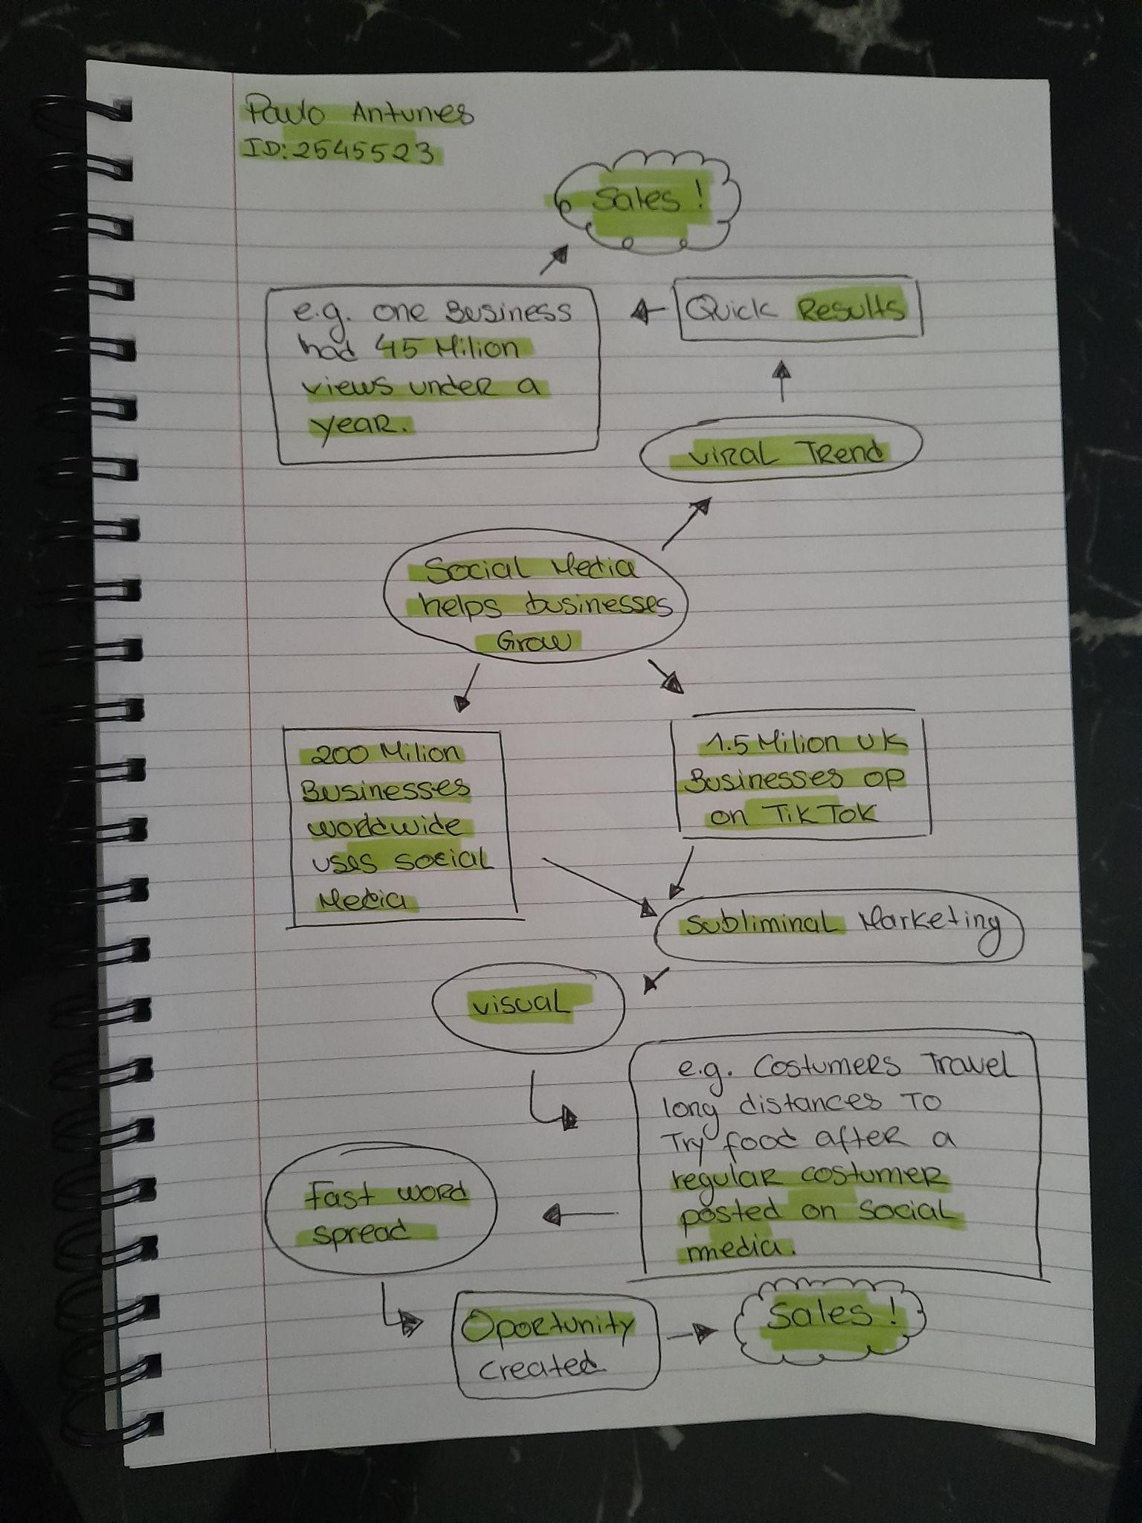
1. Answer these questions using the sentence starters below
a. What is the main idea of the text?
The main idea is that small business can grow in a impressive way by using social media to promote their services and products.
b. What are two key points?
One key point is 1.5 million UK businesses are operating on TikTok (social media) according to figures shared by the social media platform.
Another key point is 200+ million businesses worldwide are using instagram (social meda) to reach costumers according with Governments Business Academy.
c. What part of the text did you find most important? Why?
The most important part is the clear idea of how social media can have a huge impact in a business for better results.
d. Was anything unclear or difficult to understand?
I was not sure about how to identify some of the key points on the text.
e. How did creating a mind map help you understand the text better?
Creating a mind map helped me looking for specific details on the the text and have a better understanding about what i was reading.
2. One sentence reflection
Question: What did you find challenging about this task?
The hardest part was making my mind map and write down my ideas into it.

