BMIH5003
Foreign Languages and Cultural Awareness

Table of Contents
Introduction 3
Thorough Analysis of Two countries 3
Strategies of all departments in the hotel industry 5
Conclusion 6
Reference 7

Introduction
Cross-cultural communication is a process of sharing, and communicating with people from different cultural backgrounds, nationalities, ages, races, and lifestyles in similar or different ways among themselves. This report will cover the implications of Hofstede’s theory in the adoption process of a different culture in Germany and Brazil for the employee, what they should do and what they shouldn’t are also discussed. In today's workplace, intercultural competence is a must-have skill set. People from a wide range of backgrounds can help improve their ability to manage time, communicate, deal with conflict, and operate as part of a group in both the virtual and the real world (Bhasin, 2022). It helps to sell products internationally, satisfy customers' needs, and improve the contribution of work personnel to diverse markets.

Thorough Analysis of Two countries
In this report, the two countries selected are Brazil and Germany representing the home country and guest country respectively. Having a cultural understanding and learning to honour and accept individuals who are different from us can help individuals cut down the boundaries and develop bridges, therefore allowing us to better understand and interact with others and make us able to relate to people from other cultural backgrounds (Kimmel, 2022).

The Hofstede model is the most effective to use to analyse the report which has many dimensions to describe differences in culture across countries and provide important information (Zainuddin, Yasin, Arif and Hamid, 2018). It has six dimensions:

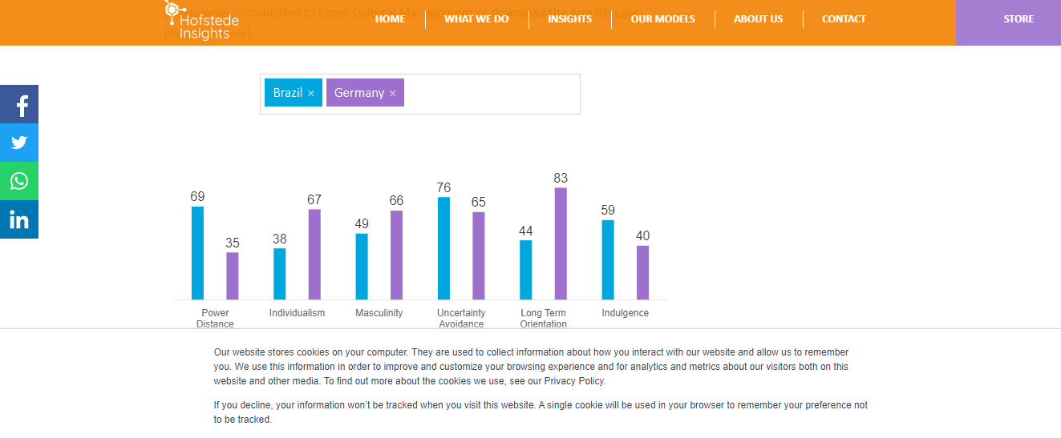
Figure 1 Comparison of cultural differences between Brazil and Germany (Source: https://www.hofstede-insights.com/country-comparison/brazil,germany/)

Individualism
In individualism, here the main priority is one's own goal, giving a high valuation of people's time & interest. But in collectivism, here gives greater priority to the whole society's goals, well-being & interests (Bruin, 2022). Here Brazil and Germany score 38 and 67 respectively. Germans believe strongly in the concept of self-actualization while Brazilians are well integrated into stable social groupings from the time they are born; this indicates that the two countries are very different in their commitment to each other (Hofstede-insights, 2022).
Power distance
People in positions of power enjoy more advantages than the rest of society because of this unequal distribution of power. Elderly people are respected in Brazil, and it is necessary to do so (Hofstede-insights, 2022). Co-determination rights in Germany, on the other hand, are much more extensive and must be taken into consideration by management (Hofstede-insights, 2022). This form of communication is commonplace, but it's loathed by those who don't enjoy being ruled by others, thus leaders have to demonstrate their knowledge before they'll be accepted. Decentralization can help Brazil’s employees and customers feel more involved.
Masculinity
Germany is a Masculine society with a score of 66. People place a high value on performance and prefer to "live to work," deriving great satisfaction and fulfilment from their jobs. Managers are required to be self-assured and determined. The two most significant values in Brazilian society, which rate 49 (Feminine) out of 100, are caring for others and enhancing one's quality of life. Standing out from the rest is considered a flaw in Feminine society, where high standards of living are valued as a sign of success.
Uncertainty Avoidance
Most Latin American countries rank high on the UAI index (76). Rules and laws are needed to keep these societies in order. Brazilians are known for their fervour and exuberance, which is at least in part due to their high rating in this category. Germany's score of 65 indicates a little tendency for uncertainty avoidance. Details help ensure a topic or endeavour is well-thought-out. In conjunction with their low Uncertainty Avoidance, where the confidence in their actions is not compensated by the boss's greater responsibility, Germans prefer to rely heavily on knowledge.
LONG TERM ORIENTATION
Germans received an impressive 83 out of 100, which indicates that the country is pragmatic. They argue that the definition of truth is influenced by context, time, and place. Pragmatists Their ability to adjust to changing circumstances is one of their many assets. They are frugal, tenacious, and adaptable. To put it another way, the normative cultures of Brazil, for example, tend to preserve long-held traditions and standards while skepticism of social change permeates them (Stuff, 2022).
INDULGENCE
This is an Indulgent score for Brazil. People in high-indulgence societies are more likely to take pleasure in life and have a good time. They're hopeful. It's safe to say that a German culture score of 40 indicates a restriction. Countries with low test scores are gloomy and pessimistic. People who hold this view believe that social norms limit their behaviour and that indulgence in oneself is improper.
By Demonstrating and comparing Germany and Brazil their key cultural differences, conventions, traditions, and behavior can be identified. Culture in Brazil tends to be more concentrated, passionate, outgoing and enthused. Culture is Restricted in Germany, and high weight is placed on performance rather than self-actualization.

Strategies of all departments in the hotel industry

Do | Don’t
Do hotel personnel involve in decision making | Don't follow inequality & centralized system
Do priority the society & its needs. | Don't follow your own needs or just profit
To overcome the uncertain situation with proper strategy | Don’t avoid uncertainty & risk-taking tendency
Do cordially accept women in the service industry | Don't discriminate in gender
do focus on the long-term goal | Don't focus on quick results and success
Do focus on customer actual needs. | Don't pressurize to accept your constrained service.

Conclusion
Cultural distinctions in marketing should be prioritized when selling goods or services globally, as cultures vary from country to country. Meaning that global firms must learn about the culture of an area before they can sell their products there. Becoming a better communicator will help users flourish at a business hotel. By doing so, they'll help create mutual trust with people from different cultural backgrounds and their joy will be contagious. Customer service can improve when employees are satisfied and for this, they need to have cross-cultural difference knowledge and how to cope with globalization.

Reference
- Zainuddin, M., Yasin, I., Arif, I. and Hamid, A., 2018. Alternative Cross-Cultural Theories: Why Still Hofstede?. International Conference on Economics, Management, and Social Study, [online] pp.1-8. Available at: <https://www.researchgate.net/publication/330204101_Alternative_Cross-Cultural_Theories_Why_Still_Hofstede> [Accessed 20 May 2022].
- Kimmel, P., 2022. Cross-cultural theories. [online] Beyond Cultural Differences. Available at: <https://beyondculturaldifferences.wordpress.com/research-theories/?fbclid=IwAR25F2oG8pclNzO0UnkbzveKBy-PUaVq1XGKiYYTXr46uQvThiOW-cm0vm4> [Accessed 19 May 2022].
- Bruin, L., 2022. Hofstede's Cultural Dimensions EXPLAINED with EXAMPLES | B2U. [online] B2U - Business-to-you.com. Available at: <https://www.business-to-you.com/hofstedes-cultural-dimensions/> [Accessed 19 May 2022].
- Stuff, F., 2022. Racial Discrimination in the Workplace - FindLaw. [online] Findlaw. Available at: <https://www.findlaw.com/employment/employment-discrimination/racial-discrimination-in-the-workplace.html> [Accessed 21 May 2022].
- Makambe, U. and Pellissier, R., 2014. The application of Hofstede’s cultural dimensions at Botho University: A model for workplace harmony in a multi-cultural business environment. IISTE, [online] 3(4), pp.92-98. Available at: <https://core.ac.uk/download/pdf/234671602.pdf> [Accessed 21 May 2022].
- Bhasin, H., 2022. Cross-Cultural Communication - Meaning, Importance, and Factors. [online] Marketing91. Available at: <https://www.marketing91.com/cross> [Accessed 22 May 2022].
- Stobierski, T., 2019. How to Improve Cross-Cultural Communication in the Workplace. [online] Northeastern University Graduate Programs. Available at: <https://www.northeastern.edu/graduate/blog/cross-cultural-communication/#:~:text=Cross%2Dcultural%20communication%20is%20the,engage%20within%20a%20given%20context.> [Accessed 22 May 2022].
- Fisic, J., 2022. How to perfect cross-cultural communication at the workplace. [online] Pumble Blog. Available at: <https://pumble.com/blog/cross-cultural-communication/> [Accessed 22 May 2022].
- Hofstede-insights, 2022. hofstede-insights. [Online] Available at: <hofstede-insights>[Accessed June 2022].

