Academic Skills portfolio- ECEY4009/C

I have not used AI, used work count

Contents
- Page 1 and 2- PDP
- Page 3 and 4- Briefing paper
- Pages 5 to 9 Written Essay

Professional development plan
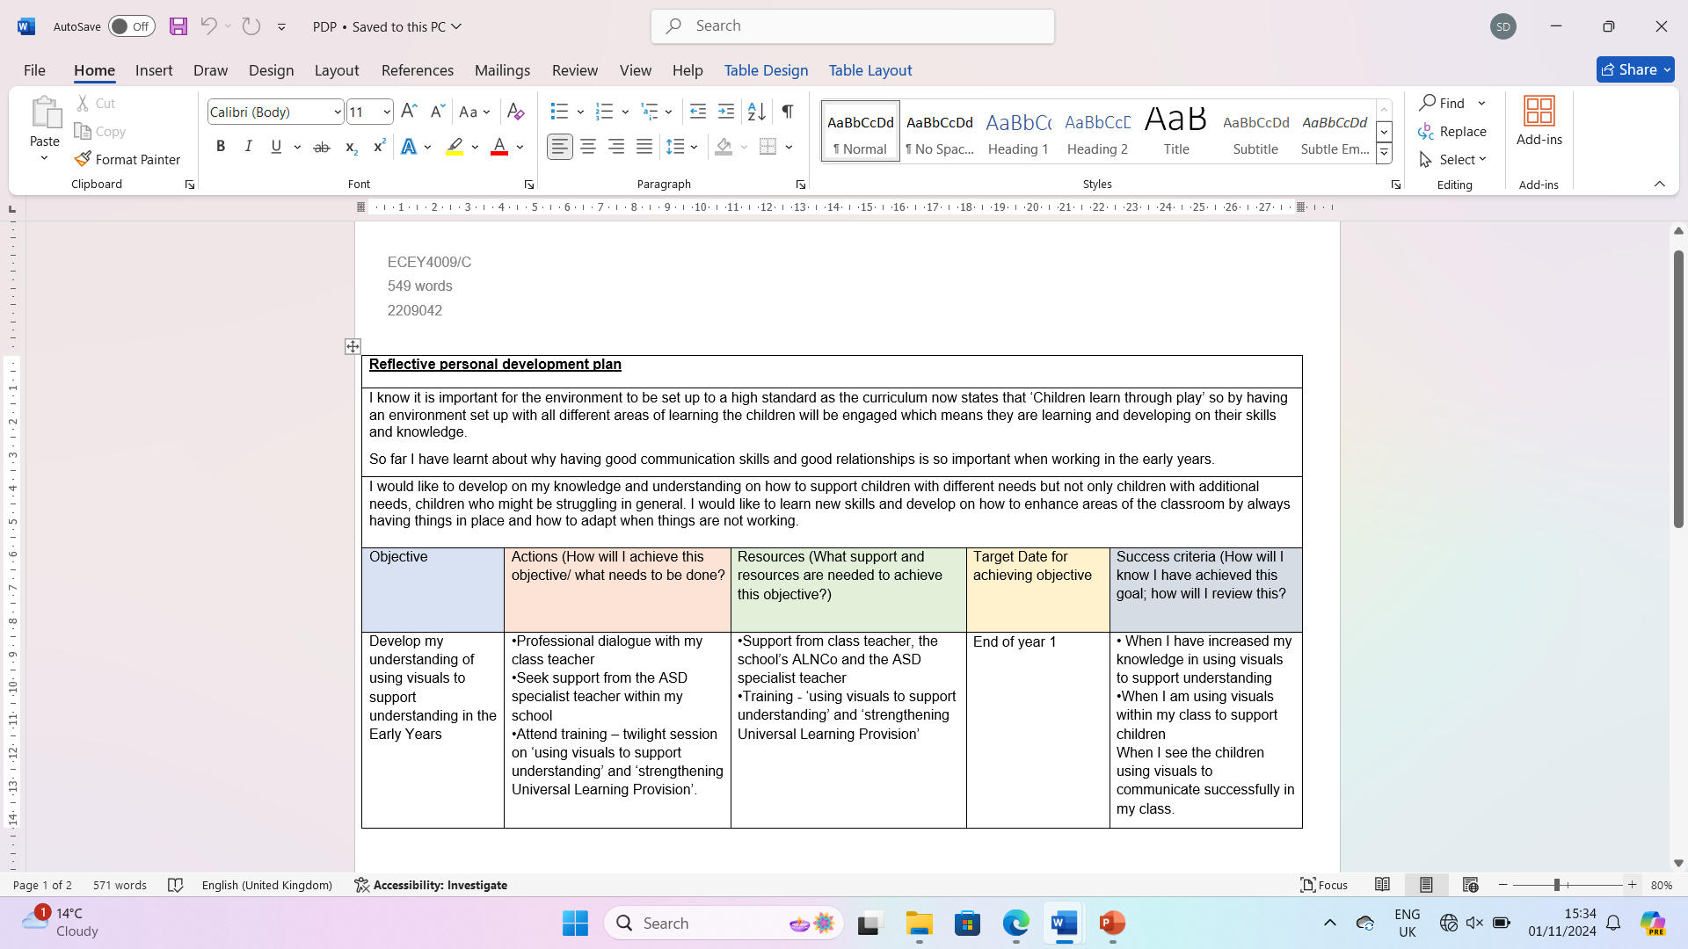

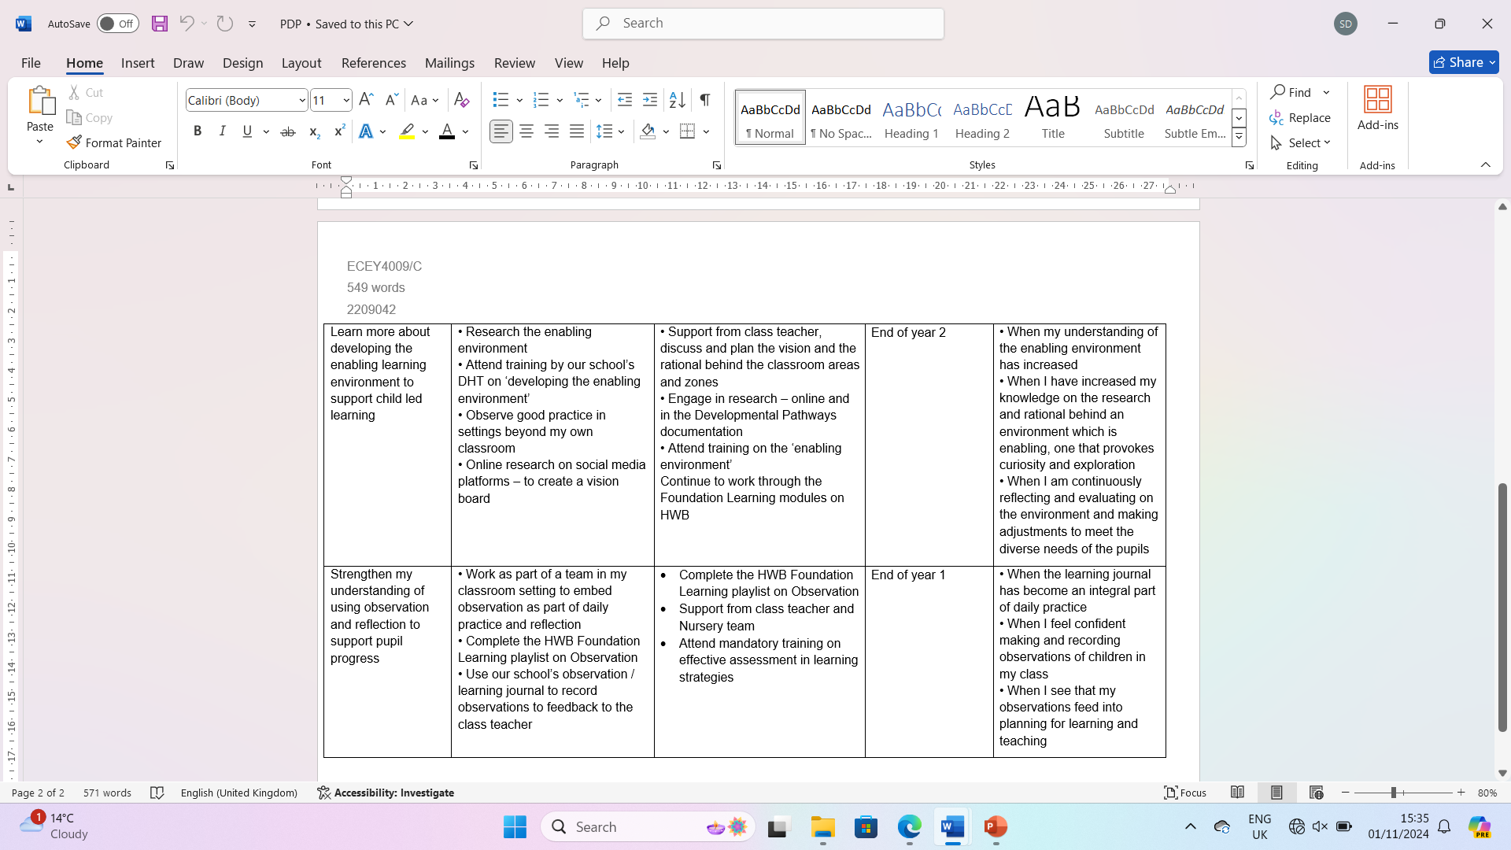

Briefing Paper
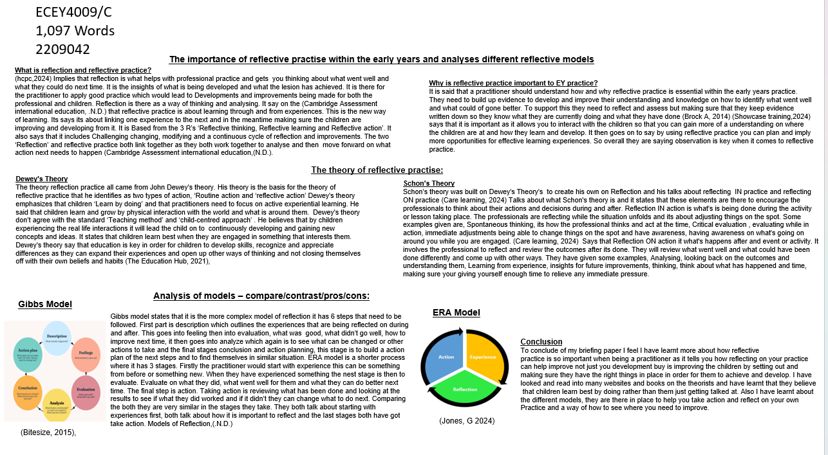
Briefing Paper
Briefing paper Reference list
Bitesize, (2015), The Gibbs Reflective Cycle, explained, Available at: https://www.bitesizelearning.co.uk/resources/gibbs-reflective-cycle-explained-diagram-examples
Brock A,(2014) The Early Years Reflective Practice Handbook- What is reflection and reflective practice, Available at:
Cambridge Assessment international education,(N.D.) What is Reflective practice? Availible at: https://www.cambridge-community.org.uk/professional-development/gswrp/index.html#:~:text=Reflective%20practice%20is%20'learning%20through,your%20students%20make%20maximum%20progress
Care learning,(2024), What is the Schon model of reflection, Available at: https://carelearning.org.uk/blog/feedback-and-improvement/what-is-the-schon-model-of-reflection/ (Accessed: October 2024).
hcpc,(2024), What is reflection? Available at: https://www.hcpc-uk.org/standards/meeting-our-standards/reflective-practice/what-is-reflection/ (Accessed: October 2024).
https://ebookcentral.proquest.com/lib/trinity/reader.action?docID=1744144
Jones, G (2024) Models of reflection you can use, Avaliable at: https://www.reflectivewriting.tips/models-of-reflection-you-can-use/ (Accessed: October 2024).
Models of Reflection,(.N.D.) Availble at: https://www.reflectivewriting.tips/wp-content/uploads/2021/07/Models-of-Reflection.pdf
Showcase training,(2024) The Importance of Reflective Practice in Early Years. Available at: https://showcasetraining.co.uk/2023/12/06/the-importance-of-reflective-practice-in-early-years (Accessed: October 2024).
The Education Hub (2021), Dewey’s educational philosophy, Available at: https://theeducationhub.org.nz/deweys-educational-philosophy/ (Accessed: October 2024).

ECEY4009/C
1,571 Words
2209042
Written Essay

Recognize and analyse the significance of different aspects of professional practice and why these are important in meeting the individual and inclusive needs of children.
First of all what is a professional? (Perez,R, 2019) says that “Professions have unique skills, knowledge and ethical standards”. It is known that they have these skills to be able to guide them with the responsibility and knowledge that is required when being a professional. By doing this it is said that it will show what they have done and learnt. To be a professional it is required that they know their values and are able to identify them as they say it is critical to the identity of the professional (Perez,R, 2019). Secondly what is professional practice? It is stated that the role of the adult within the early years is providing exceptional early childhood experiences for the children and families. Following on from this it says that it is how the practitioner evaluates and explains their own role and how it impacts on others. Professional practice is best describe as how the practitioner takes on board what their role is and how they see themselves within the role, how they carry out the work to make sure it is benefitting the young children on a daily basis and also how they interact with the parents and other professionals (Longford Childcare, 2017).
(Powell,S, 2010) Identify some of the important values that is needed as professional practitioner. One of the values that he states is that practitioner has a real interest in the children and their development. If the practitioner is not fully interested then it is said they are not going to be able to deliver that right aspects therefore the children are not going to engage which those will then would lead to the children not developing or improving their knowledge or skills. Another value that is needed by the professional is that they have good communication skills. This goes down to the children, parents, guardians or other professionals. By developing good communication skills it will make any job easier to be able to discuss anything or make decisions on what needs to be done but also building that relationships with the parents-guardians. They got to know that they can trust the Professional and know that they will have their back if they come forward with any concerns. There are many other values that he have stated in short brief such as having confidence is important, Patience and professionalism. Being caring and understanding and the ability to work effetely with other and within your team. It is considered that the values are important to the professional practice as it there to develop their professional identity, the commitment they have to the learners and colleagues around them. It also states that it is important that it supports and encourages the professional to see beyond the classroom and subject, this meaning that they need to expand more and always having different options in place in case the first thing don’t work out, there are ways to adapt (The General Teaching Council for Scotland, 2021).

Research states that it is important to the professional practice for a practitioners to have good communication skills and trusting relationships with the parents/guardians of the children in order to meet their needs. When a practitioner has effective communication it allows them to develop a relationship with the parent/guardian to share knowledge about the child which is going to help with the child’s development. It states that by listening to the parents perspective and trying to understand where they are coming from and what they might see at home could be different to what they would see, it allows the parent to put some trust in the practitioners decisions. But if the practitioner just disagrees and don’t hear out what they got to say or even listen to them this then would become a problem which could affect the child and their development. It says ‘Put yourself in their shoes’ This means don’t make them feel like they are being judged. It states that working with the parents and other professionals in school or out of school will also help bring the child’s development along as the professional will hear them out and will add to what they have said to make a decision or will collaborate the information and keep a track of evidence on the child. They then work together to figure out what the next steps will be. This is all through good communication and having a strong relationship (Raising Children Network,2006-2024).
Research states that by having the in-depth knowledge and understanding in the professional practice it can impact on how they make decisions, problem solve and having a quality of service provided. It says that the practitioner needs to have confidence, trust and making sure they have the ability to enhance professional Credibility that will benefit the children. (Social care wales,2019) states that by having the in-depth knowledge and understanding in safeguarding is important as there are different acts and procedures that need to be followed when working in a workforce. The acts and procedures are in place to ensure that practitioners and professionals are safeguarding the children and adults within the workforce. They will ensure that they are there to protect them from any abuse or neglect. They are also there in place to help the practitioners and professionals to guide them on how they apply them, they would follow the legislation which is the ‘Social services and well-being (Wales) Act 2014’ and the statutory safeguarding guidance ‘working together to safeguard people’. These acts and procedures are in place to ensure they are applied to everyone to ensure everyone is safe and not in any harm which could affect them (Social Care Wales, 2019).
Partnership is important as research states that by working in partnership it helps to care and support and to ensure that the diverse needs of the individual are met and talked about. It says by having a great understanding of how partnerships works allows you to collaborate and share information with other professionals to ensure the right practice with be carried out (Care Quality Commission, 2024). (Training Express, 2024) explains that multi-agency working also something a practitioners needs to have understanding in as the approach is to come up with a end result to provide a seamless response to the young children who may have multi and complex needs in order for them to improve their lives. By working together they will be able to share tasks, goals that will be put in place to support the children but also their families and to share responsibilities this is said that everyone needs to be on the same page about the child in order for the individual need to improve. Partnership and muti-agency both link together as they are both in ;lace to make sure that everyone in the environment of the children are working together to ensure that the needs are being met and the same strategies are put in place. This is also where you allow the parents/guardians get involve in their child’s development. Some examples on how to allow the parents to get in volve could be, bringing them in to do play group sessions, junk modelling, parent meetings, school fetes or school trips (Training Express, 2024).
(Birth to 5 matters, .N.D.) Expresses that it is essential to observe and plan when it comes to professional practice. It quotes ‘ Practice starts with the child and grows in partnership’. This is stating that when the practitioners takes a step back to observe the children’s needs they can then plan and put strategies in place. Practitioners need to find out and recognize first what the children know, understand and what they can already do. Stepping back to see a overview of the children’s development and progress. Practitioners will then collaborate all the evidence they have collected after observing an then will look into what they can do and what they can put in place in the working environment to make sure each child is meeting their specific needs. This could be that they put new areas out and expand areas in their classrooms, gather appropriate resources that are going to support them with their development. (Birth to 5 matters, .N.D.)
UNCRC makes sure that the practitioners understand the basic of human rights and that are there to be respected and applied. (Unicef,2016) in title that the UNCRC includes 54 articles and 4 broad categories which are listed as the following ‘ The right to life. The right to develop, The right to be protected and The right to participate’. It states that the UNCRC is in place to support practitioners with their knowledge and understanding on what rights the children have and a guide on what the children are intitled to in their care. The importance for them to include it in their professional practice is that they need to make sure every child is included no matter what their need is, religion or background. An example is that act 31 states that ‘every child has the right to relax, play and take part in a wide range of cultural and artistic activities’ (Unicef, 2016).
To Conclude on my written essay I believe that I have done more reading and research going into this assignment to which I feel I have got some sort of a better understanding of the individual topics that I have included and also more knowledge of what is expected as a practitioner. Something that I need to work on is looking at more websites before I decide just on one, to give myself more options.

Written Essay Referencing list
Birth to 5 matters, (N.D.) Observation, assessment and planning, Available at: https://birthto5matters.org.uk/observation-assessment-and-planning/ (Accessed: October 2024)
Care Quality Commission, (2024) Assessment framework for local authority assurance, Partnerships and communities, Available at: https://www.cqc.org.uk/guidance-regulation/local-authorities/assessment-framework/2-providing-support/partnerships#:~:text=Partnership%20working%20helps%20to%20ensure,across%20different%20agencies%20and%20services. (Accessed: October 2024)
Longford Childcare. (2017). Professional practice in early years. Journal of Early Childhood Education, https://longfordchildcare.ie/professional-practice-early-years/
Perez, R (2020). What does it mean to be a professional? University of Wales Trinity Saint David. https://moodle.uwtsd.ac.uk/pluginfile.php/720996/mod_resource/content/1/What_Does_It_Mean_to_Be_a_Professional_.71.pdf
Powell, S. (2010) ‘HIDE AND SEEK: VALUES IN EARLY CHILDHOOD EDUCATION AND CARE’, British Journal of Educational Studies.58, (2)
Raising Children Network. (2006-2024). Communication with parents (Accessed: October 30, 2024) https://raisingchildren.net.au/for-professionals/working-with-parents/about-working-with-parents/communication-with-parents

Social Care Wales, (2019) Wales Safeguarding Procedures. The Wales Safeguarding Procedures for children and adults at risk of abuse and neglect, Available at: https://safeguarding.wales/ (Accessed: October 2024).
The General Teaching Council for Scotland (2021) Professional Values in Action. Available at: Professional values into action | General Teaching Council for Scotland (gtcs.org.uk) (Accessed: october,2024)
Training Express Ltd, (2024) What is multi-agency working in safeguarding, Available at: https://trainingexpress.org.uk/what-is-multi-agency-working-insafeguarding/#:~:text=Multi%2Dagency%20working%20is%20vital,risk%20of%20later%20life%20issues. (Accessed: October 2024)
Unicef. (2016) Children’s Rights https://www.unicef.org.uk/what-we-do/un-convention-child-rights/ (Accessed: October 2024).

