

Engine Performance Characteristics
  - Noah Tucker- 2403745
  - Powertrain Technology- ACHA4029
  - 22nd March 2026
  - 2406 words

Contents
0
Engine Performance Characteristics 0
1.0 Introduction 3
1.1 Objectives 3
2.0 Literature review 4
2.1 Improving Thermal Efficiency 4
2.2 History of the dynamometer 4
3.0 Methodology 5
3.1 Method 5
3.1.1 Diagrams 5
3.2 Health and Safety 6
3.3 Data recording 6
3.4 Equations and calculations 7
4.0 Results 8
4.3 Graphs 9
5.0 Analysis 13
5.1 Graph one: Torque and Power Vs. Engine Speed 13
5.2 Graph two: SFC Vs. Engine speed 13
5.3 Graph three: Air and Fuel mass intake Vs. engine speed 13
5.4 Graph 4: BMEP compared to Torque Vs. Engine Speed 14
5.5 Graph 5: Overall Thermal Efficiency and Lambda over engine speed 14
5.6 Graph 6: Volumetric efficiency 15
6.0 Discussion and Findings 16
7.0 Conclusion 17
8.0 References 18

1.0 Introduction
The performance of an engine is one of the most fundamental aspects of any vehicle, whether it is optimised for high power, fuel economy or low-end torque, these parameters can all be measured using an engine dynamometer. Testing engines allows for companies to find out their capabilities as well as their limitations and helps decide if the engine is right for the intended purpose.

1.1 Objectives
-Collect engine data using a dynamometer during a workshop session
-Use the real-world measurements to display data in a more understandable format
-Evaluate how the engine works, and outline the main parameters on which the assignment will focus on recording
-Determine values for Horsepower, Torque, BMEP, SFC and overall thermal efficiency
-Use these values to understand and explain what is happening in the engine during the investigation

2.0 Literature review
The engine dynamometer is used to determine multiple different facets of an engine, primarily used for the power and torque figures, but more complex figures too. For example, working out the thermal efficiency can be calculated by comparing the measured power output and dividing it by the power stored in the fuel volume entering the engine (PLINT and Martyr, 2011), which gives a value that can be used to analyse an engines performance and how well it can convert chemical energy into mechanical energy.

2.1 Improving Thermal Efficiency
Modern research in engine dynamics uses the engine dynamometer to help optimize these systems, finding areas which can be improved to increase the efficiency of the internal combustion engine (Dahham, Wei and Pan, 2022), he details what techniques can be used to extract more power from an engine without making drastic changes. For example, he explains that Variable Valve Control systems- like that on the 1.6 Litre Honda V-tec engine used in this test- has a far higher Thermal efficiency than a standard engine.

2.2 History of the dynamometer
The dynamometer has existed long before the introduction of the internal combustion engine, the dyno is just a way of measuring how much work is done over a period of time, defined by a weight being lifted over a distance, (Dynamometer: Theory and Application to Engine Testing - Jyotindra S. Killedar - Google Books, no date). The dyno used in this experiment was an eddy current dyno, which uses the law of induced current to turn a weighted casing which can be measured to calculate load and therefore torque applied.

3.0 Methodology

3.1 Method
To start, the engine was bolted to the dyno, with the driveshaft input into the machine to ensure no movement under load. Sensors were installed in the fuel lines and exhaust manifold to measure exhaust lambda and fuel flow as well as coolant temperature sensor. The dyno also has a sensor for engine speed and was connected to the sensor box. The exhaust must be ventilated straight out of the building using an extractor and then the engine was started and brought up to operating temperature before conducting any rigorous testing.
To calibrate the dyno before the test, a known torque was applied to the input shaft and measured to double check the accuracy, then reset to the known torque. This helps to reduce any inconsistencies in the measurements. As well as this we tested the emergency stop to ensure safety.

3.1.1 Diagrams
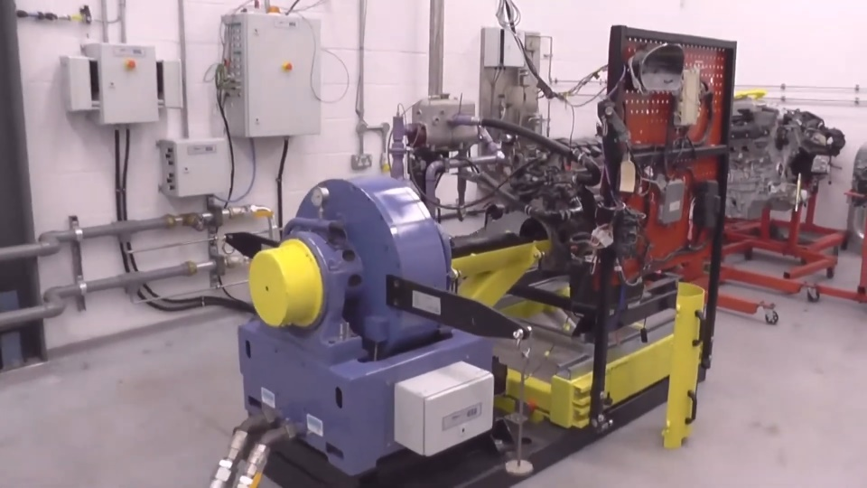

Schenck WS 230 dynamometer
Fig. 1

3.2 Health and Safety
To ensure safety during our investigations, PPE was required, wore steel cap boots were worn in the workshop at all times, to protect from heavy objects falling, and eye protection when handling coolant, fuel and oil, due to the COSHH regulations regarding these as hazardous substances. This also meant food and drinks were forbidden in the workshop to avoid contaminants which could be hazardous to health. A workshop technician oversaw and managed the investigations to ensure we carried out all sections safely and stuck to the workshop rules.

3.3 Data recording
Once the data was logged using the computer to capture the data from sensors at specific RPM, the data could then be exported and curated into more usable graphs as well as using calculations to manipulate the data into new values such as SFC.
The ambient temperature, barometric pressure and relative humidity were all recorded too so that when calculating power after the experiment, these factors were all accounted for by finding a corrected value for power by using the following formula.

$$CF= \frac{ρ_{Std}}{ρ_{Tst}}$$

Where CF is the correction factor
ρStd is the standard air density
ρTst is the air density at the time of the test

(Richard Shelquist, 2023)

3.4 Equations and calculations

$$τ= Ϝ*x$$
Torque (N/m) = Force (N) x Moment distance (m)

$$Ρ= \frac{2π* τ* Ν }{60*1000}$$
Power (kW) = (2Pi x Torque (N/m) x Engine speed (RPM)) / (60 X 1000)

Power (Hp) = Power (kW) x 1.34102209

$$BMEP= \frac{2* τ}{V_{e}}$$
Brake Mean Effective Pressure (kPa) = (2 x Torque (N/m)) / Volume of Engine ($m^{3}$)
$$SFC=\frac{\left(\left(λ* 60\right)*0.75\right)}{P}$$
Specific Fuel Consumption (Kg/ kWh) = (Fuel Flow (L/ min) x 60) x relative density of Gasoline) / Power (kW)
$$OTE= \frac{P}{m*45000}*100$$
Overall Thermal Efficiency (%) = (Power (kW) / Mass Fuel per second (Kg) x Calorific Value for gasoline (Kj/ Kg)) x 100
$$VE= \frac{2*m }{ρ*V_{e}*(\frac{N}{60})}*100$$
Volumetric Efficiency (%) =((2 x Mass air flow (Kg)) / (Density of air (Kg/ $m^{3}$) x Volume of Engine ($m^{3}$) x (Engine Speed (RPM) / 60)) x 100


4.0 Results


Fig. 2



4.3 Graphs
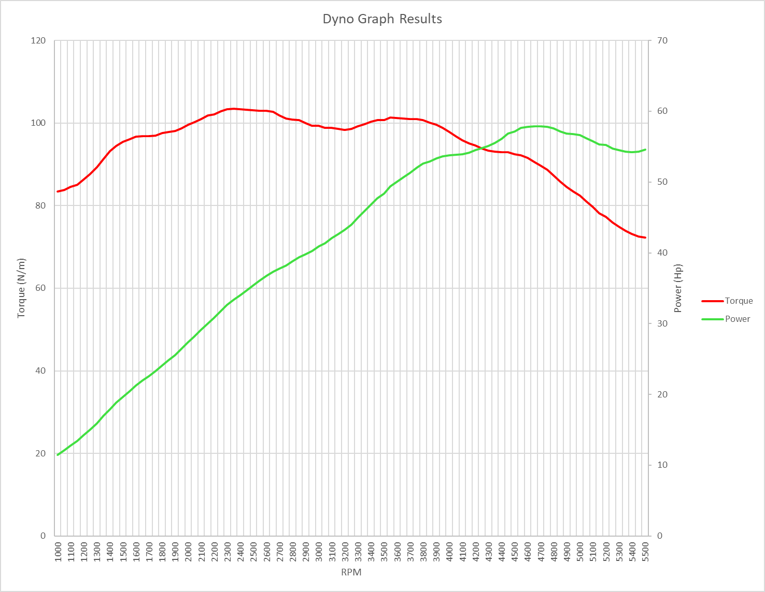
Fig. 3
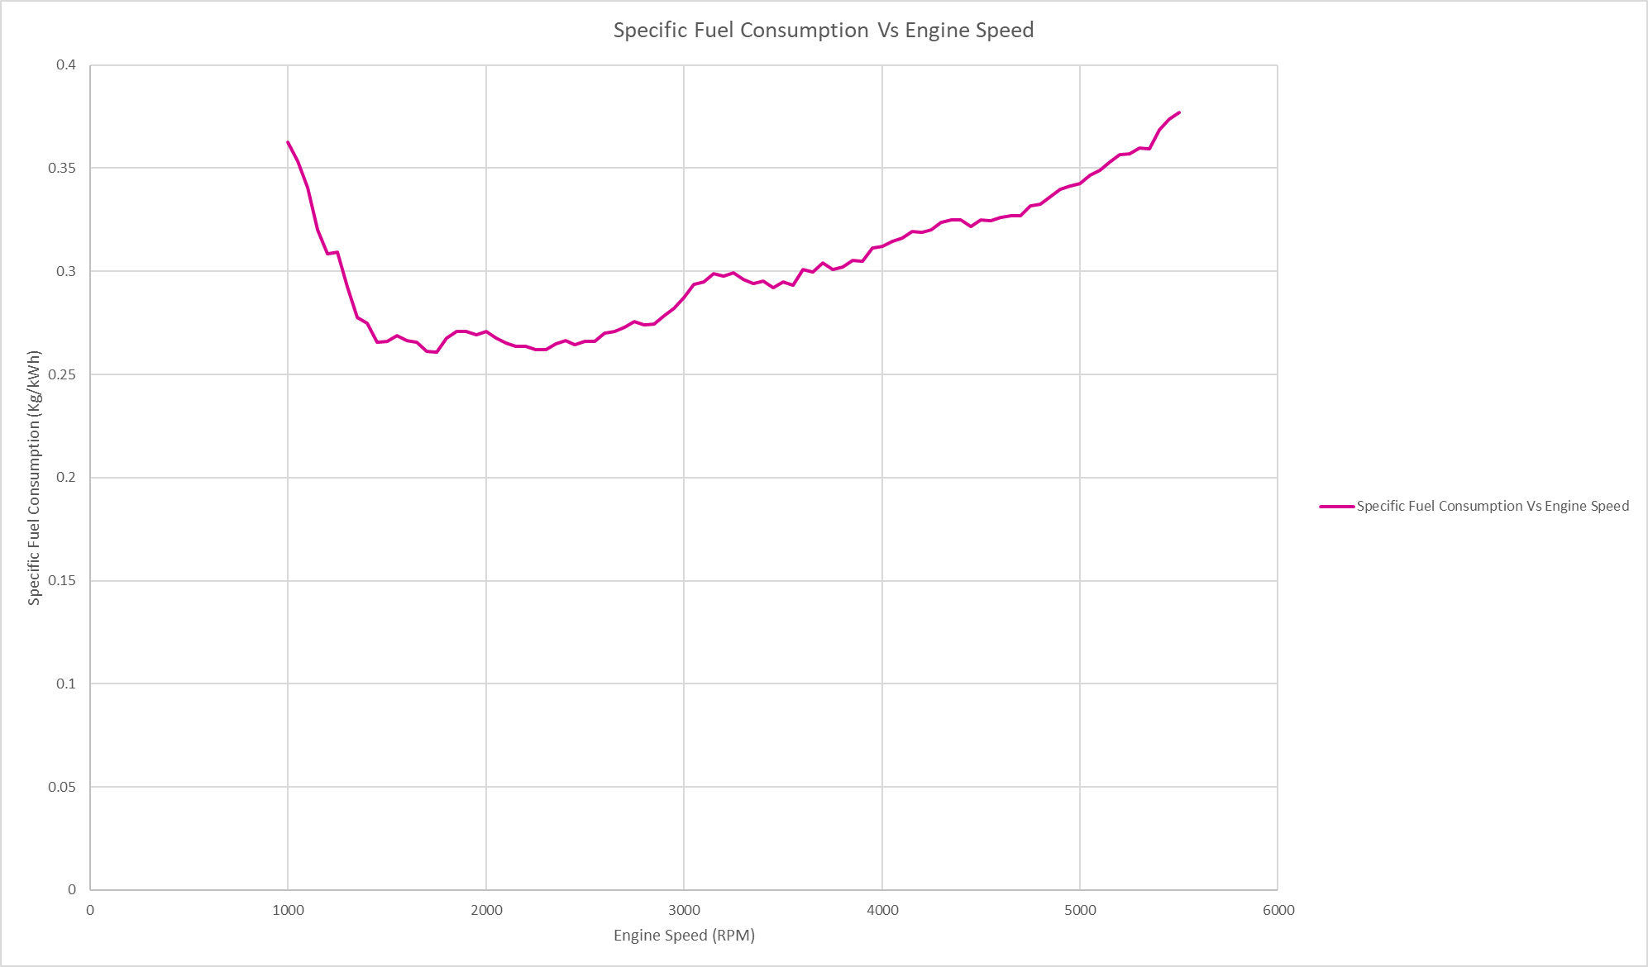

Fig. 4
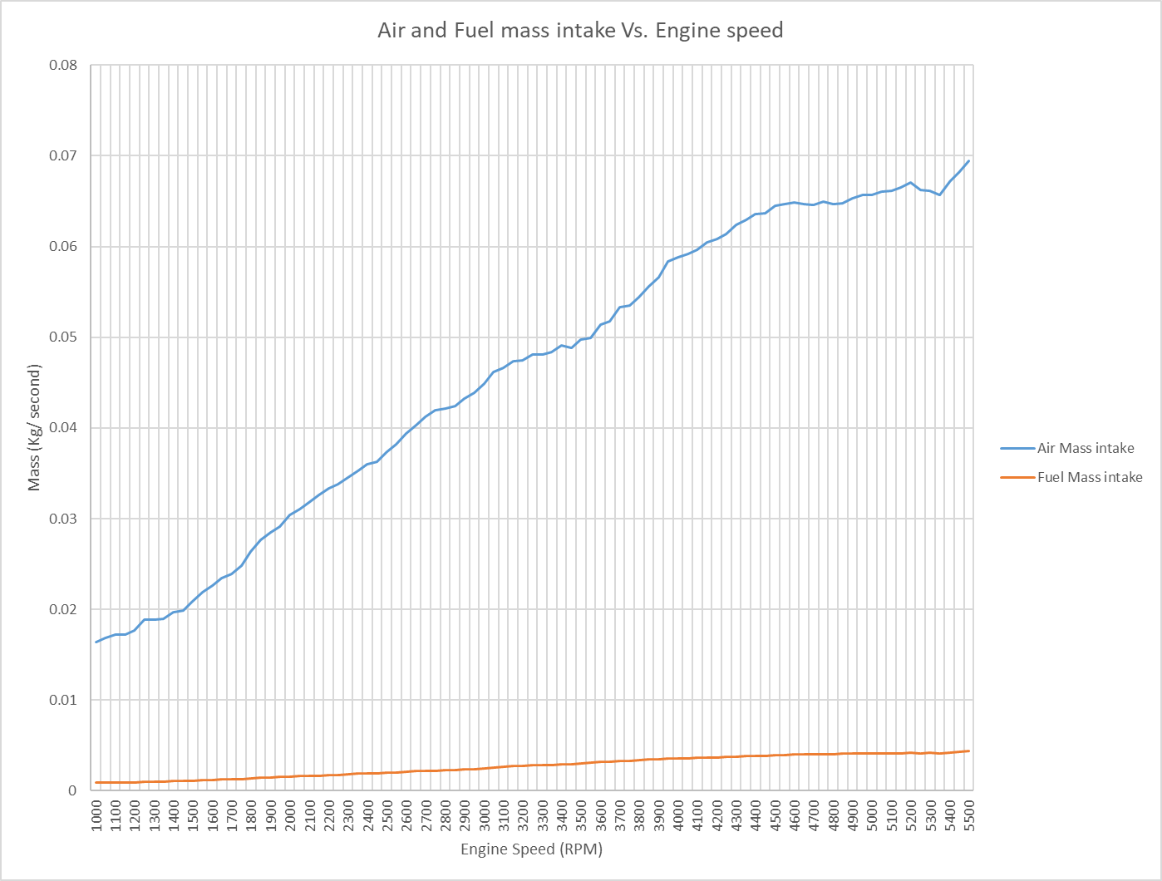

Fig. 5

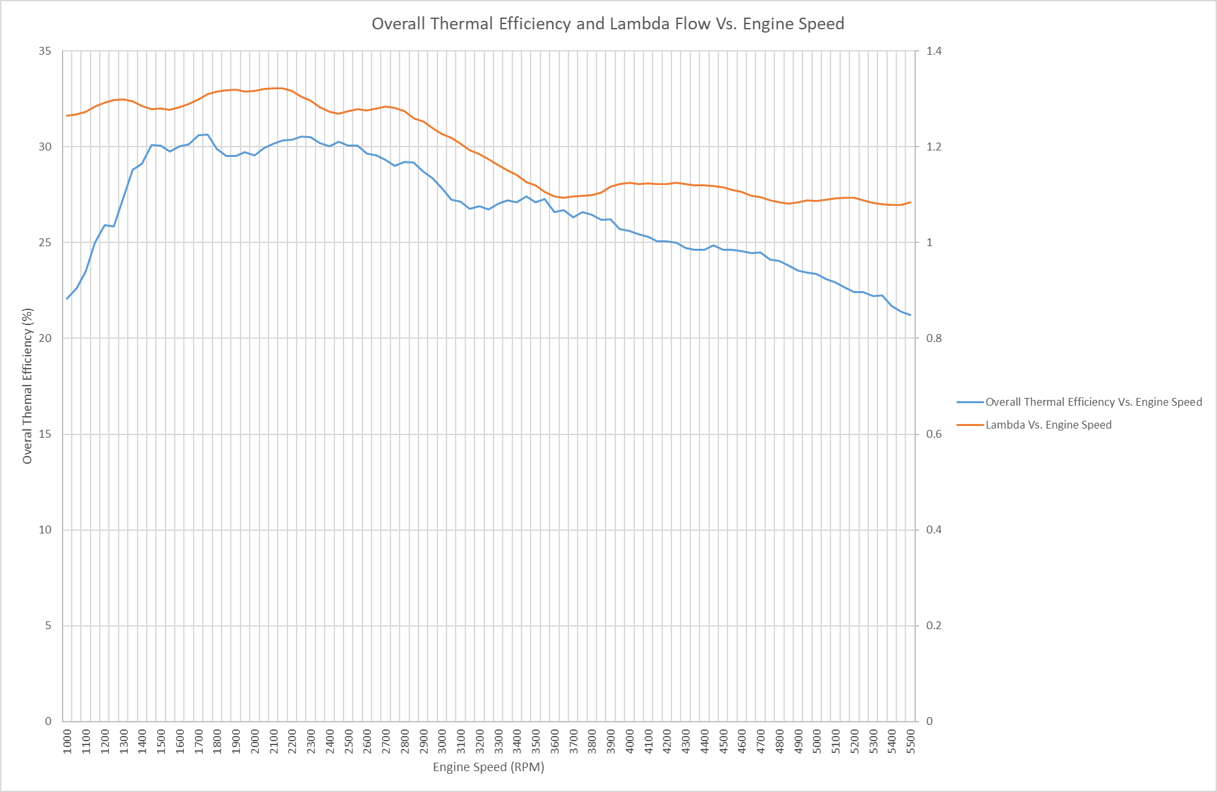
Fig. 6

Fig. 7

Fig. 8

5.0 Analysis

5.1 Graph one: Torque and Power Vs. Engine Speed
In Fig.3 the graph shows the relationship between Torque and Power over an increasing engine speed. The torque follows a relatively steady curve over the rev range, peaking at 2350 RPM at 103.46 N/m and then dropping off at around 4000 RPM. The reason the torque is highest from 2000 until around 4000 RPM and then drops off, is because this is where the engine is receiving the perfect amount of air and fuel into the cylinder, this is called volumetric efficiency (fig. 8)- a measure of how ‘full’ the cylinder is- and when it is at its peak, the engine experiences the most torque. The line representing power however follows an increasing positive correlation to engine speed. Then again around 4000 RPM onward the power begins to plateau and then drop off, peaking at a maximum power of 57.9 horsepower. The power is proportional to torque since power is simply torque times the RPM, therefore the power increases with the RPM but also increases depending on the torque.

5.2 Graph two: SFC Vs. Engine speed
The second graph, fig. 4 models the specific fuel consumption of the engine throughout the rev range, which calculates the mass of fuel consumed per unit power, in this case it is Kg/kWh. What this tells us is that the lower the SFC, the better the engine is converting the chemical energy of fuel into mechanical power. The graph shows that to begin with, the SFC is high, using 0.363 Kg of fuel per Kw over one hour, at around 1000 RPM, the SFC then drops considerably under ‘acceleration’ to a value of 0.261 Kg/kWh at 1750 RPM where it is most efficient. The SFC then slowly increases consistently, becoming less efficient until the end of the test at 5500 RPM with a value of 0.3768 Kg/ kWh showing that as the power and engine speed increase, the fuel consumption increases more, requiring more fuel for each unit of power, due to the increase in frictional forces at high RPM.

5.3 Graph three: Air and Fuel mass intake Vs. engine speed
Fig. 5 shows the relationship between the consumption of fuel and air with engine speed. This graph was made by taking the mass of fuel in kilograms and multiplying it by the ratio of air to fuel to find values for mass of air intake. The ratio was found using the exhaust lambda, which is stochiometric, meaning that we can times the value by 14.7 (stochiometric air: fuel ratio) and see how the ratio of air to fuel fluctuates. For lambda any value above 1 means the engine is running lean (more than 14.7 parts air to 1 part fuel). For this test, the average Air :Fuel ratio over the run was 17.5 : 1, so very lean. As shown, the amount of air consumed in the engine increases at a far larger rate than the fuel, peaking at 5500 RPM where the air consumption Is 0.069 kilograms per second compared to that of fuel which peaks at the same RPM at 0.00463 kilograms per second, this is to be expected as whilst the fuel flow increases, the air flow increases by a ratio of 14.7 (ideally).

5.4 Graph 4: BMEP compared to Torque Vs. Engine Speed
As shown in fig. 6 torque is directly proportional to the Brake Mean Efficient Pressure, this makes sense as BMEP is just the pressure evident in the cylinder at any one point during the rev range, therefore the higher the pressure in the cylinder, the more force is acting on the crankshaft- producing a larger output for torque, which is simply force times by the moment arm. BMEP is also directly proportional to the Volumetric efficiency, since the more air in the cylinder, the higher the pressure during combustion will be (Schweitzer, 1943).This means that engines with forced induction, and therefore higher volumetric efficiency, will also have a higher BMEP and therefore a much larger torque than a n/a engine. With our engine, an optimised flow intake would improve the performance, raising the volumetric efficiency and in turn BMEP and torque. Unfortunately the data doesn’t cover the effective rev range of the V-tec system which, in theory should show an increase in torque and power dramatically, as the increased airflow from a shift in valve timing, enabling the valves to open for longer and let in more air- boosts volumetric efficiency and BMEP.

5.5 Graph 5: Overall Thermal Efficiency and Lambda over engine speed
The thermal efficiency of an engine describes the percentage of chemical energy stored in petrol that is converted successfully into mechanical power to move the piston, energy lost through sound, heat and light all decrease the efficiency of an engine. We can see in fig. 7 that the thermal efficiency and lambda have a strong correlation, and follow a very similar pattern, this shows that when the engine is running the most lean, it is also the most efficient at 30.5% - using more of the calorific energy in the fuel since it is experiencing more complete combustion. Then as the lambda drops and plateaus, the thermal efficiency drops to around 27% then continues dropping until 5500 RPM where it is turning just 21.2% of the calorific energy in the fuel into a measurable mechanical output energy. These values are generally standard for a naturally aspirated engine, where it is limited by the available airflow at high RPM. Diesel engines usually have a slightly higher OTE and with high compression single cylinder engines, a thermal efficiency has been recorded of 45% (Ikeya et al., 2015) whereas the engine used in this test averages at 26.7% efficiency.

5.6 Graph 6: Volumetric efficiency
Finally, fig. 8 expresses the volumetric efficiency, which is the volume of air the engine is fitting into the cylinders compared to the physical volume of the engine. (De Nicolao, Scattolini and Siviero, 1996). Since the engine is 1590cc or 0.00159$m^{3}$ so a volumetric efficiency of 100% means that 0.00159$m^{3}$ of air is drawn into the engine per stroke. At 1000 RPM the value for air flow is likely far too high to be realistic as it brings a value of 103% VE which is not possible at such low engine speeds with a naturally aspirated engine, since there is no ram effect as the air is not moving fast enough. Once we reach the 2000 RPM range, the engine behaves as we would expect, with a value of 95.7% filled cylinder and rising to a maximum of 96.2% at 2700 RPM before gradually decreasing to a minimum of 77.3% at 5350 RPM showing that at high RPM, the valves are opening and closing so quickly that they simply cannot draw in enough air to fill the cylinder before they close again.

6.0 Discussion and Findings
Following the analysis of the data and graphs, the performance of the 1.6 Litre V-tec engine varies throughout the different parameters. Since the data does not extend beyond 5500 RPM, the V-tec system performance cannot be effectively determined or observed, giving us incomplete research on the true performance of the engine. This is one drawback, the other being the fact that the engine was running lean during the test, meaning that we could not extract the full amount of power that should be produced by the D16 engine.
Despite these issues, the dyno run conducted gave an insight into the way in which power, torque and other parameters change and interact during a rev cycle. For example, since the engine tested is from a Honda C-RX, we can see that the engine is tuned for both performance and economy, this is apparent when we see the exhaust lambda showing that the engine is running very lean, meaning the fuel economy is higher and the engine is tuned away from the performance aspects in this instance. This is reinforced by the SFC data showing that operating in the most efficient RPM band can reduce fuel consumption.
In a broader context, the mid-range torque and volumetric efficiency are the main contributors to a strong corner exit acceleration, whilst the drop in VE at higher RPM highlights the limitations of naturally aspirated engines- not being able to take in enough air. The graph for BMEP demonstrates how cylinder pressures correlate directly to the torque, emphasizing the importance of intake design, cam timing, and engine tuning to ensure the correct spark and valve timing to maximize performance.

7.0 Conclusion
The aim of this assignment was to gain an understanding of an engine using an engine dyno, and whilst looking at the data has been very interesting and I have thoroughly enjoyed calculating and exploring the different facets of the performance of an engine, we were not able to conduct the experiment and I think that it was more difficult to apply my knowledge without gaining hands on experience with the engine and dyno. However, I think that I did the best job I could, and I found it has increased my skills on excel to produce the data and graphs required for this assignment

8.0 References
Dahham, R.Y., Wei, H. and Pan, J. (2022) “Improving Thermal Efficiency of Internal Combustion Engines: Recent Progress and Remaining Challenges,” Energies 2022, Vol. 15, Page 6222, 15(17), p. 6222. Available at: https://doi.org/10.3390/en15176222.
Dynamometer: Theory and Application to Engine Testing - Jyotindra S. Killedar - Google Books (no date). Available at: https://books.google.co.uk/books?hl=en&lr=&id=3Yj5AAAAQBAJ&oi=fnd&pg=PA29&dq=engine+dynamometer+tests&ots=TMSwQNobXT&sig=qmLPUCGneT_YSIBki3HRTlqfYIs#v=onepage&q=engine%20dynamometer%20tests&f=false (Accessed: March 18, 2026).
Richard Shelquist (2023) Equations: Dyno Correction Factor and Relative Horsepower. Available at: https://wahiduddin.net/calc/cf.htm (Accessed: March 19, 2026).
Ikeya, K. et al. (2015) “Thermal Efficiency Enhancement of a Gasoline Engine,” SAE International Journal of Engines, 8(4), pp. 1579–1586. Available at: https://doi.org/10.4271/2015-01-1263.
De Nicolao, G., Scattolini, R. and Siviero, C. (1996) “Modelling the volumetric efficiency of ic engines: Parametric, non-parametric and neural techniques,” Control Engineering Practice, 4(10), pp. 1405–1415. Available at: https://doi.org/10.1016/0967-0661(96)00150-5.
PLINT, M.A.. and Martyr, A.J.. (2011) “Engine Testing.” Available at: https://books.google.com/books/about/Engine_Testing.html?id=iBwhkpNlym0C (Accessed: March 18, 2026).
Schweitzer, P.H. (1943) “Excess Air and Brake Mean Effective Pressure,” Journal of Fluids Engineering, 65(3), pp. 159–160. Available at: https://doi.org/10.1115/1.4018716.

