Organisational performance and culture in practice

AC 1.1: Evaluate the advantages and disadvantages of both a divisional structure and a matrix structure. Within the evaluation, you should include the reasons underpinning each structure.

Some organisations operate a divisional structure whereby the business is grouped by product, service or geographic location (Taylor and Woodhams, 2022, p.57) rather than job description to enable them to adapt and tailor their strategies to target specific audiences. For example, McDonalds uses this business model as people have different tastes in the US to what they have in Italy and so they adapt the food they produce according to the location of the division. According to Taylor and Woodhams (2022), this structure allows for each division to have its own management team, a degree of autonomy and its own business functions such as HR, IT and marketing. Miller suggests that this type of structure benefits multinational organisations and those with different products and services (2025).

According to Taylor and Woodhams (2022), the advantages of this structure are that it enables the specialised division to stay ahead of the competition by spotting emerging trends and can react and adapt swiftly. Each division can concentrate on its own area, with clearly defined specialist roles and responsibilities which enables better product development, knowledge and customer service, tailored to the market and customer needs. Furthermore, divisional managers have more autonomy leading to quicker decision making and less reliance on top management.

Some disadvantages are that with every division having its own resources such as HR and IT, this leads to higher and potentially unnecessary costs for the business. Rivalry between divisions can occur instead of each division working cohesively (Miller, 2025) and due its siloed structure, it can be slow to adapt, hindering collaboration and growth (Taylor and Woodhams. 2022, p.56). Divisions may also develop their own processes, leading to inconsistencies across the company in terms of quality and customer service.

Another popular system incorporated by businesses is the matrix structure where an employee reports to at least two managers, one based on their everyday functional role, and another based on a project they are working on. This dual reporting system creates a matrix of authority. According to Chellapa (2024), the concept was established in the 1970’s to assist the complexity of large-scale projects in business and is now widely used in engineering, technology and healthcare sectors. The structure aims to achieve effective collaboration across teams to deliver organisational goals. Within the structure, there are three strengths of matrices:

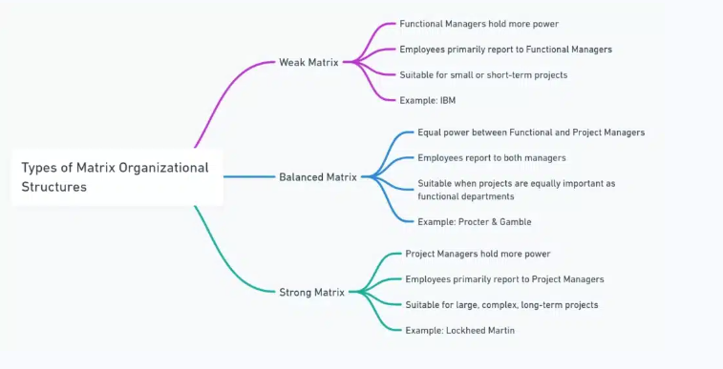
Chellappa (2024).

The advantages of this structure include the collaboration of skill sets working on a project aids the organisation to operate with optimum efficiency, with employees doing their everyday job and delivering the objectives of the project (Taylor and Woodhams. 2022, P. 59). It promotes free flowing information between teams and resource sharing, and it allows employees to develop new skills (Taylor and Woodhams. 2022, P.59).

However, Taylor and Woodhams advise the disadvantages can include confusion as employees face challenges prioritising tasks given by two managers. Management conflict caused by power struggles between the functional and project manager and Increased workload and risk of burnout as employees must juggle multiple projects and their managers objectives simultaneously.

AC 1.2: Analyse the extent to which the organisational strategy in your organisation (or an organisation with which you are familiar) helps to ensure products or services meet customers’ needs.

Strategy exists in every organisation, informing its behaviour and how it adapts to its environment (Peters, 2024). At the EH Group, our objective is to be Wales’s most trusted health and social care provider (The EH Group, 2024) and the strategic goals which have been developed to meet our customers’ needs give us a clear framework for decision making and resource allocation.

The organisation's strategy effectively ensures that its services meet customer needs by focusing on sustainable growth, client satisfaction, and service excellence. Over the years, the organisation has expanded through acquisitions of multiple companies and the Group now employs over 250 staff to support individuals across the county with complex care needs. It prioritises personalised care through individual care plans and regular reviews in line with Social Care Wales regulations. Staff training is a key component, and the Group has established its own training company to ensure staff are well trained, ensuring high-quality care and patient safety.

To attract more clients, the organisation promotes its services through social media, its website, talks at the local college and through collaborations with the local council and health board. By diversifying its services, the organisation can cater to a wider range of conditions and client needs, with specialised care in areas such as learning disabilities, elderly care, and nursing. Future plans involve expanding geographically to reach more clients.

The strategy also focuses on achieving service excellence, with a target of 95% occupancy across residential services. Investments in care homes aim to establish them as the area's best quality care homes. According to Peters, the management, and deployment of people for specific jobs, along with the availability of skills and knowledge, should all influence the business strategy (2024). The organisation supports its workforce by investing in training, recruitment, and retention, aiming to be a leading learning organisation in West Wales.

The alignment of the organisation’s vision with employee performance is crucial, and as Kaplan and Norton suggest, clear communication of the strategy ensures that all teams understand their objectives and contribute to the organisation's overall goals (2005). Through this approach, the organisation continues to expand, secure positive external reviews, and reinvest in both care homes and staff development.

AC 1.3: Analyse the current impact of interest rates, inflation and one other external factor on your organisation (or one with which you are familiar). Identify organisational priorities arising from your analysis.

The Bank of England dictates the UK’s interest rate, the cost of borrowing money, and this currently stands at 4.75% (Harari, 2024). Interest rates fluctuate, affecting both individuals and organisations and an increase in interest rates majorly disrupts businesses as higher costs reduces the amount they can borrow, meaning less disposable income and potential cash flow issues. At the EH Group, higher borrowing costs affect growth as the Group is unable to afford to purchase additional business or properties to house clients. The organisation already has huge outgoings through mortgaged properties, rental units, company car lease agreements and the hire of essential equipment for training and care purposes. Higher interest rates help reduce inflation by lowering demand in the economy, as they make saving more appealing and borrowing less attractive (Bank of England, 2023). Fluctuation and increased interest rates create uncertainty and reduced disposable income for individuals which impacts consumer spending as clients and their families may no longer be able to afford private care, leading to decreased demand for businesses like ours. Ultimately, it results in tighter margins for the business and reduced cash flow which affects investment in L&D, employee salaries, recruitment, acquisition and retention.

Given the impact of increased interest rates, managing cash flow is essential to ensure the business can continue to operate despite higher costs. Continued investment in recruitment and retention are also essential for the Group, as without adequate staffing levels, the business would not be able to support its clients and would be forced to hand back care packages resulting in a loss for the business. Despite fluctuation in interest rates, the business should ensure prices for clients care packages remain competitive as people have less disposable income, and continued demand is essential. Finally, due to higher borrowing costs, the company will need to limit its expansion and focus on the assets it has already acquired.

Inflation is the change in cost of goods, services and supplies over time. It currently stands at 2.5% and the latest figure is published every month (Office for National Statistics, 2025).
Like with interest rates, inflation rises affect individuals and businesses, inflation costs have now overtaken the rise in minimum wage meaning that people have less money and are therefore requesting higher salaries to combat the cost of living. This puts a burden on the business’s payroll. As well as increased staff costs, inflation also affects the costs of essential equipment, medication and staff uniform, and in response the company is forced to increase the costs of its care packages which could deter new clients and potentially cause existing clients to go to another provider, affecting revenue. The Group also work with the council whose pay rates for care packages are determined by their finances and spending pressures (The Health Foundation, 2023) and whose ‘budgets have failed to keep pace with rising costs’ (CQC, 2023). In these cases, passing the increased costs onto the customer is not possible, which further squeezes the margins on the company. Whilst inflation rates depend on external factors such as pandemics and supply vs demand, the UK has seen inflation rates rise consistently over the last few years and with them changing on a month-to-month basis, inflation rates have a long-term impact on business.

Social Care Wales (SCW) sets care standards in Wales, and The EH Group must comply with SCW’s code of practice when making any decisions about employees practice and conduct (Social Care Wales, 2017). Employees are required to register with SCW within their probation or face contract termination. The Group is also regulated by Care Inspectorate Wales (CIW), which influences recruitment, training, health and safety, and client rights. CIW conduct unannounced inspections, and non-compliance can result in fines, service suspension, and reputational damage. Additionally, CIW requires references from all previous care-related jobs during recruitment, which can cause delays and lead to applicants withdrawing for other opportunities.

Given higher living costs and competitive salary pressures, incentivising skilled staff to remain with the Group is essential to avoid losing them to other companies. Competitive analyses will help the Group ensure their wages and benefits can compete. Given the rising inflation rates, the Group cannot afford to receive fines or a bad reputation through non-compliance with Social Care Wales (SCW) or Care Inspectorate Wales (CIW), therefore adherence to recruitment requirements, care standards and professional training must be a continued priority. The Group must balance the requirement to raise prices to cover increased costs without deterring clients and navigate fixed-rate contracts from councils that don’t reflect the rising cost of care.

AC1.4: In February 2024, Peter Cheese, current CEO of CIPD stated, “AI is transforming jobs, careers and workplaces. People professionals have a key role to play in encouraging safe experimentation and rapid learning, so that we can reap the benefits and mitigate the risks.” Assess the extent that AI is, or could be, used in your organisation (or an organisation with which you are familiar) and assess how AI impacts work.

The Labour government has just announced the AI opportunities action plan as part of its plan for change for the UK advising that in the coming years, barely an aspect of our society will remain untouched by AI (GOV, 2025). It is important that The EH Group get on board with AI to stay ahead of industry trends and technological advances and it has already started to invest in AI software to do this. The Group has just subscribed to Otter.ai, an ai powered note taker and transcriber to assist with note taking at interviews and meetings to save HR staff time. AI is also currently used by the HR team to write scripts for meetings and to aid policy writing. In the future, the plan is to extend our use of AI to sift through applications and advise on outcomes of disciplinaries and grievances in line with employment law and our policies.

The advantages of AI include enhanced decision making by analysing large amounts of data quickly and augmented employee capabilities (CIPD, 2025). It can also boost productivity by absorbing routine admin tasks, freeing up people professionals to focus on more important issues. AI is also largely free which helps the business save costs (Boys, 2023). However, integrating AI into the business can be time consuming as it needs to get to know the business and its procedures which requires training. According to the CIPD, AI often gives wrong and inappropriate information, which feeds misinformation and bias (2025). Transcriptions can often be inaccurate which can mean manually documenting every meeting as well which does not save any time and in cases of grievance and disciplinary hearings, incorrect notes could put the company at risk. If feeding meeting notes into AI, the business needs to ensure it has robust measures in place to comply with GDPR regulations and ensure data produced by AI is not biased as this could put the company at risk of a discrimination claim.

As the capabilities of AI advance, so will its efficiency and advantages for HR and business, but there is a risk that its advancement could lead to job losses. At the EH Group, its usage is still in its infancy and there is a lot of trial and error, but the aim is for AI to work for us as People professionals, to ensure ethical practice whilst also embracing technological developments (Waite et al. 2021, p.25) which will improve recruitment, cost reduction, automation of routine admin tasks and making more informed decisions.

AC 2.1: Explain Charles Handy’s model of organisational culture and explain David Rock’s SCARF theory.

The philosopher Charles Handy stated that all organisational cultures were made up of 4 subcultures and it is the influence of these which ultimately determine a business’s culture (Waite et al. 2021, p.28).

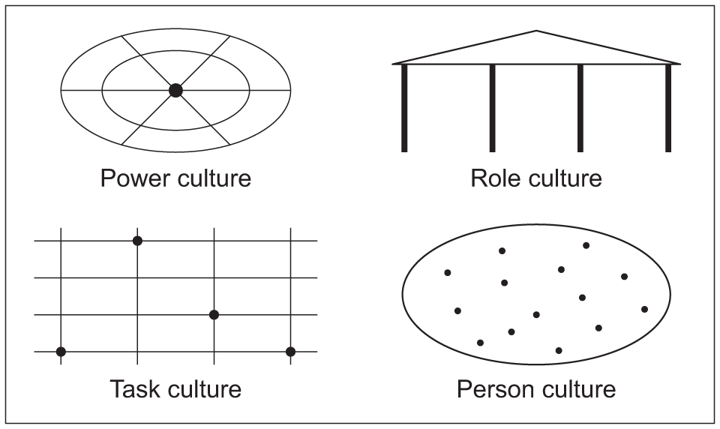
This illustration depicts the 4 types of cultures (AQA, 2025)

Power culture: this culture is presented as a spider’s web as if the spider moves, the entire web shakes. In companies with this culture, the power is held by one person or an elite group

Task culture: a net represents this culture as its focus is on teamwork to resolve problems. Employees are netted together until the task is completed.

Role culture: the Greek temples pillars each represent a key function or department. Employees work to their job descriptions and the structure is hierarchical.

Person culture: depicted as stars in the sky, it’s a culture where employees loyalty to the business is overridden by their own needs.
(Waite et al. 2021, p.28).

Often, aspects of each culture can be found within an organisation, but the one which dominates becomes the business’s identity.

David Rock’s SCARF model is a theory of motivation based on neuroscience to help explain how people behave. It’s based on the concept that different social situations trigger either a reward or threat response in the brain. The model identifies 5 key social domains which can trigger these responses:

Status: where people feel they sit in social hierarchy
Certainty: how well people feel they can predict the future
Autonomy: having choices and feeling able to make them
Relatedness: feeling safe with other people and how trusting they are
Fairness: having fair exchanges with other people
(Rock, 2010)

According to Rock, these domains steer our behaviour continuously and teach us to avoid certain situations that we perceive as threatening and in turn cause us to shut down executive function. Our brains get a reward response from things that make us look good to others and which have increased certainty, so we are drawn to those. The model serves as a framework to understand how to collaborate more effectively with others and successfully engage and influence others.

AC 2.2: Assess how employee selection or employee development impacts organisational culture and behaviour in your organisation (or one with which you are familiar).

Organisational culture is determined by the employees working for it. According to the CIPD, policies alone are not enough for a business to succeed, learning and development, and positive values and behaviours which are shared among all employees, establishes a strong and impactful organisation (CIPD, 2020).

The EH Group promotes its vacancies by highlighting its values, one of which being learning. It believes in investing in employees training to enhance skills and provides internal opportunities for career progression to boost employee morale, increase loyalty to the organisation and increase retention. As well as reducing turnover, employee development has been shown to increase employee motivation and research has shown that increased engagement goes hand in hand with higher performance (Young, 2024).

According to the NHS, it can also improve mental health, enhance collaboration, make people more adaptable to change and ultimately establish a positive and more effective workplace culture (2024). Having established its own training company, The EH Group is committed to continuing to train and upskill its employees and as it expands, will always look to recruit from within, where possible. Managers identify high performers and encourage them to apply for promotions, providing mentorship where needed.

The Group also recognises and rewards hard work with their ‘Employee of the month’ competition, where colleagues vote for a deserving employee each month, writing something positive about them and the person with the highest number of votes wins a gift card and is photographed with a certificate and published on Yammer for people to congratulate. This promotes a positive workplace culture where colleagues praise each other, and the business recognises their hard work and dedication.

AC 2.3: An organisation is planning a change relating to hybrid working. Many employees moved to home working during the Covid-19 pandemic. Whilst this approach worked well at the time, the organisation now wants all employees to work at least two days a week on site. Explain how Kotter’s approach to managing change could be used to successfully implement this change.

When implementing change, an understanding of the people who work for an organisation and the implications that change will have on them is key. According to Tracey, change initiatives often fail because organisations fail to consider employees reactions and emotions and do not communicate the reasons for the change effectively which lead to loss of market position, employee engagement and ultimately result in group resistance (2024). Since the pandemic, employees have become accustomed to remote working and have anxiety about returning to the office to the extent that some say they would quit their job if they had to (Smyrl, 2024). With such a sensitive issue, it is vital that this change is managed carefully, and Kotters 8 step change model could help to implement this change.

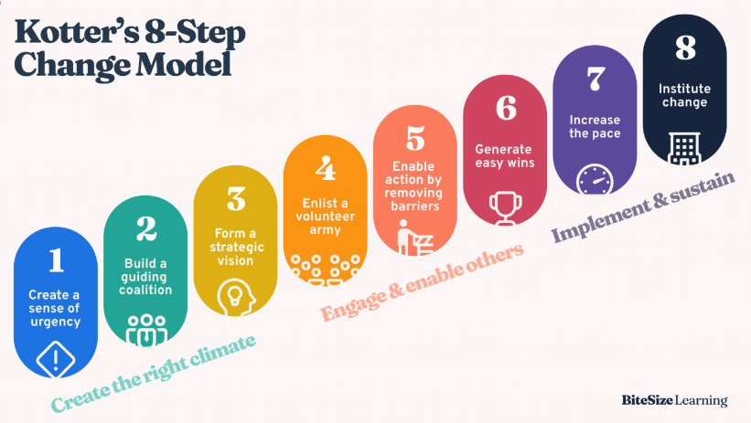

Step 1 is about explaining the change to employees and why it is imperative to do this now and what the consequences could be if it is not. A potential benefit with hybrid working is increased collaboration increasing innovation and productivity. It also enables increased access to support from colleagues which can aid employee wellbeing.

Step 2 advises that organisations group together influential employees from different areas of the business to advocate for hybrid working and advocate for it. People are more likely to buy in if they see more people on board.

Step 3 is about outlining a clear vision of what the new working pattern will look like with collaboration, and work-life balance and clarifying how hybrid work will be implemented.

Step 4 explains the need to communicate the change often and widely across the organisation and encourage questions and feedback for shaping hybrid working policies. The aim is to get people familiar with it and excited about the change.

Step 5 highlights the importance of removing any obstacles in achieving the transition such as outdated policies, lack of resources or reluctant employees.

Step 6 is about celebrating all wins relating to the transition, no matter how small they are, to keep momentum and keep motivation levels high.

Step 7 as employees start returning to the office, it is important to keep momentum by checking in with employees and providing ongoing support.

Step 8 explains the importance of ensuring the change is embedded in the culture so that overtime the hybrid working model becomes an established norm. It’s important to reflect and highlight to employees the correlation between hybrid working and the organisations success.

(Bitesize Learning, 2024)

AC 2.4: Using the Kubler-Ross change curve, discuss how change is experienced.
The way in which an employee reacts to organisational change can vary and depends on things like upbringing and their outlook on life (Waite et al. 2021, p.40), however according to the Kubler-Ross change curve framework, there are 5 recognised stages of emotional response to change which are: Denial, Anger, Bargaining, Depression and Acceptance (Waite et al. 2021, p.39).
The framework is based on Elisabeth Kubler-Ross five stages of grief, and it can be used to help organisations understand how employees respond to change and how to support them.

Denial: When a change is first implemented, employees might be shocked, question why it is needed and deny that it will ever happen, leading to resistance (Roberts, 2024). The organisation should respond by clearly explaining the reason for the change and what impact it will have on the employee. This helps to alleviate confusion and provides clarification.

Anger: Employees may feel angry about the change which is being implemented and express frustration that they are not being considered. The business can de-escalate this by listening to their concerns and offering support.

Bargaining: To regain control of the situation, employees may try and negotiate terms of the change to minimise its impact on them (Roberts, 2024). The business should embrace feedback and involvement with decision making to ensure employees feel considered and can add valuable contribution.

Depression: According to Roberts, as reality of the change sets in, employees may feel a sense of loss or sadness that things will never be as they were before. They may also be anxious about the future. The business will need to reassure employees about the benefits of the change and provide emotional support.

Acceptance: Once employees have gone through the emotional stages, they will start to accept the change and adapt. It is important that the business continues to reassure employees of the benefits of the change and help them transition successfully by providing training and feedback where necessary.

The model equips managers with the knowledge of what potential behaviour to expect when implementing changes so they can develop the tools to respond and reassure employees. However, people can be unpredictable and not always adhere to the curve which could lead individual circumstances being overlooked. The model also assumes that employees will ultimately accept the change, which could lead to managers not fully explaining the changes or proving adequate support. The model also fails to provide practical guidance on how to support employees through each stage (Roberts, 2024).

AC 2.5: The CIPD’s Health and wellbeing at work survey 2023 found the percentage of organisations that have a standalone wellbeing strategy has risen from 40% in 2018 to 53% in 2023. Although the percentage has increased, this means that 47% of organisations do not have a standalone wellbeing strategy. Assess the importance of wellbeing at work and assess how good work could impact wellbeing.

Wellbeing at work is essential for both the business and the employees working for it to ensure a positive and productive work environment. According to Suff, wellbeing is a catalyst of employee engagement and organisational performance (2024). Investing in employee wellbeing benefits the employee’s health and happiness which reduces stress and burnout, resulting in better mental and physical health and a reduction in sickness absence and turnover. This saves the organisation money and time carrying out absence meetings, paying for occupational health reports and having to find cover for shifts or recruit more staff and it also produces increased productivity as healthy and happy people are more likely to be focused and motivated delivering better outcomes. If employees know that their employer cares about their health, they are going to feel more positively about their working environment which leads to more motivated, collaborative and positive teams and greater business reputation.

The CIPD Good Work Index is an annual measure of job quality across the UK. The data captured focuses on the following 7 aspects of work to establish what good work looks like: Pay and benefits, Contracts, Work–life balance, Job design and the nature of work, Relationships at work, Employee voice and Health and wellbeing (CIPD, 2024). These key elements of work play a huge role in how employees feel about their work, how happy they are and overall job satisfaction. Employers can use the good work index as a benchmark to identify areas for improvement and in turn support their employee’s wellbeing and create a healthier work environment. Good work focuses on fair and transparent pay and reward, autonomy with involvement in decision making, job security, healthy work life balance, fair treatment and access to opportunities and supportive and constructive line management (CIPD, 2024), leading to healthier, fairer, more supportive and in turn more productive workplaces.

Wellbeing and good work benefit both employees and employers. For employees, it improves health, job satisfaction, and growth. For organisations, it boosts productivity, reduces turnover, and strengthens company culture.

AC 3.1: Provide a brief overview of the employee lifecycle and discuss people practice roles at the recruitment, development and separation stages of the lifecycle.

The employee lifecycle represents the 6 stages an employee goes through during their time within an organisation which are:

Attraction (finding employees)
Recruitment and selection (selecting employees)
Onboarding (inducting employees)
Development (training employees)
Retention (keeping employees)
Separation (losing employees)

(Waite et al. 2021, p.94).

During the recruitment stage, people professionals are responsible for identifying the role requirements by working with managers to define the job description, required skills and qualifications. This ensures the position is accurately presented and expectations are clear. HR then create job postings which may include social media campaigns and recruitment events to attract top talent and a wide range of candidates (CIPD, 2024). Following this, they review applications, potentially telephone screen applicants and shortlist candidates for interview. Interviews are scheduled taking account of any necessary amendments for neurodivergent applicants and carried out by managers with HR professionals to ensure legal and ethical compliance and avoid discrimination or bias (CIPD, 2024). Following the interview, HR assist managers to score the candidates answers using a scoring matrix and ensuring a fair process to confirm whether to offer or reject. Job offers may lead to salary and benefits negotiation and following this, the onboarding process commences.

People professionals play a key role during the development stage by identifying both organisational and individual training needs and skills gaps. Working alongside managers, they then design and implement training plans to upskill and develop staff, making employees more productive and increasing company output (Waite et al. 2021, p.100). People professionals also assist managers with performance management which helps employees, and their managers clarify their strengths and weaknesses and identify high performers who could progress into leadership roles within the organisation.

At the final stage of the lifecycle is separation which could have occurred due to dismissal, retirement, redundancy or resignation. People professionals are critical to ensure a smooth transition and manage the exit process. They will process the resignation, ensuring notice periods are adhered to and carry out exit interviews with the employee, identifying reasons for the termination and improvements for the future to aid retention. They will also provide emotional support to the employee during this time and ensure all legal compliance is adhered to including final pay or severance and confidentiality agreements. People professionals will ensure that the employee is removed from the appropriate systems but their information in kept on file in line with GDPR regulations for 6 years.

AC 3.2: Analyse how people practice supports organisational strategy through vertical integration and how people practice supports wider people strategies through horizontal integration.

According to the CIPD, strategic Human Resources Management or SHRM refers to the formal framework which connects HR strategy to a business’s overall strategy, connecting practices and policies to business goals and objectives (Taylor and Woodhams. 2022, P.53). This alignment fosters a strong link between the organisation’s goals and how it manages its workforce through areas such as recruitment, training and performance management.

SHRM has two types of integrations: vertical and horizontal. Vertical fit aligns HR policies with the organisations strategy, while horizontal fit ensures consistency across HR policies and practices (Kabir, 2021).

Vertical integration operates a top-down approach where business strategy is conceived at top management level and then given to HR to implement through policies and practices to help drive the business strategy forward. Within a care company such as The EH Group, whose objective is to provide high quality care, HR will align its practices with that goal through targeted recruitment for qualified and compassionate people, design training programmes to equip employees with the relevant skills and set high quality care performance targets to ensure every aspect of HR practice supports the organisations vision.

Horizontal integration focuses on consistency across HR practices and policies within an organisation, ensuring they align with each other to support the wider people strategy and foster a positive organisational culture. According to Peters, HR practices need to fit together and operate within a strategic framework which incorporates both employee and organisational issues. People practices must also take into consideration employee engagement and motivation to support organisational performance (2024). People practice supports people strategy through positive recruitment and onboarding, ensuring candidates match the values of an organisation and the onboarding process outlines the company culture and expectations. People practice also employs horizontal integration to ensure that the needs of both its people and the business are met (Taylor and Woodhams. 2022, P.53). HR practices implement employee wellbeing and benefits strategies to ensure employees feel valued, supporting the retention of skilled people who support the organisations vision.

AC 3.3: An organisation is planning to introduce a four-day working week. Discuss the processes the people function could use to consult and engage with managers and employees to understand their needs when moving from a five-day to four-day working week.
When transitioning from a five-day to a four-day workweek, clear and transparent reasoning for the change and how it will benefit both the organisation, and its employees is vital. HR will need to consider the employees who will be impacted and what resistance it might be met with (Waite et al. 2021, p.37). It is vital that HR consult with both managers and employees to understand their needs and concerns, ensuring a smooth transition and maximising the change's positive impact and ultimate success.
A key to successful change is employee voice and one way to consult with employees and managers is through surveys and polls to gather feedback on the proposal of a 4-day week, how this will impact work-life balance and capture any concerns about potential workload management. According to Acas, employees are more likely to support change if they have been able to give their views on it (2025). The surveys can also provide information on how managers feel about team dynamics and operational capability. The feedback from the survey can then be implemented for strategic decision-making and HR should inform employees of how the feedback provided in the survey will be incorporated into the process.
One to one consultation may not be possible in large organisations, so instead consultations with managers should be held, to understand what the practical implications of a 4-day working week will have on operations and the employees in their teams. People practitioners will be able to gage any potential team specific challenges. According to Tracey, transformative change is often reached through negotiation (2024), and HR should be open to feedback and amendments such as shifts adjustments or changes to priorities to get managers onboard and reach a solution. The managers can then feed this back to their teams, providing re-assurance where concerns have been raised, building trust and championing the initiative.
Throughout the process, consistent communication is key, and people professionals should provide regular updates to both employees and managers with updates on the transition, such as timeframes and expectations. People practitioners should advertise an open-door policy for ongoing feedback and any concerns, ensuring that all concerns are addressed promptly. Through consultation, HR and the business will have a better understanding of its employees’ views on the 4-day working week and be able to address any anxieties and overcome potential barriers. This transparency will provide re-assurance, build trust and ultimately aid the transition and success of the transition.

Word count = 4, 969

References

Acas (2025) Changing your employees contracts consulting. Available at: https://www.acas.org.uk/changing-an-employment-contract/employer-responsibilities/consulting-about-employment-contract-changes#:~:text=Consultation%20is%20when%20you%20talk,feedback%20on%20the%20proposed%20changes (Accessed: 01 February 2025).

Bank of England (2023) Financial Stability in Focus: Interest rate risk in the economy and financial system. Available at: https://www.bankofengland.co.uk/financial-stability-in-focus/2023/july-2023 (Accessed: 12 January 2025).

Boccarini, G (2023) Adult social care funding pressures. Available at: https://www.health.org.uk/reports-and-analysis/analysis/adult-social-care-funding-pressures (Accessed: 12 January 2025).

Boys, J (2023) Could AI solve skills shortages? Available at: https://www.cipd.org/uk/views-and-insights/thought-leadership/cipd-voice/skills-shortages/ (Accessed: 01 February 2025).

Care Quality Commission (2023) Combination of cost-of-living crisis and workforce pressures risks ‘unfair care’ – longer waits, reduced access and poorer outcomes for some. Available at: https://www.cqc.org.uk/press-release/combination-cost-living-crisis-and-workforce-pressures-risks-unfair-care-longer-waits (Accessed: 12 January 2025).

Chellappa, S. (2024) What is a Matrix Organization? Structure, Benefits, and Challenges Explained. Available at: https://engagedly.com/blog/matrix-organizational-structure-meaning-types-and-benefits/ (Accessed: 11 January 2025).

CIPD (2025) Automation, AI and technology. Available at: https://www.cipd.org/uk/views-and-insights/cipd-viewpoint/automation-ai-technology/ (Accessed: 01 February 2025).

CIPD (2024) CIPD Good Work Index. Available at: https://www.cipd.org/uk/knowledge/reports/goodwork/ (Accessed: 26 January 2025).

CIPD (2020) People Profession 2030: the role of organisational culture in future workplace trends. Available at: https://www.cipd.org/uk/the-people-profession/the-future/role-organisational-culture-future-workplace-trends/ (Accessed: 18 January 2025).

Harari, D. (2024) Interest rates and monetary policy: Economic indicators. Available at: https://commonslibrary.parliament.uk/research-briefings/sn02802/#:~:text=UK%20(Bank%20of%20England),quarter%20of%202025%20before%20easing. (Accessed: 12 January 2025).

Kabir, A.I., 2021. Strategic human resource management, human capital management, and talent management: same goals, many routes. [pdf] Available at: https://www.researchgate.net/publication/357393177_STRATEGIC_HUMAN_RESOURCE_MANAGEMENT_HUMAN_CAPITAL_MANAGEMENT_AND_TALENT_MANAGEMENT_SAME_GOALS_MANY_ROUTES (Accessed: 01 February 2025).

Kaplan, RS and Norton, DP. (2005) The Office of Strategy Management. Available at: https://hbr.org/2005/10/the-office-of-strategy-management (Accessed: 12 January 2025).

Miller, V. (2025) Organisational Structures. Available at: https://cpdonline.co.uk/knowledge-base/business/organisational-structures/ (Accessed 01 February 2025).

Office for National Statistics (no date) Consumer price inflation time series: D7G7. Available at: https://www.ons.gov.uk/economy/inflationandpriceindices/timeseries/d7g7/mm23 (Accessed: 12 January 2025).

Peters, R. (2024) Strategic Human Resources Management. Available at: https://www.cipd.org/uk/knowledge/factsheets/strategic-hrm-factsheet/ (Accessed: 01 February 2025).

Peters, R. (2024) What is a Matrix Organization? Structure, Benefits, and Challenges Explained. Available at: https://engagedly.com/blog/matrix-organizational-structure-meaning-types-and-benefits/ (Accessed: 11 January 2025).

Public Health Wales (no date) Employee development and progression. Available at: https://phw.nhs.wales/services-and-teams/healthy-working-wales/workplace-guidance/healthy-work-environments/employee-development-and-progression/ (Accessed: 19 January 2025).

Smyrl, N. (2024) How to encourage reluctant employees back to the office. Available at: https://www.peoplemanagement.co.uk/article/1884751/encourage-reluctant-employees-back-office (Accessed: 19 January 2025).

Social Care Wales (2017) Code of Professional Practice for Social Care. Available at: https://socialcare.wales/cms-assets/documents/Code-of-Professional-Practice-for-Social-Care-web-version.pdf (Accessed: 19 January 2025).

Suff, R. (2024) Wellbeing at work. Available at: https://www.cipd.org/uk/knowledge/factsheets/well-being-factsheet/ (Accessed: 26 January 2025).

Taylor, S. and Woodhams, C (2022) Studying Human Resource Management. 3rd edn. London, England; New York, New York: CIPD - Kogan Page.

The EH Group. (2024) EH Group Strategy Presentation. Unpublished Internal Company Document.

Tracey, H. (2024) Change management: A guide for people professionals. Available at: https://www.cipd.org/uk/knowledge/guides/change-management/#models-for-change (Accessed: 25 January 2025).

Tracey, H. (2024) Change management. Available at: https://www.cipd.org/uk/knowledge/factsheets/change-management-factsheet/ (Accessed: 19 January 2025).

Waite, K. et al. (2021) People Practice a Complete Guide. London: Kogan Page Limited.

Young, J. (2024) Employee engagement and motivation. Available at: https://www.cipd.org/uk/knowledge/factsheets/engagement-factsheet/ (Accessed: 18 January 2025).

Youtube (2010) David Rock on the SCARF Model. Available at: https://www.youtube.com/watch?v=5Wu33SdjeCs (Accessed: 18 January 2025).

