Name: Rifaat Malik
Student ID: 2524846
Module Code: LCHS4003
Module: Introduction to Health and Social Care
Lecturer: Vivian Osuchukwu


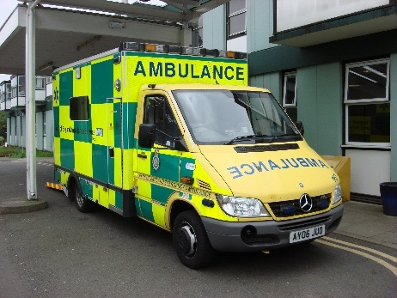

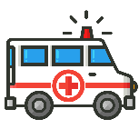
Quick facts:
(NHS England, 2017)
999
How this service works now

North East Ambulance Service, (n.d) describes how the process begins when someone calls 999.
- Call handlers in the Ambulance Control Room ask questions based on the nature of emergency and where the patient is.
- They use a special system to decide how serious the situation is and how quickly help is needed.
- Calls are put in various categories, some are life-threatening and need an answer within minutes, while others can wait a little longer.
- Depending on what is needed, they might send a full ambulance, a fast-responding car that can get through traffic quickly, or sometimes they give advice over the phone.
- Ambulance crews assess and treat patients at the scene, reducing the need for hospital visits.

AMBULANCE SERVICES
What are ambulance services?

According to NHS England, (2024), Ambulance services offer urgent emergency medical care and transport for ill and injured people. Their main goal is to make sure that every patient gets the best and most suitable help as quickly as possible.

Ambulance services work closely with hospitals, GPs, Police, Fire services and mental health teams to provide coordinated care. Modern technology such as communication systems and medical equipment helps crews respond quickly and safely to emergencies. This reduces waiting times and improves the overall quality of care.

In 2017, the NHS brought the new standards to ensure that the right type of response is sent to each emergency. NHS England, (2017) This helps to prioritise patients who are most seriously ill or injured, meaning they receive care based on their specific needs.

(Gov.UK, n.d) states that:
- Average response times vary depending on the urgency of the incident.
- Modern ambulances function as mobile treatment units, not just transporting vehicles.
- GPS technology helps crews reach patients quickly.

Service statistics: NHS Ambulance services in England receive around 13 million calls each year, including approximately 11 million emergency 999 calls, highlighting the high demand for emergency care (Association of Ambulance chiefs, 2024)
(GOV.UK, n.d) AVERAGE RESPONSE TIMES ARE USUALLY UNDER 8 MINUTES FOR EMERGENCIES.
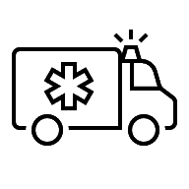

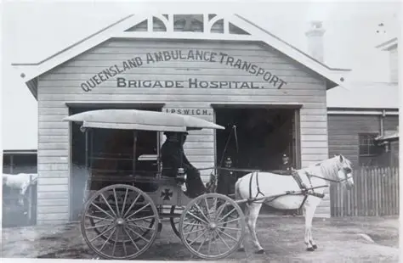
Ambulance Services work closely with a range of partners to ensure best care and practice.

Who they work with (Association of Ambulance chiefs, 2024)
- Police and fire services to keep everyone safe.
- Doctors and Nurses- inside hospitals to hand over care
- Mental health teams to support people who need emotional help.
Challenges faced by the service (Association of Ambulance chiefs, 2024)
- High demand: the service receives millions of calls each year which means crews are often very busy and under pressure to reach everyone quickly.
- Lack of resources: Sometimes there might not be enough ambulances, vehicles or equipment available when they are needed most.

Historical photo, (n.d)
Brief History
Frontiers in Disaster and Emergency medicine (2024), outlines how Ambulance services began hundreds of years ago to help wounded soldiers on battlefields. In the late 1700s, a French surgeon named Dominique-Jean Larrey created the ‘flying ambulance’ special horse-drawn wagons designed to reach people quickly.
In the 19th century, services started for ordinary people in towns and cities. They used carriages and trains.
At the start of the 20th century, motor cars replaced horses. Over time, the services changed from moving patients to giving medical treatment at the scene, leading to the trained paramedics we have today.

Did you know?
- Ambulance services operate around the clock, every single day of the year.
- Staff go through intense training to deal with all kinds of emergencies.
- Paramedics can give life-saving treatment before patients reach hospital.
- Some ambulance staff specialise in mental health emergencies.
(NHS, England, 2017)

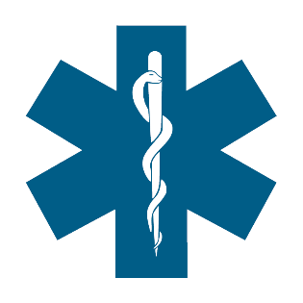
Overall, ambulance services are an important part of healthcare, providing emergency care and supporting patients when they need it most. Despite ongoing challenges, they continue to play a significant role in saving lives and improving patient outcomes.

Symbol of Ambulance Services
Community Mental Health Services: Development, Current Practice and Importance

Introduction
Community mental health services support people with mental health conditions within their local communities, promoting recovery, independence, and social inclusion. Despite challenges such as limited funding and unequal access, these services remain essential. This essay explores their development, current practice and importance.

Origins and Historical Development

Historically, people with mental health conditions were usually cared for in large psychiatric hospitals or asylums. However, concerns emerged regarding the conditions within these facilities and the limited availability of appropriate treatment. Many of these hospitals became overcrowded and failed to meet the complex needs of individuals effectively. Over time, mental health care shifted towards community-based support. Nelson, Kloos and Ornelas, (2014) explain that this change was important because it recognised that an individual’s living environment, relationships and community networks play a key role in recovery. This approach promotes social inclusion and supports individuals in maintaining meaningful roles within society.

The Mental Health Act (1983) has had a major influence on the development of mental health services in the UK. It provides a legal framework for the assessment and treatment of individuals with mental health conditions while protecting their rights. Recent reforms to mental health legislation aim to improve patient choice, independence and person-centred care Mental Health Act (2025). This approach fosters inclusion and supports quality of life.

How Services Function Today

Today, community mental health teams operate in various settings, including health care centres, community clinics and people's own homes. The main aim is to provide person-centred care that meets needs of each individual. Their role includes assessment, managing medication, psychological therapies and practical support with issues such as housing and employment (Northamptonshire Healthcare NHS Foundation Trust, 2025).

Community Mental Health Teams are multi-disciplinary teams made up of professionals such as, doctors, nurses and social workers who work together to provide coordinated care. There are also specialist teams such as Crisis Teams, which provide rapid support when an individual’s mental health deteriorates Northamptonshire Healthcare NHS Foundation Trust, (2025). For example, a person living with schizophrenia may receive support from a Community Mental Health Team through regular home visits, medication reviews, and psychological support. This helps the individual manage their condition while continuing to live independently within their community.

Services must be able to respond promptly during periods of crisis or mental health emergencies to ensure individuals can access the appropriate support. However, increasing demand for mental health services and workforce shortages can sometimes make it difficult to provide timely support to everyone who needs it. They work closely with GPs and other organisations to make sure the support is joined up properly. This enables people to access support within their local community (NHS England, 2019).

Significance for Quality of Life

Community mental health services play a key role in improving quality of life. By supporting people in their own communities, they help maintain independence and stay connected with family and friends (WHO, 2021). This can reduce social isolation and support recovery by improving emotional well-being and self-esteem. For instance, an individual experiencing severe anxiety may receive cognitive behavioural therapy (CBT) through community mental health services, helping them develop coping strategies, to return to work, and maintain social relationships.
According to the World Health Organization, (2021) community care helps people feel respected and gives them hope for the future. It allows people to take control of their own health and well-being, which leads to better outcomes. This shows that when people feel supported, they are able to live a good life and feel part of their community.

Conclusion

To sum up, community mental health services have developed significantly over time, moving from large hospitals to person-centred support, within local communities. By promoting independence, recovery and social inclusion, these services help individuals manage their mental health effectively. Overall, community mental health services play an important role in improving quality of life, enhancing overall well-being through multidisciplinary support.

References:

Association of Ambulance Chiefs (2024) Ambulance Services Annual Report. Available at: AACE: Association of Ambulance Chief Executives (Accessed: 31st May 2026).

Frontiers in Disaster and Emergency Medicine (2024) 'Scoop and treat: from an historical controversy to the emergency future'. Frontiers Journal. Available at: Frontiers | Scoop and treat: from an historical controversy to the emergency future (Accessed: 30th May 2026).

GOV.UK (n.d.) NHS England Ambulance Response Programme. Available at: Emergency response and recovery - GOV.UK (Accessed: 1st June 2026).

Historical photograph (n.d) Available at: historical photo of ambulance - Search Images (Accessed 2nd June 2026).

Nelson, G., Kloos, B. and Ornelas, J. (eds) (2014) Community Psychology and Community Mental Health. Oxford: Oxford University Press. Available at: Community Psychology and Community Mental Health: Towards Transformative Change | Oxford Academic (Accessed 29th May).

NHS Ambulance (2017) Photograph. Available at: nhs ambulance service - Search Images (Accessed: 30th May 2026).

NHS England (2017) Ambulance Services are at the heart of the urgent and emergency care system. Available at: NHS England » Ambulance
(Accessed on 6th June 2026).

NHS England (2024) New ambulance service standards announced. Available at: NHS England (Accessed: 30th May 2026).

NHS England (2019) NHS Mental Health Implementation Plan. 2019/20-3023/24. Available at: NHS England » NHS Mental Health Implementation Plan 2019/20 – 2023/24 (Accessed on 13th June 2026).

North East Ambulance Service NHS Foundation Trust (n.d) 999 Services. Available at: Home: North Eas t Ambulance Service (Accessed: 2nd June 2026).

Northamptonshire Healthcare NHS Foundation Trust (n,d) Community mental health teams. Available at: Home | NHFT (Accessed on 13th June 2026).

UK Government (1983) Mental Health Act (1983) c. 20. Available at: Mental Health Act 1983 (Accessed: 3rd June 2026).

UK Parliament (2025) Mental Health Act (2025) c. 33. Available at: Mental Health Act 2025 (Accessed: 3rd June 2026).

World Health Organization (2021) Community mental health centres: Promoting person-centred and rights-based approaches. Geneva: WHO Press. Available at Mental health (Accessed 3rd June).

