Chinese Traditional Cultural Design Based on Cultural Gene Theory
Abstract
In the context of globalization, economic globalization has led to a corresponding globalization in the realm of culture. However, it is important to note that despite the progress made in the process of globalization, the field of design has witnessed a counter-trend, where designers are increasingly focusing on local cultures for inspiration. One significant challenge faced by this design paradigm is the superficial utilization of culture in design. This issue can be attributed to the absence of a comprehensive cultural design methodology, model, and process. Particularly when confronted with diverse traditional cultures, designers struggle to draw from their prior experiences, extract cultural elements, and incorporate them into their designs.
The theory of cultural gene offers a fresh perspective and methodology to address this problem, providing valuable guidance and inspiration for design. Design serves as a crucial conduit and expression of cultural gene inheritance and innovation. By integrating the cultural gene theory with the double diamond model, a double-cycle model of cultural gene-design is formulated to facilitate the profound integration of cultural gene extraction and translation with design thinking. Furthermore, this text explores the significance of combining cultural gene theory with design thinking through notable examples of Chinese traditional cultural designs. By analyzing the strengths and weaknesses of these design cases, suggestions for designing with traditional culture are presented.
Introduction
It has been noticed that, in reaction to globalisation, an opposite trend is emerging within design, which promotes local identity and highlights cultural values and traditions (Moalosi & Hickling-Hudson, 2007). The emergence of phenomena in design that are different from globalisation is not really anti-globalisation, but rather a process of conveying cultural appeal through the world of design. The use of local culture, especially traditional culture, in design can increase the connotation and aesthetics of the design, and at the same time make the design more unique and distinctive.Therefore, designers are encouraged to cultivate cultural diversity through localisation of products in the face of globalisation. Consideration of cultural factors may prepare the way for diversification of design concepts (Moalosi & Hickling-Hudson, 2007).
Traditional culture is the cultural essence accumulated and inherited by a nation or country for a long time, with deep historical heritage and unique cultural charm. Integrating traditional cultural elements into the design can make the design more culturally rich and artistically beautiful, and at the same time can make the design more in line with local people's aesthetic habits and cultural background.
Issues
One of the major problems facing such a design status quo is the superficial use of culture in design, which is cultural appropriation. Misrepresentation of a culture through appropriation can have ‘corrosive effects on the integrity of the exploited culture’ as ‘the appropriative conduct can erroneously depict the heritage from which is drawn’Misrepresentation of a culture through appropriation can have ‘corrosive effects on the integrity of the exploited culture’ as ‘the appropriative conduct can erroneously depict the heritage from which is drawn’ (Riff and Zao, 1997, p. 9). The reason for this problem is that there is no complete cultural design methodology, model and process (Kersten et al., 2000). Especially when facing different traditional cultures, it is difficult for designers to gain design experience from their previous work, extract cultural elements and transform them into design.
Cultural Gene Theory
The theory of cultural gene provides a new perspective and methodology for solving this problem. The origin and development of the cultural gene theory can be traced back to the middle of the twentieth century, with the American anthropologists Alfred Kloeber and Clyde Clarkhorn as important pioneers of the theory. It was the British biologist and behavioural ecologist Richard Dawkins who really made the concept of "cultural genes" widely known. In his 1976 book, The Selfish Gene, he coined the term meme (Kantorovich, Aharon, 2013), a term for "cultural reproduction" as opposed to a biogenetic gene, and argued that memes are cultural genes that are transmitted through imitation. He argues that memes are cultural genes that are transmitted through imitation, are selfish and competitive, and exist for the sole purpose of "perpetuating themselves" (Dawkins Richard, 2006). This view emphasised the importance of cultural genes in cultural transmission and evolution, and provided new perspectives for later research.
With the deepening of research, the theory of cultural genes has gradually developed into an interdisciplinary research field, involving many disciplines such as biology, anthropology, sociology and psychology. Researchers have continued to refine and expand the concept and framework of cultural gene theory, exploring issues such as the mechanism of replication, transmission and innovation of cultural genes, and the relationship between cultural genes and individuals. Some researchers believe that the evolution process of cultural genes mainly includes “inheritance (replication), selection and innovation”. Culture needs to reproduce its parts that are conducive to survival in some way; the diversity of culture also depends on the selection of the external environment of culture, and different external environments breed different cultural groups; finally, culture needs innovation, it depends on Because culture occurs in the process of heredity and selection, culture is an important source of individual differences (Mengyao Wang, 2023, pp 431-441).
Cultural Gene Theory and Design
The theory of cultural genes provides important guidance and inspiration for design, while design is an important carrier and expression of cultural gene inheritance and innovation. Cultural gene theory emphasises the importance of cultural inheritance. In the field of design, designers should deeply understand and study the genes of local culture and integrate them into design to achieve the uniqueness and characteristics of design. At the same time, designers should also pay attention to the inheritance and innovation of cultural genes and promote the progress and development of culture through design.
For design, the theory of cultural gene also has important implications.
1. Guiding design ideas: Cultural gene theory can help designers better understand local culture and history, thus guiding their design ideas. Designers can draw inspiration and elements from traditional culture and history and integrate them into modern design to increase the cultural connotation and artistic beauty of the design.
2. Promoting cultural inheritance and innovation: The theory of cultural genes emphasises the importance of cultural inheritance, and designers can promote cultural inheritance and innovation through the study and application of traditional cultural genes. They can use modern design techniques and technologies to transform and recreate traditional cultural elements to achieve uniqueness and innovation in design.
3. Enhancement of cultural identity: In the field of design, models of culture act as databases for gathering information pertinent to the needs of a target audience (Nielsen, 1996) by aiding designers to understand the cultures and cultural context of their users. This helps to improve user acceptance and satisfaction, and also allows the design to better integrate into the local cultural environment.
4. Promote cross-cultural communication and integration: In the context of globalisation, designers can make use of the theory of cultural genes to carry out cross-cultural communication and integration. They can draw on the genes and elements of different cultures and integrate them into their designs to promote the diversified and innovative development of design.
In general, the use of cultural gene theory in design is mainly reflected in the borrowing and innovation of traditional culture, the exploration and application of new technology and new materials, as well as the perception and adaptation of the social and cultural environment. Designers need to deeply understand and study traditional culture and history and culture, but also need to have innovative consciousness and creativity, and constantly explore new design concepts and ways of expression. Only in this way can they design works with cultural connotation, historical sense and innovation, pass on and carry forward traditional culture, and promote the innovation and development of design.
Cultural Gene Theory and Design Thinking
Design thinking is defined as a human-centred approach to innovation that is anchored in understanding customer’s needs, rapid prototyping, and generating creative ideas (Brown, 2021). It centres on solving problems through innovative means and emphasises the importance of observation, imagination and experimentation. Within this framework, designers are encouraged to think outside the box and explore new and innovative solutions. The process of design thinking usually consists of problem definition, user research, creative conceptualisation, prototyping and testing, and is characterised by an iterative and cyclical process (Plattner et al., 2010). When applying Cultural Gene Theory to the design process, the key is to ensure the deep integration of Cultural Gene Theory and design thinking in order to effectively pass on and reflect cultural genes.
The Double Diamond Model, proposed by the British Design Council, provides a powerful tool for describing divergent and convergent thinking in the design process. The model consists of four phases: Problem Discovery, Problem Definition, Scenario Exploration and Scenario Delivery. The problem discovery phase starts with an initial idea or inspiration, listing the real-life scenarios that users may encounter and sorting out the interaction process and nodes; the problem definition phase summarises the issues that arose in the first phase and focuses on an achievable business goal; the solution exploration phase is dedicated to exploring the necessary steps to achieve the goal or solve the key problems and conceptualising the design; and the solution delivery phase is an iterative process of optimising the design. optimisation, and the final realisation of the solution design (Design Council, 2021).
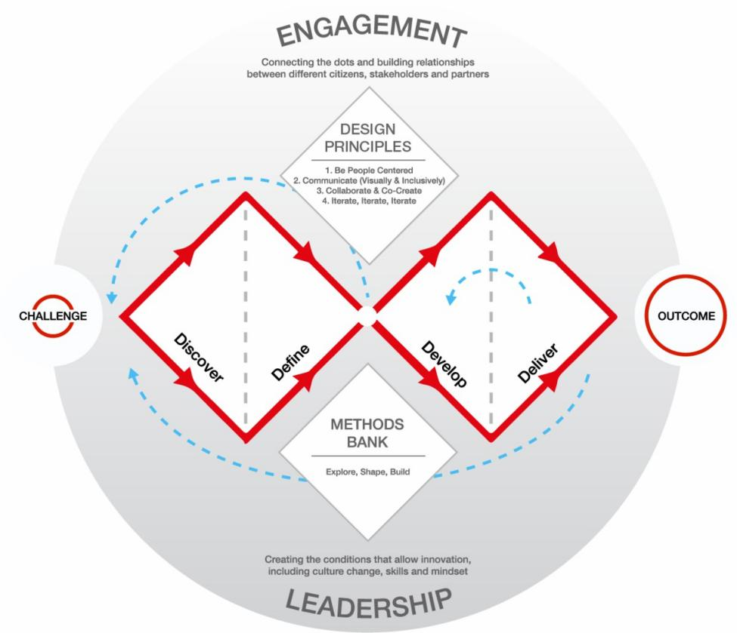
Figure 1. The Double Diamond Model. Design Council
If we want to apply the theory of cultural genes to the field of design, we need to go through four main steps: firstly, in-depth study of the history, values, traditions and customs of the target culture in order to reveal its core cultural genes; secondly, extraction of the genes of a specific culture, including the spiritual core of the culture and the genes of the form of colours, shapes, patterns, materials, etc.; thirdly, in-depth understanding of the needs, habits and expectations of the target users, and combined with the cultural genes, explore the intrinsic connection between the needs of users and design and culture; fourthly, translation of genes to culture through reasonable ways. Thirdly, deeply understand the needs, habits and expectations of the target users, and explore the intrinsic connection between the users, design needs and culture in combination with the cultural genes; fourthly, translate the genes to the culture in a reasonable way.
It is worth noting that the cultural gene theory and the two-diamond model are not exactly equivalent, although they have similarities in terms of stages. Cultural research corresponds to the problem discovery stage, which is diffuse in nature, while gene extraction is in the problem definition stage, which is constrictive in nature. The combination of user and culture also belongs to the problem definition stage. Translation design belongs to the programme exploration stage, where modern design methods are used to transform the cultural gene elements in traditional culture. Therefore, the combination of the cultural gene theory and the double diamond model forms the double loop model of cultural gene-design. In this model, both the design process and the use of cultural genes need to go through two or more iterative cycles.
Case Studies
Unique Henan Land of Dramas
Unique Henan Land of Dramas, a panoramic immersive theatre theme park located in Zhengzhou City, China, has earned the title of China's largest theatre colony cluster with its grand scale and unprecedented performance hours. It contains 21 theatres of different styles, nearly 1,000 professional actors, and a cumulative length of nearly 700 minutes of plays, which together build a huge and rich drama world (CAI Yuchen, Wang Mengting, 2022). The Loess Culture, the cultural essence of the Chinese nation, is the deep cornerstone of the creation of Unique Henan Land of Dramas. The immersive theatre art provides the Unique Henan Land of Dramas with a tense and infectious form of expression. This Unique Henan Land of Dramas is actually composed of 56 spaces which in their own way, show the deep history and culture of Henan and its unique customs in a meticulous way. The architectural pattern of the Land of Dramas adopts a checkerboard design, cleverly squaring the 622 acres of land, which not only enhances the sense of space, but also makes the Land of Dramas full of theatricality. Viewers are no longer passive receivers here, but need to take the initiative to plan their routes, travelling freely through different scenes and experiencing a wide variety of dramas in depth. This innovative way of watching while walking allows the audience to immerse themselves more fully in the drama, thus gaining a more profound and unique experience. From a design point of view, Unique Henan Land of Dramas does not fully conform to traditional design concepts, but its excellent arrangement of scenarios and use of space undoubtedly proves that the intervention of design thinking is successful. What is more worth mentioning is that the Land of Dramas has demonstrated a high level of extraction and translation of the cultural genes of Henan Province. The words "Sustained Vitality" engraved on the stone monument made of loess accurately captures the most prominent cultural gene of Henan Province. This cultural gene is fully presented through the theatre performances, landscape design and visual effects in the park, allowing visitors to gradually perceive and understand this deep cultural connotation during their visit.
Extraction of Cultural Genes
First of all, the extraction of cultural genes is a systematic project, which requires a comprehensive and precise grasp of one or several main systems, which, as the core genes of culture, have the function of leading and integrating other elements. For Unique Henan Land of Dramas, the most important task is to extract the cultural genes of Henan from the vast sea of cultural elements. The cultural genes of Henan are rich and varied, among which the two most prominent main systems are the Loess Culture and the culture of endless life.
The Yellow River civilisation is the cradle of the Chinese nation, and it flows through Henan, giving a unique flavour to this land. The name of Henan has an inseparable relationship with the Yellow River. As early as in ancient times, "Henan" referred to the area south of the Yellow River. The geographical environment and living conditions of Henan are also deeply influenced by the Yellow River, forming a distinctive regional culture. At the same time, Henan borders the Loess Plateau, to which it does not fully belong, but is deeply influenced by its culture. The loess plateau's kiln architecture, folk art, and rich historical stories and legends are all traceable in Henan and have become common cultural treasures of the two regions. This culture is also known as the Loess Culture.

Figure 2. Entrance. Unique Henan Land of Dramas
The Sustained Vitality is the spiritual trait of resilience and self-improvement that the people of Henan have gradually developed in the long course of history. This spirit is reflected in all fields of Henan, whether it is economic construction, social development, cultural inheritance or artistic innovation, all of which show the spirit of struggle and innovation of the people of Henan. This is also an important reason why the culture of Henan can be everlasting and everlasting.
In the creation of Unique Henan Land of Dramas, these two cultural genes have been precisely and deeply excavated and presented. Taking the Loess Culture as the foundation of its creation, the Land of Dramas shows the history, culture and customs of Henan through immersive theatre techniques and the unique "Land of Dramas" carrier. At the same time, Land of Dramas also cleverly integrates the Sustained Vitality into it, presenting the heaviness and vitality of Henan culture through various means such as theatre, landscape and visual effects.
Translation of Cultural Genes
The moment we enter Unique Henan Land of Dramas, a 328-metre-long loess wall immediately jumps into our eyes, as if telling us about the deep Loess Culture of Henan. Such a way of translation is direct and powerful, and by choosing loess as the main building material, it successfully presents the calmness and heaviness of Henan's Loess Culture. The entire Land of Dramas is almost entirely constructed with such loess, neatly divided into 56 squares, each of which seems to tell a story about Henan and loess.
Grain, especially sorghum and wheat, as an important part of Henan's Loess Culture, is well represented in Land of Dramas. Many of the drama's plots cleverly incorporate elements of these crops and even use them as themes. In front of the loess wall at the entrance, large tracts of sorghum are neatly lined up, golden and fruitful in spring, laying a solid foundation for Henan Province's identity as China's grain province. It's worth noting that two of the three big theatres in the theatre-the Li Jia Village Theatre and the Railway Station Theatre-have grain as their central theme. They tell the story of what happened in Henan during the Chinese famine of 1942, and show the great dedication of the people of Henan to contribute grain to the whole country even when they faced an existential crisis. This sentiment of sacrificing the small for the sake of the big deeply touches the hearts of every audience. At the same time, the play's in-depth exploration of survival, death and family fully reflects the influence of Chinese Confucian philosophy and traditional Chinese family concepts.
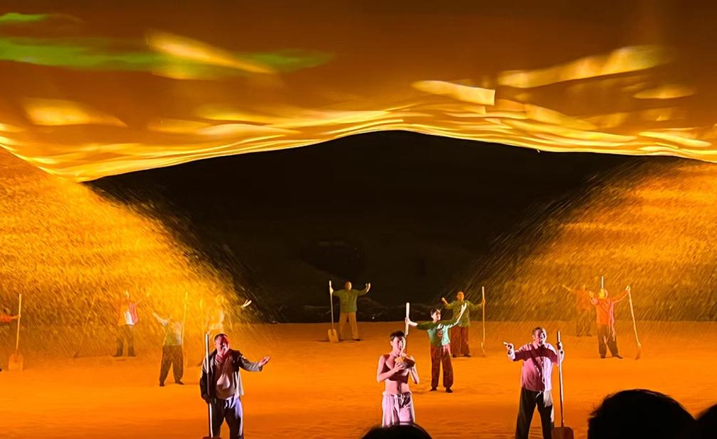
Figure 3. the Li Jia Village Theatre. Unique Henan Land of Dramas
Unique Henan Land of Dramas embodies the cultural gene of Sustained Vitality in a way that is even more deeply rooted in people's hearts. Through the theatre performance in 天子驾六(The emperor drives six carriages) Rruins, Land of Dramas cleverly allows modern archaeologists to meet the Zhou Emperor across time and space. The wail of the Zhou Emperor when he learns that modern people don't know his identity, and the subsequent exchange with modern archaeologists through Confucian classics, all give a deep sense of the coherence and greatness of Chinese civilisation. This not only reflects the long and continuous history and culture of Henan Province, but is also a powerful interpretation of the constant Chinese civilisation.

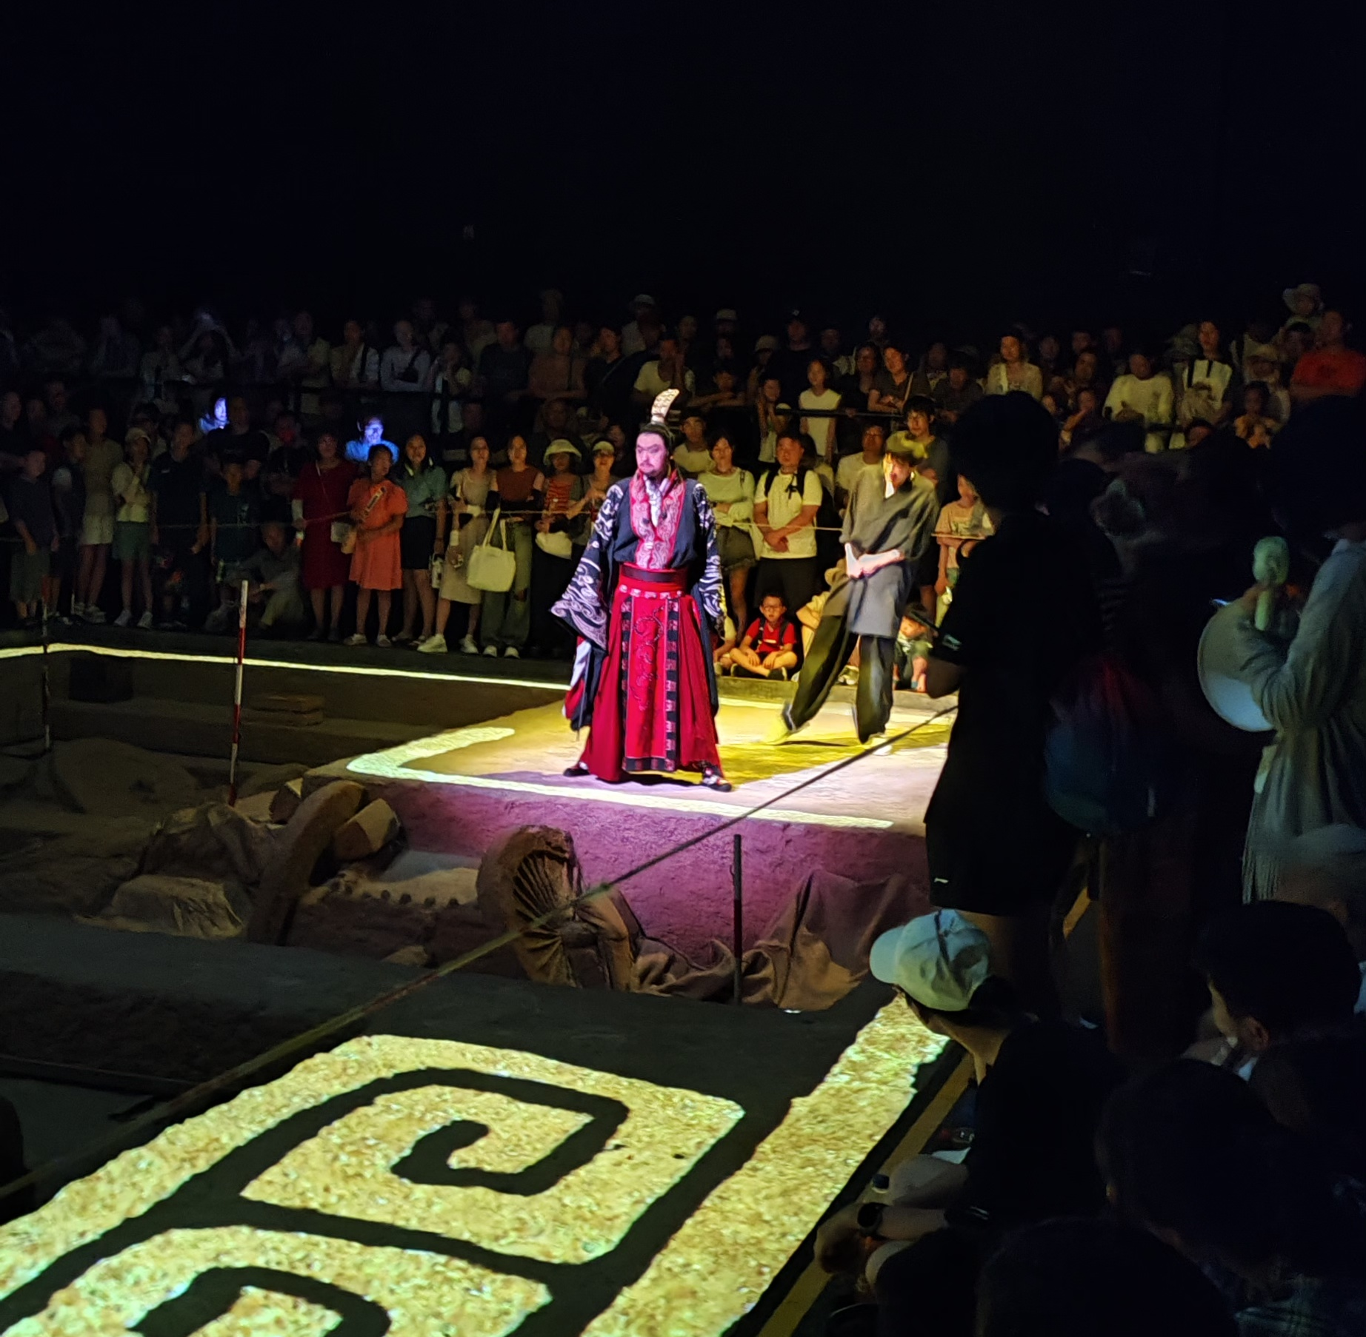
Figure 4. 天子驾六(The emperor drives six carriages) Rruins Theatre. Unique Henan Land of Dramas
Hans Wagner's China Chair
The use of Chinese culture in design has never been the exclusive preserve of the Chinese, and in fact, in the twentieth century Europe has placed Chinese culture in the modern design system. Hans Wagner's China Chair is a classic piece of furniture that blends Chinese and Western styles.Hans Jørgensen Wegner (April 2, 1914–January 26, 2007) was a Danish furniture designer. His work, along with a concerted effort from several of his manufacturers, contributed to the international popularity of mid-century Danish design. His style is often described as Organic Functionality, a modernist school with emphasis on functionality (Bernsen Jens, 2001).
Inspired by Ming(A Chinese dynasty) furniture, this chair embodies the Scandinavian concept of simple, natural and humane furniture making. When designing this chair, Wagner studied the style and characteristics of Chinese Ming furniture in depth and incorporated its essence into his design.
The design of the China Chair retains the curved lines of the rim, the S shape of the back, the straight lines of the legs, and the slightly raised angles of the seat drawer of the Ming chair. These features make the chair visually elegant with smooth lines. At the same time, Wagner has skilfully used modern steam bending techniques to produce a finished product with a minimum amount of wood, reflecting the ultimate pursuit of comfort and ergonomics (Motzkus Frank, 2008).
This China Chair is the cornerstone of Wagner's design philosophy, incorporating modern craftsmanship into traditional styles, resulting in a unique blend of East meets West. It not only represents Wagner's personal creative peak, but also injects new vigour into the global modernist movement.
Extraction of Cultural Genes
Ming-style furniture is one of the traditional furniture with unique Chinese characteristics, whose history can be traced back to the middle of the Ming Dynasty, and is mainly made of hardwoods, such as rosewood, qizi wood and pear wood. Its production techniques and stylistic features, deeply influenced by traditional Chinese culture, have formed a unique artistic style and cultural connotation. The artistic characteristics of Ming furniture can be summarised in four words:简、厚、精、雅 (Zibing Tian, 2010). 简 refers to the modelling simplicity, not cumbersome, not stacked； 厚refers to the image of thick, with a solemn and simple effect; 精refers to the fine workmanship, a line of one side, straight and twisted, rigorous and accurate, meticulous; 雅refers to the style of elegant, enduring, not a cliché, with a very high artistic style.
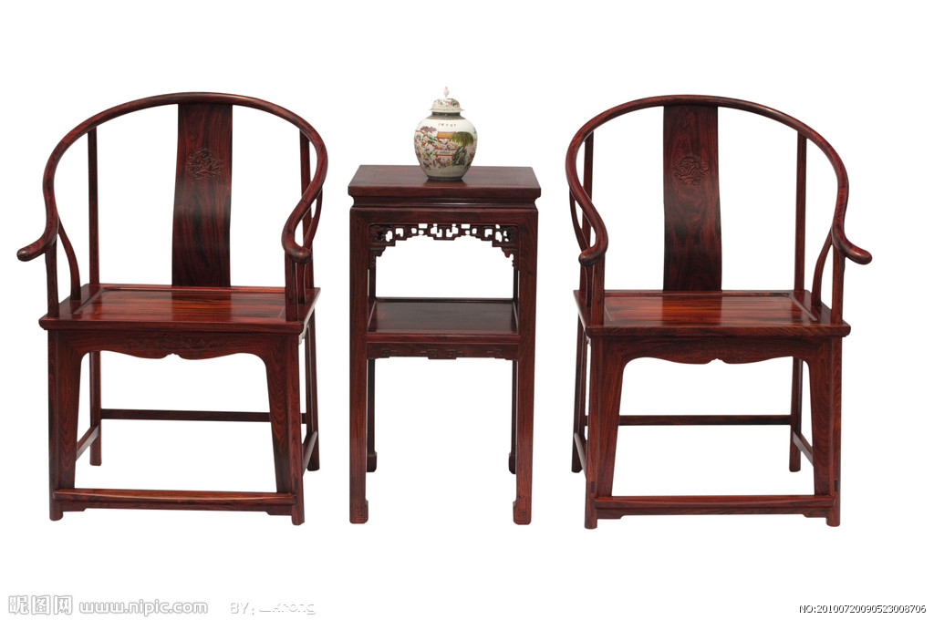
Figure 5. Ming furniture. Wkrong posted on nipic.com
The aesthetic characteristics of Ming furniture have distinctive characteristics of the era, such distinctive aesthetic characteristics also cast the cultural gene of Ming furniture. In the middle and late Ming Dynasty, with the development of social economy, culture and art, the public class living interest is also improving, the decorative style of furniture, modelling art, technology and construction also have new requirements. Coupled with the famous poets and writers of the Ming Dynasty who were involved in the design of furniture, style seminars, the promotion of the system, so that the Ming furniture breaks through the utility, and once rose to the perfect unity of functionality and aesthetics. According to the "Zhou Yi - XI Ci" in the 形而上者谓之道，形而下者谓之器 (Bokun Zhu, 2009). (Above the formality is the rule, below the formality is the artefacts) Ming furniture has obviously gradually get rid of the "artefact" bound, up to the "道" level. Here the "道" is also the modern design of the pursuit of 文质合一 (the unity of formality and content).
Translation of Cultural Genes
Wagner's inspiration for the first China Chair came from a book portrait of a Danish merchant sitting on a Ming chair. Miraculously, he had never seen a Ming chair before, and it was 40 years later that he actually saw the first Ming chair in his life. But this in no way affected his artisanal understanding of the curves and details of the China Chair. More importantly, Hans Wagner combined modern design methods with the cultural genes of Ming furniture, and translated the cultural genes and improved them according to modern living habits, which created a generation of classics in furniture design.

Figure 6. China Chair. Hans Wagner
Wagner's China Chair uses modern industrial technology in its craftsmanship, which abandons the traditional time-consuming and costly cutting and mortise and tenon joints, and is instead shaped in one piece by steam hot bending and pre-pressure cold bending technology. Three-dimensional curve of the backrest is shaped in one piece, smooth and beautiful, more modern atmosphere. In addition, Ming chairs are often decorated with relief and translucent carvings, while China Chairs remove all decorative elements and retain the natural grain of the wood, presenting a more natural and original beauty. The traditional Ming style flavour of the China Chair remains, but with the addition of modern lightness, which has led to its popularity among people from different countries. Finally, its structure borrowed from Ming chairs, the Chinese chair has cylindrical legs, removing the raised crossbar between the legs, making room for the feet to move around, making it easier and more comfortable to move around. Wagner's Chinese chair perfectly blends the essence of bentwood and the charm of Ming chair, inheriting the two main sources of modern chairs and giving a modern flavour to the Chinese Ming aesthetics.
Conclusion
The theory of cultural gene is of great significance in design, which can help designers better understand local culture and history and thus guide their design ideas. Designers can draw inspiration and elements from traditional culture and history and incorporate them into modern design to increase the cultural connotation and aesthetics of the design. The theory of cultural gene can also promote cultural inheritance and innovation, and designers can realise the uniqueness and innovativeness of design through the research and application of traditional cultural genes. In addition, the use of cultural gene theory can enhance the sense of cultural identity in the design, improve user acceptance and satisfaction, and allow the design to better integrate into the local cultural environment. In the context of globalisation, designers can make use of cultural gene theory to carry out cross-cultural communication and integration, and promote the diversification and innovative development of design.
In this paper, we take "Unique Henan Land of Dramas" as an example, the design idea of this project is to draw inspiration and elements from the local cultural genes and history of Henan. By digging deep into the history and culture of Henan, the designer combines traditional elements with modern design methods to create a unique and innovative cultural tourism project. This project not only increases the cultural connotation and artistic beauty of the design, but also promotes the inheritance and innovation of Henan culture.
Similarly, the success of the Hans Wagner Chinese Chair can be explained by the use of cultural gene theory in design. The chair draws on the design elements of traditional Chinese chairs and combines them with modern design techniques and technology to create a unique and innovative chair.
In the future, as technology continues to advance and cultural exchanges intensify, design will pay more attention to the inheritance and innovation of cultural genes. Designers need to continue to learn and study traditional culture and history and culture, but also need to maintain a sense of innovation and creativity, and constantly explore new design concepts and ways of expression. Only in this way can they design works with more cultural connotation, historical sense and innovation, and promote the progress and development of design.
Overall, the application of cultural gene theory in design is a process of continuous development and depth. By drawing on and applying traditional cultural genes, designers can create works with more uniqueness and characteristics, and at the same time promote cultural inheritance and innovation. We believe that in future design, cultural gene theory will play a more important role and provide designers with more inspiration and guidance.

Bibliography
Moalosi, R. V. & Hickling-Hudson, A. (2007). Culture-orientated product design. Hongkong, s.n.

Ziff, B.and Pratima, R. (1997) Borrowed Power: Essays on Cultural Appropriation. New Jersey: Rutgers University Press, 1-21

Kersten, G. E., Matwin, S., Noronha, S. J. & Kersten, M. A. (2000). The software for cultures and the cultures in software. s.l., s.n.

Kantorovich, Aharon. (2013) An Evolutionary View of Science: Imitation and Memetics. [Online] Available at: http://philsci-archive.pitt.edu/id/eprint/9912 (accessed 2023-12-14).

Dawkins, Richard. (2006). The Selfish Gene: 30th Anniversary edition. Oup Oxford.

Mengyao Wang. (2022). Cultural Gene: The New Enlightenment from the Display Design of University History Museum. HCII 2022. Lecture Notes in Computer Science, vol 13312. Springer, Cham. [Online] Available at: https://doi.org/10.1007/978-3-031-06047-2_32

Nielsen, J. (1996). International User Interfaces. John Wiley & Sons.

Brown, T. (2021). Design thinking. [Online] Available at: https://www.ideou.com/pages/design-thinking.
[Accessed 4 May 2021].

Plattner, H., Meinel, C., & Leifer, L. (2010). Design thinking: Understand–improve–apply. Springer Science & Business Media

Design Council. What is the framework for innovation? Design Council's evolved Double Diamond". Design Council. [Online] Available at: https://www.designcouncil.org.uk/our-resources/framework-for-innovation/

CAI Yuchen, Wang Mengting. (2022). Research on Development Ideas of Immersive Tourism Experience from the Perspective of the Integrate of Culture and Tourism Taking Unique Henan Land of Dramas as an Example. Comparative Study of Cultural Innovation. Vol 34. pp. 134-137

Bernsen, Jens. (2001). Hans J. Wegner (in Danish). Copenhagen: Dansk Design Center.

Motzkus, Frank. (2008). By design. Carl Hansen & Son, 100 Years of Craftsmanship. Copenhagen: Carl Hansen & Son. [Online] Available at: https://www.yumpu.com/en/document/read/17668765/untitled-the-academy-of-carl-hansen-sn

Zibing Tian. (2010). History of Chinese Crafts and Arts. Orient Publishing Center

Bokun Zhu. (2009). History of Yijing Philosophy. Kunlun Publishing Co.

List of Illustrations
Figure 1
Design Council. The Double Diamond Model. [Digital illustration] Available at: https://www.designcouncil.org.uk/our-resources/framework-for-innovation/

Figure 2
Unique Henan Land of Dramas. 2023. Entrance. [Image] Authors' photograph

Figure 3
Unique Henan Land of Dramas. 2023. the Li Jia Village Theatre. [Image] Authors' photograph

Figure 4
Unique Henan Land of Dramas. 2023. 天子驾六(The emperor drives six carriages) Rruins Theatre. [Image] Authors' photograph

Figure 5
Wkrong posted on nipic.com. Ming furniture. [Image] Available at: https://www.nipic.com/show/3430568.html

Figure 6
Hans Wagner. 1943. China Chair. [Image] Available at: https://auction.artron.net/paimai-art5052241001/

