DS 1 Assignment

My Screenshots/Photos
- Please add 4–6 screenshots or photos of your digital life.
- You can use your phone or laptop.
- For each screenshot, write one or two sentences explaining what it shows.

Screenshot/Photo 1
[Insert Photo/Screenshot below]
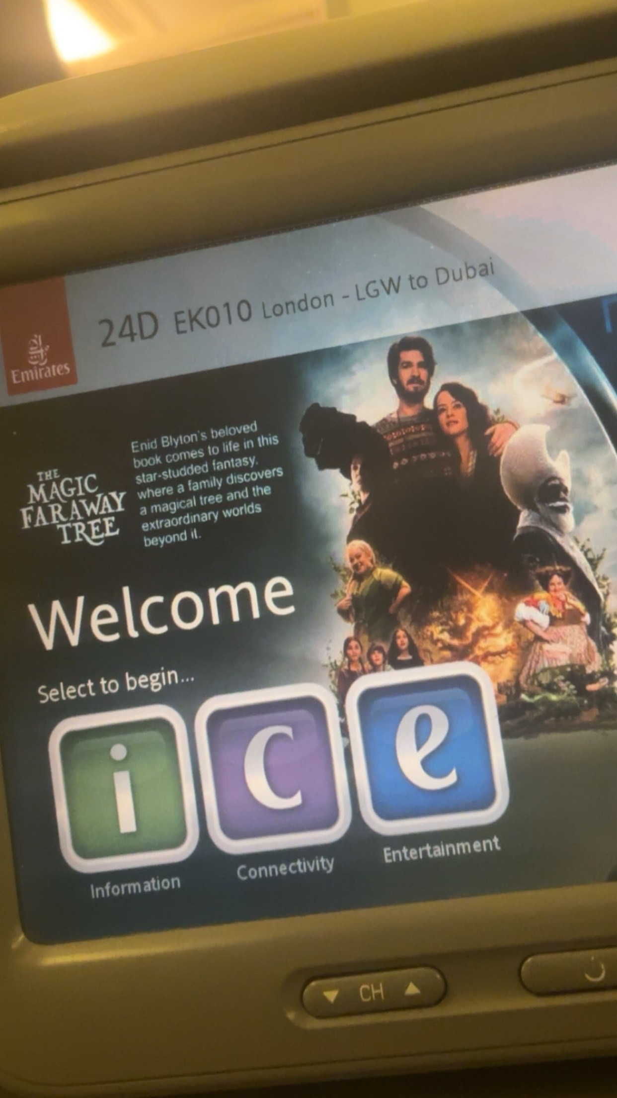
In flight TV entertainment system, which helps with boredom and keeps you occupied for hours allowing you pick from a range of movies, making the travel a lot more comfortable
[Insert Photo/Screenshot below]
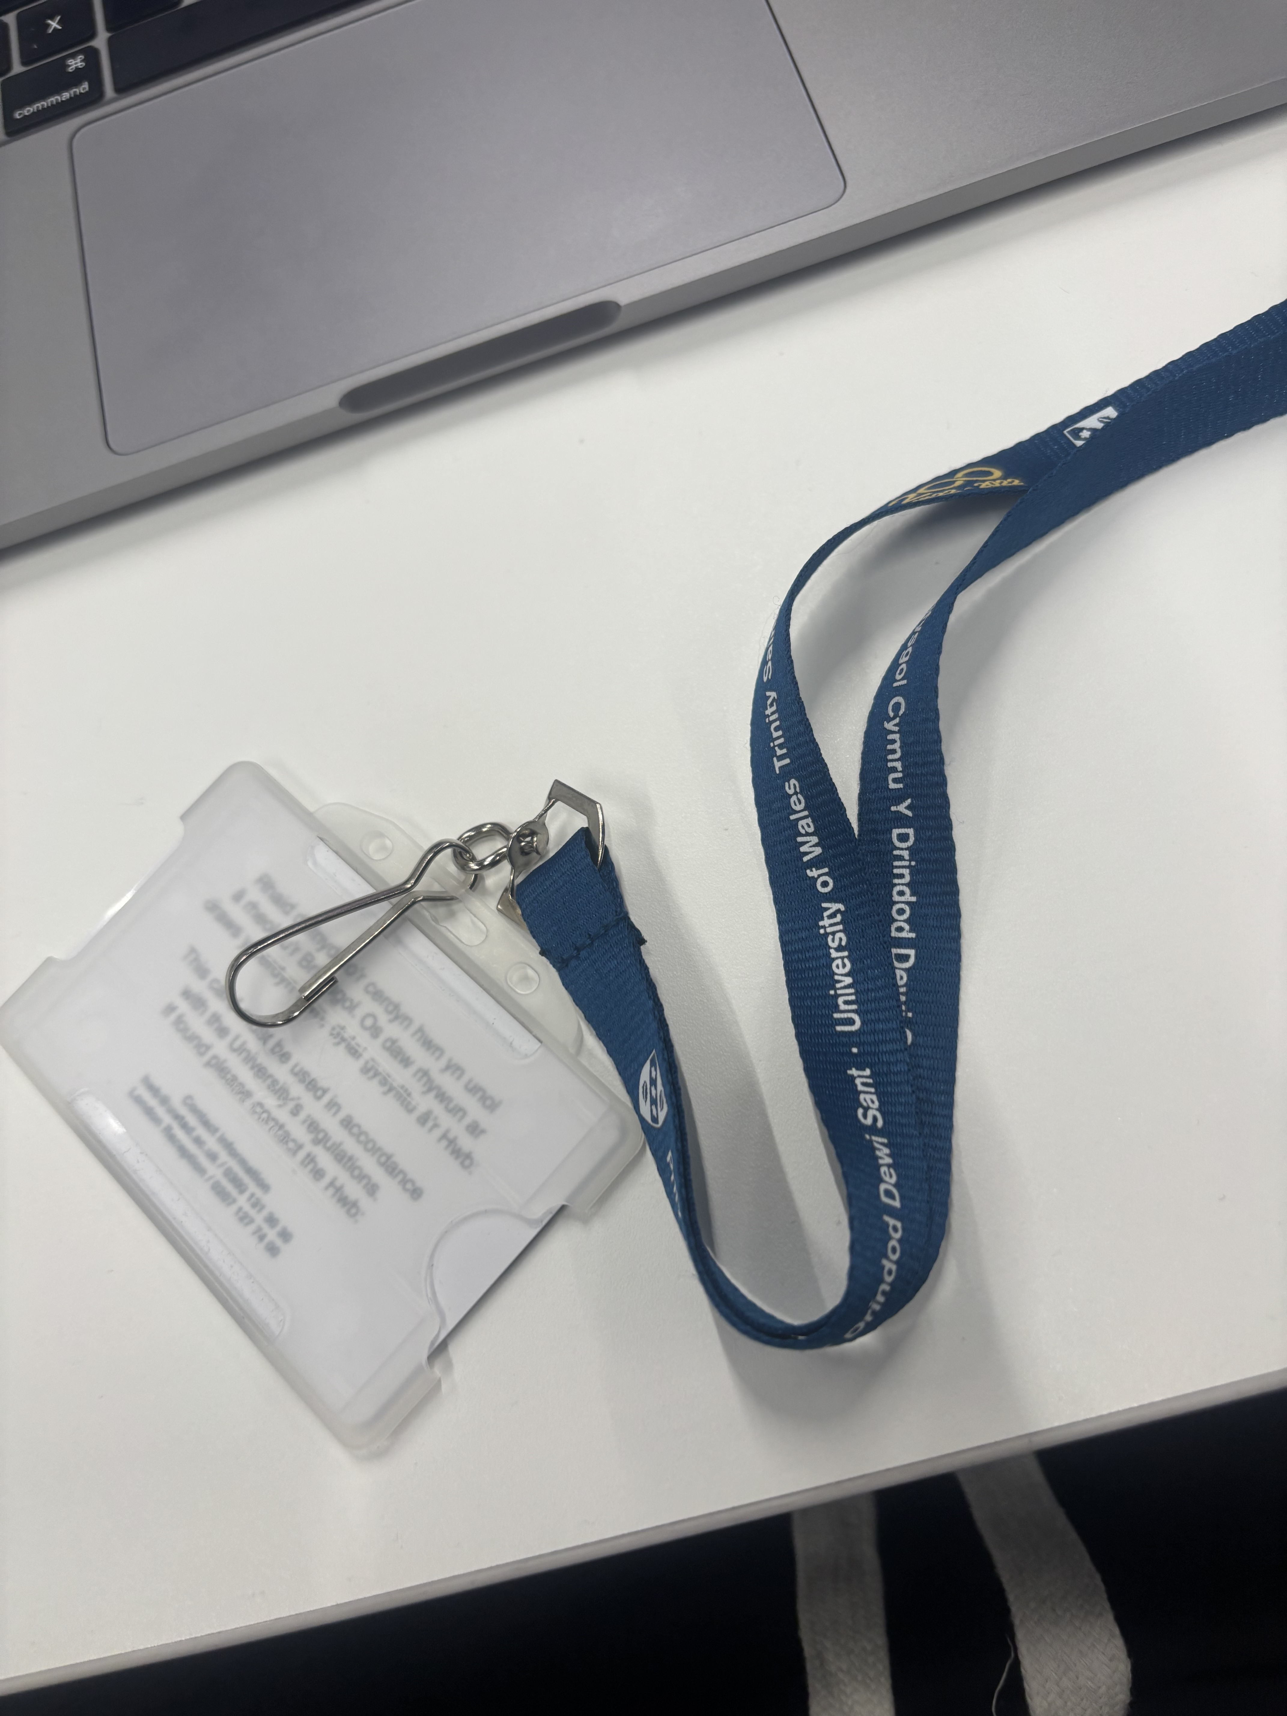
University ID CARD, which helps tutors and students identify you, you can also enter the building and classrooms by tapping on the reader

Screenshot/Photo 6
[Insert Photo/Screenshot below]
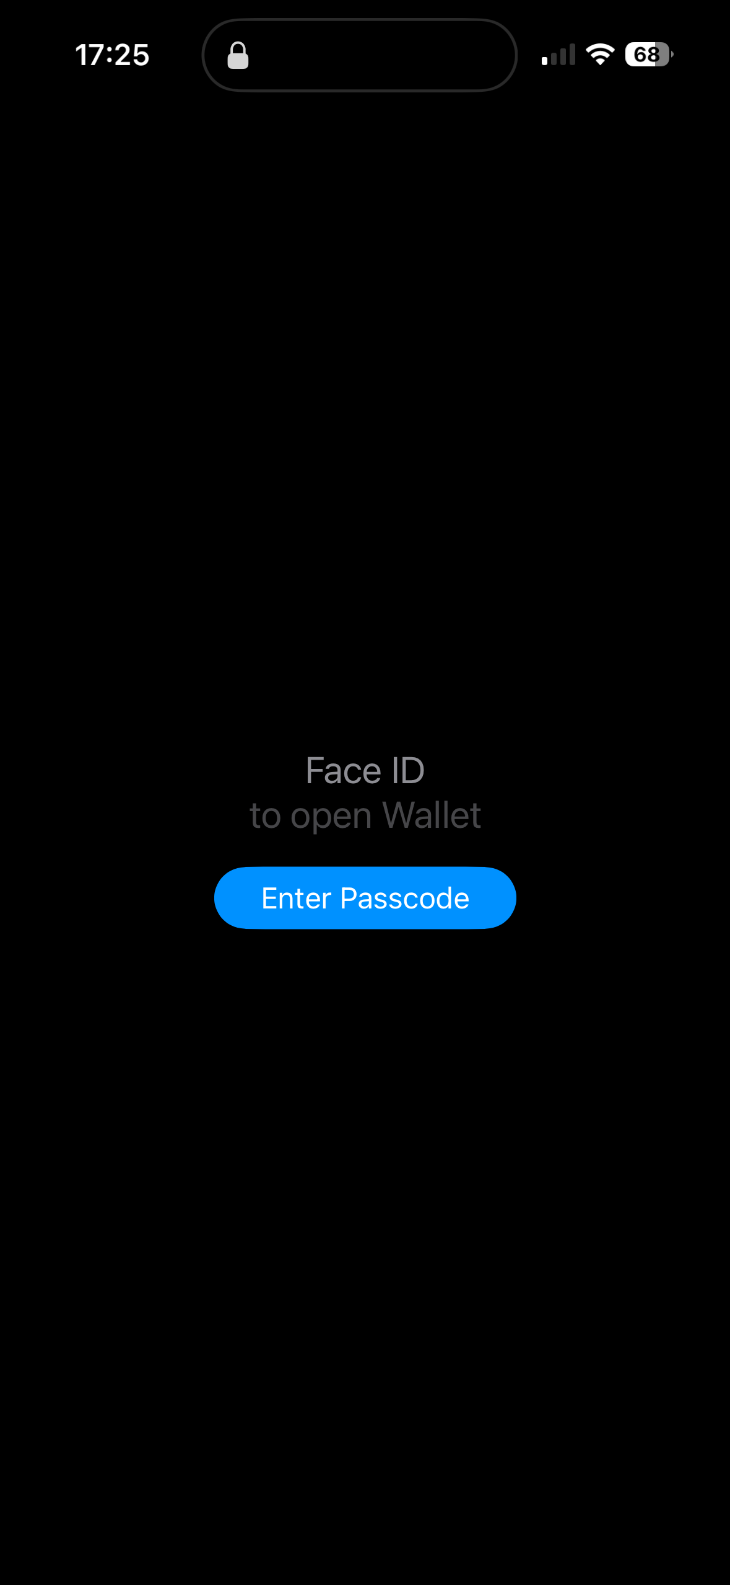
Apple wallet, which asks you to authenticate before allowing access, you could enter your password or use face ID as proof of identity

Screenshot/Photo 2
[Insert Photo/Screenshot below]
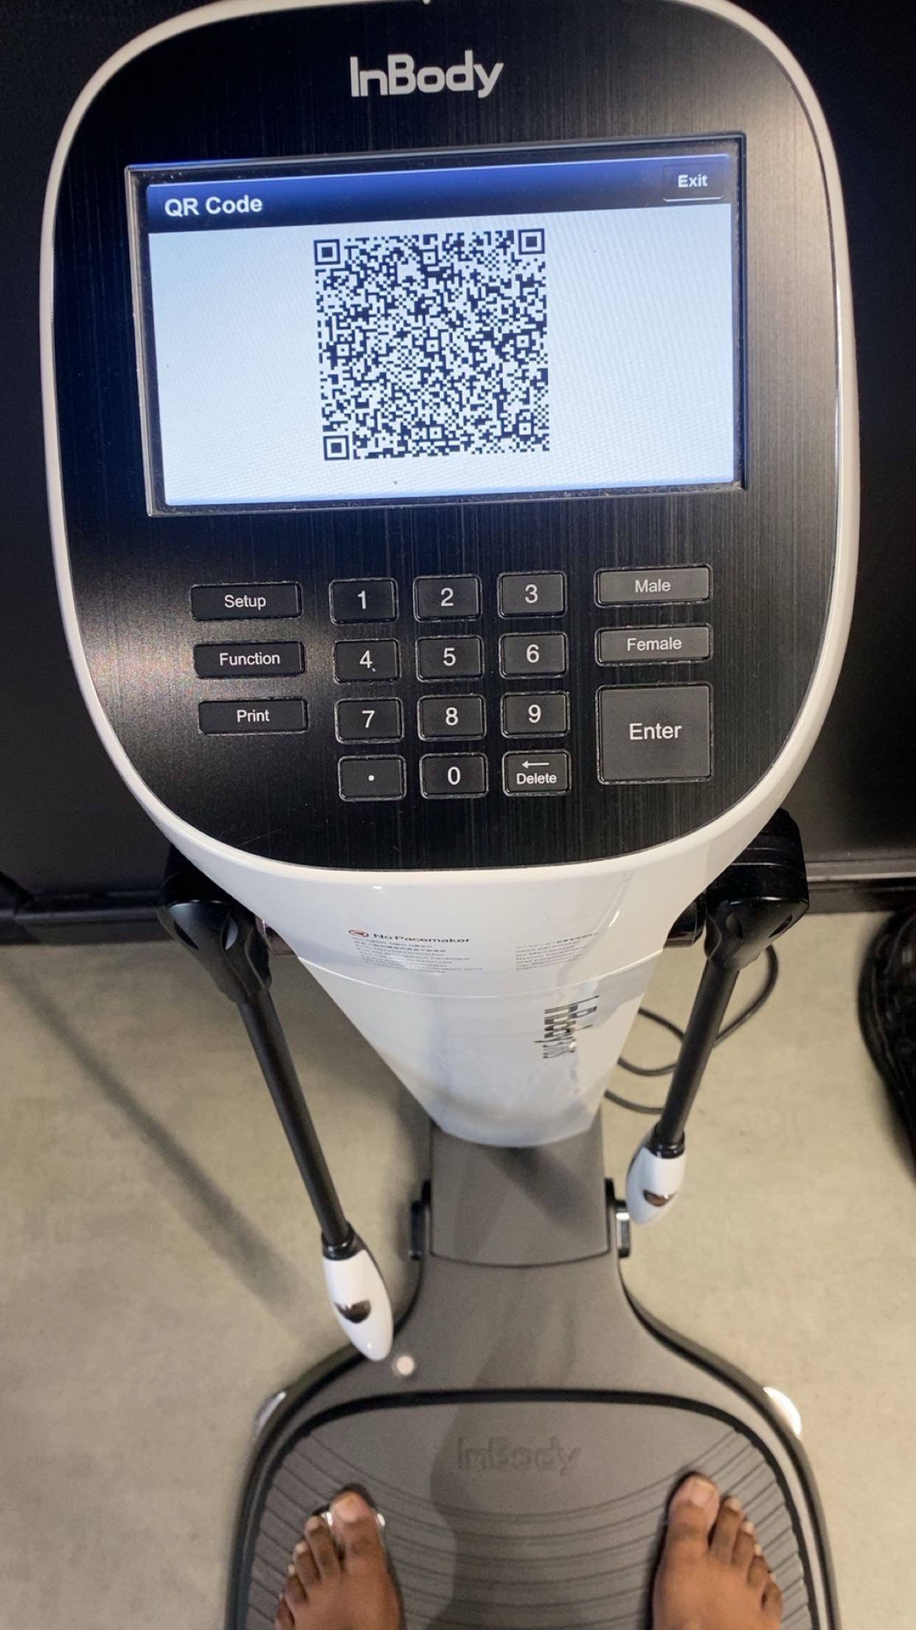
Inbody body composition analyser, a machine that measures your body fat, muscles and gives you accurate reading, then you scan the QR code download the app and you can see your results

Screenshot/Photo 3
[Insert Photo/Screenshot below]

[Write what this shows of your digital life]

Screenshot/Photo 4
[Insert Photo/Screenshot below]
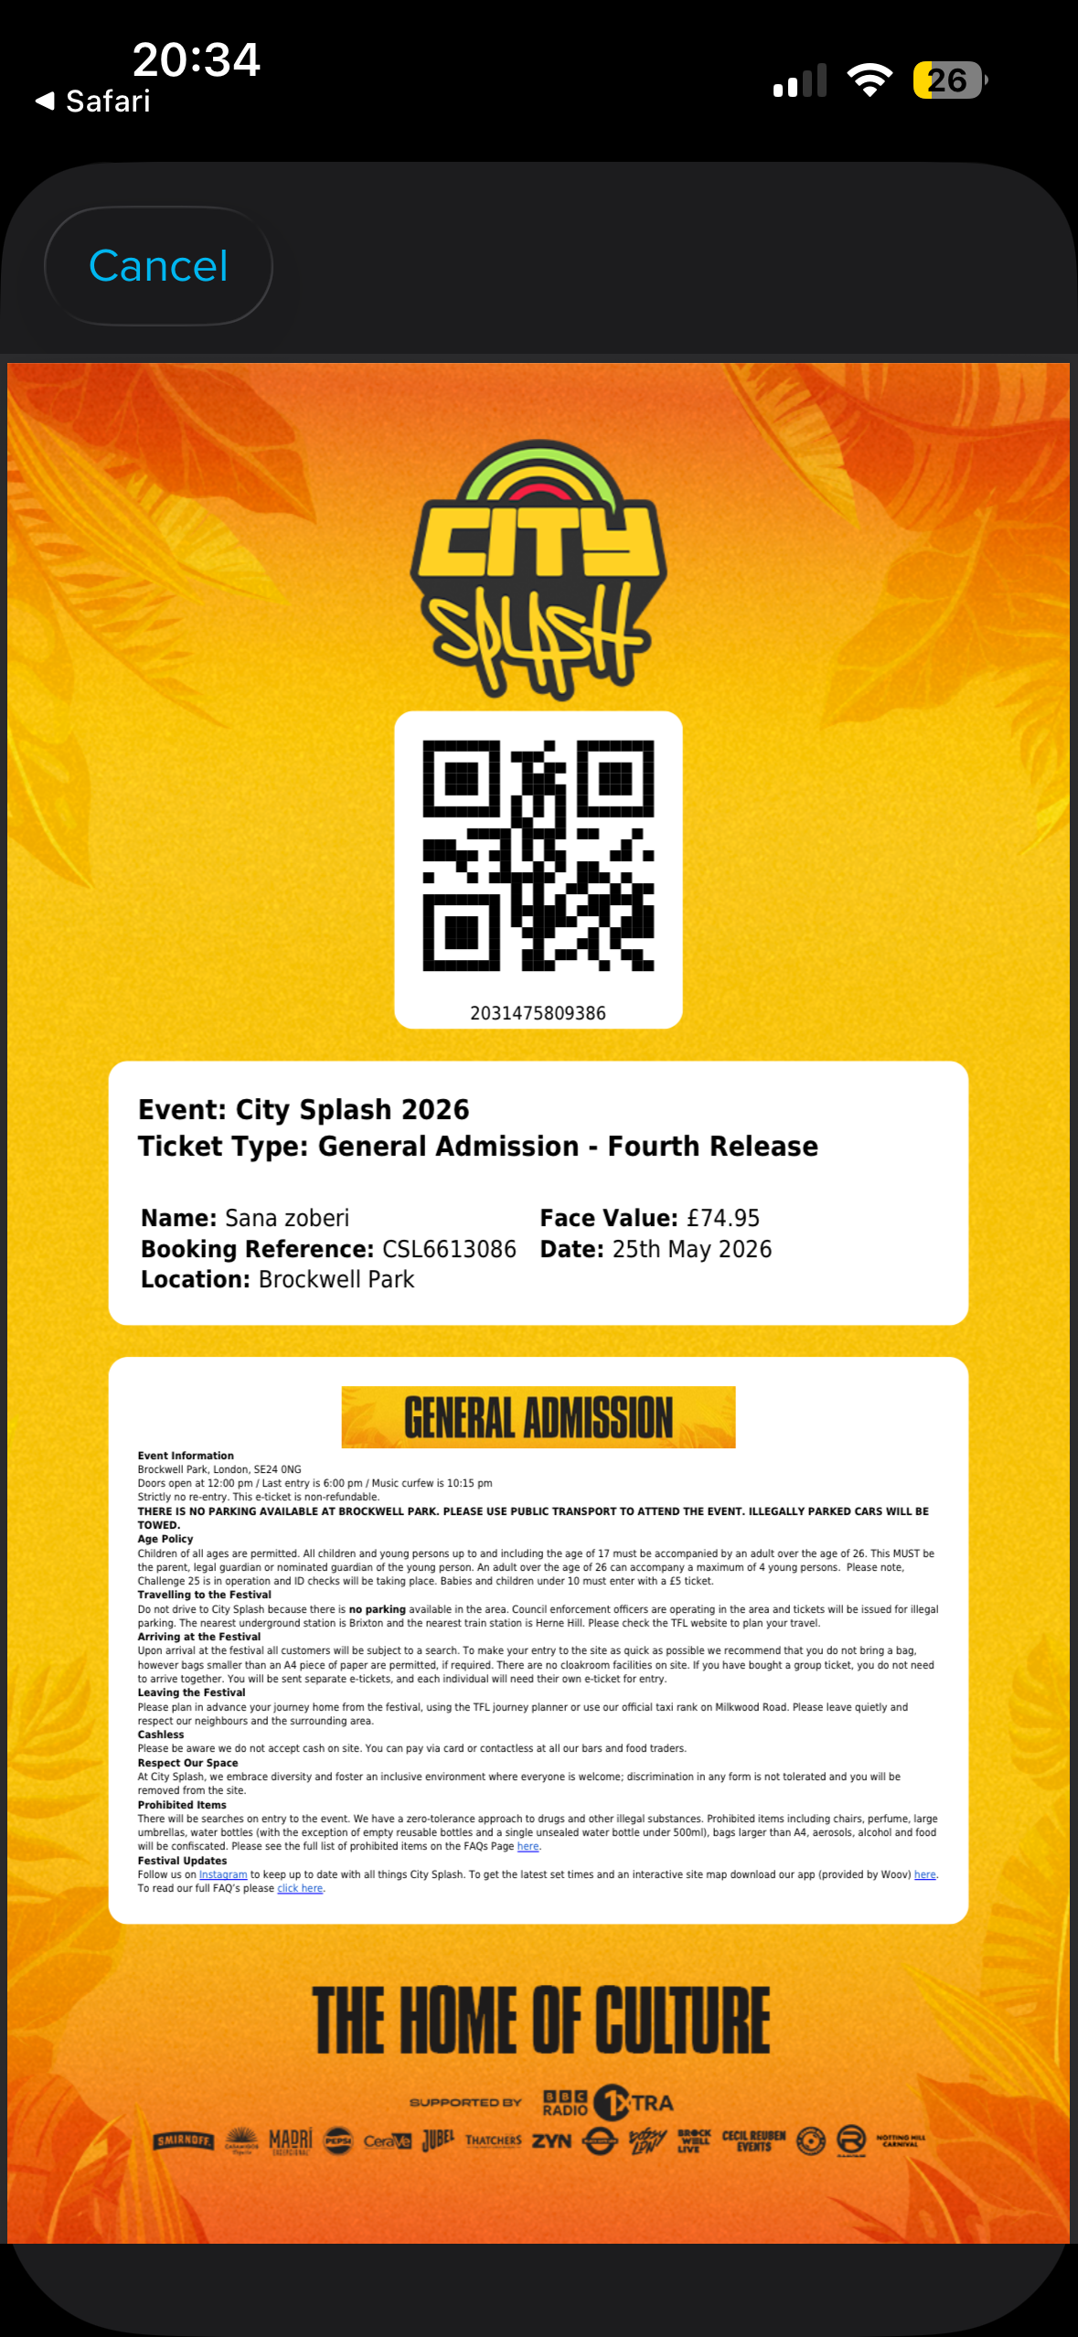
General Admission ticket, you can only buy tickets online and they send you a QR barcode once payment is received, you use the same QR code before entering the venue and they scan it with a machine to make sure is authentic

Screenshot/Photo 5

My Short Reflection
- Write 5–8 simple sentences about your digital life.
- You can use the sentence starters below if helpful.
I often use the tools I have provided on a day to day basis like scanning QR codes and proving my identity, making it easier for me when I come cross digital platforms like such. I hope this module will help me develop my digital skills even further as technology keeps on changing and getting better

Sentence starters
- I use digital tools to …
- I feel confident when I …
- I want to improve …
- I often use these tools: …
- I sometimes feel nervous about …
- I hope this module will help me …
- Digital skills are important for me because …
You can write more if you want.

Submission Checklist
Before you submit, please check:
​​​ ☐ I added 4–6 screenshots
☐ I wrote short sentences for each screenshot
☐ I wrote my short reflection
☐ My work is my own
☐ My file opens correctly
​​☐ My file opens correctly

