

LCBB 6015
Strategic Management and Sustainability
Component 1

Student Name: Iuliana Gorgan
Student ID: 2210792

Executive Summary
This report is a strategic analysis of the position of Vauxhall in the UK automotive industry. According to PESTLE, Porters five forces, Value Chain, RBV, VRIO and SWOT, the study has identified some of the major challenges, which are stiff competition in the EV industry, high supplier power and a changing customer demand. It also enjoys strengths on the brand name of Vauxhall in the UK, dealership network and Stellantis support. The report suggests accelerated electric vehicle development, enhanced local supply relationships, enhanced online customer experiences, and sustainability-based branding to improve the competitive edge and expansion of Vauxhall over time.

Contents
Executive Summary 2
1. Introduction 4
2. Strategy Analysis 4
2.1 External Environment Audit 4
2.2 Internal Environment Audit 6
2.3 SWOT Analysis 9
3. Strategy Formulation 9
4. Conclusion and Recommendations 11
References 12

1. Introduction
Strategic management assists organisations to cognise their environment, utilise resources efficiently and strategise long-term achievement in the competitive markets (Johnson et al., 2011). Strategy is a very crucial part of the UK automotive industry since firms are currently experiencing the transition to electric vehicles, stringent environmental regulations, and evolving customer behaviour. Vauxhall is an old brand of UK vehicles that was established in 1903, and currently, it belongs to the Stellantis car group. The organisation manufactures commercial vehicles and passenger cars in the UK. The vision of Vauxhall is to offer modern, affordable, and electric mobility to British customers. It is mission-driven to provide safe, innovative and zero-emission automobiles and contribute to the UK manufacturing. Its key goals will be the growth of electric vehicles, customer experience, and market share in the UK motor industry.

2. Strategy Analysis

2.1 External Environment Audit
The external environment is significant to understand as it can enable a company to view risks and opportunities before making a strategic decision (Johnson, Scholes and Whittington, 2020). In the UK automobile market, Vauxhall is rapidly evolving with electric cars, new rules, and high competition in the world market.
PESTLE Analysis
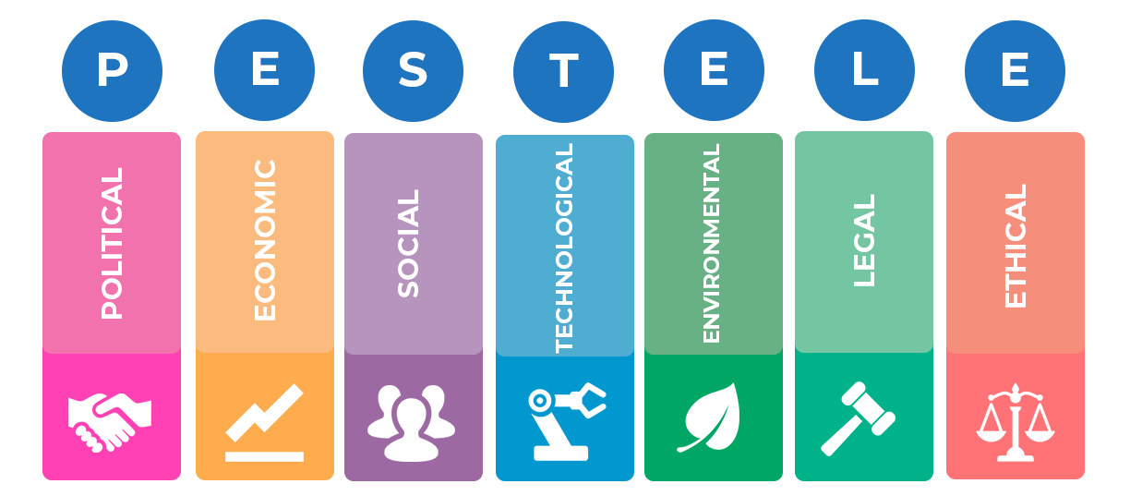
Figure 1: PESTLE Analysis (Birkinshaw, 2022)
Factor | Impact on Vauxhall
Political | The UK government is expected to prohibit petrol and diesel vehicles by 2035. This compels Vauxhall to produce more electric vehicles (EVs) (UK Government, 2023). The costs of supply chains were also improved by trade concerns following Brexit.
Economic | The production cost at the UK factories was raised due to inflation and increased energy prices. Meanwhile, the demand for EVs is increasing, and new market opportunities are emerging (SMMT, 2024).
Social | Customers have shifted their favour to eco-friendly cars as well as digital services. Young customers follow the EV technology and online shopping solutions (Deloitte, 2024).
Technological | Wireless innovation in batteries, software, and autonomous driving implies that Vauxhall has to invest in research. Other rivals such as Tesla and Volkswagen are setting the pace in EV technology (ACEA, 2025).
Legal | The emission regulations and safety standards raise the compliance costs; however, they push innovation (European Commission, 2024).
Environmental | The policies on climate change favour low-carbon vehicles. Vauxhall needs to cut carbon emissions during the production and supply chain (Stellantis, 2024).

According to the PESTLE analysis, the largest sources of strategy in the UK automotive industry are the environmental regulations and technological change.
Porter's Five Forces Analysis
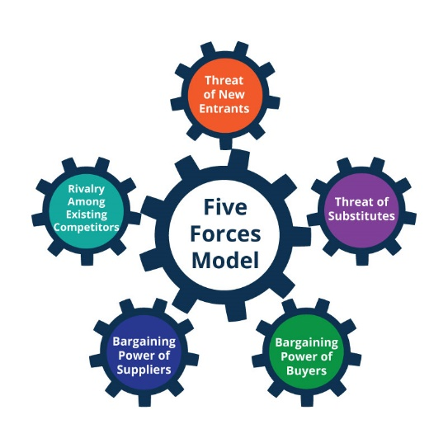
Figure 2: Porter's Five Forces (Rothaermel, 2024)
Force | Level | Explanation
Competitive Rivalry | Very High | Competition in the UK car market is good with Tesla, Volkswagen, Toyota, Hyundai and Chinese EV brands such as BYD. Price, technology and brand image are some of the factors that the firms are competing on, and this decreases the market share of Vauxhall (SMMT, 2024).
Threat of New Entrants | Medium | New EV companies may get into the market with state-of-the-art technology, but due to large capital requirements, regulations, and brand loyalty pose a barrier.
Supplier Power | High | There are a few battery and semiconductor suppliers all over the world. This adds the cost of production and reliance on suppliers (ACEA, 2025).
Buyer Power | High | Customers are able to compare prices and features online. There are numerous decisions that present buyers with great bargaining power (Porter, 2008).
Threat of Substitutes | Medium | In major cities, the ownership of cars is decreasing through the use of public transport, ride-sharing and mobility applications.

2.2 Internal Environment Audit
The internal analysis can be used to learn the strengths and weaknesses of the company. Value Chain, RBV and VRIO are some of the models that demonstrate how Vauxhall gains a competitive advantage.
Value Chain Analysis
Value Chain is an analytic model that describes how a company enhances its product (Porter, 1985).
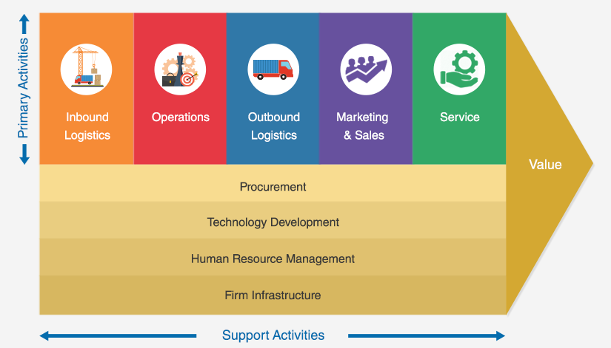
Figure 3: Value Chain Analysis (Birkinshaw, 2022)
- Primary Activities
Inbound Logistics: Vauxhall relies on international suppliers for sources of batteries and parts. The post-COVID-19 supply chain issues were not very strong.
Operations: In the UK, electric van manufacturing is taking over some of the operations in its factories, such as Ellesmere Port, and it is already a sign of adjustment to EV demand (Stellantis, 2024).
Outbound Logistics: Good dealer network in the UK.
Marketing & Sales: Vauxhall is well known in the UK, but lacks a global brand image like Tesla does.
Service: Good pre sales system increases customer loyalty.
- Support Activities
Technology: Stellantis global R&D resources.
HR: Competent engineers in the UK are at a high cost of labour.
Infrastructure: The Stellantis group provides financial stability.
As demonstrated in this analysis, Vauxhall possesses good experience in distribution and manufacturing, but needs to enhance the use of technology.
Resource-Based View (RBV)
The RBV model explains that the competitive advantage is a result of valuable resources that are not easily replicated by competitors (Barney, 1991). Important Vauxhall assets comprise:
- Strong UK brand heritage
- Stellantis financial and technology support.
- The manufacturing plants in the UK.
- Dealer and service network
Nevertheless, Vauxhall does not have distinctive EV technology in comparison to Tesla, which undermines its competitive advantage.
VRIO Analysis
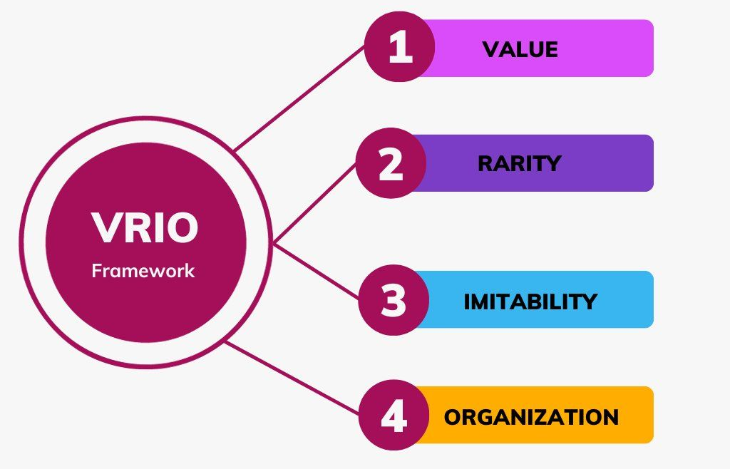
Figure 4: VRIO Analysis (Feng, 2025)
Resource | Valuable | Rare | Difficult to Copy | Organised | Result
UK Brand Reputation | Yes | Medium | Medium | Yes | Temporary advantage
Stellantis Technology | Yes | Yes | Yes | Yes | Strong advantage
Dealer Network | Yes | No | No | Yes | Competitive parity
EV Innovation | No | No | No | – | Weakness

According to the VRIO model, the primary strength of Stellantis' support is the greatest strength of Vauxhall, whereas poor EV innovation presents a significant threat.

2.3 SWOT Analysis
SWOT integrates external and internal discoveries.
Strengths | Weaknesses
Strong UK brand reputation | Late entry into EV technology
Part of Stellantis global group | High production cost in UK
Large dealer network | Dependence on suppliers
Opportunities | Threats
Growing EV demand in UK | Strong competition from Tesla, VW, BYD
Government EV incentives | Battery supply shortages
Digital sales and services | Economic slowdown reducing car demand

Critical Evaluation
The analysis shows that Vauxhall possesses an excellent background and support through Stellantis, but it faces a lot of pressure due to technology giants in EVs. External forces like the government control and consumer change are compelling the company to change very rapidly. Experience in the manufacturing and brand image are good internal strengths, but without proper innovation Vauxhall will lose its market share. Therefore, the future strategy would be to invest in EVs, supply chain partnerships, and digital customer experience in order to keep up with competitors in the UK car industry.

3. Strategy Formulation
Based on the external and internal analysis, Vauxhall needs to possess strategies that improve innovation, cost reduction and sustainable growth. An effective strategy should also align with the UK government policy, evolving customer requirements, and stiff international competition. The strategic management theory suggests that firms benefit when the resources are matched with the market opportunities (Knobbe and Proff, 2020). The strategic options that should be adopted by Vauxhall include the following.
1. Quick Vehicle Development
Vauxhall needs to allocate more funds to the development of electric vehicles (EVs) and put more effort into working with its parent organisation, Stellantis. The UK government intends to stop the use of petrol and diesel-powered vehicles by 2035, and this eventually implies a rapid increase in the demand for EVs (UK Government, 2023). Vauxhall can release cheap EV models sooner using Stellantis' battery platforms and software systems. The practicality of the affordable EVs is that in times of inflation, the customers in the United Kingdom are sensitive to prices (SMMT, 2024). The attention towards small family EV cars and electric vans will help Vauxhall to reinforce its position in the market. This plan creates a long-term competitive advantage based on the capability of technology and brand loyalty (Barney, 1991).
2. Establish Effective Local Supply Chain Relationships
The analysis revealed that the supplier's power is high, particularly in the case of batteries and semiconductors. Vauxhall ought to establish collaborations with battery manufacturers in the UK and Europe so as to minimise the risk of supply and the cost of transportation. Local supply chains are a part of the sustainability goals as well since they minimise carbon emissions (ACEA, 2025). Brand image in the UK market can be enhanced by investing in the facilities in the UK, including the Ellesmere Port electric van plant, which can save jobs (Stellantis, 2024). Companies investing locally have the tendency to be supported by the governments, resulting in the cost of production being lowered. An enhanced supply chain also enhances the efficiency of operations in the value chain.
3. Innovate Digital Customer Experience and Services
The way consumers behave is evolving, and an increasing number of consumers purchase cars online and demand related services (Deloitte, 2024). Vauxhall needs to invest in online ordering, subscription, and remote vehicle updates on digital platforms. These services will be capable of generating new revenue and better customer loyalty. To illustrate, younger buyers who like convenience may be enticed to buy the battery by providing battery leasing, flexible finance and mobile servicing. Digital strategy is also the element that will enable Vauxhall to gather customer data and enhance product design.
4. Enhancement of Brand Positioning on Sustainability
Vauxhall has a good UK brand legacy that it needs to relate to the current sustainability values. The low-emission production, recycling plans, and low-cost alternatives in EVs should be satisfied with the marketing campaigns. The UK customers currently make a decision based on the level of environmental responsibility (European Commission, 2024). This plan has the potential to enhance the reputation of the brand and to distinguish Vauxhall from the other players who concentrate on high-end EV models alone.
Critical Evaluation
These tactics are feasible as they leverage the strengths of Vauxhall, like Stellantis support, UK factories, and its good dealer network. Nevertheless, it has some risks, such as the high cost of investment and questionable EV demand. Thus, Vauxhall needs to use strategies in steps and track the market trends. Altogether, EV innovation, partnership with suppliers, digital service, and sustainable branding can enhance the competitiveness of Vauxhall and guarantee its long-term expansion in the UK automotive industry (Feng, 2025).

4. Conclusion and Recommendations
This report evaluated the external and internal environment of Vauxhall through the strategic management models. The results indicate that the UK automotive industry is evolving rapidly due to the policy of electric vehicles, new technology, and stiff competition at the global level. The opportunity that is open to Vauxhall is government regulation and demand by customers for low-emission vehicles, whereas the weaknesses are being a late entrant in EV technology and expensive manufacturing. The analysis of internal factors indicates that the UK reputation of the brand, network of dealers, and Stellantis support can be considered as the key advantages of Vauxhall. Nonetheless, the lack of accelerated innovations can deprive the company of market share to the well-developed EV competitors.
In order to enhance its position in the market and attain sustainable growth, a number of measures can be suggested. To begin with, Vauxhall needs to hurry the development of affordable EVs with the help of Stellantis technology and manufacturing plants in the UK. Second, the firm needs to forge good relations with local partners in terms of battery and semiconductor suppliers in order to minimise cost and supply risk. Third, Vauxhall must invest in online sales channels, connected services and customised finance schemes to address evolving customer demands. Lastly, marketing must concentrate on the sustainability and British production to increase loyalty to the brand. With such realistic measures, Vauxhall will be able to stay afloat in the UK automotive industry and ensure sustainable growth in the shift towards electric mobility by taking these measures in stages.

References
ACEA (2025) Economic and Market Report: Global and EU Auto Industry – Full Year 2024. Brussels: European Automobile Manufacturers’ Association. Available at: https://www.acea.auto/publication/economic-and-market-report-global-and-eu-auto-industry-full-year-2024/
Barney, J. (1991) ‘Firm resources and sustained competitive advantage’, Journal of Management, 17(1), pp. 99–120. https://doi.org/10.1177/014920639101700108
Birkinshaw, J. (2022) Strategic Management. 1st edn. Northampton, MA: Edward Elgar Publishing.
Burrow, J. and Becraft, M.B. (2020) Business Management. Boston, MA: South-Western Cengage Learning.
Deloitte (2024) Global Automotive Consumer Study 2024. London: Deloitte. Available at: https://www.deloitte.com/uk/en/Industries/automotive/perspectives/global-automotive-consumer-study.html
European Commission (2024) Fit for 55: Delivering on the Proposals. Brussels: European Commission. Available at: https://commission.europa.eu/topics/climate-action/delivering-european-green-deal/fit-55-delivering-proposals_en
Feng, X. (2025) ‘A strategic perspective on the UK automotive industry’, SSRN Electronic Journal. https://doi.org/10.2139/ssrn.5350257
Johnson, G., Whittington, R., Scholes, K., Angwin, D. and Regnér, P. (2011) Exploring Strategy. London: Financial Times Prentice Hall.
Knobbe, F. and Proff, H. (2020) ‘Dynamic capabilities in the automotive industry under digitalisation’, International Journal of Automotive Technology and Management, 20(4), pp. 436–455. https://doi.org/10.1504/IJATM.2020.10034373
Porter, M.E. (1985) Competitive Advantage: Creating and Sustaining Superior Performance. New York: Free Press.
Porter, M.E. (2008) Competitive Strategy: Techniques for Analyzing Industries and Competitors. New York: Simon & Schuster.
Rothaermel, F. (2024) Strategic Management. 6th edn. New York: McGraw-Hill Education.
SMMT (2024) SMMT Motor Industry Facts 2024. London: Society of Motor Manufacturers and Traders. Available at: https://www.smmt.co.uk/smmt-motor-industry-facts-2024/
Stellantis (2024) Stellantis N.V. Annual Report 2024. Amsterdam: Stellantis N.V. Available at: https://www.stellantis.com/content/dam/stellantis-corporate/investors/financial-reports/Stellantis-NV-20241231-Annual-Report.pdf
UK Government (2023) A Zero Emission Vehicle (ZEV) Mandate and CO₂ Emissions Regulation for New Cars and Vans in the UK. London: Department for Transport. Available at: https://www.gov.uk/government/consultations/a-zero-emission-vehicle-zev-mandate-and-co2-emissions-regulation-for-new-cars-and-vans-in-the-uk

