Suzanne Sutton 1907308

Robert Narowski BMHP5015

Changemakers, Building your personal brand for sustainable employment

Healthcare assistant cover letter:
I am pleased to be applying for the position of family support in Birmingham, which I have seen being advertised on indeed.com I am pleased to state that I have the necessary skills set, certifications and experience that makes me suitable for this job position.
I have always had a kind and caring nature and enjoy doing what I can do to try and make the elderly and vulnerable people's lives as happy and as comfortable as possible, during a time where they need as much care as they can to help meets their needs.
I feel that from my experience working in healthcare that I am very dedicated in my job role as whilst I was working for a company called fairway doing agency work, I was sent to many different care homes around Birmingham looking after and helping the elderly with dementia and to being sent to homes to do support work caring for people who have mental health conditions. I am extremely hard working in my approach to work. I can communicate very well with my colleagues and residents within the care home setting. I can follow instructions given and would be extremely interested to learn more about healthcare to gain better knowledge and more experience. I understand the importance of compassion and emphathy for the patients and family's that I would be dedicated to helping and making sure that their needs are fully met.

I am a very organised and dedicated person with excellent time management skills, and I am seeking a long-term career as a healthcare assistant.
I am also a carer for my son over the course of the last ten years as he was diagnosed with autism and ADHD as a child so I understand the importance of working together with families to support them with whatever their needs may be and require.
Furthermore, I am currently studying my second-year level 5 in health and social care as this is something I am passionate about.
I have enclosed a copy of my C.V for you to look at my experience in detail.
I look forward to hearing from you
Yours sincerely
Suzanne sutton.

Suzanne Sutton
154 Bristol road, Edgbaston, Birmingham B57XH
Tel: 07519559163 Email: su3annesutton@yahoo.com

Personal profile

I am a reliable, punctual and friendly individual who is very easy to get along with. I have excellent time keeping skills having run a busy home for the 10 years. I also have very strong communication skills and have a great deal of experience of liaising with all varieties of professionals including teaching staff, health professionals, financial organisations, county council and utility companies both over the telephone and face to face. I am extremely keen to do more work in the health and social care sector and I have had previous experience from different care settings such as dementia, residential and even house to house support worker from working with an agency. I have some very positive attributes and qualities to bring to this business including a determination to learn and develop more skills and knowledge at every opportunity.
I am also the carer to my child who was diagnosed with ADHD and autism since being diagnosed with his conditions, so I have a lot of experience with care.
Key skills and qualities
- Excellent communication and interpersonal skills
- Highly organised
- Emphatic and caring
- Motivated and hard working
- Considerate and supportive

Work history

Mother/housekeeper and carer
Over the course of the last few years, I have developed a wide variety of useful and transferable skills the would be a positive addition to any role:

- Diary management: organising appointments and calendar dates
- Ensuring that all relevant paperwork and documentation is completed as required for scheduled appointments
- Time management skills: making sure that my child is collected on time from school and any other appointments or activities
- Responsible for a managing budget: forecasting future events into the household budget ensuring school activities are included
- Setting up financial details: for example, direct debit and standing orders
- Assisting my mother with her shopping and other household duties as she has arthritis: arranging activities, medical and medicine requirements and general care
- Ensuring the health and wellbeing of my family is paramount, keeping up to date with health issue
- Fairway agency –residential and dementia care homes
- Fairway agency- support worker
- Waitressing
- carer

Education and training
Maths: pass
English: pass
Beauty therapy level 4 and 5
Fairway agency training
Theatrical hair and media makeup level 3
Hobbies and interests
I also loved to look after and care for animals too, I have volunteers last year to do a month at a cat sanctuary and even volunteers as a group at the nature centre which is local to me
- Being involved with charities
- Participating in fundraising events
- Going to the gym and gym classes
- Being outdoors

Pitch

Everybody is different, so why are people discriminated for having a disability. Therefore, I have chosen to do my pitch about a dating tv series for people with disabilities. As it currently stands more actors and actresses have been on screen currently and its more popular nowadays with seeing people with disabilities on tv such as soaps, reality tv shows and many more.
I would like this company to accept my proposal for this, as I believe my tv show would be beneficial for people with disabilities and helping them to find a match in the dating world as I believe everybody deserves to find love, regardless of if they may be different to other people. I would like to give these people the confidence to not have stage fright and anxiety and to also not worry about their self-image because we can all get a bit insecure with our self-image.
(colourbox, 2023)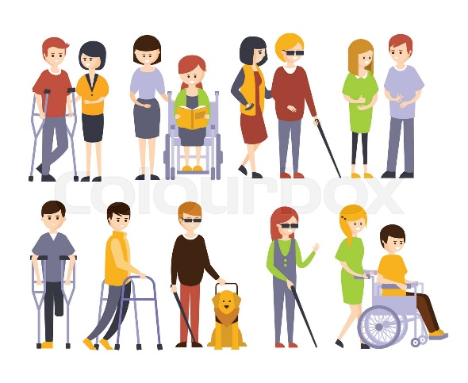

My tv show would be called matchmakers for the BBC where it would match people with similar personalities. They would be able to go on dates outside and to go to places where people have chosen where they feel it would be suitable for their needs.

Disability discrimination is when you are treated less well or put at a disadvantage for a reason that relates to your disability in one of the situations covered by the equality act (Anon., n.d.)

Why are disabled people still being shut out of TV?
In fact, despite being the largest minority group in the UK disabled people are still the most under represented group in TV (keegan, 2020) I believe everybody should be treated as equals because if you do have a disability it doesn’t mean your any less of a person or cant deliver as much as a person without one.
Your disabled under the equality act 2010 if you have a physical or mental impairment that has a substantial and ‘long-term’ negative effect on your ability to do normal daily activities (gov.uk, n.d.)
Many people in the disabled community agree that there is a great need for positive role models and that it is “profound and necessary” (AxiaGroupLLC, 2018)
Know your rights:
Whatever your physical or learning disability, you have the right to equality, fairness, respect and understanding at your workplace
Employees and jobseekers with disabilities are legally protected against discrimination under the equality act 2010 (NHS, 2021) people should be fairly treated in whatever profession when it comes to recruitment, promotion and pay. Even Though my tv show isn’t a proper job for the disabled people I would like base it only around people with disabilities as there are lots of tv dating shows with just normal people so I only think that its fair that they are given a shot at finding love and to feel included in society and the BBC. I hope that you give me this opportunity to deliver a successful show and to make my selected people I have chosen to find their other half, and to go on dates and days out doing whatever it is they love doing.

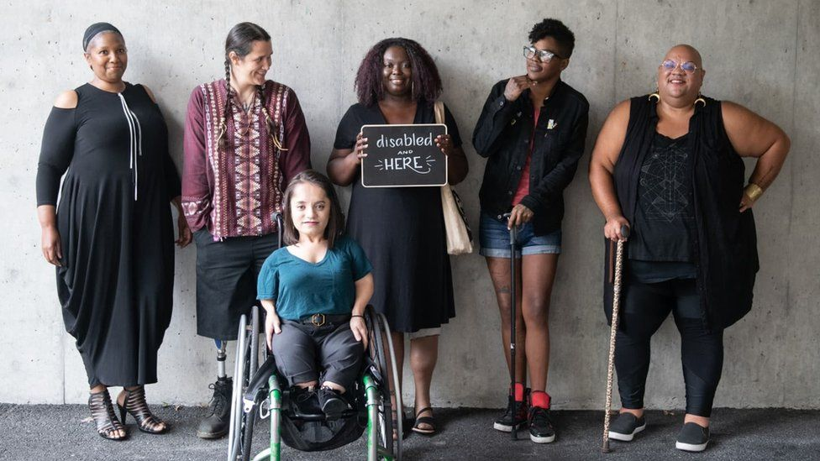 (bbc, 2021)
Around half of disabled people aged 16 to 64 years (53.5%) in the UK were in employment compared with around 8 in 10 (81.6%) for non-disabled people (July to September 2021); disabled people with severe or specific learning difficulties, autism and mental illness had the lowest employment rates. (office for national statistics, n.d.)

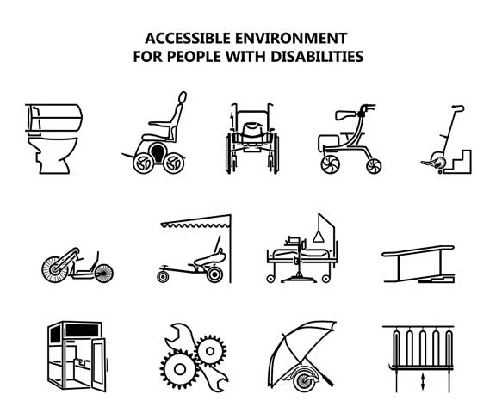
(go access LTD, 2023)

Being disabled certainly doesn’t mean that an individual is forced to remain immobile, as disabilities can sometimes simply hinder a persons mobility, which is why walking equipment for disabled individuals is so useful to have at your disposal (go access LTD, 2023) So I would make sure that all equipment is available depending on each ones disability. I really look forward to hearing from you many thanks.

Anon., n.d. equalityhumanrights. [Online]
Available at: equalityhumanrights.com
[Accessed 16 03 2023].
AxiaGroupLLC, 2018. disabilities in children television. [Online]
Available at: https://axia-group.com/2016/03/01/disabilities-in-childrens-television/
[Accessed 16 03 2023].
bbc, 2021. wethe15:'gamechange'plan for 1.2bn disabled people. [Online]
Available at: Bbc.co.uk/news/disability-58231022
[Accessed 16 03 2023].
colourbox, 2023. colourbox. [Online]
Available at: https://www.colourbox.com/vector/physically-handicapped-people-receiving-help-and-support-from-their-friends-and-family-enjoying-full-life-with-disability-set-of-illustrations-with-smiling-disabled-men-and-women-vector-22460999
[Accessed 16 03 2023].
go access LTD, 2023. walking equipment for disable popular products. [Online]
Available at: https://www.goaccess.co.uk/walking-equipment-for-disabled-popular-products/
[Accessed 16 03 2023].
gov.uk, n.d. definition of disabilty under the equality act 2010. [Online]
Available at: www.gov.uk
[Accessed 16 03 20203].
keegan, m., 2020. independant. [Online]
Available at: https://www.independent.co.uk/arts-entertainment/tv/features/disabled-tv-representation-sex-education-silent-witness-a9413871.html
[Accessed 16 03 2023].
NHS, 2021. work and disabilty. [Online]
Available at: www.nhs.uk
[Accessed 16 03 2023].
office for national statistics, n.d. outcomes for disabled people in the U.K: 2021. [Online]
Available at: https://www.ons.gov.uk/peoplepopulationandcommunity/healthandsocialcare/disability/articles/outcomesfordisabledpeopleintheuk/2021
[Accessed 16 03 2023].

