Program Of Study: BA (Hons) Business Management
Module: Entrepreneurship (LCBB5001)

Title: Entrepreneurial Traits - Report on Richard Branson

Assignment 2 - Component 2
Lecturer: Dr Said Usman
Name: Ionut Agrigoroaei (2247225)
Word No:
Table of Contents
1. Introduction 3
2. A Brief History of Richard Branson 3
Early Life and The Formation of the Virgin Group 3
Major Achievements 4
Motives Behind Branson's Success 4
3. Richard Branson Inspired Entrepreneurial Characteristics 5
Visionary Thinking 5
Resilience 5
Risk-taking 6
Networking and Relationships 6
Adaptability 7
4. Conclusion 7
Picture Reference 10

1. Introduction
An entrepreneur is an innovator who turns opportunities into market ideas, investing time, effort, money, or skills while taking risks. They drive economic change with planning and judgment, aiming to generate wealth through creative efforts (Kuratko, 2019). Richard Branson, widely known for his entrepreneurship and innovation, has made a lasting impact on the business world. From starting as a young entrepreneur, he founded the Virgin Group, which operates in diverse fields like music, airlines, telecommunications, health, and space tourism. His journey shows his remarkable skill in shaking up traditional markets and opening new opportunities. This report gives a short history of Richard Branson as an entrepreneur, looks at his major achievements and motivations, and highlights the most inspiring entrepreneurial traits to follow.

2. A Brief History of Richard Branson
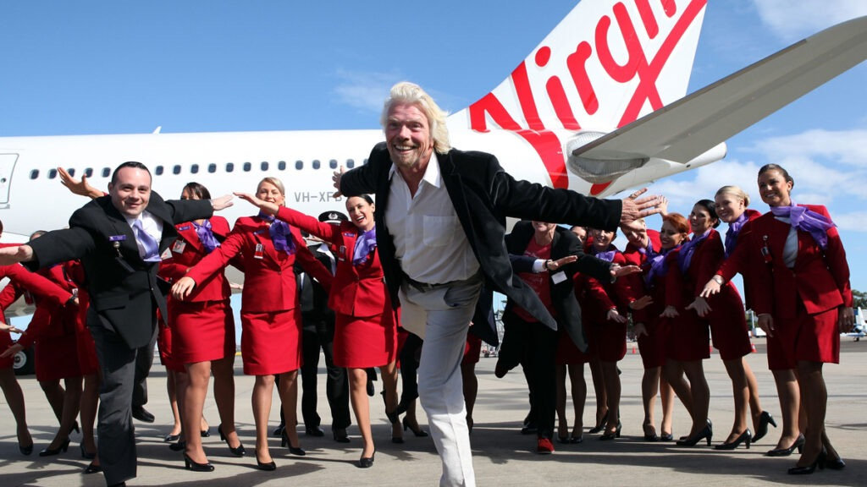
Sir Richard Branson in front of a Virgin Airlines plane and crew, for Business Leader 2024

Early Life and The Formation of the Virgin Group

Richard Branson, the founder of the Virgin Group, is a globally recognized entrepreneur known for his wide array of business ventures and charismatic nature. Famous for his unorthodox methods and adventurous spirit, Branson has achieved notable success in numerous industries, from music to airlines and more. Displaying entrepreneurial talent early on, he started a magazine called "Student" at the age of 16, paving the way for the vast business empire he would later build.
In 1970, Branson expanded into the music industry by starting a mail-order record business. Just a year later, he founded Virgin Records, which grew into one of the top record labels of the 1970s and 1980s, signing iconic artists such as the Sex Pistols, Mike Oldfield, and the Rolling Stones. Branson's innovative approach to business and his willingness to take risks were key factors in the success of Virgin Records (Jackson, 2017).
The growth of Virgin Group was not limited to the music industry. Branson's ventures quickly diversified into a variety of sectors, including airlines (Virgin Atlantic), telecom (Virgin Mobile), health and fitness (Virgin Active), and even space tourism (Virgin Galactic). As of today, Virgin Group holds over 400 companies in various fields, reflecting Branson's wide-ranging interests and his ability to identify and capitalize on new market opportunities.

Major Achievements
Richard Branson has achieved a great deal as an entrepreneur, notably founding Virgin Atlantic in 1984, a time when the airline industry was mostly controlled by major companies (Jackson, 2017). His focus on customer service and innovations like in-flight entertainment helped establish the airline as a major force (Bessant and Tidd, 2018). The Virgin Group has since expanded into over 40 businesses in sectors like travel, telecommunications, health, and space tourism with Virgin Galactic. Branson is also known for his philanthropy through Virgin Unite, addressing social and environmental issues. His adventurous side is seen in his record-breaking Atlantic Ocean hot air balloon crossing and around-the-world sailing (Jackson, 2017).

Motives Behind Branson's Success
Richard Branson's entrepreneurial journey is driven by various motives. In a 2024 documentary by Business Motiversity, he describes himself as a serial entrepreneur who continuously seeks to improve ventures and products. His passion for innovation is evident in his efforts to disrupt traditional industries with new ideas. He prioritizes customer service, consistently enhancing the customer experience in his businesses. While financial success is essential, adventure and challenges are equally important to him. He has undertaken many high-risk, high-reward projects throughout his career. Branson's adventurous spirit motivates him to take risks, viewing business as a fun and thrilling adventure. Additionally, Branson is dedicated to making a positive social impact through his businesses and philanthropy, addressing global issues like climate change and education.

3. Richard Branson Inspired Entrepreneurial Characteristics

Entrepreneurs are often defined by skills such as inner control, planning, goal setting, risk-taking, innovation, reality perception, feedback utilization, decision-making, human relations, and independence, with a common acceptance that fear of failure is minimal among successful ones (Kuratko, 2019). Richard Branson exemplifies key entrepreneurial traits including risk-taking, innovative thinking, and resilience. His readiness to take bold risks in established markets showcases an adventurous spirit, which can inspire aspiring entrepreneurs to pursue opportunities that others might avoid.

Visionary Thinking
Sir Richard Branson has a special talent for finding opportunities where others see problems. Entrepreneurs should work to develop this ability by staying open-minded and creative when solving problems and making decisions. Branson shows that being optimistic and thinking outside the box can turn difficult situations into opportunities.
As noted by Barringer and Ireland (2018), successful entrepreneurs usually have a clear idea of what they want their businesses to achieve. This clear vision helps them make important decisions, stay focused on their goals, and build trust with their team and others. When combined with the skill of finding opportunities in challenges, this clear vision becomes even more powerful. Entrepreneurs can handle uncertain situations confidently and creatively, leading to sustained growth and success in their businesses.

Resilience
Throughout his career, Branson encountered many setbacks but showed remarkable resilience, understanding that failure is a part of the entrepreneurial journey. He embodies this trait by consistently bouncing back and pushing forward despite challenges. For instance, his Virgin Cola venture, which aimed to compete with Coca-Cola and Pepsi, ultimately failed to make a significant impact in the competitive beverage market. Nonetheless, Branson's ability to persevere through such adversities is essential for any entrepreneur. According to Elfring and Hulsink (2019), resilience in entrepreneurship refers to the ability of entrepreneurs and their businesses to recover and return to their usual performance level following significant disruptions. Branson's experiences highlight the importance of resilience, as setbacks are inevitable on the path to success.

Risk-taking
Branson's willingness to take calculated risks is an essential trait for any successful entrepreneur. This disposition allows him to pursue innovative and ambitious projects, even in the face of potential setbacks. While his adventurous pursuits, such as record-breaking stunts, have brought him acclaim, they have also occasionally led to criticism and potential reputational damage, particularly when things did not go as planned. These reputation risks highlight the inherent challenges that come with a risk-taking approach.
Entrepreneurs must carefully evaluate risks and be prepared to navigate uncertainty. According to Feng, Allen, and Seibert (2022), the entrepreneurial identity necessitates significant personal initiative, work independence, risk-taking, and a strong motivation to achieve. These characteristics are crucial for successfully steering a business through the uncertainties and challenges of the entrepreneurial journey.
Moreover, risk-taking in entrepreneurial leaders involves calculated actions that not only reflect their experimental nature but also serve to inspire their employees to adopt similar behaviours (Subramaniam and Shankar, 2020). By taking informed risks, leaders like Branson prove confidence and innovation, encouraging their teams to embrace new ideas and approaches. This culture of calculated risk-taking can lead to a more dynamic, adaptable, and successful organisation.

Networking and Relationships
Branson places high importance on relationships with his employees and partners, recognising that building a strong network can provide essential support and pave the way for fruitful collaborations (BusinessNews, 2016). His charismatic leadership style is a key part of his success, as it allows him to inspire and motivate his team, thereby fostering a positive and dynamic company culture. Branson's networking skills have enabled him to build extensive connections, which he effectively uses to create diverse opportunities and partnerships. Networking goes beyond practicality; it is also about establishing trust, connecting with others, and sharing mutual interests. In uncertain times, the ability to network effectively becomes even more crucial, as it can be a vital component for an entrepreneur's survival and ongoing success (Elfring and Hulsink, 2019). Branson's approach underscores the importance of not only forming but nurturing relationships that can support and sustain entrepreneurial ventures through all manner of challenges.

Adaptability
Branson has skilfully diversified the Virgin Group's ventures to align with market demands, showing the importance of being able to adapt to changing circumstances. Developing this ability to pivot is essential for entrepreneurs. Openness, characterised by curiosity, broadmindedness, and originality, describes individuals who are willing to take risks and explore new ideas. This trait is closely linked to resourcefulness and innovativeness, which are critical in entrepreneurship for the development and management of new businesses (Van Ness et al., 2020). Creating new business ideas often requires a degree of experimentation, and encountering setbacks and failures is a natural part of this journey. The true test for entrepreneurs is their ability to persevere in the face of these challenges (Barringer and Ireland, 2018).

4. Conclusion
Becoming an entrepreneur requires developing certain traits. Although some people might naturally lean towards entrepreneurship, research by Barringer and Ireland (2018) challenges the idea that entrepreneurs are only born. Instead, these studies suggest that entrepreneurial skills can be acquired through experience, education, and effort. This inclusive perspective encourages more people to consider entrepreneurship, regardless of their starting point. It underscores the importance of ongoing personal development and gaining the skills and mindset needed to successfully navigate the entrepreneurial path. Richard Branson's journey highlights the significance of innovation, resilience, and prioritising customers. His entrepreneurial drive and dedication to having an impact make him a motivating figure. Aspiring entrepreneurs can gain essential skills by observing his successes and qualities. Embracing visionary thinking, resilience, risk-taking, networking, and adaptability can lead to success in a competitive business environment.

References
- Barringer, B. & Ireland, D. (2018) Entrepreneurship. Global Edition, Harlow: Pearson Education, Limited.

- Bessant, J. and Tidd, J. (2018) Entrepreneurship. 1st edn. Wiley. Available at: https://www.perlego.com/book/3865870. (Accessed: 12 December 2024).

- Business Motiversity (2024) Richard Branson: How To Get Rich & Change The World in 2025. Available at: https://youtu.be/-8j1rHKxrLc?si=QigiDetQ9jnkpTA_. (Accessed: 12 December 2024).

- BusinessNews (2016) Summary: The Virgin Way. Must Read Summaries. com. Available at: https://www.perlego.com/book/9679. (Accessed: 12 December 2024).

- Elfring, T. and Hulsink, W. (2019) “Dynamic Networking by Entrepreneurs: Collaborative Efforts in Developing Opportunities and Mobilizing Resources”. In: J.J. Reuer, S.F. Matusik, and J. Jones, eds. The Oxford Handbook of Entrepreneurship and Collaboration. Oxford Academic.

- Feng, J., Allen, D.G. and Seibert, S.E. (2022) “Once an entrepreneur, always an entrepreneur? Entrepreneurial identity, job characteristics, and voluntary turnover of former entrepreneurs in paid employment”. Personnel Psychology, 75(1), pp. 179–213. doi:10.1111/peps.12455.

- Jackson, T. (2017) Virgin King (Text Only). [edition unavailable]. HarperCollins. Available at: https://www.perlego.com/book/680119. (Accessed: 12 December 2024).

- Kuratko, D. (2019) Entrepreneurship: Theory, Process, Practice. Cengage Learning EMEA. Available at: https://www.perlego.com/book/2105551. (Accessed: 12 December 2024).

- Subramaniam, R. and Shankar, R. K. (2020) “Three Mindsets of Entrepreneurial Leaders”. The Journal of Entrepreneurship, 29(1), 7-37. https://doi.org/10.1177/0971355719893498

- Van Ness, R.K., Seifert, C.F., Marler, J.H., Wales, W.J., and Hughes, M.E. (2020) “Proactive Entrepreneurs: Who Are They and How Are They Different?”. The Journal of Entrepreneurship, 29(1), pp.148-175. https://doi.org/10.1177/0971355719893504.

Picture Reference
Business Leader (2024) Sir Richard Branson in front of a Virgin Airlines plane and crew. Available at: https://www.businessleader.co.uk/virgin-group-ceo-prepare-failure/. (Accessed: 12 December 2024).

