Module: Managing Hotel Administration
BMIH6004

Student Learning Log

Front Office Department at Novotel Southampton and Ibis Southampton Centre - Reflection Log

Lecturer: Jessica Newport
Student: Anamaria Cristina Salanchi
Student ID: 2206421
Word count: 1357

I acknowledge the use of Grammarly on 7th of March 2025 to check my work.
I confirm that I have not presented any Al generated text as my own work. I confirm I have copies of my drafts, notes, and other resources I used before, and after the use of Al tools which I may be asked to provide in evidence.

Introduction
The Reception/Front Office department is the hotel's administrative hub, coordinating guest interactions, reservations, check-ins, and check-outs while ensuring efficient communication across departments. My placement in this department gave me firsthand experience with hotel operations, guest service interactions, administrative procedures, and dealing with unanticipated situations.
My learning objectives during this placement were:
- Gaining technical knowledge in hotel management systems (e.g., Opera Cloud, ResaWeb).
- Understanding guest expectations and service standards in front office operations.
- Developing problem-solving and communication skills in a fast-paced environment.
- Identifying administrative inefficiencies and proposing practical solutions.
To reflect on my experiences, I will use Gibbs' Reflective Cycle (1988), which consists of six stages: description, feelings, assessment, analysis, conclusion, and action plan. This organised method will allow me to critically evaluate my placement experience and its impact on my professional development. ASET (2024) highlights the importance of structured placements that fit learning objectives, ensuring students develop important skills rather than being allocated routine tasks and jobs.

Reflection on Experience and Personal Development
Shadowing a Supervisory Position in the Front Office
Shadowing the Front Office team gave me an inside look at guest interactions, reservations, and administrative responsibilities. While some employees were friendly and took the time to explain procedures, I found that training chances were uneven.
At IBIS, I saw how receptionists handle check-ins, check-outs, and payments. The system required manual payment entry due to a lack of direct POS interface with the core hotel system. This increased the possibility of errors and inefficiencies, leading to lengthier processing times.
One of the most challenging incidents was dealing with three drunken individuals who visited Novotel reception and demanded an ambulance for an alleged medical emergency. The General Manager intervened, handling the situation firmly but controversially, refusing to call an ambulance and instead calling the police. While the individuals were forceful, I believe that contacting an ambulance should have been the priority if the guest had been in serious medical difficulty. This situation illustrated the problematic judgements that front-desk personnel must make under pressure and raised concerns about hotel regulations surrounding medical emergencies.

Challenges and Negative Experiences
While I expected to be involved in guest-facing tasks, some experiences were disappointing due to unclear expectations and communication gaps.
Lack of Training Opportunities
I was advised not to be given too much information at IBIS reception because our placement was temporary. This reduced my opportunities to learn more about revenue management, reservations, and guest service norms.
Interdepartmental Communication Issues
One of the most annoying issues was a lack of communication between the Front Office and other departments, particularly Food and Beverage. During a conference event, participants frequently asked for coffee from reception, unaware that a lounge area had already been filled with refreshments. Due to poor communication, bar staff continued to provide unnecessary refills, wasting time and resources (Musadad et al., 2021).

Conflict at IBIS Reception
On a separate occasion, I disagreed with an IBIS receptionist who was dismissive and unable to interact with me. She gave me a job list that included deep cleaning responsibilities, which I refused because they were unrelated to front office training. This sparked an altercation with the Front Desk Manager, who agreed with the receptionist. This incident highlighted workplace culture issues, where some staff members were unwilling to engage with trainees/students, and management failed to address concerns.

Critical Analysis of Work-Based Skills and Technical Knowledge
Importance of Work-Based Skills in Reception/Front Office
Front office staff must have strong communication and problem-solving skills because they contact guests daily. One important insight was that even minor activities, such as remembering a guest's preferences, can increase guest satisfaction and brand loyalty (Rutherford and O’Fallon, 2007).
I also discovered that front desk operations go beyond customer interactions; employees must coordinate with other departments, manage reservations, and resolve problems promptly. However, my experience showed that training and communication deficiencies lead to inefficiencies that may have been prevented with systematic onboarding programs (Walker, 2021).
Relevance of Technical Knowledge in Front Office Management
Technical skills, particularly experience with hotel management software, are essential for administrative effectiveness. At IBIS, I noticed that the POS system was not paired with the central booking system, resulting in delays and manual errors. Johnston, Clark, and Shulver (2012) highlight that seamless digital integration boosts operational efficiency and guest happiness.
Furthermore, inadequate staff cooperation during a system failure at IBIS (when the hotel went without internet for four days) revealed flaws in contingency planning. Instead of an organised backup system, receptionists had to manually conduct check-ins and check-outs, which resulted in visitor dissatisfaction and slow-paced service.

Reflection on Organisational Issues
Guest Service Issue: Interdepartmental Miscommunication
A significant operational difficulty was a lack of cooperation between reception and other departments. This was obvious in a number of situations, including the conference coffee miscommunication and the manual payment mechanism at IBIS.
Proposed Solutions
- Implement daily briefings to guarantee that all departments agree on guest expectations and service needs. These briefings should clarify inter-departmental roles and inform workers of upcoming events, VIP guests, and special requirements. Babbra (2020) found that efficient internal communication increases staff satisfaction and service efficiency.
- Use real-time digital communication technologies to improve coordination between the front office, housekeeping, and food and beverage. Research indicates that digital tools can reduce service delays and prevent important details from being overlooked (Forman and Udvaros, 2023). Instant messaging apps and integrated hotel management systems help improve communication and reduce confusion.
- Standardise guest communication protocols to guarantee clear instructions on available services and facilities. A lack of standardised communication results in inconsistent visitor experiences and operational inefficiencies (Sigala, 2005). Providing reception with clear instructions for responding to visitor enquiries will assist with solving these challenges.

Conclusion and Action Plan
My time in the front office department taught me the importance of structured training, efficient communication, and job-related skills in hospitality operations. One of the most important conclusions from this event was the need for structured training programs that guarantee students receive appropriate learning experiences rather than being handed repetitive, monotonous work. A well-designed internship should highlight administrative, problem-solving, and service-related abilities to prepare students for managerial positions.
Another important takeaway was the effect of interdepartmental miscommunication on service efficiency and guest satisfaction. A lack of clear communication among reception, housekeeping, and F&B frequently resulted in operational inefficiencies, avoidable delays, and visitor dissatisfaction. Implementing improved communication channels would enhance collaboration and the overall guest experience.
Finally, my placement demonstrated the significance of work-related abilities in reception. Small experiences with guests, such as properly managing complaints or delivering information, can impact their opinion of the hotel. Developing these abilities is critical for guaranteeing effective front-office operations and providing high-quality customer service.

Future Action Plan for Professional Growth
- Develop leadership and communication skills by taking on decision-making and team-coordinating tasks. My placement demonstrated the value of decision-making in high-pressure situations, such as when the general manager had to deal with an emergency involving intoxicated individuals at reception. In the future, I plan to seek supervisory positions that will allow me to practise conflict resolution and staff coordination (Somlai and Egyetem, 2019).
- Develop expertise in hospitality technology, including reservation systems and POS integration. Throughout my placement, I noticed inefficiencies in the reservation and payment processes, such as manually entering transactions due to system incompatibility. These difficulties caused delays and increased the possibility of errors, significantly affecting the visitor's experience. To overcome this, I will study integrated hotel management systems, which streamline operations and improve service efficiency. According to Cobanoglu et al. (2021), smooth system integration decreases operational disruptions while increasing overall visitor happiness, making it an important ability for future hotel administration roles.
- Encourage organised placements to provide learning-focused training for prospective students. My experience demonstrated that student placements are frequently unstructured, with chores such as cleaning storage rooms and performing menial labour taking precedence over learning critical administrative skills. To close the gap between academic learning and industry practice, I will advocate for well-structured internship programs that offer hands-on experience in relevant areas of hotel management (Walker, 2021). Future placements should focus on skill development rather than regular duties, which would benefit both students and hospitality firms.

Reference List
- ASET, 2024. Good Practice Guide for Work-Based and Placement Learning in Higher. https://www.asetonline.org/wp-content/uploads/2024/04/ASET-Good-Practice-Guide-Work-based-and-Placement-Learning.pdf
- Babbra, N.K., 2020. Evaluating Gaps in Interdepartmental Communication and Assessing Their Relation to Employee Motivation. https://www.ijariit.com/manuscripts/v6i4/V6I4-1454.pdf
- Babbra, N.K., 2020. Evaluating Gaps in Interdepartmental Communication and Assessing Their Relation to Employee Motivation. https://www.ijariit.com/manuscripts/v6i4/V6I4-1454.pdf
- Cobanoglu, C., Dogan, S., Berezina, K., Collins, G., Nanu, L., Shahtakhtinskaya, K. and Parvez, O., 2021. Hospitality and tourism information technology. University of South Florida M3 Center Publishing, 17(9781732127593), p.2. https://www.researchgate.net/publication/373718925_DIGITAL_MARKETING_IN_HOSPITALITY_AND_TOURSIM
- Forman, N. and Udvaros, J., 2023. Digital innovation in hospitality: bridging the gap between concierge services and hotel guests. Journal of Environmental Management & Tourism, 14(6), pp.2673-2684. https://www.proquest.com/scholarly-journals/digital-innovation-hospitality-bridging-gap/docview/2884351697/se-2?accountid=130472
- Gibbs, G., 1988. Learning by Doing: A Guide to Teaching and Learning Methods. Oxford: Oxford Polytechnic.
- Johnston, R., Clark, G., and Shulver, M., 2012. Service Operations Management EBook_o4, Pearson Education, Limited, Harlow. ProQuest Ebook Central. https://ebookcentral.proquest.com/lib/trinity/detail.action?docID=5173931
- Musadad, M., Dianita, I.A. and Dirgantare, P., 2021. Hotel Interdepartmental Communication: A Case of F&B Service and Sales and Marketing at Mercure Bandung Nexa. http://dx.doi.org/10.30647/trj.v5i1.97
- Rutherford, M.D., O’Fallon, M. and Rutherford, D.G., 2007. Hotel Management and Operations, John Wiley & Sons, Incorporated, 2006. ProQuest Ebook Central, https://ebookcentral.proquest.com/lib/trinity/detail.action?docID=257559.
- Sigala, M., 2005. Integrating customer relationship management in hotel operations: managerial and operational implications. International Journal of Hospitality Management, 24(3), pp.391-413. https://www.academia.edu/download/50409797/j.ijhm.2004.08.00820161118-22748-2uqhh.pdf
- Walker, J.R., 2021. Introduction to Hospitality. Global Edition. Pearson Education. Limited. ProQuest Ebook Central. https://ebookcentral.proquest.com/lib/trinity/detail.action?docID=6371059

Appendix
Level 6 Hotel Placement – Weekly Progress Tracker
Task: Maintain a weekly progress tracker documenting your experiences, tasks performed, challenges faced, and lessons learned. Bullet points format is welcome. You must submit this document to the designated Turnitin link by [Friday, 7th March 2025] at 23:59pm.

Week 1
Experiences/Tasks/Challenges/Lessons  (outline hotel department) | Shift  (Date/Time) | Student Signature | Hotel Mentor Signature
Induction Day  We were received very professionally. The reception was already informed about the induction meeting, and upon arrival, we were given access cards for the elevator, along with the floor and conference room details. The conference room was fully prepared by the time we got there.  There were six of us assigned to Novotel. When we all shared our expectations and what we hoped to learn during the placement, most of us expressed that we wanted to spend time with a manager to see what happens behind the scenes and how a hotel is managed. However, HR quickly informed us that they could not offer that kind of placement. Hearing this was disappointing for all of us.  After the induction session with HR, we were supposed to complete the Health and Safety and Fire Procedures training, but that did not happen. We were instead told that it would take place on our first shift.  Since my schedule depended on my children’s routine, my rota was set for three days a week, ensuring I could complete my 16-hour weekly shifts.  Day 1: Reception at IBIS  On the first day, I was in the office with Catherine, the HR representative responsible for us, waiting to complete the Health and Safety and Fire Procedures training. However, this did not happen again because “everyone is too busy.” Instead, I was sent to the reception at IBIS, where Catherine specifically told the receptionist not to go into too much detail with any of the students, as we would not be staying at the hotel for long.  The reception area is an open space connected to the restaurant and bar. The receptionist is responsible for all three areas, including preparing the restaurant for breakfast, lunch, and dinner and cleaning up afterwards. While there, I observed how check-ins and check-outs were handled, how payments were processed, and that they use Opera Cloud software, a product of Oracle Inc.  I noticed that the POS system is not directly connected to the central system of IBIS, so the receptionists manually enter the payments. For reservations made directly by phone, they use ResaWeb. They also have ShiftNote, where staff document daily events for the next shift. For reviews, they use TrustYou, but I noticed that some receptionists only respond to positive reviews, leaving negative ones for other team members because they are unsure how to reply without making the situation worse.  Day 2: Sorting Uniforms in Storage  On the second day, I was sent to the attic, where I spent my entire shift sorting uniforms, separating those in good condition, those for charity, and those that needed to be discarded. The goal was to complete an inventory of uniforms, which had not been done since 2019, even though it was supposed to be done periodically. This task falls under HR’s responsibility, but when we finished sorting, HR only showed up to count the inventory, which didn’t seem entirely fair.  My colleague and I were left alone in storage without even being given water for a long time. It wasn’t until three hours later that HR came to tell us we could take a break. After our break, we were sent back to finish the task. | 13/01/2025  First Week – W/C 20 January
Day 3: Reception at Novotel

I was at the Novotel reception the next day, but I didn’t do much, as I had already learned about the system on my first day at IBIS. However, I did witness an unexpected situation.
Three intoxicated individuals barged into the hotel, claiming that one of them was having an epileptic seizure and demanding that reception call an ambulance. Fortunately, the general manager was present and took control of the situation. She explained to them that the hotel could not call emergency services without sufficient details about the individual, especially since he was not a hotel guest.
This angered two of the individuals, who started causing a scene. The manager then called the police. When the police arrived, the two aggressive individuals ran away, leaving behind the man who claimed to have had a seizure. He stayed at the hotel entrance, waiting for a taxi booked by reception to take him to the hospital.
Although I was a bit shaken by the situation, especially since I had never expected to witness such an event, I don’t think the manager handled it entirely correctly. While it’s true that the men involved were somewhat aggressive, I still believe that if the individual had been having an epileptic seizure, the situation could have been serious.
In such cases, calling an ambulance seems the most logical and responsible action. You can’t just call a taxi to take someone to the hospital when they might be experiencing a medical emergency. Of course, there was no way to know for sure whether the person was really having a seizure or if the situation was exaggerated, and the men with him could have been overreacting.
Since I don’t know what happened afterwards, I can’t say for sure if they panicked and left or if the man actually had a seizure. But emotionally, if I had been in that position, I think I would have called an ambulance, just in case.
Trying to understand why the manager made that decision, I considered that she might have had more experience and recognised that the situation was not as severe as it seemed. On the other hand, it’s also possible that she has dealt with similar incidents before and knew that these situations often turn out to be false alarms.
Since I didn’t discuss the incident with her afterwards, I don’t know her perspective or why she made that decision.

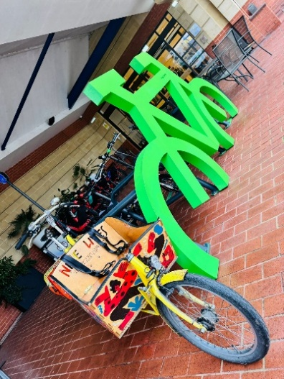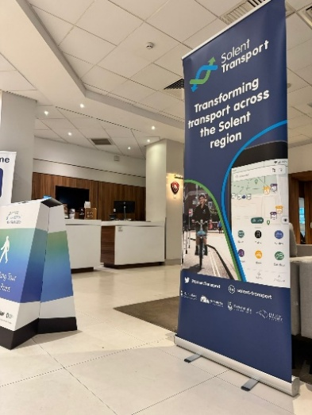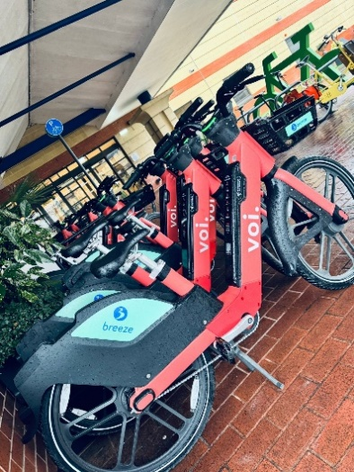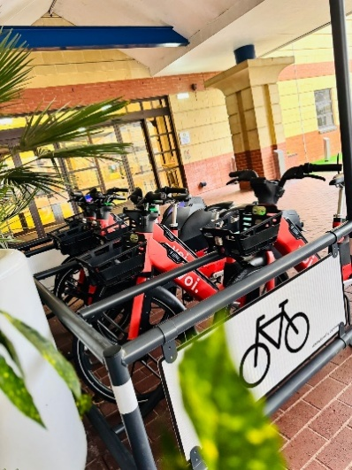

Week 2
Experiences/Tasks/Challenges/Lessons  (highlight hotel department) | Shift  (Date/Time) | Student Signature | Hotel Mentor Signature
This week, I was assigned to Food and Beverage. The supervisor was very kind and took the time to show me how breakfast payments are processed and how charges are applied to guests' rooms. Unfortunately, since it was not a busy day, I did not get the chance to put this into practice.  The F&B manager assigned my colleague and me to prepare an event hall for 130 guests. This gave us hands-on experience in setting up large-scale events.  I also learned how to operate the coffee machine and restock the bar fridge, which are essential daily tasks in the F&B department.  This week was truly enjoyable, and I was impressed by the way the Food & Beverage supervisor welcomed us. He had a positive attitude, was motivating, and maintained a light-hearted, friendly atmosphere.  What stood out the most was that they genuinely appreciated our willingness to learn. They openly expressed their happiness that we were eager to gain knowledge and even mentioned that it was refreshing to see young people so committed to their education.  He said that he wished to have been more involved in helping us, but, as he jokingly put it, his job title didn’t exactly allow it :). | W/C 27 January

Week 3
Experiences/Tasks/Challenges/Lessons  (highlight hotel department) | Shift  (Date/Time) | Student Signature | Hotel Mentor Signature
First Shift: Breakfast and HR Issue  I was assigned to Food and Beverage again this week. The first part of the morning was slow, with little to do besides clearing breakfast from the buffet, wiping tables, and resetting them.  During my shift, my colleague Cosmin asked me to speak with Catherine (HR) about his shifts. He had received an email from the university stating that he had missed all his scheduled shifts, even though he had attended everyone. He had also tried reaching out to HR, but they were not responding to his messages.  When I asked Catherine about this, she seemed annoyed by my question and told me that we were not allowed to show up whenever we wanted without notifying them, even though we had all clearly stated our availability during induction.  Second Shift: Unnecessary Tasks and Isolation  The next shift felt noticeably different. When I arrived in the morning, the general manager instructed the F&B manager to give us as many tasks as possible. As a result, I ended up spending the entire shift cleaning the glassware storage room, sorting glasses, and vacuuming hallways.  I don’t mind doing these tasks, but I do not think this is the kind of experience I should be gaining at Level 6. I expect to be given work that helps me learn about hotel operations, not just manual labour. Even if I am not being directly taught something, being surrounded by people in the industry allows me to pick up useful insights and knowledge, something that doesn’t happen when I am isolated in a storage room.  At one point, a bar staff member asked me to vacuum a long hallway and then disappeared. Since I wasn’t told which vacuum to use, I went to get the F&B vacuum and passed through the kitchen to avoid walking with the vacuum through the entire restaurant and lobby.  Halfway through vacuuming, an employee yelled at me for using a vacuum that “smelled bad” and told me I had to change the bag. This irritated me because I am not an employee and was never told that I had to do maintenance on the vacuum. When I finished, I attempted to return the vacuum to the F&B storage, again passing through the kitchen. This time, a kitchen employee told me that I wasn’t allowed to go through there with the vacuum, even though no one said anything the first time I passed through.  Third Shift: Bar Service and Supervisor’s Feedback  The next day was better. The supervisor was back, and I spent the first part of my shift shadowing again. Later, I worked at the bar, serving coffee to some guests and handling their payments on my own, with the supervisor next to me for support.  During our conversation, the supervisor told me that he didn’t think it was fair that we were being assigned the tasks we were given. He pointed out that the staff members were paid to do these jobs, so it was unreasonable to use unpaid students for cleaning and manual labour. In his opinion, since we were Level 6 students training to become hotel managers, we should be learning more relevant skills that would actually help us in our careers, confirming also my opinion.  Unexpected Cleaning Duties at IBIS  Later that day, I was sent to IBIS because they called Novotel requesting help. When I arrived, I was given a cleaning checklist and told to complete a deep cleaning session.  I didn’t think this was appropriate, but I did it anyway. The list included:  - Deep cleaning the coffee machine  - Deep cleaning the dishwasher (which meant kneeling to scrub it)  - Cleaning the restaurant and preparing it for lunch service  While I am willing to do various tasks, this didn’t feel like a learning experience, it felt like free labour. | W/C 3 February

Week 4
Experiences/Tasks/Challenges/Lessons  (highlight hotel department) | Shift  (Date/Time) | Student Signature | Hotel Mentor Signature
First Shift: Housekeeping and Fire Procedures  This week, I was assigned to Housekeeping, which is an outsourced firm. The housekeeping department is run by a company called HOTELCARE, and their employees do not receive the same benefits as the hotel’s direct staff. For example, I heard from a former housekeeping employee that during COVID-19, the hotel's direct employees received 80% of their salary while staying at home, whereas the housekeeping staff received nothing. This put them at a disadvantage compared to the rest of the team.  The first part of the day was spent with the housekeeping manager, who finally conducted the Fire Procedures training. He was genuinely shocked that I had already been at the hotel for four weeks without HR taking care of this. After that, he showed me their work system and how they handle paperwork.  At Novotel, there are only eight housekeeping employees, and they are assigned the same rooms every time so that, in case of a guest complaint, it is clear who is responsible. I also noticed they use robot vacuums for the rooms, but the manager was not satisfied with them because they are effective.  Later in the day, I was assigned to shadow a housekeeper who did not speak English. She led me to a room, said "You do beds," and then left. Since I was only supposed to shadow, I did nothing and waited for her to return.  After that, I was paired with another housekeeper, who was much nicer and told me that it was her job to do all the tasks, and I was welcome to just observe. While observing, I noticed that when the robot vacuums ran out of battery, instead of switching to a regular vacuum, they would often just pick up visible dirt by hand and leave the rest of the room unvacuumed.  I believe this situation is not acceptable, especially considering the high standards the hotel claims to uphold, particularly in terms of sustainability and cleanliness.  I can only hope that all companies remember the lessons learned during the pandemic and apply them moving forward. That period was a difficult time for everyone, and the practices we developed (especially regarding hygiene and responsible operations) should not be forgotten but rather implemented consistently.  Second Shift: Front of House and Miscommunication  The next day, the manager assigned me to Front of the House with the employee responsible for that section. She was surprised when I told her I had not made any beds the day before. When I explained that, as a Level 6 student, I was only there to observe, she told me that they usually show students how to make one bed, then expect them to make the rest on their own. I did not think this was fair, as bed-making is one of the most physically demanding parts of the job.  That day, the housekeeper initially expected me to clean toilets and locker rooms along with her. But after I explained my perspective, she only asked for help with smaller tasks, which I was happy to assist with if I was not doing her job alone.  Later, I was asked to vacuum two hallways on two different floors, which I did.  Break Time and F&B Supervisor’s Response  During my break, I ran into the F&B supervisor and mentioned wanting a coffee. He told me he would gladly make one for me, but the F&B manager was at the bar and decided that we could no longer drink coffee whenever we wanted. I found this strange and frustrating, as I could have easily just paid for my own coffee.  Final Shift: Cleaning Rooms and Questionable Practices  On my last day in Housekeeping, I was once again assigned to the same person from Front Office, but we were cleaning guest rooms this time.  I helped dust the furniture and remove the bed linens, but I noticed something troubling, repeating:  - In some rooms, if the robot vacuum ran out of battery, they wouldn’t bother vacuuming manually.  - Instead, they would quickly check for any sizeable visible dirt, pick it up by hand, and move on to the next room without properly cleaning the floor.  This made me question the cleaning standards even more, especially since guests assume their rooms are thoroughly cleaned.   | W/C 10 February

Week 5
Experiences/Tasks/Challenges/Lessons  (highlight hotel department) | Shift  (Date/Time) | Student Signature | Hotel Mentor Signature
This week, I stayed at home after informing the hotel that I could not come in. My children were on vacation, and since I had no one to look after them, bringing them with me was not an option.  I was told I would need to make up for this week at the end of my placement, meaning I will recover these shifts after March 28. | W/C 17 February

Week 6
Experiences/Tasks/Challenges/Lessons  (highlight hotel department) | Shift  (Date/Time) | Student Signature | Hotel Mentor Signature
First Day: A Positive Start at IBIS and a Shocking Discovery at Novotel  The first day of this week went surprisingly well. I was at IBIS, and the receptionist on duty was very kind. I was pleasantly surprised when he let me use the hotel’s system on the computer, which gave me a chance to interact with it firsthand.  We also had a conversation about the work culture at the hotel, and I learned that while the hotel officially promotes equality and diversity, the reality is quite different. There are clear favouritism issues among managers, and not all staff members are treated equally.  Later in the day, I was called to Novotel to inspect some rooms, and what I found was shocking: the level of cleanliness in the rooms I checked was terrible. The hotel staff even asked me to take photos of everything I found.  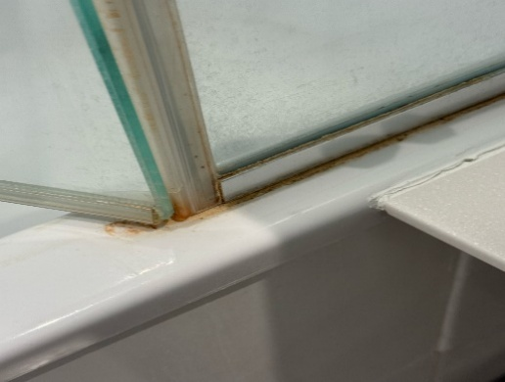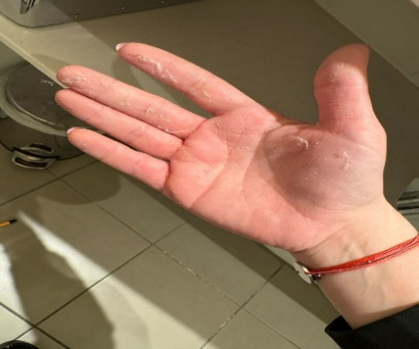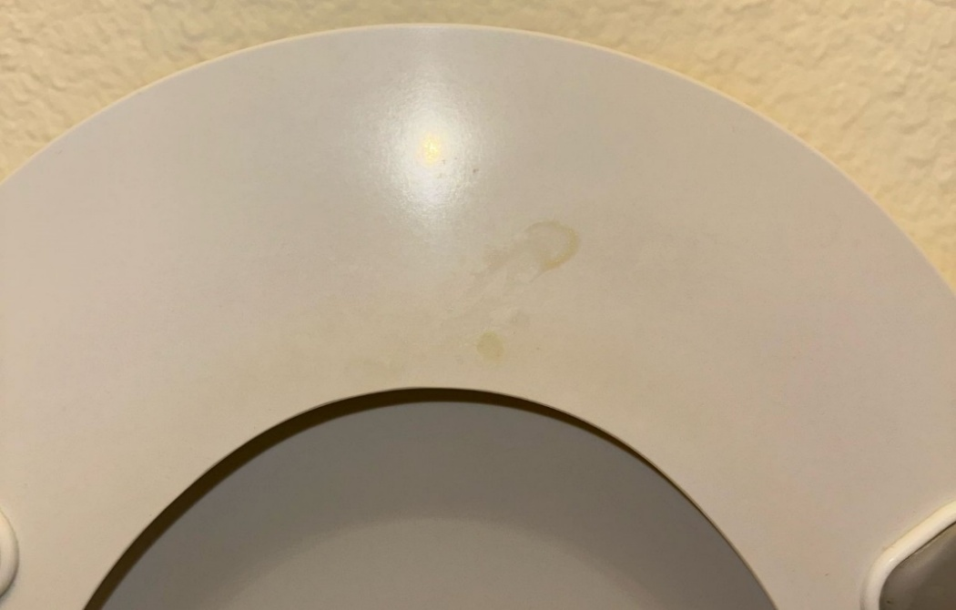  Second Day: Disrespect and Conflict at IBIS  I was back at IBIS the next day, but the experience was completely different. The staff that day was disappointing. The receptionist, a young woman, looked bored and uninterested when I entered the hotel.  From the start, she clarified that she was unhappy that I was there. When I asked if I could get the rota to sign it since I wasn’t sure where it was, she told me it was in the office. I found it odd that she expected me to go inside and search for it myself, so I politely asked if she could hand it to me.  After that, she gave me a task list, which was once again the same deep cleaning tasks and preparing the restaurant for lunch. She handed me the paper and said:  “You must do this. If there’s something you don’t know, ask me, and I will show you.”  Since I had already done all these tasks before, I told her that I was happy to help with certain things, but I was not going to do all of them, as that was not my job. She did not take this well. She snatched the paper from my hands and said she would do it herself since she had to do these daily tasks anyway.  When the manager arrived, I asked her if it was normal for staff members to act like this. From there, the situation escalated into an argument. I explained that since the start of my placement, I had barely learned anything helpful and had been assigned to do cleaning tasks most of the time. As a Level 6 student, I expected to gain valuable skills, not just be used for manual labour.  However, the manager sided with the receptionist, saying that she did not find her behaviour rude and that I should have followed the instructions.  After that, I tried to help, but the staff wanted nothing to do with me. The receptionist left me at the front desk while she did all the tasks herself. Whenever she needed something from the desk, she would grab it aggressively, and when she put things back, she would slam them on the desk near me, which I found extremely rude.  When I brought this up to the Front Desk Manager, she told me it was "normal" because I had "upset her."  Later that day, I was sent to Novotel's reception, which was a much better experience.  Final Day: Choosing Novotel Over IBIS  On my last day of the week, I was supposed to return to IBIS, but since I knew the same receptionist would be there, I went straight to Novotel instead.  I met the Front Desk Manager and asked if I could stay at Novotel instead of IBIS, and she approved my request.  At Novotel, I was assigned to work on social media content. I took photos of the buffet and lunch setup for the hotel’s Instagram page. I had done this before, and I enjoyed it. I also received positive feedback from the Deputy Manager.  Reflection on My Experience at the Hotel  Overall, my experience at this hotel was far from pleasant. No one seemed to care about the students, how we felt, or whether we were actually learning anything. The staff appeared friendly on the surface, but as soon as you turned your back, they would start talking behind it (though, of course, there were a few exceptions who were genuinely kind).  Whenever I tried to ask questions that could help me with my assignment, all the managers suddenly became too busy. They would only give rushed answers while walking away, leaving me no fundamental understanding of the topic. This showed a lack of respect for students who were there to learn.  During my conversation with the Front Desk Manager, I explained my perspective and how I felt I had not learned anything valuable for a future managerial role. Her response? No other students had ever complained, and I was supposedly the only one with an issue with their training methods. But that’s simply not true. Students (mostly migrants) enter universities through recommendations. In our area, many students attend the same institutions, and of course, people share their experiences, whether good or bad. It’s nearly impossible not to know a student, whether they’re in a different year, semester, or even just a few months ahead or behind you.  University marketing largely works through word of mouth. Even when people find opportunities online, they still ask around before committing. Before enrolling, most students will seek opinions from those who have already gone through the experience.  That being said, this shifts into a marketing discussion, which isn’t really the focus of this conversation.  I found it frustrating that instead of addressing my concerns, they chose to compare me to past students. Everyone has different career goals and personal expectations for their learning experience. I refuse to settle for nothing—just because others might have, whatever their reasons were. | W/C 24 February
Hotel Issues and Operational Challenges

Even though my questions were often ignored throughout my placement, I observed several significant problems within the hotel’s operations. These issues affected efficiency, communication, and staff morale, leading to unnecessary complications.

- Poor Kitchen Stock and Limited Menu Options

One of the biggest issues in the kitchen is that their stock levels are extremely low, sometimes close to zero. This leads to limited menu choices for guests, which is frustrating for both customers and staff.
Since the restaurant staff never know which items are actually available, they constantly have to run back and forth between the guest tables and the kitchen, checking if certain dishes are still an option. This wastes time and creates a disorganised dining experience. The root cause? Weak communication (and lack of interest from the employee and even manager side) between the kitchen and restaurant teams could be easily solved with a better system for tracking inventory and updating the menu accordingly.

2. Lack of Communication Between F&B and Reception

The communication between the F&B team and reception is poor, which leads to avoidable confusion. One example I witnessed occurred during Week 2 of my placement.
A conference room on the top floor had coffee included in its rental package. The guests kept calling reception, requesting coffee refills, but the bar staff (who were responsible for delivering it) found the coffee flask untouched each time they checked. Since there was no direct communication between the departments, this cycle continued multiple times.
I suggested that the bar staff speak directly to reception to clarify the issue, as the WhatsApp messages used for interdepartmental communication were too vague. When we arrived at reception, we discovered that the conference guests had never been informed about the lounge area where their complimentary coffee was located. Instead, they assumed they needed to order coffee from the bar separately.
To resolve the issue, we went to the conference room, explained the situation, and let them know that if they wanted any extra coffee outside of what was included, they would have to order it directly from the bar. This slight lack of communication created an unnecessary issue that could have been prevented with clearer instructions at the start of the event.

3. Maintenance Staff Avoiding Work

At the time of my placement, they had a major project: replacing all the doors in the hotel. They were supposed to install 12 doors per day, but they were only completing 5-6 doors daily, leaving them far behind schedule.
During one of their smoke breaks, I asked the maintenance manager if he could provide some insight into their department and the challenges they faced. His response?
“We have a lot of problems to solve, but we just focus on finding solutions. We don’t actually try really hard to implement them.”

4. Overloading Reception Staff at IBIS

At IBIS, receptionists are not just responsible for front desk duties, they are also expected to handle:

- Bar service
- Restaurant duties
- Sometimes even kitchen work
- Occasionally helping with maintenance tasks

This creates stress and inefficiency, as receptionists are often pulled in too many directions. On busy days, this leads to longer wait times for guests and a generally chaotic work environment.

5. System Failure at IBIS – Four Days Without Internet

For four consecutive days, IBIS had major internet issues, which meant staff could not access the hotel’s system at all. This affected check-ins, check-outs, and reservations, making it impossible to run operations smoothly. Instead of having a backup plan, staff were left struggling to handle guests manually, causing frustration for both employees and customers.

6. Favouritism and Unequal Treatment Among Staff

One of the biggest issues across the hotel is the clear favoritism from management. Instead of treating all employees equally, certain staff members are given special treatment, while others are overlooked.
This creates a toxic work environment, where some employees feel undervalued and unmotivated. When management plays favourites, it damages team morale and prevents fair career growth opportunities.

In a nutshell

Most of these problems stem from poor communication, lack of organisation, and management issues. While some individual employees were professional and helpful, the overall system within the hotel was flawed. Simple improvements in communication, task distribution, and staff engagement could make a massive difference in how efficiently the hotel operates.

