Component 2 Report

An Analysis of SDG 3 Good Health and Wellbeing’ and
SDG 10 Reduced Inequalities
Impact On the Health and Wellbeing.

Student Name: Salima Begum
Student Number: 2128697
Module: Health, Wellbeing and Sustainable Development
Module Code: BMHP6030

Contents
1. Introduction: 2
2. Section 1: SDG 3 - Good Health and Wellbeing 2
2.1. Overview of SDG 3: 2
2.2. Critical evaluation of Global Initiatives: 3
a. Reduction in Child Mortality: 3
b. Fighting Diseases: 3
2.3. Critical evaluation of UK initiatives: 4
2.4. Implication and Theoretical framework (Health Belief Model): 5
2.5. Challenges: 6
2.6. Recommendations: 6
3. Overview of SDG 10 Reduced Inequalities: 6
3.1. Critical evaluation of global policies and/or initiatives. 7
3.3. Challenges: 8
3.4. Recommendations: 8
4. Conclusion: 8
5. Reference list 10

Introduction:
The 17 Sustainable Development Goals targeting health, climate change, poverty, health and inequality. It offers a framework for an improved sustainable future by 2030 (United Nations, 2015). SDG 3, Health and Wellbeing aim to achieve universal health coverage (UHC), stop epidemics, and lower maternal mortality for people of all ages. While SDG 10 Reduced Inequalities focus on the impact of social determinants on overall lives of people. As it is a known fact that all these goals are interconnected and progress in one area influence advancements in another (United Nations, 2015; OECD, 2024).
The report examines the significance of sustainable development highlighting the significance to improve overall wellbeing at both global and national level. The report aims to critically evaluate how international frameworks, along with national and local policies and initiatives contribute in achieving these goals, while identifying key challenges and success in implementation. The focus is placed on understanding the interconnection between health and inequality (RGO, 2025). The report is divided in two sections Section 1 provides the critical analysis of SDG 3 and section 2 deals with SDG 10. The analysis further includes global and national initiatives and policies, drawing on relevant theories such as Health Belief model (1950), and Whitehead and Dahlgren model of social determinants (1991). The report concludes with evidence-based recommendations and finally discussed future implications for meeting the goals effectively.

Section 1: Good Health and Wellbeing (SDG3)

Overview:
In the 2030 Agenda for Sustainable Development, the SDG 3 (Health and Wellbeing), "ensures healthy lives and promoting well-being for all at all ages" (United Nations, 2015). The goal targets reduction in the maternal mortality ratio, ending avoidable infant and child deaths, ending the epidemics of AIDS, TB, malaria, and other infectious diseases, reducing mortality from non-communicable diseases, strengthening the prevention and treatment of substance abuse, reducing road traffic accident deaths and injuries, ensuring universal access to sexual and reproductive health care services, universal health coverage and lowering the number of illnesses and deaths from pollution and hazardous chemicals ( Figure1. United Nations, 2025a).
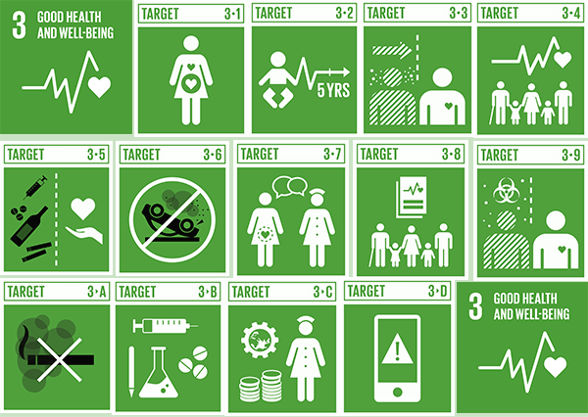

Source: (United Nations, 2025a)

Critical evaluation of Global Initiatives:
- Reduced Child Mortality:
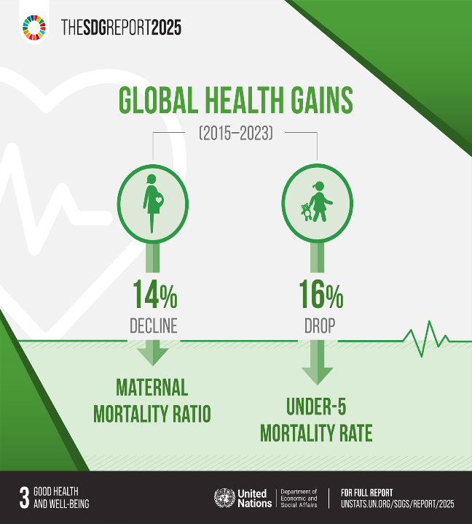
Better nutrition, immunisation campaigns, and more access to healthcare have all contributed to a global decline in under-5 mortality rates (Figure2. United Nations, 2025d). Every Woman Every Child (EWEC) initiative since launch shows there have been notable improvements in the health and well-being of mothers, newborns, and children worldwide. Over a billion children received vaccinations. Since 2000, maternal deaths have decreased by 35%. Of pregnant women living with HIV, 85% have received effective treatment to prevent the virus from being passed from mother to child, up from 45% in 2010 (EWEC, 2020).
Source: FIG.2. (United Nations, 2025d)

- Fighting Diseases:
Polio cases have drastically decreased as a result of programs like the Global Polio Eradication Initiative. In a similar vein, broad access to antiretroviral medication has decreased HIV/AIDS-related mortality worldwide. An estimated 10 million people have been spared from paralysis caused by polio, and almost 2.5 billion children have received vaccinations, but Pakistan and Afghanistan are still not free of polio and UN has extensive strategy for targeting these countries (Global Polio Eradication Initiative, 2024). From 350,000 cases in 1988 to 118 cases in 2017, the number of polio cases globally has dropped by more than 99% (Global Health Progress, 2025).
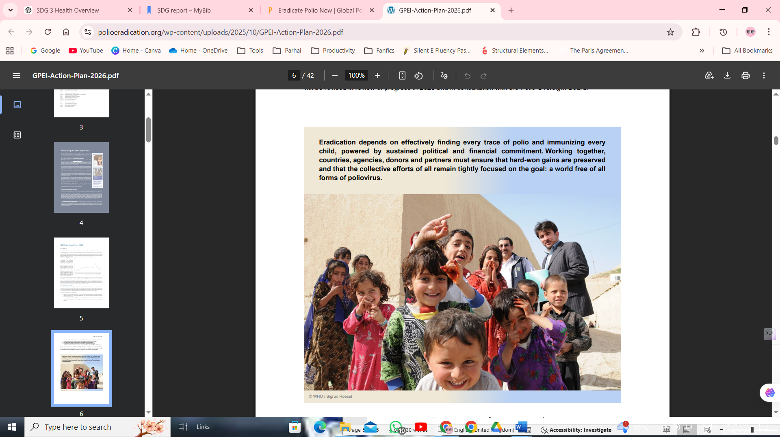

(Global Polio Eradication Initiative, 2024)
The world has made significant progress since 2015 in closing the digital gap, increasing access to education, and enhancing mother and child health. Millions of lives are improved by the Sustainable Development Goals, but the current pace of progress is not enough to achieve all of the Goals by 2030. However, progress is inconsistent as millions continue to experience severe poverty, hunger, poor housing, and lack of essential services. Systemic disadvantages still affect women, individuals with disabilities, and marginalised communities (Owusu et al., 2024). Future development is hindered by escalating conflicts, climatic instability, growing inequality, and high debt payment costs (United Nations, 2025d). The COVID-19 pandemic revealed weaknesses in international health systems, impeding the achievement of SDG 3 and escalating already-existing health inequities.
  - Critical evaluation of UK initiatives:
One of the UK's strongest assets is health, and the health and care system is contributing to a better, more equitable, and prosperous future by preventing illness and increasing happiness, health, and the economy. The UK is committed to utilising its potential to revolutionise health and healthcare delivery (GOV.UK, 2019). NHS Long Term Plan 2019, outlines the NHS's top priorities for the upcoming ten years, with the goals of enhancing digital health, lowering health disparities throughout the United Kingdom, and improving prevention.
The Prevention Vision, which was introduced in November 2018 in England shows over six million people have had NHS health checks in England alone, making it one of the biggest preventative initiatives globally, with the greatest benefits going to members of the most underprivileged areas (Public Health England, 2018). NHS Diabetes Prevention: The Healthier You, the program, in collaboration with NHS England and Diabetes UK, now covers 75% of England (PHE, 2018).
A nationwide NHS England strategy called Core20PLUS5 aims to guide work to lessen healthcare disparities at the systemic and national levels. The strategy, which at first focused on the disparities in healthcare that adults faced, has now been modified to include children and youth (Fig. 3 NHS England, 2021).
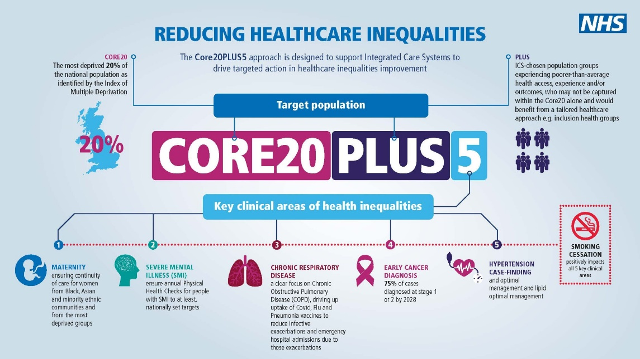

Source FIG.3 (NHS England, 2021)
Targeting high mortality neonatal rates in black ethnic groups the UK initiatives show maternal mortality has decreased by 8%, neonatal mortality by 5.8%, and stillbirths by 18.8% in England since 2010. Over this period, approximately £40 million has been invested on maternity services in England, supporting this achievement (GOV.UK, 2019).
The general population is protected against 19 diseases throughout their lives by the National Immunisation Program, developed between NHS England and PHE. NHS England to provide vaccinations to "hard to reach groups." (Public Health England, 2021).

Implication and Theoretical framework (Health Belief Model):
According to Orji, Vassileva, and Mandryk (2012), the HBM has been modified to accommodate various medical and cultural circumstances that impact public health through community-based preventive initiatives and health promotion (healthyaddict, 2023). The HBM has been utilised to assess and enhance COVID-19 vaccination compliance and intentions and health promotion campaigns like Diabetes prevention Programme (Yenew et al., 2023). One of the main factors influencing COVID-19 vaccination reluctance is people's health views (Limbu, Gautam and Pham, 2022). However, the HBM has a number of limitations like neglecting social and cultural influences and structural barriers like poverty and healthcare access. Decisions can be impacted by emotions, habits, and other external pressures (Harrison, Mullen, and Green, 1992; Alyafei and Carr, 2024).

Challenges:
The UK meets 24% of the targets with good performance, 57% with performance gaps, and 15% with poor performance or little to no policy change. Additionally, many policy inconsistencies are highlighted in Bond's most recent performance report on the UK's worldwide contribution to the Sustainable Development Goals (HAD, 2019). The Covid-19 pandemic has had detrimental effects on people's health and has made health disparities worse, especially for those with disabilities and those who previously had them. These disparities have been made worse by vaccine disparity. A catastrophic blow amid a worldwide pandemic, preliminary data shows that the UK's global health spending has been reduced by up to 40% (Bond, 2022).

Recommendations:
Global initiatives should shift from disease specific programmes to integrated health system strengthening. This includes workforce. Infrastructure and primary care funding. Evidence shows resilient healthcare systems are better equipped to respond health outcomes. The COVID-19 pandemic demonstrates how weak health systems lead to delays in responding to serious health risks and interruptions in the provision of necessary medical care (Binagwaho, Hirwe and Mathewos, 2022). Policies must go beyond addressing social determinants of health to tackle poverty, education and inequality in access to health.

Overview of SDG 10:
A "just, equitable, tolerant, open, and socially inclusive world in which the needs of the most vulnerable are met" is what the 2030 Agenda demands (United Nations, 2015). SDG 3 Goals and Targets linked to SDG 10 are to achieve universal health coverage, including financial risk protection, access to high-quality essential healthcare services, and universal access to safe, effective, high-quality, and reasonably priced essential medicines and vaccinations (World Bank, 2019).
Inequality hampers long-term social and economic progress, and hinders the fight against poverty. Every day, preventable diseases like measles and tuberculosis, as well as child birth, claim the lives of women and children who lack access to healthcare. Every nation in the world faces discrimination and a lack of opportunity for older people, migrants, and refugees. One in five people said they had experienced discrimination on at least one basis that is forbidden by international human rights legislation (United Nations, 2025).

Critical evaluation of global policies/ initiatives.
Structural injustices linked with housing, health care, and education systems cause health disparities. Women, males, and members of sexual and gender minorities are examples of unique populations for which this is particularly true (Egede, 2025). For certain population segments, structural injustices lead to poor results and greater health inequalities. For instance socioeconomic and demographic factors influence women's access preventative care for infectious diseases and screening for HIV and Cancer (Park et al., 2020).
UN Women works to lessen inequality both within and between nations targeting the gender gap (UN Women, 2019). Although the initiatives show betterment still not everyone has access to high-quality education and health services. In sub-Saharan Africa, 48.1% of teenage girls do not attend school. Women are still under-represented in leadership roles, and progress is unacceptably unequal and sluggish in other areas like maternal mortality and child marriage (UN Women, 2018). Women's ability to lead healthy lifestyles is hampered by a number of factors, including lack of control over resources, gender-based violence, the burden of unpaid care and household chores, longer workdays, and unhealthy working conditions (United Nations, 2026).
3.2. Critical evaluation of national and local examples.
Health disparities are more than just differences; they are unjust and preventable consequences of unequal access to opportunities, resources, and power. Whitehead and Dahlgren 1991, "rainbow model" shows how environmental, social, economic, and personal factors affect health. This model aids practitioners and legislators in realising that broader structural and environmental settings influence health outcomes in addition to personal decisions (Chelak and Chakole, 2023).
According to Marmot Review 2010, reducing inequality benefits everyone, not just the most disadvantaged (Marmot et al., 2020). The burden of these inequalities is bore in form of lost productivity, more healthcare services and decreased economic growth (Public Health England, 2013). SDG 3 and SDG 10 both have an impact on health outcomes.
Women's and girls' rights have advanced significantly with the FCDO's inaugural International Women and Girls Strategy. For women and girls to realise their full potential, they must have equal rights and freedoms. The UK government is collaborating with the corporate sector to increase girls' access to school in partner nations through the Girls’ school Skills Partnership, which was established in March 2022 (GOV.UK, 2023). By 2030, this entails making sure that 80% of the FCDO's bilateral initiatives promote gender equality.
Through its funding of GAVI (previously the Global Alliance for Vaccines and Immunisation), the Global Fund, and Unitaid, the UK has contributed to international initiatives to expand access to medications, vaccines, and diagnostics for certain diseases pertinent to poor nations (Mariotti, 2019).

Challenges:
The UK had not demonstrated a strong commitment to accomplishing every facet of SDG 10, according to the 2019 SDG Bond report (Bond, 2019). It pointed out that the UK had made progress in a few pertinent policy areas, particularly with regard to its strategy for incorporating a number of under-represented groups into its initiatives. Therefore, the establishment of higher-paying positions alone will not be sufficient for many low-paid women workers, who face obstacles to employment due to social conventions that assign higher-paid work to males or unequal, unpaid care work.
  - Recommendations:
Evidence from the Marmot Review suggests that upstream interventions are more than individual level strategies. Government should prioritise policies addressing social determinants of health including education housing and employment. Expanding social safety nets can reduce poverty and health outcomes (Binagwaho, Hirwe and Mathewos, 2022). However, these must be sustainably funded to avoid dependency on foreign funding. Egede (2025), stated high income countries including UK should maintain and increase development funding to support global inequality reduction.

Conclusion:
In conclusion, the report highlights that while significant progress has been made achieving the sustainability goals particularly SDG 3 and SDG 10 in improving health outcomes, substantial challenges remain including health inequalities and social disparities like gender gap (Chelak and Chakole, 2023). The analysis shows that SDG 3 and SDG 10 are closely interconnected as inequalities in income, education and access to healthcare continue to shape health outcomes both globally and nationally. Despite strong policy frameworks like NHS Long term Plan implementation gaps and structural barriers limit progress (NHS England, 2019). The findings emphasised that integrated approach is needed to address healthcare systems and wider social determinants. Without addressing inequality progress towards SDG 3 will remain uneven, hampering the broader goals od sustainable development.

Reference list
Alyafei, A. and Carr, R.E. (2024) The Health Belief Model of Behavior Change, National Library of Medicine. StatPearls Publishing. Available at: https://www.ncbi.nlm.nih.gov/books/NBK606120/.
Binagwaho, A., Hirwe, D. and Mathewos, K. (2022) ‘Health System Resilience: Withstanding Shocks and Maintaining Progress’, Global Health: Science and Practice, 10(Supplement 1), p. e2200076. Available at: https://doi.org/10.9745/ghsp-d-22-00076.
Bond (2019) The UK’s global contribution to the Sustainable Development Goals Progress, gaps and recommendations 2 About Bond. Available at: https://www.bond.org.uk/wp-content/uploads/2023/03/bond_the_uks_global_contribution_to_the_sdgs_online_full_report.pdf
Bond (2022) The UK’s global contribution to the Sustainable Development Goals . Available at: https://www.bond.org.uk/wp-content/uploads/2022/09/sdg3.pdf (Accessed: 19 March 2026).
Chelak, K. and Chakole, S. (2023) ‘The role of social determinants of health in promoting health equality: a narrative review’, Cureus, 15(1). Available at: https://doi.org/10.7759/cureus.33425.
Egede, L.E. (2025) Structural Inequalities and Health Outcomes for Chronic Disease. Academic Press.
England, N. (2025) NHS England» Record numbers using NHS App to manage health, England.nhs.uk. Available at: https://www.england.nhs.uk/2025/12/record-numbers-using-nhs-app-to-manage-health/.
EWEC (2020) Every Woman Every Child | Global Movement, Every Woman Every Child. Available at: https://www.everywomaneverychild.org/ (Accessed: 14 March 2026).
Global Health Progress (2025) Global Polio Eradication Initiative - Global Health Progress, Global Health Progress. Available at: https://globalhealthprogress.org/collaboration/global-polio-eradication-initiative/ (Accessed: 17 March 2026).
Global Polio Eradication Initiative (2024) GPEI-Homepage, Global Polio Eradication Initiative. Available at: https://polioeradication.org/.
GOV.UK (2019) Voluntary National Review of progress towards the Sustainable Development Goals. Available at: https://assets.publishing.service.gov.uk/media/5d2f3d6aed915d2feeac49f4/UKVNR-web-accessible1.pdf.
GOV.UK (2023) International women and girls strategy 2023 to 2030, GOV.UK. Available at: https://www.gov.uk/government/publications/international-women-and-girls-strategy-2023-to-2030/international-women-and-girls-strategy-2023-to-2030#part-1-context-prioritising-women-and-girls-at-a-time-of-global-instability.
HAD (2019) Sustainable Development Goals: A review of the UK’s performance - HAD, HAD. Available at: https://had-int.org/the-biggest-threats-to-the-sustainable-development-goals/ (Accessed: 18 March 2026).
Harrison, J.A., Mullen, P.D. and Green, L.W. (1992) ‘A meta-analysis of studies of the Health Belief Model with adults’, Health Education Research, 7(1), pp. 107–116. Available at: https://doi.org/10.1093/her/7.1.107.
healthyaddict (2023) The Power of the Health Belief Model in Shaping Your Wellness Journey | Exploring HBM |healthyaddict, YouTube. Available at: https://www.youtube.com/watch?v=UW8-NDAWuvc.
Limbu, Y.B., Gautam, R.K. and Pham, L. (2022) ‘The Health Belief Model Applied to COVID-19 Vaccine Hesitancy: A Systematic Review’, Vaccines, 10(6). Available at: https://doi.org/10.3390/vaccines10060973.
Mariotti, C. (2019) ‘The Role of the UK in Tackling Global Inequality: Contributions to achieving SDG 10’. Available at: https://doi.org/10.21201/2019.4467.
Marmot, M. et al. (2020) Health equity in England: The Marmot review 10 years on, The Health Foundation. Available at: https://www.health.org.uk/publications/reports/the-marmot-review-10-years-on.
NHS England (2019) NHS Long Term Plan, NHS. Available at: https://www.england.nhs.uk/long-term-plan/ (Accessed: 17 March 2026).
NHS England (2021) Core20PLUS5 an Approach to Reducing Health Inequalities, www.england.nhs.uk. NHS England. Available at: https://www.england.nhs.uk/about/equality/equality-hub/national-healthcare-inequalities-improvement-programme/core20plus5/.
NHS England (2023) Digital transformation, England.nhs.uk. Available at: https://www.england.nhs.uk/digitaltechnology/.
OECD (2024) Sustainable Development Goals (SDGs), OECD. Available at: https://www.oecd.org/en/topics/sustainable-development-goals-sdgs.html (Accessed: 17 March 2026).
Orji, R., Vassileva, J. and Mandryk, R. (2012) ‘Towards an Effective Health Interventions Design: An Extension of the Health Belief Model’, Online Journal of Public Health Informatics, 4(3). Available at: https://doi.org/10.5210/ojphi.v4i3.4321.
Owusu, M.F. et al. (2024) ‘Tackling the non-communicable disease epidemic: a framework for policy action in low- and middle-income countries’, The Pan African Medical Journal, 47(82). Available at: https://doi.org/10.11604/pamj.2024.47.82.41089.
Park, E. et al. (2020) ‘Structural Barriers to Women’s Sustained Engagement in HIV Care in Southern California’, AIDS and Behavior, 24(10), pp. 2966–2974. Available at: https://doi.org/10.1007/s10461-020-02847-9.
PHE (2018) Credible, independent and ambitious. Available at: https://assets.publishing.service.gov.uk/government/uploads/system/uploads/attachment_data/file/696145/PHE_Business_plan_2018.pdf.
Public Health England (2013) Public Health Outcomes Framework, GOV.UK. Available at: https://www.gov.uk/government/collections/public-health-outcomes-framework.
Public Health England (2018) NHS Health Check: stocktake and action plan. Available at: https://assets.publishing.service.gov.uk/government/uploads/system/uploads/attachment_data/file/675590/NHS_Health_Check_stocktake_and_action_plan.pdf (Accessed: 17 March 2026).
Public Health England (2021) PHE Immunisation Inequalities Strategy. Available at: https://assets.publishing.service.gov.uk/media/60192bc1d3bf7f70bb9b00e1/immnstn-equity_STRATEGY_v11.pdf.
RGO, A. (2025) Mapping the commercial determinants of health in countries of the WHO South-East Asia Region: conceptualizations, impacts and actions, Who.int. World Health Organization. Available at: https://www.who.int/publications/i/item/9789290220336.
The Global Goals (2025) Goal 3: Good health and well-being, The Global Goals. Available at: https://globalgoals.org/goals/3-good-health-and-well-being/ (Accessed: 17 March 2026).
UN Women (2018) WHY GENDER EQUALITY MATTERS ACROSS ALL SDGS AN EXCERPT OF TURNING PROMISES INTO ACTION: GENDER EQUALITY IN THE 2030 AGENDA FOR SUSTAINABLE DEVELOPMENT. Available at: https://www.unwomen.org/sites/default/files/Headquarters/Attachments/Sections/Library/Publications/2018/SDG-report-Chapter-3-Why-gender-equality-matters-across-all-SDGs-2018-en.pdf.
UN Women (2019) Sustainable Development Goal 10: Reduced Inequalities, UN Women. Available at: https://www.unwomen.org/en/news/in-focus/women-and-the-sdgs/sdg-10-reduced-inequalities.
United Nations (2015) Health and Population | Department of Economic and Social Affairs, sdgs.un.org. United Nations. Available at: https://sdgs.un.org/topics/health-and-population (Accessed: 15 March 2026).
United Nations (2025a) Goal 3: Ensure healthy lives and promote well-being for all at all ages, United Nations. Available at: https://sdgs.un.org/goals/goal3.
United Nations (2025b) Goal 5: Achieve gender equality and empower all women and girls, United Nations Sustainable Development Goals. United Nations. Available at: https://www.un.org/sustainabledevelopment/gender-equality/.
United Nations (2025c) Goal 10: Reduce Inequality within and among Countries, United Nations Sustainable Development. United Nations. Available at: https://www.un.org/sustainabledevelopment/inequality/.
United Nations (2025d) SDG Indicators, Un.org. Available at: https://unstats.un.org/sdgs/report/2025/.
United Nations (2026) Sustainable Development Goals (SDG 10) | UN Western Europe, United Nations Western Europe. Available at: https://unric.org/en/sdg-10/.
World Bank (2019) Sustainable Development Goal 10 -Reduced Inequalities: Progress and Prospects. Available at: https://thedocs.worldbank.org/en/doc/925671552682607792-0090022019/original/SDG10EGM2019conceptnote.pdf.
World Health Organization (2025) Maternal mortality, World Health Organization. Available at: https://www.who.int/news-room/fact-sheets/detail/maternal-mortality (Accessed: 16 March 2026).
Yenew, C. et al. (2023) ‘Intention to receive COVID-19 vaccine and its health belief model (HBM)-based predictors: A systematic review and meta-analysis’, Human Vaccines & Immunotherapeutics, 19(1). Available at: https://doi.org/10.1080/21645515.2023.2207442.

