Name: Oliver Shopland

Student Number: 2404045

WORKSHEET 3 – TESTING (Chickens)

- Original code:
#Worksheet 3 - Chickens
while True:
print("\n1. Regular Food\n2. Superfood\n3. Mixed Food\n4. Exit")
choice = input("Select option (1-4): ")
if choice == "4":
break
if choice not in ["1", "2", "3"]:
print("Invalid option")
continue
try:
days = int(input("Enter total days: "))
if days < 0:
print("Days must be positive")
continue
if days > 35: # Check for egg spoilage
print("Eggs are bad and cannot be used")
continue
if choice == "1":
eggs = days # Regular: 1 egg per day
elif choice == "2":
eggs = (days // 2 * 3) + (days % 2) # Superfood: 3 eggs per 2 days
else:
super_days = int(input("Enter days on superfood: "))
if super_days > days:
print("Superfood days cannot exceed total days")
continue
regular_days = days - super_days
super_eggs = (super_days // 2 * 3) + (super_days % 2)
regular_eggs = regular_days
eggs = super_eggs + regular_eggs
print(f"\nTotal eggs: {eggs}")
print(f"Possible cakes: {eggs // 2}")
print(f"Remaining eggs: {eggs % 2}")
except ValueError:
print("Invalid number")

Code Testing

For each test below, run your code and enter the values provided. Provide a screenshot of what happened when the programme ran. Did the programme behave correctly or did it do something unexpected? Fill in a box for each test below. You should present 8 separate boxes, 1 for each test. (Note: the first box is provided as a template)

Normal food
i. 4 days (should be 4 eggs = 2 cakes)
ii. 9 days (should be 9 eggs = 4 cakes)
iii. -3 days (no cakes or error handled)
iv. 10000 days (program should catch the error – many of these eggs would be bad!)

Superfood
v. 4 days (should be 6 eggs = 3 cakes)
vi. 5 days (should be 7 eggs = 3 cakes)
vii. 1 days (should be 1 egg = 0 cakes)

Test your menu
viii. What happens if you enter “3”?

Test:
Normal food i) 4 days

Screenshot(s) of output:
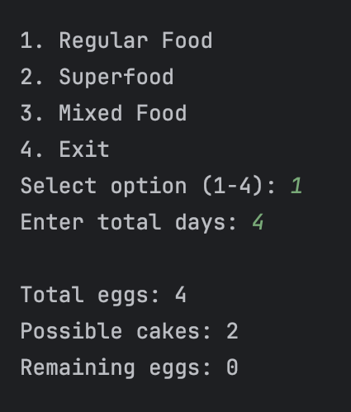
Result: Did the program behave as expected ie syntactically and logically correct?
YES

Test:
Normal food ii) 9 days

Screenshot(s) of output:
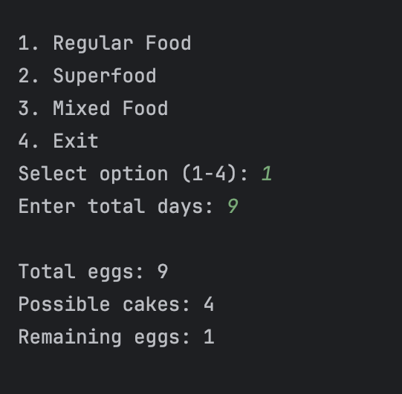
Result: Did the program behave as expected ie syntactically and logically correct?
YES

Test:
Normal food iii) -3 days

Screenshot(s) of output:
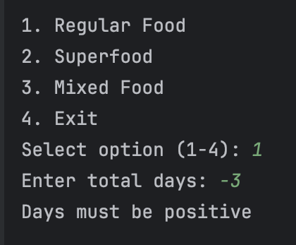
Result: Did the program behave as expected ie syntactically and logically correct?
YES

Test:
Normal food iv) 10000 days

Screenshot(s) of output:
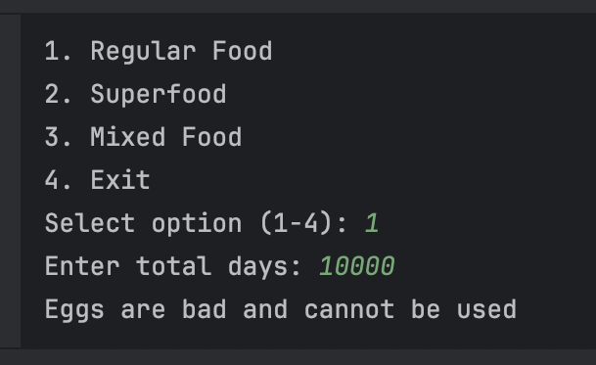
Result: Did the program behave as expected ie syntactically and logically correct?
YES

Test:
Superfood v) 4 days

Screenshot(s) of output:
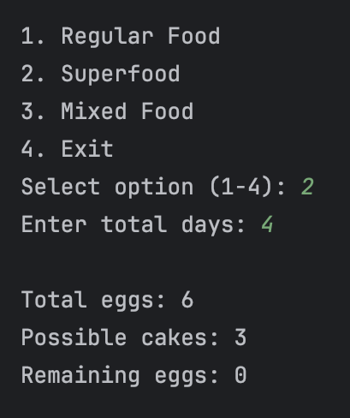
Result: Did the program behave as expected ie syntactically and logically correct?
YES
Test:
Superfood vi) 5 days

Screenshot(s) of output:
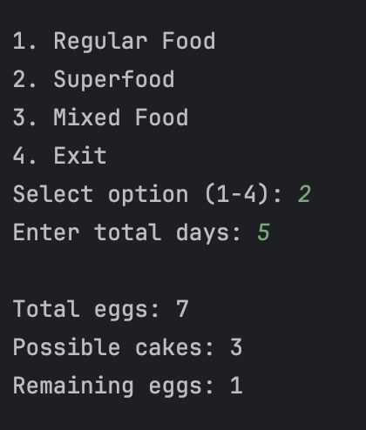
Result: Did the program behave as expected ie syntactically and logically correct?
YES
Test:
Superfood vii) 1 days

Screenshot(s) of output:
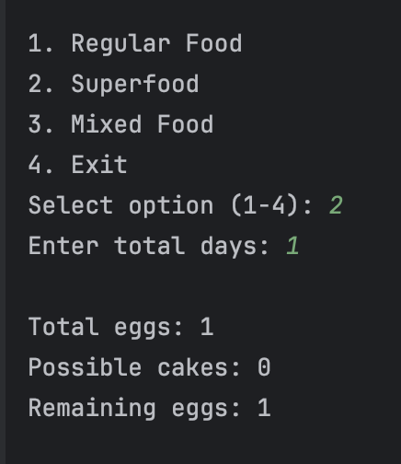
Result: Did the program behave as expected ie syntactically and logically correct?
YES
Test:
Superfood viii) Enter 3 and 4

Screenshot(s) of output:
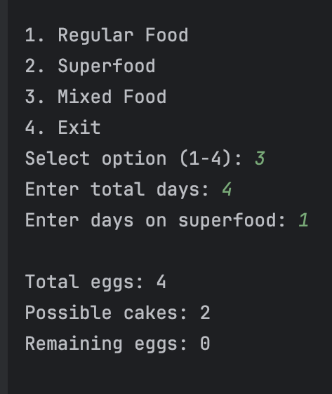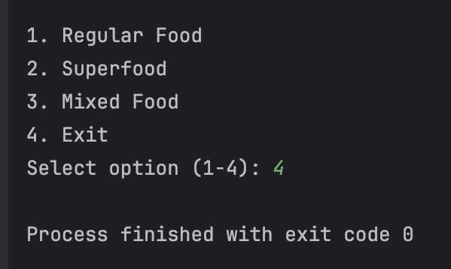
Result: Did the program behave as expected ie syntactically and logically correct?
YES

- Consider the results of the above tests and revisit your original code in order to address the tests that failed. (Note: you may not be able to solve all of the problems that were originally encountered, but solve as many as you can.)

Paste your full revised code here : n/a

