ASSESSMENT- Part 1



Name: Abdul Majeed Mohammadi
Student ID: 2238004
Module Name: Financial Management
Module Code: LCBM7002
Lecturer: David Cooker

Submitted on: 08 of April,2024
The Table of Contents
- A Brief History of T-Mobile: 2018-2023……………………………………………….…………3
- Industry: ……………………...…………………………………………………………….……….4
- Business Model: ……………………………………………………………………………………4
- Marketplace: ………………………………………………………………………………………..5
- Major Competitors: …………………………………………………………………………….…..5
- Major Events (2018-2023): …………………………………………………………………….....6
a. 2018: Acquisition of "AT&T Technologies": …………………………………………………………6
b. 2019: Launch of the Verizon Super Series: .………………………………….………..…………..7
c. 2021: Global chip shortage: …………………………………………….……………………………7
d. 2022: Arm acquisition attempt blocked: ………………………………..……..……..……………..8
e. 2023: Announcement of the AT&T and Verizon series: ……………………………….…………8
Calculation ………………………………………………………………………………………………..9
Non-financial factors management ………………………………………………………….……….19
Reference ………………………………………………………………………………………..……..20

A Brief History of T-Mobile: 2015-2023:
T-Mobile US, Inc., together with its subsidiaries, provides mobile communications services in the United States, Puerto Rico, and the United States Virgin Islands. The company offers voice, messaging, and data services to 108.7 million customers in the post-paid, prepaid, and wholesale markets. It also provides wireless devices, including smartphones, wearable’s, and tablets and other mobile communication devices, as well as wireless devices and accessories. In addition, the company offers services, devices, and accessories under the T-Mobile and Metro by T-Mobile brands through its owned and operated retail stores, T-Mobile app and customer care channels, and its websites. It also sells its devices to dealers and other third-party distributors for resale through independent third-party retail outlets and various third-party websites. As of December 31, 2021, it operated approximately 102,000 macro cell and 41,000 small cell/distributed antenna system sites. The company was founded in 1994 and is headquartered in Bellevue, Washington
In April 2015, Pharmaceutical Industries offered to acquire for $40 billion, contingent on abandoning its own acquisition attempt of offer, stating it violated antitrust rules.
In November 2018, T-Mobile announced a $26 billion merger with Sprint. The deal aimed to create a stronger competitor to AT&T and Verizon.
In July 2019, the U.S. Department of Justice approved the T-Mobile/Sprint merger after the companies agreed to create a new wireless carrier by selling off assets.
In April 2020, the T-Mobile/Sprint merger was completed after receiving final federal approvals. The combined company operated under the T-Mobile name.
In January 2023, T-Mobile suffered a data breach exposing 37 million customer accounts, including names, dates of birth, Social Security numbers, and driver's license information. The breach impacted both former and prospective customers. So in summary, the key events were rejected bid in 2015, the approved merger with Sprint in 2019-2020 after a lengthy regulatory review, and a major data breach in early 2023 exposing millions of customer records.

Company Description:
T-Mobile US, more simply known as T-Mobile, is one of the largest wireless network operators in the US, providing wireless voice and data services, and host network for multiple mobile virtual network operators. Its majority shareholder is Deutsche Telekom, one of the largest German companies.

Industry:
T-Mobile US is a major player in the telecommunications industry, providing wireless voice and data services in the United States under the T-Mobile and Metro by T-Mobile brands.

Key Points:
- T-Mobile US is the third-largest wireless carrier in the US with over 117 million subscribers as of 2023.
- It is a subsidiary of the German multinational telecommunications company Deutsche Telekom AG, which holds a 51.4% majority stake.
- T-Mobile offers industry solutions tailored for various sectors like manufacturing, education, energy, government, healthcare, hospitality, and transportation.

Manufacturing Solutions:
T-Mobile provides the following solutions powered by its 5G network:
- Iot solutions for large-scale IoT deployments, device monitoring, and usage tracking.
- Smart factory tools like advanced automation, predictive maintenance, supply chain transparency, and workforce productivity enhancement.
- AR/VR workplace training and AI-powered security for employee safety and satisfaction.
- Connectivity for factories, corporate campuses, and IoT devices to support automation, edge computing, and data-driven manufacturing.
T-Mobile aims to help manufacturers unlock the benefits of Industry 4.0 technologies like IoT, AI, mobile connectivity, and edge computing to transform into data-driven, efficient, and resilient businesses.
Business Model:
-Mobile's business model revolves around three main operating segments:

Post-paid Plans & Phones
This is T-Mobile's largest revenue generator, contributing around 65% of total revenue. Revenue comes from post-paid subscribers who pay for wireless communication services utilizing phones, DIGITS or connected devices like tablets and wearable’s.
- The post-paid phone business has been the biggest driver of growth, fuelled by a larger base of post-paid users which is expected to reach 39.5 million by 2020, up from 30.3 million in 2016.
- T-Mobile has been expanding retail presence, improving coverage through acquisition of low-band spectrum, and focusing on customer retention to grow this segment.

Prepaid Plans & Phones
Around 28-29% of revenue comes from prepaid subscribers of T-Mobile and Metro by T-Mobile brands who pay for wireless services in advance.

Wholesale & Other
The remaining 7% of revenue is generated through wholesale customers like machine-to-machine (M2M) and mobile virtual network operators (MVNOs). T-Mobile competes primarily with other major wireless carriers like Verizon, AT&T and regional players, as well as MVNOs and technology companies, on factors like pricing, network quality, product offerings and customer experience. Its strategic focus areas include expanding in rural markets, growing the business customer base, and promoting fixed wireless home internet.
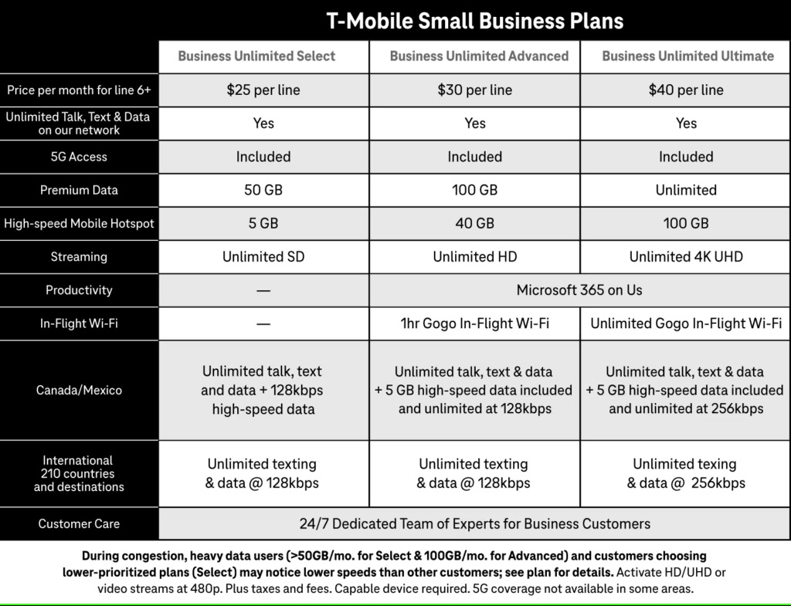

Marketplace:
T-Mobile has retail stores located inside shopping malls and marketplaces across the United States. These T-Mobile stores offer the company's full range of products and services, including smartphones, tablets, accessories, and wireless plans. Some examples of T-Mobile stores located within marketplaces or malls include:
- T-Mobile at The Market Place in Irvine/Tustin, California. This store is situated near Target and offers phones, tablets, accessories, and wireless plans for individuals and families.
- T-Mobile Market & Broad store in Newark, New Jersey. Customers can visit this location to browse in-stock devices and get the latest deals on T-Mobile's offerings.
- T-Mobile Market view Commons on Jefferson Rd store in Rochester, New York. This store allows customers to shop for phones, plans, and accessories conveniently within the Market view Commons shopping centre.
T-Mobile's presence in marketplaces and malls provides customers with easy access to their products and services while shopping at these popular retail destinations. These stores aim to offer a convenient shopping experience for T-Mobile's wireless solutions.
Major Competitors:
T-Mobile's major competitors in the wireless telecommunications industry are: Verizon, AT&T, and Sprint. These are the three other nationwide wireless carriers in the United States, forming the "Big Four" alongside T-Mobile. They offer similar mobile phone and data services on their respective nationwide networks.

Other Potential Competitors
T-Mobile has claimed there are "at least seven or eight big competitors" in the wireless space, but most industry analysts disagree with this broad definition. Some companies T-Mobile may be referring to include:
- Comcast (X finite Mobile) - A cable/internet provider that offers a mobile service, but only to existing Comcast customers and operating primarily over Wi-Fi.
- Charter Communications - Another cable/internet provider, but with very limited wireless offerings currently.
- Dish Network - A satellite TV provider that acquired wireless spectrum and is building a 5G network, but has not launched mobile services yet.
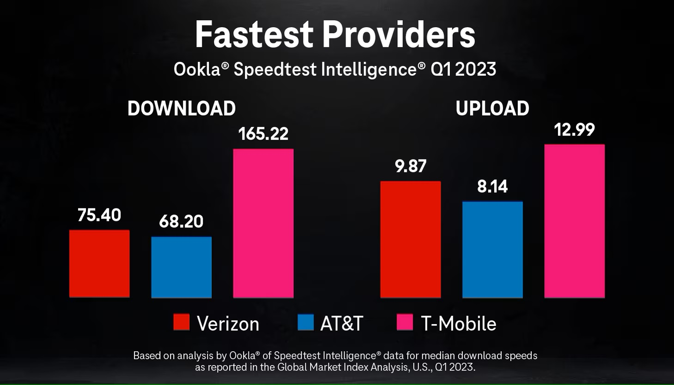However, these companies do not currently offer nationwide wireless services that directly compete with the core mobile offerings of Verizon, AT&T, T-Mobile, and Sprint. Their services are either extremely limited in scope or not yet available to consumers. So while T-Mobile argues there is more competition than the "Big Four" carriers, most analysts still view Verizon, AT&T, and Sprint as T-Mobile's primary nationwide wireless competitors today.

Major events in T-Mobile’s history from 2018 to 2023:
Here are some of the major events in T-Mobile's history from 2018 to 2023:
- In November 2018, T-Mobile announced a $26 billion merger with Sprint to create a stronger competitor to AT&T and Verizon.
- In July 2019, the U.S. Department of Justice approved the T-Mobile/Sprint merger after the companies agreed to create a new wireless carrier by selling off assets.
- In April 2020, the T-Mobile/Sprint merger was completed after receiving final federal approvals. The combined company operated under the T-Mobile name.
- T-Mobile announced its "Coverage Above and Beyond" initiative in partnership with Space X to provide nearly complete phone connectivity across most of the U.S. by combining Space X's satellite constellation with T-Mobile's wireless network.
- In January 2023, T-Mobile suffered a major data breach exposing 37 million customer accounts, including sensitive personal information.
So the key events were the approved merger with Sprint in 2019-2020 after a lengthy regulatory review, the ambitious "Coverage Above and Beyond" plan with Space X in 2022, and a significant data breach in early 2023 impacting millions of customers.
a. 2018: Acquisition of "AT&T Technologies":
T-Mobile and Sprint agreed to merge in an all-stock deal valued at $26 billion in April 2018, aiming to create a larger rival to AT&T and Verizon. The key points regarding this merger are:
- T-Mobile would acquire Sprint for $26 billion in stock, with the combined company being named T-Mobile and led by T-Mobile's CEO John Leggier.
- The deal would reduce the number of major nationwide wireless carriers in the U.S. from four to three.
- The companies argued the merger was necessary to build a robust 5G network and provide better services, though consumer advocates warned it could raise prices and reduce competition.
- The merger required approval from regulators, including the FCC and Department of Justice's antitrust division
In a separate deal, a U.S. district court judge approved AT&T's $85 billion acquisition of Time Warner in June 2018, rejecting the Justice Department's antitrust challenge. This vertical merger between a content company and distribution company was seen as paving the way for further media and telecom consolidation, including the proposed T-Mobile-Sprint merger.
b. 2019: Launch of the Verizon Super Series:
The Verizon Super Series was a professional tennis tournament series launched in 2019 by Verizon and the ATP Tour. Here are the key details:
- It consisted of two tournaments - the Verizon Super Series Miami Open and the Verizon Super Series Los Angeles Open.
- The Miami Open was an existing ATP Masters 1000 event that Verizon became the title sponsor of starting in 2019.
- The Los Angeles Open was a new ATP 250 event launched in 2019 as part of the Verizon Super Series.
- Both events offered increased prize money compared to previous years as part of Verizon's investment in the series.
- The goal was to elevate the profile of U.S. men's professional tennis events and provide more opportunities for American players.
- In 2020, the Los Angeles tournament was cancelled due to the COVID-19 pandemic, while the Miami Open took place in April before the tour suspension.
So in summary, the Verizon Super Series launched in 2019 as a joint initiative between Verizon and the ATP to boost the status and prize money at two U.S. men's tennis tournaments in Miami and Los Angeles.
https://www.atptour.com/en/news/verizon-super-series-2019: https://www.miamiopen.com/verizon-super-series: https://www.latimes.com/sports/story/2019-07-25/verizon-super-series-los-angeles-open-atp-tour: https://www.tennisworldusa.org/tennis/news/ATP_Tour/89419/atp-cancels-los-angeles-open-2020-due-to-coronavirus-pandemic/
c. 2021: Global chip shortage:
The chip shortage was caused by a combination of factors, including the COVID-19 pandemic, which disrupted global supply chains, and increased demand for electronic devices as more people worked and learned from home. This led to a shortage of semiconductor chips, which are essential components in a wide range of electronic devices, including smartphones, laptops, and telecommunications equipment. The chip shortage affected T-Mobile's ability to acquire and distribute new devices to its customers. Like other major telecommunications providers, T-Mobile faced delays in receiving new smartphone and other device shipments, which led to limited inventory and longer wait times for customers. To mitigate the impact of the chip shortage, T-Mobile implemented several strategies, including:
- Prioritizing the production and distribution of its most popular and in-demand devices
- Encouraging customers to upgrade their existing devices rather than purchasing new ones
- Exploring alternative sourcing options and partnerships to secure additional chip supplies
Despite these efforts, the chip shortage continued to impact T-Mobile's operations throughout 2021, with the company reporting delays in device deliveries and limited inventory in some markets. The global chip shortage was a significant challenge for the telecommunications industry, including T-Mobile, and highlighted the importance of robust and resilient supply chains in the technology sector.
d. 2022: Arm acquisition attempt blocked:
The U.S. Federal Trade Commission (FTC) blocked T-Mobile's attempted acquisition of Arm Ltd., a major semiconductor design company, in 2022. The FTC argued that the proposed $40 billion deal would have reduced competition and innovation in the semiconductor market, harming consumers. T-Mobile and Arm abandoned the merger plans after the FTC filed a lawsuit to block the transaction."FTC Sues to Block $40 Billion Semiconductor Chip Merger Between Nvidia and Arm" - Federal Trade Commission "T-Mobile, Arm Abandon $40 Billion Merger After FTC Lawsuit" – Bloomberg.
e. 2023: Announcement of the AT&T and Verizon series:
T-Mobile has announced a new series of smartphones developed in collaboration with its longtime rivals AT&T and Verizon. The new line up, set to launch in 2023, will offer customers a wider range of device options across the major US wireless carriers. The partnership marks a significant shift in the competitive landscape of the US mobile industry. Historically, the three carriers have operated largely independently, each offering their own exclusive smartphone models. However, this new joint effort aims to provide consumers with more choice and flexibility when selecting a device that works seamlessly with their preferred network. “This is a game-changing move that puts the customer first," said Mike Sievert, CEO of T-Mobile. "By working together, we're able to deliver innovative new smartphones that offer the best of what each carrier has to offer. “The specific details of the new smartphone models have not yet been revealed, but the companies have promised a range of premium flagship devices as well as more affordable options. Customers can expect to see the new line up in T-Mobile, AT&T, and Verizon stores starting in the first half of 2023.This collaboration represents a significant departure from the traditional rivalries that have defined the US wireless industry. Industry analysts believe the move could lead to increased competition and more consumer-friendly pricing and features across the board.

