
Applied Computing

Wales Institute of Science and Art (WISA)

Networks and Cybersecurity Essentials (ACCA4024)

Lab 9: The art of ensuring Integrity
(Digital Signatures)



n.kaliyamurthy@uwtsd.ac.uk 1

Objectives
Using open source password cracking tool to recover the password.
Use of Digital Signatures.
Tasks
1. Use John the ripper tool to recover the passwords of Alice, Bob, Eve and Eric 2. Create digital Signatures to validate the document
Required Resources
- PC with Ubuntu 16.0.4 LTS installed in a VirtualBox or VMware virtual machine. (Alternatively, Any Linux Platform)
- Internet Connection to refer the outcomes o References:
- John the Ripper: http://www.openwall.com/john/ o Digital Signatures: http://nmichaels.org/rsa.py

Task 1
- Login as User Cisco.
- Go to Terminal and Type the following commands and examine
- Run John the Ripper (Hint: Change your directory to Downloads/ John-
1.8.0/run)
▪ cisco@ubuntu:~/Downloads/john-1.8.0/run$ sudo ./unshadow /etc/passwd /etc/shadow > mypasswd o This command will combine the /etc/passwd file where user accounts are stored, with the /etc/shadow file where user passwords are stored, into a new file called “mypasswd”.

  - Recover Passwords: Type the following command in terminal:
    - cisco@ubuntu:~/Downloads/john-1.8.0/run$ ./john --show mypasswd
There are no cracked passwords at this point. Why?
All we have done is combine the information from 2 separate files.

  - Type the following command in terminal:
    - cisco@ubuntu:~/Downloads/john-1.8.0/run$ ./john -wordlist=password.lst --rules mypasswd --format=crypt o The program, John the Ripper, uses a predefined dictionary called password.lst with a standard set of predefined “rules” for handling the dictionary and retrieves all password hashes of both md5crypt and crypt type.
  - The results should display the passwords for each account. To check the passwords and evidence them, open the file you have created to see the passwords cracked

There are cracked passwords. List the outcome.
cisco@ubuntu:~/Downloads/john-1.8.0/run$ ./john --show mypasswd
cisco:password:1000:999:Cisco,,,:/home/cisco:/bin/bash
Alice:123456:1001:1001::/home/Alice:
Bob:12345:1002:1002::/home/Bob:
Eve:password:1003:1003::/home/Eve:
Eric:password1:1004:1004::/home/Eric:
roy:roy1:1007:1006:Roy,100,2355,:/home/roy:/bin/bash
mac:mac1:1010:1007:Mac,,,76603:/home/mac:/bin/bash

7 password hashes cracked, 6 left

Task 2

Using Digital Signatures
In this part, you will use a website to verify a document signature between Alice and Bob. Alice and Bob share a pair of private and public RSA keys. Each of them uses their private key to sign a legal document. They then send the documents to each other. Both Alice and Bob can verify each other’s signature with the public key. They must also agree on a shared public exponent for calculation.
Table 1 - RSA Public and Private Keys
Public RSA Key | d94d889e88853dd89769a18015a0a2e6bf82bf356fe14f251fb4f5e2df0d9f 9a94a68a30c428b39e3362fb3779a497eceaea37100f264d7fb9fb1a97fbf 621133de55fdcb9b1ad0d7a31b379216d79252f5c527b9bc63d83d4ecf4 d1d45cbf843e8474babc655e9bb6799cba77a47eafa838296474afc24be b9c825b73ebf549
Private RSA Key | 47b9cfde843176b88741d68cf096952e950813151058ce46f2b048791a2  6e507a1095793c12bae1e09d82213ad9326928cf7c2350acb19c98f19d3  2d577d666cd7bb8b2b5ba629d25ccf72a5ceb8a8da038906c84dcdb1fe6  77dffb2c029fd8926318eede1b58272af22bda5c5232be066839398e42f5 352df58848adad11a1
Public Exponent | 10001
Sign the Document.
Alice signs a legal document and send it to Bob using the RSA public and private keys shown in the table above. Now Bob will have to verify Alice’s digital signature in order to trust the authenticity of the electronic document.
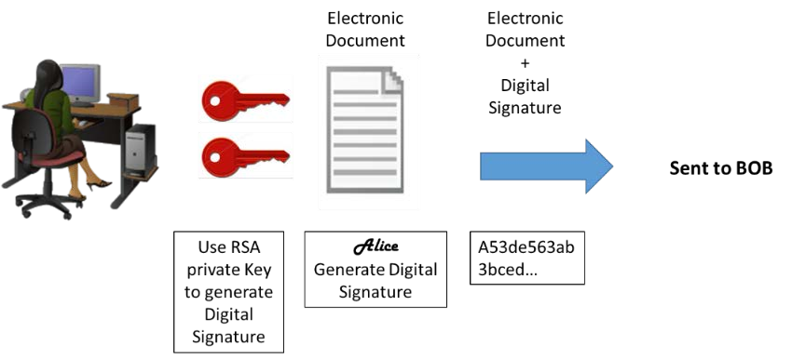
Verify Digital Signature.
Bob receives the document with a digital signature shown in the table below.
Table 2 - Alice's Digital Signature
Alice’s Digital Signature
0xc8 0x93 0xa9 0x0d 0x8f 0x4e 0xc5 0xc3 0x64 0xec 0x86 0x9d 0x2b 0x2e 0xc9 0x21 0xe3 0x8b 0xab 0x23 0x4a 0x4f 0x45 0xe8 0x96 0x9b 0x98 0xbe 0x25 0x41 0x15 0x9e 0xab 0x6a 0xfb 0x75 0x9a 0x13 0xb6 0x26 0x04 0xc0 0x60 0x72 0x28 0x1a 0x73 0x45 0x71 0x83 0x42 0xd4 0x7f 0x57 0xd1 0xac 0x91 0x8c 0xae 0x2f 0x3b 0xd2 0x99 0x30 0x3e 0xe8 0xa8 0x3a 0xb3 0x5d 0xfb 0x4a 0xc9 0x18 0x19 0xfd 0x3f 0x0c 0x0a 0x1f 0x3d 0xa4 0xa4 0xfe 0x02 0x9d 0x96 0x2f 0x50 0x34 0xd3 0x95 0x55 0xe0 0xb7 0x2a 0x46 0xa4 0x9e 0xae 0x80 0xc9 0x77 0x43 0x16 0xc0 0xab 0xfd 0xdc 0x88 0x95 0x05 0x56 0xdf 0xc4 0xfc 0x13 0xa6 0x48 0xa3 0x3c 0xe2 0x87 0x52 0xc5 0x3f 0x0c 0x0d
Click http://nmichaels.org/rsa.py to use the online RSA tool to verify the authenticity of Alice’s digital signature.
Table 3 - Online Digital Signature Tool
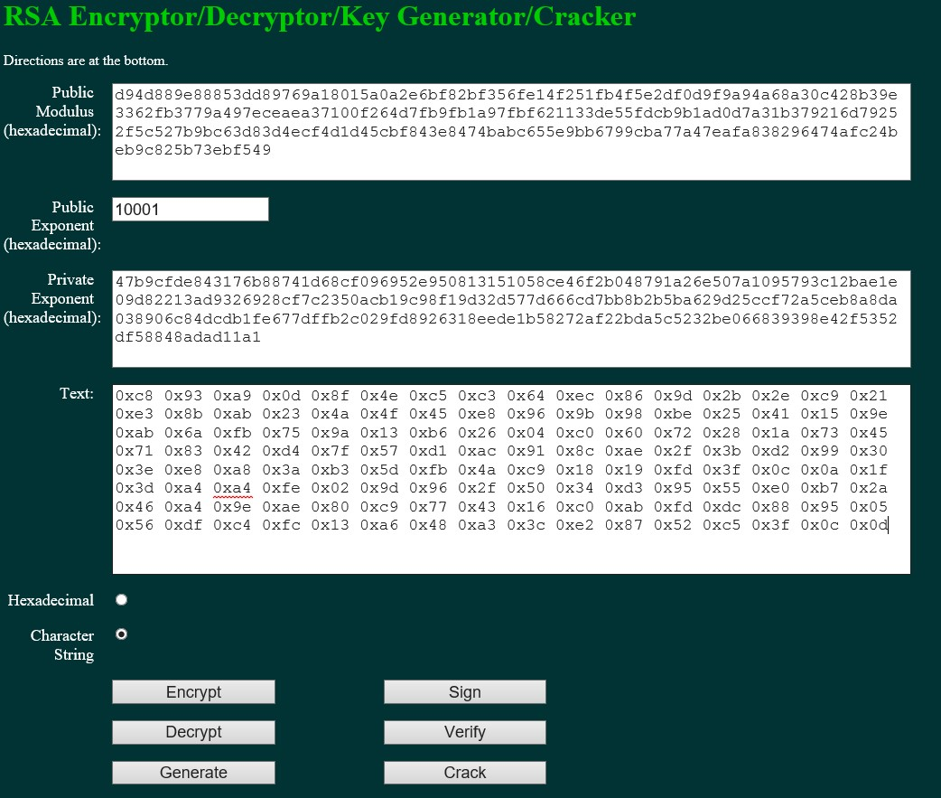
Copy and paste the public and private keys from Table 1 above into the Public Modulus and Private Exponent boxes on the website as shown in the picture above.
Make sure the Public Exponent is 10001.
Paste Alice’s digital signature from Table 2 in the box labeled text on the website as shown above.
Now BOB can verify the digital signature by clicking the Verify button near the bottom center of the website.
Whose signature is identified?
Alice

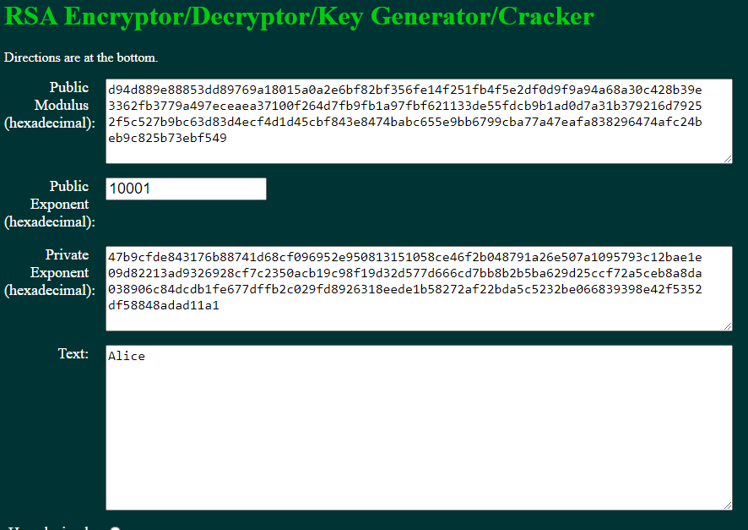

Generate a Response Signature.
Bob receives and verifies Alice’s electronic document and digital signature. Now Bob creates an electronic document and generates his own digital signature using the private RSA Key in Table 1 (Note: Bob’s name is in all capital letters).
Table 4 - BOB Digital Signature
BOB’s Digital Signature
0x6c 0x99 0xd6 0xa8 0x42 0x53 0xee 0xb5 0x2d 0x7f 0x0b 0x27 0x17 0xf1 0x1b 0x62
0x92 0x7f 0x92 0x6d 0x42 0xbd 0xc6 0xd5 0x3e 0x5c 0xe9 0xb5 0xd2 0x96 0xad 0x22
0x5d 0x18 0x64 0xf3 0x89 0x52 0x08 0x62 0xe2 0xa2 0x91 0x47 0x94 0xe8 0x75 0xce
0x02 0xf8 0xe9 0xf8 0x49 0x72 0x20 0x12 0xe2 0xac 0x99 0x25 0x9a 0x27 0xe0 0x99
0x38 0x54 0x54 0x93 0x06 0x97 0x71 0x69 0xb1 0xb6 0x24 0xed 0x1c 0x89 0x62 0x3d
0xd2 0xdf 0xda 0x7a 0x0b 0xd3 0x36 0x37 0xa3 0xcb 0x32 0xbb 0x1d 0x5e 0x13 0xbc
0xca 0x78 0x3e 0xe6 0xfc 0x5a 0x81 0x66 0x4e 0xa0 0x66 0xce 0xb3 0x1b 0x93 0x32
0x2c 0x91 0x4c 0x58 0xbf 0xff 0xd8 0x97 0x2f 0xa8 0x57 0xd7 0x49 0x93 0xb1 0x62
Bob sends the electronic document and digital signature to Alice.
Verify Digital Signature.
Copy and paste the public and private keys from Table 1 above into the Public Modulus and Private Exponent boxes on the website as shown in the picture above.
Make sure the Public Exponent is 10001.
Paste Bob’s digital signature from Table 4 in the box labelled text on the website as shown above. Now Alice can verify the digital signature by clicking the Verify button near the bottom centre of the website.
Whose signature is identified?
Bob

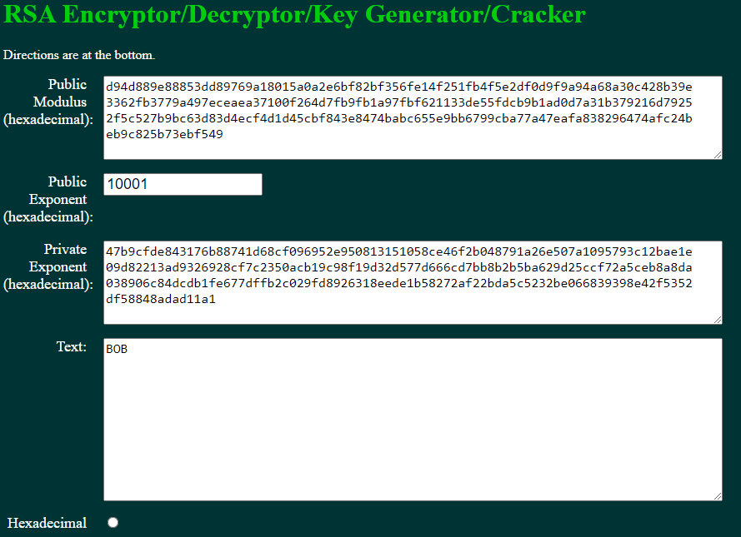

Verify this Digital Signature

Table 5 – Your lecturer’s Digital Signature
Public RSA Key | d639edcb90b508fba5005ed5f6e2b06f885e7a2ad5f6babbde7b0481e8b7 af73f4a821951757f797  6e2b8a925b6940e930a4bab189ccb93a9e81f74829140e767ec2ef3acad 7afecb3d1a114498524cd  084f9ae54a7ffd1f35c50ebdb24abb95dd5d8dfcd3ee7dd06630c831877b ee8549a1c2b615e53098  8f5cee0255a75f71
Private RSA Key | 63cf1d91885c30513e310bfe584689b98d29a775a9b6888ddb3c297f753 38f9550d9bcbbbfe28642  915bcbf6208ccb6759f885db0dbeca561b5fa61c82b70b7d2337c28ce193 4fc7ad035c87367a089a  24d2eca2583822fd5a7505bb76a7c3fd8486989ef8876617488a07330ca e414fce708b1c7278151d e92a994a639b85b9
Public  Exponent | 10001
Text | 0x8d 0x2d 0xcc 0x0c 0x12 0xdf 0xa2 0xbe 0x16 0x51 0x6e 0x5a 0x6a 0xf3 0x02 0xb9 0xf4 0x26 0x90 0xbe 0xfb 0x8f 0x3e 0x42 0xf4 0x59 0x60 0x6c 0xb5 0x44 0xbb 0x89 0xe1 0x8e 0x34 0x7f 0xa4 0x00 0xcf 0x30 0x12 0x89 0xb8 0x44 0x7f 0xde 0x23 0x70 0xad 0x92 0xdb 0xf9 0x77 0x87 0xf4 0x8e 0xe9 0xd2 0xd0 0xcc 0xa0 0x85 0x43 0x21 0xd1 0xcf 0x9b 0x51 0x11 0x39 0xe7 0xd2 0x6f 0xa3 0x1a 0x32 0xa6 0xed 0xe4 0x2d 0xbc 0x98 0xe9 0x69 0xaf 0xb7 0x4b 0x21 0xfe 0x62 0x38 0x10 0xfd 0x3e 0x79 0x90 0x75 0x08 0x14 0x0f 0x43 0x9b 0xb2 0xa5 0xe1 0x72 0xee 0x41 0xee 0x0d 0x2c 0xfb 0x2c 0x36 0x28 0x32 0xed 0xac  0x19 0x60 0x23 0x88 0x1d 0xd8 0x74 0xee 0x47 0xa0

Whose signature is identified?
Nitheesh Murugan 101

Create Your Own Digital Signature
Now that you see how digital signatures work, you can create your own digital signature.
Generate a New Pair of RSA Keys.
Go to the website tool and generate a new set of RSA public and private keys.
Delete the contents of the boxes labeled Public Modulus, Private Modulus and Text. Just use your mouse to highlight the text and press the delete key on your keyboard. Make sure the “Public Exponent” box has 10001.
Why should you have the Public Exponent as 10001? Research and
document your reflections here.
The exponent can be any odd value greater than 1. I found that converting 10001 to decimal gives the number 65537 which is a prime number.
I could be completely wrong here but from spending many hours searching the web, there doesn’t seem to be a reason as to why the public exponent has to be 10001. It can be any odd number so long as it is coprime with the modulus.
A low exponent does not necessarily make the message easy to decrypt. What is important is that the message is properly embedded with a randomized, padded structure before it is encrypted. A low public exponent with poorly padded data could be easy to decrypt.

Generate a new set of RSA keys by clicking the Generate button near the bottom right of the website.
Copy the new keys in Table 6.
Table 6 - New RSA Keys
Public Key | eef8629f546545cc0b766057f848a72cf22dc069f9fa2c2538489a25e534212acc5e5d2d80bc7446  7a9f47918cdd80432416b07366413a4973a398659985a0d81ca7dbc692c9d56e72bf848561a2c5e5  c93b20178e7225bf83e720e5dff384749f89a3ba9f25a7df0ddd7fa608f949894bb4549dd8a3c118  0a81282fd0ec356f
Private key | 97b78aa5ad673e90f5160ac4cf15114e2fd36c3ddc3f4097c0cc1751c7daf8d3bb3c8ddbbdc7e7ea  771f78c8a7ae59284759405d83a615e35c4f9909a81676ae842afc359e4b366f2f3c91d2d3747a03  354d0b56664744dcdf0cf514e764d87c6192def0a756e80711c5202913170960830cee9f7f9f61a1  044d2e1ee77d3581
Now type in your full name into the box labeled Text and click Sign.
Table 7 - Personal Digital Signature
Personal  Digital  Signature | 0xc4 0x9c 0x07 0xa6 0xa3 0x3a 0xd2 0xfe 0xcc 0x29 0x81 0x37 0xcc 0x3e 0x89 0xd7 0xba 0xea 0xdf 0x5f 0xd4 0x96 0xeb 0xb5 0x1e 0x87 0x77 0x30 0xe8 0xd0 0xc7 0x50 0x5f 0xb2 0x52 0xc0 0xd9 0xe2 0x08 0x5a 0xbc 0x58 0xf7 0x65 0x21 0x35 0xdc 0xde 0x31 0xad 0xfb 0xdc 0x56 0x63 0x1f 0xd4 0x4e 0x42 0x47 0x17 0xdd 0xce 0x15 0xc6 0x0e 0x00 0x3a 0x8c 0x17 0x4b 0x33 0x2b 0xf4 0x4f 0x60 0xc9 0x02 0xba 0x57 0x19 0xc4 0x87 0xae 0x76 0x4c 0xa8 0xde 0xa1 0x89 0xe1 0x80 0x7a 0xd9 0x34 0xae 0xfb 0x3f 0xbe 0xec 0xac 0x0a 0x83 0x17 0x5e 0xd6 0x04 0x0b 0xf7 0xc2 0x75 0x12 0x1b 0x84 0xb5 0x6e 0x68 0x16 0xac 0xaa 0x4b 0xc1 0x3b 0x6a 0x65 0x6e 0x23 0xb8 0x83

Exchange and Verify Digital Signatures
Now you can use this digital signature.
Exchange your new public and private keys in Table-6 with your lab partner.
Record your lab partner’s public and private RSA keys from their Table-6.
Record both keys in the table below.
Table 8- Lab Partners RSA Keys
Public key | b7cce979144a46b02dee28026800ee13aaac6ae6874865980b41d47101bcb0c7828dfe16ce782576  fa89804ed43869d96972ed9e7146f8fb85182a51a3beb3b3e2d06f2661257fc7757a688c9f9cffa0  54021cf35e50f4ca79a3985fe84092953aad9d0dda3c8c57f63c9e88c9f800c0bc559028c9dde276  3a44dad9a722c12d
Private key | 72f4712dae380a601449f8b210944c52f69321c50ee583cd057565c64c1cd4bfe372a571642f16d7  8438cd8c00054c8693023385be39726df53f38f098a6244395870daee4bc53857f3862904bb5b642  fd522490e06aef1dc93880ec27e3b4a8ee303703eb30bdb9e3719716660d41f39eccbb6684542429  c91e6f2122db55c1
Now exchange their digital signature from their Table-6. Record the digital signature in the table below.
Lab Partner’s  Digital  Signature | 0x84 0xc6 0x5d 0x47 0x76 0xc3 0x89 0x5a 0x21 0x4c 0xe1 0x2b 0xdf 0x15 0x30 0xa2 0x67 0x82 0xa9 0xbb 0xc7 0xa9 0xb4 0x62 0xc7 0x84 0x65 0x6a 0x06 0x44 0xad 0xe5 0x6b 0xff 0x14 0x4e 0xe4 0x18 0xbb 0x3f 0xf3 0xbc 0x44 0x27 0x6c 0x2a 0x3d 0x09 0xed 0xbc 0xb3 0x84 0x60 0x6b 0xfe 0x39 0xc5 0x2b 0x65 0xb3 0x23 0xae 0x8c 0x2a 0xc2 0x88 0x74 0x89 0x9a 0x2a 0x78 0x24 0xea 0x22 0x74 0x00 0x76 0x22 0x6d 0xc8 0xc5 0xbc 0x32 0xdf 0xf2 0x47 0x9f 0xc9 0xd4 0xce 0x2d 0x22 0x1b 0xf9 0x5c 0x59 0x51 0x34 0xc7 0x61 0xdd 0x5a 0xde 0xa2 0x47 0x82 0x7e 0xf8 0xa3 0x0d 0x4c 0xd3 0x0e 0x07 0x39 0x23 0xa9 0xd6 0xc9 0xac 0x7f 0x88 0x59 0x49 0x5b 0x87 0x5c 0x63
Verify Lab Partners Digital Signature
To verify your lab partner’s digital signature, paste his or her public and private keys in the appropriate boxes labeled Public and Private modulus on the website.
Now paste the digital signature in the box labeled Text.
Now verify his or her digital signature by clicking the button labeled verify.

What shows up in the Text box?
Rhian (I had to use my girlfriend’s name as I couldn’t get time to finish the lab until Sunday)

Learnings from tutorials so far:
Part 1 (Packet Tracer, Host Machines)
- Build a home Network
- Understand and configure IP Address
- Use Ping/ Trace route Utility to check the connection status
- Use ipconfig /all command to determine the MAC address of a Windows computer on an Ethernet network.
- Analyze a MAC address to determine the manufacturer.
- Analyze the Wired and Wireless Network connection.
- Analyze Address Resolution Protocol (ARP).
- Connect to a Wireless Router and configure the basic settings in a wireless router and add security features.
- Use nslookup command to understand the url to ip conversion.
- Configure basic connectivity settings in Intermediate devices (Switch/ Router).
- Work with SBA Packet Tracer Files/ environment
- Configure ftp, web, email, dns, ntp and aaa Servers Part 2
- Set up a virtual lab environment
- Troubleshooting the virtual lab environment
- Working with virtual machines
- Authentication, Authorization and Accounting
- Threats and Vulnerabilities – Using NMAP
- Hide and Seek – Use Steghide to hide a data file within an image file ✓ Password Cracking using John the Ripper ✓ Digital Signatures – Creating and Verifying.

