Material and manufacturing

Wooden acoustic Guitar Body
The wooden acoustic guitar is made out of mainly made out of two different woods, the front and back of the guitar is made from mahogany. The sides of the guitar is made from a variety of different woods such as mahogany or rosewood. The reason for using mahogany for the guitar is for its solid and punchy tone. Also by using mahogany throughout the guitar it it’ll make the bass and a treble stand out more which is important with a acoustic guitar. By using mahogany it also is a light material which has to be.

The body of the guitar is started by getting punched by a 30 ton press which cuts the shape of the body out of the wood of choice. The centre of the guitar is then punched which gives it its acoustic sound. The smaller the cut out in the body the more bass, and bigger the cut will then affect the treble. Before attaching the sides of the body they need to boil the wood which gives it the flexibility to bend to it’s shape, while they are placed into a heated press to make the curve of the sides of the guitar. As the sides of the guitar are in half they are then connected together to create the outer shape of the guitar. After attaching the supports in the centre of the guitar they then place a wooden lining that’ll connect the front and back of the guitar onto the outer frame. After this process they attach the front and back peace’s onto the sides of the guitar, by gluing them together. To speed up the drying process the body goes into a a press which will hold the body in the right place while it is the drying rack. After the drying process they will clue a plastic binding that will protect the guitars edges. After this whole process the guitar is then sanded down to get the smooth finish.
The body and neck are connected using what is called a dovetail joint. A dovetail joint is formed by fitting a trapezoidal bulge extending from the neck into a similarly shaped hole in the body, for a tight fit with little gap space. This is ideal for transmitting sound as the joint is made from surface to surface without using nails or the like. The name of the joint comes from the fact that the shape resembles the tail of a dove. After the neck and the body are connected the structure of the guitar is finished, after this process then they attach the mechanics of the guitar which gives the guitar the sounds. Different woods give the acoustic guitar different sounds, as others react differently to sound and vibrations.

As they make these guitars in such light volume, the process of making a guitar takes 3 weeks due to having to wait for the clue to dry on several occasions. The first process I would like to consider would be using a CNC by doing this it can change the body from being in three different parts to being two main parts. As the original process is in four different peace’s the waiting time on production is slowed down by the wait of the clue to dry, which is the reason for taking three weeks to finish.

Manufacturing using a CNC
The manufacturing process I have chosen to use would be buy using the CNC to create the main body into two parts which would change the time on the manufacturing process of one guitar. The advantages of using the CNC is that it can make the exact peace every time the same. Also as stated the time would change as the body is in two peace’s, I would make small 5mm holes in the two peace’s that they can be joint together by a dowel.

These holes will be evenly spread throughout the body to make the body as secure as possible. By gluing the two peace’s together it’ll be put into a press and drying rack like the other process and placed into the drying rack, by only having these two components to attach together the process becomes quicker as there is no need to glue the sides onto the back of the guitar. Also there will be a support down the middle of the guitar so make it more sturdy which also takes a step out of the original process which also shortens the production time.

As seen in the picture above there would have to be a cut in the middle to allow the sound the travel around the whole of the guitar to create the acoustic sound. Before gluing the top onto the guitar the inside would need a slight sand as the roughness of the cut of the CNC could affect the quality of sound coming out of the guitar. After cutting and gluing the top of the guitar onto the main body it would need a sander to give it that smooth look that a guitar needs. The use of the CNC to create the body of the guitar is a good idea as can create the same design over and over and they would all be the same. Also by using the CNC there is a possibility of having a design on the front of the guitar to make it as unique as you would like.

By doing this on the face of the guitar makes it more unique there could be so much more design ideas, this is the advantage of using the CNC the customer could ask for its own unique design to be put onto the face of the guitar which would separate this from the other markets. Also the whole in the guitar is what affects the different tones that will come out of the guitar, this is easily changed in the setting so would not take any time to change. the time scale of this process would not take long at this part of the process, the process of creating the main body will take up 4 hours due to the depth and the detail the cutter will need to under take.

By using the CNC there is disadvantages, the main would be the wastage. By using one block of wood that would affect the wastage, as they are only using a thin peace of mahogany, the wastage is low as they could make 10-20 guitars with the amount of wood used by the CNC. Another disadvantage is that even though the overall process will take less time the cutting time of the CNC would take far longer and cost more to use rather than using the press to cut out the peace’s. A possible disadvantage could be the quality of sound may not be the same while doing this process, it is a possibility and in which that would be a massive flaw in the method. Another disadvantage for using the CNC would be that the machine is very expensive, the CNC that would be needed to make this product can cost anywhere from £20,000 to upwards of £60,000 which can be a problem.

Manufacturing using a laser cutter
The second process I would like to consider would be using a laser cutter, by using a laser cutter I there would need to made into different layers and then glued together to make into a solid structure of a guitar, it would start by getting a template for the front and back side of the guitar that would be two cuts with the laser cutter. This can be a quicker process compared to the CNC machine as yes there would be more cuts needed but as they would be split into 20 different sections of 5mm mahogany then put into a template that would then be glued to secure that the back and sides of the guitar are all in the right position. By using this process the whole of the guitar would be thinner than the option of using the CNC, the vibrations of the wood is what gives the acoustic guitar it’s bass and treble. After gluing these 20 peace’s together the process from there would be similar to the original process by putting supports in the middle of the guitar to make more sturdy.
By using the laser cutter for the face of the guitar it can also be edited just like the CNC, with a laser cutter it can etching a deign onto the face with would give the guitar it’s own unique design and feel.
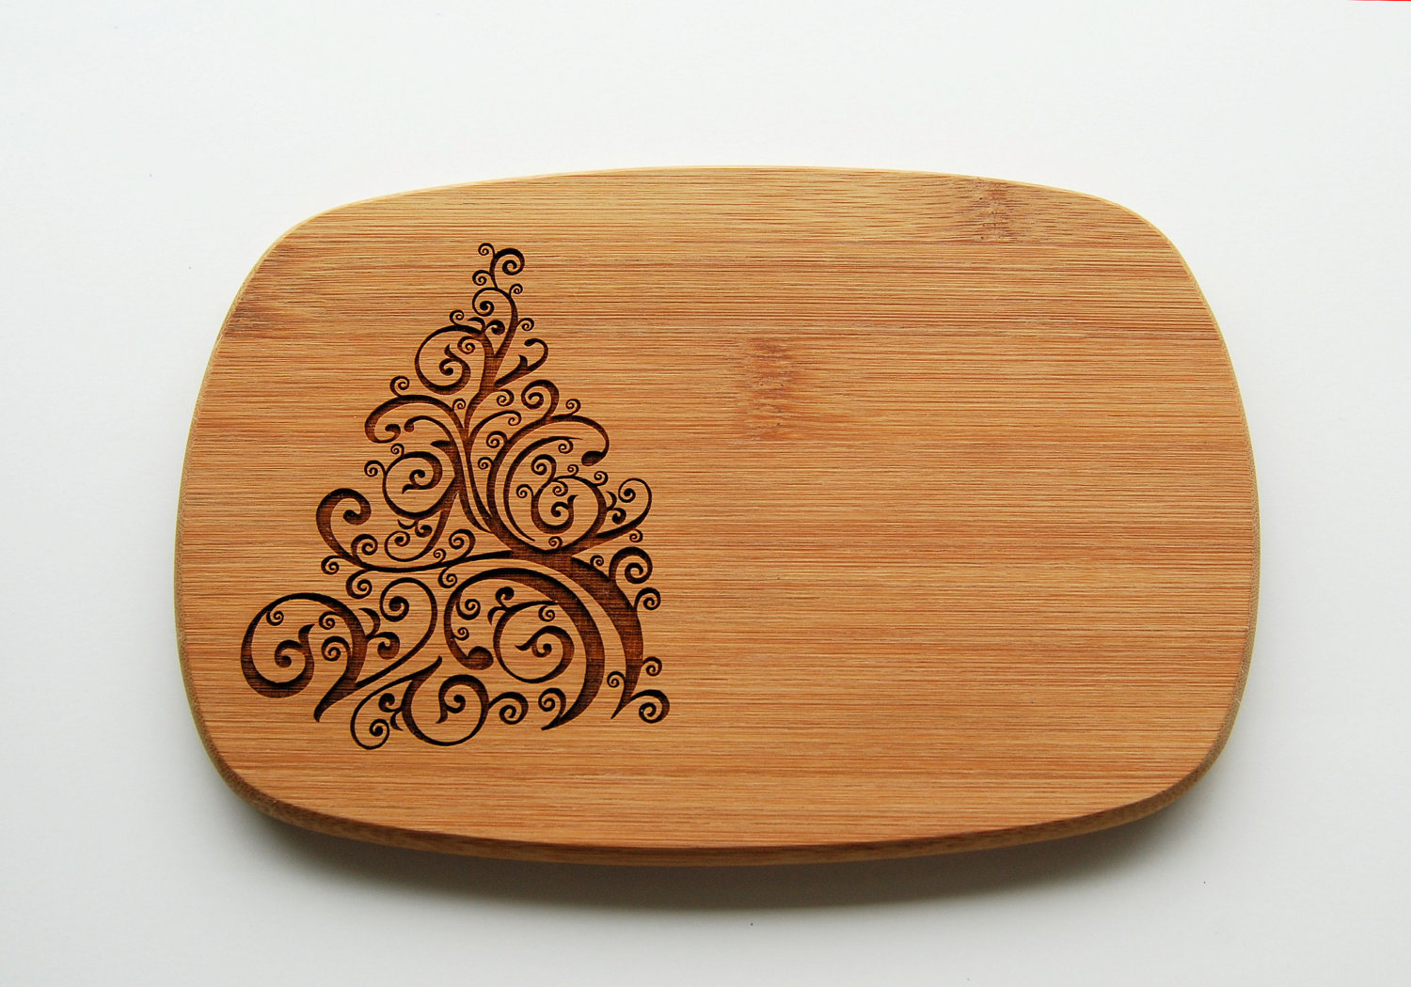

These designs can be attached to any face of the guitar and could be chosen by the customer. The joining process of gluing will be a lengthy process, which would take the same amount of time as the original way of manufacturing the guitar, by using this process I feel as if the structure of the guitar would be stronger and more sturdy. A dowel could also be placed through the whole of the layers of mahogany to make the structure more secure. After gluing the front of the guitar to the bottom and sides, the sides would need sanding as the cut of the laser cutter would leave a burn to the wood. The sanding process gets carried out throughout all of these processes but I feel because of the roughness of the cut with the CNC the laser cutter would take half the time to finished rather than the CNC. The burn of the laser cutter can also be seen as part of the room of the guitar and would give a nice look to the edge of the guitar and could be seen as a finish for the customer and could be an option while buying the guitar.
The disadvantages of using the laser is the time frame of the manufacturing process, as the whole of the structure of the guitar would be laser cut, it would take 1-2 hours to finish the whole body. But longer if the face of the guitar needed etching, would could add another hour onto the process depending on the detail needed. Another disadvantage would be the cost of the machine which would be £10,000 for a good enough laser cutter that could deal with the cutting of the wood and the dimensions of the guitar. The main disadvantage would be the wastage of this process as each cut will leave a internal waste and outside waste which is a problem but could be used in other manners of the guitar such as the handle of the guitar.

Conclusion
The conclusion I have come to is that the best out of the two would be the laser cutter, due to the speed and the different designs that would be available while building. The price of the machines are very different, the laser cutter is much cheaper than the tooling for the CNC. I feel the finish on the laser cutter would be of a better quality compared to the CNC. The finish of the laser cutter can be seen, as a design feature with the guitar which gives it a rustic look. With the laser cutter ability to etch a design onto the face of the guitar which had the edge on the CNC which is a nice feature to have. The biggest disadvantage to both of these processes is the wastage as spoken about, the wastage is a huge factor in design, the positive the laser cutter has against the CVC is it has the ability to reuse the off cuts for other parts of the guitar. As I’ve compared the two similar processes I have come to conclusion that the laser cutter would be a better process to use compared to the CNC, with it’s advantages of etching and the use of being able to reuse the off cuts to put towards other peace’s of the guitar.

Bibliography

http://baleia.me/wood-engraved-pictures/adf84/gallery/laser-cutting-engraving-etching-dt-solutions-ltd.asp

