PAUL WHITE 2530876
ACCA4025 BEN MOHAMMED FARAH, MASUD SIDDIQUI

DUE DATE 25/03/2026

LEARNING IN THE DIGITAL ERA

CONTENTS PAGE

PAGE 1) COVER PAGE
PAGE 2) CONTENTS PAGE
PAGE 3) TASK 1/TASK 2
PAGE 4) GOAL PROGRESS / VIDEO PRESENTATION TOPIC SUMMARY
PAGE 5) INTRODUCTION LINK

Task 1 – Self-evaluation.
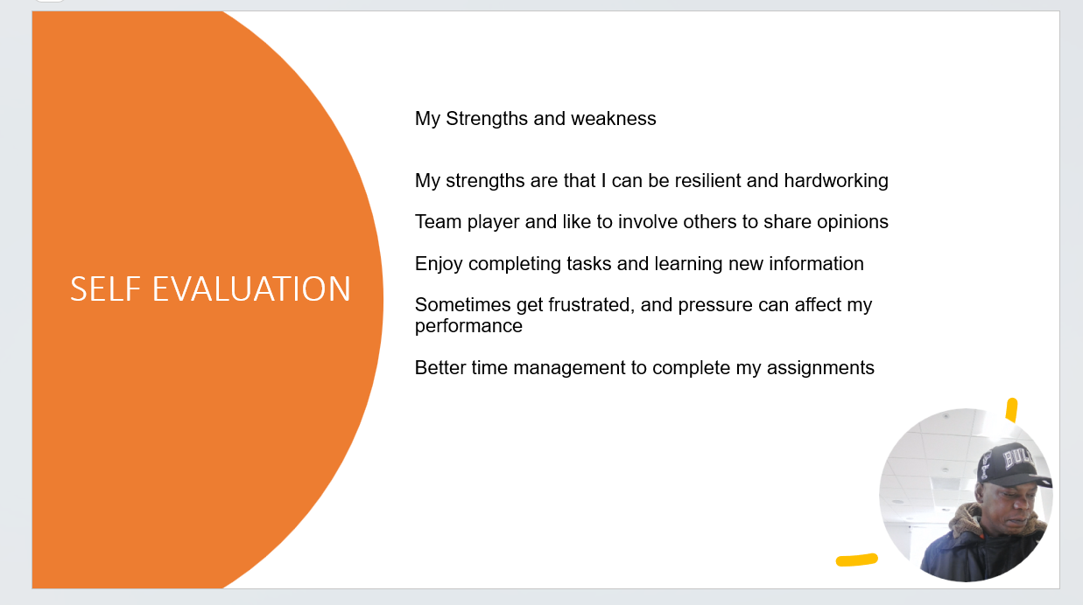
Task 2 – PDP.
* A screenshot of the PDP from either e.g. word, PowerPoint or video presentation.
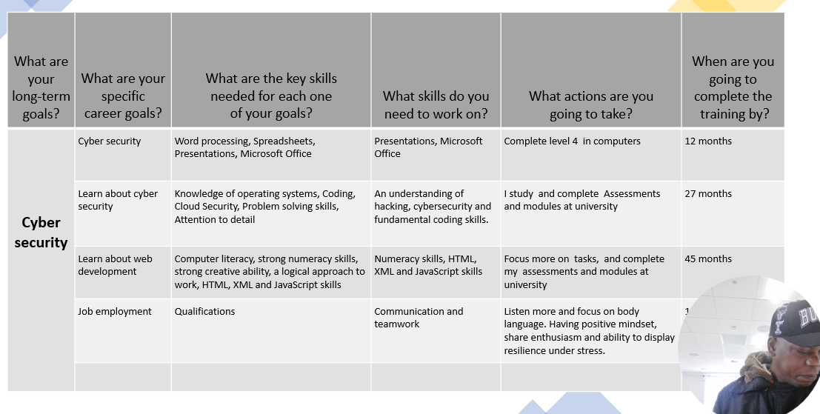
* A screenshot of goal progress engagement.
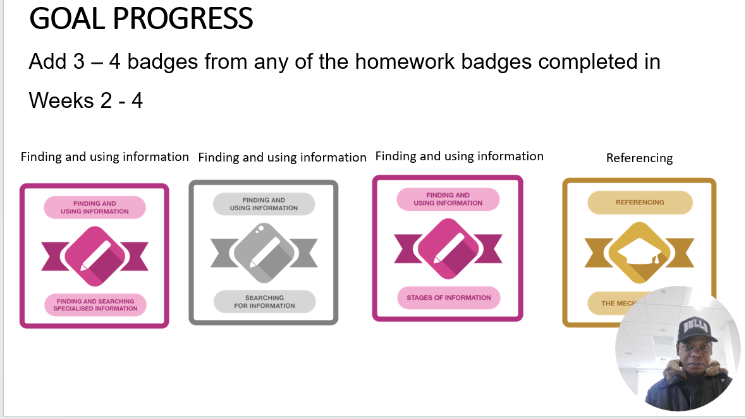
Task 3 – Unit 4 topic summary.
* A screenshot of the task answer from either e.g. word, online source, PowerPoint or video presentation.

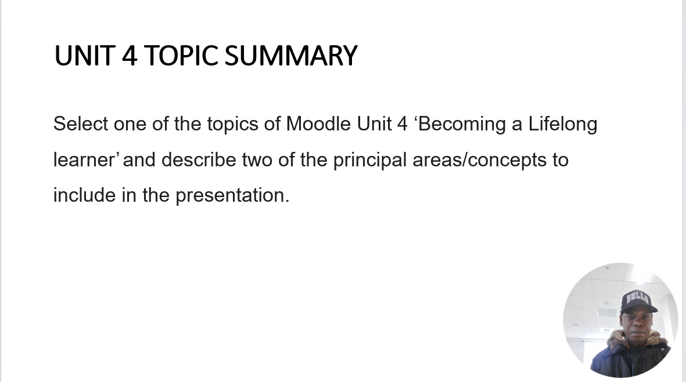

Task 4 – Video presentation.
- A link to the Video in it’s cloud platform (e.g. YouTube).
https://youtu.be/lgduVP5TKfo

- A single screenshot of the Video in it’s cloud platform (e.g. YouTube).

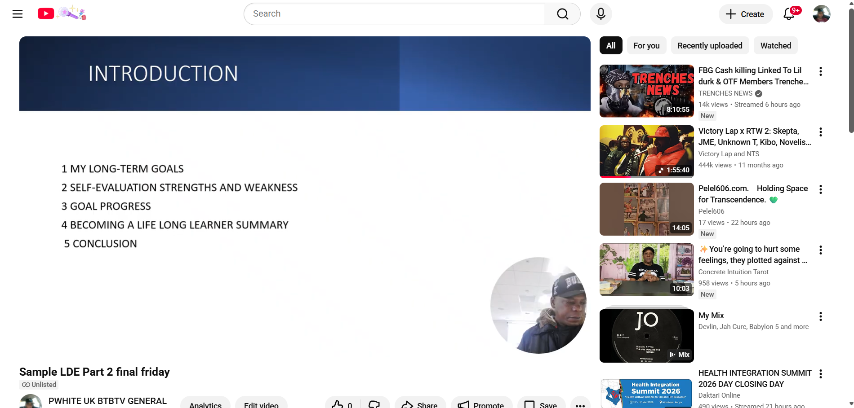
- A link to view/download the Presentation (e.g. PowerPoint file) from it’s cloud storage (e.g. OneDrive, google drive).
https://1drv.ms/p/c/955a9c29f5231005/IQBWXhnLXlt7QqG3O7OyhbjkAcs8HMPb5-6e7eGpDRMCsCg?e=D3S4jk

