
Conducting an attack on a simulated network using footprinting methods to determine security weaknesses
Research Proposal


Preferred advisor: Nitheesh Kaliyamurthy

Contents

Contents 1
Figures 2
1. Introduction 3
2. Background to the Proposed Research 4
3. Aims & Objectives 5
4. Project design 6
4.1 Outline of Project Process 6
4.2 Data Collection 6
4.3 Data Evaluation 6
4.4 Risks & Limitations 7
4.5 Ethical Issues 7
5. Resources & Planning 8
5.1 Resources Required 8
5.1.1 Hardware Resources 8
5.1.2 Software Resources 8
5.2 Planning Chart 9
6. Reference List 10

Figures

- Host machine specifications…………………………………………………………………….8
- Planning chart………………………………………………………………………………………….9

1. Introduction

As the field of technology advances, it is important to consider the risks that arise within these advancements. As with each passing moment our dependence on technology grows to the point where we put all our information onto these machines, they are then connected to a network where we depend on its security. These networks then become a vulnerable source to attack for criminal hackers. Therefore, it is of utmost importance that these networks are securely set up and maintained. “Computer network security is very complex. New threats from inside and outside networks appear constantly.” [1]

It is due to the high value care needed for network security that the chosen project idea will centre around exploring a network’s vulnerabilities by simulating an attack. Whether it is a network for personal use, or one used in high critical health care it is important to be aware of the dangers. One of the most important risks being illegal discovery of sensitive data, “Big data privacy is a major issue as it may disclose sets of sensitive data with regard to hospitals, banks, identity of an individual etc. For example, bank account data can disclose the financial condition of a person, health data can disclose the type of disease a person is suffering from, which is considered as a sensitive data for any individual ..”[2]

This attack will use methods of footprinting to gather crucial information to enter the network. The big aim of this project will be to bring light into network security and the different vulnerabilities that a network could have.

2. Background to the Proposed Research

With cyber crime on the rise many businesses have seen the importance of cyber security, this means that the need for more intricate network security is needed. With many obvious risks on the line, including leaks of private data as mentioned above, network security specialists need to stay vigilant of new and uprising attacks.

In recent years, computer systems at the U.S. Department of Defense (DoD) have been hacked by foreign powers, China has carried out extensive efforts to steal digital information from U.S. companies in what has been called “the greatest transfer of wealth in history,” and the number of commercial enterprises victimized by data breaches has increased exponentially.[3]

Unfortunately, many businesses are reluctant to change the form in which their networks work in, this is often due to money or resource needs. They build an impressive infrastructure in its early days and expect it to do be secure even years later. This is obviously unrealistic as hackers are constantly advancing in their methods of attacks and involving them with new technology.

Cyber risk assessment frameworks aim at addressing a challenging problem that public and commercial organizations and nations embrace today - a proper estimation of likelihood of cyber-related risks and assessment of their potential impact on an enterprise. However, current frameworks fail at adapting to changes which happen in dynamically shifting environments and keep organizations blind to new possible threats. [4]

In order to bring more light onto the situation, for the project idea it was decided that there would be a simulation of an attack on a basic network set up, this will be to uncover and document the different vulnerabilities that will be exploited and to work on the overall repairability of the security of the network. It will begin by using footprinting tools to gather needed information to enter the network successfully.

3. Aims & Objectives

Aims
With the project title being centred around network security and the dangers that come from attacks using footprinting to disrupt a network, it made sense for the overall aim to include the main concerns and categories surrounding the security aspect of networking. So, the big aim of this project will be to;

Analyse a basic network security system and to find vulnerabilities within its structure and exploit them by simulating attacks.

Objectives

The first objective will centre around the research stage of the project, this means different documented attacks will be investigate as well as common vulnerabilities that exist within networks today. This will be accomplished by an in-depth revision of different journal papers. As well as forms of research there will be a questionnaire given out via email to establish people’s existing understanding of network security. The answers will then be analysed, and a report will be conducted.

The second objective will be to research the most appropriate way to simulate a network using virtual machines and to gather all needed resources. The network must then be set up as stated appropriately.

The third objective will centre around researching and planning different ways to conduct a successful attack on the network, this will be done using footprinting tools. After the planning stage is done the attack will be instigated using the decided forms of attacks.

The last objective will be the documenting of the different attacks that were possible and the revision of the different vulnerabilities that were evident on the network set up.

4. Project design

4.1 Outline of Project Process

The first process will be the research stage, as discussed above, there will be a thorough revision of different documented attacks and different vulnerabilities within commonly set up networks. A questionnaire will also be created and given out to determine the average person’s grasp on network security.

Next phase will be building the network infrastructure, this will be done using virtual machines. Different processes will be examined to determine the most suitable network set up for this situation. “Virtual machines are the building blocks for today’s data centers. Once an infrastructure is in place, the process of populating the environment with workloads begins.”[5]

At the attack stage different footprinting tools will be used to discover and document the vulnerabilities within the network. After those vulnerabilities are successfully uncovered the attack on the network will be conducted and the aim will be to completely disrupt the network.
Information gathering, also recognized as footprinting, is the process of collecting all accessible information about that specific target. In a security assessment, the importance of this phase is clamorous and involves the examination, collection and classification of large volumes of data from the target network. [6]

The final part will be the analysis of the documented vulnerabilities of the network which was used in order conduct the attack. A report will be conducted which will evaluate ways in which to minimise these risks and increase the network security.

4.2 Data Collection

The data collection for the research stages will be done using the university library and google scholar. When collecting the primary data there will be a questionnaire designed and sent out to ascertain the basic understanding of network security.

4.3 Data Evaluation

The data collected will be evaluated and a small report will be produced about how the general approach most people have about network safety is not sufficient for the ever-evolving world of cybercrime.

4.4 Risks & Limitations

When conducting this project, it is important to be aware of the risks and limitations, the big main one being time constraint. For this project to have a successful outcome it is important to implement good time management techniques and ensure that progress is always being achieved. A big limitation of a personal matter which will also need considering will be chronic illness, It will be important to maintain a good level of prioritization with both work and health to minimise chances of crashes.

4.5 Ethical Issues

With this project there will be no minors or vulnerable people involved, the only ethical issue which may raise some alarm will be the hacking process on the simulated network. This will be done securely with no real victims involved.

5. Resources & Planning

5.1 Resources Required

5.1.1 Hardware Resources

The first hardware resource which will be needed will be the host computer. This will host the virtual machines. The specifications are as such;


(fig. 1)

5.1.2 Software Resources

For the software resources which will be needed there will be a few of them, first to conduct the simulation of the attack, a network must first be built. This will be done using Oracle virtual box which will use a windows server, a windows iso and lastly a kali ISO which will be used to conduct the attacks.
For the attack stage of the project, the tools used will be different search engines, databases, websites, netcraft, sublist3r, whois, traceroute and shodan.io. This is very much a draft list as more methods of footprinting will be researched and analysed later.

5.2 Planning Chart

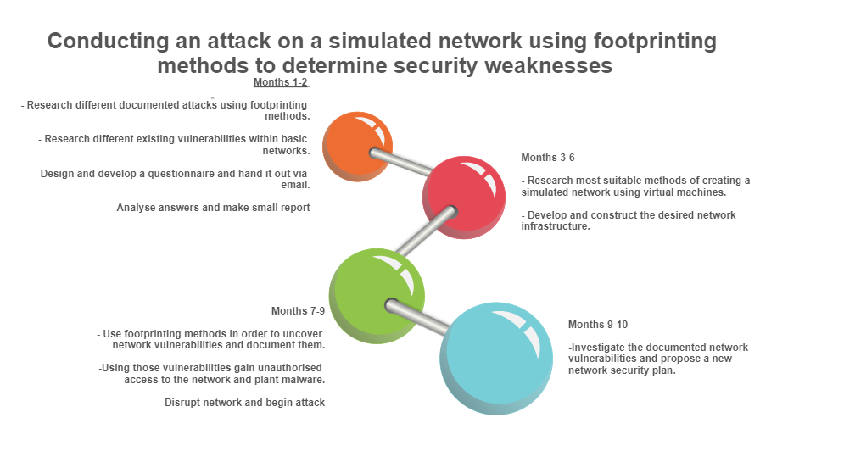
(fig. 2)

6. Reference List

[1]

J. M. Stewart and D. Kinsey, Network security, firewalls, and VPNs, Third edition. Burlington, MA: Jones & Bartlett Learning, 2021.

[2]
I. Chandrakar and V. R. Hulipalled, "Improved Technique for Preserving Privacy While Mining Real Time Big Data," International Journal of Communication Networks and Information Security, vol. 14, (1), pp. 86-92, 2022. Available: https://www.proquest.com/scholarly-journals/improved-technique-preserving-privacy-while/docview/2693940040/se-2.
[3]
R. M. Harrison and T. Herr, Cyber insecurity : navigating the perils of the next information age. Lanham, Maryland: Rowman & Littlefield, 2016.
[4]
S. Naumov and I. Kabanov, "Dynamic framework for assessing cyber security risks in a changing environment," 2016 International Conference on Information Science and Communications Technologies (ICISCT), 2016, pp. 1-4, doi: 10.1109/ICISCT.2016.7777406.
[5]
M. Portnoy, Virtualization essentials, 1st edition. Indianapolis, IN: John Wiley & Sons, Inc., 2012.
[6]
B. Dinis and C. Serrao, "External footprinting security assessments: Combining the PTES framework with open-source tools to conduct external footprinting security assessments," International Conference on Information Society (i-Society 2014), 2014, pp. 313-318, doi: 10.1109/i-Society.2014.7009066.

