
Skills for the Workplace
Module Assignment Submission
Student Name: | Alin Chirila
Student Number: | 2008838
Module No: | BMSK4004
Module Title: | Problem Solving and Decision Making

Statement of Confirmation of Authenticity
By the act of making this submission, the student declares that this is the work of the student named above. The work has not, in whole or in part, been knowingly presented elsewhere for assessment, or where assessment has been built on a previous assessment, this has been identified. Where materials have been used from other sources it has been properly acknowledged. If this statement is untrue, the student acknowledges that an assessment offence has been committed.
Attention is drawn to the plagiarism and unfair practice policies of UWTSD.

Table of Contents

Define a complex problem in the workplace, including its scope and impact 2

Analyse information on the identified problem, to help inform the decision making process 3-4-5-6

Propose a range of alternative solutions to the problem 7

Using a decision making technique, evaluate a range of solutions to identify the most appropriate option 8-9

Develop a detailed plan for implementing the solution………10-11-12-13-14-15

Communicate the plan to relevant stakeholders 15-16

Assess appropriate monitoring and review techniques to ensure successful implementation of solution 17

References 18

Appendix 1 19

Define a complex problem in the workplace, including its scope and impact
Ten years ago, I started working in the hospitality industry as a staff member in a bar with a nightclub. It is a very busy place Monday through Monday with lots of different things and promotions. I was quickly promoted to bartender, bar supervisor and deputy manager. As a deputy manager, I feel I must improve my knowledge and last year I decided to start a course in business management. Now, the Christmas season is coming, there are many problems to solve and this year I have been charged with being responsible during Christmas with the stock. The biggest issue with stock is wastage. This action plan must be successful in order to be promoted and rewarded at the end of the year, and I must implement what I learned from this module combined with my bar experience. If we are going to achieve the objective, I will have guaranteed the position of bar manager, is the position I dream of for a long time.
The Christmas season begins in early November of this year, starting on 01/11/2021. And involving more customers in our bar, than usually. Those are big corporate parties during the days. It increases the level of problems because there are going to be more people to serve and coordinate in a short period of time.
During the last five Christmas periods I have only observed, I have not been directly involved in coordination and problem reduction plans. This year, I can show what I learned in August and put into practice during the Christmas season, and to tackle various problems.
The biggest problem is the stock, especially the wastage. Wastage means all that is lost, including free drinks, over pouring, broken bottle, thieves, and deliveries. By reducing waste, the gross profit will increase significantly, now the waste is at 7% and my goal will be to reduce to 3%. This will impact the gross profit by 3 or 4%, which means the stock is at £24k per week, about £2.88k improved per month. Gross profit stands at £2.88k x 70% GP = £4.89k.
The Bar Manager is responsible for minimizing wastage, but in the coming months, I will be responsible for resolving the problem by reducing it to 3 per cent. The root of the problem started from the delivery when we get to the end of the product, the customer. Products missing from a large delivery affect both parties because they need to recount the delivery again 2 or 3 times, sometimes, and this has led to frustration and delay in delivery. During service: broken bottles, spillage, over pouring, can have a significant impact on the finances and the health and safety of clients and employees, someone can cut themselves, fall from a spill. The last thing is the customer, even after we sold the drink, the mistakes are made by the customers, dropping the drink, creating the same spill and the broken glasses. Another common case is where a client complains that the beverage was taken by a floor staff member.
This level of waste is too high in all bars and needs to be addressed equally. This will only reduce the problem and provide a solution that can be implemented for less waste but will not be eliminate as we are human beings and is part of our life learning process for making mistakes or breaking something. Roberson, K (2016)

Analyse information on the identified problem, to help inform the decision-making process
There are different methods that we can use to generate ideas and to collect and analyse information about the problem, and they are Brainstorming, Mind Mapping, Five Whys or Root Cause Analysis.
Brainstorming -this is a technique to generate a potential solution for a simple problem. Alex Osborne was named and is the creator of “father of brainstorming” (Chae, 1997a) and “made creative thinking and brainstorming household words” (Alex F. Osborn,” 1966, p. 47).
There are various techniques to study the basic problem, and those are:
CATWOE analysis -formed from six elements. Peter Checkland developed the Soft Systems Methodology (SSM) in the late 1960s, which can be used to solve certain problems. In 1975, David Smyth, a member of Peter Checkland, developed the CATWOE method to enhance the success of the SSM (Smyth and Checkland, 1976,
Checkland, 1981:224). CATWOE was published in 1976. CATWOE stands for Customers – Actors – Transformation process – Worldview – Owners – Environmental constraints. A simple checklist to find a solution to the problem. Adding the waste problem through CATWOE:

C = Customers

• Who is it for?

General Manager, Area Manager, CEO

• What problem is there now?

Losing too much stock, financial deficit.

• What will their reaction be to your proposal?

Reducing waste and financial loss, they will react in a positive way, the next step will be to introduce on other sites, and to be integrated in the internal rules.

• Who are the winners/losers?

Winners:

Senior management can easily hit targets, reducing losses.

Personnel-overtime, extra bonuses, and incentive prizes.

Customers: By reducing complaints and dropping beverages on the floor, staff will have less time to clean the floor.

Losers:

Beverage retail company- by cutting waste, there will be less stock to order.

A = Actor

• Who are the actors who will "do the right thing" to implement your solution?

All employees are involved:

Floor staff: provision and replenishment of bars.

Bartenders and waiters- preparing and delivering to the table.

Managers and supervisors - inventory monitoring and surveillance.

Approval by senior executives.

• How does this affect them?

Supplementary training and overtime for delivery and preparation.

• How would they respond?

Positively, less waste will be more free beverages at the end of the shift and more money for bonuses and incentives if the target is reached. Morale will increase as it always does when incentives are offered.

T = Transformation process

• How to convert inputs into outputs?

Identical but more carefully to minimize waste.

• What are the components? Where are these coming from?

Order online or by phone -Inventory delivered by truck.

• What are the outcomes? Where are they headed?

Consummated by the customers.

• What are all the steps in between?

Cellar for cooling-or storage for other beverages- refrigerator at bars or display -preparation-sale-delivery to table or bar.

W = World View

• What is your real challenge?

Cutting waste will lead to fewer losses.

• What are the broader implications of the solution?

About £5k a month can be saved -3 to 4% less than the regular waste.

O = Owner

• Who really owns the process or situation you are modifying?

The line of command above me is a Bar Manager after General Manager, after Area Manager, at the top is the CEO.

Deputy Manager, supervised by Bar Manager.

• Can they help you or stop you?

Help me and support me as this is a complex issue that needs the help of all staff, counting, checking, and monitoring.

• What could stand in their way?

Short-time staff if monitoring and follow-up are not possible on different days. Not counting the stock in a day will not get the correct figure, in case something needs to be modified. If more days are not done, the waste will be counted at the end of the week but might be under control.

• What can they do to help?

Counting each day to keep an eye on the stock is the key to success. By counting the stock, you can see if someone steals, breaks a bottle, gives free drinks or, in some cases, the stock could be increasing.

E = Environmental constraints

• What are the larger constraints that influence the situation and your ideas?

This will be done through teamwork; everyone must be part of the team, which is critical to being part of the team and doing your part. Some staff may not play their part or under-perform, starting to get tired as Christmas is a busy time.

• What are the ethical limits, legislation, financial limitations, limited resources? Regulations, and so on?

No financial constraints, as the Christmas season is an important investment in overtime and additional training. Because we run daily the club all will be the same, no new application for a license or other legal things.

• How could this limit your option? How do you get around these things?

By adding incentives and bonuses, we create a solid link between employees, which improves morale. Provide additional brakes, if available. Additional days off to allow employees to recover by hiring part-time staff.

5 Whys analysis:

The waste is so high.

1.Why is there a high level of wastage?

The personnel over pour and lack of concentration by breaking the bottles.

2.Why do personnel over pour and break the bottles?

There is insufficient staff training.

3.Why is personnel training, insufficient?

No funds to be allocated.

4.Why do we not have a budget?

The loss is too high after the end of the month to be allocated for staff training.

5.Why is the loss so high?

The main cause is high waste.

Root cause: High wastage.

For identifying possible causes of the problem, there are other simple techniques, like Ishikawa (Fishbone).

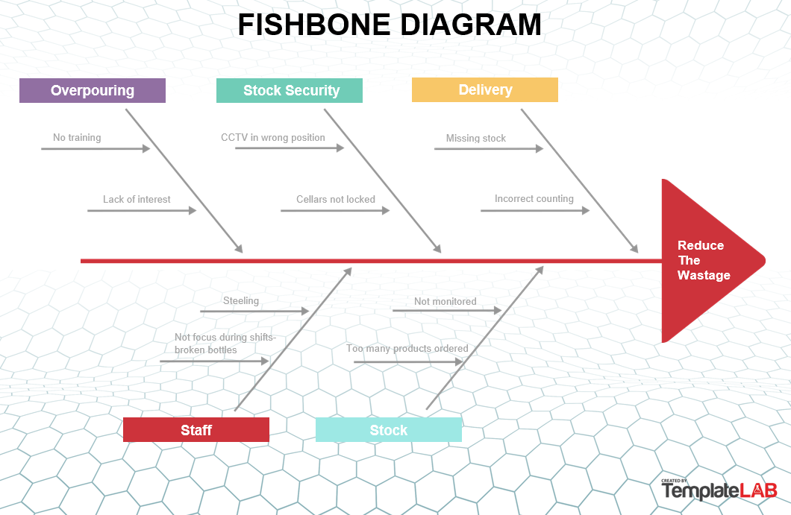

These tasks will make the best course of action to achieve the 3% waste over the Christmas period. The whole solution must be implemented in order to have a positive outcome. Tasks can be implemented separately, but the result will only be partial and will not make much difference in the waste outcome.

These solutions will require additional staff, staff training and monitoring over the nine-week period.

The alternative is no action, which is not a good solution to the problem.

Propose a range of alternative solutions to the problem
Brainstorming with a group can be a great tool to identify a possible alternative but because I have to use it alone, the mind map is a different alternative.
There are different solutions for reducing waste. There are always two choices for any problem. One solution is to do nothing but on this occasion is not applicable as interact with my dreams. Another solution is to act and create a plan, which has to be divided into more tasks to do because of complexity, involving all staff, customers, delivery drivers and their staff. The task consists of:
Delivery
Storage
Preparation
Secure
Training and implementing
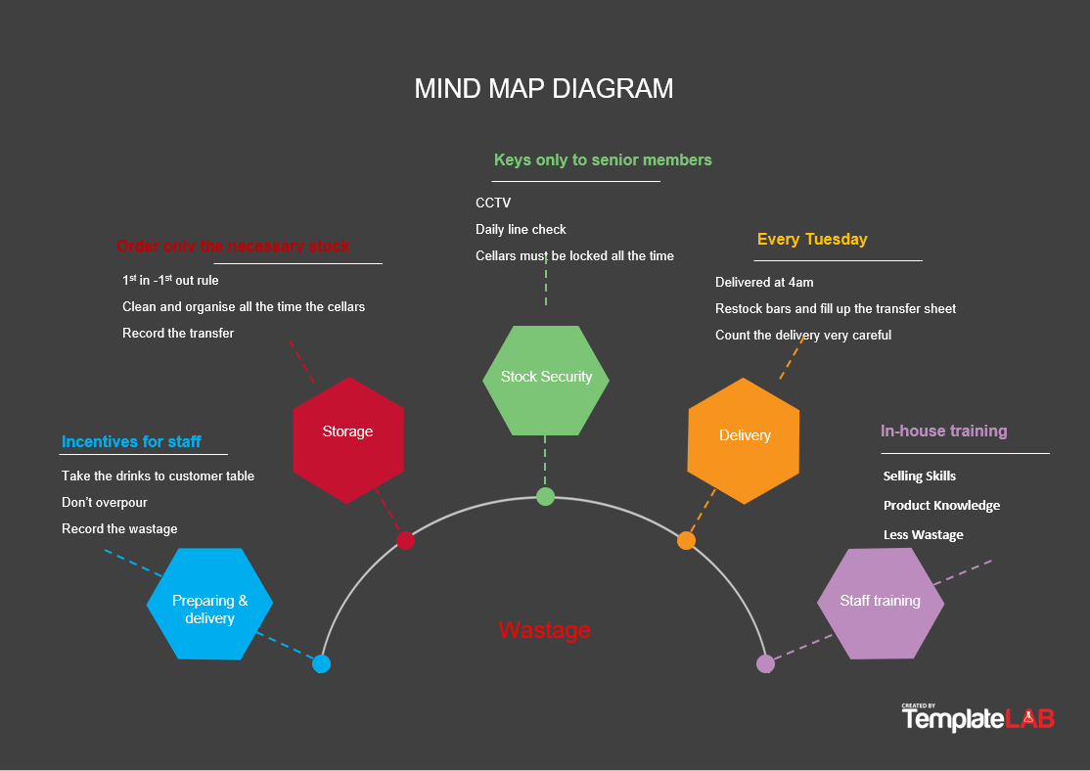
Monitoring

Using a decision-making technique, evaluate a range of solutions to identify the most appropriate option.
In a poll conducted by Deibel, C. (2015) 1 out of 326 bars, properly records their losses and the real amount of waste is 10%.
I used cost analysis to look at whether it's costly to fix the waste problem. I used 2020 data from bar analysis, cost, and waste, and last year there was a 7% waste. I added the 7% on this year's sales projections. I have divided the loss into subcategories, including staff training and a supplement for updating when needed and the money for staff to count the stock in every day. Budget acceptable margins for loss of food, free drinks, and complaints. The broken bottles and over-pouring must be kept to minimum levels. The total cost of waste per week £5561 for 9 weeks of Christmas from 01/11/21 until 31/12/21. The benefit cost ratio is 2.72:1 compared to last year's 7%.
Not the cheapest solution for waste reduction, a capital injection is necessary for training, coaching, and monitoring. In doing so, we reduce waste from 7% to 3%, which is a great success compared to 10% in the survey carried out in Deibel, C. (2015). The secret of this solution is to monitor and inform staff as the stock progresses through the Christmas season. In doing so, people will be more aware of, we monitor the stock, and they will be more careful not to break the bottles or pour too much.

Develop a detailed plan for implementing the solution

To maximize this year, it's even more important that our functional planning is perfect. Proper planning will ensure that each function functions effectively. This will ensure great service as well as all functions performed on time. This is very critical because it will reduce losses and have a significant impact on waste. A small delay in time, we may need to reorganize a complete tour of drinks and buffets.

Because this problem is complex, I have divided into different tasks, and I am going to start with the delivery and finished with the customer:

Delivery

We currently have just one delivery day per week (Tuesday). With the anticipated increase in sales, we will have to increase the quantity of inventory ordered. Our inventory is on average 24k, but it could change according to the week and when pre-orders come, during the Christmas period from November to December.
We will be watching the stocks very carefully. Instead of a delivery date, we will keep it on two during the Christmas period, with the first day being the big delivery day and the second day only to be completed during the week, this will balance the inventory.
A couple of years ago, we had some deliveries at 4:00 instead of 10:00. This worked well as everyone was in the building and had just finished cleaning. This has allowed deliveries to function very well and effectively. We will also try to obtain deliveries at that time this year. Having all staff at 4:00 am will be faster than 4 hours with 2 people, will be reduced to 1 hour, including replenishing bars. With all staff on site the waste will decrease to a minimum level even to none.
It is essential to maintain close contact and good relations with the receptionist team to ensure that all inventory is in place for pre-orders.

Cellar Space & Storage

We are a busy location, which means we still need a lot of storage space. During the Christmas period, we will use one of the warehouses which are currently only used at half capacity. We also have our stationary cupboard that will be used to store stock.

We have a bar support working during the days that is trained in stock. One of its tasks is the organization and cleaning of the cellars. This will be even more important during this busy time and will be reflected in the waste as being organized will improve the loss.
Staff meetings/Briefings
Weekly meetings will be held with all supervisors to communicate matters that need to be resolved. If required, an information session will be held for the entire team after work once a week to share information with bar staff.

Daily information sessions will be held with bar staff about all night duties. Communication is what matters!
Once a week there will be a Christmas meeting with all the reservationists, then pre-orders and upcoming functions will be discussed. This will allow us to get ready for smooth operation of all functions.

Orders

The par levels for the bar will not change much for Christmas as we are busy all year.
Pre-orders will be communicated to the reservations team on weekly pre-order sheets.
Orders will be carefully planned to ensure that we have everything in stock for all functions, as well as to ensure that our stock is not too high.
To make sure the right amount of stock is ordered, we have ready by levels and order sheets that we use on the computer.

Stock Team

Our current inventory team consists of.

• Deputy Manager
• Delivery Team (2 Bar support)
• Stock controller
• Supervisors

All the supervisors have taken inventory, so they can assist.
In addition, our delivery team has been working for a long time and has also undergone internal training on deliveries, line checks and shopping lists.
The inventory controller has years of experience and has worked the past two Christmases for us as well. That will help a lot during Christmas to control the stock and reduce the waste to 3%.
All supervisors received cross-training to help manage inventory, orders, and deliveries during the Christmas season.

Line Checks/Shopping Lists

After all the bars are cleaned up after we close, we make all the shopping lists for the bars. The bartenders and the bar support each other to take the stock to the bars. Everything is monitored by the supervisors to ensure that the right quantity of inventory is brought to the bars.
Upon completion of the shopping lists, the line check is performed by a supervisor or inventory controller.
Doing shopping lists at night is much faster because there are a lot of people working. It also ensures that the day shift bar support can spend time on setting up bars and setting up functions.

Staffing for November and December

We must ensure that we have all the necessary personnel at the right time. This requires hiring extra staff during the Christmas period.
The important issue will be to recruit personnel before the holiday season starts as a previous experience it can be a bit of a problem and even create problems later if the staff are not fully trained.
We will not need to do major recruiting for Christmas as we are a busy place, and we already have a good staff team. In addition, some of our part-time employees want to work full-time during Christmas because they have completed their studies for the Christmas break. This will help us to avoid having to employ excessive numbers of staff. We will still have to hire some part-time employees to cover additional shifts.
Pre-holiday training will be essential to ensure that personnel and venues are fully prepared for the Christmas season. That will be the key, with fully trained staff, we don't have to exceed staff, instead, we will have the right number of well-trained staff, and it will increase the customer experience along the way with good customer service, and by reducing waste.

Stock Security

During the day, when the downstairs bar is closed, the door to the bottom is always locked to keep people out of the bars.
4 cameras facing the front doors and 2 emergency exits remain on the desktop monitors in the office to help us keep an eye on people outside the venue and people entering the venue.
Personnel was advised of how to prevent the theft. They always keep their eyes open and always inform the management team if they believe there is anything suspicious.
All the cellars have locks and most of the drinks in the bar downstairs are locked up at night.
Daily line checks will be done to check if a stock has gone missing from the bars and to monitor waste and loss.

Set Up

The finger/fork buffet setup is very important. The customer's first impression is critical.
Decorations will be brought to be put on the tables to increase the visualization; we will also use different boxes to create different heights on the buffet table.
In order to increase the GP, the buffet table arrangement is important. In the buffet, you will first have bread, potatoes, and rice, for instance, these are all cheap items and customers tend to bulk up the plate early on, then they will take less of the more expensive items.
A set-up will be made as much as possible the evening before to help people in the morning. Afterwards, the rest of the installation will be done in the first hour in the morning. If the configuration is correct, the change will take place smoothly and effectively.

Table Service and during service -the preparation

All bartenders have gone through table service training. The training covered the following elements:

• 8 Steps of Table Service
• Speed & Efficiency
• Suggestive Selling
• Up-selling
• Going the Extra Mile
• Complaint Handling
• How to carry a tray
• Appearance

Without this training, bartenders are not authorized to perform table service. This will reduce wastage by reducing the fall of customers in drinks.
Teamwork is very important if the table service is to be successful. Orders will be placed on a cashier and the order will be printed on the cashier behind the bar. Then one bartender will be doing the drinks. In this way, it will function efficiently and reduce waste because this station will create more space for bartenders to prepare drinks without being crushed by other bartenders.

Upselling

A training will be held with the whole team. In the training we will go through selling skills and which products should be targeted for a “high” GP (gross profit) delivery.
High GP products will be targeted first. A pre-order sheet will be put together to make sure everything runs a smooth as possible. All pre-orders will be communicated to the Bars manager in their weekly Christmas meeting.

Incentives

Incentives will be running throughout the Christmas period. This will aid in motivating staff. Incentives will first be prioritized by reducing waste in order to incentivize staff to reduce waste.
The incentive will continue throughout the Christmas period, there will be weekly prizes and then a larger prize at the end of the period. Weekly league charts will be displayed to staff to indicate their location on the chart.

Staff training

- Product Knowledge

It is vital that staff have good product knowledge to be able to deliver a high gross profit. When staff has good product knowledge, it is easier to use their sales skills to offer customers a better product and reduce waste. They will also be more confident, and they can tell customers about the various products we have in stock.
- Selling Skills

It's a skill that distinguishes a great team member from a brilliant one. This is where staff can demonstrate to customers how well informed and experienced, they are.
Many of our customers will have uncertainty about the products we offer. Some people will be uncertain about the taste of our product as well as some will just want to try something different. In any of these situations, team knowledge will make a difference. This is referred to as a win-win situation. You sell something to the customer to make our venue profitable, and the customer gets a product that makes them happy!
- Less Wastage

After the product knowledge training the bartenders will know the products better and less errors will be made, such as: waste. With waste reduction, the gross profit will improve as well, and the waste target will be met.

Clearing and offering delivery at their table.

Once the beverage is ready, introduce it to the customer and ask if they would like to send it to their table. By doing this will reduce the waste a lot as bartenders are trained with a table service compare with customers that most of the time, they dropped the drinks.
Once they are finished, floor staff should ask clients if they can remove the glass they take from the table. By doing that, we will reduce complaints and waste, because there will be less complaints.

The Gantt chart was used to create an action plan. Is the most used format in the modern era, consisting of a deliverable list on one axis, versus time on the other axis. It was designed by L. Gantt in the early nineteenth century. The early "Gantt graphs" looked more like tables than graphs. Lyons, T. (2018).

As you can see in this Gantt chart, training, presentation, communication plan and approval began in week 0 at the end of October. Two reports from weeks 4 and 8 to be submitted to the General Manager. Inventory counting, incentives and inventory monitoring will begin in week one. Week 2 will begin to coach and mentor staff and if there is refresher training or correction, it should be adjusted for this week until week 9. The result, bonuses and prizes of the competition will be delivered with a great staff celebration in week 10.
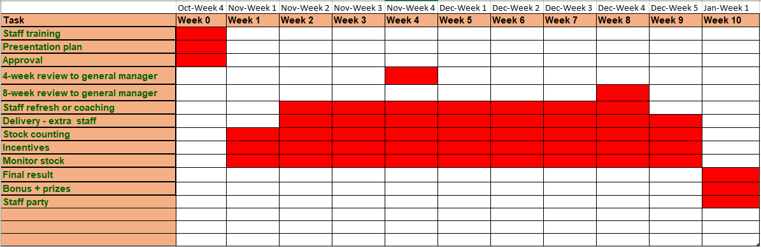

Communicate the plan to relevant stakeholders
The plan will be communicated via Microsoft Teams to the Area Manager in week 0 and approved the following day. The next stage will be staff training and inventory monitoring from week 1 to week 9. Training will be delivered in person or if personnel are ill through Microsoft Teams. Any correction to staff training will be from week 2 to week 9 in the event there is a need for coaching and refreshing. A review of weeks 4 and 8 will be presented to the General Manager to indicate whether we are within the expected target. The incentives will be held during week 1 through week 9, the weekly prices and the final price at the end of week 10. Also, week 10 will host a great staff celebration and will announce bonuses, prizes, and the final report on waste.

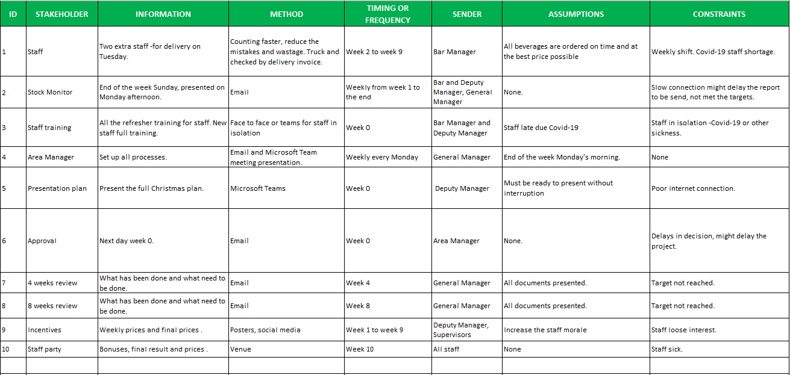

Assess appropriate monitoring and review techniques to ensure successful implementation of solution

Oversight of waste is extremely important to success. Techniques for monitoring waste are as follows:
The run chart is used, a powerful, simple, and easy to use process improvement tool Berardinelli, C. and Yerian, L. (No year). Monitor the stock and compare it against forecasts.
Daily line checks -most of the house spirits must be checked daily -this will have a moral impact on the staff knowing that they will be more careful.
Weekly report -end of the week -when the inventory is completely calculated - where the percentage of waste is calculated if on target, encourage notes to the staff, if below target, retraining, coaching, and mentoring of staff.
4 weeks and 8 weeks of review-when is submitted to the General Manager and any adjustments that need to be implemented. An additional action plan may be required depending on the outcome of 4 or 8 weeks.
One to one meeting with staff who need more time to get used to the pouring technique or waste recordings, and any other issues could arise.
Weekly progress on incentives with weekly awards - posters and graphics displayed around the office and staff area and social media.
Weekly manager formal meetings - presenting the next weekly planning on booking, training, delivery, and personnel.

References

Alex F. Osborn, 77, a founder and officer of B.B.D.& O., dies. (1966, May 6). New York Times, p. 47.
Chae, K. (1997a). Alex Osborn – Homepage. Retrieved October 18, 1999, from http://uts.cc.utexas.edu/~chaekm/afosborn.htm. Retrieved Wheeler, R. A. (2021) Alex F. Osborn: The Father of Brainstorming [online] Available at: Accessed: 01/10/2021

Creating minds (no year) CATWOE [online] Available at: http://creatingminds.org/tools/catwoe.htm Accessed: 27/09/2021
Deibel, C. (2015) Average Inventory Losses Experienced by Bar Operators [online] Available at: https://www.linkedin.com/pulse/average-inventory-losses-experienced-bar-operators-charles-deibel Accessed: 05/10/2021
Lyons, T. (2018) A brief history of Gantt charts [online] Available at: https://www.apm.org.uk/blog/a-brief-history-of-gantt-charts/ Accessed: 05/10/2021
Roberson, K. (2016) 7 Reasons Why It's OK To Make Mistakes [online] Available at: https://www.theodysseyonline.com/its-okay-to-make-mistakes Accessed: 27/09/2021
Basden, A. & Wood-Harper ,A.T.(2016) A Philosophical Enrichment of CATWOE Available at: https://www.researchgate.net/profile/Andrew-Basden/publication/28579152_A_philosophical_discussion_of_the_root_definition_in_soft_systems_thinking_An_enrichment_of_CATWOE/links/5f8444ba458515b7cf79fc06/A-philosophical-discussion-of-the-root-definition-in-soft-systems-thinking-An-enrichment-of-CATWOE.pdf Accessed: 27/09/2021
Templatelab (2021) 25 Great Fishbone Diagram Templates & Examples [Word, Excel, PPT] [online] Available at: https://templatelab.com/fishbone-diagram-templates/#google_vignette Accessed: 26/09/2021
Templatelab (2021) 45 SMART Goals Templates, Examples & Worksheets [online] Available at: https://templatelab.com/smart-goals/ Accessed: 26/09/2021
VanGundy, A.B. (1984), "BRAIN WRITING FOR NEW PRODUCT IDEAS: AN ALTERNATIVE TO BRAINSTORMING", Journal of Consumer Marketing, Vol. 1 No. 2, pp. 67-74. [online] Available at: https://doi.org/10.1108/eb008097 Accessed: 26/09/2021
Wheeler, R. A. (2021) Alex F. Osborn: The Father of Brainstorming [online] Available at: https://www.russellawheeler.com/alex-osborn Accessed: 01/10/2021

Appendix 1

