Business Plan

for

Name : Shikder Sujan
Student Number : 2115669
Programme : Skills for the Workplace (CertHE.)
Module : Managing Enterprise in the 21st Century
Module Code : BMSW4006
Word Count : 2893
Date of Submission : 06/07/2022

TABLE OF CONTENTS

INTRODUCTION 7
MAIN BODY 7
Name of Business : 7
Type of Business: 7
Product/Service Offerings: 7
Mission Statement: 8
Business Aim: 8
Business Objectives: 8
Location of Business: 8
Marketing & PR Activities : 9
Human Resource : 11
Marketing mix 13
Financial Resources : 15
SWOT analysis : 15
CONCLUSION 22
REFERENCES 23
APPENDICES 25

Executive Summary

Redchillis Corporation (RC) is a professional student consulting firm that specializes in providing placement information for potential undergraduate and graduate students interested in studying at colleges and universities in the United Kingdom. Our goal is to make our services for home and overseas students adequately and successfully, assisting them in their search for undergraduate and postgraduate programs designed to meet their individual needs. We are committed to providing honest and accurate information as per the admission criteria of each institution. We are providing A-Z services for those who are looking for world class education and a bright career. Our mission statement is - "Committed to serve you better & faster with quality”.

INTRODUCTION
Business plan is basically document which provides the details regarding the business aim & objective, etc so that achieving significant direction for gaining success can become possible. In the current era having significant detailed plan for operating in business is improvident so that significant strategy can be formulated. The current study is based on offering the business plan for Redchillis corporation which operates in consulting for students career development. It will provide information regarding the name of business, type, mission, aim, location, marketing activities, etc. so that depth understanding can be derived.

MAIN BODY

Name of Business :
Redchillis Corporation

Type of Business:
This is a Partnership business plan where me and two of my other friends are owner. My friends and I agreed to start a partnership business because - each partner will bring their own skills, knowledge, experience and contacts to the business, potentially giving it a better chance of success than the individuals who have transacted individually.

Product/Service Offerings:
The particular business is operating in consultancy industry by offering students service of admission to various university, visa processing, accommodation, career plan, etc. In this both local & international students to get admission in UK university by providing consultancy in effective manner.

Mission Statement:
The mission statement of our business is : "Committed to serve you better & faster with quality", so that requirements of targeted audience can be fulfilled.

Business Aim:
The main aim of the business is give professional & quality service which is capable of accomplishing students requirements by complying with standardized performance to obtain greater customer satisfaction.

Business Objectives:
- To increase the profitability of business by 12% at the end of year.
- To reduce cost by 15% within year.
- To increase market share by 5% within 6 months.
- To enhance customer satisfaction by increasing 15% marketing & promotional practices by 10% at the end of year.

Location of Business:
There are two offices which are operated in distinct location such as UK & Bangladesh. Both the locations possessing offices will pay attention on offering the consultancy service so that admission in UK universities can be derived by local & Bangladeshi students. The location of the UK & Bangladesh offices are :
36, Oliver Road,
Newport, NP19 0HU, South Wales, UK
Mobile : 0044 7882810173, 0044 7918234925

Section: 12/C, Lane 21, Plot: 1/1,
Pallabi, Mirpur, Dhaka -1216, Bangladesh,
Mobile : 0088 01711487951, 0088 01711487889,
These both the location will focus on accomplishing the aim of the business so that leading position in consultancy sector can be derived.

Marketing & PR Activities :
In order to become successful in the current era it is highly important for the organization to pay attention on having the significant evaluation of market performance so that suitable course of action can be taken. Consultancy sector in UK is facing the growth of 4.5% per average year that it is indicating that operating in specified area for operating business is found to be positive. In addition to this, Bangladesh is having the performance in positive manner which is indicating the good demand for consultancy service (Barrow et al., 2018). In the present era, there are different types of the courses & higher level of competition is prevailing which has inclined the demand for obtaining the consultancy service so that effective career development can be obtained. On the basis of this, it can be interpreted that there is higher level of demand for the student consultancy so that significant growth can be achieved by the particular organization.

Marketing is the significant technique which is related with spreading the awareness about the services to customers so that greater attention from them can be derived (Morgan et. al., 2019). There are different types of the marketing practices which can be taken into the process by the firm that involves both traditional & digital method so that objective of higher profitability and sustainability can be achieved.

- Print media is one of the significant method that can be taken into the consideration by distributing leftlet, posters, newspaper advertisement, etc about quality & benefits of consultancy services. This can provide assistance in targeting students who are searching for career related guidance.
- Content marketing is highly trending in the current working scenario as usage of technological devices for having podcasts, informatics, etc which aids in driving customers to have key ability to position in market.
- Social media marketing is largely taken into the process as targeted audience such as students have enhanced their social connection by using different platforms such as Facebook, Instagram, etc (9 Marketing Promotion Strategies, 2022). This helps in improving brand image, creates greater awareness among customers, etc. that can become possible by using this promotion method. Referral marketing with social media marketing can provide assistance in having oral publicity by satisfied students to attract potential customers.
- Email marketing helps in directly connecting with target audience which allows sharing information regarding new offers, discounts, succession rate, etc.
- Influencing marketing by having involvement of celebrity, business tycoons, etc can help in attaining & retaining customers (Souto and Rodríguez-López, 2021). Promotions techniques as mentioned can help the both the location offices to have ability to create good brand image, etc so that achieving higher profitability & sustainability can be achieved.
On the basis of this, it can be interpreted that public relationship is one of the significant action that helps in attaining the crucial connection for gaining appropriate ability to get higher attaining & retaining customers can become possible.

The targeted audience can be obtained by using the STP technique which is helpful in accomplishing the proper segmentation, targeting and positioning. Segmentation will be exerted on the basis of psycho graphic so that achieve those students who have objective of gaining guidance. This includes ensuring that customer who wants guidance are targeted so that positioning on the basis of higher quality & grater customer satisfactions can be exerted.

Human Resource :
It is one of the crucial resource of the organization which helps in accomplishing the different roles & responsibilities so that attaining success can become possible (Cassar et. al., 2018). The recruitment process which will be taken into the consideration for recruiting the different employees for right jobs that involves using social media, business based platform, consulting with recruiting agency, etc. so that corrective employees can be derived. The process includes identifying needs, formulating job description, devising recruitment strategy, interviewing, etc. This will help in gaining the corrective form of the employees for right position (Lahtinen et. al., 2020). There are different employees will be required and recruited for the 12 months for managing the student consultancy firm in order to offer the quality services to the targeted audience in turn objective of attaining leading position can become possible. The sourcing the team members can be done by using the various options available that involves having contacting with agency of recruitment, adverting on business based platform, etc. These can provide assistance in achieving the corrective form of personnel in the company so that exerting actions of offering significant services can be provided.
Team members | Number of members | Roles and responsibilities
Marketing executive | 6 | This involves using the significant techniques such as social media, email, etc. so that understanding their requirements and reverting for having greater conversion rate.
Marketing manger | 2 | Significant allocating of marketing activities according to plan, managing performance of marketing executing, etc.
Data analyst | 2 | Proper data collection, evaluation, finding insights from the gathered data regarding trends, etc (Scott, 2022)
Customer relationship manager | 2 | Having the proper customer building relationship activities by communicating and analyzing their needs, offering them corrective solutions, etc (Lim et. al., 2021).
Financial manager | 2 | The significant identification of resource requirement allocation of resources, sourcing finance, filing tax, etc.
Consultants | 6 | This involves conducting research, detecting the problems of clients, creating trustworthiness professional communication process, offering corrective suggestion, etc.

On the basis of the provided information it can be mentioned that these are the job roles which will be accomplished by these team members so that effectual functioning through sourcing them on corrective position to get higher productive results can become possible.

Marketing mix
It is one of the crucial technique which aids in making the strategic formulation of the actions so that offering proper service can become possible (The 7 Ps of marketing, 2022).
Product :
This is a significant component of the marketing mix that involves providing unique forms of services such as consulting services to target audiences like students. Redchillis corporation's main products or services include arranging for national and international students to be admitted to various UK universities, assisting in visa processing, assisting in accommodation, advising on career development, etc.

Price:
There are different form of the pricing strategies which can be taken into the consideration by this consultancy firm for having the effective functioning which involves costs plus, competitive, penetration, skimming, etc (Inkon, 2019). For gaining the significant profit margin and higher ability to compete with requirements of students the firm will focus on using the competitive pricing approach.

Place:
This consultancy firm having the presence in two locations such as UK and Bangladesh so that effectual functioning by covering greater customer share can become possible. These are the two places where firm will focus on giving the consultancy services to customers so that higher productive results to meet the customers requirements can become possible. These two locations will jointly provide services to the students.

Promotion:
In order to become successful it is important for the enterprise to pay attention on having the significant execution of marketing actions so that significant focas on clients can be provided (Akanbi, 2021). This involves using the print media for distributing the leaflet. In addition to this, the consultacy firm will emphasize on having such as social media, email, direct marketing, etc so that effectual awareness regrading offered services can be provided. This can provide the assistance in gaining the reliable ability to coordinate with the prevailing competition in market so that effectual service offering can become possible.

People:
For gaining the success in the industry it is important for the organization to get the effectual processing in turn accomplishing the goal in effective manner can be done (Lim, 2021). This involves the distinct form of the employees which are placed at the corrective position in turn meeting the requirements of higher productivity and sustainability can become possible. On the basis of this it can be mentioned that the consultacy firm can gain success with help of the available employees.

Processes:
There are distinct form of the procedure which involve consulting clients, marketing processes, etc which are required to be exerted in the highly effective manner (McKeever, 2018). In order to gain the competitive position in the market there are various processes which involves having the quality based procedure in the organization in turn accomplishing the organizational objective in order to get the proper success in competitive manner can become possible.

Physical evidence:
Redchillis corporation is having the physical evidence of offices and online presence so that greater trustworthiness can be shared. This firm operates successfully in the market in with having these all elements' execution in effectual manner (Hanák and Grežo, 2020).

Financial Resources :
There are different form of the business sources which can be taken into the consideration by the organization in turn effective profitability and sustainability can be attained (Shrotriya, 2019). For successful operating the business Redchillis corporation will focus on having the course of action such as bank loan, crowdfunding, investment from equity and angel investors so that effective functioning can be obtained.

SWOT analysis :
A SWOT analysis is a strategic management tools or techniques which is very important for an organization as well as individual. “SWOT Analysis is a simple but powerful tool for sizing up an organization’s resource capabilities and deficiencies, its market opportunities, and the external threats to its future” (Thompson et al., 2007).
Following is the SWOT analysis of Redchillis Corporation:

Strengths  - Financial availability,  - Presence of skilled employees,  - Effective marketing technique (Akanbi, 2021), etc | Weaknesses  - Lack legal compliance with industrial norms,  - Lower coordination with technological aspects,  - Ineffetive management of resources, etc
Opportunity  - Partnership with top companies/Universities,  - Merge and acquision option for growth,  - Higher revenue generating capacity, etc | Threats  - Higher competition,  - Strict legal compliance,  - Frequent technological advancement, etc

Cash Flow Forecast :
12-Months Cash flow forecast of Redchillis Corporation :

Select your starting month: | June, 2022
 |  |  |  | MONTHS
Cash in-flows | Description (as required) | Starting point | 1 | 2 | 3 | 4 | 5 | 6 | 7 | 8 | 9 | 10 | 11 | 12 | TOTAL
Anticipated sales | It is generated from offering the service to the selected clinets | £0 | £10000 | £11,200 | £12,544 | £14,049 | £15,735 | £17,623 | £19,738 | £22,107 | £24,760 | £27,731 | £31,058 | £34,785 | £241,331
Value of your Start Up Loan | The source of financing is used to get easy liquidity | £0 | £15,000 | £15,000 | £15,000 | £15,000 | £15,000 | £15,000 | £15,000 | £15,000 | £15,000 | £15,000 | £15,000 | £15,000 | £180,000
Other sources of cash or equity | This is basically obatianed from the equity source of finance | £0 | £2,000 | £2,000 | £2,000 | £2,000 | £2,000 | £2,000 | £2,000 | £2,000 | £2,000 | £2,000 | £2,000 | £2,000 | £24,000
Existing assets for business purposes | It is basically concerned with possessing the set of assets for processing of business | £0 | £7,000 | £7,000 | £7,000 | £7,000 | £7,000 | £7,000 | £7,000 | £7,000 | £7,000 | £7,000 | £7,000 | £7,000 | £84,000
Crowdfunding |  | £0 | £5,000 | £5,000 | £5,000 | £5,000 | £5,000 | £5,000 | £5,000 | £5,000 | £5,000 | £5,000 | £5,000 | £5,000 | £60,000
Angel investors |  | £0 | £2,000 | £2,000 | £2,000 | £2,000 | £2,000 | £2,000 | £2,000 | £2,000 | £2,000 | £2,000 | £2,000 | £2,000 | £24,000
Total cash in-flows (A) |  | £0 | £41,000 | £42,200 | £43,544 | £45,049 | £46,735 | £48,623 | £50,738 | £53,107 | £55,760 | £58,731 | £62,058 | £65,785 | £613,331
 |  |  |  | MONTHS
Cash out-flows | Description (as required) | Starting point | 1 | 2 | 3 | 4 | 5 | 6 | 7 | 8 | 9 | 10 | 11 | 12 | TOTAL
Cost of sales |  | £0 | £2,000 | £2,000 | £2,000 | £2,000 | £2,000 | £2,000 | £2,000 | £2,000 | £2,000 | £2,000 | £2,000 | £2,000 | £24,000
Existing assets for business purposes |  | £0 | £700 | £700 | £700 | £700 | £700 | £700 | £700 | £700 | £700 | £700 | £700 | £700 | £8,400
Rent or premises costs |  | £0 | £1,500 | £1,500 | £1,500 | £1,500 | £1,500 | £1,500 | £1,500 | £1,500 | £1,500 | £1,500 | £1,500 | £1,500 | £18,000
Business rates for your business premises |  | £0 | £500 | £500 | £500 | £500 | £500 | £500 | £500 | £500 | £500 | £500 | £500 | £500 | £6,000
Utilities (gas, electricity, water) |  | £0 | £800 | £800 | £800 | £800 | £800 | £800 | £800 | £800 | £800 | £800 | £800 | £800 | £9,600
Insurance |  | £0 | £1,500 | £1,500 | £1,500 | £1,500 | £1,500 | £1,500 | £1,500 | £1,500 | £1,500 | £1,500 | £1,500 | £1,500 | £18,000
Telephone and internet |  | £0 | £500 | £500 | £500 | £500 | £500 | £500 | £500 | £500 | £500 | £500 | £500 | £500 | £6,000
Marketing and advertising expenses |  | £0 | £250 | £250 | £250 | £250 | £250 | £250 | £250 | £250 | £250 | £250 | £250 | £250 | £3,000
Vehicle running costs |  | £0 | £200 | £200 | £200 | £200 | £200 | £200 | £200 | £200 | £200 | £200 | £200 | £200 | £2,400
Equipment purchase or leasing |  | £0 | £2,000 | £2,000 | £2,000 | £2,000 | £2,000 | £2,000 | £2,000 | £2,000 | £2,000 | £2,000 | £2,000 | £0 | £22,000
Postage, printing, stationery |  | £0 | £200 | £200 | £200 | £200 | £200 | £200 | £200 | £200 | £200 | £200 | £200 | £200 | £2,400
Transport and delivery |  | £0 | £250 | £250 | £250 | £250 | £250 | £250 | £250 | £250 | £250 | £250 | £250 | £250 | £3,000
Professional fees (legal, accounting etc.) |  | £0 | £2,500 | £2,500 | £2,500 | £2,500 | £2,500 | £2,500 | £2,500 | £2,500 | £2,500 | £2,500 | £2,500 | £2,500 | £30,000
Your salary (if PSB is in deficit)* |  | n/a | £0 | £0 | £0 | £0 | £0 | £0 | £0 | £0 | £0 | £0 | £0 | £0 | £0
Your salary (over and above your PSB needs)* |  | n/a | £200 | £200 | £200 | £200 | £200 | £200 | £200 | £200 | £200 | £200 | £200 | £200 | £2,400
Staff costs |  | £0 | £2,500 | £2,500 | £2,500 | £2,500 | £2,500 | £2,500 | £2,500 | £2,500 | £2,500 | £2,500 | £2,500 | £2,500 | £30,000
Start Up Loan monthly repayment* |  | n/a | £150 | £150 | £150 | £150 | £150 | £150 | £150 | £150 | £150 | £150 | £150 | £150 | £1,800
Total cash out-flows (B) |  | £0 | £15,750 | £15,750 | £15,750 | £15,750 | £15,750 | £15,750 | £15,750 | £15,750 | £15,750 | £15,750 | £15,750 | £13,750 | £187,000
 | Your net cash flow (A-B) | £0 | £2  5,250 | £26,450 | £27,794 | £29,299 | £30,985 | £32,873 | £34,988 | £37,357 | £40,010 | £42,981 | £46,308 | £52,035 | £426,331
 | Your monthly opening business bank account balance | £0 | £0 | £25,250 | £51,700 | £79,494 | £108,793 | £139,778 | £172,652 | £207,640 | £244,997 | £285,007 | £327,987 | £374,296 | £426,331
 | Your closing cash position | £0 | £25,250 | £51,700 | £79,494 | £108,793 | £139,778 | £172,652 | £207,640 | £244,997 | £285,007 | £327,987 | £374,296 | £426,331 | £426,331

The above data is presenting that Redchillis corporation will have significant positive cash balance at the end of the year which is a positive sign.

CONCLUSION
From the above report it can be concluded that the business plan of Redchillis corporation is helpful in achieving significant information regarding the activities to carry out the operational practices. In order to understand this in depth, emphasis has been laid on its aims, objectives, business location, marketing and PR activities. Also, the Redchillis corporation offering a wide range of services for its clients to attract them into the business.

REFERENCES

Books and Journals
Akanbi, A., 2021. Awareness of Government Facilitated Sources of Finance among Owners of Micro Small and Medium-Sized Enterprises in Nigeria. Journal of Global Economics and Business. 2(4). pp.47-74.

Barrow, C., Barrow, P. and Brown, R., 2018. The Business Plan Workbook: A Step-By-Step Guide to Creating and Developing a Successful Business. Kogan Page Publishers.

Cassar, V., Tracz-Krupa, K., Bezzina, F. H. & Przytula, S., 2018. “The times they are-a-changin”: Reconstructing the new role of the strategic HR manager.

Hanák, R. and Grežo, M., 2020. The effect of entrepreneurial experience on the quality of a business plan proposal in applying for angel investment. International Journal of Entrepreneurial Venturing. 12(6). pp.617-647.

Inkon, K., 2019. A cross-sectional study on the relationship between business plan, entrepreneur type, development stage and profitability of US SMEs. Academy of Entrepreneurship Journal. 25(1). pp.1-21.

Lahtinen, V., Dietrich, T. and Rundle-Thiele, S., 2020. Long live the marketing mix. Testing the effectiveness of the commercial marketing mix in a social marketing context. Journal of Social Marketing.

Lim, W.M., 2021. A marketing mix typology for integrated care: the 10 Ps. Journal of Strategic Marketing. 29(5). pp.453-469.

Lim, X. J., Cheah, J. H., Ng, S. I., Basha, N. K. & Soutar. G., 2021. The effects of anthropomorphism presence and the marketing mix have on retail app continuance use intention. Technological Forecasting and Social Change. 168. p.120763.

McKeever, M.P., 2018. How to write a business plan. Nolo.
Morgan, N.A., Whitler, K.A., Feng, H. & Chari, S., 2019. Research in marketing strategy. Journal of the Academy of Marketing Science. 47(1) pp.4-29.

Shrotriya, D.V., 2019. Internal sources of finance for business organizations. International Journal of Research and Analytical Reviews. 6(2). pp.933-940.

Souto, J.E. and Rodríguez-López, Á., 2021. Entrepreneurial learning in an experiential and competences training context: A business plan in Bachelor thesis. The International Journal of Management Education. 19(3)./ p.100513.

Scott, J.C., 2022. The “Business Plan” of Hunter-Gatherers. The American Historical Review. 127(1). pp.445-447.

THOMPSON, A. A., STRICKLAND, A. J. & GAMBLE, J. E., 2007. Crafting and Executing Strategy-Concepts and Cases, (15th Edition), USA: McGraw-Hill/Irwin.

Online
9 Marketing Promotion Strategies. 2022. [Online]. Available through: <https://www.creatopy.com/blog/marketing-promotion-strategies/#f>

The 7 Ps of marketing. 2022. [Online]. Available through: <https://www.business.qld.gov.au/running-business/marketing-sales/marketing-promotion/marketing-basics/seven-ps-marketing>

APPENDICES

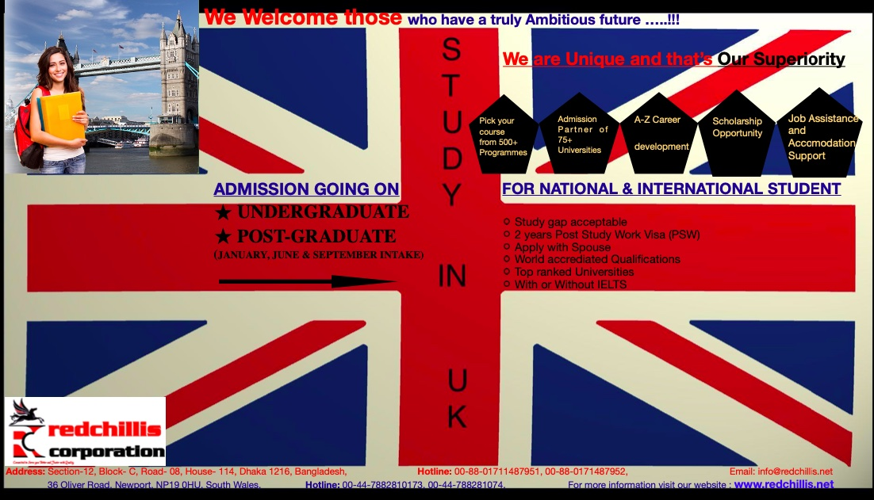
Leftlet design :

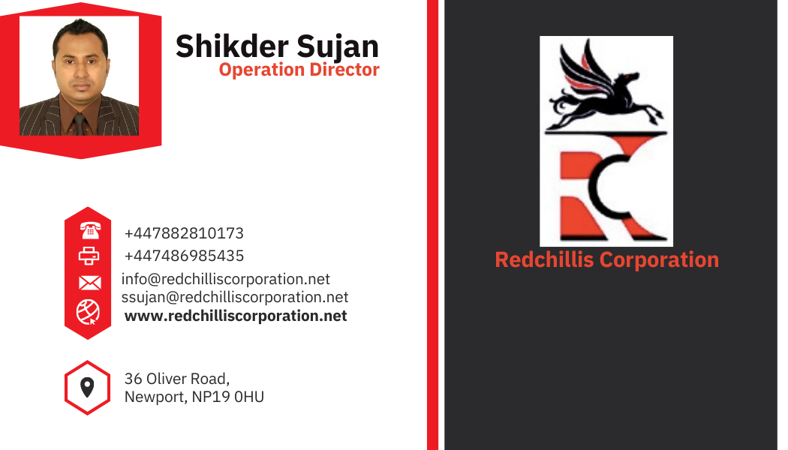
Business Card:

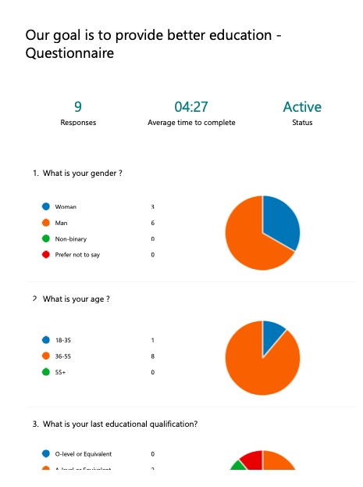
Market Research (Primary Research - Questionnaire):
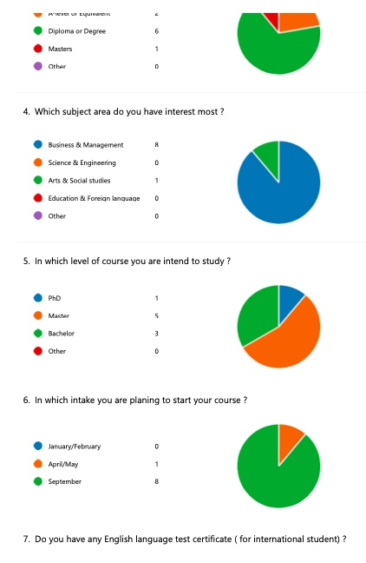

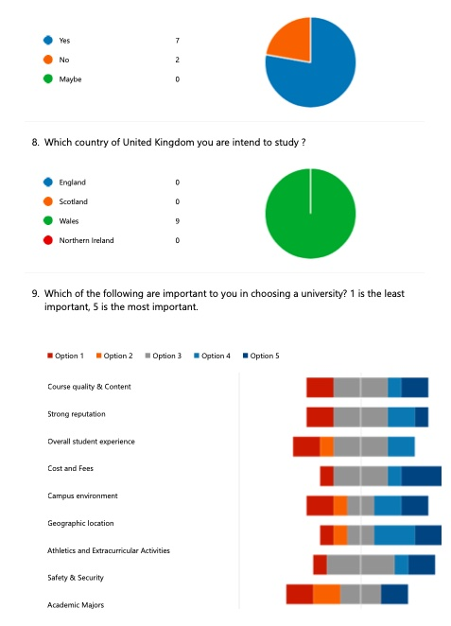

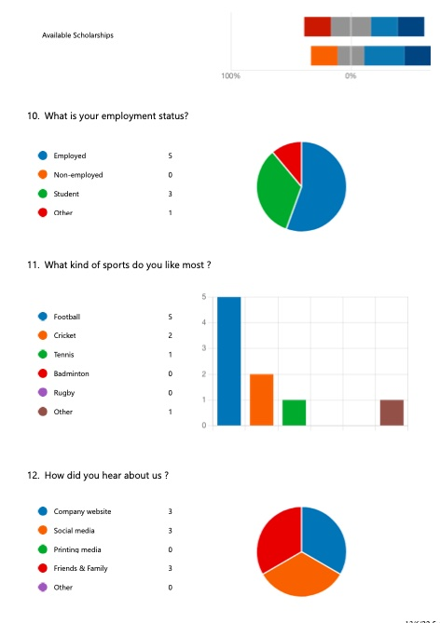

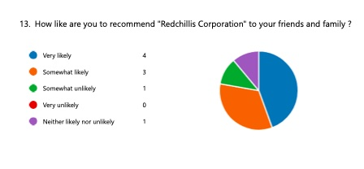

Screenshot of Website Design:









