SOFTWARE DEVELOPMENT
SECTION 2

Student ID: 1909223

Module Leader: Paul Jenkins

Module Code: ACCC4006

TABLE OF CONTENTS
1.0 INTRODUCTION 3
2.0 PART A (UNDERSTANDING) 3
2.1 ARRAYS AND THEIR IMPORTANCE IN PROGRAMMING 3
2.2 INHERITANCE 5
3.0 PART B (TESTING) 8
4.0 PART C (IMPLEMENTATION) 9
4.1 PROGRAMME CODE 9
4.2 OUTPUT 13
5.0 CONCLUSION 13
6.0 REFERENCES 14
7.0 APPENDICES 14

1.0 INTRODUCTION
Programming requires knowledge of certain concepts to ensure that coding is made easier, manageable with ease of maintenance. This avoids repetition and use of much space which may slow down the programme. This can be ensured through use of such object oriented programming (OOP) techniques as inheritance and use of arrays. This report will look at arrays and their importance in programming using relevant examples. In addition, it will look at inheritance as used in OOP using specific examples. Various methods used in programme testing will also be discussed as well as implementation of the programme using OO concept.

2.0 PART A (UNDERSTANDING)

2.1 ARRAYS AND THEIR IMPORTANCE IN PROGRAMMING
An array is a collection of variables called elements which are of the same data type. For instance, an int array holds elements of int type and a double array holds elements of double type. In C# the elements of an array are numbered with indices, that is, 0,1, 2, …N-1. The total number of elements in any given array are referred to as the length of an array and all elements in an array are of the same type whether primitive or reference and this allows for representation of a group of similar elements as an ordered sequence and working on them as a whole. Arrays can be in many forms but the most common ones are one-dimensional (vectors) and two-dimensional (matrices) (Nakov and Kolev 2012).
Arrays are mostly used in programming in such areas like scientific applications and mathematical problems like algebra and sparse array. According to Kumar (2012) the main objective of using arrays is minimizing the space required and improving the speed of the program. For example, consider a scenario where an average of 100 integer numbers entered by user needs to be found. In C#, there are two ways to do this. The first if by defining 100 variables with int data type and then performing 100 Console.WriteLine() operations in order to store the entered values in the variables followed by calculating their average. The second method involves having a single integer array to store all the values, then looping the array to store all the entered values in array and then calculating the average. This shows that the use of arrays simplifies and speeds up programme execution.
using System;

namespace ArrayApplication {
class MyArray {
static void Main(string[] args) {
int [] n = new int[10]; /* n is an array of 10 integers */
int i,j;

/* initialize elements of array n */
for ( i = 0; i < 10; i++ ) {
n[ i ] = i + 100;
}

/* output each array element's value */
for (j = 0; j < 10; j++ ) {
Console.WriteLine("Element[{0}] = {1}", j, n[j]);
}
Console.ReadKey();
}
}
}
The output of the above code is shown below.
Element[0] = 100
Element[1] = 101
Element[2] = 102
Element[3] = 103
Element[4] = 104
Element[5] = 105
Element[6] = 106
Element[7] = 107
Element[8] = 108
Element[9] = 109

In addition, arrays are cache friendly since their values are close to each other in the memory. As such, they are easily accessed from the CPU to cache hence iteration over an array becomes much faster compared to other forms of iterations.
For example, this can be achieved through use of the FOREACH loop as shown in the example below.
using System;

namespace ArrayApplication {
class MyArray {
static void Main(string[] args) {
int [] n = new int[10]; /* n is an array of 10 integers */

/* initialize elements of array n */
for ( int i = 0; i < 10; i++ ) {
n[i] = i + 100;
}

/* output each array element's value */
foreach (int j in n ) {
int i = j-100;
Console.WriteLine("Element[{0}] = {1}", i, j);
}
Console.ReadKey();
}
}
}
When the above code is compiled and executed, it produces the following result −
Element[0] = 100
Element[1] = 101
Element[2] = 102
Element[3] = 103
Element[4] = 104
Element[5] = 105
Element[6] = 106
Element[7] = 107
Element[8] = 108
Element[9] = 109

2.2 INHERITANCE
Inheritance is creation of a base class which has common properties and methods that can be used by classes derived from the base class. These classes are called derived classes of child classes.
The main purpose of inheritance is to create a base class that is able to encapsulate the properties and methods which can be used by the derived classes of the same type. This helps the developer in creating only one code common code for all the classes which ensures easier maintenance and management (Clark, 2013). For instance, a base class Account can be created with a GetBalance method. From this, SavingsAccount and CheckingAccount derived classes can inherit the GetBalance method.

Another example can be shown by the Vehicle class as a parent class with method Hooting. From this class, the Hooting method can be inherited by a child class Car. In C# this inheritance is shown by the use of the colon (:) symbol as shown below.
<acess-specifier> class <base_class> {
...
}

class <derived_class> : <base_class> {
...
}
Inheritance establishes a relationship between a derived class and an base class. This sees the compiler include all the members of the base class and the new class hence the class being implemented becomes a specialization of the base class.
For instance;
//Support class for Lorry
class Container {}
class Lorry: Vehicle {
public Lorry( Container load, Engine engine, Body body, Wheel fl, Wheel fr, Wheel, rr, Wheel, rl ) : base( engine, body, fl, fr, rl, rr )
{
this.load = load;
}
Private Container load;
}
This code shows how the derived class Lorry inherits the members of the base class Vehicle. That is, from the members of the Vehicle class which include Container load, Engine engine, Body body, Wheel fl, Wheel fr, Wheel, rr, Wheel, rl, the derived class Lorry has inherited some of these fields which include engine, body, fl, fr, rl, rr.
According to Cahill and Lafferty (2012). the term inherited members are those fields, properties and methods which are available in the base class that get included in the derived class as demonstrated above. These members can be inherited either directly when declared in the base class or indirectly when added to the base class if it is makes use of inheritance.
The ability to inherit from base class to derived class ensures avoidance of maintenance problems of copying and pasting since there is ability to reuse the functionality of the base class. For example;
class InsuredEmployee : InsuranceClient {
Date startDate;
int training;
public const int Technical = 1, Other = 2;
public InsuredEmployee(string name, int gender, Date birthday, Address home, DATE startDate, int training) : base( name, gender, birthday, home) {
this.startDate = startDate;
this.training = training;
}
This programme demonstrates the use of inheritance to include InsuranceClient functionality where there is a continuing link between the InsuredEmployee class and the InsuranceClient class. With this update from one class automatically results into update in another class. This therefore avoids the copy and paste where an update from InsuredEmployee class needs an update everytime InsuranceClient class is changed (Cahill and Lafferty, 2012)
Consider another example of a base class Vehicle and derived class Car shown below.
class Vehicle // base class (parent)
{
public string brand = "Ford"; // Vehicle field
public void honk() // Vehicle method
{
Console.WriteLine("Hooting");
}
}

class Car : Vehicle // derived class
{
public string modelName = "Mustang"; // Car field
}

class Program
{
static void Main(string[] args)
{
// Create a myCar object
Car myCar = new Car();

// Calling the honk() method (From the Vehicle class) on the myCar object
myCar.honk();

// Display the value of the brand field (from the Vehicle class) and the value of the modelName from the Car class
Console.WriteLine(myCar.brand + " " + myCar.modelName);
}
}
In the above example, the base class is the Vehicle class which has a field Ford and a method honk. The derived class Car inherits the field and the method of the base class Vehicle and hence it is able to call the method honk following inheritance of the two classes through the use of “class Car : Vehicle”.

3.0 PART B (TESTING)
Creation of a software or an application requires several types of tests and such tests include black box testing, white box testing and grey box testing among others (Basu, 2015).
White box testing involves reviewing of the functioning of the internal structure and processes of the application rather than its functionalities. In this testing method, all the internal components of the software are tested using the source code as the main work base of the tester. White box testing offers such advantages as avoiding of points which may turn into errors in future, optimization and exhaustiveness of the system through code modification. On the other hand, the method poses drawbacks such as need for strong programming knowledge, longer times, need for automation tools like debuggers and analysers (Saunois, 2016).
Black box testing involves reviewing functionalities of the application and not its internal structures. It is suitable for checking after the final stage of development. It is beneficious in that it is simple, fast and impartial. However, it is disadvantageous in that it is superficial and redundant.
Grey box testing is a combination of the white box and black box testing where both functionalities and internal structures of the system are tested. It has such advantages as impartiality with distinction between the developer and tester and also guarantees that through intelligence of the tester. Conversely, the method is non-exhaustive since the code is not accessible hence incomplete coverage of the programme (Saunois, 2016).

4.0 PART C (IMPLEMENTATION)

4.1 PROGRAMME CODE

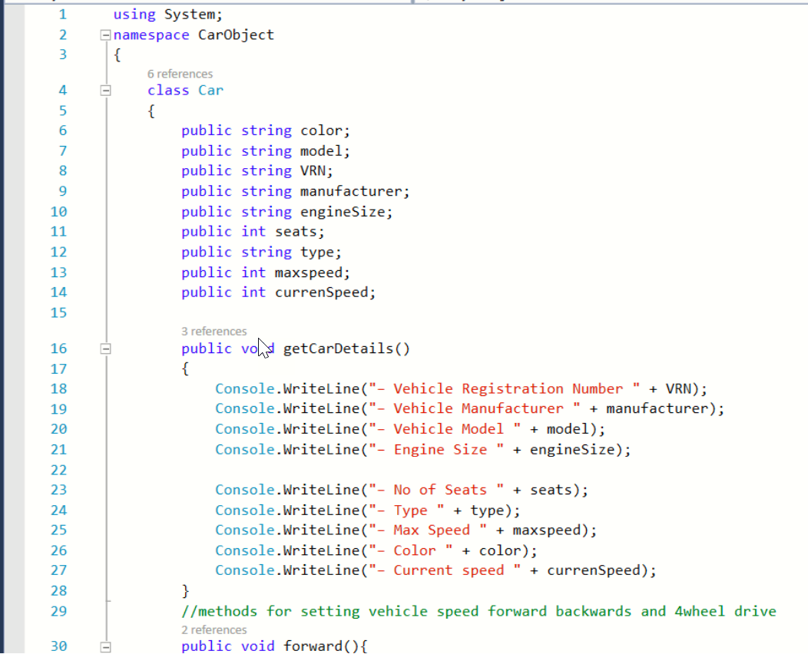
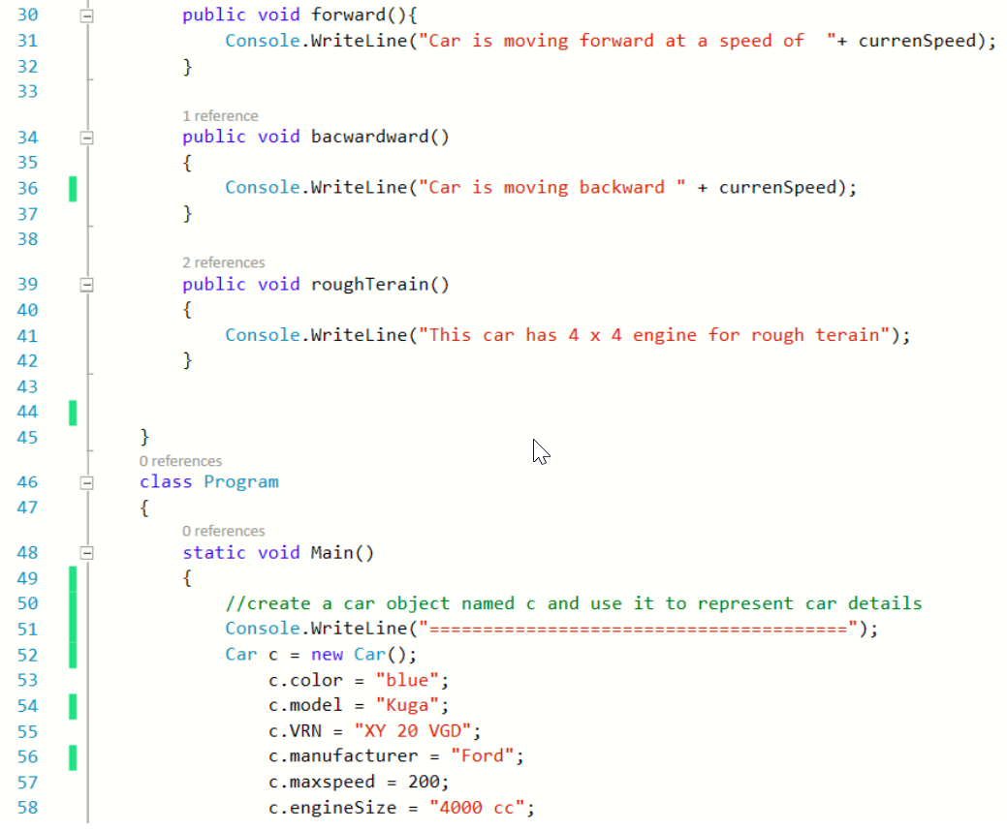

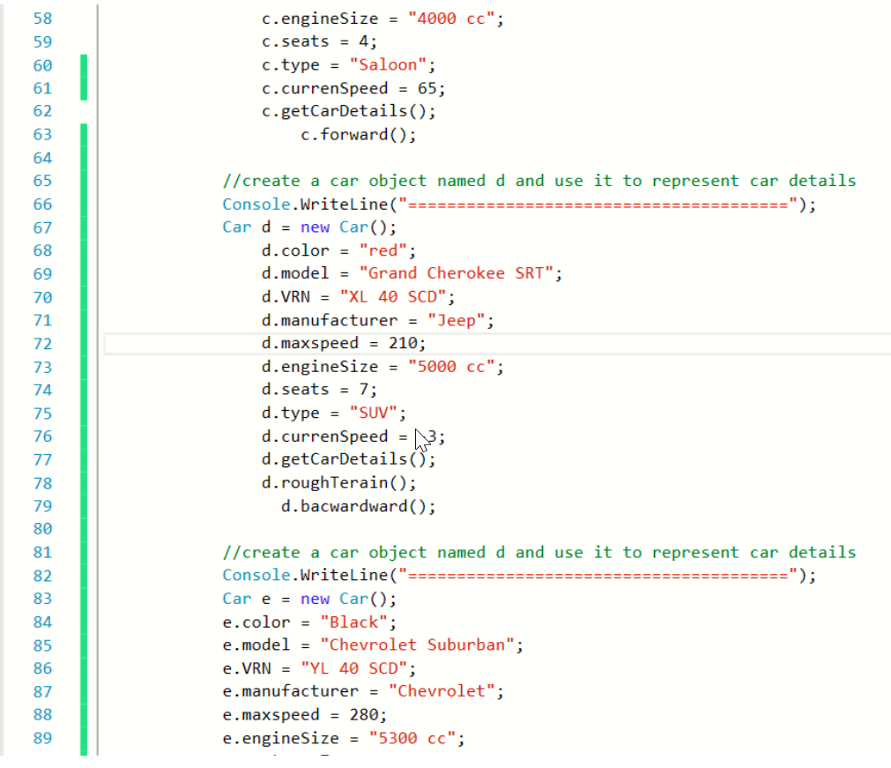

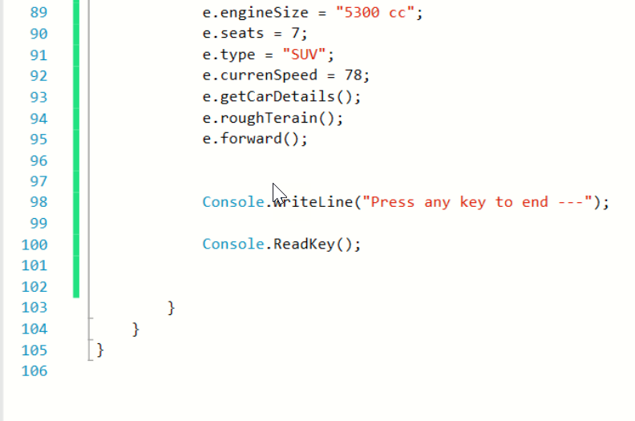

4.2 OUTPUT
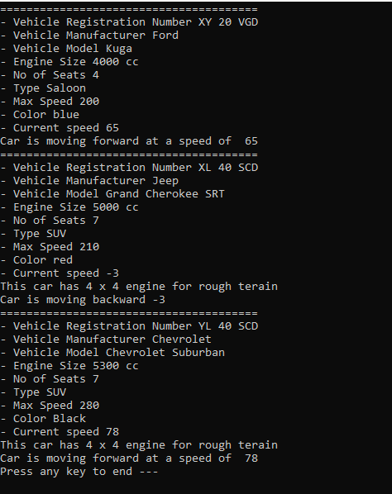

5.0 CONCLUSION
The concept of OOP provides ways through which programming can be made simpler and easier without need for repetition through use of inheritance. It also ensures fast functionality of the developed applications through use of such techniques as arrays which ensures that processing is fast. Programme testing during and after development is vital in ensuring an efficiently functioning application and as such, there are methods in place for testing. However, a suitable method should be chosen depending on the stage and purpose of testing.

6.0 REFERENCES
Basu, A. (2015). Software Quality Assurance, Testing and Metrics. New Delhi: PHI Learning.
Cahill, V. and Lafferty, D. (2012). Learning to Program the Object-Oriented Way with C#. London: Springer Science & Business Media.
Clark, D. (2013). Beginning C# Object-Oriented Programming. New York: Apress.
Kumar, A. (2012). Data Structure for C Programming. New Delhi: Firewall Media.
Nakov, S. amd Kolav, V. (2013). Fundamentals of Computer Programming with C#. Faber Publishing.
Saunois, L. (2016). Black box, grey box, white box testing: what differences?. [online] Available at: https://www.nbs-system.com/en/blog/black-box-grey-box-white-box-testing-what-differences/ [Accessed 10 Aug 2020].

7.0 APPENDICES

